<Project Name>

Version <1.0>

Revision History

|  |  |  |  |
| --- | --- | --- | --- |
| **Date** | **Version** | **Description** | **Author** |
| 23/11/2019 | 1.0 |  | <name> |
|  |  |  |  |
|  |  |  |  |
|  |  |  |  |

Table of Contents

1. Introduction 4

2. Architectural Goals and Constraints 4

3. Use-Case Model 4

4. Logical View 4

4.1 Component: UI Layer 5

4.2 Component: Business Logic Layer 6

4.3 Component: Data Access Layer 6

4.4 Component: Data Base Layer 7

4.5 Component: MVC model 8

# Introduction

[The introduction of the **Software Architecture Document** provides an overview of the entire **Software Architecture Document**. It includes the purpose, scope, definitions, acronyms, abbreviations, references, and overview of the **Software Architecture Document**.]

# Architectural Goals and Constraints

[This section describes the software requirements and objectives that have some significant impact on the architecture; for example, safety, security, privacy, use of an off-the-shelf product, portability, distribution, and reuse. It also captures the special constraints that may apply: design and implementation strategy, development tools, team structure, schedule, legacy code, and so on.]

# Use-Case Model

[This section includes the use case diagrams that are already modeled and presented in the use-case specification document.]

# Logical View

The logical view of the Convenience Store Sale Management Software follow the layered architecture with 4 main layer:

* **UI Layer**: Contains all the boundary classes that represent the software screens that the users use to communicate with the software.
* **Business Logic Layer**: Contains class that supports logic processing. It process user input from UI and transfer to the Data Access Layer. Process the data receive from the Data Access Layer and transfer it to UI.
* **Data Access Layer**: Contains class that supports access to the data base. It receive the statement from the Business Logic Layer and access to the data base toget the data. Transfer the data get from the data base to the Business Logic Layer.
* **Database Layer:** Contains the data base of the store.

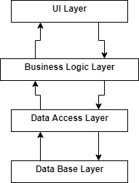

## Component: UI Layer

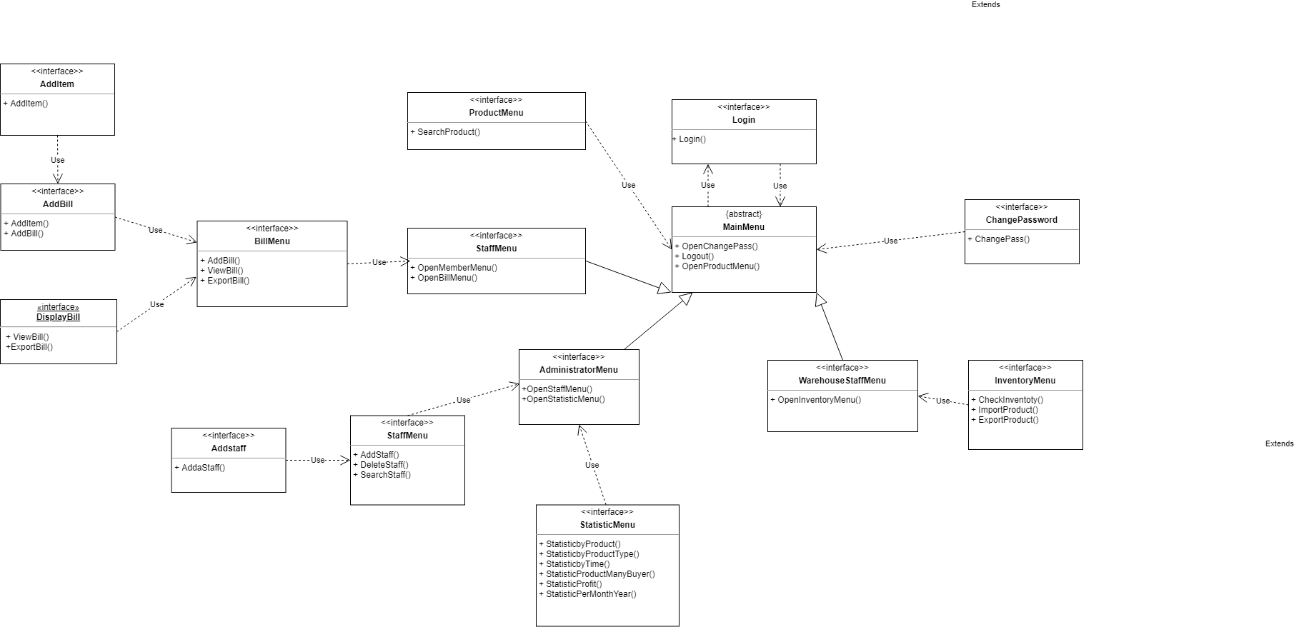

* Login class: Login screen class, supports login for all users.
* ChangePassword class: Change password screen, supports all users changing password.
* MainMenu class: Abstract classes for all user main menu classes.
* StaffMenu class, WarehouseStaffMenu, AdministratorMenu: Main menu screen for each type of staffs, warehouse staff, administrator. Displays menu to choose which action users want to do.
* BillMenu class: Menu displays for staffs and administrator all action can do on the bills.
* ProductMenu class: Displays screen support search and watch product information for all user.
* InventoryMenu class: Display screen supports warehouse staff choose to check inventory, to import or to export product.
* StaffMenu: Displays screen support administrator to add a staff, remove a staff or search for a staff.
* StatisticMenu: Displays screen support administrator to make statistic report in many type.

## Component: Business Logic Layer

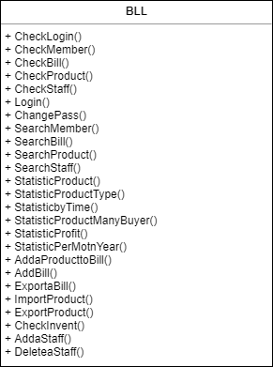

* BLL class: Supports logical process in the software like process input from UI Layer for Data Access Layer or process data from Data Access Layer for UI.
* CheckLogin(): Check if username and password user input is right
* CheckMember(): Check if ID Member is exists
* CheckBill(): Check if ID Bill is exists
* CheckProduct(): Check if ID Product is exists
* CheckStaff(): Check if ID Staff is exists
* SearchMember(): Find member based on ID Member user input, if it exists, return information of this member, else show notice to user
* SearchBill(): Find bill based on ID Bill staff input, if it exists, return information of this bill, else show notice to staff
* SeachProduct(): Find product based on ID Product staff input, if it exists, return information of this product, else show notice to staff
* SearchStaff(): Find staff based on ID staff manager input, if it exists, return information of this staff, else show notice to manager
* StatisticProduct(): check amount of product in store/warehouse
* StatisticProductType(): check amount of type product in store/warehouse
* StatisticbyTime(): check the statistic of products sold over time
* StatisticProductManyBuyer(): statistic the products which bought many times
* StatisticProfit(): statistic revenue from sasles
* StatisticPerMotnYear(): statistic revenue by month of year
* AddaProducttoBill(): insert a product to bill
* AddBill(): insert a bill to system
* ExportaBill(): export a bill to the customer
* ImportProduct(): insert product to warehouse
* ExportProduct(): insert a product to store from warehouse
* AddaStaff(): add a new staff
* DeleteStaff(): remove a staff

## Component: Data Access Layer

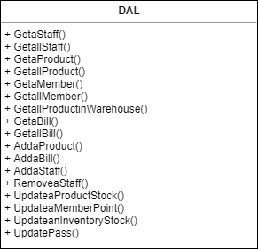

* DAL class: Supports access to the data base to get data insert data, delete data, update data on the databse follow the require from the Business Logic Layer.
* GetaStaff(): Search information of a staff

+ Input: ID staff.  
+Output: all information of this staff.

* GetallSatff(): Search information all staff.

+Output: all information of all staff.

* GetaProduct(): Search information a product in store

+Input: ID product.  
+Output: all information of this product in store.

* GetallProduct(): Search information of all product

+Output: all in formation of all product in store.

* GetaMember(): Search information a member(customer)

+Input: ID member.

+Output: all information of this member.

* GetallMember(): Search information all member(customer)

+Output: all information of all Member.

* GetallProductinWarehouse(): Search information of all product which in Warehouse.

+Output: all information of all product in warehouse.

* GetaBill(): Search information a bill

+Input: ID bill.

+Output: information of this bill.

* GetallBill(): Search information of all bill

+Output: all information of all Bill.

* AddaProduct(): Add a new product into store

+Input: ID new product, name, value,…  
+Output: a new product inserted into database.

* AddaBill(): Add a new bill

+Input: ID new bill, ID staff, ID member,…  
+Output: a new bill inserted into database.

* AddaStaff(): Add a new staff

+Input: ID new staff, name, phone number,…

+Output: a new staff inserted into database.

* RemoveaStaff(): Delete a staff

+Input: ID staff.

+Output: this staff will be removed away from database.

* UpdateaProductStock(): Edit, update information of product

+Input: ID product.

+Output: this product will updated with new value.

* UpdateaMemberPoint(): Edit, update point of a member

+Input: ID member.

+Output: point of this member will be updated with new value.

* UpdatePass(): all type of user can update their password

+For customer: update owner password.

+For staff: update owner password.  
+For manager: update owner password and other password of remain type of user.

## Component: Database Layer

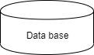

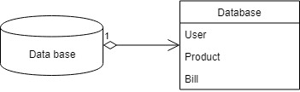

## Component: MVC model

### For staff

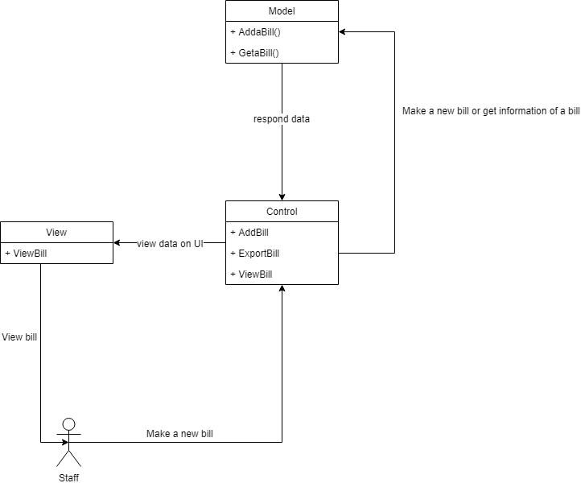

### For warehouse staff

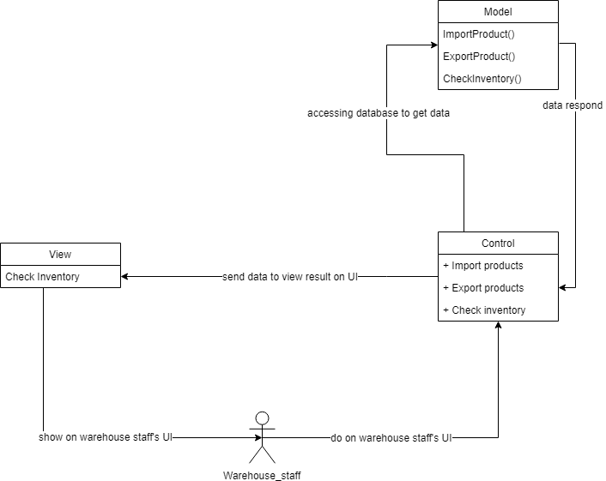

### For administrator (manager)

