

**SOURCE CODE MANAGEMENT**

**(CS181)**

**Task 1.1**

Submitted by – Submitted to –

Dhruv Jain Dr. Monit Kapoor  
2110990443

G8-B

**Experiment No. 01**

**Aim:** Setting up of Git Client

* For git installation on your system, go to <https://git-scm.com/book/en/v2/Getting-Started-Installing-Git>.

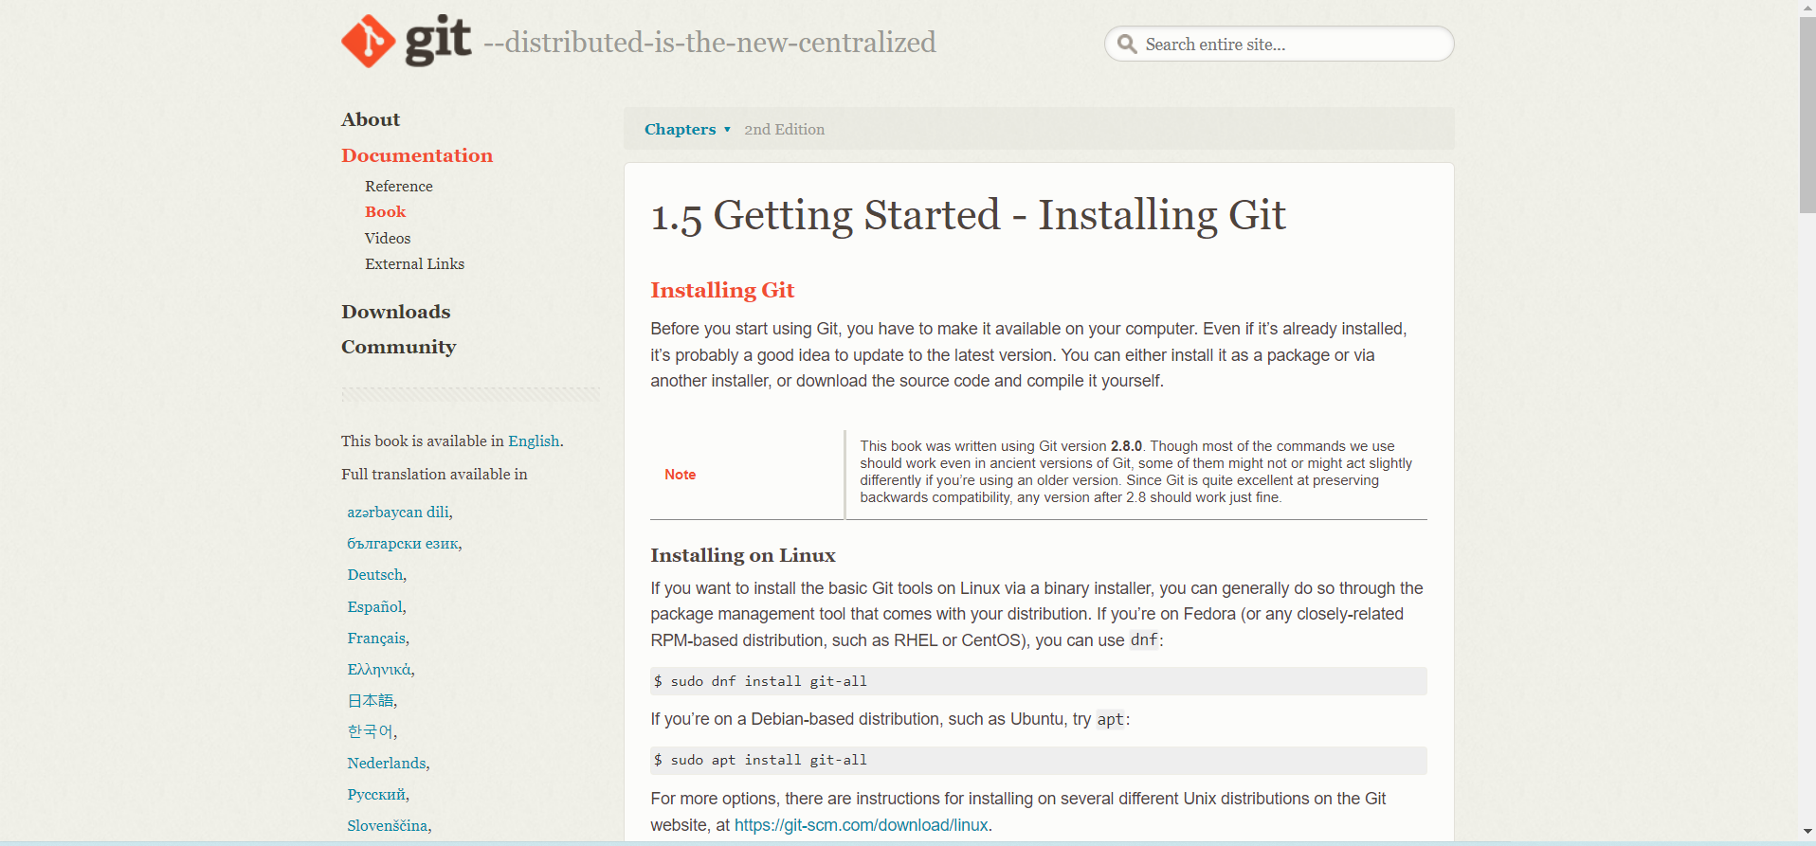

* Choose the operating system by clicking on it. I'll choose the Windows operating system.

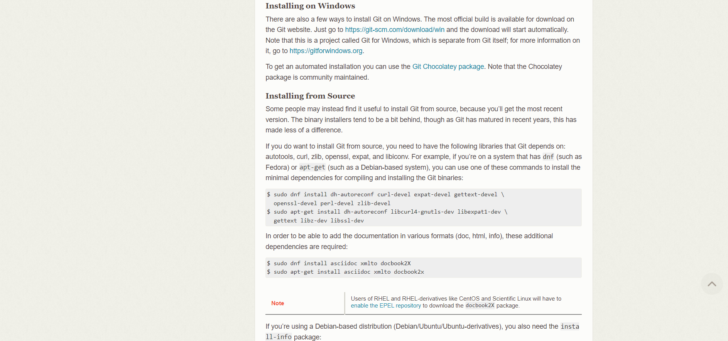

* Select the CPU for your system now. (I choose to 64-bit Git for Windows Setup.) 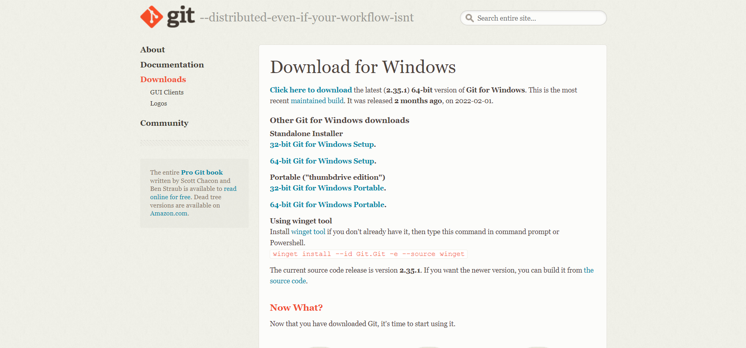
* Then, open the Git in Download folder. We will be asked if you want to enable this program to make modifications to your PC once you launch it. Select YES.

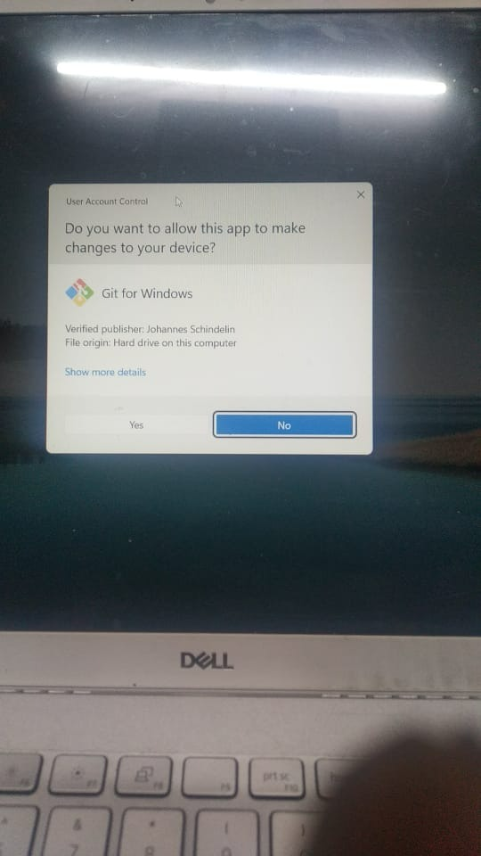

* The below window will appear. Click on Next.

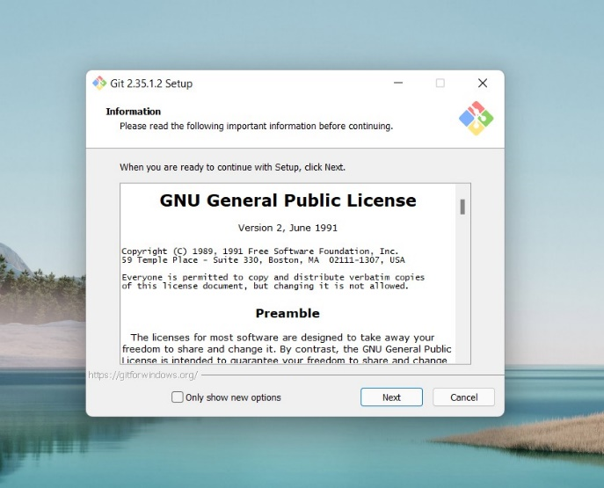

* Continue clicking on next few times more.

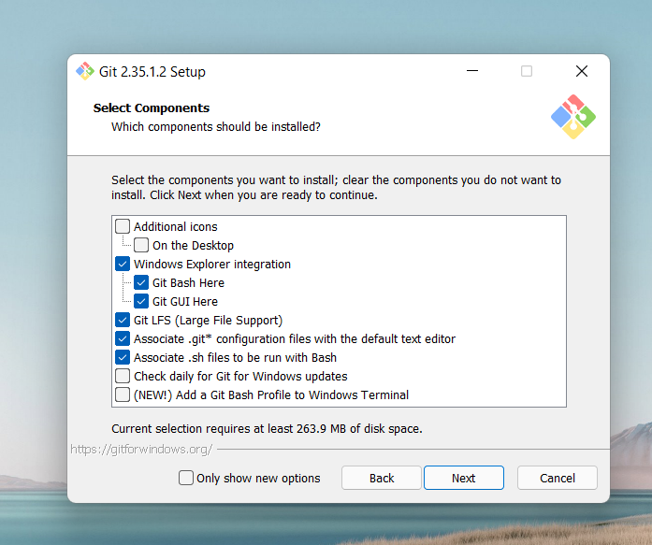 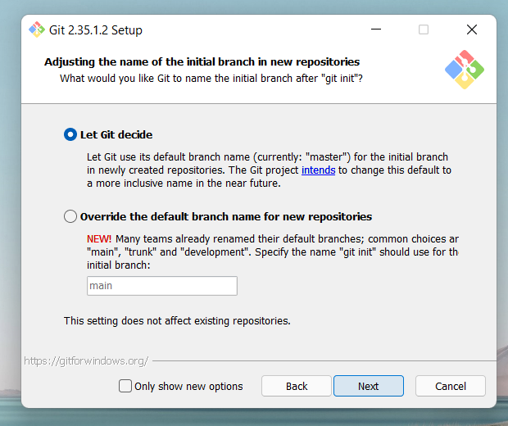

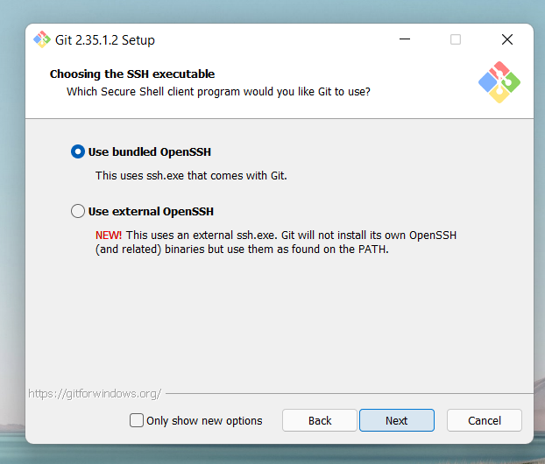 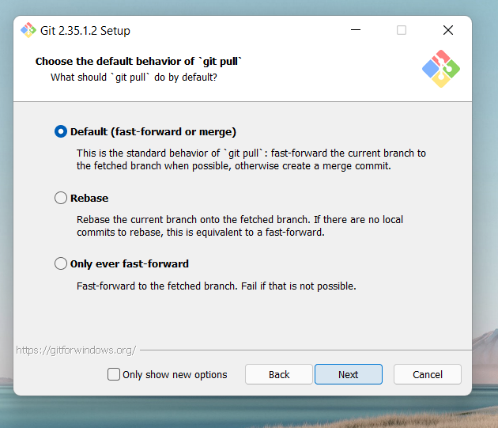

* Now select the Install option.

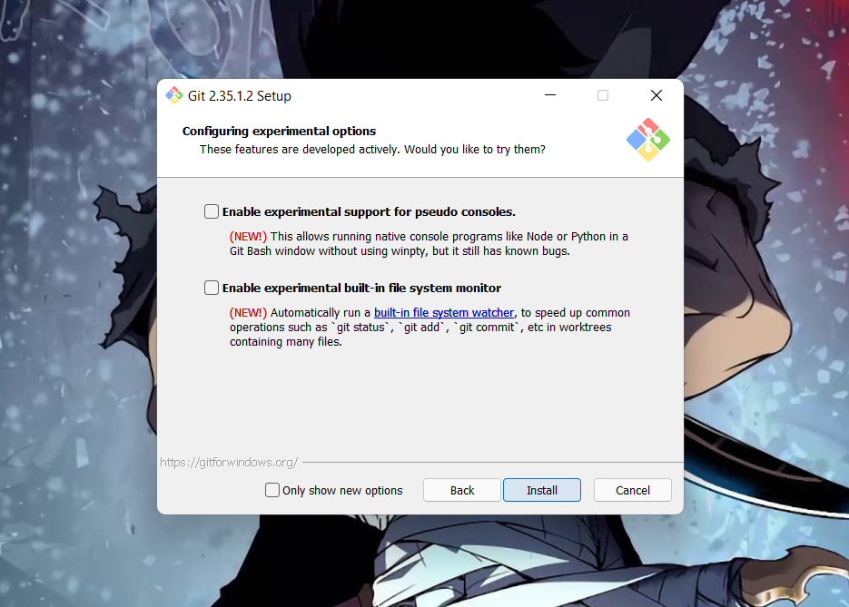

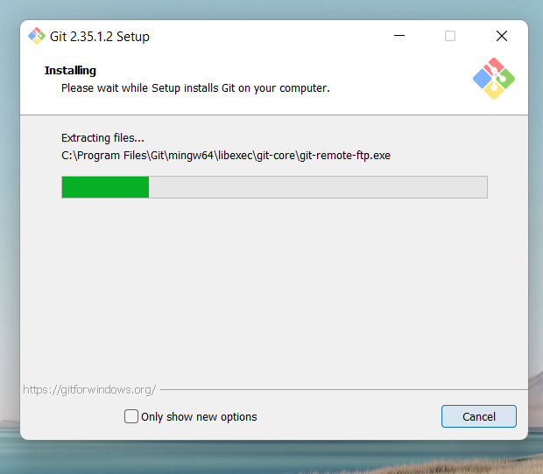

* After completion of installing, click on Finish after the installation is finished.

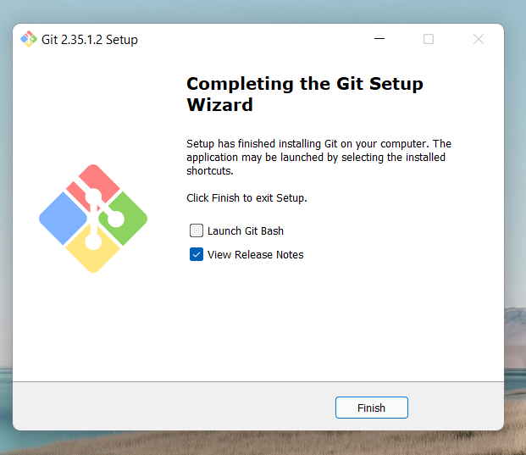

The installation of the git is finished and now we have to setup git client and GitHub account.