

**SOURCE CODE MANAGEMENT**

**(CS181)**

**Task 1.1**

Submitted by – Submitted to –

Dhruv Jain Dr. Monit Kapoor  
2110990443

G8-B

**Experiment No. 02**

**Aim:** **Setting up GitHub Account**

* Open your web browser search <http://github.com> .
* Click on Sign Up on the upper-right conner of desktop window.



* After clicking on "Sign Up," a new page will appear where we must enter your email address for your account.

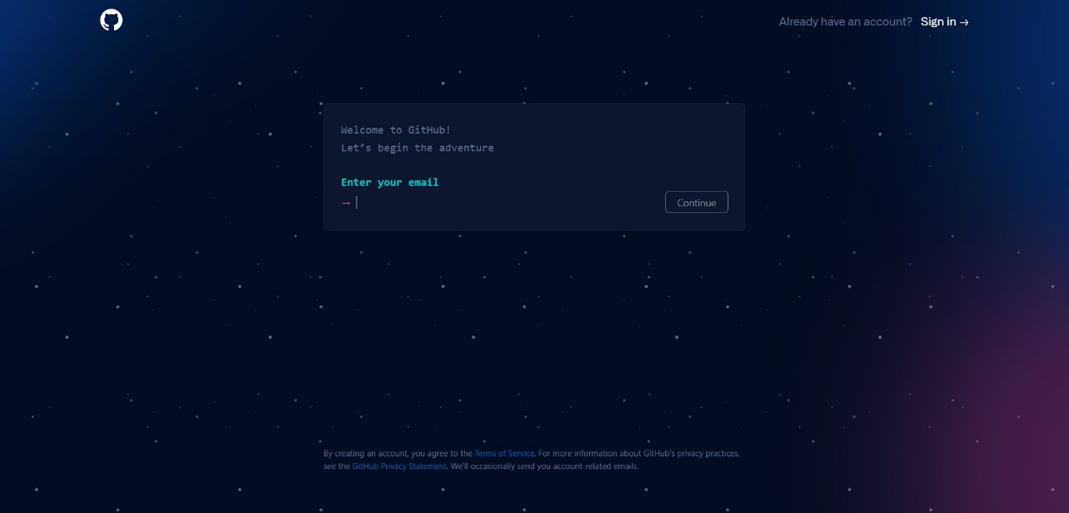

* Now type in the password we want to use for your GitHub account. Then you'll be prompted to enter your username.

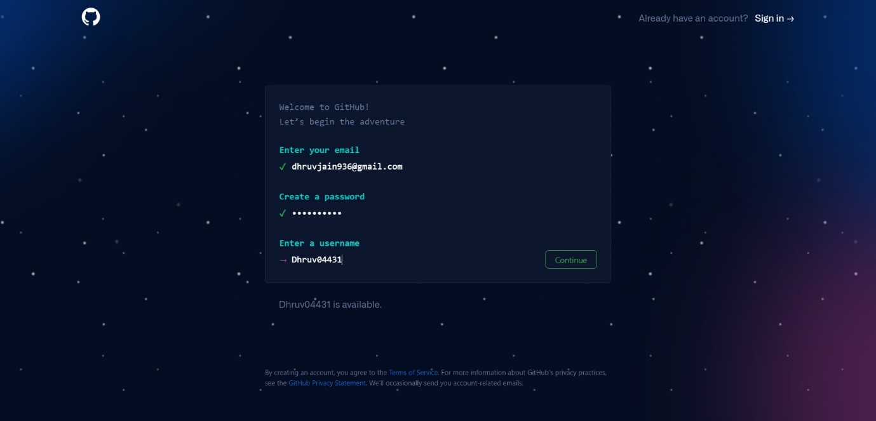

* Now Click on Create Account.
* Verify the email and our Github account is ready.

