

**SOURCE CODE MANAGEMENT**

**(CS181)**

**Task 1.1**

Submitted by – Submitted to –

Dhruv Jain Dr. Monit Kapoor  
2110990443

G8-B

**Experiment No. 03**

**Aim: Program to Generate logs**

## First of all create a local repository using Git. For this, you have to make a folder in your device, right click and select “Git Bash Here”. This opens the Git terminal. To create a new local repository, use the command “git init” and it creates a folder .git.

## 

* When we use GIT for the first time, we have to give the user name and email so that if I am going to change in project, it will be visible to all.

For this, we use command 🡪

**“git config --global user.name *Name*”**

**“git config --global user.email *email*”**

**Some Important Commands:**

**git add -A [** For add all the files in staging area. **]**

**git commit -m “write any message” [** For commit the file **]**

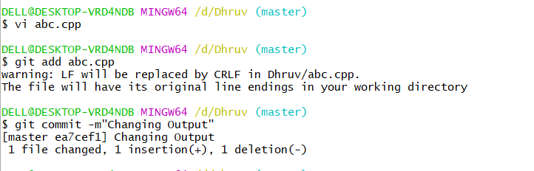

* **git log:**The git log command displays a record of the commits in a Git repository. By default, the git log command displays a commit hash, the commit message, and other commit metadata.

