

**SOURCE CODE MANAGEMENT**

**(CS181)**

**Task 1.1**

Submitted by – Submitted to –

Dhruv Jain Dr. Monit Kapoor  
2110990443

G8-B

**Aim:** Create and visualize branches

* **Branching:** A branch in Git is an independent line of work(a pointer to a specific commit). It allows users to create a branch from the original code (master branch) and isolate their work. Branches allow you to work on different parts of a project without impacting the main branch.

Let us see the command of it:

Firstly, add a new branch, let us suppose the branch name is activity1.

For this use command 🡪

* **git branch name [**adding new branch**]**
* **git branch [**use to see the branch’s names**]**
* **git checkout *branch name* [**use to switch to the given branch**]**

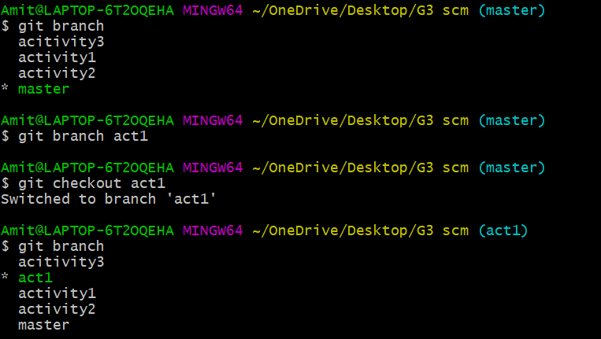

In this you can see that firstly ‘git branch’ shows only one branch in green colour but when we add a new branch using ‘git branch act1’, it shows 2 branches but the green colour and star is on master. So, we have to switch to act1 by using ‘git checkout act1’. If we use ‘git branch’, now you can see that the green colour and star is on act1. It means you are in activity1 branch and all the data of master branch is also on act1 branch. Use “ls” to see the files.

Now add a new file in activity1 branch, do some changes in file and commit the file.

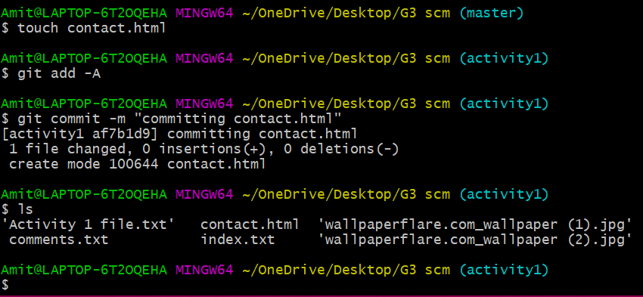

If we switched to master branch, ‘contact.html’ file is not there. But he file is in activity1 branch.

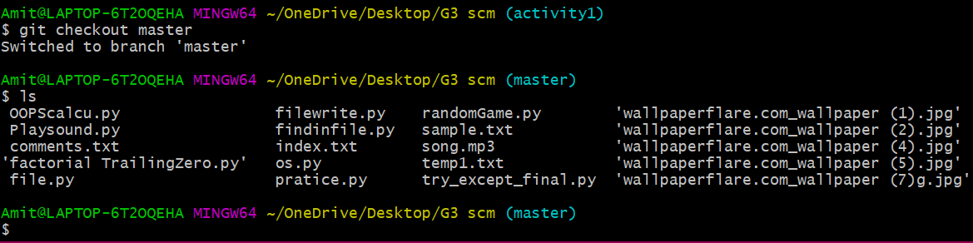

* To add these files in master branch, we have to do merging. For this firstly switch to master branch and then use command 🡪

**git merge branchname [**use to merge branch**]**

