

**SOURCE CODE MANAGEMENT**

**(CS181)**

**Task 1.1**

Submitted by – Submitted to –

Dhruv Jain Dr. Monit Kapoor  
2110990443

G8-B

**Experiment No. 05**

**Aim:** Git lifecycle description

# Stages in GIT Life Cycle:

When a directory is made a git repository, there are mainly 3 states which make the essence of Git Version Control System. The three states are –

* Working Directory
* Staging Area
* Git Directory

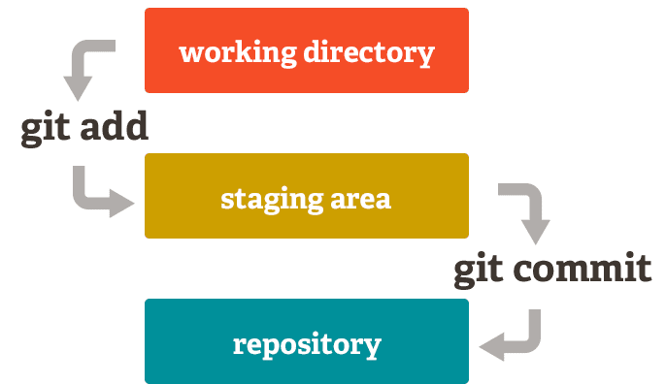

* **Working Directory:** Whenever we want to initialize our local project directory to make it a git repository, we use the ***git init*** command. After this command, git becomes aware of the files in the project although it doesn’t track the files yet. The files are further tracked in the staging area.



* **Staging Area:** Now, to track the different versions of our files we use the command ***git add***. We can term a staging area as a place where different versions of our files are stored. ***git add*** command copies the version of your file from your working directory to the staging area.

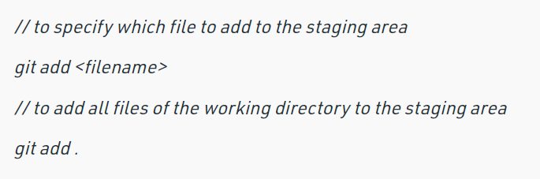

* **Git directory(repository):** Now since we have all the files that are to be tracked and are ready in the staging area, we are ready to commit our files using the ***git commit***command. Commit helps us in keeping the track of the metadata of the files in our staging area. We specify every commit with a message which tells what the commit is about.

