**Name: Hamza Shakeel**

**Roll Number: 2110990540**

|  |  |  |
| --- | --- | --- |
| |  | | --- | | **Experiment No. 01** | |  |

**Aim:** Setting up the git client.

**Procedure:**

* Search download git on chrome or any search engine available to you.

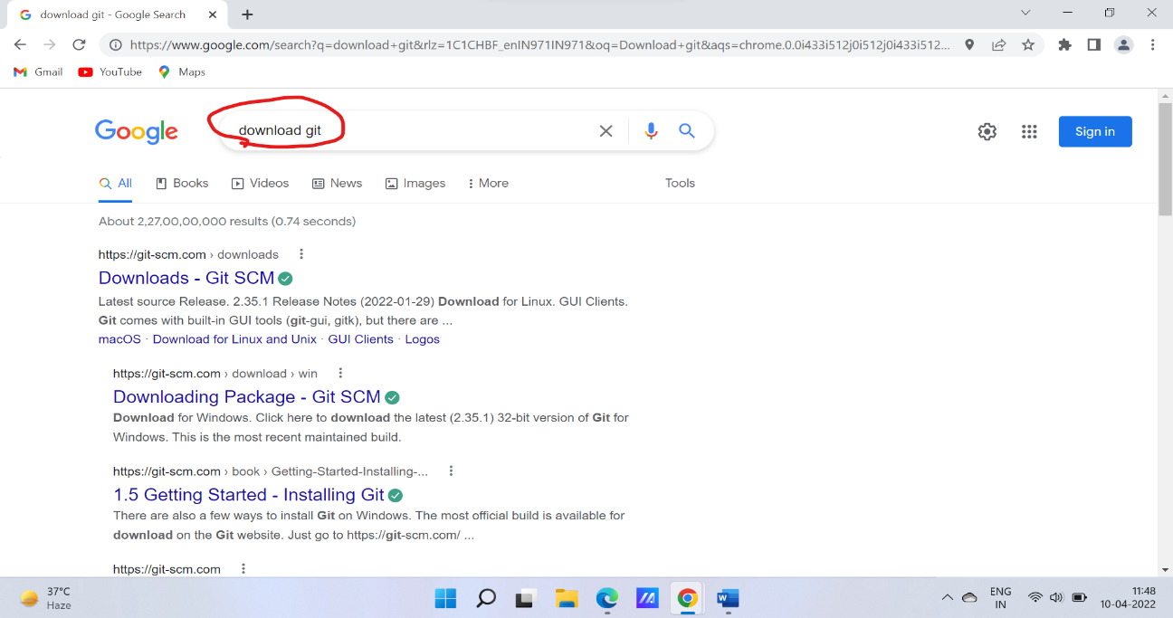

* Click on https://git-scm.com › downloads

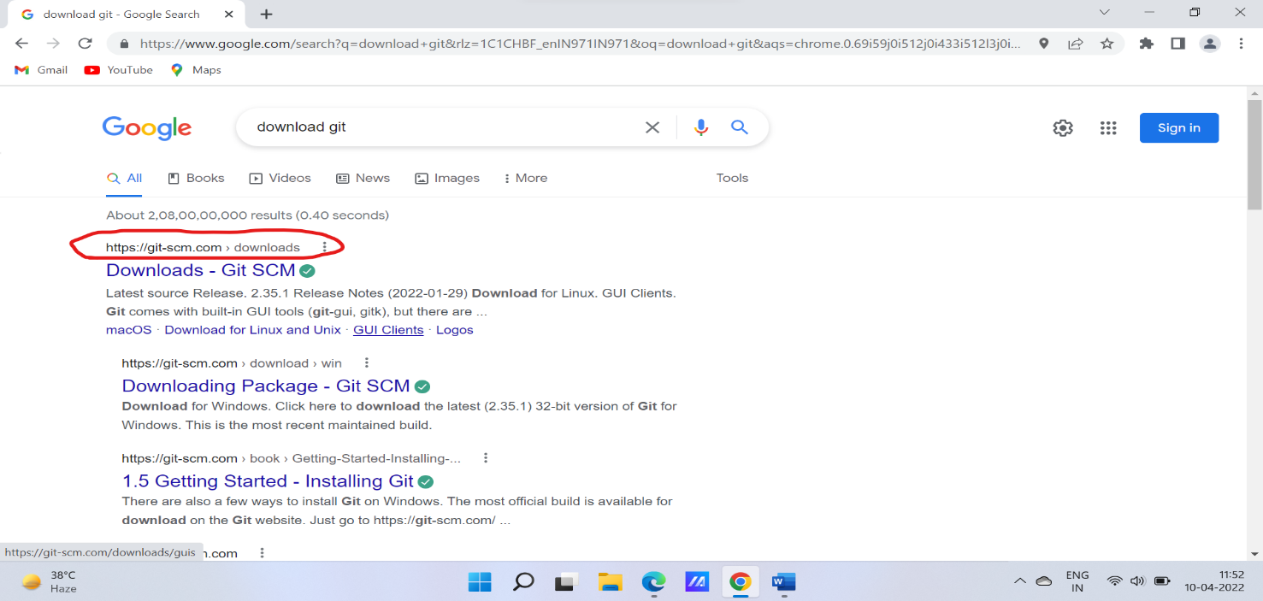

* Chose a version you have to download and the download will start

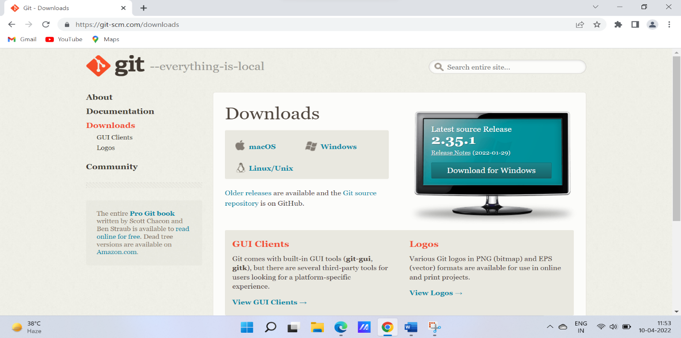

* After downloading a pop-up will open and click next and keep the default setting as it is but if you want to change you can .

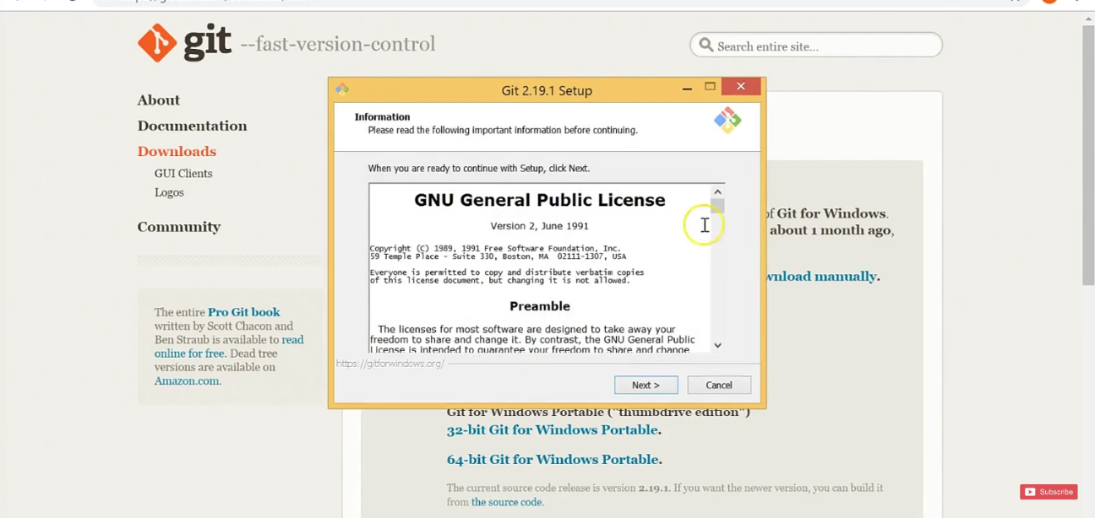

* Click finish and launch Git bash

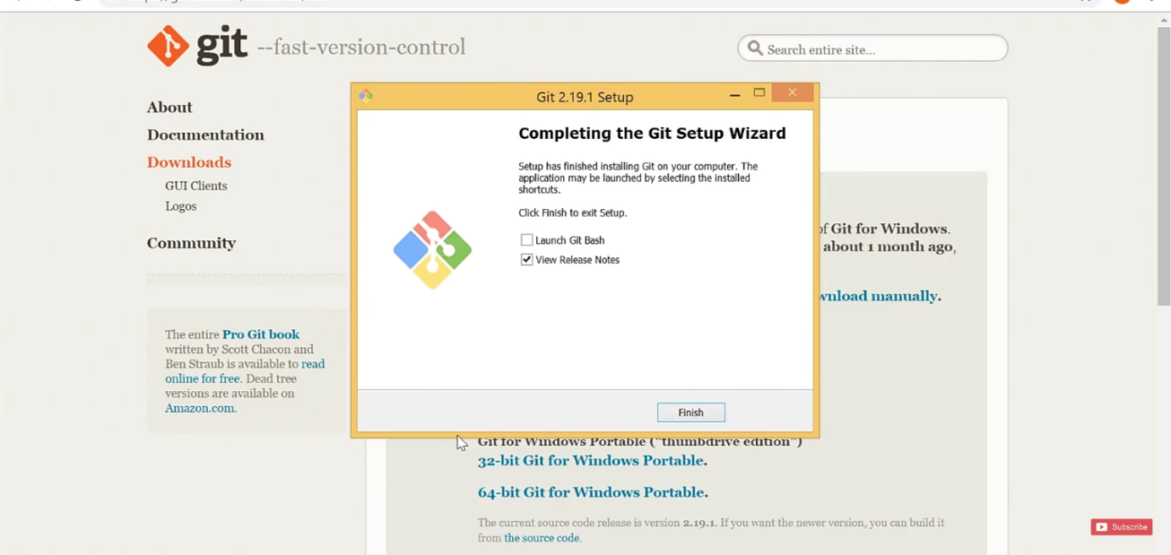

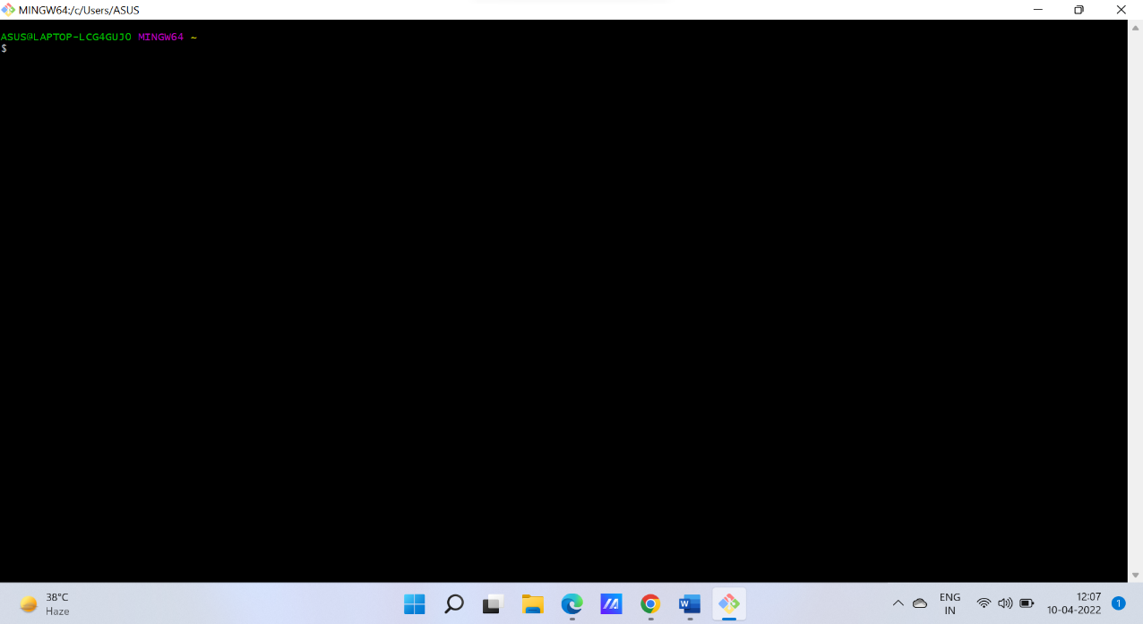

|  |  |  |
| --- | --- | --- |
| |  | | --- | | **Experiment No. 02** | |  |

# Aim

Setting up GitHub Account

The steps for setting up a github account are:

* Search Github on any search engine available to you and click on <https://github.com>.

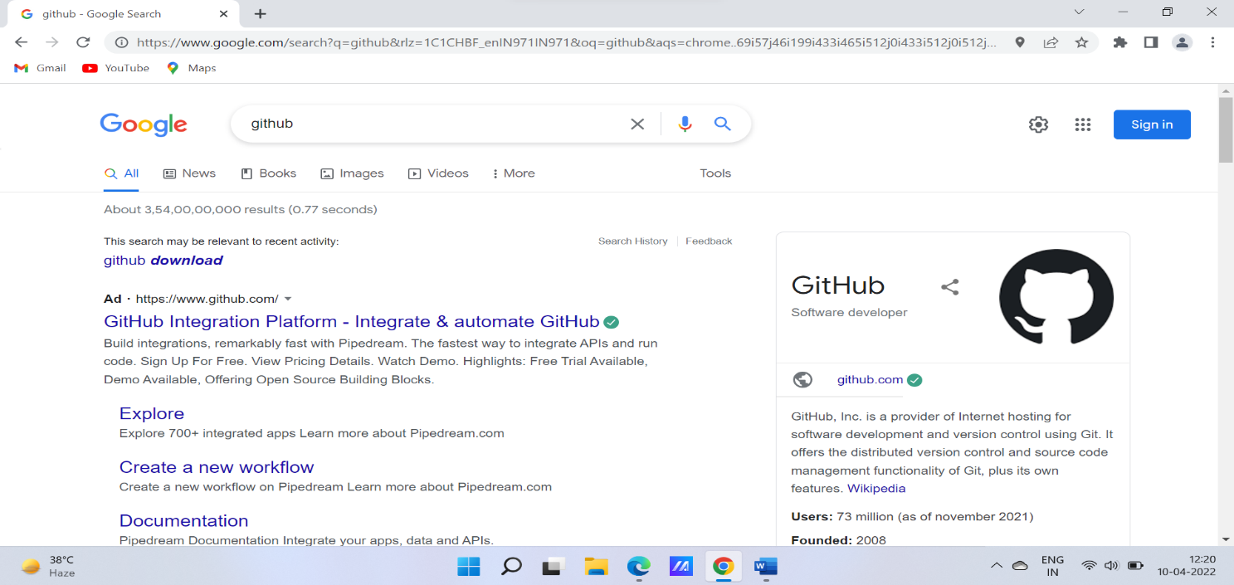

* Click on sign-up and enter you email, password and username.
* Enter the code that has been mailed to you.
* Select the members and your designation.
* Select your plan
* And your Github is set up

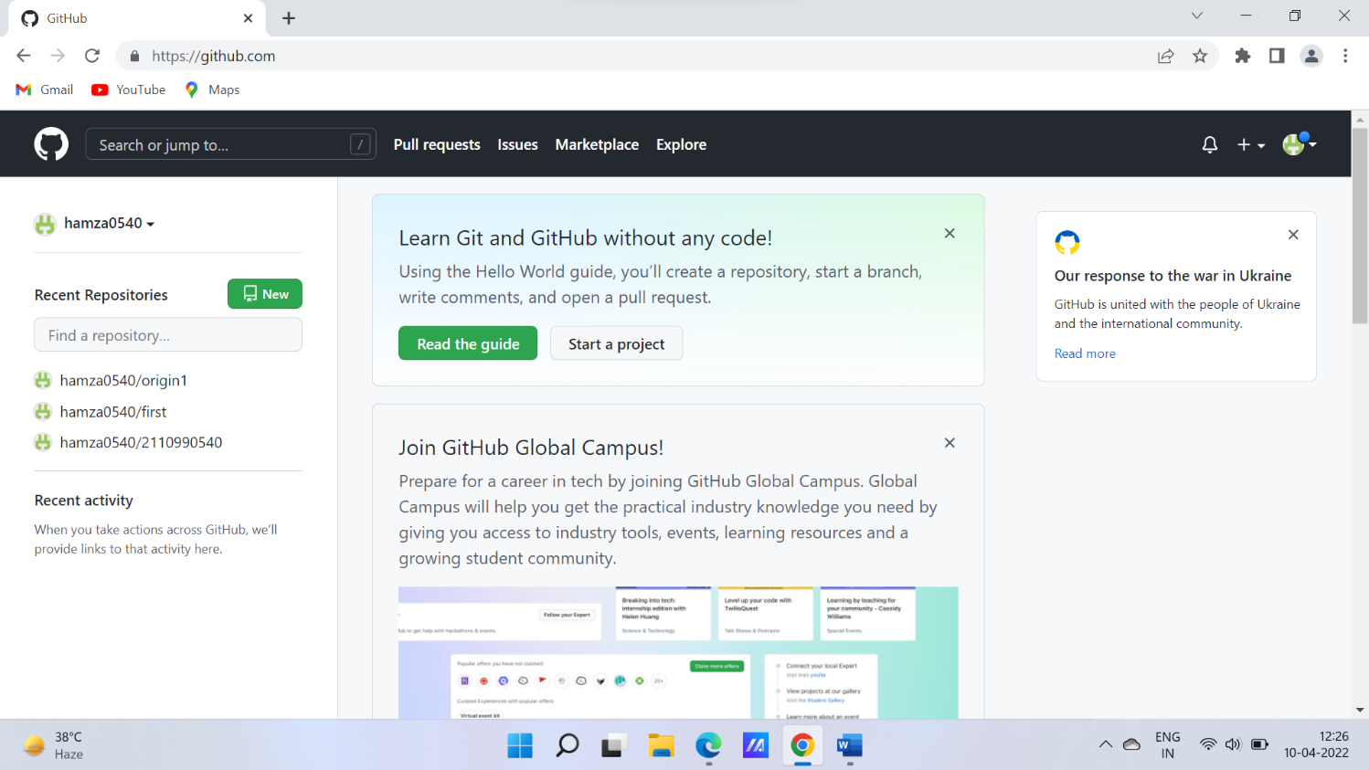

|  |  |  |
| --- | --- | --- |
| |  | | --- | | **Experiment No. 03** | |  |

**Aim:** Program to generate logs

**Pwd** – (print working directory) Shows us where we are

**Ls** – (list) Lists all the files

**Cd** – Changes the directory

**Clear** – Clears all the screen

**Mkdir** – makes a new directory

**Git –version -** shows the version

**Git config - - list –** list all of the config values

**Git init -** Git init command creates a new Git repository.

**Git status -** The git status command displays the state of the working directory and thestagingarea. **Git commit –** Captures a snapshot of the projects currently staged changes.

**Git add command -** The git add command adds a change in the working directory to the staging area

**Git log -** Git log command is one of the most usual commands of git.

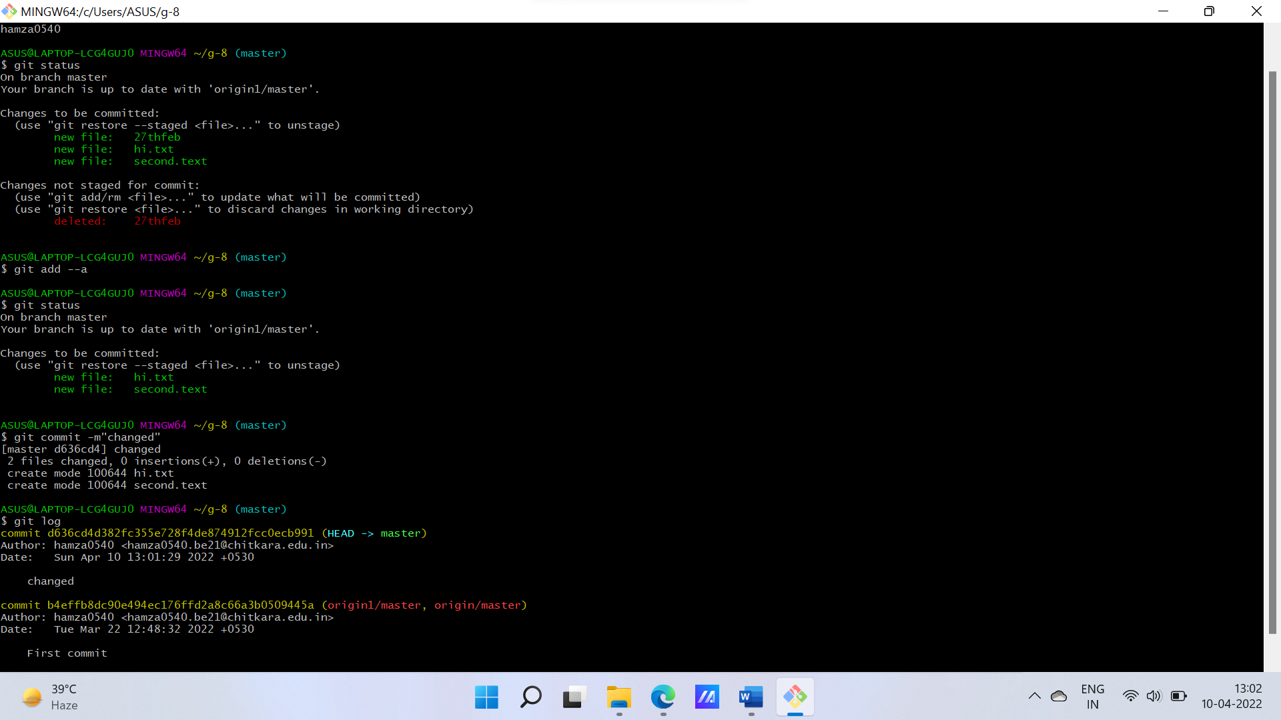

|  |  |  |
| --- | --- | --- |
| |  | | --- | | **Experiment No. 04** | |  |

**Aim:**  Create and visualize branches in Git

The main branch in git is called the master branch. All the files present in master can be shown in branch but the files which are created in branch are not shown in master branch.

* Git branch “name of the branch” – Creates a new branch
* Git branch – Checks how many branches are there.
* Git checkout “name of the branch” – change the present working branch

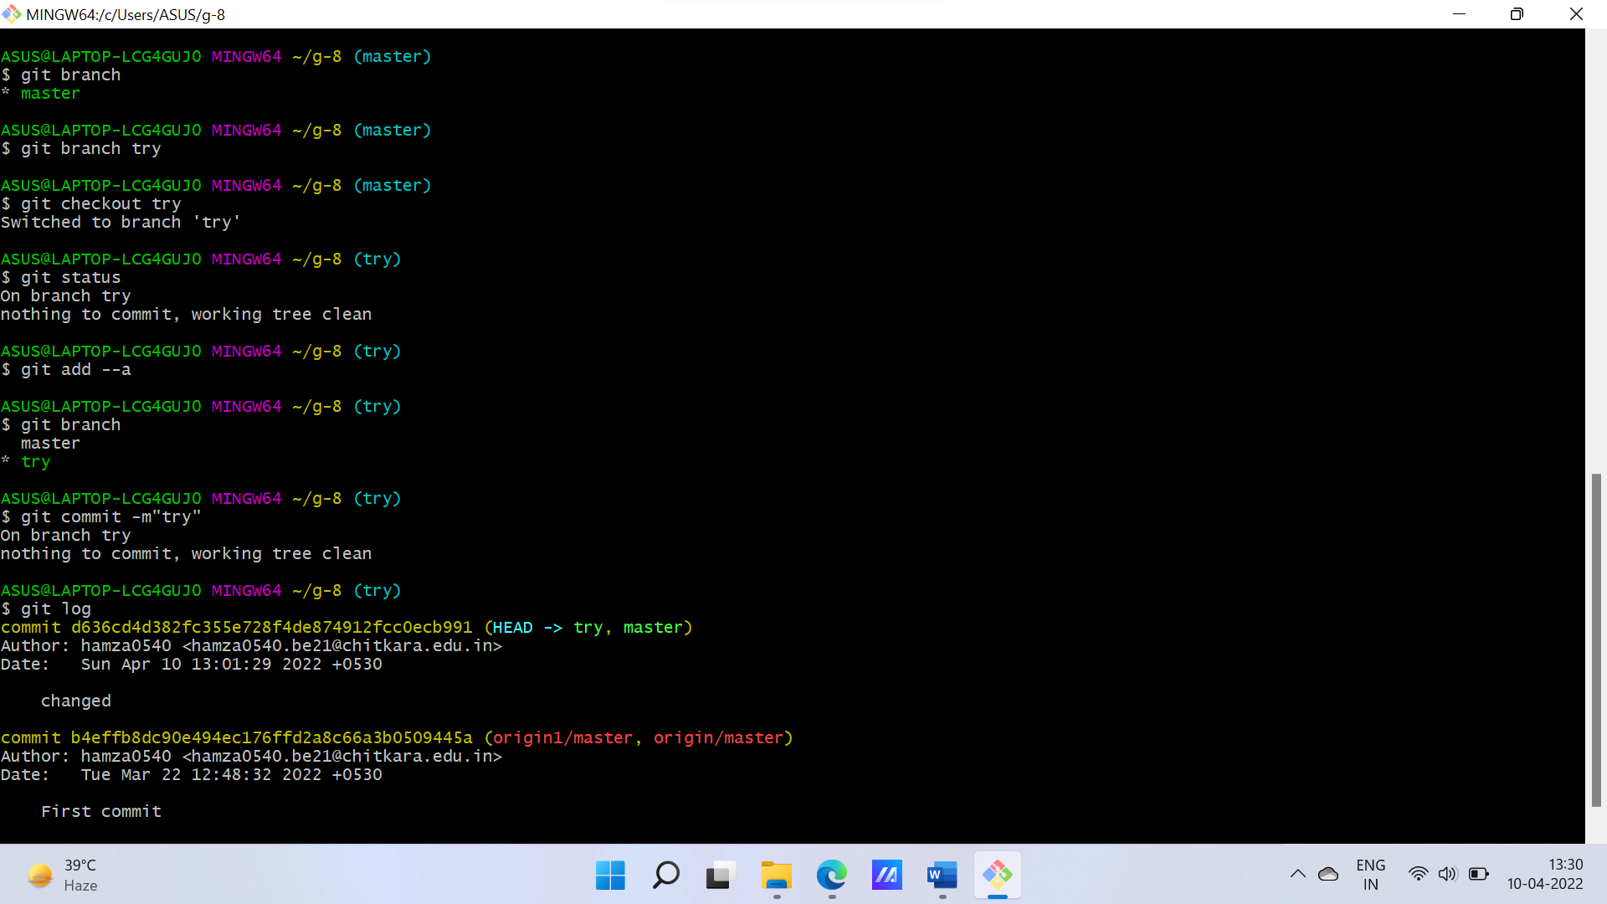

|  |  |  |
| --- | --- | --- |
| |  | | --- | | **Experiment No. 05** | |  |

**Aim:** Git lifecycle description

Git lifecycles have stages and following are the lifecycle stages of files in Git:

1. **Working Directory:**

* The place where your projects reside in your local disks.
* It may or may not be tracked by git
* Can be tracked by git by using the command “git init”
* By doing git init , it automatically creates a hidden git folder.

1. **Staging Area:**

* Once we are in the working directory we have to specify which files are to be tracked by git.
* To add files in the staging area, we use command git add

1. **Commit :**

* Once we are done in the staging area file is now ready to be saved in the repository.
* Saving a file in a repository of git is know as doing a commit.
* The commit is identified by commit id.
* The command for initializing this process is git commit -m “message”.

1. **Github or other platform:**

* After commit we need a platform where we can put our file and show to others or on the internet.
* This platform is called GitHub.
* To get your files on these platform you need to push(upload) those files on there.

