**Soft Work Group 8**

**Topic selection and needs analysis report**

Fuzhou University

November 28, 2022

I. Introduction 3 3

1.1. Positioning and Objective 3 3

1.2 Object 3 4

1.3 Software requirements Analysis Theory 3 4

1.4 Software requirements analysis Objective 4 4

Ii. Demand Overview 4 5

2.1 Project Background 4 5

2.2 Requirements Overview (NABCD model)5 6

2.2.1 Need Demand 5 6

2.2.2 Approach 5 7

2.2.3 Benefit 5 7

2.2.4 Competitors 6 7

2.2.5 Delivery Promotion 6 7

2.3 System Architecture 6 7

Iii. Project Structure 9

3.1. Mind Map 7 9

Iv. System functional requirements 8 10

4. 1 Function Overview 8 10

4.2 Interface prototype 8 11

4.3 Class Figure 9 12

4.4 Use case Figure 10 13

4.5 Data Flow Analysis 10 13

4.6 Data Dictionary 11 14

4.7 E-R Figure 13 18

Software and system interface requirements and acceptance criteria 14 19

5.1 User Interface 14 19

5.2 Operating Environment 15 19

# I. Introduction

## 1.1. Positioning and objectives

With the highly developed computer technology, it has become a common and practical means to effectively manage a large number of complex information by using information technology. On the one hand, this greatly reduces the overhead of bookkeeping and manpower. On the other hand, the powerful computing power of modern computers and the widespread deployment of networks have greatly simplified the processing and flow of large amounts of information.The campus sports meeting is a common but very important event, so we came up with the idea of developing such a software.It can bring great convenience to the athletes, spectators, and even the judges and judges who publish the ranking results. It will greatly optimize the experience of the spectators and significantly improve the working efficiency of the event side.The new functions it brings mainly include: get rid of the traditional broadcast results and use paper announcement results, site personnel management, automatic arrangement of areas, location of check-in venue, automatic import excel athletes information and export check-in content information.

## 1.2 Objects

All project team members

Fuda Games Committee

## 1.3 Software requirements analysis theory

Software demand analysis is the research of user needs, fully understand the complete function of the user's software requirements, confirm the user's software functional requirements, and establish a identifiable and verifiable basic basis.Software requirements analysis is the beginning of a project, but also the most important key point of project implementation.According to the analysis results of related organizations, more than 80% of the problems such as incompleteness and incorrectness of designed software products are caused by demand analysis errors, and the fundamental functional problems caused by demand analysis errors are particularly prominent.Therefore, software requirements analysis is a critical step for the success of a project.

## 1.4 Software requirements analysis objectives

Make a comprehensive description of the functions of the software to help users judge the correctness, consistency and integrity of the functions, and promote users to carefully and comprehensively think about the software requirements before the software design starts. Understand and describe all the information required for software implementation to provide a baseline for software design, validation, and validation.

It provides the basis for software managers to calculate software cost and prepare software development plan.

The specific content of requirement analysis can be summarized into six aspects: functional requirements of software, interfaces between software and hardware or other external systems, non-functional requirements of software, reverse requirements of software, limitations on software design and implementation, and reading supporting information.

Software requirements analysis should try to provide all the information of software functional requirements, so that software designers and software testers no longer need to contact the demand side.This requires that the content of software requirements analysis should be correct, complete, consistent and verifiable. In addition, in order to ensure the quality of software design and facilitate the rest and verification of software functions, the software demand expression is non-bifurcated, traceable and modifiable.

# Ii. Demand overview

## 2.1 Project Background

The software to be developed is called Campus Sports Meeting. The development team is the eighth Group of Maynus Soft Engineering, and the main users are undergraduates and postgraduates of Fuzhou University. The software is independent of other systems and becomes a complete system of its own, which is convenient for application.It is convenient for the one-stop management of sports or private events. In previous events, private or collective events were broadcast to express the users reminded by themselves, as well as the ranking, etc. The corresponding event process was also published to the corresponding bulletin board, and users or athletes also needed to go to the site to check their ranking or their class situation.Of course, a lot of work needs to be done to manage the results and rankings.So the campus sports meeting program was created.

Convenient user referee administrator and the corresponding athletes a collective ranking and management, on-site check-in, by college by position, one key import, export statistics table, etc

## 2.2 Requirement Overview (NABCD model)

With the development of society, the Internet era has arrived.In this era, nothing can stay the same. Bookkeeping has changed from paper offices to paperless offices, paper money payments have changed to mobile payments, and many sports events remain the same: personnel information is manually managed, athletes are notified via radio, and events and rankings are announced via paper or radio.The traditional model sometimes runs into problems like not being able to check in on site.

### 2.2.1 Need Requirements

Through the questionnaire survey, we found that, no matter informal competition or formal competition such as campus sports meeting, we mainly worry about the current situation of our team, as well as the site location and other detailed information.We also find that people are willing to learn about sports by watching the games.

### 2.2.2 Approach

We can provide customized services for colleges and universities or private events outside the venue. We can also cooperate with advertising operators to release advertisements.

### 2.2.3 Benefit

Provide location check-in;Users can observe the status of the game, as well as the ranking information of the athletes;Managers can import the information of athletes with one click and make statistics by field.

### 2.2.4 Competitors

Now on the market this kind of application and management system is not common.

### 2.2.5 Delivery promotion

Our promotion mode: Find the competition parties and recommend our products for their use

## 2.3 System Structure

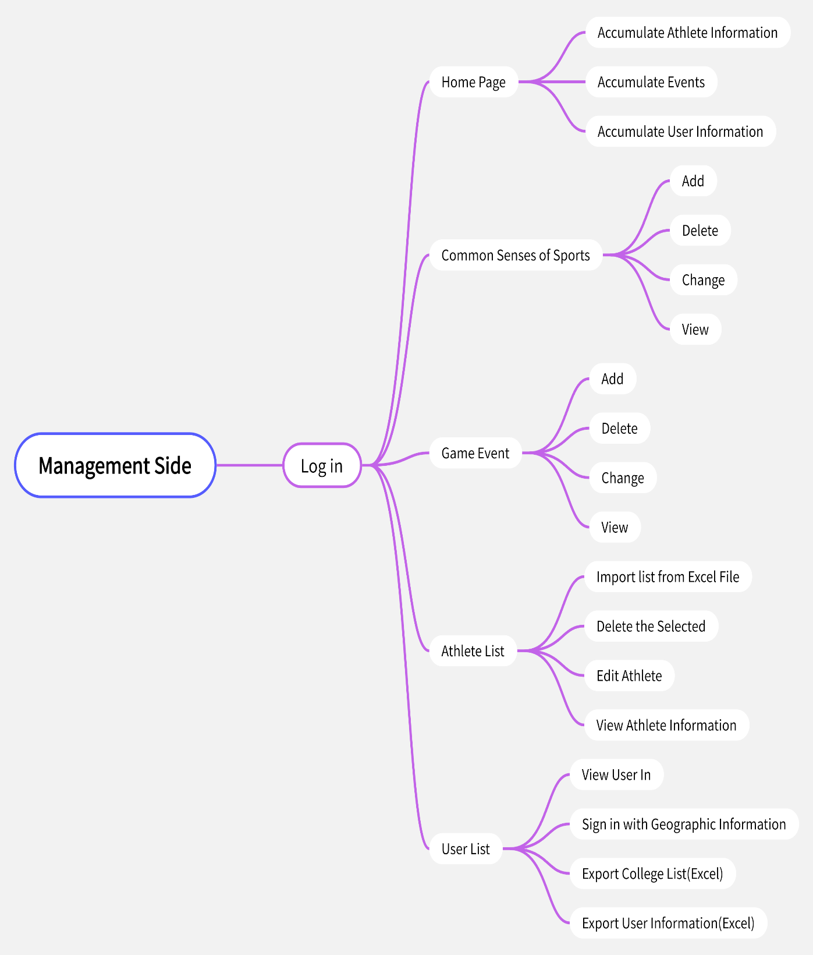

Management End

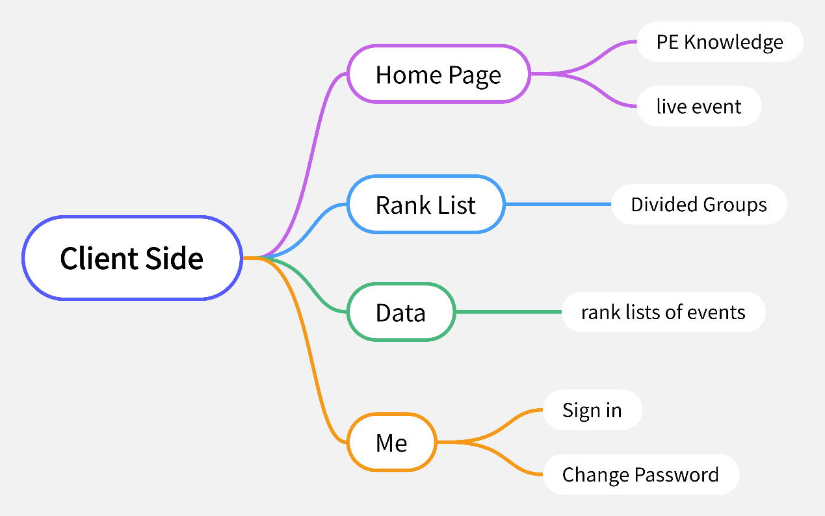

The client

# Iii. Project structure

# 3.1. Mind mapping

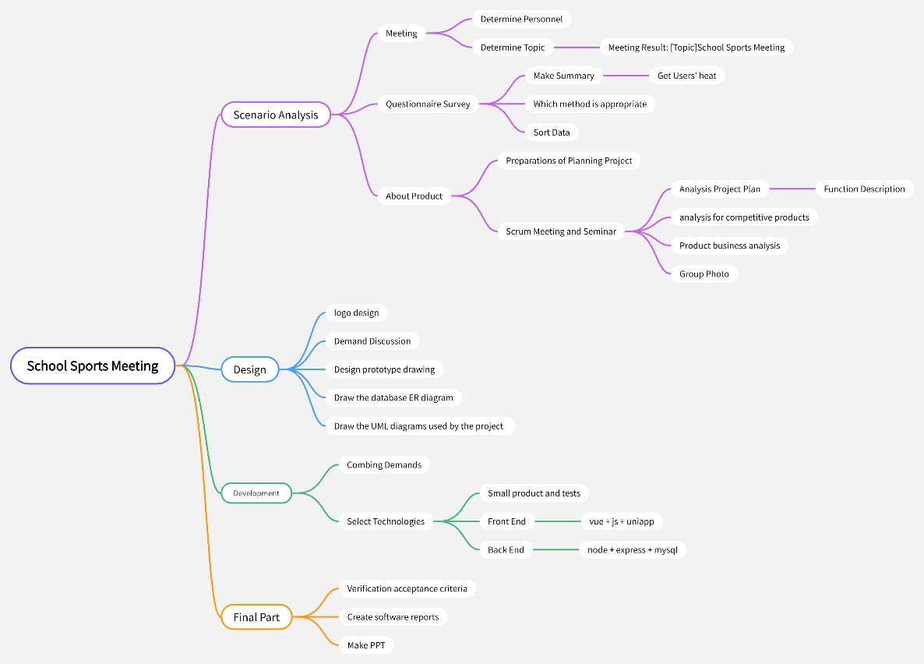

Project Structure

# Iv. System functional requirements

## 4. 1 Function overview

|  |  |  |
| --- | --- | --- |
| function | Specific Description | role |
| Logging In to the Client | User registration input user name password can be logged in | All of them |
| Sign in | After arriving at the venue sign in, you can locate the user's location | The audience |
| Look at the game | You can view the individual events as well as athlete information, race time and ranking, and previous events | All of them |
| Log in to the management terminal | Special administrator account information login background | Sponsor (Administrator) |
| Common sense of Sports | Manage the addition, deletion, modification and check of common knowledge on the user app | Sponsor (Administrator) |
| Event of the Competition | Add the addition, deletion, modification, and ranking of events | Sponsor (Administrator) |
| List of Athletes | Add athlete information, which can be imported and deleted from excel in batches | Sponsor (Administrator) |
| User Management | Used to manage client user information, check-in and location information;Automatically calculate college information and export user list information to excel file with one click | Sponsor (Administrator) |

## 4.2 Interface Prototype

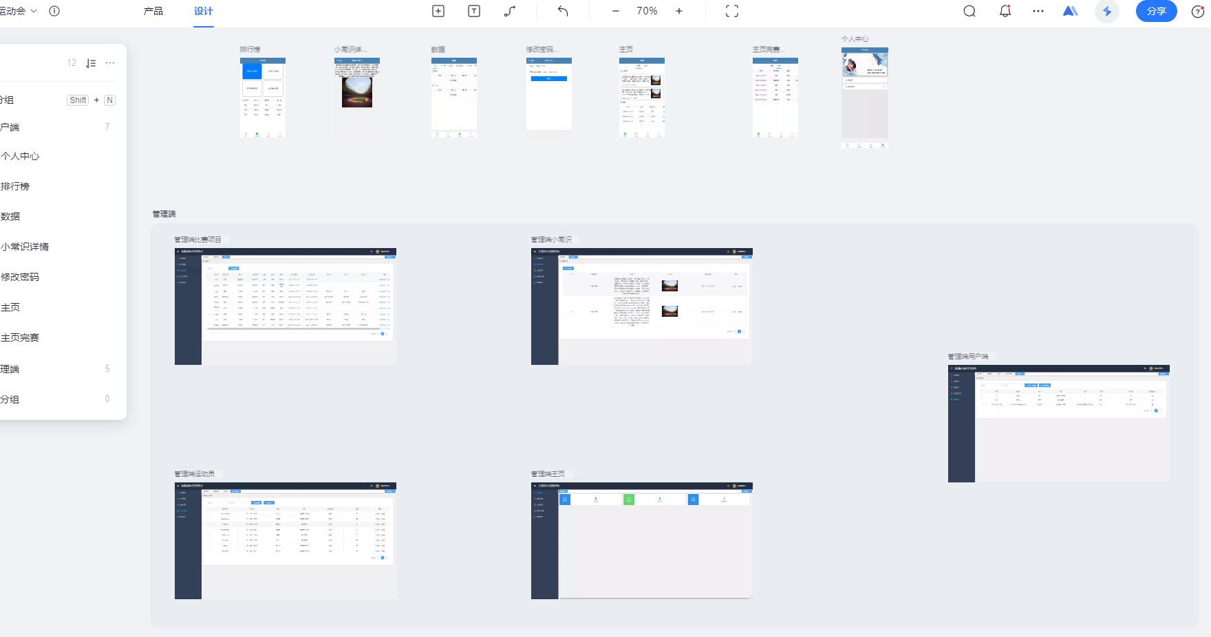

## 4.3 Class Diagram

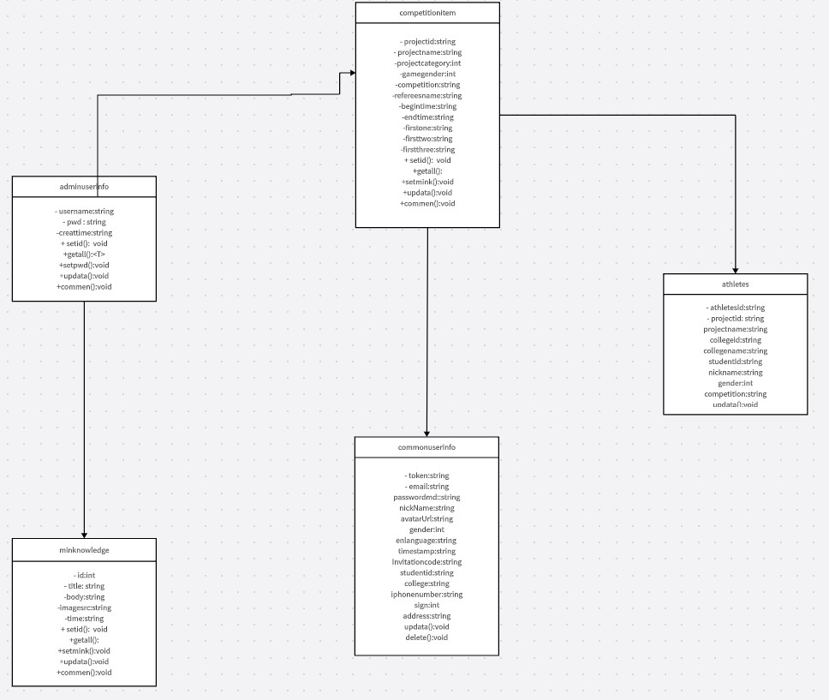

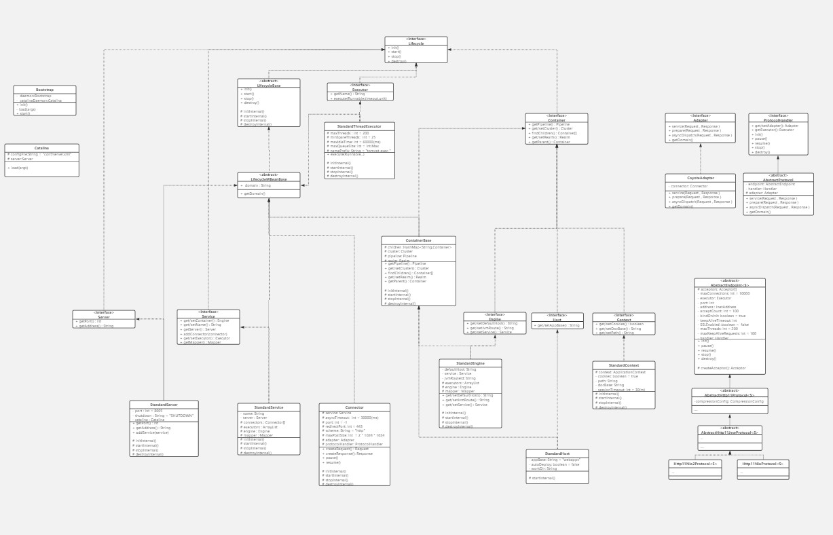

## 4.4 Use Case Diagram

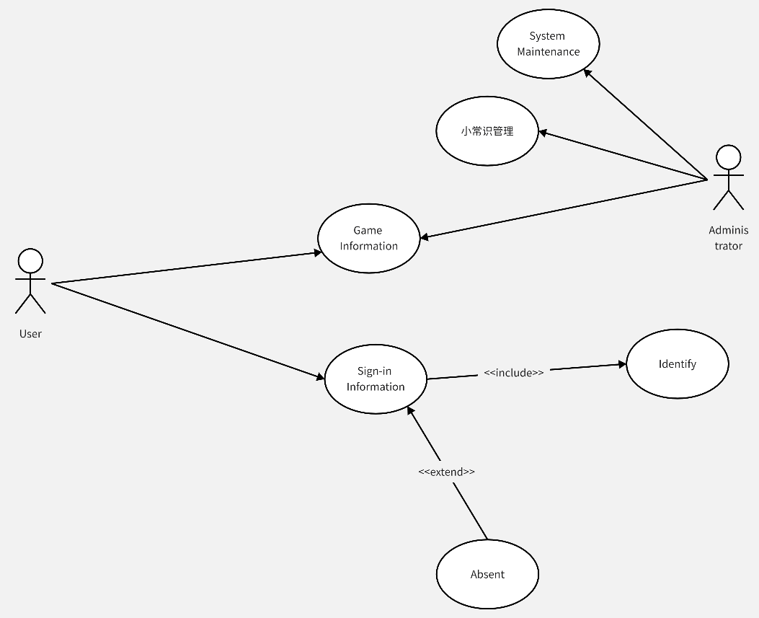

## 4.5 Data stream analysis

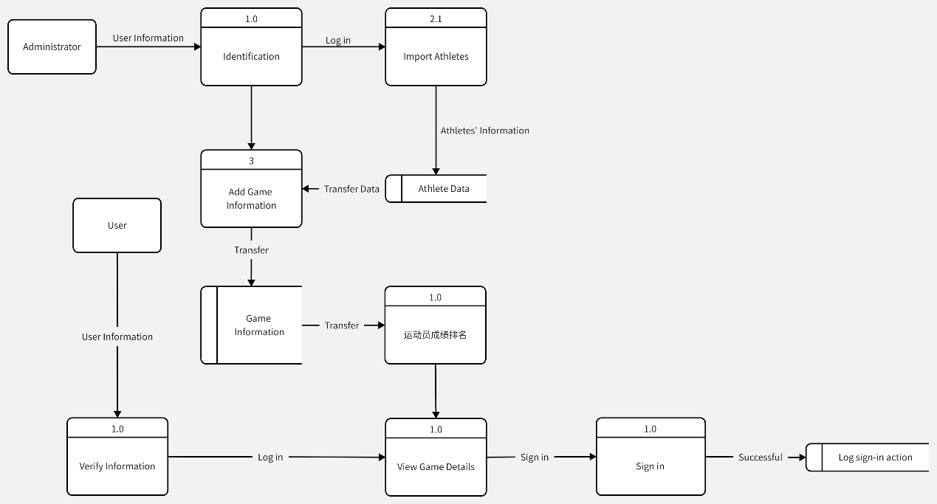

## 4.6 Data Dictionary

Data entry entry that identifies the entity. The data dictionary is an important part of the database. It stores the relevant information used by the database. It is a set of read-only tables for the user. It's a collection of information about data. It is the place where all the elements of the data flow diagram are strictly defined, including the data flow, the composition of the data flow, the files, the processing instructions, and all the other data that should enter the dictionary, where each element corresponds to an entry in the data dictionary. Some keywords referenced are described: PK (primary key), FK (foreign key), Check (scope constraint for check), Not null (not null value).

Table 1 User table

|  |  |  |  |  |  |  |
| --- | --- | --- | --- | --- | --- | --- |
| Serial number | Field Name | Field Type | Length of field | A primary key | Default Value | Parameter Meaning |
| 1 | uuid | varchar | 100 | is |  | Serial number |
| 2 | email | varchar | 50 | is |  | email |
| 3 | passwordmd | varchar | 50 |  |  | password |
| 4 | nickName | varchar | 60 |  |  | nickname |
| 5 | avatarUrl | varchar | 255 |  |  | Head portrait |
| 6 | gender | Int | 0 |  |  | gender |
| 7 | enlanguage | varchar | 20 |  |  | language |
| 8 | timestamp | varchar | 20 |  |  | Registration Time |
| 9 | college | varchar | 30 |  |  | college |
| 10 | iphonenumber | varchar | 30 |  |  | Mobile phone number |
| 11 | sign | Int | 0 |  |  | Sign in or not |
| 12 | address | varchar | 30 |  |  | Sign in address |

Table 2 Competition information

|  |  |  |  |  |  |  |
| --- | --- | --- | --- | --- | --- | --- |
| Serial number | Field Name | Field Type | Length of field | A primary key | Default Value | Parameter Meaning |
| 1 | projectid | varchar | 30 | is |  | Project Identification |
| 2 | projectname | varchar | 30 |  |  | Project Name |
| 3 | projectcategory | Int | 0 |  |  | Category of Project |
| 4 | gamegender | Int | 0 |  |  | gender |
| 5 | competition | varchar | 10 |  |  | event |
| 6 | refereesname | varchar | 10 |  |  | The referee |
| 7 | begintime | varchar | 20 |  |  | Start time |
| 8 | endtime | varchar | 20 |  |  | End Time |
| 9 | firstone | varchar | 10 |  |  | First place |
| 10 | firsttwo | varchar | 10 |  |  | Second place |
| 11 | firstthree | varchar | 10 |  |  | Third place |

Table 3 Athlete information

|  |  |  |  |  |  |  |
| --- | --- | --- | --- | --- | --- | --- |
| Serial number | Field Name | Field Type | Length of field | A primary key | Default Value | Parameter Meaning |
| 1 | athletesid | varchar | 30 | is |  | Athlete No. |
| 2 | projectid | varchar | 30 |  |  | Project No. |
| 3 | projectname | varchar | 30 |  |  | Project Name |
| 4 | collegeid | varchar | 30 |  |  | School Number |
| 5 | collegename | varchar | 30 |  |  | Name of College |
| 6 | studentid | varchar | 30 |  |  | Student Number |
| 7 | nickname | varchar | 30 |  |  | Name of Student |
| 8 | gender | Int | 0 |  |  | gender |
| 9 | competition | varchar | 30 |  |  | event |

Table 4 Facts

|  |  |  |  |  |  |  |
| --- | --- | --- | --- | --- | --- | --- |
| Serial number | Field Name | Field Type | Length of field | A primary key | Default Value | Parameter Meaning |
| 1 | Id | Int | 0 | is |  | Id |
| 2 | title | varchar | 30 |  |  | The title |
| 3 | body | Text | 255 |  |  | content |
| 4 | imagesrc | varchar | 40 |  |  | time |

## 4.7 E-R Diagram

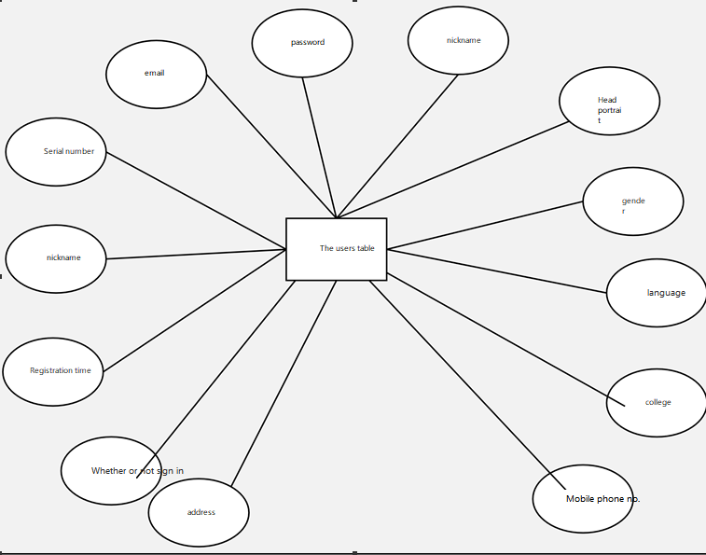

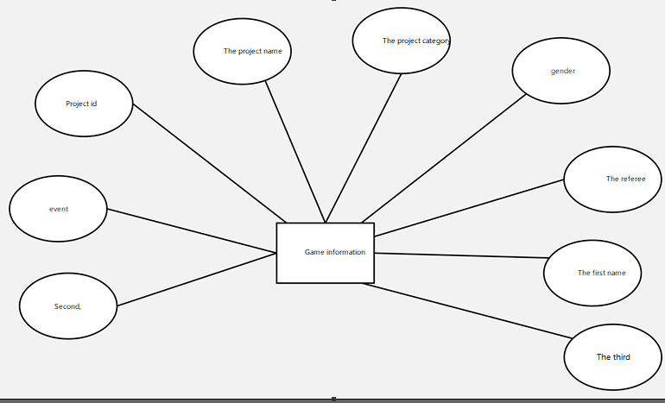

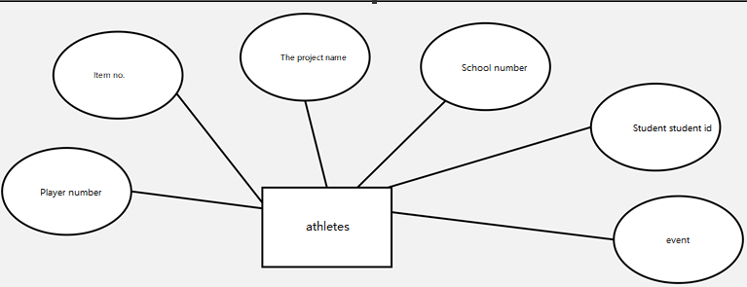 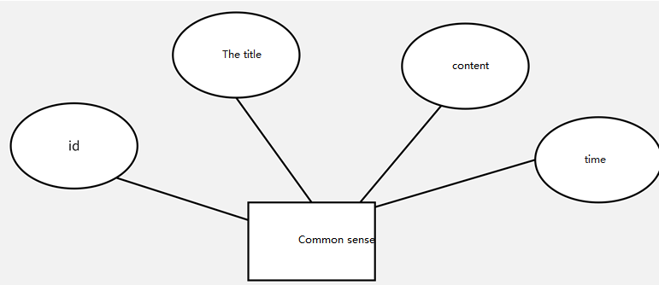

# Software and system interface requirements and acceptance standards

## 5.1 User Interface

The user interface is the part of the program that the user can see and interact with. It is very important to design a good user interface. This design will provide users with a beautiful, generous, intuitive and easy to operate user interface.

## 5.2 Operating Environment

**Web browsers: 0+, Chrome, Opera, Safari, Firefox, and any browser that supports the HTML5 standard**

Standard resolution: 1024*768, 1920*1080, 2K