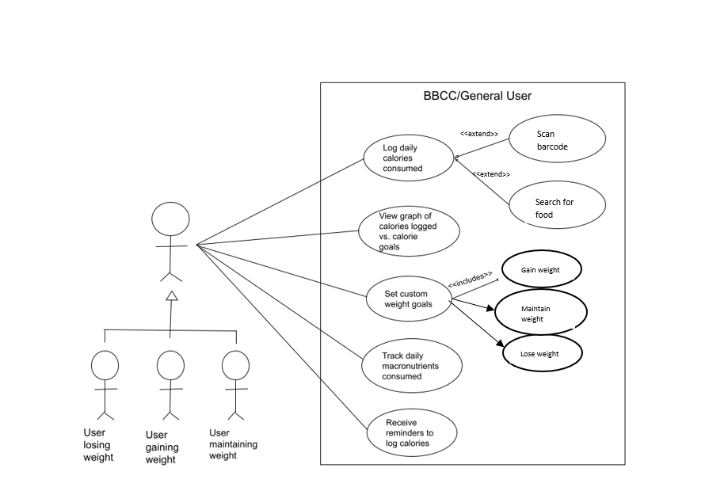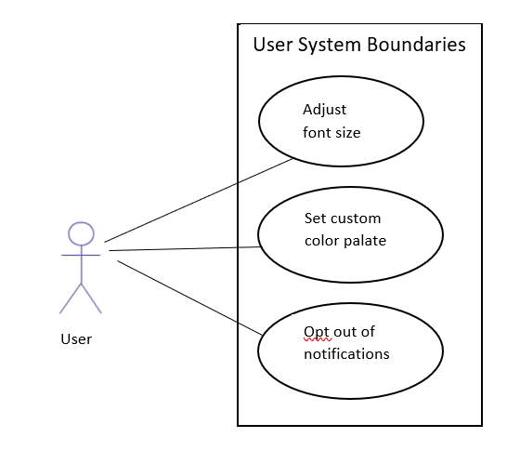

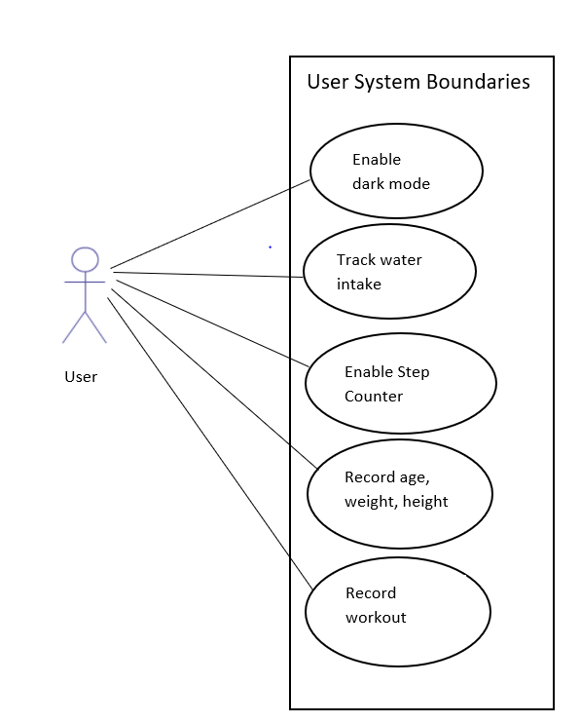

**Use case U1.1:** Log daily calories consumed

**Relevant user story IDs**: A7, A10, A12, B4

**Actors:** user losing weight, user gaining weight, user maintaining weight 🡪 general user

**Related use cases**:

**Extension of:**

* Scan barcode
* Search for food

**Preconditions:** This use case assumes that the user has already set their custom weight goal and received a suggested daily caloric intake.

**User/system steps:**

**User actions** **System responses**

1. Choose “Add an entry” command 2. Dialog box appears

3. Specify method for inputting calories

(search or scan)

4. Choose “Confirm entry” command 5. Dialog disappears

**Post-conditions**: Food item and calories are added to the user’s calorie log, which can subsequently be accessed and viewed at the user’s discretion

**Use case U1.2:** View graph of calories logged vs. calorie goal

**Relevant user story IDs:** A7, A8

**Actors:** user losing weight, user gaining weight, user maintaining weight 🡪 general user

**Preconditions:** This use case assumes that the user has set their custom weight goal and received a suggested calorie intake, and that the user has logged at least one calorie entry.

**User/system steps:**

**User Actions System responses**

1. Choose “View graph” command 2. System displays graph

3. User views the graph

4. Choose “Close” command 5. Graph disappears

**Post-conditions:** After closing out the graph, the user is returned to the app’s home screen.

**Use case:** Set custom weight goals

**Relevant user story IDs:** A1, A4, A5, A6

**Actors:** user losing weight, user gaining weight, user maintaining weight 🡪 general user

**Related use cases:**

**Includes:**

* Choose to maintain current weight, lose, or gain weight

**Preconditions:** Use case assumes that the user has downloaded the app, that the user knows what their goals are, and that the user knows some basic information about themself.

**User/system steps:**

**User Actions System responses**

1. User opens app for the first time 2. Dialog appears prompting user for info

3. User fills in basic personal info 4. New dialog appears prompting user to select

their weight goals

5. User selects their weight goal 6. Dialog disappears

**Post-conditions:** User is then brought to the main home screen of the app.

**Use case:** Track daily macronutrients consumed

**Relevant user story IDs:** A2, A3

**Actors:** user losing weight, user gaining weight, user maintaining weight 🡪 general user

**Preconditions:** This use case assumes the user has set their custom weight goal and has received suggestions for daily macronutrient intake.

**User/system steps:**

**User Actions System responses**

1. Choose “Add an entry” command 2. Dialog box appears

3. User selects “Log macronutrient intake” 4. Dialog prompts user to input food

5. User inputs food via search or scan 6. Macronutrients are logged

**Post-conditions:** After macronutrients are logged, the user is returned to the app’s home screen.

**Use case:** Receive reminders to log calories

**Relevant user story IDs:** B3

**Actors:** user losing weight, user gaining weight, user maintaining weight 🡪 general user

**Preconditions:** This use case assumes that it is nearing the end of the day and that the user has not yet logged their food intake for that day.

**User/system steps**:

**User Actions System responses**

1. System notifies user to log their food intake

2. User opens the app 3. Notification disappears

4. User logs their food intake for that day

**Post-conditions:** After the user logs their food intake for the day, the system will not send another notification/reminder until the next time the preconditions are met.

**Use case:** Enable dark mode

**Relevant user story IDs:** C2

**Actors:** User

**User/system steps**:

**User Actions System responses**

1. User opens settings 🡪 Display Settings

2. User selects “Dark Mode” 3a. If “Dark Mode” is not active, activate dark mode and change color palette of app to predominately black/gray

3b. If “Dark Mode is active, deactivate and return app to original color palette

**Post-conditions:** The color palette of the app is changed. This change persists even after a user exits and reopens the app.

**Use case:** Track water intake

**Relevant user story IDs:** C3

**Actors:** User

**User/system steps**:

**User Actions System responses**

1. Choose “Add an entry” command 2. Dialog box appears

3. User selects “Log water intake” 4. Dialog prompts user to input amount, in ounces

5. User enters amount 6. Amount is stored

**Post-conditions:** The amount of water entered is added to the daily intake tab.

**Use case:** Enable step counter

**Preconditions:** The user has given the app permission to continue to use resources while app is operating in the background, but not completely suspended (e.g. user takes phone call, opens another app, etc.). The user currently has the step counter disabled.

**Relevant user story IDs:** C6

**Actors:** User

**User/system steps**:

**User Actions System responses**

1. User navigates to “Fitness” section

2. User selects “Step tracker” 3. Dialog prompt appears, asking user if they would like to enable step tracker

4. User selects “yes” or “cancel” 5a. If “yes,” step tracker begins to track gyroscopic motion of phone to record steps

5b. If “cancel,” prompt closes and nothing is changed

**Post-conditions:** The number of steps taken in a day is recorded and stored in the app. This data can be compared to previous days.

**Use case:** Record age, weight, height

**Relevant user story IDs:** A1

**Actors:** User

**User/system steps**:

**User Actions System responses**

1. User selects “Personalize” on home page 2. Prompt for age, weight, height input appears

3. User enters info and selects save 4. Prompt is removed, the data is saved for the user

**Post-conditions:** The app provides personal suggestions for calorie and macronutrient intake per day, using this information as a factor.

**Use case:** Log workouts

**Relevant user story IDs:** C5

**Actors:** User

**User/system steps**:

**User Actions System responses**

1. User navigates to “Fitness” section

2. User selects “Record Workout” 3. App provides a list of exercises

4. User inputs exercises and time/reps for each   
(plus weight if applicable), selects “Save” 5. App saves workout routine and date of workout for later use.

**Post-conditions:** The user can use this feature to keep track of personal workout regimens. While the feature is currently a recording tool, there are ambitions to add the estimated number of calories burned as a feature.

**Use case:** Adjust font size

**Relevant user story IDs:** B1

**Actors:** User

**User/system steps**:

**User Actions System responses**

1. User navigates to “Settings” 🡪 “Display”

2. User selects “Font Size” 3. System provides a slider to change font size

4. User slides until desired size is reached,  
selects “Confirm” 4. System saves preference and removes slider

**Post-conditions:** The font size of the text within the application is changed.

**Use case:** Set custom color palette

**Relevant user story IDs:** C4

**Actors:** User

**User/system steps**:

**User Actions System responses**

1. User navigates to “Settings” 🡪 “Display”

2. User selects “Color Palette” 3. System prompts two boxes of preset colors.  
 One for primary color, one for secondary

4. User selects colors, selects “Confirm” 4. System saves preference and removes prompts

**Post-conditions:** The colors displayed in the app are now changed to the user’s selection.

**Use case:** Opt out of notifications

**Relevant user story IDs:** B3

**Actors:** User

**Preconditions:** User has notifications enabled.

**User/system steps**:

**User Actions System responses**

1. User navigates to “Settings” 🡪 “Notifications” 2. System presents user with notification settings

3. User selects “Disable Notifications” widget 4. System turns off all notifications

**Post-conditions:** The user no longer sees any notifications from the app outside of the app.