Segmentation Fault

COS 420 Software Engineering

Deliverable 5

Software Architecture Document

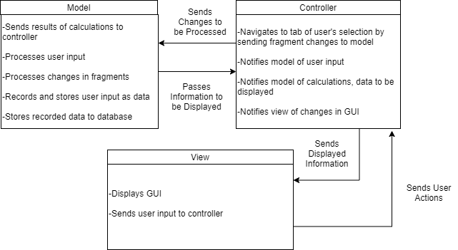

The pattern above is an example of a Model-View-Controller (MVC) pattern. An MVC pattern describes the functions and relationships of the modeling of the system, the way in which the system is viewed, and the interpretation of user input.

This was the most appropriate architectural design for building our application because the app’s data is interacted with both from the user’s view and the system. Data can be seamlessly changed and interacted with due to the controller’s relation to both the view and the model.