**Burndown Chart**

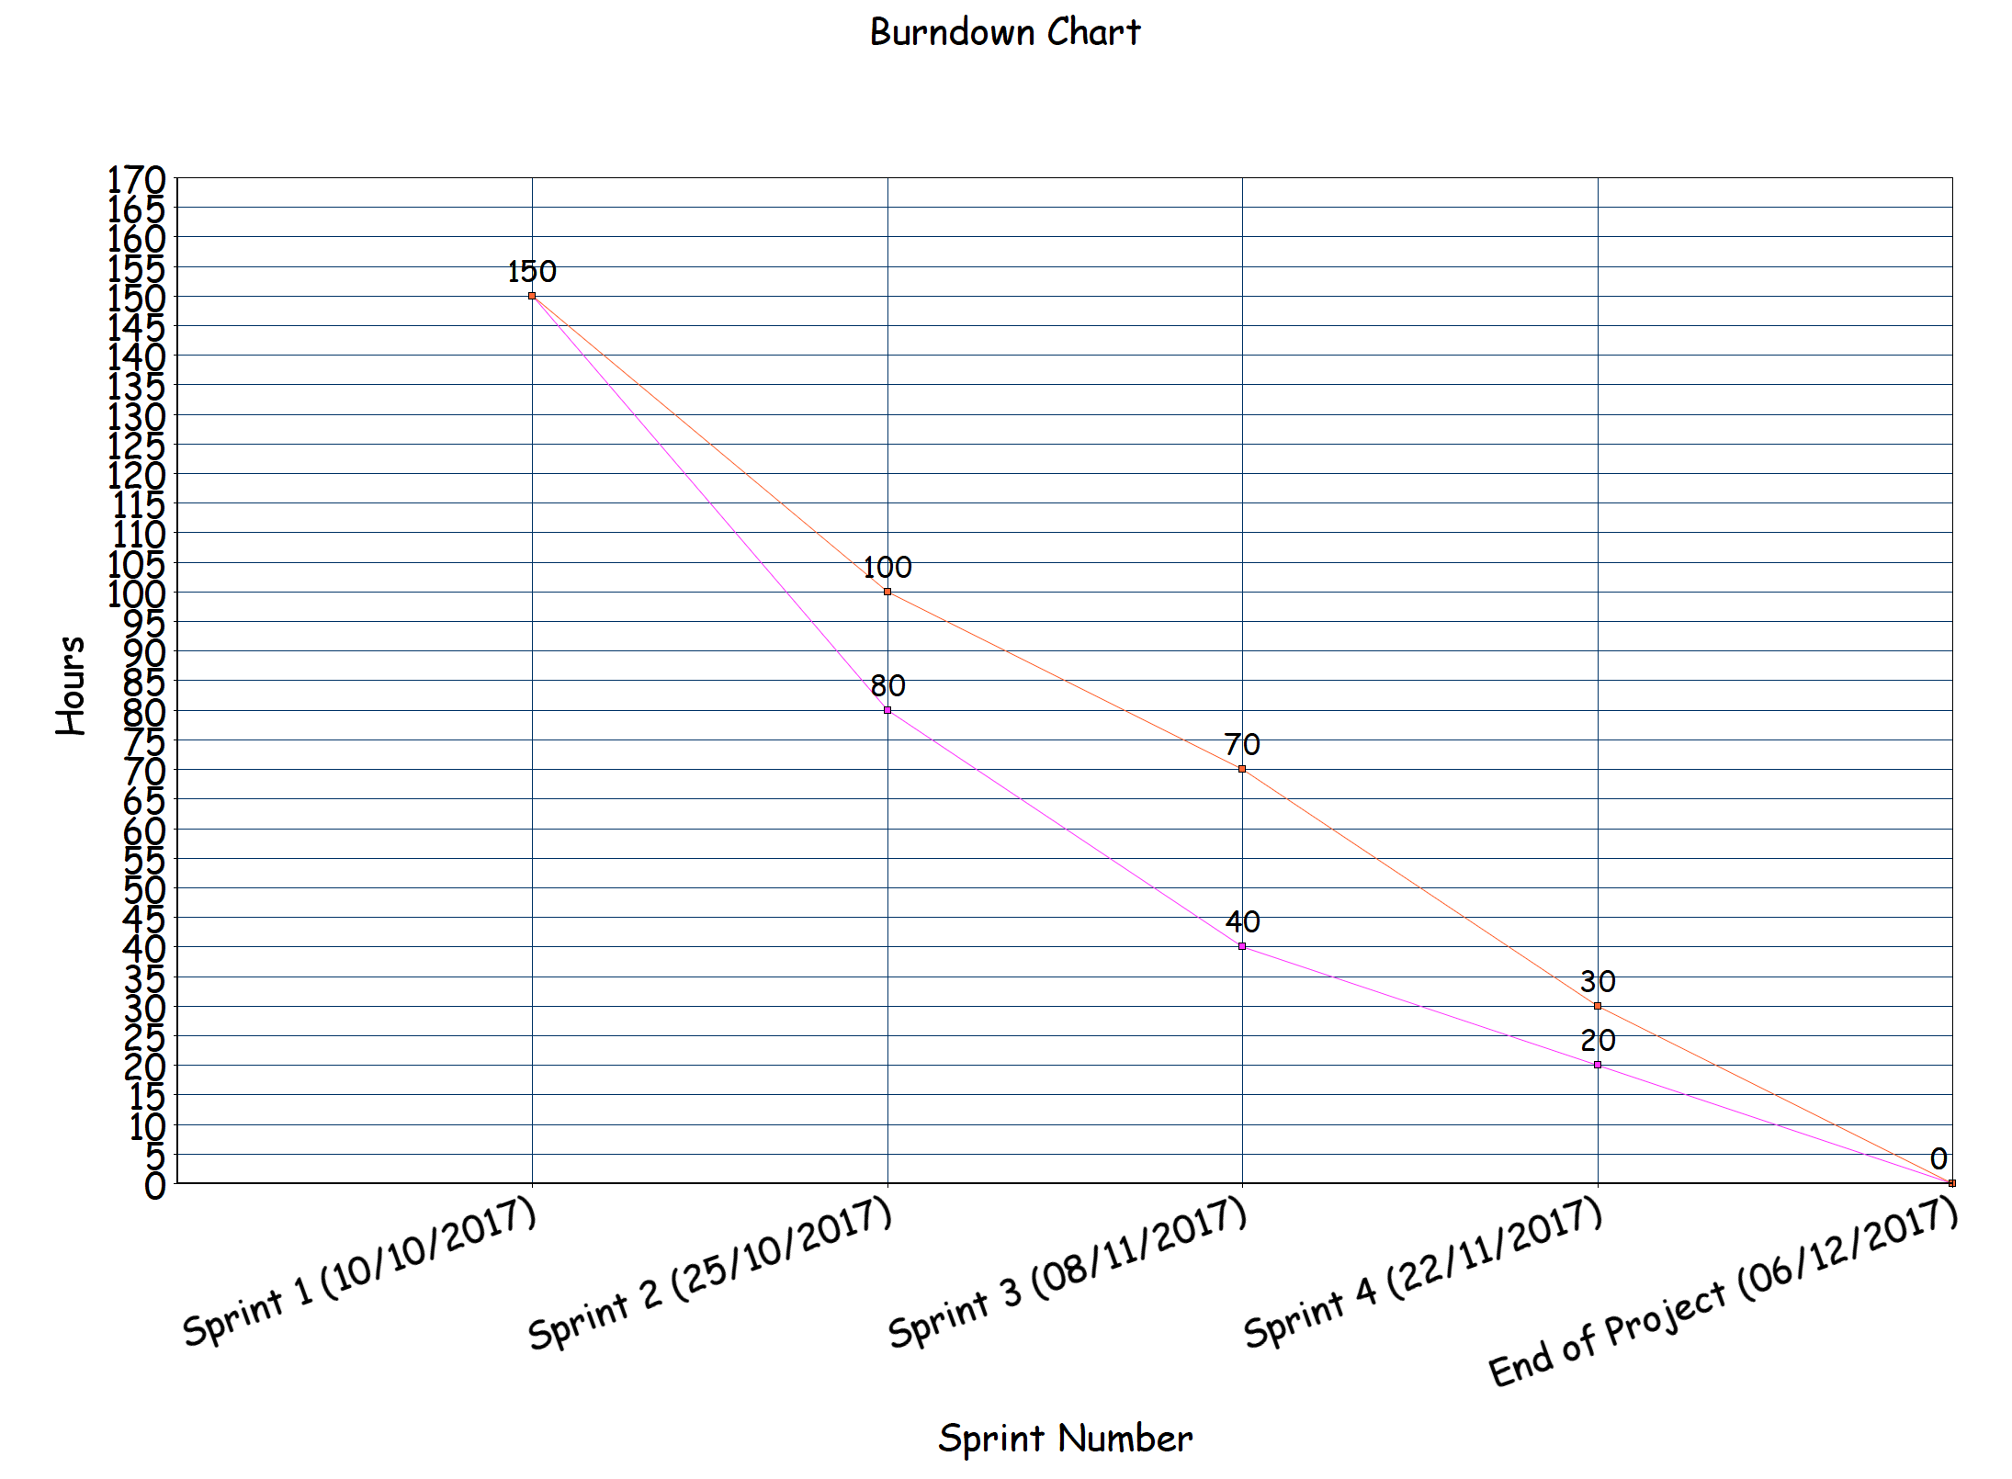

Orange - Projected time taken

Pink - Actual time taken

The burndown chart allows us to easily visualise how much work is left in our project in a simple way to read and view. We originally projected to get the majority of the work done in the first sprint, and this came to fruition. Having the burndown chart as a reference and consistently updating it after every sprint, we could see that we were ahead of schedule in every sprint, so we may have done too much in the first sprint. This came to our advantage and the project still took the original estimated time to complete.

**Testing**

For our multi page web application testing, we tested it with the use of Selenium. Selenium is a software testing framework that was perfectly fit for our web page hosted application. We had to chose between multiple test automation testing tools to use for our project, including Catalan Studio, Ranorex and TestComplete. We ended up using Selenium as it is globally recognised as it is supported by multiple operating systems, including Windows and Mac, and it is used by many big companies and was recommended to us by other students that have used it in the past.

Selenium was a very flexible and easy to use Integrated Development Environment that made the testing element of our project much more streamlined than initially anticipated. Selenium I've tested the code as we wrote it, so this saved us a lot of time in the end. We could see if our tests were accurate as they were readable in any language we wanted, like C++ or Java. This Integrated Development Environment made the testing simple and effective, as we could chose which sections of the project we wanted to test individually

**Story Maps**

In our first week meeting where we collectively decided to go with Conors idea of a multi page web application named Dished-Out, we put together a Story Map to paint a picture of all the use cases that we aimed to get into the application by the end of the development process. We designed it with the intent of changing it as the weeks had gone on and react to change in the development process, but Conor had a clear and concise vision of what this application would end up being, so the Story Map did not change as the development cycle went on. The story map was used as a checklist of sorts, where we would decide which use cases we would attempt to complete within individual sprints. Our story map from the start looked like this :

| Account Management | Waitressing | Chef | Management |
| --- | --- | --- | --- |
| As a user I want to be able to log in so that I can access my account. | As a user I want to know how long an order will take so I can inform the customer of how long they will be waiting. | As a user I want to be able to prepare orders more efficiently to decrease the pressure in the kitchen. | As a user I want to see the total amount of orders processed throughout the day. |
| As a user I want to be able to send the order to the chef. | As a user I want to be notified as soon as each meal is ready. | As a user I want to be notified if a customer has been waiting too long for a meal so I can speed up the order. | As a user I want to be able to see the rosters for the week. |
|  | As a user I want to be notified if we do not have certain foods so I can let the customers know as soon as possible. | As a user I want to be able to get rid of an order when it is complete so I don't get confused. | As a user I want to be able to know the total profit for the day. |
|  | As a user I want to be able to take orders for customers. | As a user I want to be able to see what time each order was taken. | As a user I want to be able to edit the menu so I can have all meals prepared for each day. |
|  | As a user I want to be able to log out when I’m done for the day. | As a user I want to be able to remove items from the menu when there is none left of it to ensure the food wont be sold again. |  |
|  |  | As a user I want to be able to let the waiter know when a meal is ready. |  |

End case story map

There were a few adjustments to the story maps as the weeks went on, but nothing major was changed. We were fortunate that Conor had a clear vision as to what this application would end up being. Some changes included not having a unique log in for each page, instead they would all use the same log in. This change makes it very useful for smaller businesses as the manager could also be working in the kitchen, or waiting staff could have to prepare deserts etc..

| Account Management | Waiting / Waitress | Chef | Management |
| --- | --- | --- | --- |
| As a user I want to be able to log in so that I can access my account. | As a user I want to know how long an order will take so I can inform the customer of how long they will be waiting. | As a user I want to be able to prepare orders more efficiently to decrease the pressure in the kitchen. | As a user I want to be able to change the prices of the items. |
| As a user I want to be able to chose the user experience that I’m required to use. | As a user I want to be notified as soon as each meal is ready. | As a user I want to be know if a customer has been waiting too long for a meal so I can speed up the order. | As a user I want to define the amount of tables that are available in the restaurant. |
|  | As a user I want to be notified if we do not have certain foods so I can let the customers know as soon as possible. | As a user I want to be able to get rid of an order when it is complete so I don't get confused. | As a user I want to be able to edit the menu so I can have all meals prepared for each day. |
|  | As a user I want to be able to take orders for customers. | As a user I want to be able to see what time each order was taken. |  |
|  | As a user I want to be able to log out when I’m done for the day. | As a user I want to be able to remove items from the menu when there is none left of it to ensure the food wont be sold again. |  |
|  | As a user I want to know which order is for which table by table number. | As a user I want to be able to let the waiter know when a meal is ready. |  |

Overall, the main functionality of the application did not change from the first week. We made some adjustments to the management page due to time constraints and other obstacles that came in our way, but we are collectively very proud of what we have created with this application.