Average of 1000 words per chapter

Chapter 0 -

**Chapter 0 - Introduction to Agile Development**

Agile development is based on the idea of iterating on an idea and taking continuous feedback to get the maximum business value in the shortest time. This results in a low cost of change to the project and less wasted time as you can course correct much more efficiently than with other development strategies.

The Agile development method that we used for this project was the Scrum Agile Process. This process allowed us to continuously review our working software, correct and collaborate with each other. We did this roughly every two weeks. Scrum is absolutely reliant on effective communication between all of the people involved in the project, so great communication between team members is key to successfully utilising the Scrum Agile process.

**What is scrum?**

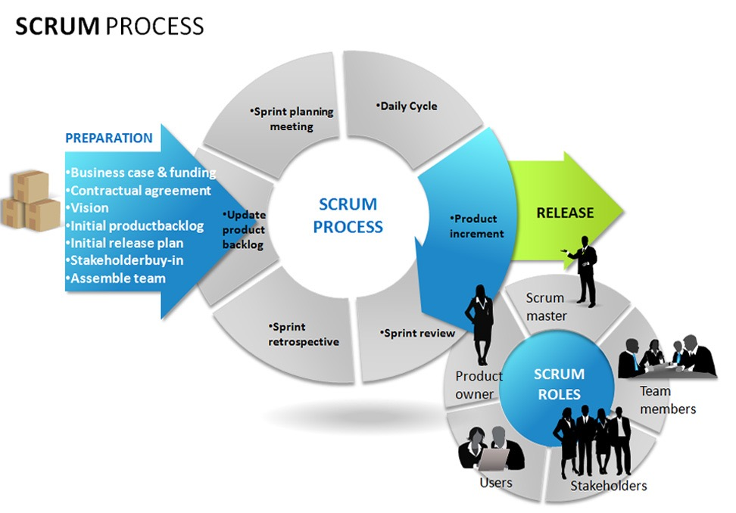

Scrums origins date back to 1993 when Jeff Sutherland hosted the initial scrums at Easel Corp in 1993. Jeff Sutherland co-wrote the definitive scrum guide with Ken Schwaber. The main benefit of the Scrum Agile Process to the receiving customer is that the customer can, and will, change their minds about what they want out of the software as the weeks go by. With this method of development you can adapt to change and make the software that your customer wants. The definitive scrum guide details how you can use the Scrum. Ken Schwaber also co-founded Scrum Alliance in 2002 with Mike Cohn, which was initially with the Agile Alliance.

The Scrum Agile Process is used by a number of big companies, for example, Microsoft, Google, Philips and Yahoo all use this method of Agile Development. It is mainly used for commercial software, but also has use cases for video game development, websites and financial applications, among many others. Since the product progresses in a series of month long sprints, with Scrum you focus on the key elements of the software, which are stored in a product backlog. These requirements are captured as items in the product backlog, and Scrum uses constantly changing requirements to create a environment that can quickly adapt to change to deliver the product required. This results in a smoother process than, for example, the waterfall model, which uses inclusive rules, therefore you cannot adapt to change as efficiently with this model. This results in much longer development time. This can be also delayed even longer if the client changes their mind about what they need in the middle of the development process. Scrums low cost of change gives it a huge advantage over Waterfall.

**Sprints**

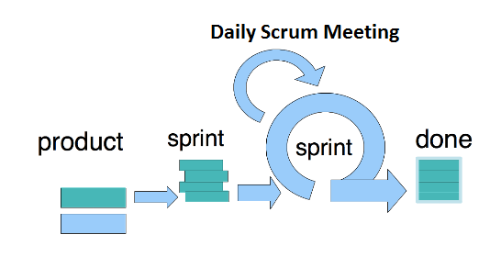

Scrums are progressed through a series of sprints. This is the crux of the Scrum Agile Process, and they usually last around two to four weeks. Most of the time, you keep the sprint length the same for the duration of the project to ensure consistency in work output. A sprint consists of taking user requirements and turning them into tasks. These tasks are then completed in the sprint, with daily scrum meetings to review what has been done, what the plans are for the future and foreseeing any potential roadblocks that may appear in the sprint and how to avoid them.

The product is designed, coded and tested in the sprint. The main goal of a sprint is to have working software at the end of the amount of weeks agreed upon, with a use case checked off for the project. You can change the duration of a sprint depending on your goals for the sprint, as you should try to commit to not changing the goal of the sprint in the middle of the current sprint.

There are three different roles in the Scrum framework : the Product Owner, the ‘ScrumMaster’ and the rest of the team. The product owner is the person who defines the features, release date and content of the product, and is responsible for the financial gain of the software developed. They also accept or reject work results after sprints, and prioritise features based on the real world financial benefits of the product that is made at the end of the development cycle.

The ScrumMaster has the managerial role over the team. They have to ensure that the principles of the Scrum Agile Process are used to ensure successful progress of the software throughout the development of the project. They have to make sure that the team is functioning correctly and that all the team is contributing and communicating. The ScrumMaster also encourages co-operation between everyone involved in the project, which in turn helps the productivity of the team.

The team makes up the rest of the Scrum framework. The team usually consists of around five to nine people, and consists of all of the members that contribute to the functions of the project. For example, testers, programmers, UI designers and database administrators. If the members are trained in a multitude of positions, they can swap roles, but this should only be done between sprints, not in the middle of them. Team members can also be a scrum master, and vice versa.

**Sprint Planning**

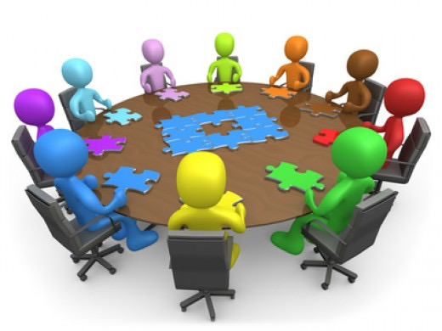

When planning a sprint, the team agrees upon items taken form the product backlog that they can commit to completing in the sprint. These items have to be feasibly completed in the sprint, and then a sprint backlog is created with the goal of completing as many of these tasks as possible within the sprint duration. These tasks are individually identified and each is given an estimated time in hours by each team member individually, then a time in hours is agreed upon by the entirety of the team.

The daily Scrum is a roughly 15 minute meeting where everyone answers three questions. What did you do yesterday, what will you do today and is anything in your way. The ScrumMaster ensures that the answers are kept quick and to the point, which establish an efficient meeting. This Scrum helps avoid other unnecessary meetings, and provides complete transparency on what everybody goals are and what they have accomplished thus far.

At the end of each individual sprint there is a Sprint Retrospective in which the group periodically take a look at what is working and what is not working. They are roughly 30 minutes in duration and the entire team participates in the Sprint Retrospective. The group gathers and discusses what they would like to start doing, stop doing and what they would continue doing.

**Product Backlog**

The product backlog is the the list of all the required and desired work on the project. The requirements are ideally expressed such that the items have significant value to the end user of the product. The product owner orders the product backlog and prioritises the more important elements of the product. This can change after every sprint based on feedback and how things are progressing.

To manage the Spring backlog, individuals involved in the Scrum framework chose which requirement they would like to tackle in the Sprint. The ScrumMaster or the Product Owner do not assign any work to the team members, instead the team members decided themselves on what work they would like to do. The team estimates the time that it will take to complete the tasks in the product backlog using a method called ‘Planning Poker’.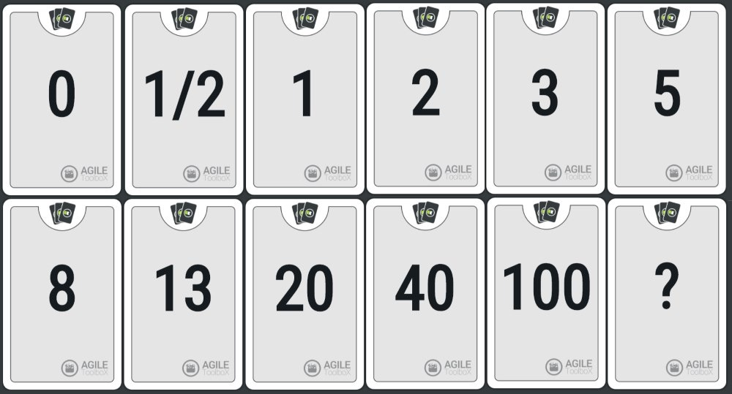

This involves assembling everyone involved and giving each member a deck of cards similar to those pictured above. The moderator reads a description of the user story and each team member selects a card and places it face down. The cards are flipped over and the team deliberates which hour estimate they should assign to the user story.

The sprint user story estimates are added up and tabulated into a burnout chart. This chart should approach 0 as the weeks go on and work is getting done. However there can be spikes in between sprints as the Product Owner can add more user stories to the requirements. A burnout chart usually looks like this :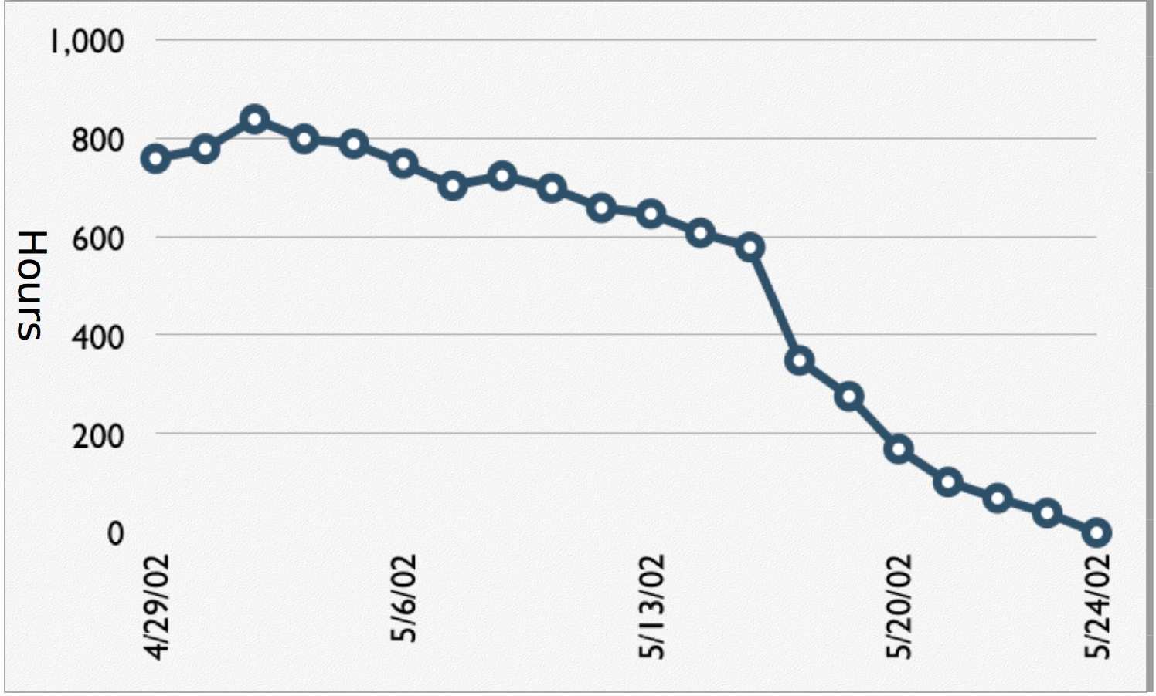

**Conclusion**

To conclude, Agile Development is an effective software development methodology, and in particular the scrum agile process. The multitude of sprints involved in this process result in a constantly evolving end product for the user, while everybody involved in the project has clear and concise goals to accomplish in the sprints duration.

Chapter 1 -

Chapter 2 - The Actual Project

Chapter 3 - The SCRUM process

Chapter 4 - Your Contribution

Chapter 5 - Summary