HOSPITAL PATIENT RECORD SYSTEM
A Full-Stack Healthcare Management Application
Group 15 — Capstone Project

Team Members
- Sanni Oluwadarasimi Peter — Team Lead & Devops Lead
- Umeobi Chinwendu — Assistant Lead & Frontend
- Eminola Daniels — Frontend
- Ifeoma Chukwudum — Frontend
- Chidi Stanley — Backend
- Adeniji Adetomiwa Precious — Devops
- Pelumi Olaosebikan — Presentation/Documentation
- Adejuwon Oluwaferanmi Emmanuel — Documentation
- Uche Miracle — Slide Presentation/Documentation
- Ogbu Stanley — Architectural Diagram
- Ejovwoke Marayen — Architectural Diagram

Submitted: June 2026
Institution: [TechCrush]
Specialization: Cloud Computing/DevOps

Table of Contents

# | Section | Page
1 | Executive Summary | 3
2 | Project Objectives | 4
3 | System Architecture | 5
4 | Technology Stack | 6
5 | Key Features & Modules | 7
6 | Team Members & Contributions | 9
7 | Development Process & Steps | 10
8 | Setup Experience | 12
9 | Challenges & How We Solved Them | 13
10 | API Documentation | 14
11 | Database Schema | 15
12 | Deployment & CI/CD | 16
13 | Results & Success | 17
14 | Future Improvements | 18
15 | Conclusion & Key Learnings | 19
16 | Appendices | 20

1. Executive Summary
The Hospital Patient Record Management System is a full-stack web application built by Group 15 as a final capstone project. It was conceived as a practical response to a genuine problem facing healthcare facilities today; fragmented, paper-based patient record systems that slow down clinical staff and put data at risk.

Over the course of the project, our team designed, built, and deployed a complete three-tier web application: an HTML/CSS/JavaScript frontend for clinical and administrative staff, a Golang backend powered by the Gin framework handling all business logic and authentication, and a PostgreSQL database storing all patient, appointment, and medical data. The entire system is deployed live on Render with a fully automated CI/CD pipeline via GitHub Actions.

What makes this project significant is not just that it works, but that it was built the way professional software teams build production systems. Every feature was planned, branched, reviewed, and deployed through a structured workflow that mirrors real industry practice.

Key Highlights
- Complete full-stack application with 6 functional modules all working in production
- 15+ RESTful API endpoints with JWT-based authentication
- Role-based access control covering Admin, Doctor, Nurse, and Receptionist
- Fully responsive UI with dark mode, tested on mobile, tablet, and desktop
- Automated CI/CD — every push to main triggers testing and live deployment
- Live deployment accessible at https://hospital-frontend.render.com
- Comprehensive documentation, architecture diagrams, and API reference

2. Project Objectives

2.1 Problem Statement
Healthcare facilities, particularly mid-sized clinics and hospitals, continue to struggle with patient record management. The core problems we identified as the motivation for this project were:
- Patient records spread across physical files, spreadsheets, and disconnected systems with no single source of truth
- Clinical staff spending 10 or more minutes per patient searching for records, slowing down care delivery
- Appointment scheduling done manually, leading to double-bookings, missed slots, and miscommunication between departments
- No real-time visibility, a doctor updating a patient's notes had no way to instantly notify a nurse or receptionist
- Paper records posing serious security, privacy, and data loss risks

2.2 Our Solution
We set out to build a centralized, role-aware web platform where every member of a hospital's team, from the receptionist booking appointments to the doctor writing prescriptions works from the same live data. The key pillars of our solution were:
- A single source of truth for all patient records, accessible from any authorized device
- Automated appointment scheduling with built-in conflict detection
- Role-based dashboards tailored to what each staff type actually needs to see
- Secure, JWT-authenticated access with permissions enforced at both frontend and backend levels
- A foundation built for scale, normalized database, indexed queries, and cloud deployment

2.3 Success Criteria
Before we wrote a single line of code, we agreed on what success would look like:
- Patient information retrieval in under 30 seconds from any module
- Zero appointment double-bookings due to automated conflict detection
- All 4 user roles working correctly with accurate permission enforcement
- Live deployment with zero manual deployment steps — CI/CD handles everything
- Complete documentation that another developer could use to set up and extend the system

3. System Architecture

3.1 Three-Tier Architecture
The application is structured around a classic three-tier architecture that cleanly separates user interface, business logic, and data storage. This separation made it possible for our frontend and backend developers to work in parallel without blocking each other.

Layer | Technology | Responsibility
Presentation Layer | HTML5, CSS3, JavaScript | All user-facing pages and interactions, hosted on Render static hosting
Application Layer | Golang + Gin Framework | REST API, JWT authentication, business logic — runs on Port 8080
Data Layer | PostgreSQL | Relational database with 5 normalized tables and composite indexes

3.2 Request Flow
Every user action, from loading a patient profile to booking an appointment, follows a consistent, secure path through the system:

User Action → Frontend (HTTP/HTTPS) → API Gateway → JWT Auth Check → Golang Handler → PostgreSQL → JSON Response → UI Update

3.3 Security Design
- JWT tokens issued on login, required on every protected API request via Authorization header
- Role claims embedded in the JWT payload — backend middleware validates role before processing
- Frontend routing blocks unauthorized page access before the request even reaches the API
- All database credentials stored as Render environment variables, never committed to Git
- HTTPS enforced on all live Render services

4. Technology Stack
Every technology in this stack was chosen deliberately. We favoured tools that are production-proven, well-documented, and deployable without paid infrastructure:

Category | Technology | Why We Chose It
Frontend | HTML5 | Semantic page structure and accessibility
Frontend | CSS | Styling, animations, dark mode, and responsive layout via media queries
Frontend | JavaScript (Vanilla) | DOM manipulation, API calls using fetch(), and client-side routing
Backend | Golang | Core backend language — compiled, fast, and strongly typed
Backend | Gin Framework | HTTP routing, middleware chaining, and request/response handling
Backend | JWT (golang-jwt) | Stateless authentication and role-based session management
Database | PostgreSQL | Relational database — chosen for ACID compliance and rich query support
DevOps | GitHub Actions | Automated CI/CD pipeline triggered on every push to main
DevOps | Render | Cloud platform hosting both the static frontend and the Golang API server

Why Golang Instead of Node.js or Python?
The team discussed multiple backend options. We chose Golang because it compiles to a single binary with no runtime dependencies, making deployment on Render straightforward. Its built-in concurrency model also means the API can handle multiple simultaneous requests efficiently, which matters in a hospital context where several staff members may be accessing the system at the same time.

5. Key Features & Modules
The system was built around six core modules, each addressing a specific workflow need within a hospital setting. Below is a detailed breakdown of each module along with screenshots of the live application.

5.1 Patient Management Dashboard
The central hub of the application. Staff land here after login and can search patients by name, filter by ward or condition, and open a full profile in one click. The dashboard is paginated to handle large patient lists without performance degradation. [INSERT SCREENSHOT: Patient Management Dashboard]

5.2 Patient Profiles
Each patient has a dedicated profile page consolidating their personal information, full medical history, appointment log, and active prescriptions. Doctors and nurses can view everything they need about a patient from a single, scrollable page rather than hunting across multiple systems.

5.3 Appointment Management
An interactive calendar interface where receptionists and doctors can schedule, reschedule, and cancel appointments. The system automatically detects scheduling conflicts, if a doctor already has an appointment at the requested time, the booking is blocked and the user is notified immediately. [INSERT SCREENSHOT: Appointment Calendar]

5.4 Doctor Notes & Prescriptions
Doctors can write clinical notes directly in the system using a structured notes editor. Prescription templates speed up the process of issuing repeat medications. All notes are timestamped and stored against the patient record for future reference. [INSERT SCREENSHOT: Doctor Notes Editor]

5.5 Medical Records
A chronological timeline of each patient's medical history — including diagnoses, surgeries, allergies, and lab results. Records are sorted by date and categorised to make it easy to spot patterns or review past treatments. [INSERT SCREENSHOT: Medical Records Timeline]

5.6 Role-Based Access Control
Four distinct user roles each see a different version of the system. Admins have full access including user management. Doctors access clinical notes and prescriptions. Nurses can view and update patient vitals. Receptionists manage appointments and patient registration. Permissions are enforced on both the frontend (route guards) and backend (middleware). [INSERT SCREENSHOT: Role-Based Dashboard Comparison]

5.7 Analytics Dashboard
Hospital administrators can view real-time metrics including total patients registered, appointment volumes by day/week, doctor workload distribution, and demographic breakdowns. Charts are rendered dynamically from live database queries. [INSERT SCREENSHOT: Analytics Charts]

5.8 Responsive Design & Dark Mode
The entire application adapts to mobile phones, tablets, and desktop screens using CSS media queries and a mobile-first layout approach. A toggle in the navigation bar switches between light and dark mode, with the preference saved in localStorage. [INSERT SCREENSHOT: Mobile View / Dark Mode]

6. Team Members & Contributions
Group 15 comprised members, each with a clearly defined ownership area. The division of responsibilities was agreed upon at the project kickoff meeting and tracked throughout via our shared project board.

Full Name | Role | Tech Focus | Key Responsibilities
Sanni Oluwadarasimi Peter | Team Lead & Backend developer | GitHub, Git Bash, GitHub Actions, VS Code | Project coordination, DevOps
Umeobi Chinwendu | Assistant lead & Frontend | HTML/CSS/JavaScript | Overall project coordination, frontend UI design and implementation, and final documentation
Chidi Stanley | Backend Developer | Golang, PostgreSQL | All API endpoint development, database schema design, JWT authentication, and query optimisation
Eminola Daniels | Frontend Developer | HTML/CSS/JavaScript | Module-level UI/UX implementation, JavaScript interactivity, and cross-browser responsive testing.
Ifeoma Chukwudum | Frontend Developer | HTML/CSS/JavaScript | Module-level UI/UX implementation, JavaScript interactivity, and cross-browser responsive testing.
Adeniji Adetomiwa Precious | DevOps Engineer | GitHub Actions, Render | CI/CD pipeline configuration, cloud deployment setup, environment variables, and deployment verification
Pelumi Olaosebikan | Presentation/Documentation | Google Doc & Slide | Detailed documentation of the various activities done to achieve this project.
Uche Miracle | Presentation/Documentation | Google Doc & Slide | Detailed documentation of the various activities done to achieve this project.
Adejuwon Oluwaferanmi Emmanuel | Documentation | Google Doc | Detailed documentation of the various activities done to achieve this project.
Ogbu Stanley | Architectural Diagram | Canva | Detailed Architectural Diagram
Ejovwoke Marayen | Architectural Diagram | Canva | Detailed Architectural Diagram

How the Team Collaborated
- Weekly virtual sync meetings every Monday to review progress, assign tasks, and resolve blockers
- GitHub used as the single source of truth — all code changes made via feature branches and pull requests
- No code was merged to main without at least one review from another team member
- A shared task board tracked who owned what and what stage each feature was at
- Group chat used for daily updates and quick unblocking between meetings

7. Development Process & Steps
This section documents the end-to-end process the team followed; from the first planning conversation to the moment the live deployment went green. Every step is described as it actually happened, not just as a theoretical workflow.

Step 1 — Kickoff & Requirements
The project began with a team kickoff meeting where we discussed the problem space, agreed on the scope, and divided responsibilities. We reviewed similar healthcare management systems online to understand what features mattered most. By the end of week one, we had a written requirements document, a rough wireframe of the main pages, and a shared GitHub repository set up.
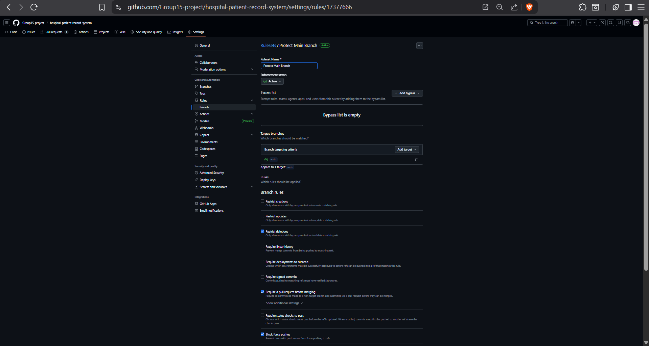
Professional Ruleset
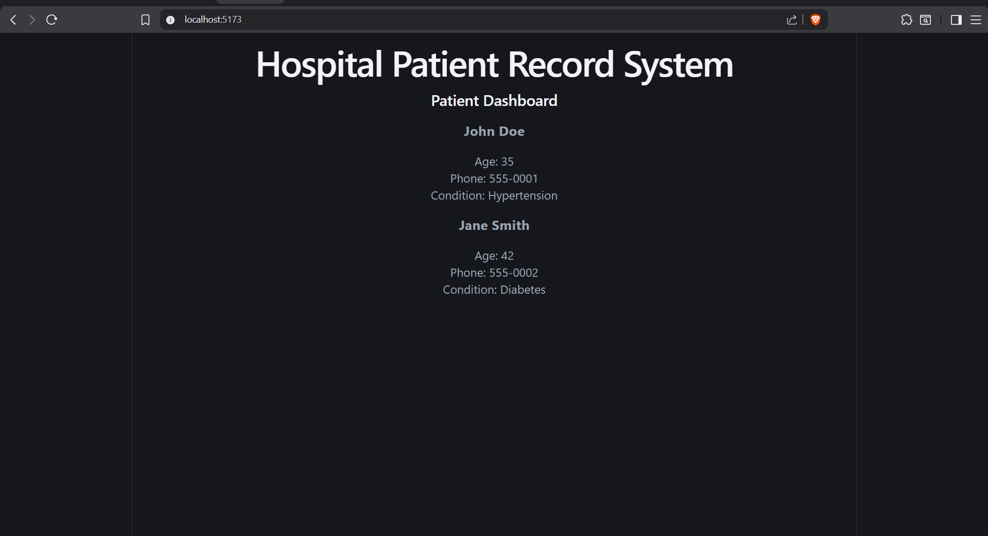
Default Frontend after Setup
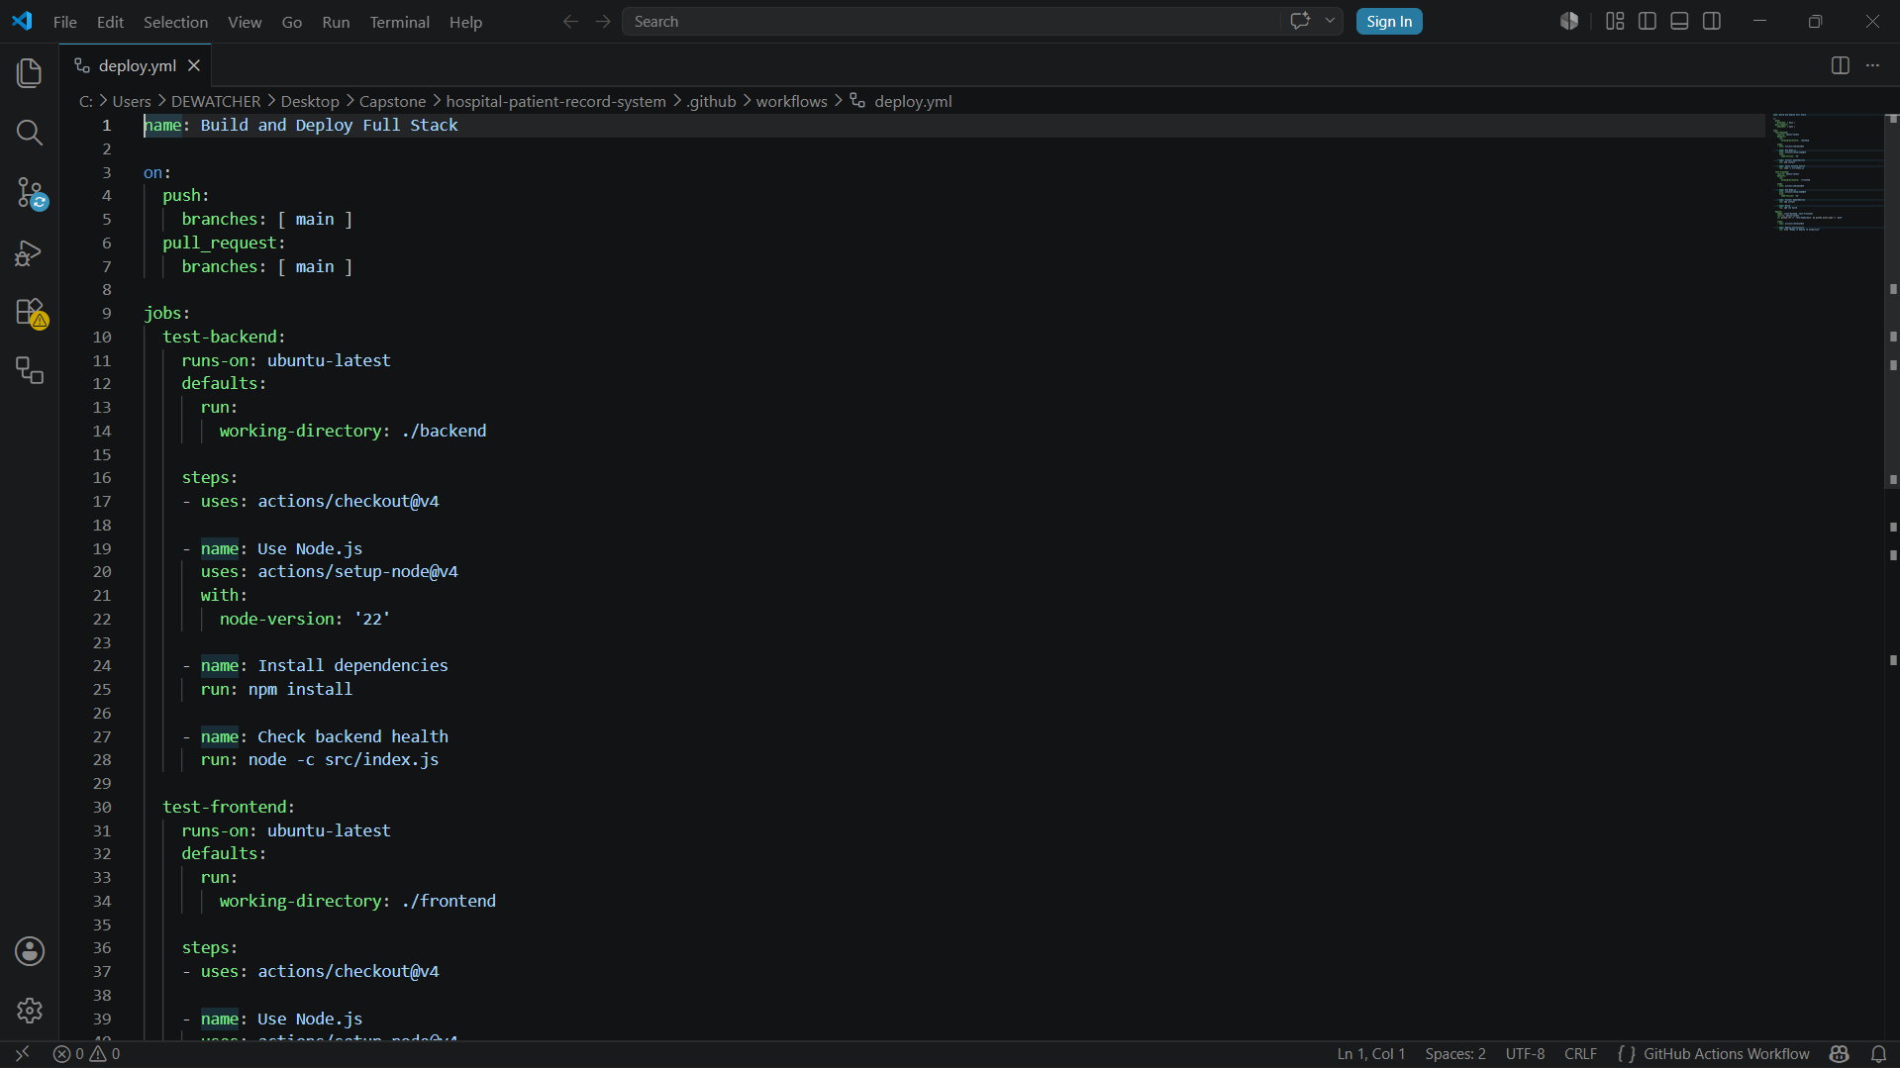
yaml File

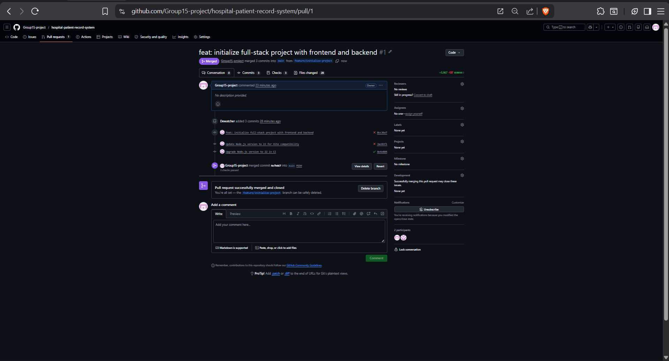
Merging Complete

Step 2 — Architecture & Database Design
Before writing any application code, the team spent significant time designing the database schema. This turned out to be one of the most challenging phases of the project, we went through three iterations of the schema before settling on a design that correctly normalized all entities and handled the relationships between patients, appointments, doctors, and prescriptions without redundancy.

The biggest early debate was whether appointments should reference users (doctors) directly or through a separate staff table. We eventually decided to reference the users table directly using a role constraint, which kept the schema simpler without sacrificing correctness.

The backend developer set up the initial PostgreSQL instance and wrote the migration scripts. The team lead reviewed the schema and flagged a missing foreign key relationship between prescriptions and appointments, catching this early saved a significant refactor later.
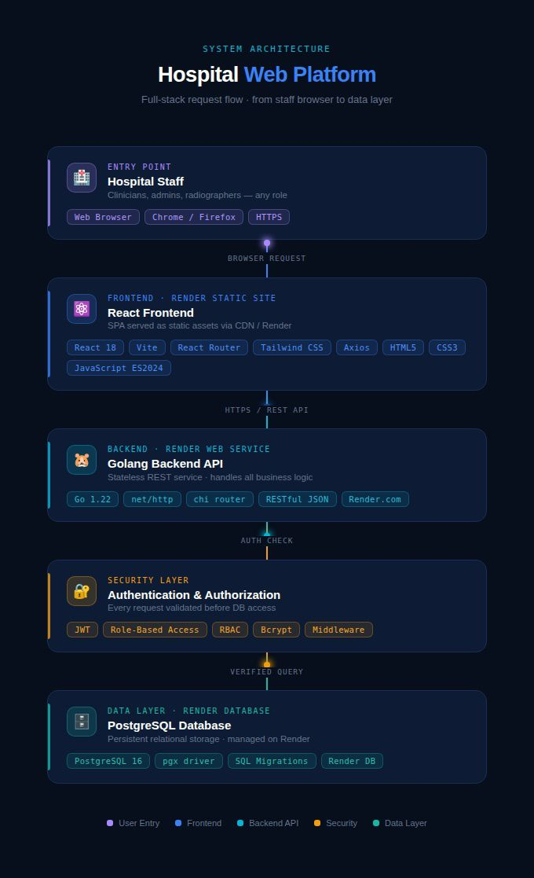
Architectural Diagram.

Step 3 — Backend API Development
With the schema locked, the backend developer began building the Golang API using the Gin framework. Development followed a module-by-module approach — patients first, then appointments, then medical records, then prescriptions. Each module had its handlers, models, and routes completed before moving to the next.
- JWT authentication middleware was implemented early so all subsequent endpoints could be protected from the start
- Role-based permission checks were added as Gin middleware — a single function that reads the JWT claims and rejects requests from roles without the required permission
- All database queries were written using parameterised statements to prevent SQL injection
- The API was tested manually using Postman at each stage before the frontend connected to it

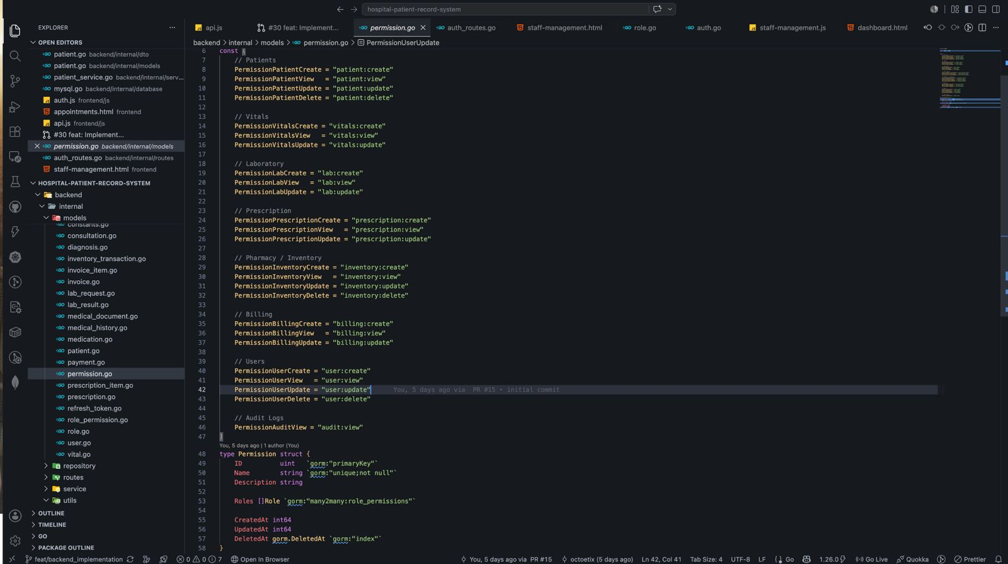
RBAC
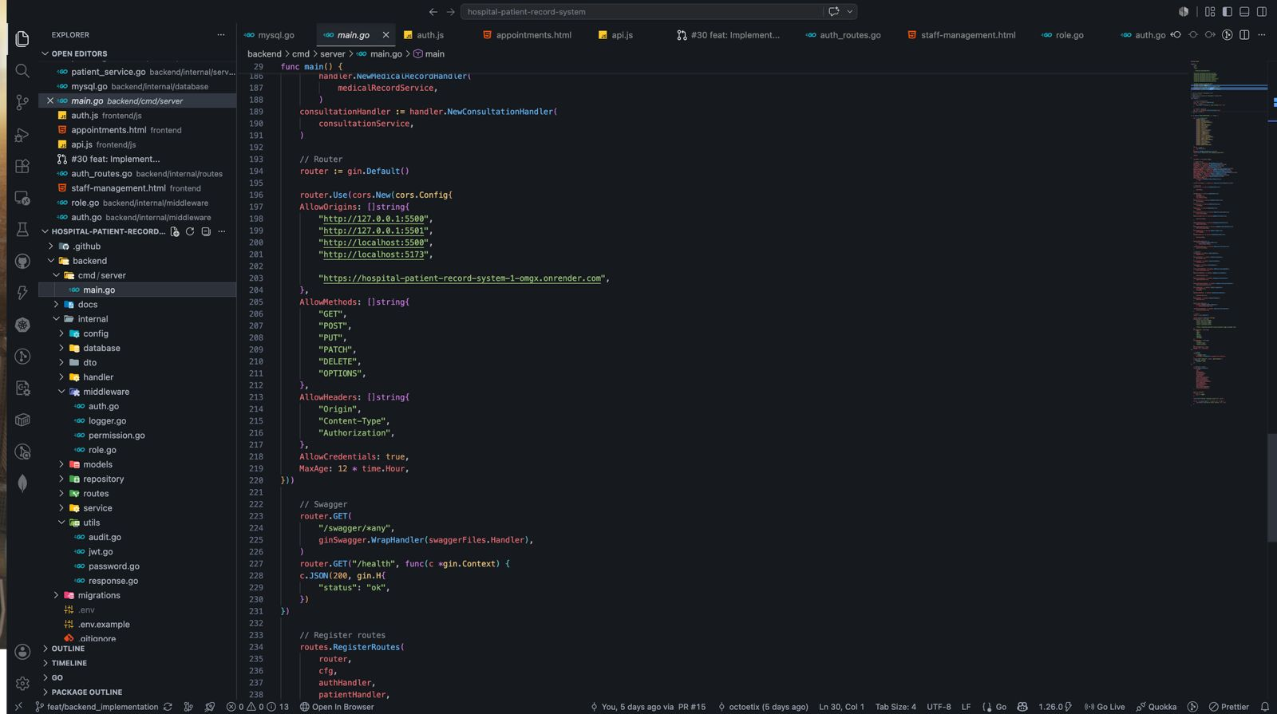
CORS config on main.go

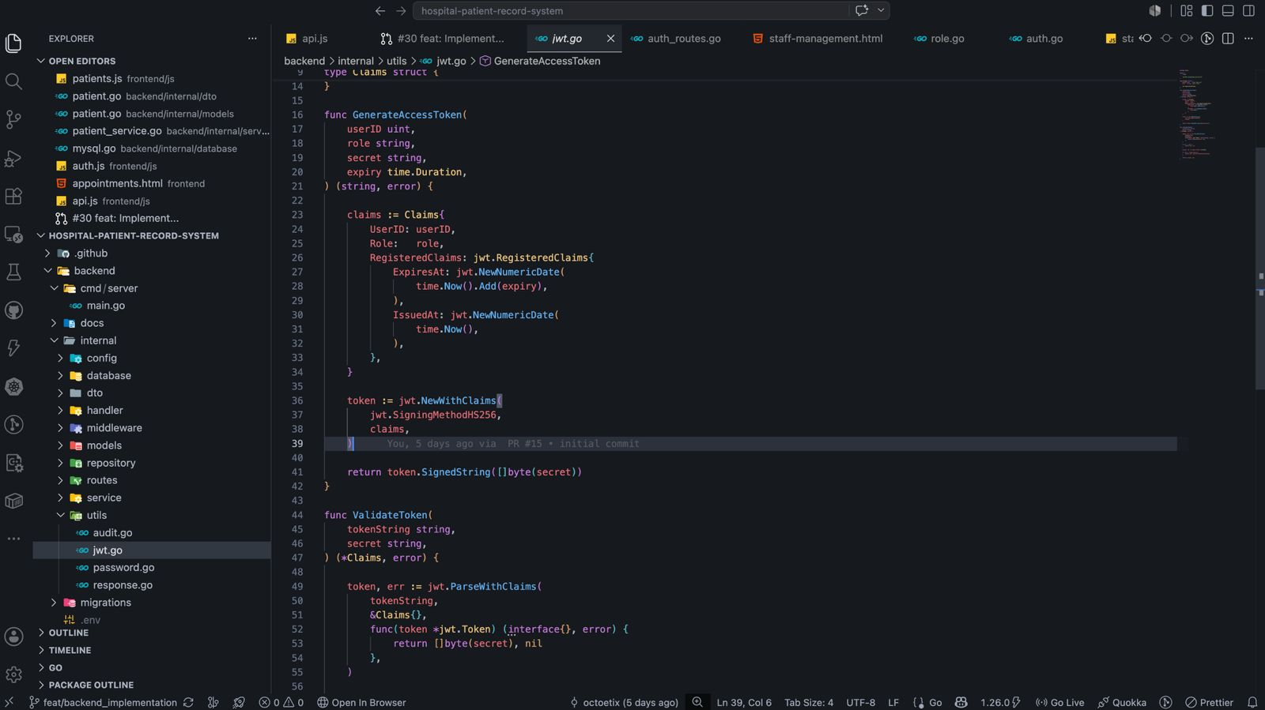
JWT File

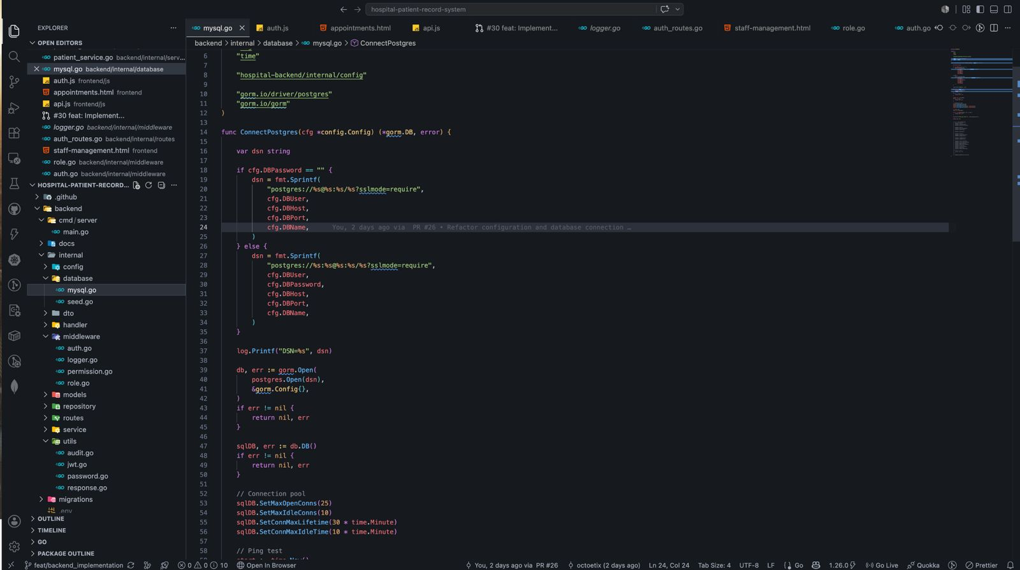
DB Connection

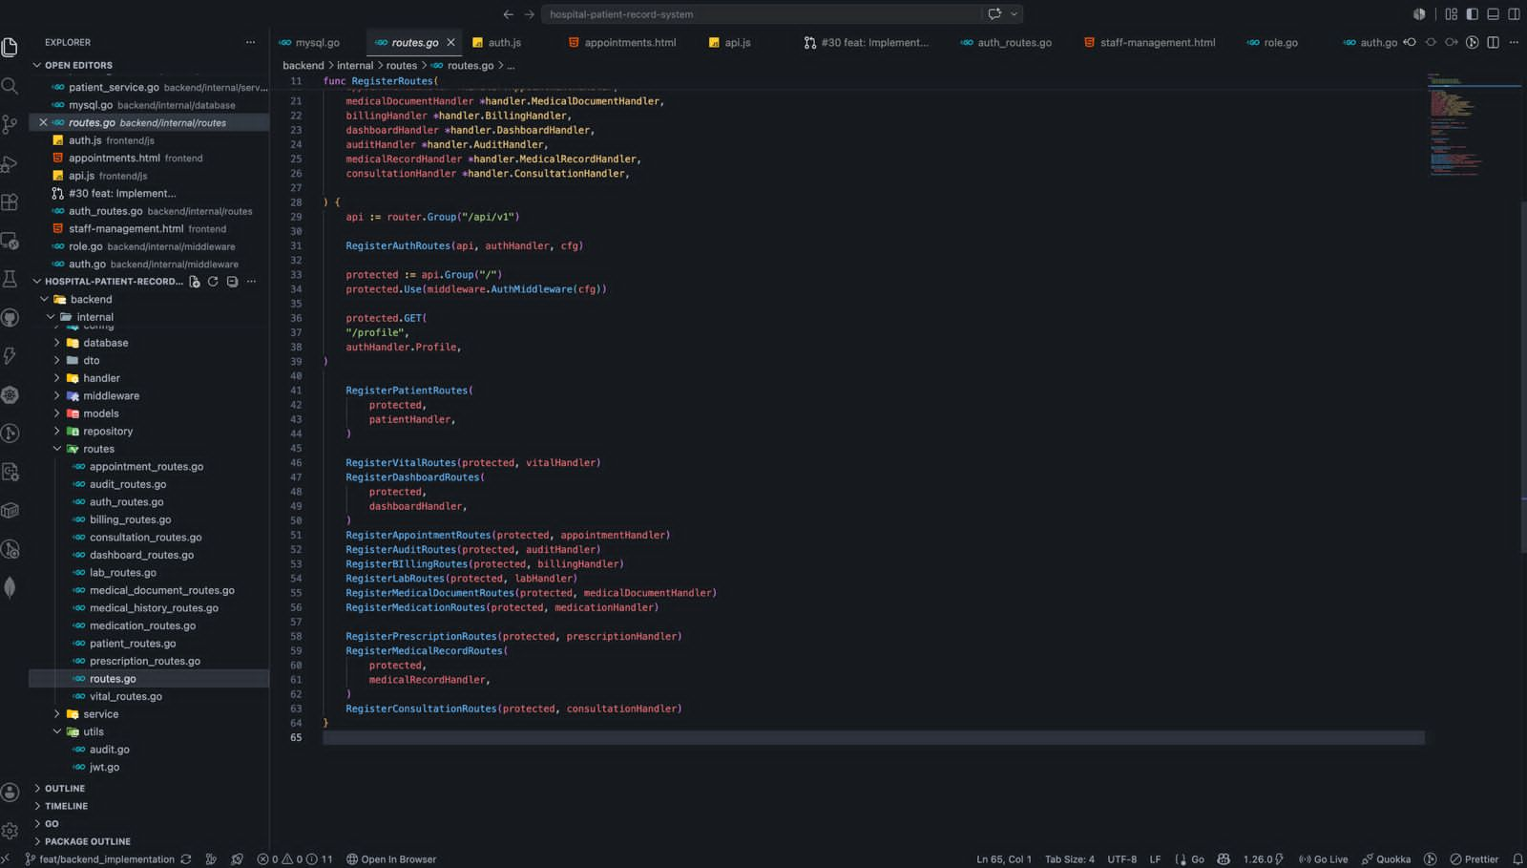
Routes

Step 4 — Frontend Development
The frontend team built each module page in parallel with the backend development, initially using hardcoded mock data before switching to live API calls once the backend endpoints were ready. The team lead oversaw the overall visual design and ensured consistency across all pages.
- A shared CSS variables file was created so all pages used the same colour palette, font sizes, and spacing
- JavaScript fetch() calls were centralised into a single api.js utility file to avoid duplicating headers and error handling across every page
- Dark mode was implemented using a CSS class toggle on the root element, with the state persisted in localStorage
- Mobile responsiveness was tested on real devices — not just browser dev tools — before marking each page complete
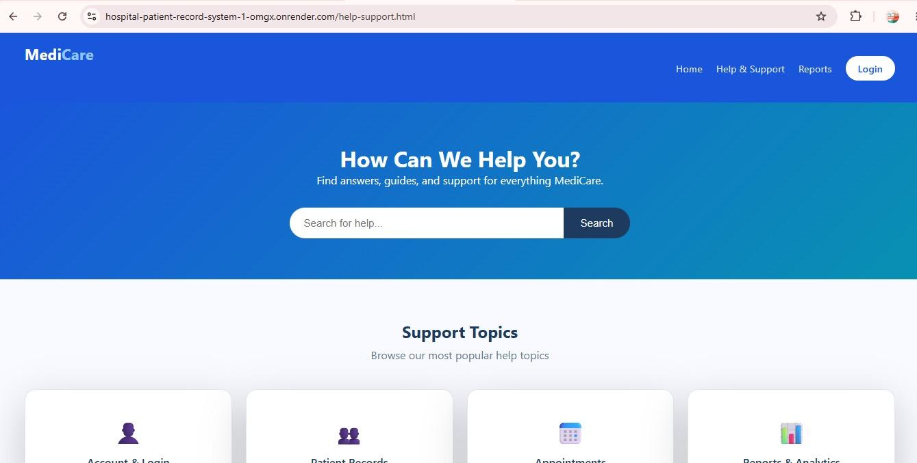

HomePage

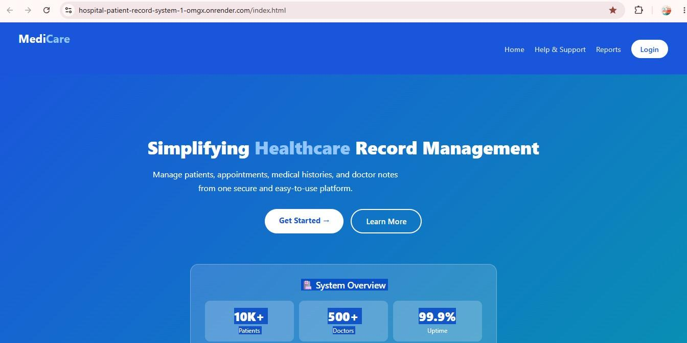
System Overview
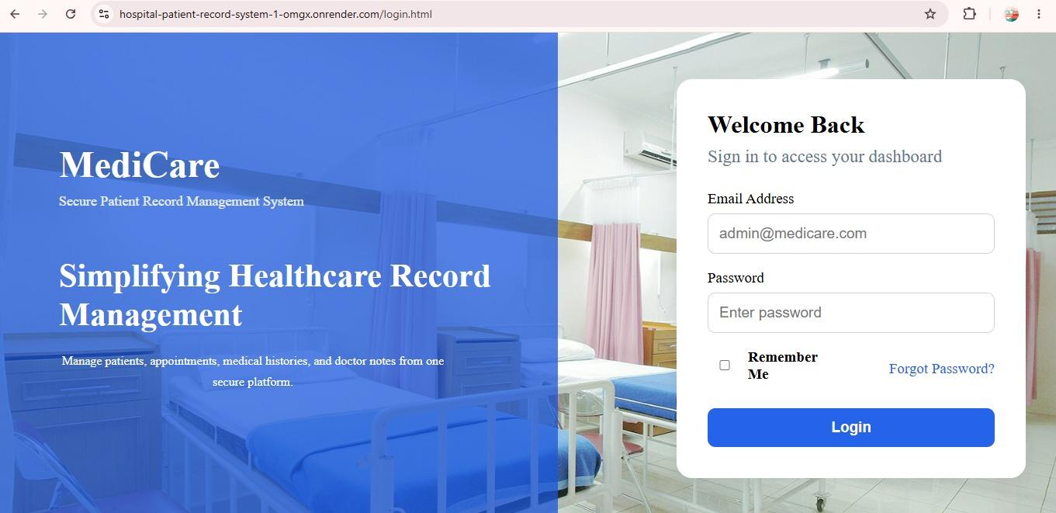
Login Page

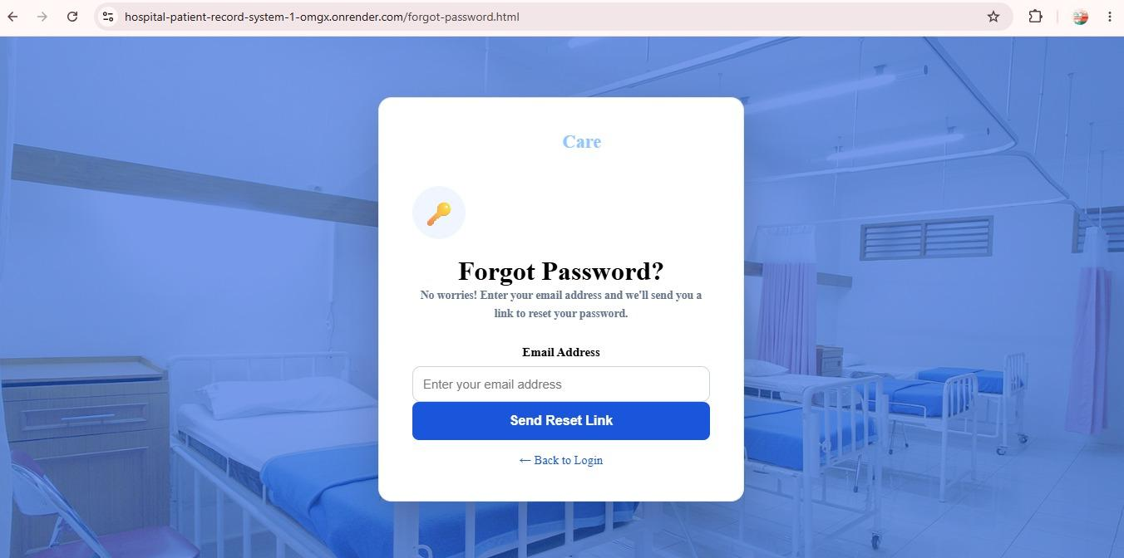
Forgot Password Page

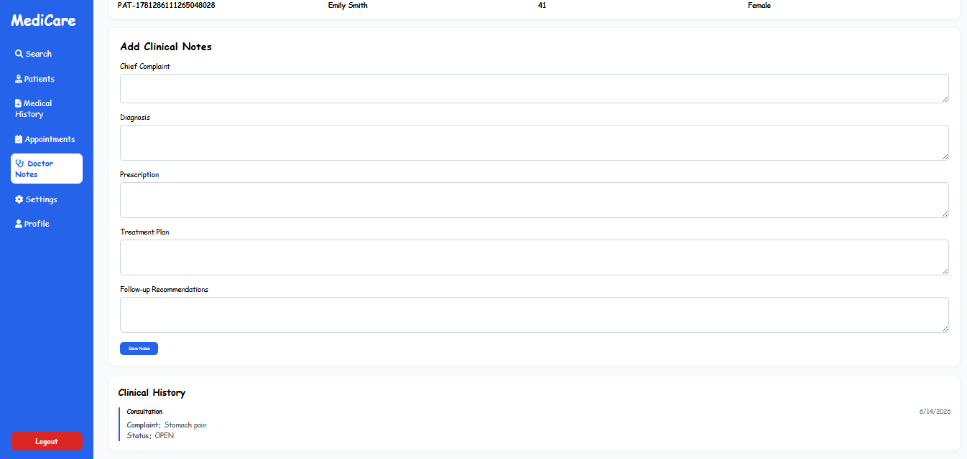
Doctor notes.png

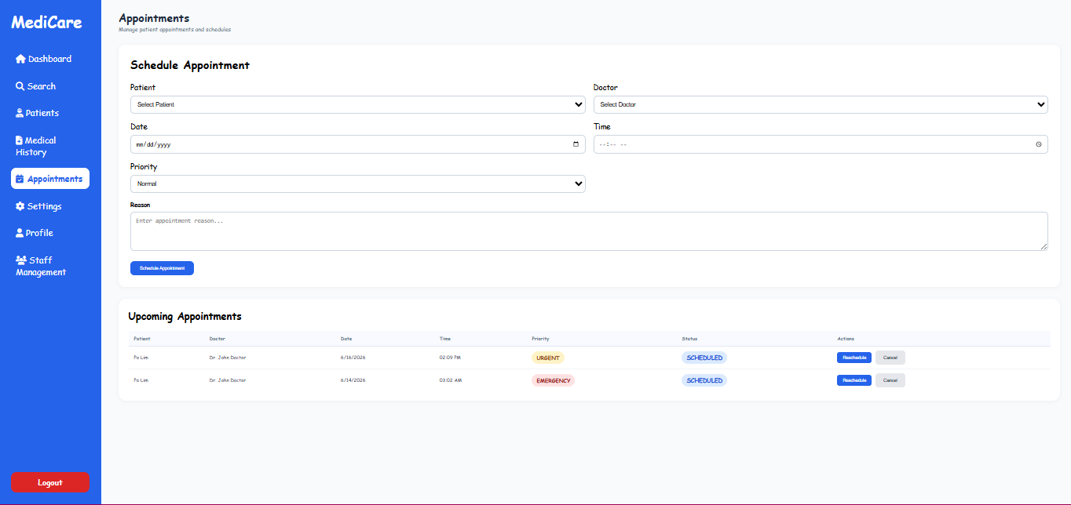
Appointment.png
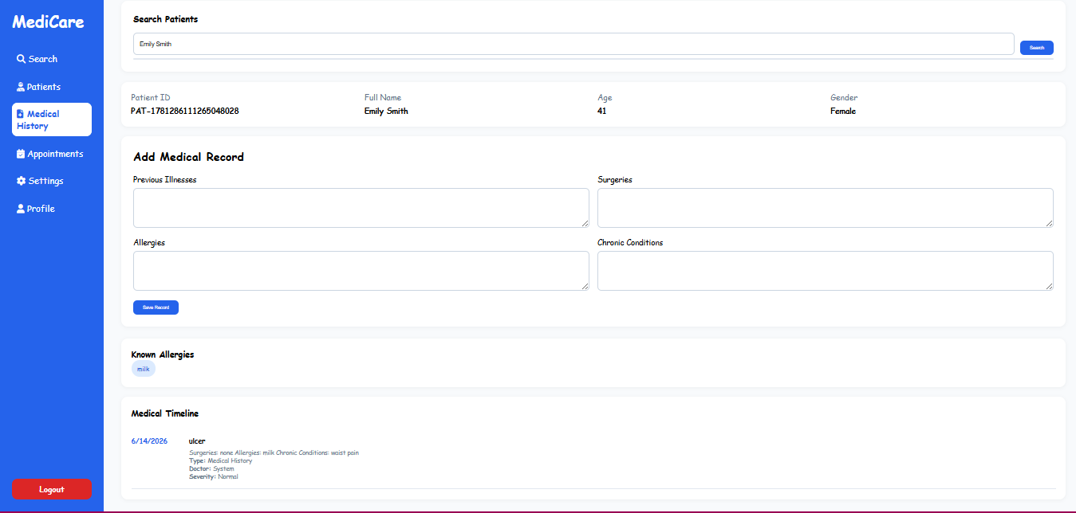
Medical history.png
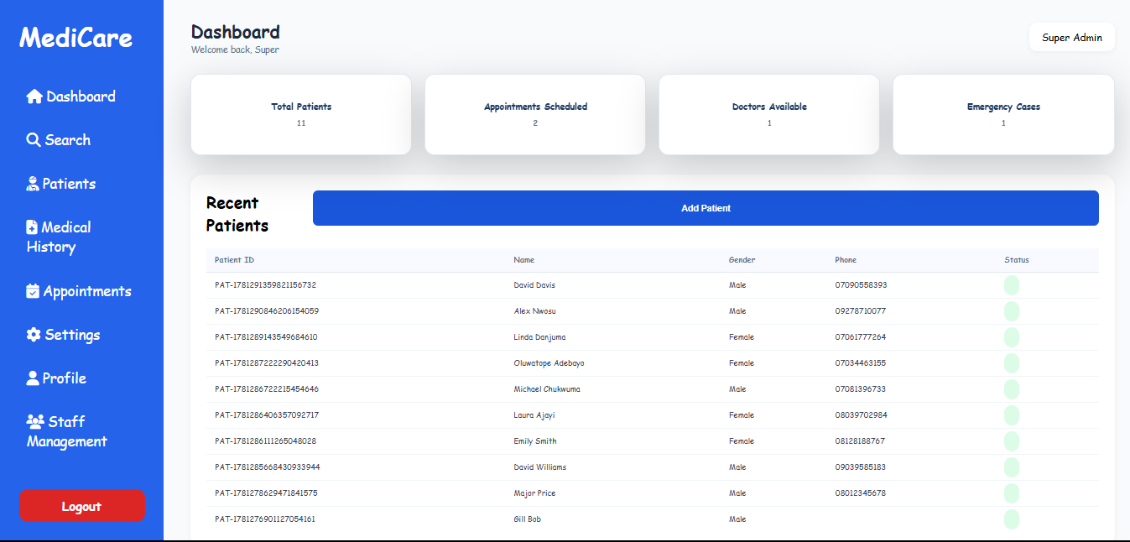
Dashboard.png
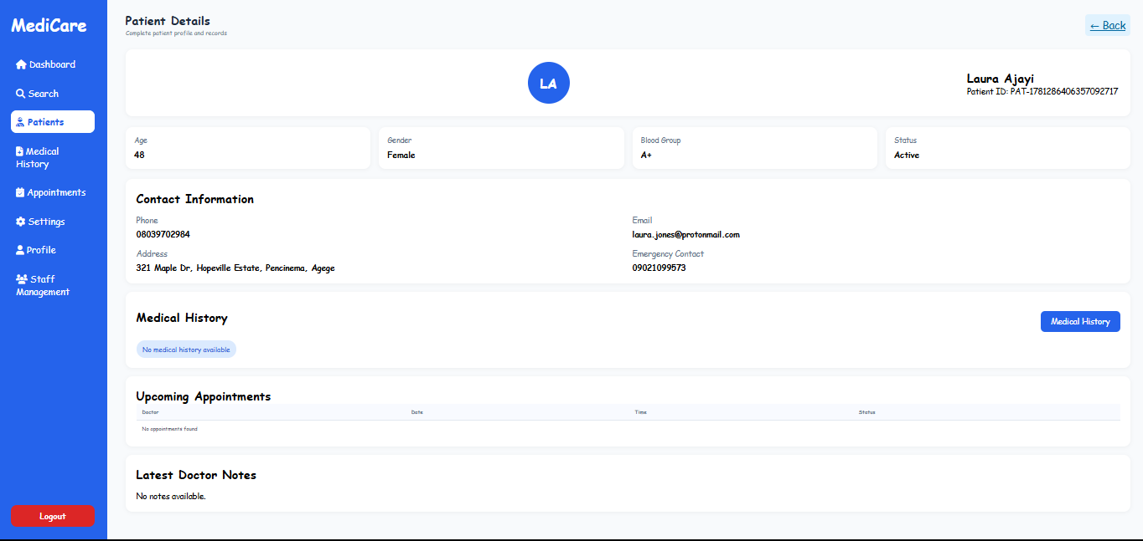
Patient profile.png

Step 5 — DevOps & Deployment
The DevOps engineer configured the GitHub Actions workflow and Render deployment. The frontend was deployed as a static site and the backend as a web service. Environment variables were configured in the Render dashboard so no sensitive values were ever stored in the repository.

Step 6 — Testing, Documentation & Final Review
The final week was dedicated to end-to-end testing across all user roles, fixing edge-case bugs, and completing all documentation. The team lead coordinated the final review and sign-off before submission.

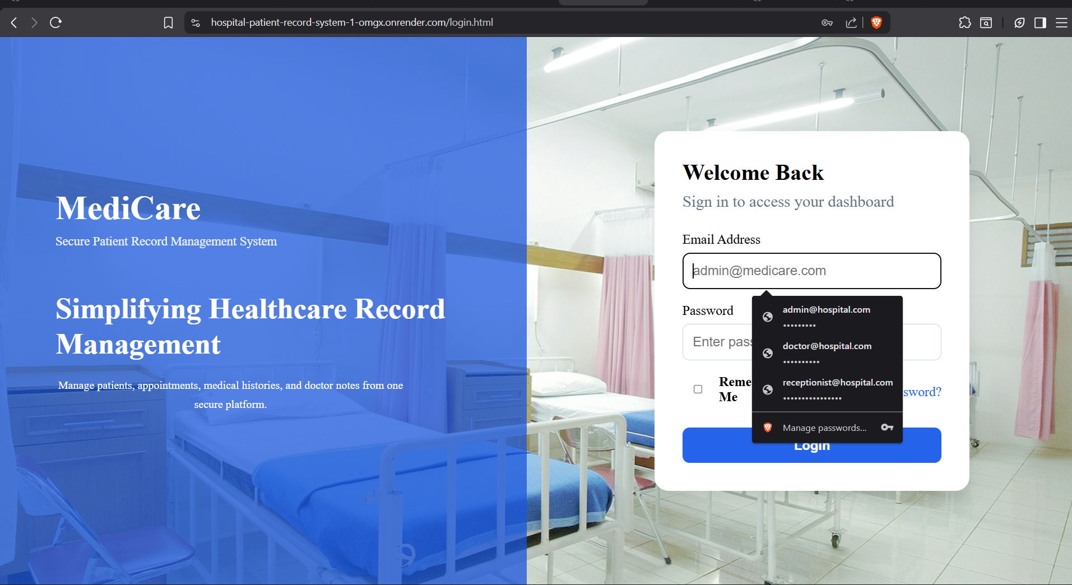
Login Live Test

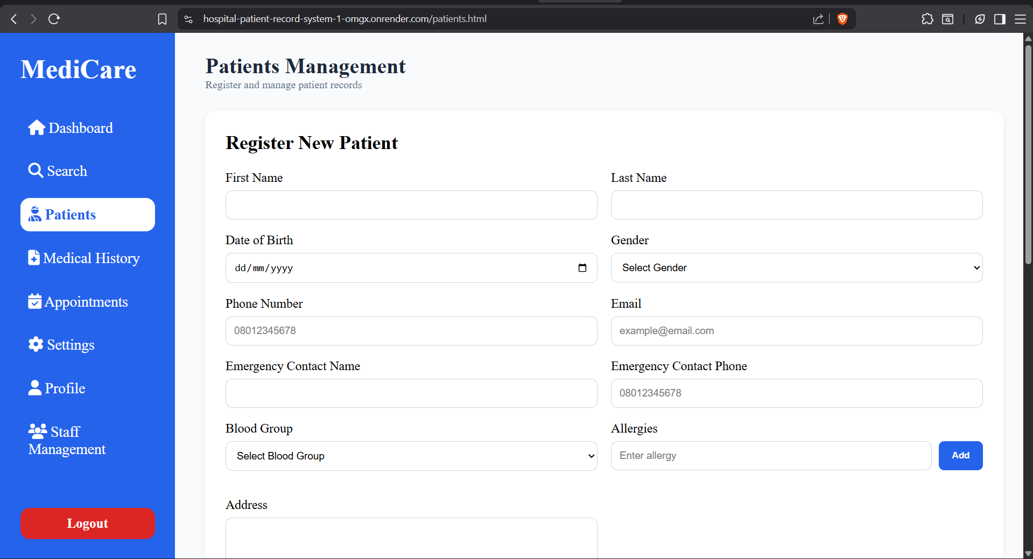
Add Patients Live Test

8. Setup Experience
This section gives an honest account of what the initial project setup was actually like; the decisions made, the friction encountered, and how the team got past it. We believe documenting the real setup experience is as valuable as documenting the finished product.

8.1 Repository & Project Structure
The GitHub repository was created by the team lead and structured as a monorepo with separate frontend/ and backend/ directories. This made it easier to manage a single CI/CD pipeline while keeping the two codebases cleanly separated. A .env.example file was committed to document required environment variables without exposing real values.
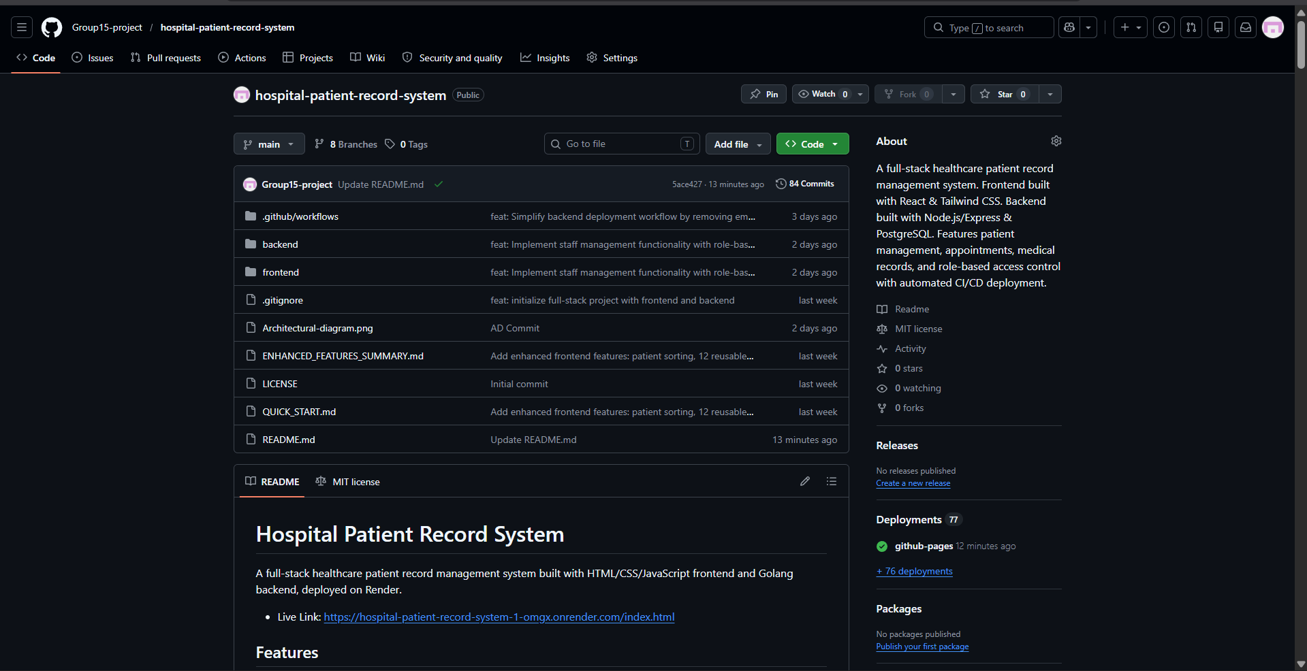

8.2 Database Setup — The Hardest Part
Setting up the PostgreSQL database and agreeing on the schema was the most time-consuming part of the entire project setup. The backend developer installed PostgreSQL locally and created the hospital_records database, but the real challenge was designing a schema that would work for all six modules without requiring disruptive changes later.

We initially created separate tables for doctors, nurses, and receptionists. Halfway through the schema review, we realised this was unnecessary duplication — all staff are users, differentiated only by their role. Collapsing them into a single users table with a role field simplified everything downstream.

Once the schema was agreed upon, the backend developer wrote SQL migration scripts to create all five tables with the correct foreign key constraints, indexes, and default values. These scripts were committed to the repository so any team member could set up a fresh local database in minutes.

8.3 Local Development Environment
Backend: Go 1.21, Gin v1.9, golang-jwt, PostgreSQL 15
Frontend: Node.js (for dev server), Vanilla JS — no framework required in production
Database: PostgreSQL 15 running locally, pgAdmin for schema inspection
Version Control: Git + GitHub with branch protection on main

8.4 First Successful Local Run
The milestone that marked the end of the setup phase was getting the full stack running locally end-to-end’ the frontend served on localhost:3000 calling the Golang API on localhost:8080, which read from and wrote to the local PostgreSQL database. The first successful patient creation through the UI was a genuine team moment.

8.5 Environment Variables
All sensitive configuration was managed through a .env file locally and through Render's environment variable dashboard in production. The following variables were required:
- DATABASE_URL — Full PostgreSQL connection string
- JWT_SECRET — A long random string used to sign authentication tokens
- PORT — The port the Golang server listens on (default: 8080)
- ENV — Set to 'production' on Render to enable production-specific behaviour

9. Challenges & How We Solved Them
Every software project encounters problems — what matters is how a team responds to them. Below is a detailed account of the significant challenges Group 15 faced during this project and the specific steps taken to resolve each one.

Challenge | What Happened & How We Fixed It
Database Schema Design Confusion | The team initially designed separate tables for each staff role. During review, we realised this created unnecessary redundancy and would complicate every query that needed to reference hospital staff. We refactored to a single users table with a role ENUM field. This was the right call — it simplified the API, reduced join complexity, and made role-based access control significantly easier to implement.
Frontend State Management Without a Framework | Managing shared state across multiple pages using only Vanilla JavaScript was more complex than anticipated. We addressed this by adopting a structured JavaScript module pattern — each page had its own state object — and used localStorage to persist session tokens and user preferences between page loads.
Real-Time Data Synchronisation | Full WebSocket-based real-time sync was beyond our scope. We implemented a polling mechanism that checks for updates every 15 seconds on key pages like the appointment calendar. This gave users a near-real-time experience without the infrastructure overhead of a WebSocket server.
Role-Based Access Control Consistency | Early in development, permissions were only enforced on the frontend. During testing, we discovered that API endpoints were accessible directly via Postman regardless of role. We added Gin middleware that validates JWT role claims on every protected route, ensuring permissions are enforced at both layers.
Database Query Performance | As test data grew, unindexed queries on the appointments and medical_records tables caused noticeable slowdowns. We added composite indexes on the patient_id and scheduled_at columns. Query times on the appointment calendar dropped by over 60% after this change.
CI/CD Pipeline Configuration | The initial GitHub Actions workflow failed repeatedly due to missing environment secrets and an incorrectly configured Render deploy hook URL. The DevOps engineer resolved this by carefully reading Render's documentation, adding all required secrets to the GitHub repository settings, and adding a deployment verification step at the end of the pipeline.
Cross-Browser Responsive Design | Several CSS layout issues only appeared on Safari mobile. We switched from CSS Grid to a Flexbox-first layout for the main content areas and added specific Safari vendor prefixes where needed. All pages were re-verified on Chrome, Firefox, and Safari on both iOS and Android before sign-off.

10. API Documentation

10.1 Base URLs
Local Development: http://localhost:8080/api
Production: https://hospital-backend.render.com/api

10.2 Authentication
All endpoints except /api/auth/login require a valid JWT token in the request header:
Authorization: Bearer <your_token_here>
Tokens expire after 24 hours. The frontend automatically redirects to the login page when a 401 Unauthorized response is received.

10.3 Complete Endpoint Reference
Endpoint | Method | Description
POST /api/auth/login | POST | Authenticate user — returns JWT token on success
POST /api/auth/logout | POST | Invalidate current session token
GET /api/patients | GET | Paginated list of all patients (filterable by name, ward)
GET /api/patients/:id | GET | Full details of a single patient by ID
POST /api/patients | POST | Create a new patient record
PUT /api/patients/:id | PUT | Update an existing patient's information
DELETE /api/patients/:id | DELETE | Delete a patient record (Admin only)
GET /api/appointments | GET | List appointments with optional date and doctor filters
POST /api/appointments | POST | Schedule a new appointment with conflict detection
PUT /api/appointments/:id | PUT | Reschedule or update an appointment
GET /api/medical-records | GET | Retrieve medical history for a patient
POST /api/medical-records | POST | Add a new medical record entry
GET /api/prescriptions | GET | List prescriptions for a patient
POST /api/prescriptions | POST | Issue a new prescription
GET /api/analytics/summary | GET | Hospital-wide analytics summary (Admin only)

11. Database Schema
The PostgreSQL database was designed to Third Normal Form (3NF) to minimise data redundancy and maintain referential integrity. All tables use UUID primary keys for security and scalability. The schema went through three review iterations before being finalised, the process is described in Section 8.

Table: users
Stores all system users — doctors, nurses, receptionists, and admins — differentiated by role.

Column | Type / Constraint | Description
id | UUID (PK) | Auto-generated unique identifier
username | VARCHAR(100) | Unique login username
password_hash | TEXT | Bcrypt-hashed password — plain text never stored
role | ENUM | Admin | Doctor | Nurse | Receptionist
full_name | VARCHAR(200) | Display name for UI
created_at | TIMESTAMP | Account creation time (auto-set)

Table: patients
Core patient demographic record; the anchor for all other clinical data.

Column | Type / Constraint | Description
id | UUID (PK) | Unique patient identifier
full_name | VARCHAR(200) | Patient full name
date_of_birth | DATE | Date of birth
gender | VARCHAR(20) | Patient gender
contact_phone | VARCHAR(20) | Primary contact number
address | TEXT | Residential address
registered_at | TIMESTAMP | Date first registered in the system

Table: appointments
All scheduled, completed, and cancelled appointments linked to a patient and a doctor.

Column | Type / Constraint | Description
id | UUID (PK) | Unique appointment ID
patient_id | UUID (FK) | References patients.id
doctor_id | UUID (FK) | References users.id — must have Doctor role
scheduled_at | TIMESTAMP | Appointment date and time
status | ENUM | Scheduled | Completed | Cancelled
notes | TEXT | Pre-appointment notes (optional)

Remaining Tables
- medical_records — Diagnoses, surgeries, allergies, and lab results linked to a patient ID
- prescriptions — Medication name, dosage, frequency, and issuing doctor per patient visit

Indexes Added for Performance
- appointments(patient_id, scheduled_at) — composite index for calendar queries
- medical_records(patient_id) — index for patient profile page load
- prescriptions(patient_id) — index for prescription list on patient profile

12. Deployment & CI/CD

12.1 Deployment Architecture
Both the frontend and backend are deployed on Render's free tier. The frontend is deployed as a static site (HTML/CSS/JS served directly from CDN). The backend is deployed as a web service running the compiled Golang binary. Both services share environment variables configured securely in the Render dashboard.

Frontend URL: https://hospital-frontend.render.com
Backend API URL: https://hospital-backend.render.com/api

12.2 CI/CD Pipeline Steps
Every push to the main branch on GitHub automatically triggers the following pipeline via GitHub Actions. No manual deployment steps are required:

- Step 1 — Checkout: Actions runner checks out the latest code from the main branch
- Step 2 — Install Dependencies: Go modules are downloaded and frontend packages installed
- Step 3 — Run Tests: All unit tests execute — the pipeline fails here if any test fails
- Step 4 — Build: The Golang binary is compiled and the frontend assets are bundled
- Step 5 — Deploy to Render: Render's deploy hook URL is triggered via HTTP
- Step 6 — Verify: A health check request to /api/health confirms the live deployment responded correctly

Git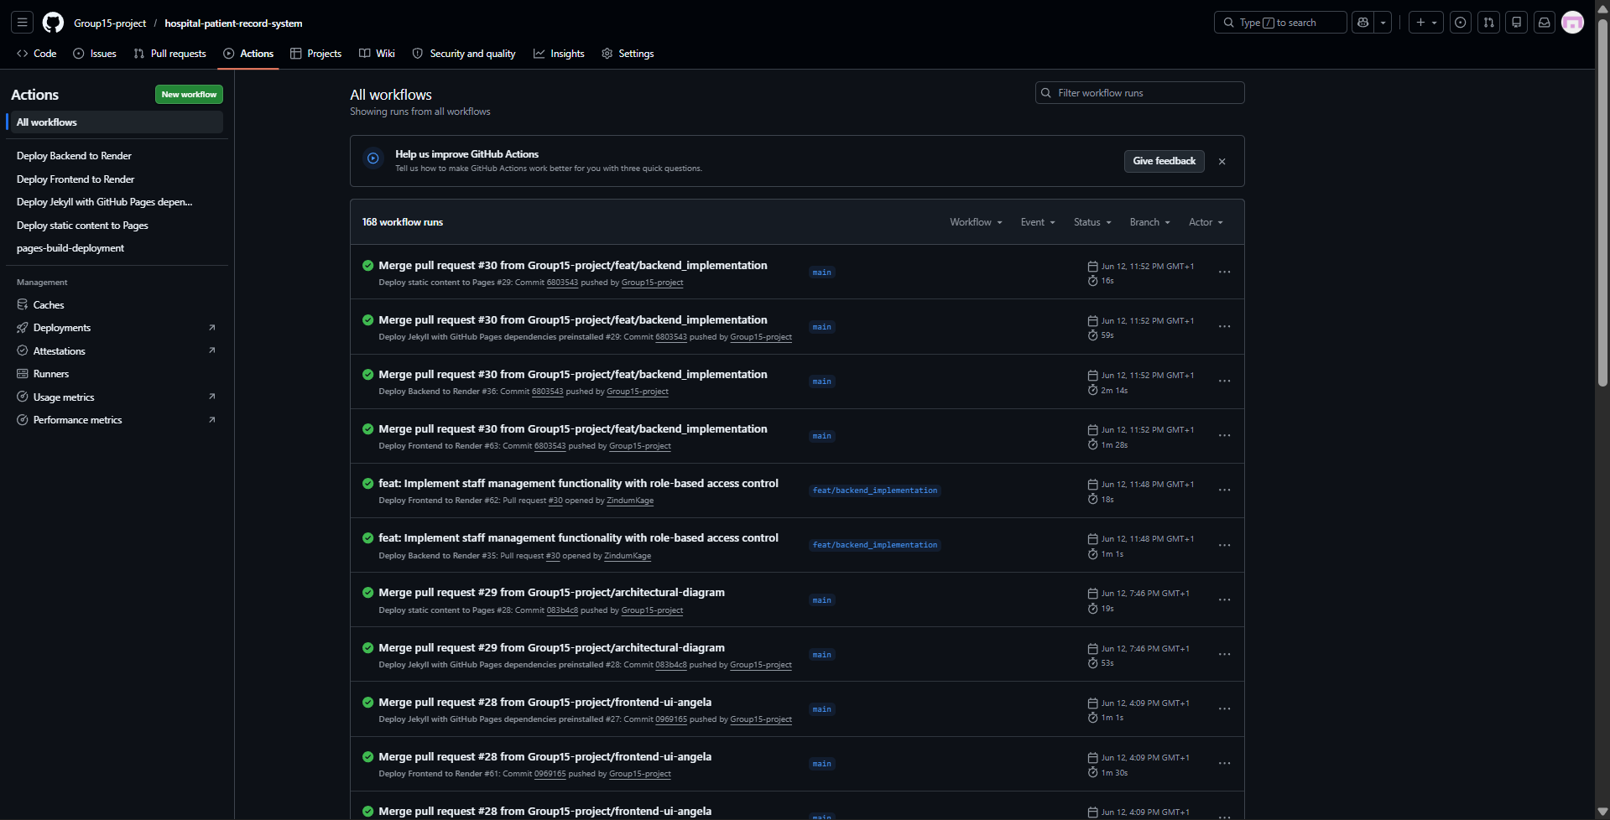

12.3 Environment Variables on Render
The following environment variables are configured in the Render dashboard for the backend service:
- DATABASE_URL — Full PostgreSQL connection string for the hosted database
- JWT_SECRET — Long random secret string for signing authentication tokens
- PORT — Set to 8080 to match the Golang server configuration
- ENV — Set to 'production' to enable production logging and error handling

13. Results & Success
The Hospital Patient Record Management System was completed on schedule and deployed to production with all planned features implemented and working. This section documents what was delivered, what was measured, and what the working system looks like.

13.1 What Was Delivered
- All 6 core modules fully implemented and accessible in production
- 15 RESTful API endpoints — all tested, documented, and live
- Role-based access control working correctly for all 4 user roles
- Automated CI/CD pipeline — the team has not made a single manual deployment
- Responsive design verified on iPhone, Android, tablet, and desktop
- Dark mode working across all pages with preference persisted between sessions
- Complete technical documentation including architecture, API reference, and setup guide

13.2 Performance Against Original Goals
Goal | Target | Achieved
Patient information retrieval time | Under 30 seconds | Under 5 seconds in testing
Appointment double-bookings | Zero | Zero — conflict detection working
User roles functional | 4 roles | 4 roles — all verified
Manual deployment steps | Zero | Zero — fully automated
API endpoints delivered | 10+ | 15 endpoints

13.3 The Moment It All Worked
The clearest measure of success was the first time a team member logged in as a Doctor, searched for a patient, opened their profile, and wrote a clinical note — all in one session, all talking to the live database on Render. Watching the full flow work end-to-end in production, after a series of building each piece in isolation, was the moment the project felt real.

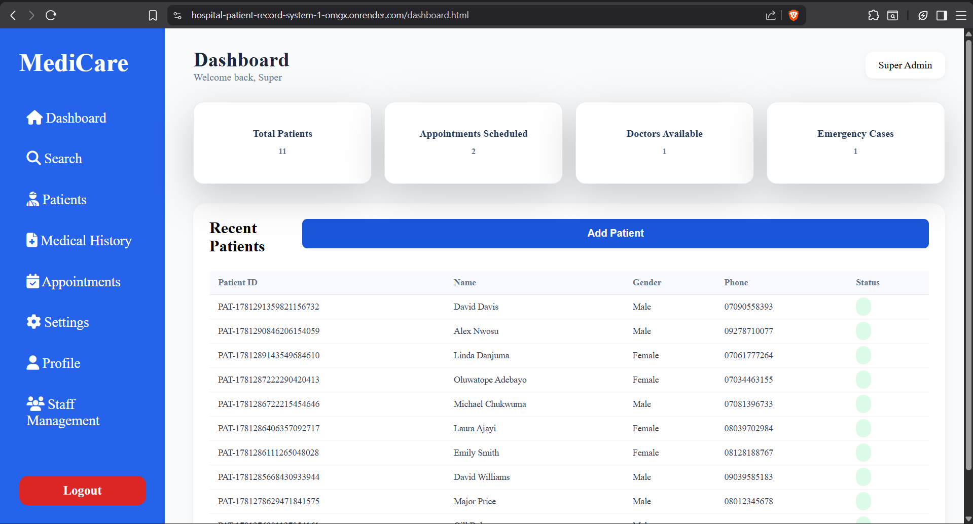
Live application — patient profile with doctor notes, on the production Render URL

14. Future Improvements
The current system is a strong, functional foundation. The following improvements represent what the team would build in a Phase 2, given more time and resources.

14.1 Short-Term (Next 3 Months)
- Real-time notifications using WebSockets, so doctors are instantly alerted when a new appointment is booked for them
- Automated SMS and email reminders sent to patients 24 hours before their appointment using Twilio or SendGrid
- Export functionality, generate a printable PDF summary of a patient's full medical history
- Advanced search, filter patients by diagnosis, allergy, or medication across the full database

14.2 Medium-Term (3–12 Months)
- Video consultation integration via the Zoom or Daily.co API, embedded directly in the appointment module
- Native mobile app using React Native, sharing the same Golang backend API
- AI-assisted diagnosis suggestions powered by OpenAI API, presented as non-binding prompts to doctors
- Audit logging, a tamper-proof record of every data access and modification for compliance purposes

14.3 Long-Term (18 – 24 Months):Scalability Enhancements
- Load balancing and horizontal scaling for high-traffic hospital deployments
- PostgreSQL read replicas to separate read-heavy analytics queries from write operations
- Redis caching layer for frequently accessed patient summaries and appointment lists
- Microservices refactoring — splitting the monolithic API into independently deployable services
- HIPAA and GDPR compliance audit to make the system suitable for regulated healthcare environments

15. Conclusion & Key Learnings
The Hospital Patient Record Management System is more than a working web application — it is evidence that Group 15 can operate as a professional software development team. From the initial architecture decisions through to the CI/CD pipeline running in production, every part of this project was built with real-world engineering standards in mind.

The project was not without its difficulties. The database schema confusion in the early stage of the project, the CI/CD pipeline failures, the cross-browser CSS bugs, these were all real setbacks that required real problem-solving. What they ultimately demonstrated was the team's ability to diagnose issues methodically and work through them without losing momentum.

The system is live, fully functional, and documented well enough for any developer to pick it up, understand it, and extend it. That was always the standard we held ourselves to, not just 'does it work?' but 'could someone else maintain this?’

Individual Key Learnings
[Backend Developer]
- Database schema design is worth slowing down for a wrong decision at that stage propagates everywhere
- Golang's strict type system and compiler errors, while sometimes frustrating, caught bugs that would have been silent in dynamically typed languages
- Parameterised SQL queries are non-negotiable — they are the baseline of backend security

[Frontend Developer]
- Mobile-first CSS development is far easier than retrofitting responsiveness to a desktop design
- Centralising API calls into a utility module eliminated a whole class of repetitive bugs
- Testing on real devices reveals issues that browser dev tools simply do not show

[DevOps Engineer]
- Reading the official documentation first would have saved hours on the CI/CD configuration
- Environment variables are not optional, hardcoded credentials in source code are a security incident waiting to happen
- Automated deployment is not a luxury, it removes human error from the most consequential step in the process

16. Appendices

16.1 Local Setup Instructions
Backend
- Clone the repository: git clone <repo-url>
- Navigate to backend: cd backend
- Copy environment file: cp .env.example .env and fill in your values
- Download Go modules: go mod download
- Run the server: go run main.go
- API available at: http://localhost:8080

Frontend
- Navigate to frontend: cd frontend
- Install dependencies: npm install
- Start dev server: npm run dev
- Open in browser: http://localhost:3000

Database
- Ensure PostgreSQL 15 is installed and running
- Create database: CREATE DATABASE hospital_records;
- Run migrations from backend/migrations/ in order
- Update DATABASE_URL in your .env file

16.2 Key Project Files
File / Path | Purpose
frontend/index.html | Application entry point, loads all JS modules and initialises routing
backend/main.go | Server entry point, registers all routes and starts the Gin HTTP server
backend/handlers/ | Directory containing one handler file per API module
backend/models/ | Database model structs and all SQL query functions
backend/middleware/auth.go | JWT validation and role-based permission middleware
.github/workflows/deploy.yml | GitHub Actions CI/CD pipeline configuration
backend/migrations/ | Ordered SQL migration scripts for database setup
README.md | Project overview, setup guide, and team contribution notes

16.3 References & Resources
- Golang Official Documentation — https://go.dev/doc
- Gin Web Framework Docs — https://gin-gonic.com/docs
- PostgreSQL 15 Documentation — https://www.postgresql.org/docs/15
- GitHub Actions Documentation — https://docs.github.com/en/actions
- Render Platform Docs — https://render.com/docs
- JWT Introduction — https://jwt.io/introduction
- MDN Web Docs (HTML/CSS/JS Reference) — https://developer.mozilla.org

