Calibrating and errors on a telescope:

Remember disclaimer to say we have not calibrated our pictures:

(Tom’s pictures and graphs that take into account earth’s atmosphere, as it will effect absorption bands)

(Tom’s curves needs to be added as well)

Need to calibrate the filters of the telescope against something with a known spectrum. We couldn’t have done this as the filters of the telescope does not work. This is the reason why we are supposed to find spectra on line, but we have not found any. Need to calibrate it to take into account that the filters won’t let thru the exact same amount of intensity as each other and ultimately give us reflectivity. Won’t need to calculate total intensity hitting the moon (Tom’s formula).

Mention Tony’s pictures where dust on the lens can clearly be seen.

Optical resolution:

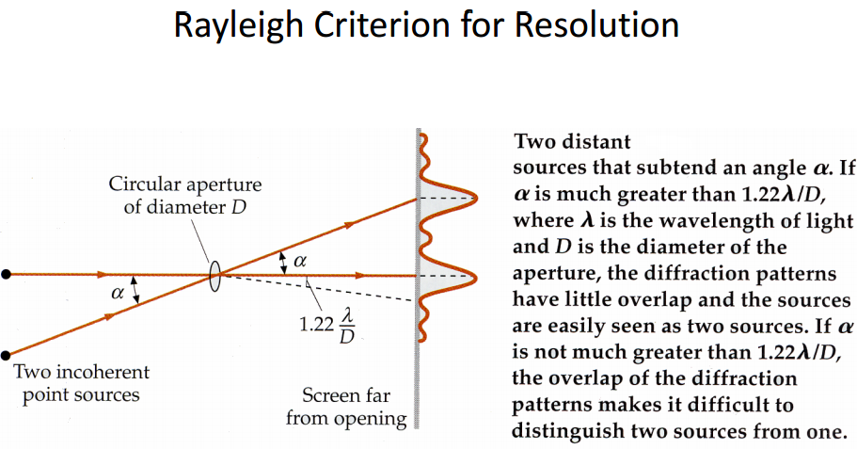

Vignette:

See if we can see examples of vignette in Tony’s pictures when putting them tougher like in example:

Example:

