UNIVERSITY OF BUEA

FACULTY OF ENGINEERING AND TECHNOLOGY
DERPARTMENT OF COMPUTER ENGINEERING
A REPORT ON INTERNET PROGRAMMING AND MOBILE APPLICATION

COURSE CODE: CEF 479
COURSE INSTUCTOR: Dr. NKEMENI VALERY
DEPARTMENT: COMPUTER ENGINEERING (SOFTWARE/NETWORK)

GROUP MEMBERS:

LEKEUGO DEMELIEU ROCHINEL | FE22A237
CHUYE PRINCELY | FE22A184
DIONE CHANCELINE NZUO SONE | FE22A187
ACHUO ESEGNI | FE22A135
MISHAEL ZABUD | FE22A248

Table of Contents
Types of Mobile Apps by Technology 5
1. Native Apps 5
2. Progressive Web Apps (PWAs) 6
3. Hybrid Apps 7
Types of Mobile Apps: How to Choose Just One 7
Decision Factor: I Need an App ASAP! 8
Decision Factor: My App Must Be Fast and Stable 8
B. Review and Comparison of Mobile App Programming Languages 8
E. STUDY OF HOW TO COLLECT AND ANALYSE USER REQUIREMENTS FOR A MOBILE APPLICATION (REQUIREMENT ENGINEERING) 19
1. WHAT IS REQUIREMENT ENGINEERING? 20
A. STEPS IN THE REQUIREMENT ENGINEERING PROCESS 20
B. TOOLS INVOLVED IN REQUIREMENT ENGINEERING 23
C. ADVANTAGES OF THE REQUIREMENT ENGINEERING PROCESS 24
D. DISADVANTAGES OF THE REQUIREMENT ENGINEERING PROCESS 24
• Importance of Understanding Mobile App Development Costs 24
1. Key Factors Affecting Mobile App Development Costs 24
Emerging Trends Influencing App Development Costs in 2025 25
• AI and Machine Learning Integration 25
• Blockchain and Decentralized Apps 25
• Internet of Things (IoT) Applications 25
I. Cost Breakdown by App Complexity 25
1. Simple Apps: Estimated Costs and Real-World Examples 25
2. Medium Complexity Apps: Estimated Costs and Real-World Examples 25
3. Complex Apps: Estimated Costs and Real-World Examples 25
II. Feature-Based Cost Estimation 26
• Breakdown of Costs by Feature Integration 26
1. User Authentication & Profiles 26
2. Push Notifications 26
3. Geolocation & Maps 26
4. Payment Gateway Integration 26
5. Chat/Messaging Features 26
6. Backend & Database Development 27
Impact of App Monetization Strategies on Development Costs 27
➢ In-App Advertising 27
➢ Subscription Models 27
➢ Freemium Models and In-App Purchases 28
Development and Maintenance Costs 28
➢ Initial Development Costs 28
➢ Maintenance Costs 29
➢ First-Year Maintenance Expenses 29
➢ Annual Maintenance Costs for Subsequent Years 29
Development Timeframes and Their Impact on Cost 29
Average Development Duration by App Type 29
Impact of Timeline on Budget 29
Regional Cost Comparison for Mobile App Development 30
North America vs. Europe vs. Asia 30
Advantages and Disadvantages of Offshore Development 30
Cost-Saving Strategies for Mobile App Development 30
Tips for Reducing App Development Price 30
Leveraging Offshore Development Teams: 31

6

Task 1
- To Review and Compare the Different Types of Mobile Apps and their Differences
Mobile apps come in various types, including native, hybrid, and web-based, each suited for different needs. This guide covers the different types of mobile apps and key factors to help you choose the right one.

Types of Mobile Apps by Technology
There are three basic types of mobile applications if we categorize them by the technology used to code them:

Native Apps
Native apps are built specifically for a mobile device’s operating system (OS). Thus, you can have native Android mobile apps or native iOS apps, not to mention all the other platforms and devices. Because they’re built for just one platform, you cannot mix and match – say, use an Android app on an iOS phone or an iOS app on an android phone.
Technology Used: Native apps are coded using platform-specific programming languages. For Android, these include Java and Kotlin and for iOS, they include Swift and Objective-C.

Advantages
- Because of their singular focus, native apps have the advantage of being faster and more reliable in terms of performance.
- They’re generally more efficient with the device’s resources than other types of mobile apps.
- Native apps utilize the native device UI, giving users a more optimized customer experience.
- And because native apps connect with the device’s hardware directly, they have access to a broad choice of device features like Bluetooth, phonebook contacts, camera roll, NFC, and more.

Disadvantages
- The problem with native apps lies in the fact that if you start developing them, you have to duplicate efforts for each of the different platforms. The code you create for one platform cannot be reused on another.
- This drives up costs, not to mention the effort needed to maintain and update the codebase for each version.
- Additionally, long development cycles and the need to go through app store review processes for updates can delay deployment.
- Native apps also take up space in the device’s storage.

Example of a Native App
WhatsApp is a prime example of a native app. It is built using platform-specific languages like Java for Android and Swift for iOS. This approach ensures optimal performance, seamless user experiences, and full access to device features like the camera, contacts, and push notifications, making it highly reliable and fast.
Other examples are Apple Music, Spotify, LinkedIn, Netflix, etc.

Progressive Web Apps (PWAs)
Progressive Web Apps (PWAs) deserve a special mention because they blend the best of web apps and some native app capabilities. They can be “installed” to a device’s home screen without needing to visit an app store, and they can work offline or under poor network conditions by caching data in the browser. PWAs also support push notifications, can synchronize in the background, and are generally lightweight. Some well-known examples include the Starbucks, Pinterest, Spotify (web player), Uber and Twitter Lite PWAs.
Technology Used: Like standard web apps, PWAs rely on common technologies such as HTML, CSS, and JavaScript, plus service workers and web app manifests. Service workers enable offline caching, background synchronization, and push notifications, while the web app manifest provides installability prompts for users.
Advantages:
- PWAs can support offline functionality and background sync, which allows them to keep working even under limited or no internet connection.
- There is no need for users to visit an app store to install them; they can be “installed” directly from the browser, offering a quick, seamless process.
- Because they run in the browser, they’re generally faster than standard web apps and can re-engage users with push notifications.
- Maintenance is easier than fully native apps since developers can push updates through the web without requiring users to install new versions.
Disadvantages:
- PWAs have limited access to certain device-specific features compared to fully native apps, although support for deeper integration continues to improve.
- Many users may be less familiar with “installing” apps outside an official store, which can affect adoption rates and overall visibility.

Example of a Progressive Web App
Pinterest is a notable example of a progressive web app. It provides a fast-loading, offline-capable experience built using web technologies like HTML, CSS, and JavaScript. Users can browse pins and boards seamlessly, even in low-network conditions.
Other examples of PWAs are Uber, Twitter Lite, Spotify (web player), etc

Hybrid Apps
And then there are the hybrid apps. These combine features of both native and web apps. They use web technologies like HTML5, CSS, and JavaScript but are wrapped in a native shell to allow access to platform-specific capabilities and app store distribution.
Technology Used: Hybrid apps are often developed using frameworks such as React Native, Flutter, or Ionic, which enable cross-platform compatibility.
Advantages:
- Building a hybrid app is much quicker and more economical than a native app. As such, a hybrid app can serve as a minimum viable product to test the market.
- They also load rapidly, are ideal for usage in countries with slower internet connections, and provide users with a consistent experience.
- Because they use a single codebase, there is much less code to maintain.
Disadvantages:
- Hybrid apps might lack power and speed compared to native apps.
- Performance issues can arise when handling complex graphics or heavy workloads.
- Additionally, while the single codebase reduces initial costs, optimizing hybrid apps for seamless performance across multiple platforms may require additional development effort and resources.

Example of a Hybrid App
Instagram uses a hybrid approach to deliver a seamless and consistent user experience across multiple platforms, combining web technologies and native features. This allows Instagram to leverage shared backend components for efficiency while ensuring smooth performance. This approach enables faster development and easier updates while maintaining high functionality and reliability for its users.
Other examples are Facebook (partly hybrid), Alibaba, Google pay, etc.

Types of Mobile Apps: How to Choose Just One
While developing an app, decisions are been made about which type of app is to be created. There will be certain factors that are ideal only for one type of app and not for others.
The following decision factors answer: what is the single most important factor for the best decision today? The answer will dictate which type to focus on NOW.

Decision Factor: I Need an App ASAP!
If you absolutely must have an app in the shortest amount of time possible, then you need to invest in building a web app or PWA. Not only will one codebase drastically speed up development time, but it will also mean that your users already have what they need to use it: a mobile browser.
Decision Factor: I Have Limited Resources
If time and money are not on your side, then consider either a PWA, or hybrid app. The hybrid app gives you a chance to test the market with a minimum viable product that can be in the hands of users within a few months.

Decision Factor: My App Must Be Fast and Stable
If performance is of the utmost importance, then there’s no way around it: you need to develop a native app. This type of app will give you the speed, stability, and customization features you deem crucial to your success.
In the end, choosing which type of mobile app you will build is not a one time decision. You can always choose to build another type down the road, depending on the user’s needs. And once you do finally build it, make sure to monitor the metrics that matter for the actual growth of the brand.

B. Review and Comparison of Mobile App Programming Languages

Mobile app development involves choosing a programming language based on the platform, performance requirements, development speed, and ecosystem support. Below is a review and comparison of the most common mobile app programming languages.

Native App Languages

1. Java
This language was a favorite for creating apps on the Android platform. It’s still one of the most widely used languages today, with a lot of legacy software having been written in Java.
Advantages:
- Well suited for large, complex tasks.
- There is an extensive amount of resources and libraries available, so it’s unusual for a developer to have to create new code in problem-solving.
Disadvantages:
- It takes longer to write code for lightweight, quick tasks.
- Has some outstanding inefficiencies, which have been solved by other languages like Kotlin.
2. Swift
Swift is a native language for iOS. It has surpassed Objective-C, which was Apple’s previous choice of coding languages. Designed specifically for iOS, it makes it easy and convenient to develop software for Apple devices.
Advantages:
- Easy to read as a language.
- Due to its interactive nature, Swift makes it simpler to catch errors while coding, thus saving overall development and debugging time.
- Swift provides a great user experience and often requires less on-device memory.
Disadvantages:
- Apple products work great within the Apple ecosystem. However, compatibility with other operating systems remains an issue. An app written in Swift doesn’t translate as easily to Android and other platforms.

3. Kotlin
This codebase has become the new preferred language for Android development. Though relatively new, we can only expect to see more mobile apps coded in this programming language.
Advantages:
- This language is interoperable with Java, making it easy for all Java-based programming to be expanded upon and improved with Kotlin.
- It provides native-level support while still running on multiple platforms.
Disadvantages:
- Since Kotlin is a newer language, there can be less information and limited resources on it. This makes it tricky when developing and problem-solving.

4. Objective-C
Before Swift, iOS software was written in Objective-C. It’s fallen out of fashion with new development, which favors Swift. But there is a lot of remaining software that was created in Objective-C and still runs today.
Advantages:
- Works incredibly well within the Apple ecosystem and supports older versions of iOS.
- Its maturity as a language has created a wealth of resources for it.
Disadvantags:
- Some inadequacies remain that are fixed in newer languages like Swift.
- Though the age of Objective-C is a plus, it is also a weakness, as it’s less secure than newer versions and some apps built in Objective-C are more vulnerable to attack.
Cross-Platform/Hybrid Languages

5. C# and Xamarin
Pronounced “C Sharp,” this language is a great option with native support for Android app development. Initially, a drawback was that it could only run on Windows systems, but with the invention of the cross-platform framework Xamarin, C# can now run on any platform.
Advantages:
- It provides a near-native level of performance and speed on iOS and Android.
- C# Xamarin has simplified maintenance, which helps in minimizing continuing development hours.
Disadvantages:
- There can be a comparative lag in API calls
- It’s not a great choice for apps with a complex UI

6. Dart and Flutter
Flutter isn’t technically a language, but a cross-platform app framework developed by Google. The language powering Flutter is Dart. Flutter is quickly gaining popularity as a framework, as it allows the developer to write code once and have it deployed on multiple platforms. Therefore, the importance of knowing Dart is also on the rise.
Advantages:
- The programming language can be shared across mobile apps and web-apps.
- Mobile apps can be launched across platforms quickly.
- Flutter provides a smooth, near-native user experience that is often only enjoyed by native apps.
Disadvantages:
- There is less backend support in comparison to other established languages.
- There are fewer language packages available, which can mean more time spent in creating them from scratch for some applications.

7. JavaScript and React Native
JavaScript is one of the older programming languages still commonly used, so it is time tested. React Native is a cross-platform codebase that works with it, which supports both frontend and backend development and has a large community of developers behind it.
Advantages:
- Its longtime use means there are a lot of frameworks, patches, and support available.
- It is the basis for some cross-network coding languages, like React Native, which is growing in popularity.
- JavaScript delivers very fast results.
Disadvantages:
- Since the code is viewable by the client, it’s not as secure as other languages and more open to malicious attacks. Although, this isn’t so much of an issue on a mobile app as it is on a website.
Mobile Web-Apps Languages

8. Python
Python is one of the most popular languages, as it’s a general-purpose language that powers many versatile purposes. The cross-platform codebase uses the framework Kivy for app development.
Advantages:
- There are a ton of libraries and toolkits that support Python – especially for big data and researchers.
- Python is a very readable language and many developers know how to use it, so it’s easy to hire someone who specializes in it.
Disadvantages:
- It doesn’t perform well in some high-performance specialized tasks.
- Python isn’t native to either iOS or Android, so for mobile app deployment specifically, it can cause some cross-platform inconsistencies.

9. Rust
This programming language is similar to C++. It’s great when you’re developing under time constraints and looking for something to go cross-platform, as it can feed into Flutter with an FFI (foreign function interface).
Advantages:
- It allows developers to discover errors during the time of compilation, often resulting in more quality code.
- It is a memory efficient language, designed as well for performance and safety.
Disadvantages:
- Difficult to install and run on Windows operating systems.
- Rust can be comparatively slow during compiling.

10. Golang
More commonly this language is simply called “GO.” Stemming from Google, the designers wanted to make a programming language that created applications quickly and easily. By using its compiler “Gobuild” and its binding system “Gobind,” the GO language can be translated to work with other languages and on all platform interfaces.
Advantages:
- It’s more secure than many other languages.
- Go prioritizes speed and is, therefore, a very fast language.
Disadvantages:
- A complex program written in this language can be less efficient.
- Though efficient in its simplicity, it makes calling complicated code written in other languages tricky, so integration can become slow.

11. C++
Pronounced “C Plus Plus,” this language improved upon any inefficiencies in the older, yet popular language “C.” It’s very adaptable, in that a developer can write the code once, then run C++ on any platform that has a compiler for the language. It can become a cross-platform codebase by using Microsoft’s tools in Visual Studio.
Advantages:
- It’s an incredibly powerful language, which has built impressive programs like Google Chrome, Photoshop, and PayPal. It exists in sectors ranging from banking to VR.
- C++ can run the same program on different operating systems and interfaces, even if the original code isn’t supported.
- It optimizes memory storage and can deliver very fast results.
Disadvantages:
- It is a very complicated language to learn. If a developer is not proficient in the app language, it can result in more errors as C++ isn’t as forgiving as other languages.
- There is no garbage collection. Depending on your opinion, this is either a pro or a con. But it means that memory is not automatically being managed by the application.

C. Mobile App Development Frameworks Comparison
Frameworks are pre-built components such as libraries, tools, and interfaces, which accelerate the development process and ensure consistency across different projects.
1. Review of Frameworks
Framework | Best Known For
React Native | Building apps that feel like native ones, using code that works on both iOS and Android. Fast development process.
Flutter | Creating beautiful and high-performance apps with customizable designs. Good for complex graphics and animations.
Ionic | Quickly developing simple apps using familiar web technologies. Good for apps that don't require heavy graphics.
Xamarin | Letting developers build apps that look and feel native using Microsoft tools. Great for businesses already using Microsoft technology.
NativeScript | Ensuring high performance and native look by using real native components. Ideal for apps that need a smooth, native experience.

2. Detailed Comparison
Framework/  Feature | React Native | Flutter | Ionic | Xamarin | NativeScript
Performance | Good, uses native components but slower than Flutter due to JavaScript bridge. | Excellent, compiles to native code for high speed. | Moderate, performance limited by WebView rendering. | Good, native-like but can be slower than others. | Excellent, compiles to native code for high performance.
Programming Language | JavaScript (with JSX), familiar but may have a learning curve. | Dart, user-friendly but less common. | HTML, CSS, JavaScript, very accessible for web developers | C#, popular in enterprise but may have a steep learning curve. | JavaScript or TypeScript, flexible and familiar for many developers.
Cost & Time to Market | Open-source and free; fast development with reusable components. | Open-source and free; very fast development due to hot reload feature. | Open-source with some premium features at a cost; quick assembly of simple apps, although performance may hinder complex projects. | Free with options for paid enterprise features; slower development due to complexity. | Completely open-source and free; fast development benefiting from hot-reloading and plugins.
UI and UX | Decent UI capabilities with extra work needed for native adherence. | Excellent customization and visually appealing designs. | Good UI but less native feel due to WebView usage | Good consistency but may lack true native aesthetics. | Excellent native feel with direct component access.
Complexity | Moderate complexity, manageable for those familiar with JavaScript. | Moderate to high complexity with a learning curve for Dart. | Low to moderate complexity, easier for web developers. | Moderate to high complexity requiring C# and .NET knowledge | Moderate complexity, approachable for JavaScript developers.
Community Support | Large and active community with abundant resources. | Growing community, rapidly expanding support. | Established community among web developers, but less focused on mobile. | Established community among web developers, but less focused on mobile. | Established community among web developers, but less focused on mobile.
Use Cases | Great for social media, e-commerce, and interactive applications. | Best for visually rich apps, mobile games, and multimedia applications. | Ideal for informational apps and simple business tools. | Suitable for enterprise applications requiring rich features. | Ideal for apps needing rich features and native performance.

Other Notable Frameworks:
- Apache Cordova (PhoneGap)
- Appcelerator (Titanium)
- Sencha Touch
- Framework7
D. Mobile Architecture and Pattern
I.Mobile Application Architecture
II.Mobile Application design Pattern

I. Mobile Application Architecture
Definition
Mobile app architecture: is the blueprint of building an application. It define how components interact to process input and deliver output, ensuring well-structured scalable, and maintainable application.
According to Ralph johnso. “Architecture is about the importance stuff whatever that is”.

Purpose
the architecture of an application ensure that every component functions as a whole, is scalable and can be effectively maintained.
A well-defined architecture is crucial for building a successful mobile application that meets the user expectation and remains successful in the long run.

Example of Architecture Patterns
MVC (Model-View-Controller): is the pattern for separating concerns, where the Model handles data, the view display it, and the controller manages user interaction.

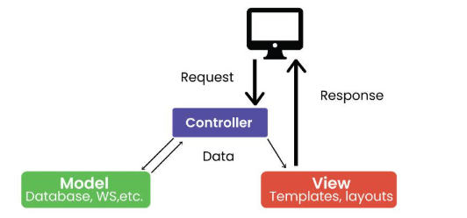

MVVM(Model-View-ViewModel) is the patten that promotes a clear separation of concerns, making the code base easier to understand, test, and
modify

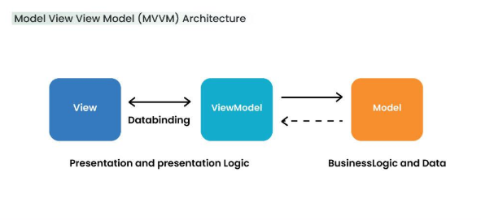
Considerations
Scalability: The architecture should be able to handle increasing users base and data volume.
Maintainability: The architecture should be easy to update, debug, and modify.
Performance: The architecture should ensure a smooth and responsive user experience.
Security: The architecture should protect user data and prevent vulnerabilities.
Etc…
II. Mobile Application design Pattern
Type of architecture design Pattern:
1.layers Architecture:
the design of layered architecture consists of three core layers (Presentation layers(UI/UX), Business
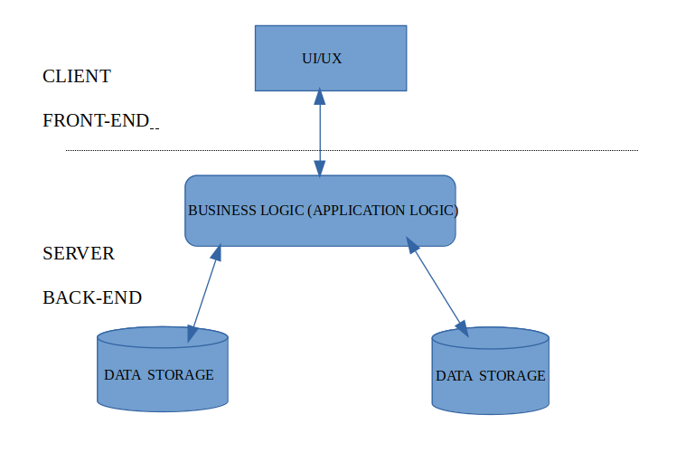
Logic(application logic), and data access and storage).
example of layers Architecture:
=> web application using the Model-view-controller (MVC) pattern.
2.micro services architecture:
is based on the principles of decentralization and modularity. It also allows for the development of complex and scalable mobile application that can be easily maintained. Here is an example of micro services architecture for a simple system
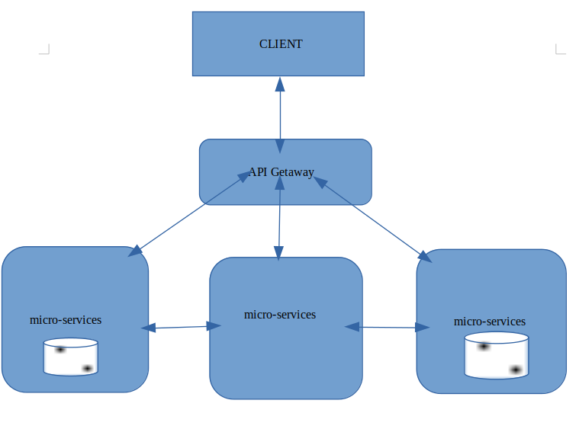
3-event-drive-architecture:
event-driven architecture is the approach that revolves around asynchronous communication between loosely couple components in a system. It has threes primary building blocks: events, event producers, and event consumer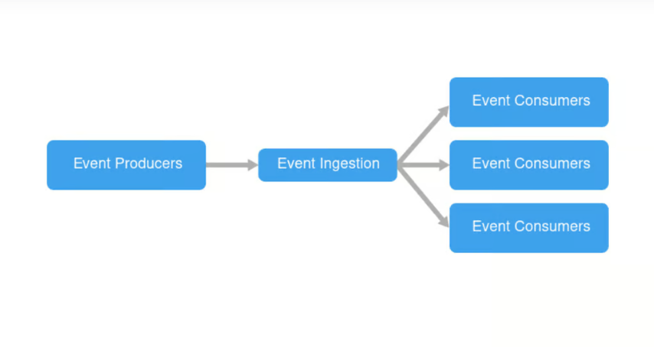 e
The diagram above show an example of event-driven architecture.

4-monolithic architecture:
is a singular, large computer network with one code base that couples all of the business concerns together. And some application like Netflix Uber, WhatssApp and Facebook they all start with monolith architecture.

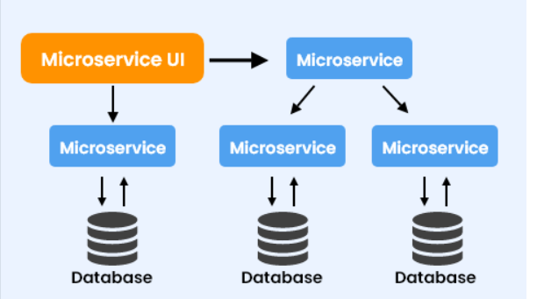

E. STUDY OF HOW TO COLLECT AND ANALYSE USER REQUIREMENTS FOR A MOBILE APPLICATION (REQUIREMENT ENGINEERING)

WHAT IS REQUIREMENT ENGINEERING?
Requirement Engineering is defined as the process of formalizing and defining needs at each stage of system design, including customer requirements, design requirements, and testing requirements. It focuses on identifying, tracing, and characterizing these needs to ensure their implementation and impact are clearly understood.
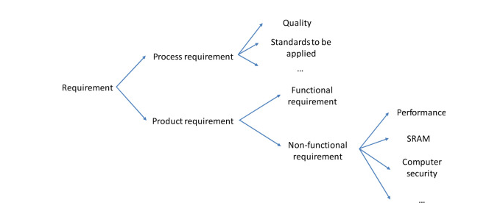

Fig. Breakdown of requirement engineering

STEPS IN THE REQUIREMENT ENGINEERING PROCESS

FEASIBILITY STUDY
The feasibility study mainly concentrates on below five mentioned areas below. Among these Economic Feasibility Study is the most important part of the feasibility analysis and the Legal Feasibility Study is less considered feasibility analysis.
- Technical Feasibility: In Technical Feasibility, current resources, both hardware and software along required technology are analyzed/assessed to develop the project. This technical feasibility study reports whether there are correct required resources and technologies that will be used for project development. Along with this, the feasibility study also analyzes the technical skills and capabilities of the technical team, whether existing technology can be used or not, whether maintenance and up-gradation are easy or not for the chosen technology, etc.
- Operational Feasibility: In Operational Feasibility degree of providing service to requirements is analyzed along with how easy the product will be to operate and maintain after deployment. Along with these other operational scopes are determining the usability of the product, Determining suggested solution by the software development team is acceptable or not, etc.
- Economic Feasibility: In the Economic Feasibility study cost and benefit of the project are analyzed. This means under this feasibility study a detailed analysis is carried out will be cost of the project for development which includes all required costs for final development hardware and software resources required, design and development costs operational costs, and so on. After that, it is analyzed whether the project will be beneficial in terms of finance for the organization or not.
- Legal Feasibility: In legal feasibility, the project is ensured to comply with all relevant laws, regulations, and standards. It identifies any legal constraints that could impact the project and reviews existing contracts and agreements to assess their effect on the project’s execution. Additionally, legal feasibility considers issues related to intellectual property, such as patents and copyrights, to safeguard the project’s innovation and originality.
- Schedule Feasibility: In schedule feasibility, the project timeline is evaluated to determine if it is realistic and achievable. Significant milestones are identified, and deadlines are established to track progress effectively. Resource availability is assessed to ensure that the necessary resources are accessible to meet the project schedule. Furthermore, any time constraints that might affect project delivery are considered to ensure timely completion. This focus on schedule feasibility is crucial for the successful planning and execution of a project.

REQUIREMENT ELICITATION
It is related to the various ways used to gain knowledge about the project domain and requirements. The various sources of domain knowledge include customers, business manuals, the existing software of the same type, standards, and other stakeholders of the project. The techniques used for requirements elicitation include interviews, brainstorming, task analysis, Delphi technique, prototyping, etc. Elicitation does not produce formal models of the requirements understood. Instead, it widens the domain knowledge of the analyst and thus helps in providing input to the next stage.
Requirements elicitation is the process of gathering information about the needs and expectations of stakeholders for a software system. This is the first step in the requirements engineering process and it is critical to the success of the software development project. The goal of this step is to understand the problem that the software system is intended to solve and the needs and expectations of the stakeholders who will use the system.
Several techniques can be used to elicit requirements, including:
- Interviews: These are one-on-one conversations with stakeholders to gather information about their needs and expectations.
- Surveys: These are questionnaires that are distributed to stakeholders to gather information about their needs and expectations.
- Focus Groups: These are small groups of stakeholders who are brought together to discuss their needs and expectations for the software system.
- Observation: This technique involves observing the stakeholders in their work environment to gather information about their needs and expectations.
- Prototyping: This technique involves creating a working model of the software system, which can be used to gather feedback from stakeholders and to validate requirements.
It’s important to document, organize, and prioritize the requirements obtained from all these techniques to ensure that they are complete, consistent, and accurate.
- REQUIREMENT SPECIFICATION
This activity is used to produce formal software requirement models. All the requirements including the functional as well as the non-functional requirements and the constraints are specified by these models in totality. During specification, more knowledge about the problem may be required which can again trigger the elicitation process. The models used at this stage include ER diagrams, data flow diagrams (DFDs), function decomposition diagrams (FDDs), data dictionaries, etc.
Requirements specification is the process of documenting the requirements identified in the analysis step in a clear, consistent, and unambiguous manner. This step also involves prioritizing and grouping the requirements into manageable chunks.
The goal of this step is to create a clear and comprehensive document that describes the requirements for the software system. This document should be understandable by both the development team and the stakeholders.
Several types of requirements are commonly specified in this step, including
- Functional Requirements: These describe what the software system should do. They specify the functionality that the system must provide, such as input validation, data storage, and user interface.
- Non-Functional Requirements: These describe how well the software system should do it. They specify the quality attributes of the system, such as performance, reliability, usability, and security.
- Constraints: These describe any limitations or restrictions that must be considered when developing the software system.
- Acceptance Criteria: These describe the conditions that must be met for the software system to be considered complete and ready for release.
To make the requirements specification clear, the requirements should be written in a natural language and use simple terms, avoiding technical jargon, and using a consistent format throughout the document. It is also important to use diagrams, models, and other visual aids to help communicate the requirements effectively.
Once the requirements are specified, they must be reviewed and validated by the stakeholders and development team to ensure that they are complete, consistent, and accurate.

REQUIREMENT VERIFICATION AND VALIDATION
Verification: It refers to the set of tasks that ensures that the software correctly implements a specific function.
Validation: It refers to a different set of tasks that ensures that the software that has been built is traceable to customer requirements. If requirements are not validated, errors in the requirement definitions would propagate to the successive stages resulting in a lot of modification and rework. The main steps for this process include:
- The requirements should be consistent with all the other requirements i.e. no two requirements should conflict with each other.
- The requirements should be complete in every sense.
- The requirements should be practically achievable.
Reviews, buddy checks, making test cases, etc. are some of the methods used for this.

Requirements verification and validation (V&V) is the process of checking that the requirements for a software system are complete, consistent, and accurate and that they meet the needs and expectations of the stakeholders. The goal of V&V is to ensure that the software system being developed meets the requirements and that it is developed on time, within budget, and to the required quality.

- Verification is checking that the requirements are complete, consistent, and accurate. It involves reviewing the requirements to ensure that they are clear, testable, and free of errors and inconsistencies. T
- Validation is the process of checking that the requirements meet the needs and expectations of the stakeholders. It involves testing the requirements to ensure that they are valid and that the software system being developed will meet the needs of the stakeholders. This can include testing the software system through simulation, testing with prototypes, and testing with the final version of the software.
- Verification and Validation is an iterative process that occurs throughout the software development life cycle. It is important to involve stakeholders and the development team in the V&V process to ensure that the requirements are thoroughly reviewed and tested.
It’s important to note that V&V is not a one-time process, but it should be integrated and continue throughout the software development process and even in the maintenance stage.

REQUIREMENT MANAGEMENT
Requirement management is the process of analyzing, documenting, tracking, prioritizing, and agreeing on the requirement and controlling the communication with relevant stakeholders. This stage takes care of the changing nature of requirements. It should be ensured that the SRS is as modifiable as possible to incorporate changes in requirements specified by the end users at later stages too.
Several key activities are involved in requirements management, including:
1.Tracking and controlling changes
2.Version control
3.Trace-ability
4.Communication
5.Monitoring and reporting
Requirements management is a critical step in the software development life cycle as it helps to ensure that the software system being developed meets the needs and expectations of stakeholders and that it is developed on time, within budget, and to the required quality.

TOOLS INVOLVED IN REQUIREMENT ENGINEERING
- Observation report
- Questionnaire (survey, poll)
- Use cases
- User stories
- Requirement workshop
- Mind mapping
- Roleplaying
- Prototyping

ADVANTAGES OF THE REQUIREMENT ENGINEERING PROCESS
- Helps ensure that the software being developed meets the needs and expectations of the stakeholders
- Can help identify potential issues or problems early in the development process, allowing for adjustments to be made before significant
- Helps ensure that the software is developed in a cost-effective and efficient manner
- Can improve communication and collaboration between the development team and stakeholders
- Helps to ensure that the software system meets the needs of all stakeholders.

DISADVANTAGES OF THE REQUIREMENT ENGINEERING PROCESS
- Can be time-consuming and costly, particularly if the requirements-gathering process is not well-managed
- Can be difficult to ensure that all stakeholders’ needs and expectations are taken into account
- It Can be challenging to ensure that the requirements are clear, consistent, and complete
- Changes in requirements can lead to delays and increased costs in the development process.

https://www.geeksforgeeks.org/software-engineering-requirements-engineering-process/

F. How to Estimate Mobile App Development Cost
In 2025, mobile apps remain vital for businesses to connect with customers, enhance operations, and drive growth.
In this comprehensive guide, we examine the key components determining the price of mobile app development and explore how businesses can effectively plan their budgets.

Importance of Understanding Mobile App Development Costs
- Businesses must clearly understand mobile app development costs to allocate resources efficiently and avoid unexpected expenses.
- It enables companies to set realistic expectations, prioritize features, and achieve their desired outcomes without exceeding budgets.

Key Factors Affecting Mobile App Development Costs

Emerging Trends Influencing App Development Costs in 2025
Staying updated on industry trends is essential for companies to anticipate shifts in development costs. Here are some key trends shaping the landscape in 2025:

AI and Machine Learning Integration
- AI and machine learning are increasingly common, enabling features like predictive analytics, chatbots, and personalization.
- These advanced technologies add significant value and increase development costs due to their complexity and need for specialized expertise.

Blockchain and Decentralized Apps
Blockchain technology powers secure and transparent transactions, while decentralized apps (dApps) provide innovative solutions across industries. Implementing blockchain increases costs due to the development complexity and the demand for skilled developers.

Internet of Things (IoT) Applications
IoT-enabled apps are becoming more prevalent in healthcare, smart homes, and logistics sectors.
However, developing apps that interact with IoT devices requires integrating with hardware and specialized APIs, which increases costs.

Cost Breakdown by App Complexity
Understanding the cost range for various app complexities helps businesses budget effectively. Below is a detailed breakdown:

Simple Apps: Estimated Costs and Real-World Examples
Simple apps typically cost between $10,000(6,080,000FCFA) and $50,000(30,400,000FCFA). Real-world examples include unit converters, tip calculators, and essential to-do lists. Their limited features and straightforward functionality keep development costs low.

Medium Complexity Apps: Estimated Costs and Real-World Examples
Apps of medium complexity cost between $50,000(30,400,000FCFA) and $100,000(60,800,000FCFA). Examples include apps with user authentication, data storage, or integration with third-party APIs, such as fitness trackers or restaurant booking platforms.

Complex Apps: Estimated Costs and Real-World Examples
Complex apps often cost $100,000(60,800,000FCFA) or more. These include feature-rich platforms like e-commerce marketplaces (e.g., Amazon), social media networks (e.g., Instagram), or on-demand service apps (e.g., Uber). Integrating advanced functionalities, real-time updates, and multiple APIs drives up costs.

Feature-Based Cost Estimation
When estimating the cost of app development, it’s essential to consider the features that will be integrated. Each feature can vary in complexity and impact the project’s overall cost.

Breakdown of Costs by Feature Integration

1. User Authentication & Profiles
Secure authentication and personalized user profiles are critical for ensuring a smooth user experience. This involves building a safe system to manage passwords, third-party login (e.g., Google, Facebook), and potentially multi-factor authentication (MFA).
The integration cost can range from $2,000(1,216,000FCFA)
to $5,000, depending on the solution’s chosen security features and scalability.

2. Push Notifications
Push notifications are essential for maintaining user engagement, providing real-time updates, and encouraging users to return to the app.
Essential integration using tools like Firebase can be inexpensive, but fully customizing notifications (e.g., location-based or in-app behavior-based) can increase development time and cost. Expect costs between $1,000 and $3,000.

3. Geolocation & Maps
Integrating geolocation features can significantly enhance an app, especially for navigation, delivery, or location-based recommendations.
Mapping features, particularly real-time location tracking and routing, require integration with APIs like Google Maps or Mapbox.
Depending on its complexity, such as custom map designs or integration with other services (e.g., ride-sharing), a full-fledged geolocation feature can cost between $3,000 and $10,000.

4. Payment Gateway Integration
Payment gateway integration is fundamental for apps that process credit card payments, subscriptions, or in-app purchases.
The cost of setting up secure and scalable payment solutions can range from $3,000 to $7,000, and it can increase depending on factors such as recurring billing, fraud prevention, and custom integrations for regional payment systems.

5. Chat/Messaging Features
Integrating chat functionality can be complex for apps that require real-time messaging or communication. Suppose the feature is simple one-on-one messaging.
In that case, costs may be lower, but adding capabilities such as group chats, file sharing, or media-rich communication (voice, video) can drive up costs.
Expect chat systems to cost between $5,000 and $15,000, especially if using third-party services like Firebase or custom-built solutions for scalability.

6. Backend & Database Development
The backend infrastructure forms the app’s foundation and manages everything from user data to in-app purchases and notifications.
A scalable, secure backend is necessary for performance and reliability. Depending on the app’s requirements (e.g., cloud integration, data management, and real-time updates), backend development can cost between $10,000 and $50,000+.

Impact of App Monetization Strategies on Development Costs
Monetization is essential to app development, directly affecting revenue generation. However, the choice of monetization model also influences the complexity and costs of development.
Here’s how various monetization strategies impact app development:

In-App Advertising
Incorporating ads into the app through network-based ad services like AdMob or custom implementations can be a quick way to start generating revenue.
However, balancing ad placement with the user experience requires fine-tuning to avoid intrusive interruptions.
Ads should feel like a natural part of the app and not detract from its primary purpose. Expect integration costs for ads to be around $2,000 to $5,000.
The cost depends on the complexity of ad integration, whether banner ads, interstitial ads, or video ads are displayed.
Optimizing the ad experience also requires testing and adjustments to ensure it adds value rather than alienates users.

Subscription Models
A subscription model is popular for apps that deliver premium content or services (e.g., media streaming educational platforms like Spotify).
This model requires a more complex backend system for user management, recurring billing, and content access control.
Integrating subscription models like Apple In-App Subscriptions or Google Play Billing adds a layer of development, which, depending on the level of customization, can cost between $5,000 and $15,000.
Beyond payment systems, subscription models often require integration with authentication services to manage free trials, paid tiers, and content restrictions. The added complexity of this system usually translates into higher development costs.

Freemium Models and In-App Purchases
Freemium models—where basic features are free, but users can purchase advanced features or items—are popular in mobile games and productivity apps.
In-app purchases (IAP) require integrating payment solutions to manage one-time purchases and recurring billing for premium features.
Development costs for this feature typically range from $5,000 to $20,000, as it involves both frontend and backend work to ensure a smooth purchase flow.
Additional complexity comes with handling virtual currencies and digital goods and managing access to premium content or features that users unlock by purchasing.
Ensuring seamless and secure transactions, combined with custom interfaces for IAP, increases development time and costs.

Development and Maintenance Costs
Understanding the initial development and ongoing maintenance costs is crucial for planning a mobile app’s lifecycle.
While the development phase may receive most of the attention, maintenance is an ongoing, recurring cost ensuring the app remains functional, secure, and current. Here’s a breakdown of the costs involved:

Initial Development Costs
The initial development phase is the most significant expense for any mobile app. It involves all the processes from ideation and planning to coding, testing, and launching the app.
Costs vary greatly depending on the app’s complexity, the number of features, and the platform(s) for which it will be developed. Typically, initial development costs range from $50,000 to $250,000+.
This includes all app-building aspects, including design, coding, testing, and deployment. The development team’s expertise, geographic location, and any needed third-party integrations will also influence the final price.

Maintenance Costs
Once the app is launched, ongoing maintenance is essential to keep it running smoothly. Maintenance includes regular updates, bug fixes, improvements to functionality, server management, and adapting to changes in mobile operating systems.
These costs are usually significantly lower than the initial development but can still add up.

First-Year Maintenance Expenses
Maintenance expenses are higher during the first year, as the app will likely require updates to fix bugs, adjust to feedback, and ensure compatibility with the latest OS versions. First-year maintenance can range from 15% to 25% of the initial development cost.
For instance, if your initial development cost was $100,000, you can expect to pay between $15,000 to $25,000 in the first year for maintenance. This includes updates, bug fixes, security patches, and minor feature tweaks.

Annual Maintenance Costs for Subsequent Years
After the first year, maintenance costs typically decrease as significant updates and fixes are less frequent.
However, your app will require ongoing support to remain functional and competitive. Annual maintenance costs in the subsequent years usually range from 10% to 20% of the initial development cost.
If your app initially costs $100,000 to develop, you can expect to pay between $10,000 to $20,000 annually for ongoing maintenance.
These costs help ensure the app continues to operate efficiently, update with new features, and stay secure from vulnerabilities.

Development Timeframes and Their Impact on Cost
The development timeline directly influences the overall cost, with longer projects increasing costs due to additional labor and resources. Here’s a breakdown of typical timeframes and how they impact the budget:

Average Development Duration by App Type
- Simple Apps (e.g., informational apps): 2 to 4 months
- Medium Complexity Apps (e.g., fitness, educational apps): 4 to 8 months
- Complex Apps (e.g., e-commerce, social networks): 8 to 16 months
- Enterprise Apps (e.g., business apps): 12 to 24 months+

Impact of Timeline on Budget
- Shorter Timelines (2-4 months): Faster development may increase costs by 10% to 30% due to resource prioritization and overtime.
- Standard Timelines (6-12 months): More predictable and cost-effective, with minimal extra charges.
- Longer Timelines (12+ months): Extended timelines can raise costs by 20% to 40% due to prolonged labour and potential delays.

Regional Cost Comparison for Mobile App Development
The cost of developing a mobile app can vary significantly depending on the region where the development team is based. Factors such as labour rates, expertise, and market demand influence pricing, and understanding these differences helps make informed decisions.

North America vs. Europe vs. Asia
- North America: Development costs in the U.S. and Canada are among the highest, ranging from $150 to $300+ per hour due to the high demand for skilled developers and the overall cost of living.
- Europe: In Western Europe, rates range from $70 to $200 per hour, while Eastern Europe offers lower rates, typically between $40 and $100 per hour. Western European developers often offer high quality, while Eastern European developers provide competitive rates.
- Asia: Countries like India, China, and the Philippines offer the most affordable development costs, typically ranging from $20 to $80 per hour. While the rates are lower, the quality can vary depending on the team’s expertise.

Advantages and Disadvantages of Offshore Development
- Advantages: Offshore development can significantly reduce costs, especially when outsourcing to countries like India or Vietnam. It also offers access to a broad talent pool and allows for round-the-clock work with different time zones.
- Disadvantages: Potential challenges include communication barriers, differences in work culture, and less control over the quality of the final product. There might also be risks related to data security and intellectual property.

Cost-Saving Strategies for Mobile App Development
There are several strategies to manage and reduce development costs without sacrificing quality. Businesses can achieve cost-effective results by considering the right approach and optimizing the development process.

Tips for Reducing App Development Price
- Define Clear Requirements: Ensure the project scope is well-defined to avoid scope creep, which can lead to unexpected costs.
- Use Cross-Platform Development: Tools like Flutter or React Native allow for the simultaneous development of iOS and Android apps, reducing costs compared to building separate apps for each platform.
- MVP (Minimum Viable Product): Launching an MVP version first allows you to test the app with fewer features and iterate based on user feedback before adding more features.

Leveraging Offshore Development Teams:
Outsourcing to offshore development teams can drastically reduce labor costs. By hiring teams in regions with lower hourly rates, you can maintain a high level of quality while significantly reducing overall costs.
However, it’s essential to vet teams carefully and establish clear communication channels to avoid potential issues
Finally,
Choosing the right strategy for mobile app development is crucial for balancing cost and quality. Businesses can make informed decisions that fit their budget by understanding the factors that affect development costs, such as region, complexity, and features.
Leveraging cost-saving strategies like offshore development and MVP models can reduce expenses while ensuring the app meets user expectations.

