**Project Requirements v2**

The website shall have links to separate pages for all national and state parks, an interactive game, a donation system, a ticketing system, and integration with social media. General structures and features for the parts of the website will be listed below.

Website template should be mobile responsive.

**Back End (Tentative)**

●  The back-end of the website shall be hosted on Amazon Web Services. Personal logins will be provided to System Administrators

●  The Layout of the website back-end shall be as follows:

○  The website server shall be hosted on an EC2 instance

○  The user database shall be stored as an encrypted SQL database on the same EC2 instance

○  All other information shall be stored in an ElasticSearch cluster

●  Site will be secured with SSL/TLS Certificates

**Home Page**

●  The website shall have links on the home page to the following sections:

○  A list of parks

○  An interactive game (name tbd)

○  A donation page for public and private parties integrated through a 3rd party (PayPal, etc.)

○  A ticket based support page

○  National Parks’ Facebook, Twitter, Instagram, Snapchat, etc.

○  Log in or create account

●  The Home Page shall contain the following information

○  Description of National Parks system

○  Layout of the website, key features

**User Profile**

●  Each user shall have a profile page, which shall be linked to alongside every submission they make on the website (reviews, images, support tickets, etc.)

●  The user shall be able to choose a profile picture.

●  The profile shall keep track of all the user’s submissions on the website, organized by type of submission and which park they submitted to.

●  The profile shall keep track of the user’s support tickets.

**User Roles**

●  **System Administrators** shall have the ability to:

○  Access website system, virtual machine, and AWS account

○  Edit any and all parts of the website that are viewable by the public

○  Moderate any and all posts by all users, including moderators

○  Access back end information, such as website statistics, logs, and changes to profiles and park information.

○  Access user database information, including usernames and other publicly viewable information (but NOT passwords)

○  Access and edit the website’s park database, add, remove, and edit information on any park.

○  Access and roll back to website backups or snapshots, and undo changes and deletions to user and park information by moderators or editors

○  ***Access any and all abilities of all user roles below them***

●  **System Moderators** shall have the ability to:

○  Moderate any and all park pages, user posts to park pages, and park information

○  Respond to reports of user posts for any park, and remove user posts to any park

○  Manually reset user passwords (but not view them)

○  Change usernames, as well as publicly viewable user information, if they contain information that is sensitive/profane

○  Update blacklisted words and phrases

○  Ban/Unban users from posting publicly viewable information

○  Monitor and undo any changes made by Park Moderators

○  ***Access any and all abilities of System Editors***

●  **System Editors** shall have the ability to:

○  Write and edit important park information, choose and upload primary park pictures (displayed as its official picture) for any park

○  Respond to park reviews, and send emails to users who post reviews through an official group email

○  Approve user image and description posts to any park

○  Monitor and undo any changes made by Park Editors

●  **Park Moderators** shall have the ability to:

○  Moderate and edit information and posts to **their assigned park only**

○  Remove user posts and images (NOT reviews) to their assigned park

○  Respond to reports of user posts for their park

○  ***Access any and all abilities of Park Editors***

●  **Park Editors** shall have the ability to:

○  Write and edit important park information, choose and upload primary park pictures (displayed as its official picture) for **their assigned park only**

○   Respond to park reviews, and send emails to users who post reviews to their park through an official group email

○  Approve user image and description posts

●  **Users** shall have the ability to:

○  Post descriptions, images, and reviews to any park

○  Update their information

○  Request to change their username

○  Reset their password

○  Edit their own posts and reviews (NOT images, because they have to be approved)

○  Delete their own posts, reviews, and images

**List of Parks Page**

●  The website shall have an organized list of parks,

○  Searchable by state

○  Searchable by alphabet

○  Searchable by location, including current location (i.e. any park(s) within 50 miles of Towson, MD)

●  Each park shall have an official picture as its icon (chosen by park services), and a link to its page

●  Each park shall have at least one “administrative” user, who will have the power to moderate that park’s page, images, and descriptions, and will have the ability to respond to reviews.

**Individual Park Pages**

●  Each Park Page shall have the following sections:

○  Notable pictures of park

○  Brief description of park

○  Notable landmarks/traits

○  Lodging/Vacation Details, nearby hotels or vacation spots

○  Link to images, reviews, and descriptions of the park by users

■  Link to submit images, reviews, and descriptions of parks

**Donation**

●  For security purposes, payment will be processed by a third party, such as PayPal or Stripe.

○  User will not leave the website to pay, payment process will be embedded onto the webpage

●  Donators shall enter their name/company and email.

●  Donators shall enter an amount, in USD, or choose from a list of suggested amounts.

●  Donators shall have the option to pay via PayPal or Credit Card.

●  Website will send an automatic confirmation email to the donator upon payment processed.

●  A portion of the donation page will be dedicated to emphasizing the top donator of the week.

●  Donors also have the option to remain anonymous and be exempt from receiving the donator of the week reward.

●  Anonymous donors’ information will not be saved to the website. If they opt to donate in the future, the database will not store their information and will need to be entered again.

**Submission of Images, Reviews, and Descriptions by Users**

●  The user shall have the option to submit anonymously or as a user.

○  If the option to submit as a user is selected, the submitter must login or create an account.

●  The user shall select the park they wish to submit information to.

●  The user shall have the option to submit one or more images, one description, and/or one review of the park.

●  After submission, user is taken to the page of the park they submitted information to.

**Ticketed Support Services**

●  The user must login to submit a support ticket.

●  The user shall select the park they wish to submit a ticket for.

●  The user shall select from a list of possible topics for the ticket:

○  Report vandalism

○  Report litter/dumping ground

○  Report natural disasters (fallen tree, landslide, etc)

○  Report problem with facilities

○  Other, as specified by the user

**Game**

●  User, account holder or not, can download the APK and play the android base game

●  Object of the game is to capture the spawned animals in a certain order.

●  Animals will randomly spawn around the virtual terrain changing the areas in which they are captured.

●  Animals will roam and will increase in speed the closer you get.

●  User completes the game by capturing all animals in the scene.

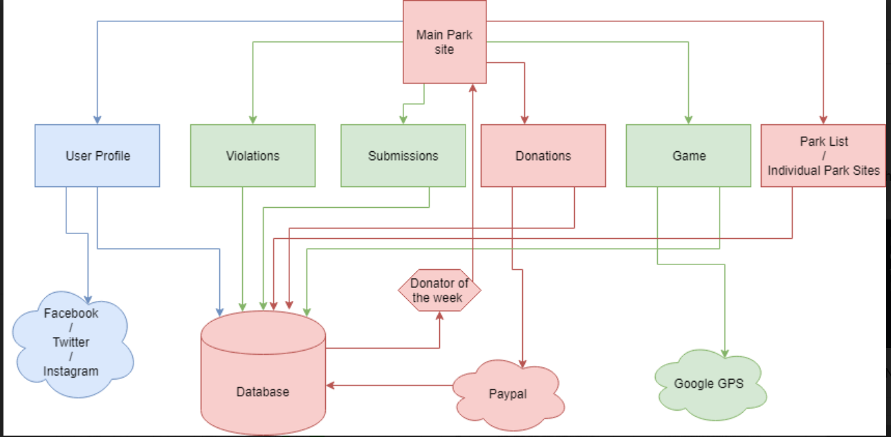

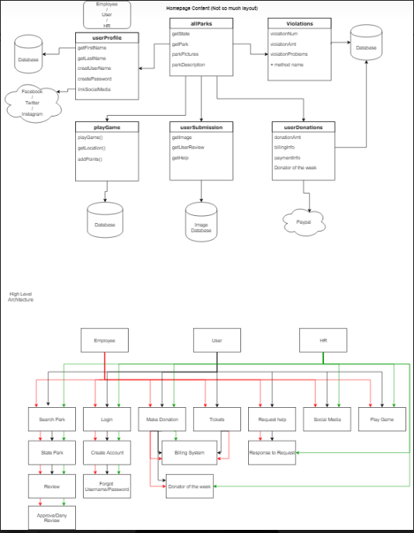

[**https://github.com/Group2-COSC-412/COSC412WebServer/blob/lilydarla/npsweb/website/html_files/payment.html**](https://github.com/Group2-COSC-412/COSC412WebServer/blob/lilydarla/npsweb/website/html_files/payment.html)