|  |  |  |
| --- | --- | --- |
|  | Unit Tests | Integration Tests |
| Home Page | Links working  Display news? | None |
| List of parks | Organize parks, picture, link, admin correctly  Links correctly to individual park site | Correctly accesses database |
| Game | Game data storage  Reports bugs | Database connection  GPS function |
| Donation Page | Info send correctly to 3rd party | Database connection  Paypal / Credit Card |
| Submissions | Info submitted correctly | Database connection |
| Ticket-based Support | Ticket system works | Database connection |
| Social Media |  | Social Media linked |
| Login/Create Account | Test functions | Database connection |
| User Profile | Administrator/Moderator/Editor Tests  Regular user tests (basic profile) | Database connection |

Regression Testing – Prioritization Method

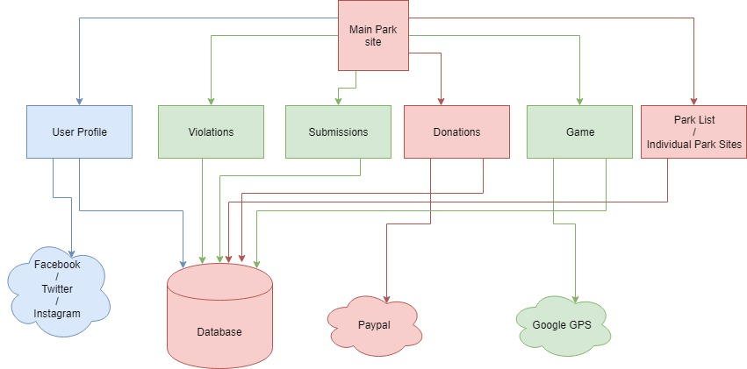

Most Important – Red

Medium Important – Blue

Least Important – Green

End-to-End Test Procedure:

1. Test connection to Main Park Site
2. Test link to Park List
   1. Park List -> Database
3. Test link to Donations
   1. Donations -> Database
   2. Donations -> Paypal
4. Test link to User Profile
   1. User Profile -> Database
   2. User Profile -> Social Media
5. Test link to Submissions
   1. Submissions -> Database
6. Test link to Game
   1. Game -> Database
   2. Game -> Google GPS
7. Test link to Violations
   1. Violations -> Database