Sakowski M M (FCES)

Brainvire

Leave Management – User Guide



Contents

1. Registering – Michal 30012104 2

2. Logging – Michal 30012104 3

**3. Main interface 17030285 …………………………………………………………………………………………………3**

**4. Apply personal vacation 30008859 …………………………………………………………………………………….4**

**5. leave application 30008859………………………………………………………………………………………………….4**

**0. how to make an application 17030285…………………………………………………………………………………5**

# Registering – Michal 30012104

(changed by Hao Jiang)

To register New user to the system follow these steps:

|  |  |
| --- | --- |
| **Step 1.**  Click the Register option from the login window. | **Step 2a.**  Insert basic required information in textboxes next to it.    To amend any information simply change data in a textbox or Click the RESET button. By clicking RESET all inserted data will be cleared.  **NOTE**: If you miss any information or incorrect data will be enter program will prevent you from registering and the registration process won't continue. |
| **Step 2b.**  Choose your user name and a password.    **NOTE:** Please choose a safe password and **do not** share it with anyone. | **Step 3.**  Read and confirm the terms and conditions, then check “I agree to all terms and conditions”. Double-check if all the information provided are correct and click SUBMIT to register.      **NOTE**: By doing this step you agree to all terms and conditions included in the document. |
| **Step 4.**  Upon successful registration application will close the registration window and go back to log in view. |

# Logging – Michal 30012104

(changed by Hao Jiang)

To login existing user to system follows these steps:

|  |  |
| --- | --- |
| **Step 1.**  In username, box insert Your username | **Step 2.**  In the password, box enter Your password    NOTE: Please note that the password is case sensitive so make sure your caps lock is off. |
| **Step 3a(optional).**  If any of the data, you provided was incorrect simply click the reset button to start the login process from the beginning.  SKIP THIS IF THE DATA ENTERED WAS CORRECT. | **Step 3b(optional).**  If data entered was incorrect or the user does not exist in the database application will inform You with the following window.    Go back to step one to try again or click on the REGISTER button to add a new user. |
| **Step 3c.**  Click the login button to login into the system. | **Step 4.**  Once successful login to the system main menu will be displayed. |

1. Main menu– Wei 17030285

In this programme have two different interfaces for different authority users. The manager interface is like that

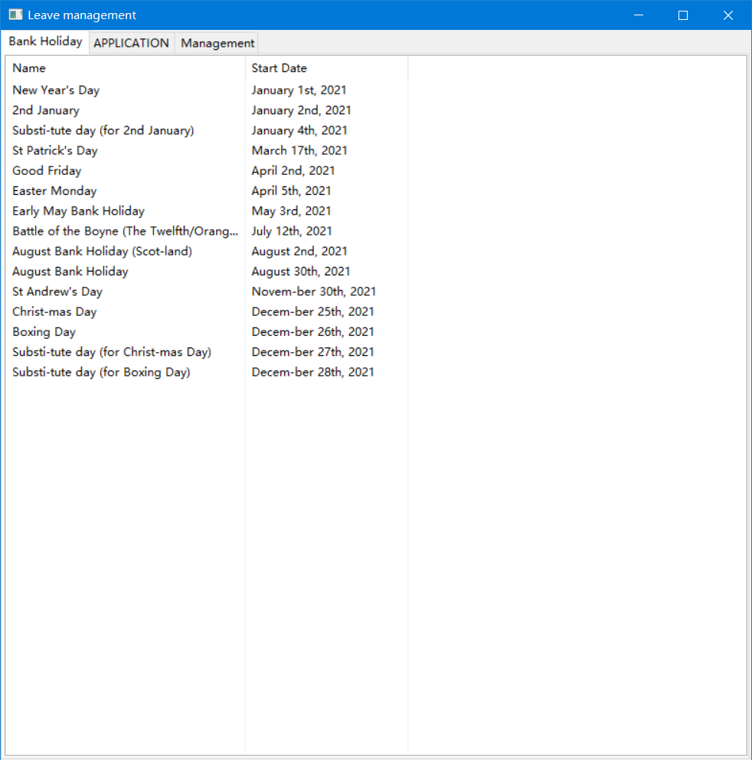 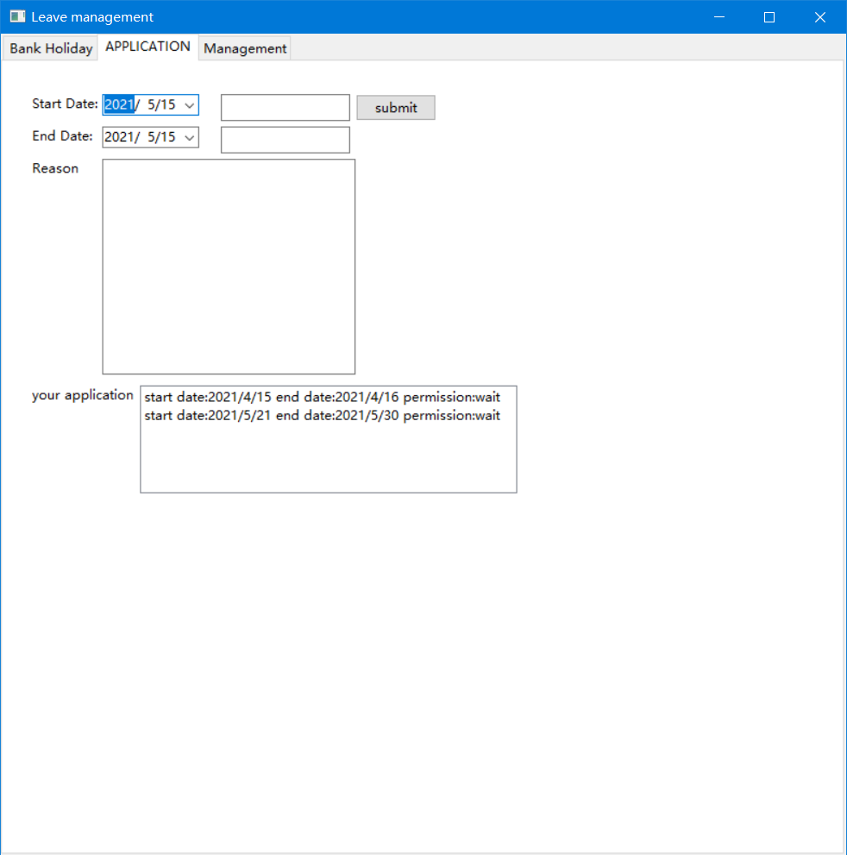 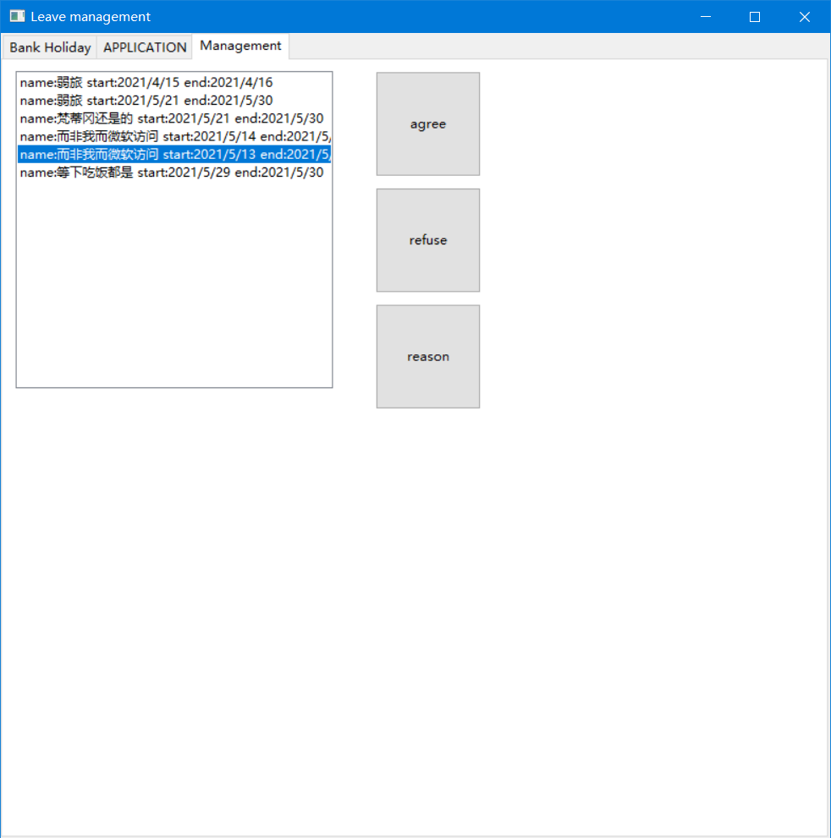

And the normal user’s interface is like that There is only have two pages only can look the bank holiday list and apply personal vacation.

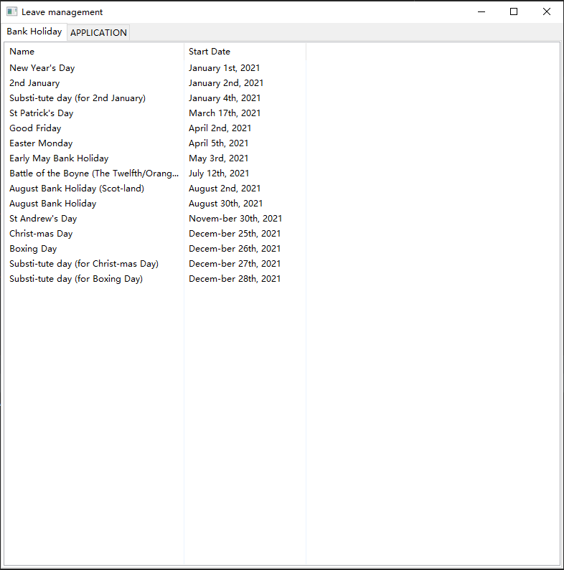

1. How to apply your personal vacation– Hao 30008859

Step1: choose start date and end date and write your reason: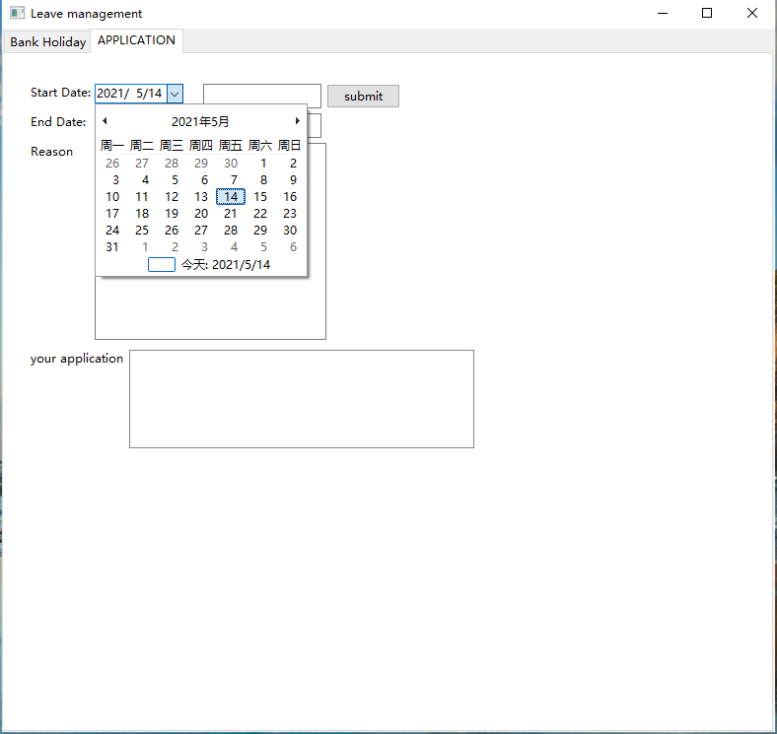

Step2: click submit button and your application will be submitted. Then wait for accept.

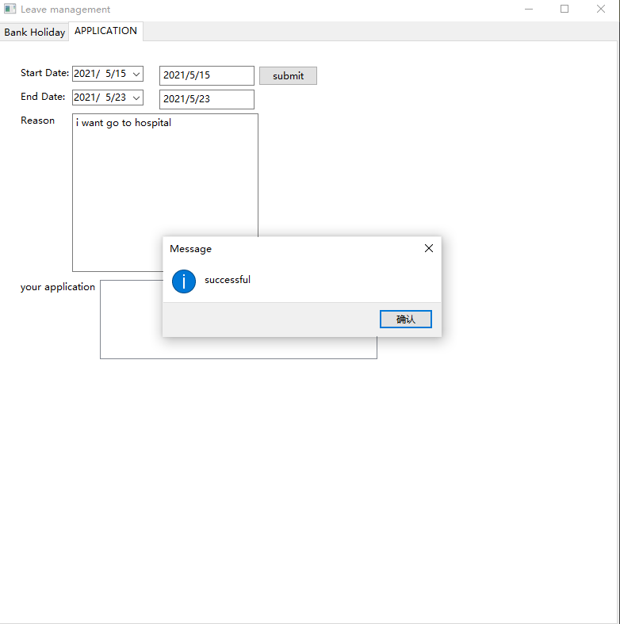

1. How to handle other people's leave application– Hao 30008859

Management interface

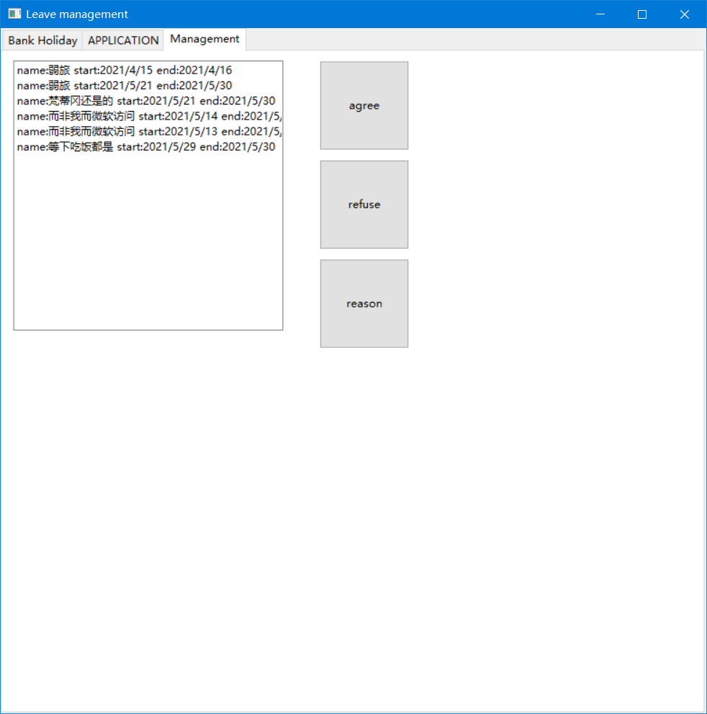

Step1: you can see the application reason by click the reason button:

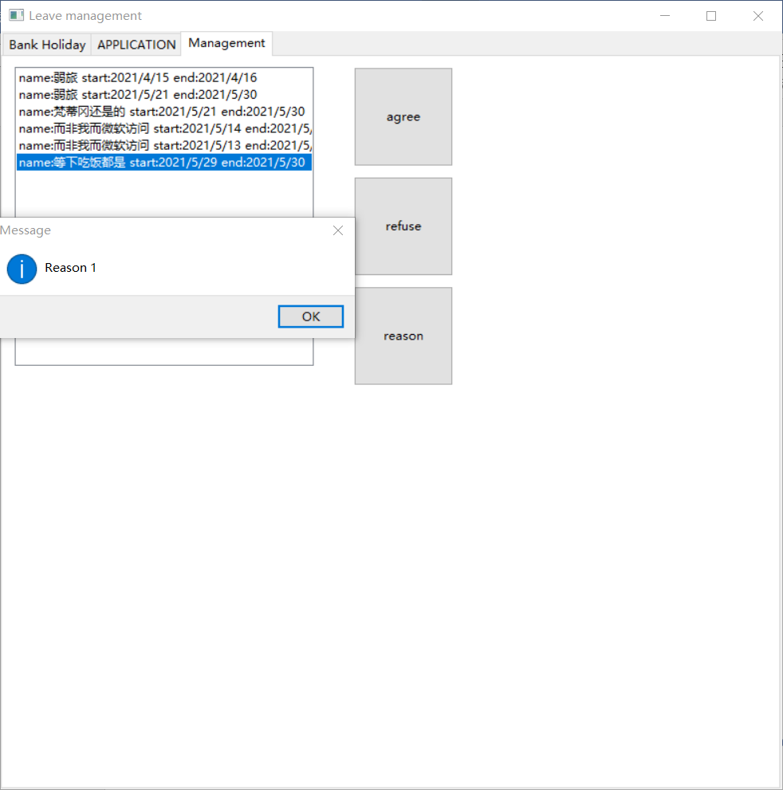

Step2: you can accept or refuse the application by click the button:

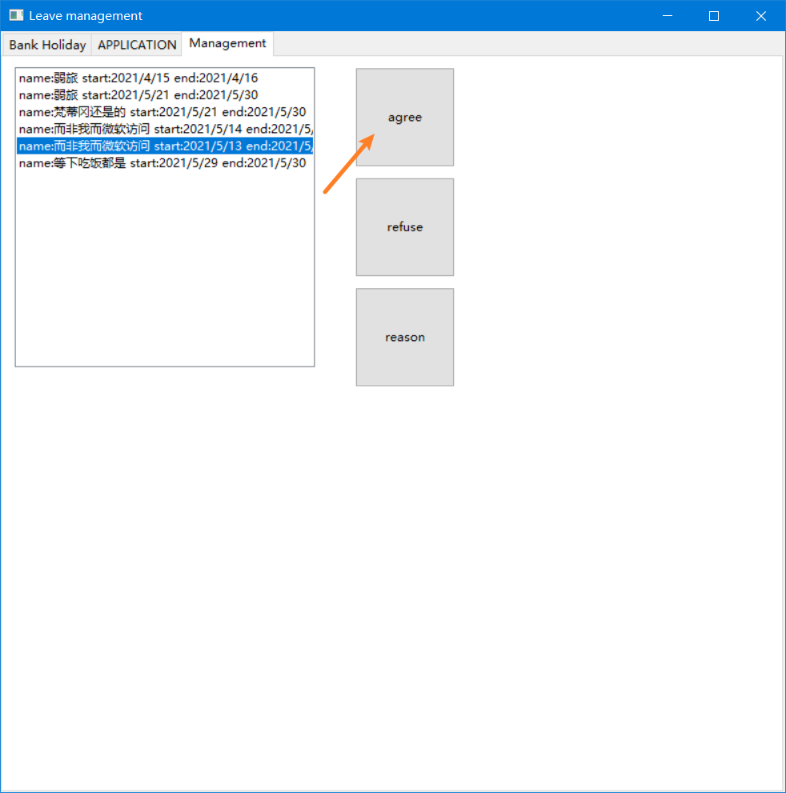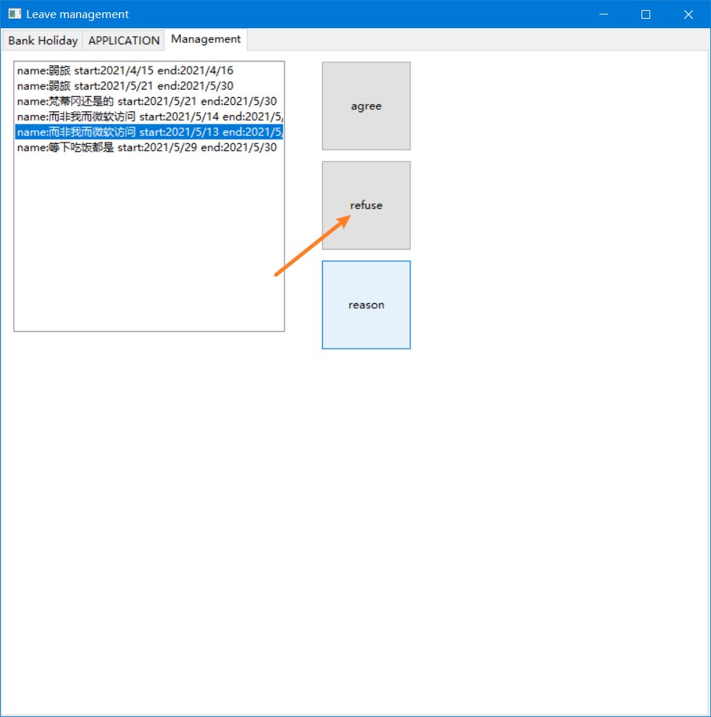

How to run this program and how to do the configuration. – Wei 17030285

Pip required documents:

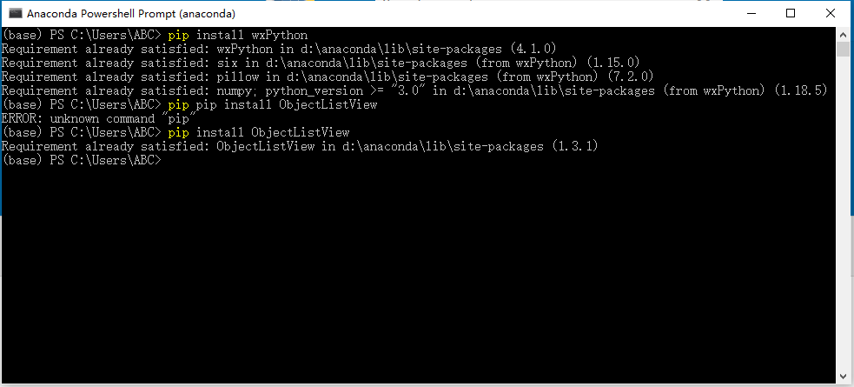

This is the root directory of the programme. If you want to running this programme you should configurate the program entry is loginPanel.py.



Then you can run this programme.