|  |  |  |  |  |  |
| --- | --- | --- | --- | --- | --- |
| **Descriptive Statistics** | | | | | |
|  | N | Minimum | Maximum | Mean | Std. Deviation |
| Medage | 4176 | 10.50 | 81.40 | 42.6749 | 10.41688 |
| QBlack | 4176 | .00 | 100.00 | 15.6687 | 20.96436 |
| QNatam | 4176 | .00 | 23.94 | .3820 | .58862 |
| QAsian | 4176 | .00 | 23.60 | 2.1813 | 2.22064 |
| QHisp | 4176 | .00 | 100.00 | 20.4214 | 22.34338 |
| QAgedep | 4176 | .00 | 89.53 | 24.5545 | 12.51790 |
| Ppunit | 4176 | 1.00 | 6.00 | 2.4774 | .48552 |
| QRenter | 4176 | .00 | 100.00 | 27.8840 | 17.70132 |
| QNrres | 4176 | .00 | 55.00 | .4269 | 1.54399 |
| QFemale | 4176 | .00 | 100.00 | 51.1553 | 4.08210 |
| QFhh | 4176 | .00 | 100.00 | 13.8317 | 8.06870 |
| Percap | 4176 | 378.16 | 99521.68 | 26514.6613 | 13385.63987 |
| QEsl | 4176 | .00 | 100.00 | 21.0597 | 17.90934 |
| QCvlun | 4176 | .00 | 100.00 | 24.9983 | 9.41201 |
| QPovty | 4176 | .00 | 94.53 | 14.1536 | 10.78393 |
| QMoho | 4176 | .00 | 100.00 | 9.9598 | 16.97772 |
| QEd12les | 4176 | .00 | 79.11 | 14.8164 | 10.64889 |
| QFemlbr | 4176 | .00 | 100.00 | 47.5417 | 7.50299 |
| QExtract | 4176 | .00 | 54.02 | 1.2411 | 3.62461 |
| QServ | 4176 | .00 | 100.00 | 19.2328 | 8.68498 |
| QSsben | 4176 | .00 | 100.00 | 33.1842 | 16.13934 |
| QNoauto | 4176 | .00 | 100.00 | 6.8669 | 7.66990 |
| QFam | 4176 | .00 | 100.00 | 65.1318 | 22.22428 |
| QRich200k | 4176 | .00 | 100.00 | 3.7760 | 6.22257 |
| Mdgrent | 4176 | 225.000000 | 2000.000000 | 1053.16690613 | 344.640311559 |
| Mdhsval | 4176 | .000000 | 1000000.000000 | 231576.26915709 | 146467.674763016 |
| qunocchu | 4176 | .000000 | 90.006810 | 16.30022697 | 11.565987614 |
| Valid N (listwise) | 4176 |  |  |  |  |

|  |  |  |
| --- | --- | --- |
| **Communalities** | | |
|  | Initial | Extraction |
| Zscore(Medage) | 1.000 | .921 |
| Zscore(QBlack) | 1.000 | .811 |
| Zscore(QNatam) | 1.000 | .289 |
| Zscore(QAsian) | 1.000 | .453 |
| Zscore(QHisp) | 1.000 | .783 |
| Zscore(QAgedep) | 1.000 | .913 |
| Zscore(Ppunit) | 1.000 | .877 |
| Zscore(QRenter) | 1.000 | .803 |
| Zscore(QNrres) | 1.000 | .204 |
| Zscore(QFemale) | 1.000 | .620 |
| Zscore(QFhh) | 1.000 | .838 |
| Zscore(Percap) | 1.000 | .817 |
| Zscore(QEsl) | 1.000 | .621 |
| Zscore(QCvlun) | 1.000 | .613 |
| Zscore(QPovty) | 1.000 | .746 |
| Zscore(QMoho) | 1.000 | .622 |
| Zscore(QEd12les) | 1.000 | .840 |
| Zscore(QFemlbr) | 1.000 | .460 |
| Zscore(QExtract) | 1.000 | .419 |
| Zscore(QServ) | 1.000 | .457 |
| Zscore(QSsben) | 1.000 | .886 |
| Zscore(QNoauto) | 1.000 | .709 |
| Zscore(QFam) | 1.000 | .518 |
| Zscore(QRich200k) | 1.000 | .782 |
| Zscore(Mdgrent) | 1.000 | .560 |
| Zscore(Mdhsval) | 1.000 | .825 |
| Zscore(qunocchu) | 1.000 | .541 |
| Extraction Method: Principal Component Analysis. | | |

|  |  |  |  |  |  |  |  |  |  |
| --- | --- | --- | --- | --- | --- | --- | --- | --- | --- |
| **Total Variance Explained** | | | | | | | | | |
| Component | Initial Eigenvalues | | | Extraction Sums of Squared Loadings | | | Rotation Sums of Squared Loadings | | |
| Total | % of Variance | Cumulative % | Total | % of Variance | Cumulative % | Total | % of Variance | Cumulative % |
| 1 | 6.965 | 25.797 | 25.797 | 6.965 | 25.797 | 25.797 | 4.636 | 17.172 | 17.172 |
| 2 | 4.053 | 15.010 | 40.807 | 4.053 | 15.010 | 40.807 | 3.820 | 14.148 | 31.320 |
| 3 | 2.258 | 8.364 | 49.171 | 2.258 | 8.364 | 49.171 | 3.252 | 12.043 | 43.363 |
| 4 | 1.791 | 6.635 | 55.806 | 1.791 | 6.635 | 55.806 | 2.283 | 8.456 | 51.819 |
| 5 | 1.585 | 5.869 | 61.675 | 1.585 | 5.869 | 61.675 | 2.069 | 7.662 | 59.481 |
| 6 | 1.274 | 4.719 | 66.394 | 1.274 | 4.719 | 66.394 | 1.866 | 6.913 | 66.394 |
| 7 | .976 | 3.616 | 70.010 |  |  |  |  |  |  |
| 8 | .863 | 3.197 | 73.207 |  |  |  |  |  |  |
| 9 | .817 | 3.026 | 76.232 |  |  |  |  |  |  |
| 10 | .752 | 2.786 | 79.019 |  |  |  |  |  |  |
| 11 | .699 | 2.588 | 81.607 |  |  |  |  |  |  |
| 12 | .678 | 2.510 | 84.117 |  |  |  |  |  |  |
| 13 | .604 | 2.236 | 86.352 |  |  |  |  |  |  |
| 14 | .555 | 2.057 | 88.409 |  |  |  |  |  |  |
| 15 | .480 | 1.778 | 90.187 |  |  |  |  |  |  |
| 16 | .473 | 1.752 | 91.939 |  |  |  |  |  |  |
| 17 | .408 | 1.513 | 93.451 |  |  |  |  |  |  |
| 18 | .347 | 1.285 | 94.736 |  |  |  |  |  |  |
| 19 | .276 | 1.024 | 95.760 |  |  |  |  |  |  |
| 20 | .240 | .890 | 96.650 |  |  |  |  |  |  |
| 21 | .202 | .747 | 97.397 |  |  |  |  |  |  |
| 22 | .171 | .634 | 98.031 |  |  |  |  |  |  |
| 23 | .160 | .594 | 98.625 |  |  |  |  |  |  |
| 24 | .124 | .460 | 99.084 |  |  |  |  |  |  |
| 25 | .112 | .415 | 99.500 |  |  |  |  |  |  |
| 26 | .093 | .346 | 99.846 |  |  |  |  |  |  |
| 27 | .042 | .154 | 100.000 |  |  |  |  |  |  |
| Extraction Method: Principal Component Analysis. | | | | | | | | | |

|  |  |  |  |  |  |  |
| --- | --- | --- | --- | --- | --- | --- |
| **Component Matrixa** | | | | | | |
|  | Component | | | | | |
| 1 | 2 | 3 | 4 | 5 | 6 |
| Zscore(Medage) | -.691 | .635 | .032 | .046 | .145 | -.132 |
| Zscore(QBlack) | .659 | .023 | .363 | .057 | .083 | .484 |
| Zscore(QNatam) | .233 | .043 | -.361 | -.029 | -.318 | .026 |
| Zscore(QAsian) | -.107 | -.529 | .200 | -.194 | -.264 | -.120 |
| Zscore(QHisp) | .339 | -.321 | -.217 | .384 | .374 | -.480 |
| Zscore(QAgedep) | -.485 | .764 | .130 | .077 | .212 | -.159 |
| Zscore(Ppunit) | .439 | -.530 | -.332 | -.021 | .502 | .202 |
| Zscore(QRenter) | .659 | -.148 | .307 | .267 | -.342 | -.251 |
| Zscore(QNrres) | .071 | .165 | .224 | .063 | -.128 | -.318 |
| Zscore(QFemale) | -.147 | .107 | .530 | -.137 | .500 | -.191 |
| Zscore(QFhh) | .782 | -.150 | .228 | .020 | .327 | .213 |
| Zscore(Percap) | -.821 | -.127 | .109 | .300 | -.102 | .122 |
| Zscore(QEsl) | .537 | .067 | -.289 | .322 | .154 | -.342 |
| Zscore(QCvlun) | .140 | .612 | -.128 | .210 | .206 | .340 |
| Zscore(QPovty) | .758 | .272 | .095 | .242 | -.129 | .114 |
| Zscore(QMoho) | .073 | .457 | -.516 | -.363 | -.040 | .089 |
| Zscore(QEd12les) | .768 | .277 | -.296 | .222 | .188 | -.023 |
| Zscore(QFemlbr) | .143 | .086 | .492 | -.358 | .222 | .110 |
| Zscore(QExtract) | .192 | .174 | -.577 | .081 | -.018 | .108 |
| Zscore(QServ) | .608 | .272 | .094 | .011 | -.066 | -.011 |
| Zscore(QSsben) | -.407 | .806 | .005 | -.013 | .257 | -.064 |
| Zscore(QNoauto) | .536 | .332 | .328 | .414 | -.145 | -.112 |
| Zscore(QFam) | -.521 | -.289 | -.360 | -.075 | .116 | -.119 |
| Zscore(QRich200k) | -.622 | -.219 | .004 | .506 | .022 | .302 |
| Zscore(Mdgrent) | -.496 | -.441 | .079 | .209 | .263 | .008 |
| Zscore(Mdhsval) | -.598 | -.312 | .045 | .577 | .050 | .177 |
| Zscore(qunocchu) | -.278 | .516 | .006 | .277 | -.319 | .133 |
| Extraction Method: Principal Component Analysis. | | | | | | |
| a. 6 components extracted. | | | | | | |

|  |  |  |  |  |  |  |
| --- | --- | --- | --- | --- | --- | --- |
| **Rotated Component Matrixa** | | | | | | |
|  | Component | | | | | |
| +  Race (Black) and Poverty | +  Age (Old) | -  Wealth | +  Ethnicity (Hispanic) | +  Gender (Female) | +  Small Households |
| Zscore(Medage) | -.387 | .768 | .156 | -.179 | .165 | .313 |
| Zscore(QBlack) | .806 | -.123 | -.104 | -.109 | .148 | -.319 |
| Zscore(QNatam) | .065 | -.076 | -.201 | .009 | -.488 | .006 |
| Zscore(QAsian) | -.201 | -.598 | .066 | -.159 | .106 | .121 |
| Zscore(QHisp) | .021 | -.192 | .054 | .861 | .024 | -.040 |
| Zscore(QAgedep) | -.174 | .834 | .046 | -.097 | .241 | .341 |
| Zscore(Ppunit) | .072 | -.327 | -.070 | .446 | -.004 | -.749 |
| Zscore(QRenter) | .616 | -.454 | -.104 | .258 | -.063 | .369 |
| Zscore(QNrres) | .107 | .018 | -.090 | .083 | .109 | .407 |
| Zscore(QFemale) | -.038 | .172 | -.029 | .054 | .762 | .061 |
| Zscore(QFhh) | .669 | -.234 | -.234 | .260 | .235 | -.398 |
| Zscore(Percap) | -.418 | .118 | .722 | -.285 | .053 | .156 |
| Zscore(QEsl) | .272 | .032 | -.184 | .681 | -.217 | .038 |
| Zscore(QCvlun) | .360 | .656 | -.024 | -.013 | -.133 | -.187 |
| Zscore(QPovty) | .790 | .027 | -.232 | .171 | -.190 | .040 |
| Zscore(QMoho) | -.148 | .396 | -.504 | -.113 | -.388 | -.162 |
| Zscore(QEd12les) | .554 | .184 | -.351 | .516 | -.275 | -.185 |
| Zscore(QFemlbr) | .204 | -.015 | -.259 | -.236 | .537 | -.086 |
| Zscore(QExtract) | .015 | .214 | -.149 | .185 | -.516 | -.225 |
| Zscore(QServ) | .548 | .036 | -.365 | .119 | -.065 | .067 |
| Zscore(QSsben) | -.163 | .882 | -.067 | -.112 | .165 | .194 |
| Zscore(QNoauto) | .724 | .097 | -.036 | .212 | -.002 | .361 |
| Zscore(QFam) | -.669 | -.038 | .202 | .068 | -.082 | -.132 |
| Zscore(QRich200k) | -.213 | .099 | .837 | -.125 | -.045 | -.086 |
| Zscore(Mdgrent) | -.377 | -.137 | .553 | .083 | .260 | -.138 |
| Zscore(Mdhsval) | -.220 | .014 | .880 | .002 | .009 | -.023 |
| Zscore(qunocchu) | .099 | .469 | .226 | -.282 | -.261 | .334 |
| Extraction Method: Principal Component Analysis.  Rotation Method: Varimax with Kaiser Normalization. | | | | | | |
| a. Rotation converged in 10 iterations. | | | | | | |

|  |  |  |  |  |  |  |
| --- | --- | --- | --- | --- | --- | --- |
| **Component Transformation Matrix** | | | | | | |
| Component | 1 | 2 | 3 | 4 | 5 | 6 |
| 1 | .724 | -.264 | -.497 | .345 | -.129 | -.149 |
| 2 | .227 | .863 | -.302 | -.152 | -.067 | .290 |
| 3 | .402 | -.165 | .157 | -.314 | .753 | .348 |
| 4 | .365 | .166 | .751 | .442 | -.216 | .185 |
| 5 | -.107 | .344 | .003 | .471 | .584 | -.554 |
| 6 | .342 | .110 | .271 | -.585 | -.155 | -.657 |
| Extraction Method: Principal Component Analysis.  Rotation Method: Varimax with Kaiser Normalization. | | | | | | |

Comp 6

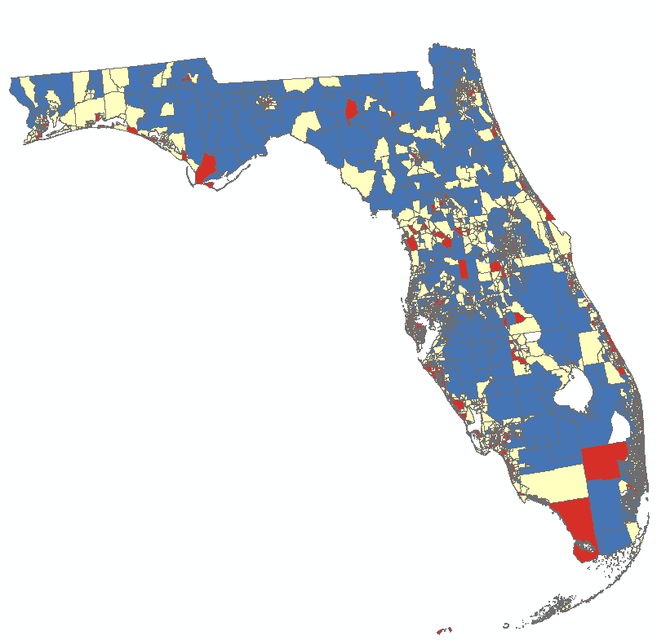

|  |  |  |  |  |  |  |  |  |
| --- | --- | --- | --- | --- | --- | --- | --- | --- |
|  | Mean | STD | 1 (n/mean) | 2 | 3 |  |  |  |
| Ppunit | 2.4774 | 0.4855 | 910  2.4436 | 2084  2.4684 | 1182  2.5193 |  |  |  |