Identify and Design Architectural Patterns

GitHub Repo Link:

https://github.com/Group557/Group5

- Proposed Architecture

We decided the use of two different architecture patterns would work best for our app:
- Model-View-Controller (MVC)
- Layered

Explanation on why it fits best:

- Our two main app priorities are security and usability which are typically viewed as on opposite ends of the spectrum. MVC is best used for components that focus on user interaction. For instance, viewing workouts and updating the current workout list for a user. However, a Layered architecture would be best for screens and components that focus on securing important data. For example, for personal information(such as login and measurements) the architecture would best fit into a Layered one. Our current plan is to start with MVC as this is the architecture we are most comfortable with from activities in class but if we are able to and have the time, we will implement the Layered architecture for components that focus on security.

Diagrams:

MVC

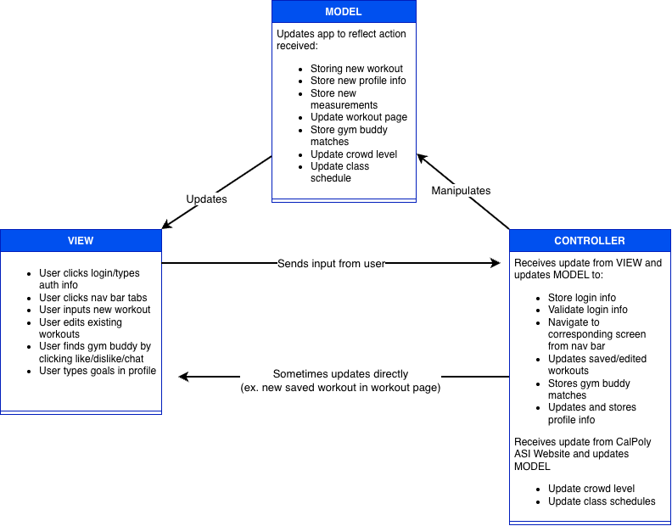

Layered
*organize by responsibility

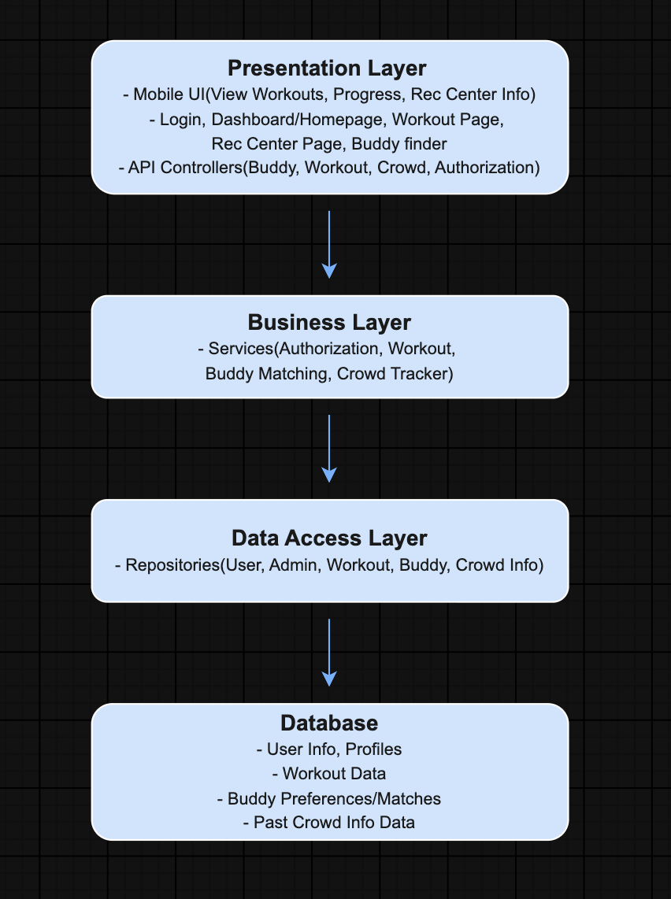

- High Level Design Diagram

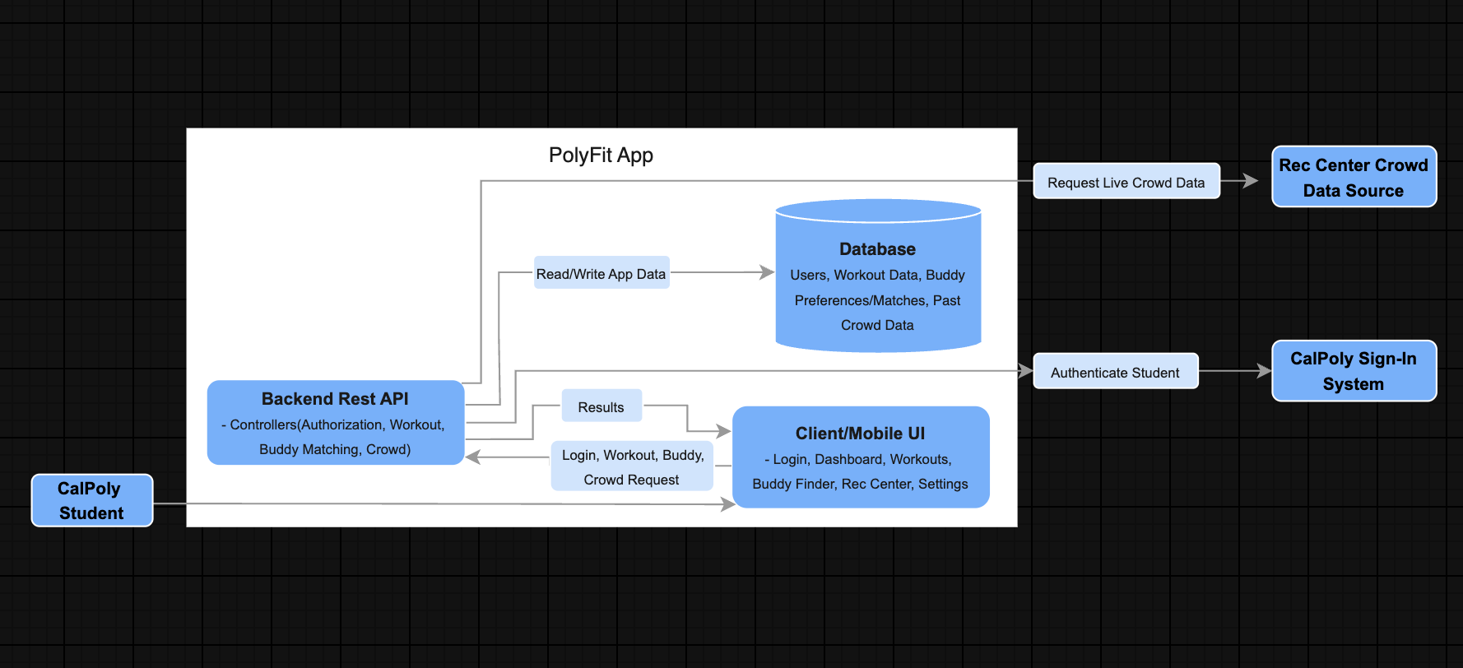

- Design Pattern - State

  - Our team plans to use the State design pattern for PolyFit’s workout sessions.
  - A workout behaves differently depending on whether it is active, paused, or cancelled. For example, pausing an active workout should stop its timer, while continuing a paused workout should resume the timer. A cancelled workout should not allow either action. The State pattern organizes these behaviors and prevents invalid actions.
  - Components involved
- Workout screen: Displays the workout and sends user actions to the session.
- WorkoutSession: Stores the current state and delegates actions to it.
- WorkoutState: Defines common operations such as pause(), resume(), and cancel().
  - ActiveState: Handles pausing or cancelling an active workout.
  - PausedState: Handles resuming or cancelling a paused workout.
  - CancelledState: Prevents further actions on a cancelled session.
  - Pseudocode
- WorkoutSession:
State = workoutState;
pauseWorkout();
state.ActivateState.pause(this)
resumeWorkout():
state.pauseState.resume(this)
cancelWorkout():
state.cancel(this)
- WorkoutState:
ActiveState:
pause(session):
Stop timer
Session.state = PausedState
resume(session)
“Session already resumed”
cancel(session):
stop timer
session.state = CancelledState

PausedState:
resume(session)
Resume timer
Session.state = resumed

pause(session)
“Session already paused”
cancel(session):
session.state = CancelledState

CancelledState:
pause(session), resume(session), cancel(session):
report "Workout has been cancelled"

Why use this pattern?

Putting everything in one large component would mix screen rendering, timer operations, and conditions for each workout state. Separate state classes keep each state’s behavior together, making it easier to understand, test, and change. For example, we could test that a paused workout resumes correctly and that a cancelled workout cannot resume.

Implementation plan

We will create the shared WorkoutState interface and its three state implementations. We will connect them to WorkoutSession, then have the workout screen’s buttons call the session’s methods. We will test the allowed transitions and confirm that invalid actions do not change the session.

- Design Decisions and Tradeoffs
  - Switching from MongoDB to Supabase
We considered MongoDB and Supabase and chose Supabase. Supabase uses PostgreSQL, a relational database that organizes data into tables with rows and columns. This fits the relationships between our users, workouts, and measurements. MongoDB stores data in flexible, JSON-like documents.
Supabase also provides built-in user authentication, reducing the work needed to implement registration, login, and email verification. With MongoDB, we would need to build or integrate a separate application authentication solution.
The tradeoff is that PostgreSQL requires more upfront planning of table structures and relationships compared with MongoDB’s flexible document structure.
b) Using Protected Routing
- We considered relying only on redirects after login or using protected routes that check authentication and onboarding status before allowing access to screens.
- We chose protected routing. Users must be signed in before accessing onboarding or the dashboard. Signed-in users who have not completed onboarding are directed to the onboarding page. Once their information is successfully saved, their onboarding status is set to true, and they can access the dashboard. Returning users who have already completed onboarding go directly to the dashboard.
- This fits our needs because it keeps users in the correct application flow and requires them to complete their profile before accessing workout features. The tradeoff is additional logic to handle loading, login, logout, and onboarding status. However, this makes navigation more reliable than relying only on redirects after login.

