**2.1**

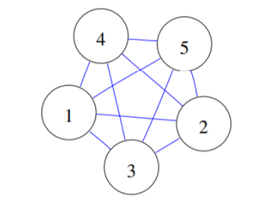

- The complexity before simplify is : 5+10= 15

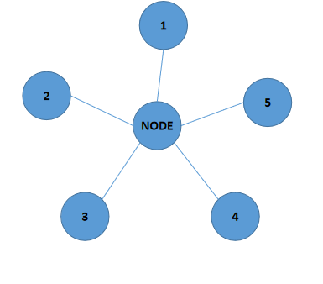

- The complexity after simplify is : 6+5= 11

**2.2**

- there are 15 modules

- there are 23 relationships

-Total = (15x5) + (11x1) + (12x3x2)=158 complexity

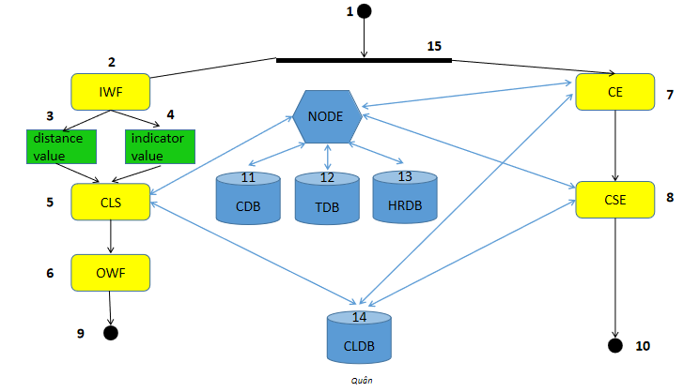

- The complexity after simplify =(15x5) + (11x1) + (9x3x2)=140 complexity

**2.3**

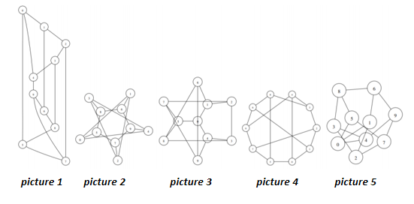

The complexity each picture is:

1. 10+15=25
2. 10+15=25
3. 10+15=25
4. 10+15=25
5. 10+15=25

- Five pictures have the same complexity is 25