**1.Brainstorming**

| **Problem** | **Possible Cause** | **Sensor/Tech Solution** |
| --- | --- | --- |
| Fish death | Low oxygen | Use DO Sensor + alert system |
| Sudden water contamination | Tank pollution | Water Purity Sensor |
| Poor hatching rate | Wrong temperature | DHT11 + Auto Heater control |
| Water overflow/leakage | Pipe leak or soil soak | Soil Moisture Sensor + alert |
| Manual checking is time-consuming | Human labor fatigue | Dashboard + Remote IoT monitoring |

**2.Idea Posting**

| **Component / Layer** | **Description** |
| --- | --- |
| Water Tank with Fish Eggs | Central hatchery unit where fish eggs are incubated |
| Water Purity Sensor | Detects chemical contamination or turbidity in water |
| Dissolved Oxygen (DO) Sensor | Measures oxygen level in water to support healthy hatching |
| DHT11 Sensor | Monitors ambient temperature and humidity around hatchery |
| Soil Moisture Sensor | Detects leakage or excess ground moisture indicating possible tank failure |
| Microcontroller (ESP32) | Collects data from sensors and sends to the cloud |
| Cloud Storage (e.g., Firebase) | Stores real-time data for historical tracking and analysis |
| ML Prediction Module | Analyzes trends to predict water quality issues or contamination |
| Web Dashboard | Displays live sensor values, graphs, and warning alerts |
| Alert System (SMS/App/Buzzer) | Sends instant alerts to hatchery staff for corrective action |

**3.Customer Mapping**

| **User Type** | **Pain Point** | **What They Gain with Your Solution** |
| --- | --- | --- |
| Hatchery Manager | Fish die without early signs | Get alerts, save fish early |
| Worker | Manual checks every hour | Let sensors monitor 24/7 |
| Owner/Investor | High loss from bad conditions | Better data, better profit |
| Aquaculture Expert | Difficult to trace water trends | View dashboards, run analysis easily |

**4.Idea Layout**

| **User Type** | **Pain Point** | **What They Gain with Your Solution** |
| --- | --- | --- |
| Hatchery Manager | Fish die without early signs | Get alerts, save fish early |
| Worker | Manual checks every hour | Let sensors monitor 24/7 |
| Owner/Investor | High loss from bad conditions | Better data, better profit |
| Aquaculture Expert | Difficult to trace water trends | View dashboards, run analysis easily |

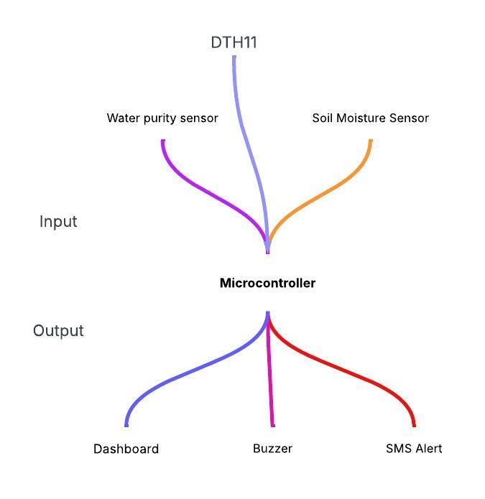

**5.Reflection**

| **What Worked Well** | **What Was Challenging** | **What I’d Improve Next** |
| --- | --- | --- |
| Real-time sensing + cloud logging | Connecting DO sensor reliably | Add automatic water purifier |
| Alert system was responsive | Sensor calibration took time | Include mobile app interface |
| Dashboard visualized trends well | Need better power backup | Add solar or UPS module |

**6.Design of Modules (Workforce/Function Separation):**

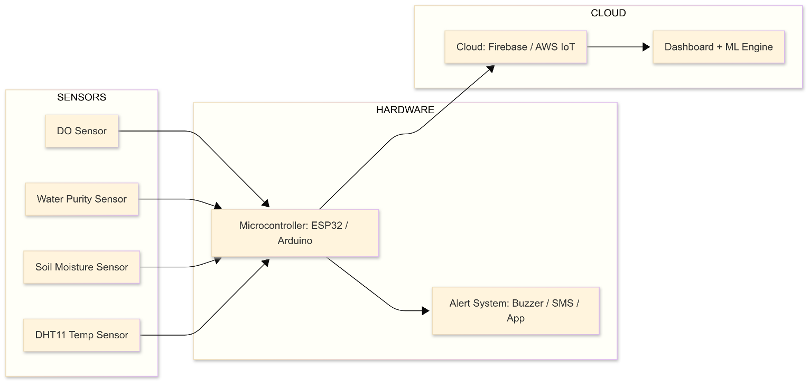

**7.Resources Identification:**

| **Resource** | **Type** | **Status** |
| --- | --- | --- |
| DHT11 Sensor | Hardware | Available |
| Firebase | Cloud Platform | Ready |
| ESP32 | Microcontroller | Procured |
| Technician help | Human Resource | Assigned |

**8.Planning:**

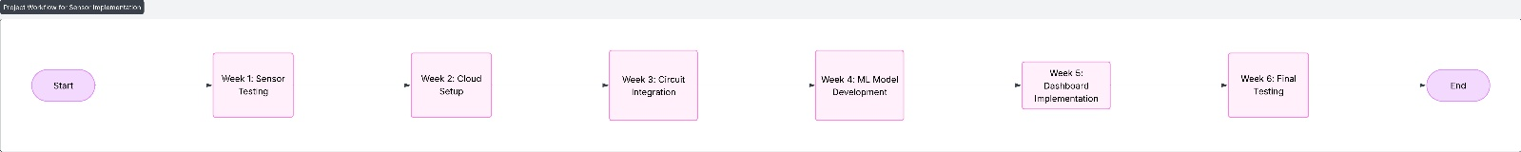

**9.Redesign:**

| **Component** | **Issues Found** | **Fix Applied** |
| --- | --- | --- |
| DHT11 | Delay in reading | Pull-up resistor |
| Firebase | Intermittent data | Optimize API |

**10.Execution Framework:**



**11. Micro Modules:**

