**Functional review of system**

**Sandesh file**

**Admin user and password (admin dashboard)**

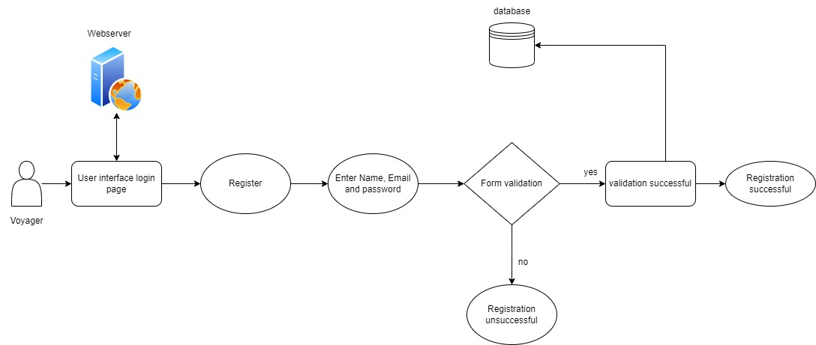

**Add item**

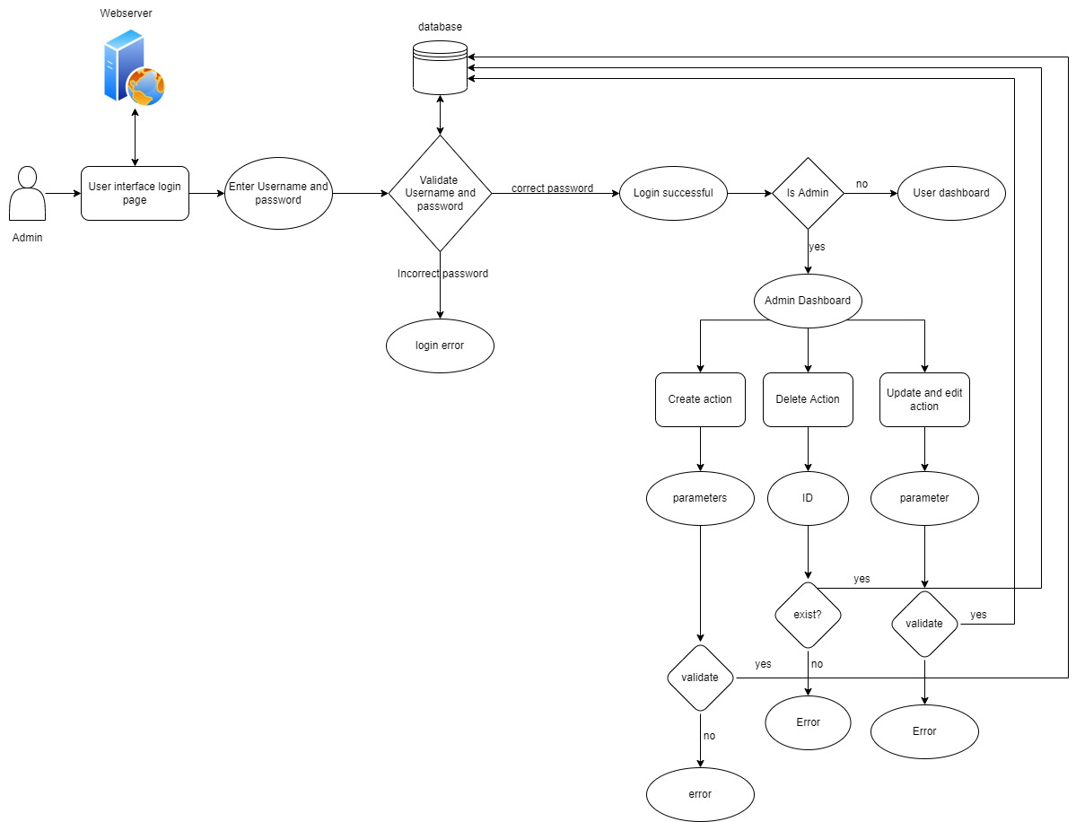

**Edit/ delete item**



**Booking resort and movie**

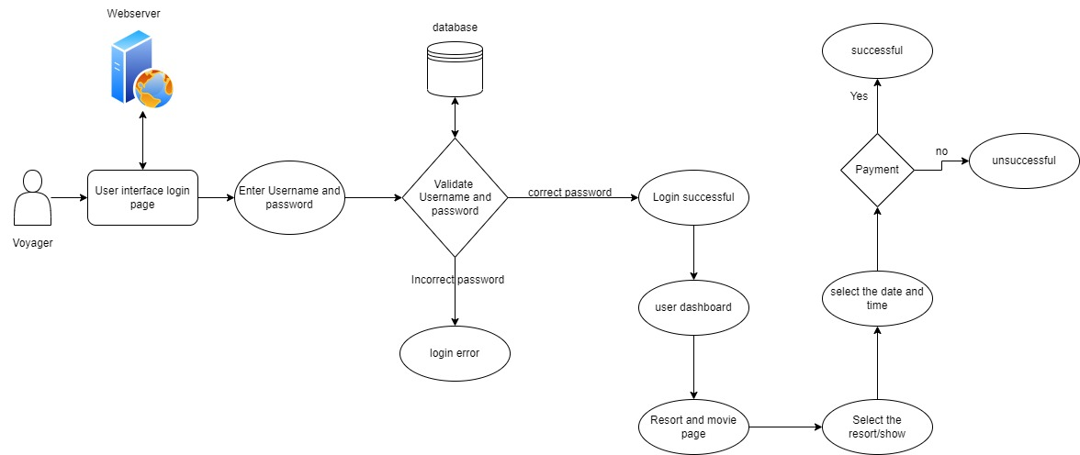

**Booking stationary item**

