# Hardware Components

Carnival cruise line wish a management system which keep records of customers, cruise, order that accessible from anywhere over the internet. Therefore, carnival cruise line management system is implemented and deploy as web application, which enable customer to access their service as well as make order from any location and at any time. Though, it requires infrastructure-based resources in term of hardware components. There are some options for owner of carnival cruise line to implement and deploy a system. Owner may make initial investment on hardware infrastructure in premises or may take rental hardware components from cloud vendors such as Amazon, Azure, Google etc. In both the scenario, owner needs some sort of hardware to run their application. Hardware components specification is given below.

* [Intel Core 2 Duo Processor 2.4 GHZ](https://www.amazon.in/Processor-Socket-Motherboard-Excellent-Performance/dp/B0B94NNZ5X/ref=pd_lpo_1?pd_rd_i=B0B94NNZ5X&psc=1)
* 512 MB RAM (Random Access Memory)
* 20 GB Hard Disk (Secondary Storage)
* Server Computers or Workstations
* UPS (Un-interrupted Power Supply)
* Backup Storage

[**Intel Core 2 Duo Processor 2.4 GHZ**](https://www.amazon.in/Processor-Socket-Motherboard-Excellent-Performance/dp/B0B94NNZ5X/ref=pd_lpo_1?pd_rd_i=B0B94NNZ5X&psc=1) – Minimum intel core 2 duo processor is required to implement carnival cruise line management system. It offers 2.4 GHz cpu speed, 2400 MHz frequency, 1066 MHz Bus speed and 2 cores of processor.

**512 MB RAM (Random Access Memory) -** To store all implementation process of system, at-least 512 MB RAM is required. RAM allows storing processes of system which are concurrently executed by the processor for the application development.

**20 GB Hard Disk (Secondary Storage) -** During the development or implementation of an application, several files are created that require to store persistently. For this, at-least 20 GB hard disk is required as hardware components.

**Server Computers or workstations-** Carnival cruise line management system is served as web application. Therefore, after the development of system, it is deployed on high computing sever computers or workstations that make application available on internet. It is very crucial components, because performance, reliability and availability of an application depend on it.

**UPS (Un-interrupted Power Supply) -** To make an application always available, require un-interruptible service of system regardless of power failure. If power failure or cut off then UPS is maintained as backup.

**Backup Storage-** In case of any failure like server crash or hardware malfunction, we require backup plan of application. For, this we require backup storage and recovery tools so we can recover an application from backup copy. Backup storage leads extra cost for cruise line owner but it assures application reliability in case of any fault.

In above discussion, some hardware components are used to implements application and their modules. Rest hardware components used for deployment and backup purpose. After the hardware components requirement, we require sort of software which runs on this hardware for system development. Further, minimum software components require for the development, run and accessing of an application are discusses here.

# 3. Database Design final Entity Relationship Diagram

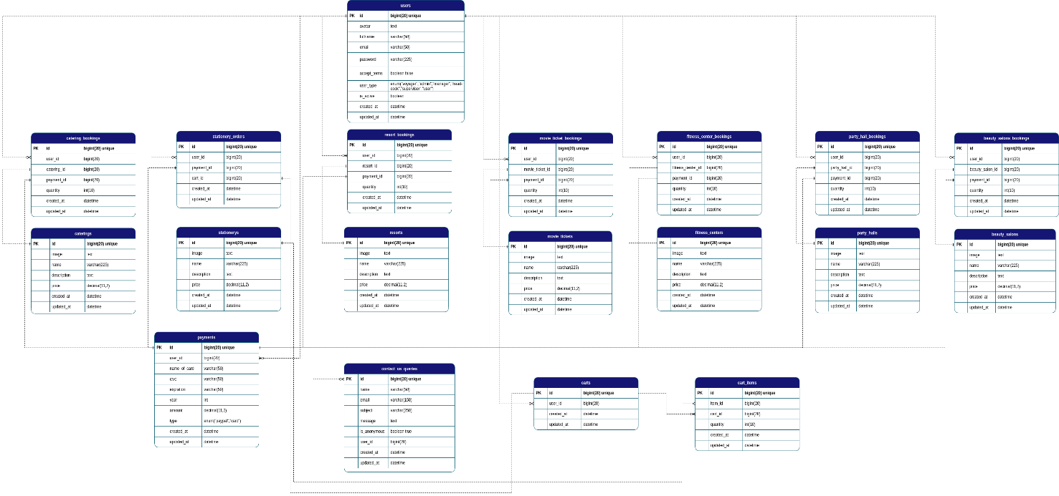

Fig no 5: final and revised ERD

# 3.2 Developed database

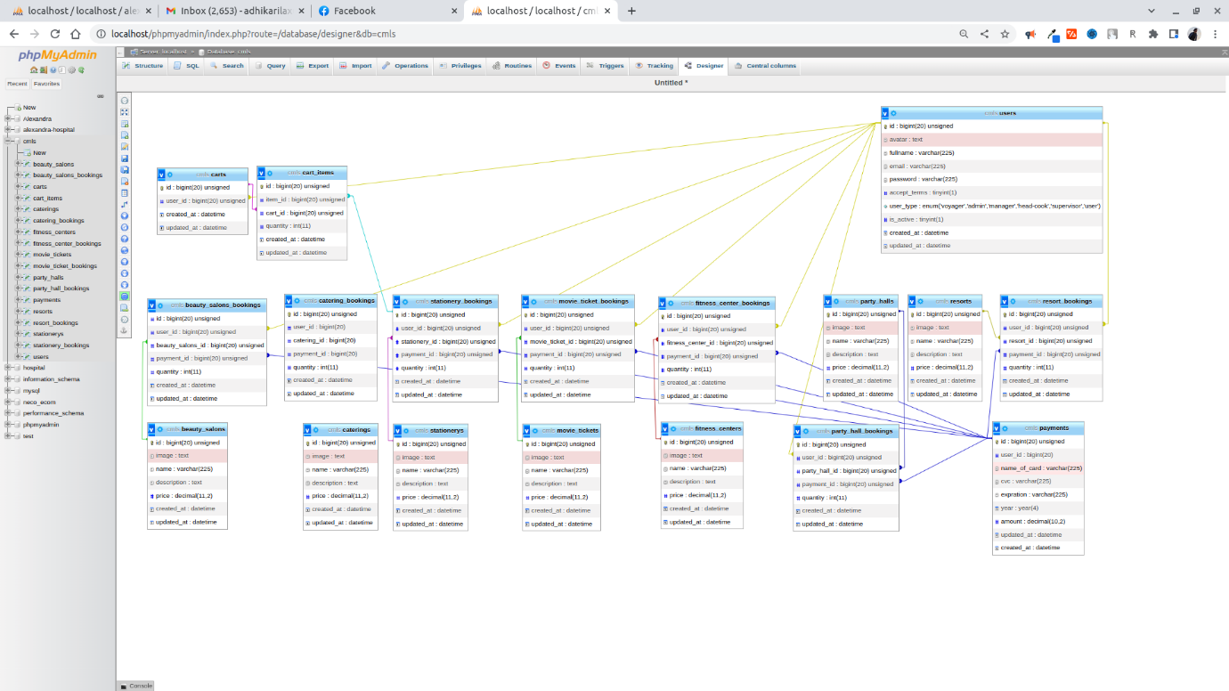

Fig no 6 :Developed database