Sean Kelly S00182062

Week 1 Research

For my first week of work I researched which types of routers and switches that the college would provide by studying the five previous projects available to me. Project D and F did not specify which types of equipment they used. Project H used three routers and 2 switches, Project G noted that they had used the cisco 3500 XL switch and cisco router 2610 XM. I explained that they used 3x cisco 2811 routers and 2x cisco catalyst 2950-24 switches. As most of the projects stated that they had not spent any money on switches and routers I will check which types of routers/switches are available. As for cabling until we know which types of routers/swithes we have been provided with we cannot determine what speeds i.e ethernet, fast ethernet or gigabyte ports or if we are combining cables into link aggregation. Right now, I don’t know what equipment will be available from the college but I have started my research with examining these two options.

Cisco 2811 router:

https://www.router-switch.com/pdf/cisco2811-datasheet.pdf

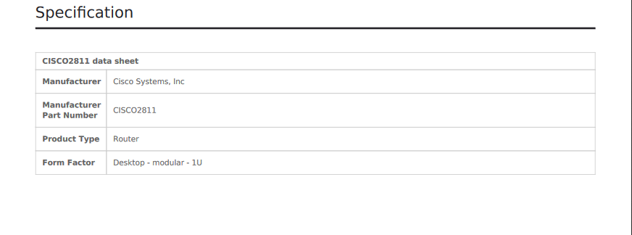

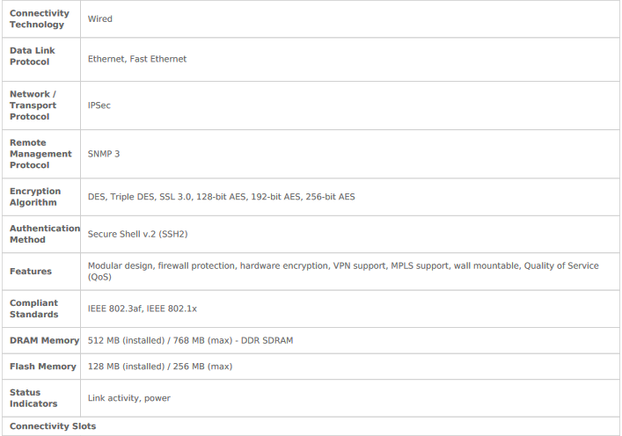

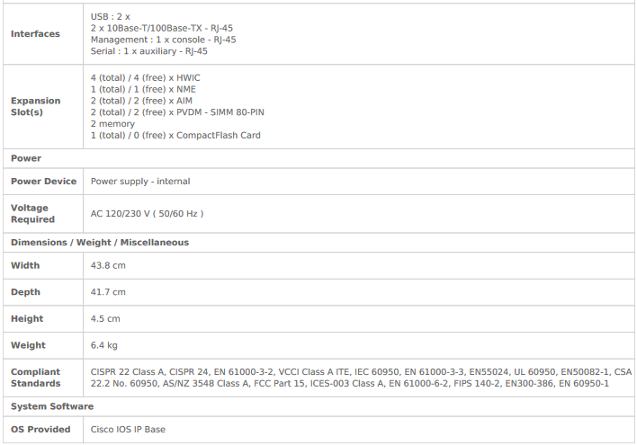

Catayst 3500 switch

https://docstore.mik.ua/univercd/cc/td/doc/product/lan/c2900xl/29_35wc/3500hig.pdf

The Catalyst 3500 series XL switches—also referred to as Catalyst 3500 XLswitches—are stackable 10/100 Ethernet switches to which you can connectworkstations and Cisco IP Phones and other network devices such as servers,routers, and other switches. These switches also can be deployed as backboneswitches, aggregating 10/100 and Gigabit Ethernet traffic from other networkdevices. A feature specific to the Catalyst 3524-PWR XL switch is its ability toprovide inline power to Cisco IP Phones. (Phone adapters are not required whenconnecting to the Catalyst 3524-PWR XL 10/100 switch ports.)

