**CSC 4110**

**GROUP PROJECT III**

**Group Members:** Issa Habeeb, Ali Algahim, Emran Ali, George Ebaugh, Munassar Shariff, Nadia Aktar, Rasheed Kareem.

**Overview:**

The employee tracker app kicks off with a screen displaying roles like software engineers or HR, each with its own image. Users can pick a role, leading them to a detailed page showing the current employee count and individual info. The app simplifies management by allowing users to easily add or remove employees in the selected role, making workforce tracking straightforward.

**Why Choose Our Team for the Employee Tracker App:**

**Expertise in Tkinter:**

* Our team has a proven track record of utilizing Tkinter to create powerful and intuitive graphical interfaces.
* Successfully completing Project II involving Tkinter demonstrates our deep understanding of the library's capabilities and its potential for crafting user-friendly interfaces.

**HTML and CSS Proficiency:**

* We bring extensive expertise in HTML and CSS, as evidenced by successful projects completed in previous classes.
* Our team excels in writing clean, semantic HTML and designing visually appealing, responsive CSS styles.

**Diverse Skill Set:**

* Our team comprises individuals with diverse skills, including graphic design, user experience (UX) design, and programming (CSS, HTML, etc.).
* This diversity enables us to approach the project holistically, ensuring both flawless functionality and visually appealing, user-friendly design.

**Innovative Design:**

* We have a proven record of delivering innovative and eye-catching designs that captivate users.
* Our creative approach to web design incorporates the latest trends, ensuring a modern and engaging user interface.

Responsive Web Design:

* Prioritizing responsive web design, we guarantee that our interfaces seamlessly adapt to various screen sizes and devices.
* Our commitment to a mobile-first approach ensures the project reaches a diverse audience.

**Scalability and Adaptability:**

* We design interfaces with scalability in mind, allowing for easy expansion and adaptation as project requirements evolve.
* Our interfaces are robust and capable of handling future enhancements and changes.

**Collaborative Teamwork:**

* Our team thrives on a strong collaborative spirit, communicating effectively and working seamlessly together.
* We deliver a cohesive and integrated interface that aligns with the project's goals through effective collaboration.

**Passion for UI/UX:**

* Creating graphical interfaces using Tkinter is not just a project for us; it is our passion.
* We are genuinely excited about the opportunity to work on this project and are committed to delivering outstanding results.

**AWS hosting quote:**

**Linux/Unix:**

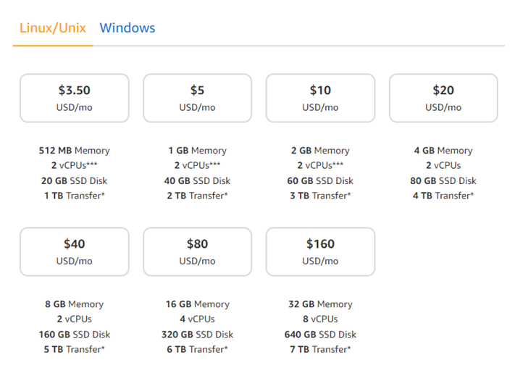

**Windows:**

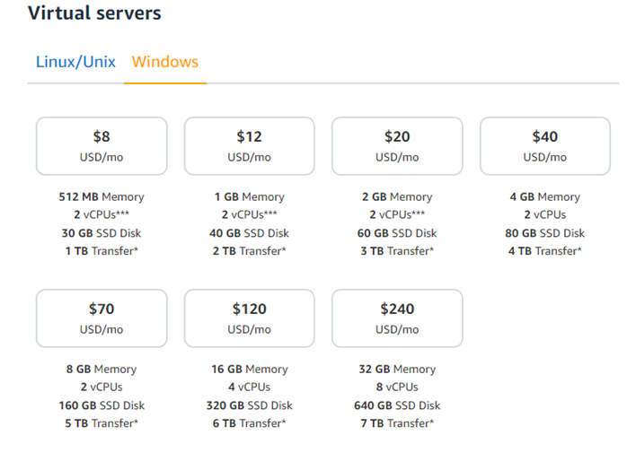

**Future Recommendations:**

Looking ahead, consider adding a search feature and filters for quicker employee access. An analytics dashboard could offer visual insights into workforce distribution and key stats. Strengthen the app's security with user authentication and access levels, while a notification system keeps users in the loop on important updates. Also, ensure mobile responsiveness for easy access on various devices. These enhancements will elevate user experience and overall functionality.

**APA references:**

**Amazon Web Services. (n.d.). Amazon LightSail Pricing. Retrieved from** [**https://aws.amazon.com/lightsail/pricing/**](https://aws.amazon.com/lightsail/pricing/)

1. Written (including technical documentation) (1 to 2 pages)

State your case!!

Format is Times New Roman, 12 point, double spaced

Include similar technical documentation from the website(architectural diagrams)

Include hosting quote in various platforms, such as AWS(optional)

Include future recommendations/ further BI potentials

->APA references