[**Prussia x Reader- Based off of Beer: Part 2 Prussia x Reader- Based off of Beer: Part 2**](http://silverspidergerman.deviantart.com/art/Prussia-x-Reader-Based-off-of-Beer-Part-2-350808117)

* by ~[SilverSpiderGerman](http://silverspidergerman.deviantart.com/), Jan 26, 2013, 8:37:51 PM
* [Literature](http://www.deviantart.com/literature/) / [Prose](http://www.deviantart.com/literature/prose/) / [Fiction](http://www.deviantart.com/literature/prose/fiction/) / [Romance](http://www.deviantart.com/literature/prose/fiction/romantic/) / [General](http://www.deviantart.com/literature/prose/fiction/romantic/general/) / [Short Stories](http://www.deviantart.com/literature/prose/fiction/romantic/general/shortstory/)

You woke up in bed with a pounding headache.

outline 1

outline 2

outline 3

outline 4

~~outline 5~~

outline 6

outline 7

outline 8

outline 9

* outline 10
* outline 11

1. outline 12
2. outline 13
3. outline 14
4. outline 15
   1. outline 16
   2. outline 17

"Ouch. What the-" you muttered, then looked at your clothes and saw that they were the same ones you wore last night. This is new text met.... you met his brother and girlfriend. And the albino ordered....  
  
  
He ordered beer for you.  
  
  
"Shit." The brief thought of Gilbert being a vampire popped into your head. You laughed. What a stupid thought.

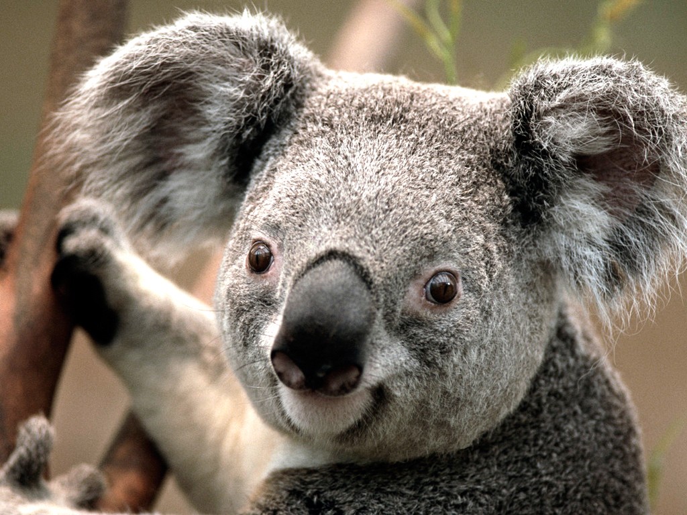New abzac.  
  
  
Wait a second. He had kissed you. You. That was something that you remembered. Didn't he also... say something... he was the one who had put you in your bed, you were sure. Didn't he say something? It was in German, that you were also sure of. You reached for the cordless phone on a table by your bed. The line rang until he answereed.  
  
  
  
"Ah, good morning! Did you sleep well?" you could imagine him snickering on the other line.  
  
  
"No no no, I change this document. Erm, I remember some things...." you said, not sure what to say suddenly.  
  
  
"Do you now?" he sounded generally concerned.

New text in abzac Uhm... that got me thinking. I feel.... behind him. So, I was thinking. Then you said, "You know what? Why not?"  
  
  
"Yes. Ah... Did you, uh," you cleared your throat, "kiss me?" you asked in a tiny voice.   
  
  
"Well.... There's no denying that. Ja, I did." Your face blushed. But you had to know what else he said. Before you could say anything, though, he beat you to the punch.  
  
  
"Uhm. Did you hear? Ludwig proposed to Feliciana after they left yesterday."