

Course Name: System Analysis and Design

Course number: INFO 1113 Section S10



Date:1/12/2021da

FULL NAME: SAGAR STUDENT ID: 100420154

EMAIL ID: [sagar3@email.kpu.ca](mailto:sagar3@email.kpu.ca)

website URL: https://sites.google.com/view/recycling-move/home

FULL NAME: amrit kaur sandhu STUDENT ID: 100416424 EMAIL ID: amrit.sandhu8@email.kpu.ca

website url: <https://sites.google.com/view/farmingapplication>

PROJECT MEMBERS

PROJECT TITLE: VEGETABLE STORE MANAGEMENT SYSTEM

FULL NAME: sanjot singh STUDENT ID: 100416640 EMAIL ID: sanjotsingh @email.kpu.ca

website url: <https://sites.google.com/view/sanjot-singh-sidhu>

FULL NAME: akashdeep singh STUDENT ID:100415028 EMAIL ID: akashdeepsingh11@email.kpu.ca

website url: <https://sites.google.com/view/systemanalysis2021s10/home>

Trello Link: <https://trello.com/b/HmRMLXyZ/akash>

<https://trello.com/b/Ug7t9KUY/amrit>

<https://trello.com/b/6QmQpgQp/sagar>

https://trello.com/b/odNk5Oy4/sanjot

Github links of all:

<https://github.com/Amrit789/vegetable-store-management>  
<https://github.com/sanjot212/sanjot212>  
<https://github.com/pruthi7230/testProject/projects>

|  |  |
| --- | --- |
| **Sr. no.** | **Title** |
| 1 | Introduction |
| 2 | Use case diagrams |
| 3 | Class diagrams |
| 4 | Interface prototype |
| 5 | Relational experience |
| 6 | Work experience |
| 7 | Conclusion |

**VEGETABLES STORE MANAGEMENT SYSTEM:**

INTRODUCTION: -

The "Online Vegetable Store" was created to address the shortcomings of the traditional manual approach. This programme is designed to remove or, in some circumstances, mitigate the difficulties that this system now faces. Furthermore, this system is tailored to the company's specific requirements for smooth and efficient operations. Their information and management systems are critical for collaborating with and influencing suppliers. On the other side, marketing and other methods are critical in understanding client demand.

The project's key feature is that it allows administrators to manage the records of Shops and their Vegetable Shops, including Vegetable Sales, Vegetable Stocks, and Vegetable Sales History. Other elements of the Vegetable Shop Management System include the requirement for the user to supply Vegetable name, Vegetable price, and Vegetable quantity when adding goods from the admin account.

Similarly, while replenishing Vegetables, the user must first pick the Vegetable by entering its name, and then input the amount. Removing a Vegetable is likewise a piece of cake; all he needs to do is open the report and select the remove Vegetable option. While examining stocks, the system provides Particulars (Vegetable name) along with Available stock and Price.

The goal of the project is to develop a system that allows customers to book vegetables from a certain store using precise information. So that there is no squandering of time.

Because they are the ultimate point of contact for customers, retailers and their related services play a crucial role in the supply chain. Retailers are the final link in the supply chain, as they are in direct touch with the end users. This is the most important link because it is the customer's final opportunity for purchasing products.

USE CASE DIAGRAM

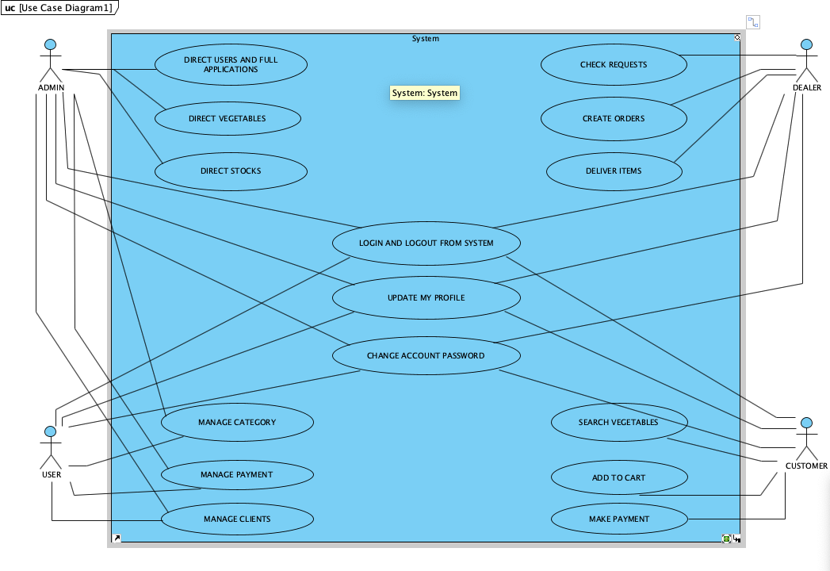

The relationships among the pieces of the Vegetable Store Management System are graphically shown in this Use Case Diagram. It describes the system analysis technique for identifying, clarifying, and organising the system requirements of the Vegetable Store Management System. In this Use Case Diagram, the main actors of the Vegetable Store Management System are Admin, User, Dealer, and Customer, who perform various use cases such as Vegetable, Manage Store, Manage Stock, Manage Category, Manage Payment, Manage Bill, Manage Customer, Manage Users, and Full Vegetable Store Management System Operations.

The relationship between, as well as the use cases of the Vegetable Store Management System:

* Vegetable, Manage Store, Manage Stock, Manage Category, Manage Payment, Manage Bill, Manage Customer, Manage Users, and Full Vegetable Store Management System Operations.
* System User Entity: Manage Store, Manage Stock, Manage Category, Manage Payment, Manage Bill, Manage Customer, Manage Users, and Full Vegetable Store Management System Operations.
* Dealer Entity: Check Requests, Create Orders, Deliver Items, Create Invoices, and Collect Payments are examples of Dealer use cases.
* Customer Entity: Customer use cases include searching for vegetables, adding items to cart, and making a payment.

CLASS DIAGRAM

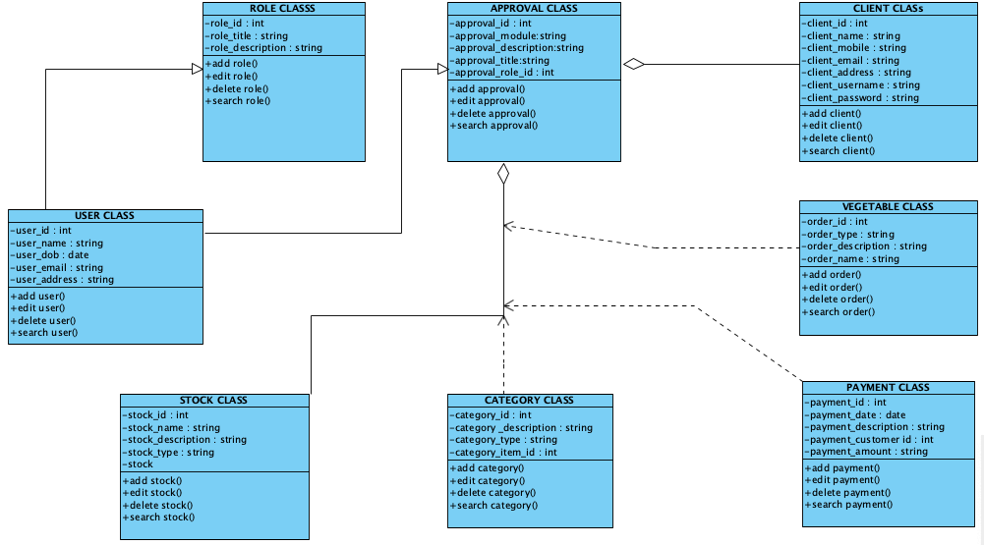

The structure of a Vegetable Store Management System class, its characteristics, operations (or methods), and relationships among objects are described in the Vegetable Store Management System Class Diagram. Vegetable, Store, Stock, Category, Payment, and Bill are the main classes of the Vegetable Store Management System.

Vegetable Store Management System Types Diagram of a Class:

* Vegetable Class: Manage all Vegetable activities.
* Store Class: Manage all Store operations.
* Stock Class: Manage all Stock operations.
* Category Class: Manage all Category operations.
* Payment Class: Manage all Payment operations.
* Bill Class: Oversee all of Bill's operations.

Vegetable Store Management System Class Diagram shows the classes and their characteristics.

* Vegetable id, Vegetable Name, Vegetable Type, Vegetable Description.
* Store id, store name, store type, and store description are some of the store attributes.
* Stock id, stock items, stock number, stock type, and stock description are some of the stock attributes.
* category id, category item id, category type, and category description.
* Payment id, payment customer id, payment date, payment amount, and payment description are some of the payment attributes.
* Bill id, bill customer id, bill number, bill type, bill receipt, and bill description are some of the bill attributes.

Vegetable Store Management System Class Diagram:

Classes and Methods

* Vegetable methods include add Vegetable(), edit Vegetable(), delete Vegetable(), update Vegetable(), save Vegetable(), and search Vegetable().
* Add Store(), edit Store(), delete Store(), update Store(), save Store(), and search Store() are all store methods ()
* Stock methods include add Stock(), edit Stock(), delete Stock(), update Stock(), save Stock(), and search Stock() ()
* Add Category, edit Category(), delete Category(), update Category(), save Category(), search Category() are some of the category methods.
* Add Payment(), edit Payment(), delete Payment(), update Payment(), save Payment(), search Payment() are all payment methods ().
* Add Bill(), edit Bill(), delete Bill(), update Bill(), save Bill(), and search Bill are some of the bill methods.

INTERFACE PROTOTYPE

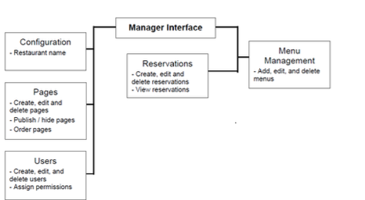

Relational database tables.

Registration page: -

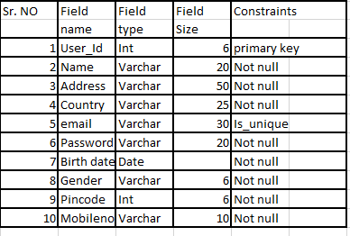

Login table:-

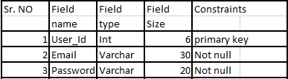

Customer details:-

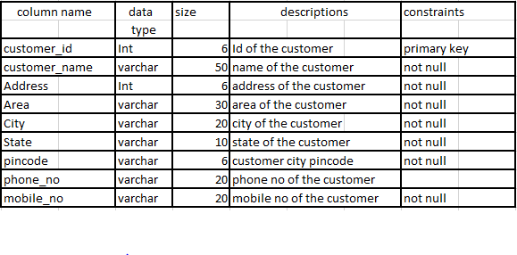

Order details: -

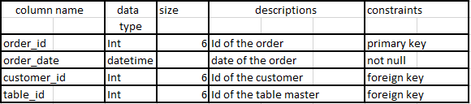

Bill vegetable items: -

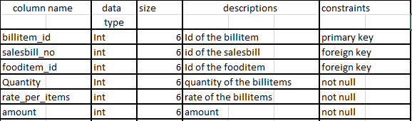

Payment collection: -

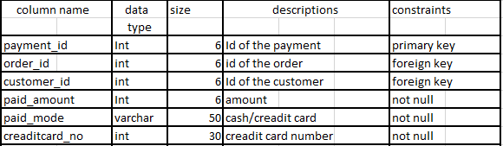

* Login Pages: - A user and admin must login with his user name and password to the system after registration.
* Vegetable menu maker: - menu maker helps you transform a handful of vegetable photos and some saucy sentences into a complete, professional menu in just a few minutes.
* Online vegetable booking: - In order to manage the vegetables, they must memorise or retain information about what vegetables are available.
* Payment methods: - online payments let your customers pay for your goods and services through your website or app. Payments can be automatic and convenient. Make sure you use encryption for sending payment information to protect your customers from cyber criminals.
* Reservation management: - It can manage all table reservations
* Table management: - it can manage table and seats of the restaurant.

Work Experience

It was a great work experience as it was first time when we worked together like a group in this project and feel like we are working for a big company in a big project moreover it was full of knowledge as well as fun because in this project we get a chance to share our knowledge about this course and the project content. There were difficulties too as it was totally new to us and we feel some pressure too like in use case diagram we are not able to draw correctly but with the help of Sanjot we were able to draw it very well though we have divided the tasks but each of us was available for each other whenever someone needs any help. In the rest part of the we also helped each other, for making everyone comfortable and to make feel everyone that he /she is doing good in project we motivated each other at every step of the project, the main lesson we get with this project is that we learn how to manage time properly. Overall, it was a great working experience and we all think it will help us in our future jobs.

Conclusion:

The project's key feature is to address the difficulties in vegetable stores so that they can manage their operations smoothly. Not only for administration it also focuses on the requirements of customers to access precise information. Every actor in the use case diagram performs various use case functions. Relation database table consists of login pages, vegetable menu makers, Online booking, payment methods reservation, and table management.