AI-Based Smart Food Delivery System for ICST University Park
Project Proposal / Week 1 Report

Name: ____________
Course: ____________
Date: ____________

Table of Contents

1. Introduction
2. Literature Review
3. Requirements Gathering
4. System Design
5. Dataset Collection
6. Data Cleaning
7. Exploratory Data Analysis
8. Feature Engineering
9. Tools & Technologies
10. Conclusion
11. References

1. Introduction

This project focuses on developing an intelligent food delivery system for ICST University Park using Artificial Intelligence (AI) and web/mobile technologies. The system will allow students and staff to order food online, track deliveries in real time, and receive AI-based recommendations based on their preferences and previous orders. The goal is to improve convenience, reduce waiting time, and optimize delivery operations inside the campus.

2. Literature Review

- Several studies show that AI can improve online food ordering and delivery systems.
- K. Zhao et al. (2020) discussed how AI-based recommendation systems improve customer satisfaction in food delivery apps.
- Uber Eats and DoorDash use AI for route optimization and order prediction.
- Machine learning algorithms help predict delivery time and suggest popular menu items.

3. Requirements Gathering

- Functional Requirements
- User registration and login
- Browse restaurants/food stalls available in ICST
- Search and filter food items
- Add items to cart and place orders
- AI-based food recommendations
- Real-time order tracking
- Online payment / Cash on delivery
- Admin dashboard to manage restaurants, orders, and user
- Delivery staff panel for delivery updates

Non-Functional Requirements

- Fast response time
- Secure payment processing
- User-friendly interface
- High availability and reliability
- Scalability for future expansion
- Data privacy and security

4. System Design

Architecture
The system can use a 3-tier architecture:
Presentation Layer – Mobile app / Website
Application Layer – Backend server with AI engine
Database Layer – Stores users, orders, restaurants, and delivery data

Diagram format:

User App / Website
↓
Backend Server + AI Engine
↓
Database

Use Case Diagram

Actors:

Customer
Admin
Restaurant Staff
Delivery Person

Use Cases:

Register/Login
Place Order
Make Payment
Track Order
Manage Menu
Assign Delivery
View Reports
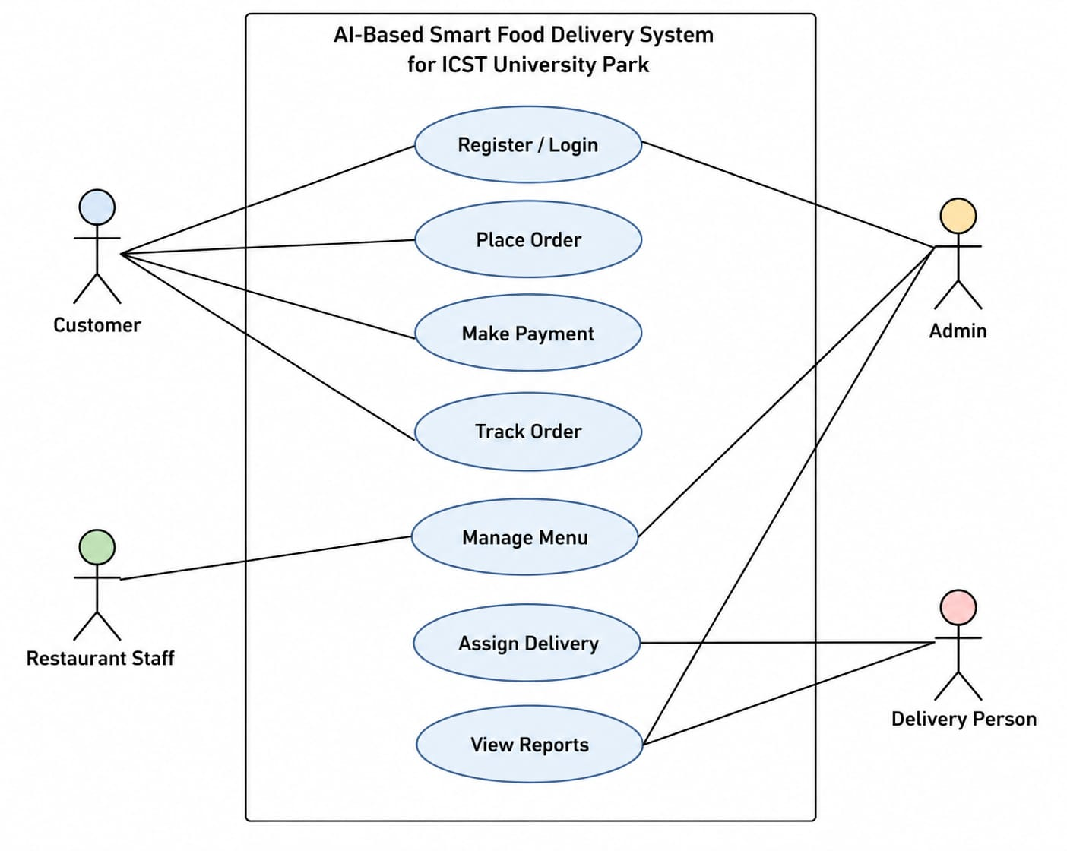

DFD (Data Flow Diagram)

- Main Processes:
- User places order
- System processes payment
- Restaurant prepares food
- Delivery person delivers order
- User receives notification

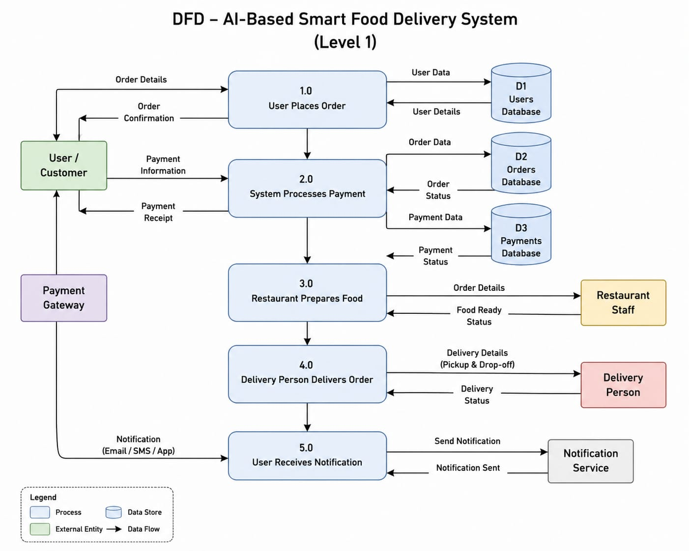

5. Dataset Collection

Data can be collected from:

- User order history
- Food item details
- Delivery times
- Customer ratings and reviews
This data will be used for AI recommendations and delivery time prediction.
6. Data Cleaning

- Data cleaning involves:
- Removing duplicate records
- Handling missing values
- Standardizing food categories
- Formatting dates and time properly

7. Exploratory Data Analysis (EDA)

EDA can help identify:
- Most popular food items
- Peak ordering times
- Average delivery times
- Customer preferences
- Sales trends

8. Feature Engineering

Important features include:
- Customer purchase patterns
- Food categories
- Delivery distance
- Order time
- Weather or event-based demand prediction

9. Tools & Technologies

Programming Languages: Python, JavaScript
Frontend: React / Flutter
Backend: Node.js / Django
Database: MySQL / MongoDB
AI/ML: TensorFlow / Scikit-learn

10. Conclusion

This project demonstrates how AI can improve food ordering and delivery services within ICST University Park. By using AI for recommendations and delivery optimization, the system can increase efficiency, improve user satisfaction, and support smarter campus services.

11. References

Zhao, K. et al. (2020). AI-based recommendation systems in food delivery.
Research papers on smart delivery systems and AI in e-commerce.
Documentation from Google Cloud AI, Microsoft Azure AI, and IBM Wat

