

**FACULTY:** Applied and Computer Sciences

**DEPARTMENT:** Computer Sciences

**SUBJECT:** Business Analysis 3.1

**SUBJECT CODE:** AIBUX3B

**LECTURER:** Mrs Thabane

**MODERATOR:**  Mr. R. Baxter

**YEAR:** 2025

|  |  |
| --- | --- |
| **ASSESSMENT NAME:** | Assessment 3: Project Plan |
| **ASSESSMENT DATE:** | 05 May 2025 |

|  |  |  |
| --- | --- | --- |
| **STUDENT NUMBER** | **SURNAME AND INITIALS** | **SIGNATURE** |
| 222776358 | SEROBA MG |  |
| 223273856 | MOLAMU KAM |  |
| 223561029 | MAIMELE NG |  |
| 223549525 | NOBELA A |  |
| 224074962 | MULONDO DM |  |

**DECLARATION**

We, Seroba Matlakala

Kamogelo Molamu

Glad Maimele

Angela Nobela

Dembe Mulondo

declare that the contents of this project represent our own unaided work, and that the project has not previously been submitted for academic examination towards any qualification. Furthermore, it represents our own opinions and not necessarily those of the Vaal University of Technology.

Seroba MG 01/05/2025

|  |  |  |
| --- | --- | --- |
|  |  |  |

**Signed Date**

Molamu KAM 01/05/2025

|  |  |  |
| --- | --- | --- |
|  |  |  |

**Signed Date**

Maimele NG 01/05/2025

|  |  |  |
| --- | --- | --- |
|  |  |  |

**Signed Date**

Mulondo DM 01/05/2025

|  |  |  |
| --- | --- | --- |
|  |  |  |

**Signed Date**

Nobela A 01/05/2025

Table of Contents

**DECLARATION** i

1. Introduction 1

2. Project Scope 1

2.1 Project Stakeholders 1

2.2 Project Requirements 1

2.3 Project Deliverables 2

2.4 Work Breakdown Structure 3

3. Project Schedule 4

3.1 Gantt Chart 5

4. Resource Plan 5

5. Quality Management Plan 6

5.1 Quality Standards 6

5.2 Quality Assurance (QA) Process 7

5.3 Quality Measurement and Monitoring 7

5.4 Conclusion: 7

6. Risk Management Plan 8

7. Communication Plan 8

7.1 Objective: 8

7.2 Communication Channels: 9

7.3 Communication Protocols: 9

7.4 Roles & Responsibilities: 9

8. Project Budget 10

9. Conclusion 10

**SwiftService Project Plan**

# Introduction

SwiftServices is a mobile cleaning service that functions through an application that offers instant, simple, and efficient services. By utilizing the application, the project aims to transform the booking process, auto-book appointments, and add price quotes, cleaner profiles, and live status updates to enhance customer experience. By enhanced efficiency and transparency, SwiftServices enhances response time and competes in the growing on-demand economy. The strategy allows the business organization to build confidence, tap into technologically savvy clients, and expand operations more towards long-term growth.

# Project Scope

The objective is to build a practical and simple mobile app for SwiftServices. This app will allow people to book services, monitor service providers, and manage their payments. Key features will include user sign-up, booking services, real-time tracking of providers, and secure payment methods. However, this project will not involve creating a web version of the app or linking with outside third-party services, except for tasks related to home cleaning and personal errands.

## Project Stakeholders

* **Customers**: Individuals or organizations that need speedy, reliable, and convenient cleaning services through the application. Satisfaction from them is what will bring success to the project.
* **Cleaners/Service Providers**: Registered cleaners who utilize the app to acquire work, book, and earn payment for services.
* **Management Team:** Run business, manage the quality of service, and audit business performance via application.
* **Development Team:** Designs, develops, and maintains the app so that it becomes operable and functional.
* **Business Owners/Investors:** Provide funds in exchange for payment in the future in the form of market efficiency and size growth.
* **Customer Support Team:** Deals with customer support, feedback, and complaints for user satisfaction.
* **Project Manager:** Oversee project execution and delivery.

## Project Requirements

**Included:**

* User-friendly mobile app interface
* User registration and authentication
* Service booking and scheduling
* Real-time tracking of service providers
* Secure payment integration
* Notifications and reminders
* Feedback and rating system

**Excluded:**

* Web application development
* Integration with non-related third-party services

## Project Deliverables

1. **Technical Deliverables:**

**Mobile Application (iOS and Android):** New age, trendy UI/UX with sign-ups, bookings, real-time status updates, cleaner profiles, and in-app payment through secure payment gateways.

**Cleaner Side Features:** Job reminders, navigation support, and performance tracking.

**Admin Dashboard:** Web-based job assignment, service monitoring, and customer feedback management control.

**Backend System:** Secure database, user verification, and push messages.

1. **Documetation Deliverables:**

**Project Proposal and System Design:** Writing down objectives, system structure, and backend layout.

**User and Developer Guides:** App usage and maintenance guidance.

1. **Business and Performance Deliverables:**

**Rewards Program:** User return incentives.

**Performance Reports:** Improved performance and satisfaction data.

**Launch Strategy:** Marketing and onboarding rollout strategy.

1. **Excluded Deliverables:**

Advanced analytics, third-party integrations, offline, and in-house cleaner training are out of scope for this phase.

## Work Breakdown Structure

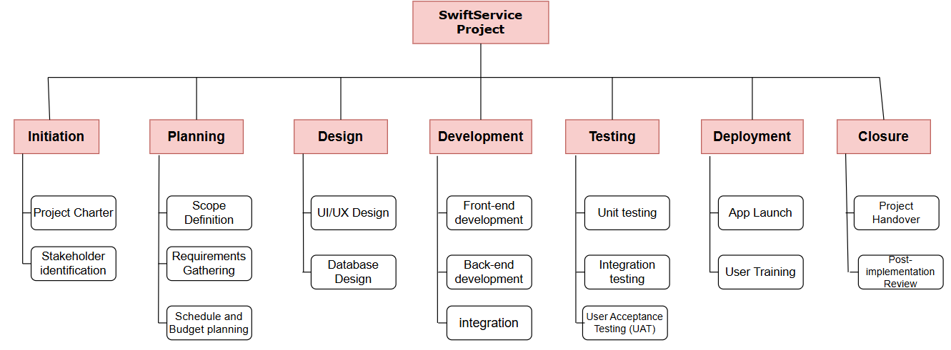

WBS in Tabular Form:

|  |  |  |
| --- | --- | --- |
| **SwiftService Project** |  |  |
|  | 1.Initiation |  |
|  |  | 1.1 Project Charter |
|  |  |  |
|  |  | 1.2 Stakeholder identification |
|  | 2.Planning |  |
|  |  | 2.1 Scope Definition |
|  |  | 2.2 Requirements Gathering |
|  |  | 2.3 Schedule and Budget planning |
|  | 3.Design |  |
|  |  | 3.1 UI/UX Design |
|  |  | 3.2 Database Design |
|  | 4.Development |  |
|  |  | 4.1 Front-end development |
|  |  | 4.2 Back-end development |
|  |  | 4.3 Integration |
|  | 5.Testing |  |
|  |  | 5.1 Unit Testing |
|  |  | 5.2 Integration Testing |
|  |  | 5.3User Acceptance Testing (UAT) |
|  | 6.Deployment |  |
|  |  | 6.1 App Launch |
|  |  | 6.2 User Training |
|  | 7.Closure |  |
|  |  | 7.1 Project Handover |
|  |  | * 1. Post-Implementation Review |

# Project Schedule

|  |  |  |  |  |  |
| --- | --- | --- | --- | --- | --- |
| **Phase** | **Task** | **Start Date** | **End Date** | **Dependencies** | **Milestone** |
| Initiation | Project Charter | 06/01/2025 | 17/01/2025 | None | Project officially initiated (17/01/2025) |
|  | Stakeholder identification | 13/01/2025 | 24/01/2025 | Project charter |  |
| Planning | Scope Definition | 27/01/2025 | 07/02/2025 | Stakeholder identification | Project planning finalized and approved (28/02/2025) |
|  | Requirements Gathering | 03/02/2025 | 21/02/2025 | Stakeholder identification, Scope Definition |  |
|  | Schedule and Budget planning | 10/02/2025 | 28/02/2025 | Requirements Gathering |  |
| Design | UI/UX Design | 03/03/2025 | 21/03/2025 | Requirements Gathering | Design phase completed (21/03/2025) |
|  | Database Design | 03/03/2025 | 21/03/2025 | Requirements Gathering |  |
| Development | Front-end development | 24/03/2025 | 25/04/2025 | UI/UX Design, Database Design | Development phase completed (16/05/2025) |
|  | Back-end development | 244/03/2025 | 25/04/2025 | Database Design |  |
|  | Integration | 28/04/2025 | 09/05/2025 | Front-end development, Back-end development |  |
| Testing | Unit testing | 12/05/2025 | 23/05/2025 | Integration | Testing phase completed, sign-off for deployment (20/06/2025) |
|  | Integration testing | 26/05/2025 | 06/06/2025 | Unit testing |  |
|  | User Acceptance Testing (UAT) | 09/06/2025 | 20/06/2025 | Integration testing |  |
| Deployment | App Launch | 23/06/2025 | 04/07/2025 | User Acceptance Testing (UAT) | Successful deployment and training completed (04/07/2025) |
|  | User Training | 23/06/2025 | 04/07/2025 | User Acceptance Testing (UAT) |  |
| Closure | Project handover | 07/07/2025 | 11/07/2025 | App launch, user training | Project officially closed (18/07/2025) |
|  | Post-implementation review | 14/07/2025 | 18/07/2025 | Project handover |  |

## Gantt Chart

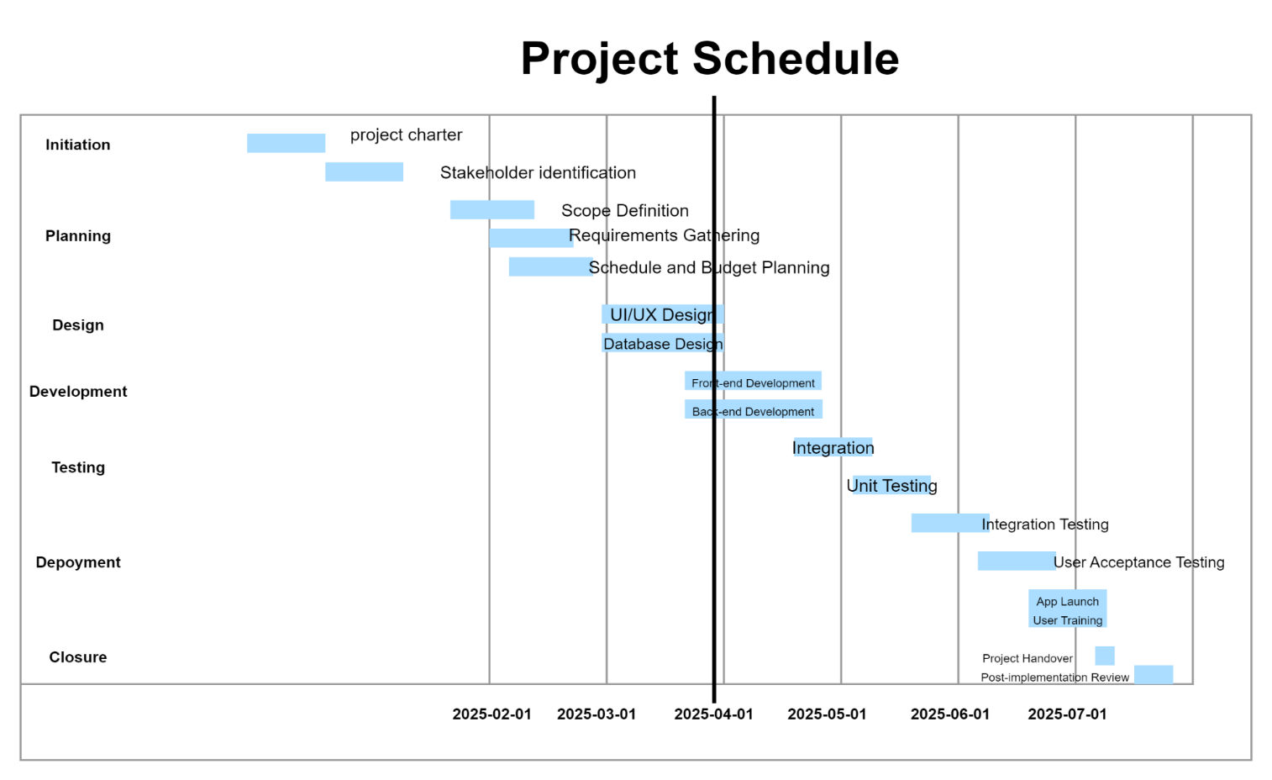

# Resource Plan

1. **Human Resource**

* Project Manager- a person to oversee progress, timeline and team coordination
* Back-end Developer-Develops the server side, database and APIs for functionality example booking, payment and service tracking .
* UI/UX –create a user friendly interface and ensure seamless user experience.
* Front-end Developer-implement the user interface using mobile app development framework.
* Testing- conduct unit testing, integration testing and user acceptance testing
* Customer support team – handles customer queries during and after the launch.
* Marketing specialist- plan and execute campaigns to elevate the apps visibility online.

1. **TimeLine**

* Planning phase-define requirements and conduct feasibility analysis
* Design phase- finalize app design and prototype
* Development phase-front-end and back-end development in parallel
* Testing phase-identify and resolve issues through rigorous testing
* Launch and marketing phase-release the app and promote through campaigns.

1. **Financial Resources**

* Development costs – salaries or hourly rates for developers, designer and others.
* Prototyping and testing- costs for prototype and usability testing
* Operational costs –office rental, equipment purchases and maintenance.
* Branding and content- expenses and promotional videos and other marketing materials.
* Customer Support Tool-costs for help desk software and chatbots.
* Unforeseen costs- reserve funds to address unexpected technical challenges delays or added features.
* Legal documentation-draft term of service, privacy policies and data compliance.

1. **Material resource**

* Software licence- development tools for coding designing and testing.
* APIs –enable real time tracking and secure payment integration.
* Documentation Materials- create user guide, developer manual and other project reports.

# Quality Management Plan

The goal of this quality plan is to define the standards, processes, and measures that will ensure the Swiftservice Mobile App meets customer expectations, functions reliably, and provides a seamless user experience.

## Quality Standards

The following quality standards will guide the development of the Swiftservice app:

* **Functionality:** The app must perform all intended tasks correctly, including service booking, scheduling, tracking, and payment.
* **Usability:** The interface must be user-friendly and intuitive for all users.
* **Reliability:** The app should operate without crashes or unexpected behavior.
* **Security:** User data, especially payment information, must be protected using industry-standard encryption.
* **Compatibility:** The app must run smoothly on both Android and iOS platforms, across various devices.
* **Performance:** The app should load quickly and handle multiple users without lag.

## Quality Assurance (QA) Process

To ensure quality, the following processes will be implemented:

* **Requirement Review:** All features and requirements will be reviewed and confirmed by stakeholders before development begins.
* **Code Reviews:** Regular peer reviews of code to ensure clean, maintainable, and secure code.
* **Automated and Manual Testing:** Includes functional, usability, performance, and security testing.
* **Bug Tracking:** Issues found during testing will be tracked using tools like Jira or Trello and resolved before release.
* **User Acceptance Testing (UAT):** Final testing phase involving real users to validate the app’s quality.

## Quality Measurement and Monitoring

* **Defect Rate:** Monitor the number of bugs per module. Aim for fewer than 3 critical bugs per release.
* **Performance Benchmarks:** App should launch within 3 seconds and transactions should complete within 5 seconds.
* **User Feedback:** Post-launch surveys and app store reviews will be monitored to improve future versions.
* **Testing Coverage:** Ensure at least 90% of code is covered by unit and integration tests.
* **Audit Logs:** Security and compliance will be monitored through backend audit logs.

## Conclusion:

Quality will be built into every phase of the Swiftservice project. Through proper planning, continuous testing, and user feedback, we will deliver a reliable, secure, and user-friendly app that enhances customer satisfaction and brand reputation.

# Risk Management Plan

* **Technical risks**

Use reliable framework and well documented third party APIs to reduce integration issues. Conduct regular security audits and use encryption to safeguard user data. Perform thorough testing on multiple devices to ensure cross platform compatibility.

* **Project management risks**

Define project scope and prioritize features early in the planning phase. Develop a contingency plan to handle resource shortages or delays. Hold regular team meetings to track progress and address issues proactively.

* **Market and User risks**

Involve a user group during the development stage to gather feedback.

Design an intuitive and user friendly interface following best UI/UX practise.

Allocate sufficient budget and resource for pre-launch marketing effort.

* **Financial risks**

Prepare a detailed budget with provisions for contingency funds. Monitor spending and adjust priorities to stay on budget. Seek additional funding through sponsorships or investors.

* **Legal and compliance risks**

Consult legal experts to draft terms of service and privacy policies. Ensure compliance with local and international data protection regulations.

Perform due diligence to avoid intellectual property infringement.

* **Risk Monitoring and Review**

Conduct weekly risk review meetings to assess new risk and re-evaluate existing ones. Use project management tool to track risks and mitigation risks. Regularly update stakeholders on risks status and strategies.

Have a backup team members available to mitigate resource shortage. Include flexibility in the timeline and budget to adapt to unforeseen challenges.

# Communication Plan

## Objective:

To ensure effective and timely communication among all SwiftService project stakeholders, facilitating smooth collaboration, transparency, and swift resolution of issues.

## Communication Channels:

|  |  |  |  |
| --- | --- | --- | --- |
| **Channel** | **Purpose** | **Audience** | **Frequency** |
| Email | Formal updates, documents, key decisions | All stakeholders | Weekly and as needed |
| Slack (or Teams) | Instant messaging for quick coordination | Development team, QA team, PM | Daily |
| Zoom/Google Meet | Project meetings, sprint reviews, demos | Project team, management, clients | Bi-weekly or as needed |
| Phone Calls | Urgent issues and clarifications | Project manager, team leads | As needed |
| Project Management Tool (e.g., Jira, Trello) | Task tracking, progress updates, issue tracking | Development, QA, PM | Continuous (real-time updates) |
| In-app Feedback Tool | Customer feedback collection post-launch | End-users, customer support | Continuous |

## Communication Protocols:

* Meeting Agendas: Sent at least 24 hours before any scheduled meeting.
* Meeting Minutes: Documented and shared within 24 hours after meetings, highlighting key decisions and action items.
* Escalation Path: Issues unresolved for more than 48 hours must be escalated to the Project Manager, and if necessary, to the Business Owner.
* Status Reporting: Project Manager provides weekly progress reports to Business Owners and Stakeholders. Developers and QA team update the task board daily.
* Feedback Management: User feedback collected post-launch is reviewed weekly. Critical feedback is addressed within 72 hours.

## Roles & Responsibilities:

|  |  |
| --- | --- |
| **Role** | **Communication Responsibility** |
| Project Manager | Main point of contact, organizes all communications |
| Developers | Communicate development progress, blockers |
| QA Team | Report test results, defects, and quality updates |
| Business Owners | Provide project vision, approve major milestones |
| Customer Support Team | Relay customer feedback, report recurring issues |
| End-users | Provide feedback post-launch through in-app surveys |

# Project Budget

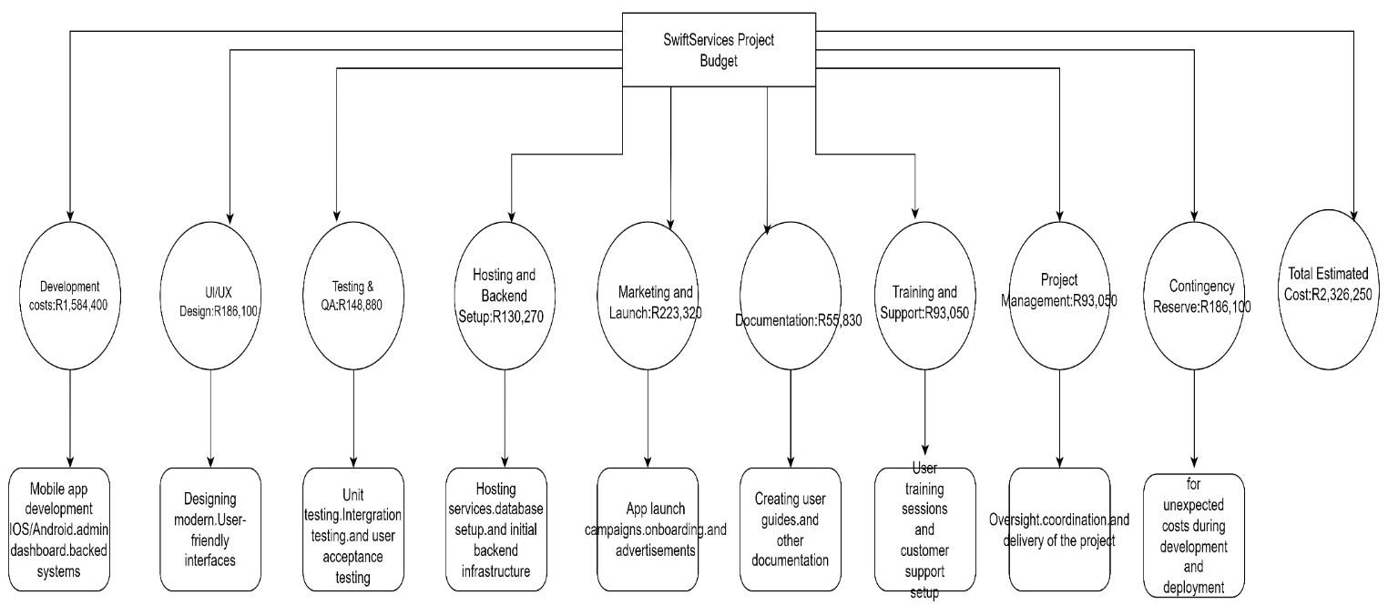

# Conclusion

Swiftservice is an on-demand cleaning service that is set to simplify the booking process and do it online. The project offers a cross-platform (both Android and iOS) app with main features such as instant booking, cleaner profiles, real-time status updates, and in-app payments for more user comfort and transparency to make the business competitive within the on-demand services sector.