The Requester Web App

User Manual

Table of Contents

01.Introduction 3

02.Log In Page 3

03.Forgot password? 4

04.Student Account 5

i) Student Home Page 5

ii) Student Filter Requests 6

iii) Student navigations 6

iv) Student New Request 7

v) Student Profile 8

vi) Student Responses 9

05. Lecturer Account 13

i) Lecturer Home Page 13

ii) Lecturer Filter Requests 14

# 01.Introduction

There should be good communication between students and lecturers. Students have to request various things from lecturers. Some of them are very urgent. Therefore, having paper works for this task is very inefficient. With the hope of overcoming that situation, we developed the Requester Web App where students can send their requests easily and lecturers can respond to them accordingly.

# 02.Log In Page

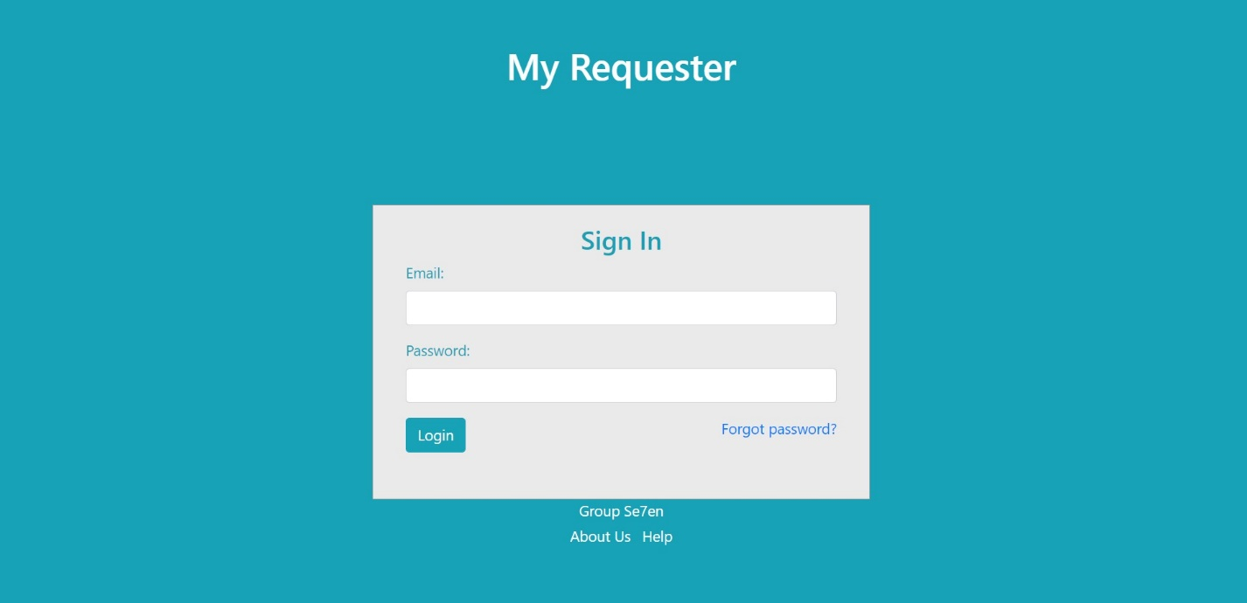

Figure 01

Anyone who has a registered email and password can log in by entering relevant details. After that selecting Login will take you to your account.

If a user forgot his or her password, he or she has to select “Forgot password?”

# 03.Forgot password?

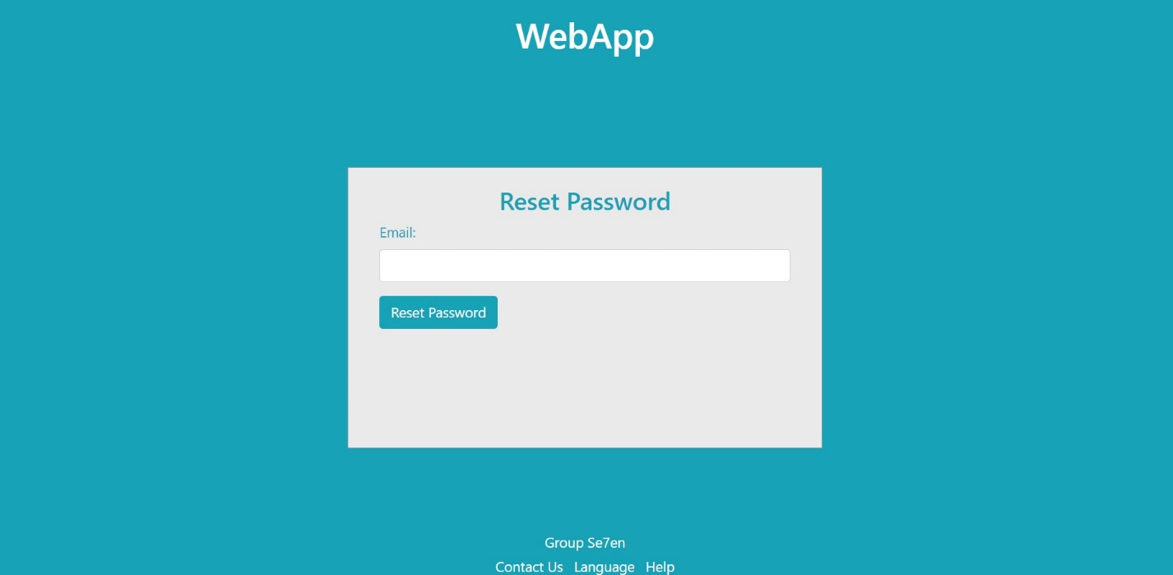

Figure 02

Users have to enter a valid Email and select Reset Password. Then you will receive an email with instructions to reset your password.

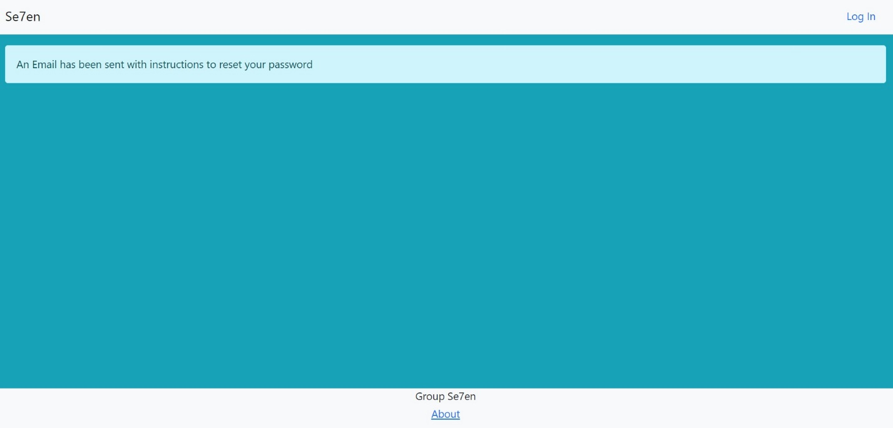

Figure 03

# 04.Student Account

## i) Student Home Page

Once a student is logged in, the student is taken to this page. In the middle, there are all the requests the user made along with the responses he got. Students can filter their requests by selecting Filter requests. Students can send a new request by selecting “New Request”. The student can view and update his profile if needed. Students can logout after finishing work by selecting “Log Out”.

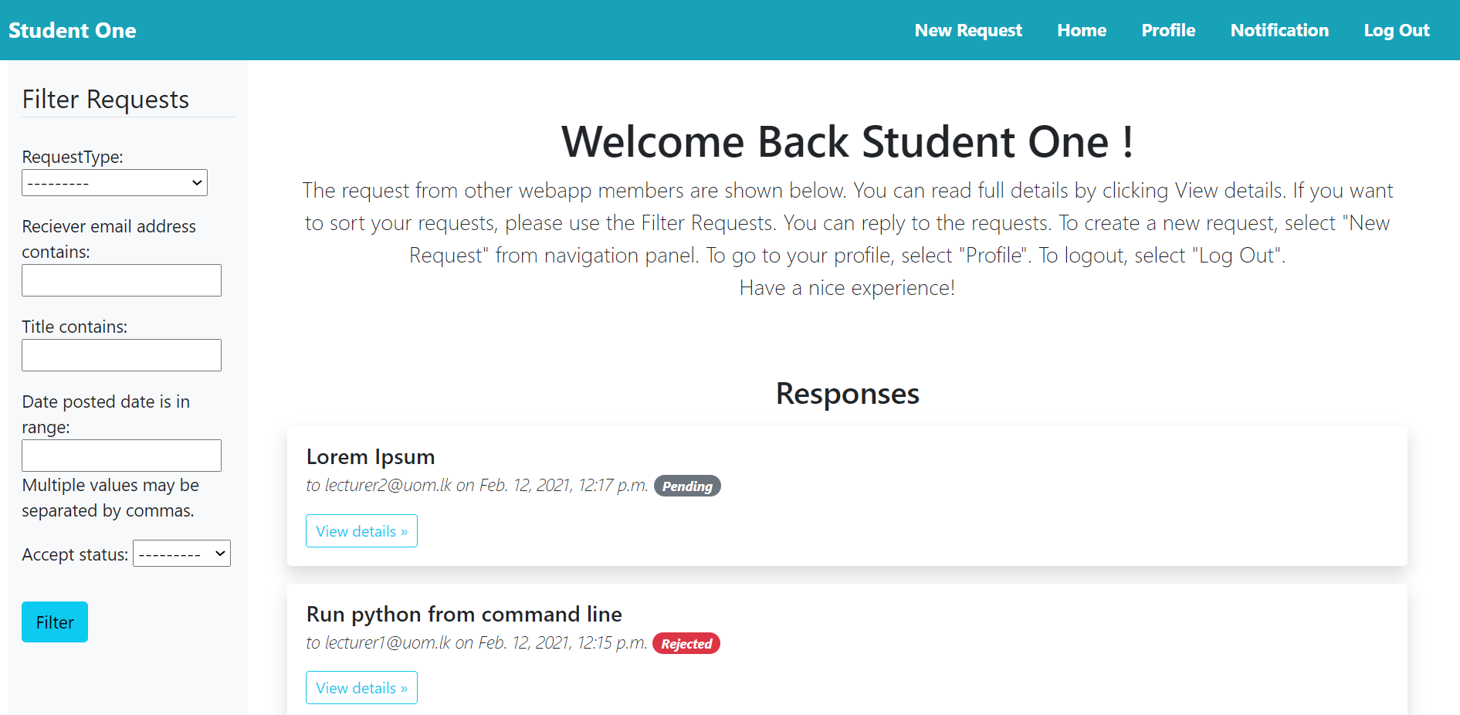

Figure 04

## ii) Student Filter Requests

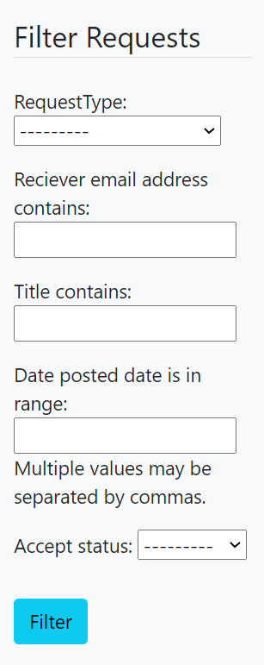

Students can fill these fields accordingly and filter. Then the student will be able to see the filtered requests on the home page.

Figure 05

## iii) Student navigations



Figure 06

Notifications - This is a dropdown list. It will show notifications when a lecturer comment, reply, accept or reject your request. The blue icon will display the count of notifications at that moment (ex: now zero notification available).

New Request – Selecting this will allow the student to send a new request. More details are available below.

Home – This will take the student to Figure 01. If the student is already on the Home Page, selecting this will only refresh the page.

Profile – This will take the student to his or her profile. More details are available below.

Log Out – This will allow the student to log out. Therefore only he can log in again.

## iv) Student New Request

Once a student selects “New Request” in figure 03. He or she will be directed to Figure 04.

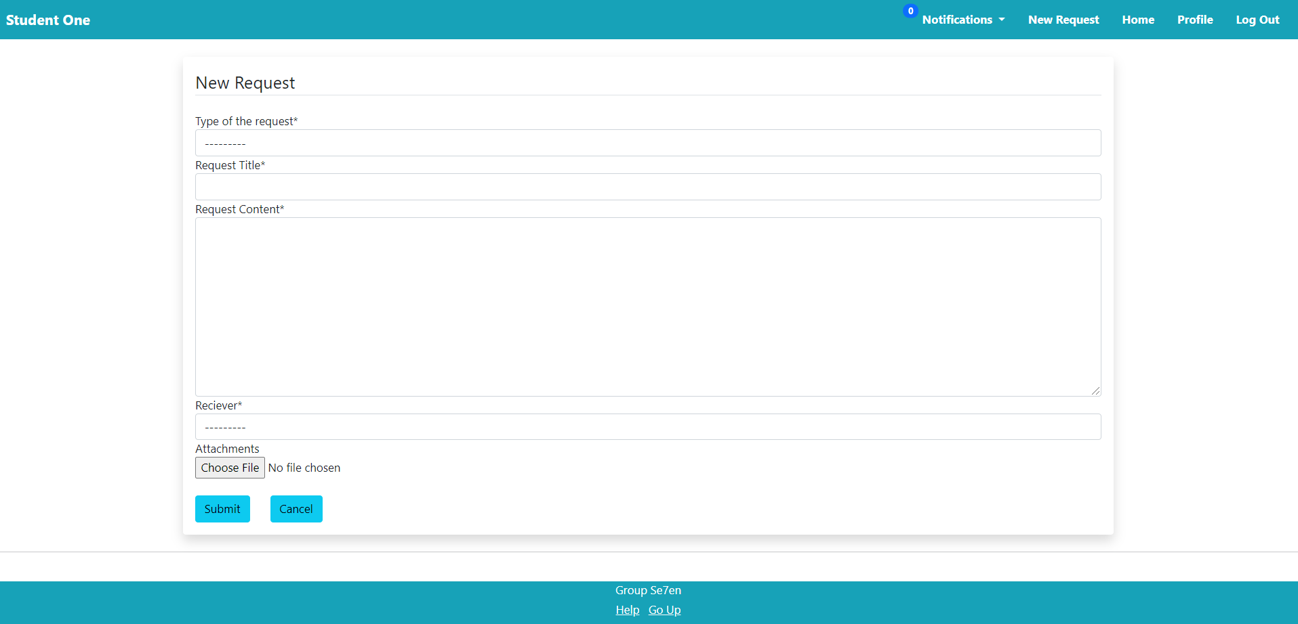

Figure 07

Type of the request – student can select any of the following from the drop-down list,

Extending Deadline

Leave Request

Rescheduling of a Lecture

Miscellaneous Request

Request Title – student can enter the request title

Request Content – user can enter request contents here

Receiver – student can select the lecturer he wants to send the request from the dropdown list

Attachments – User can upload files that he wishes to send

Submit – student can send the request after filling in all details

Cancel – In case a student wants to cancel a request he can use this button.

## v) Student Profile

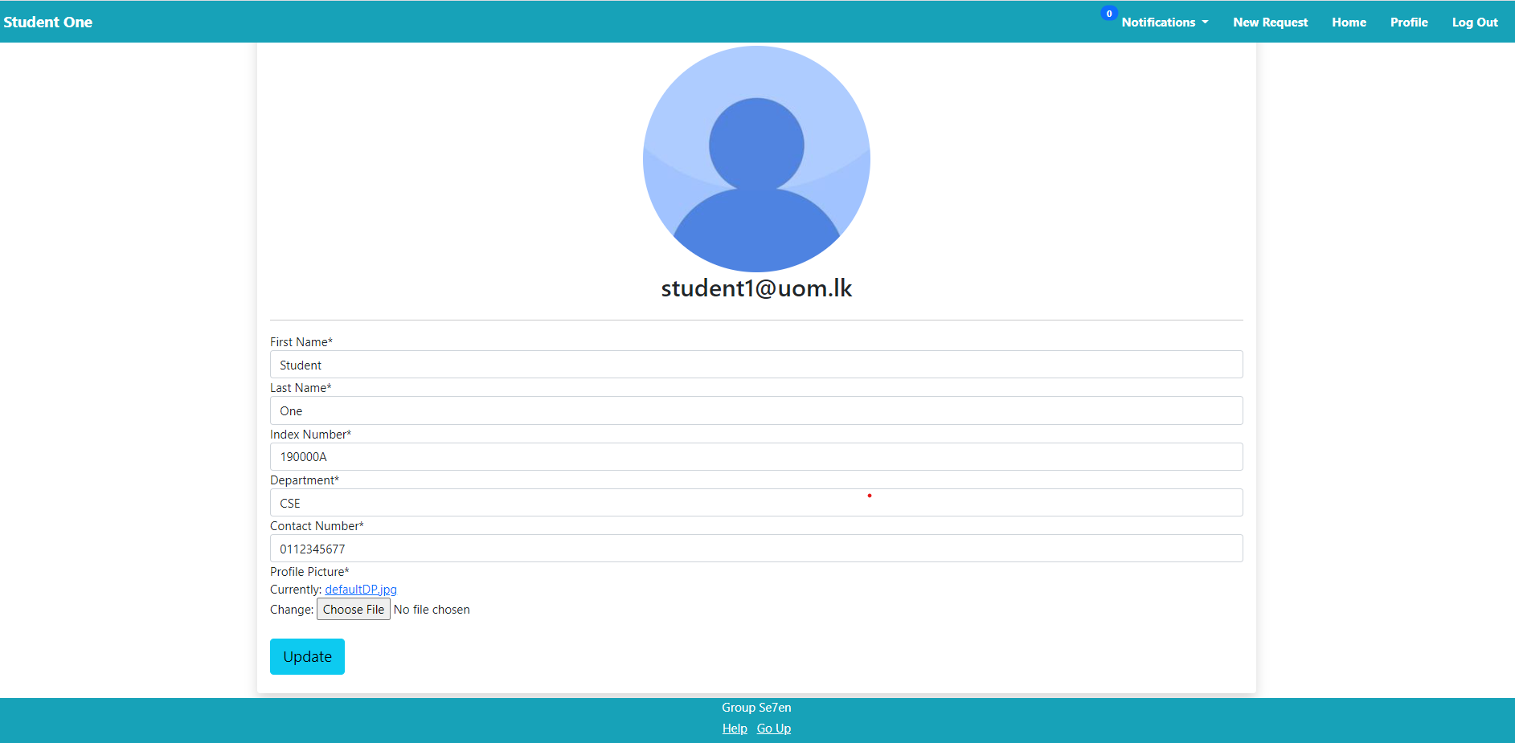

Figure 08

## Here is a dummy account. Once a student selects “Profile” in figure 03. The student will be directed to a similar page in figure 05 with particular student details. A student can change profile details as he or she prefers. If a student doesn't upload a profile picture, “defaultDP.jpg” will be the student's profile picture as in figure 05. Here if a student uploads a profile picture of high resolution, the application will reduce the resolution and saves it to save the memory.

## In the beginning, the students’ accounts are created by the admin of the app according to the details collected by students manually. Only then a student can log in and update profile details. (meka methanat agalapenawada?)

## vi) Student Responses

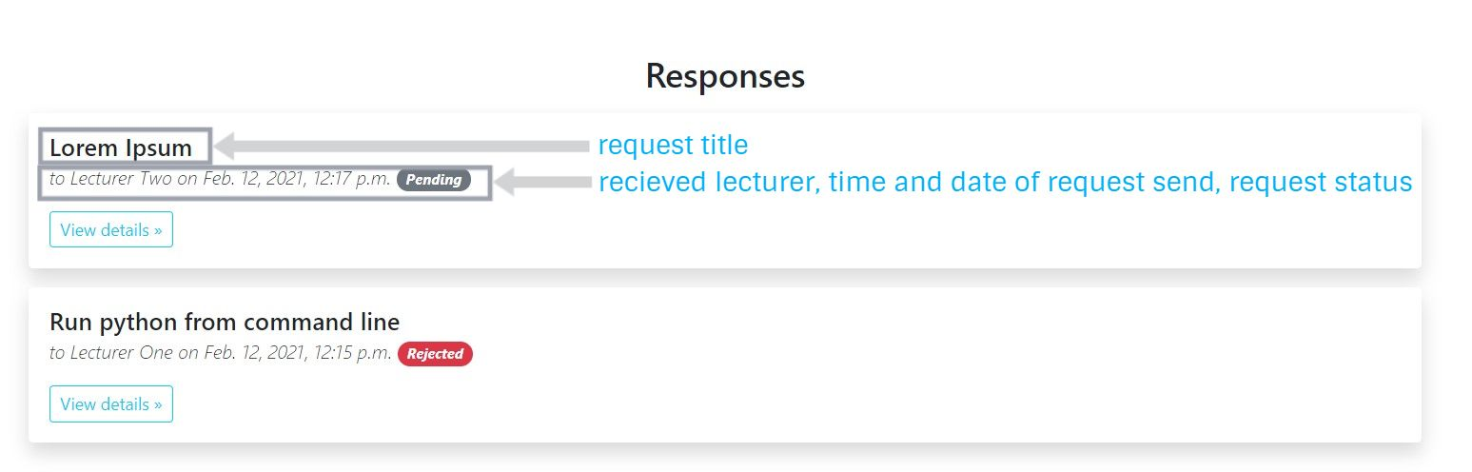

Figure 09

All responses a student made will be listed under “Responses”. The “View Details” button will allow the user to view more details by directing to Figure 07.

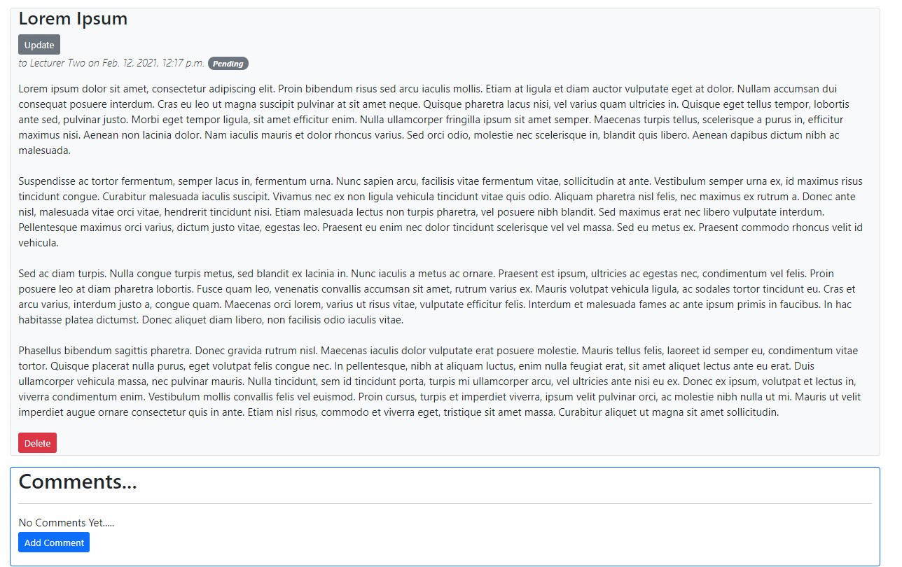

Figure 10

Other than the details in Figure 06. Here, a student can update, delete and add a comment to this requester.

* Update – the student will be directed to a similar page like figure 08. This page is similar to figure 04 with current request details init. Students can change the fields as necessary and submit the request again.
* Delete – This is an irreversible option because of that, after you select the “Delete” button, it will ask the student again whether he is sure about the choice(see Figure 09). If the student is sure, he can select “Delete” again on the page similar to Figure 09. If he wants to cancel, he can select “Cancel”
* Add Comment – Students can type a comment in the box in Figure 10 and submit it. Figure 11 shows a view after adding comments. Adding a comment will send the particular lecturer and notification. Then lecturer and student can reply regarding the comment. Figure 12 shows the reply window.

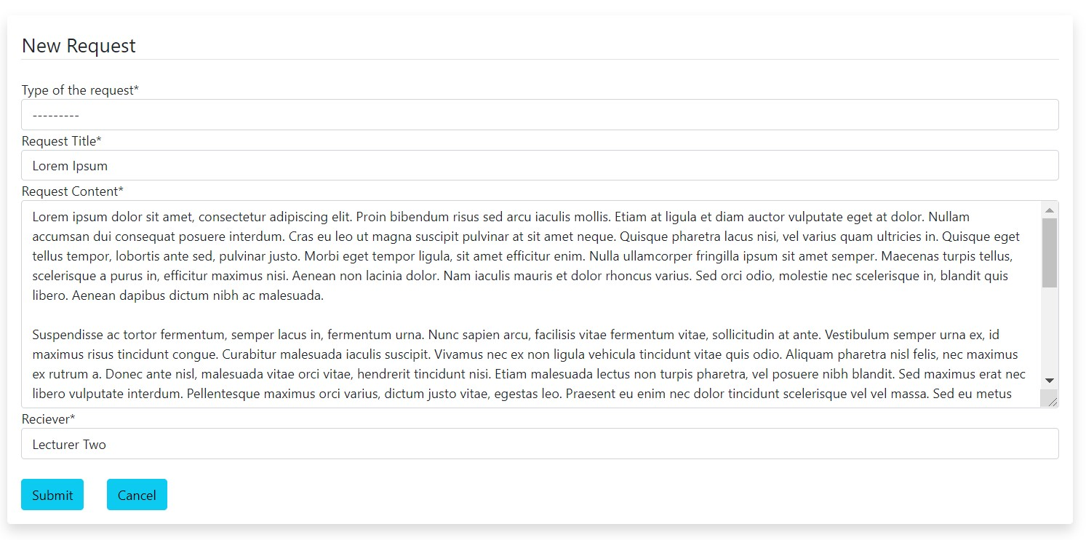

Figure 11

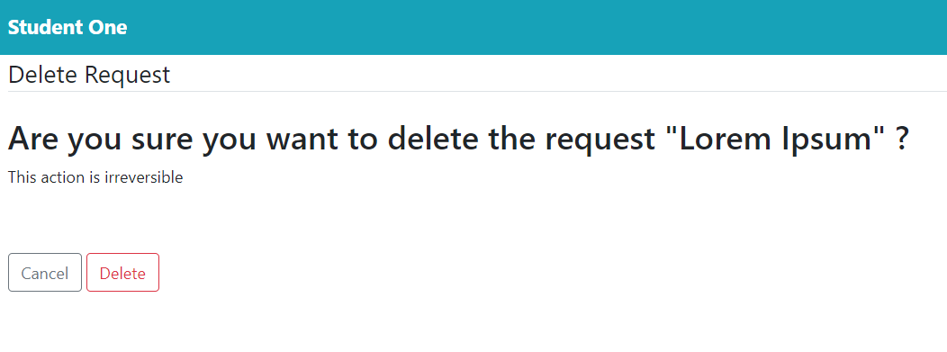

Figure 12

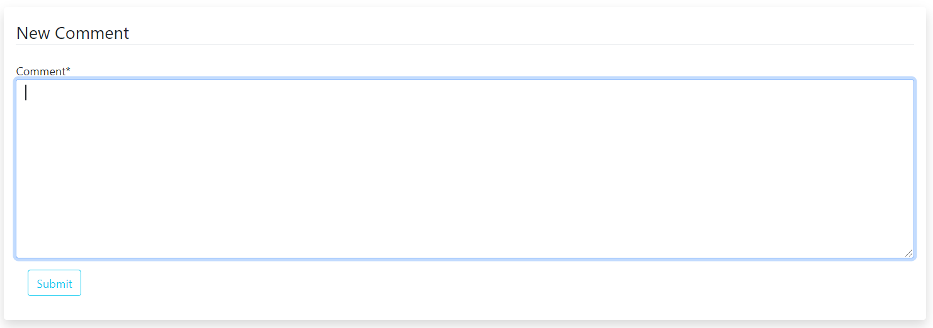

Figure 13

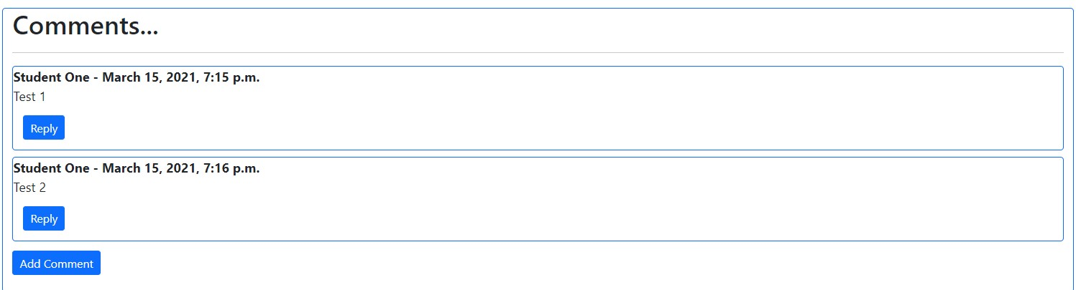

Figure 14

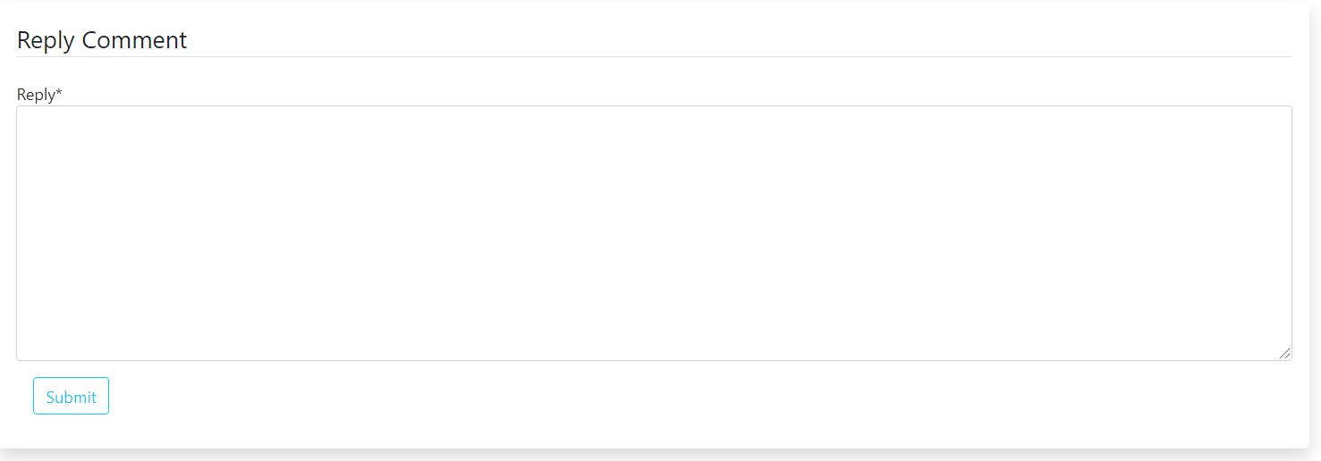

Figure 15

# 05. Lecturer Account

## i) Lecturer Home Page

Once a lecturer log in to the application, he or she will be directed to the below page. This page is very much similar to the student home page.

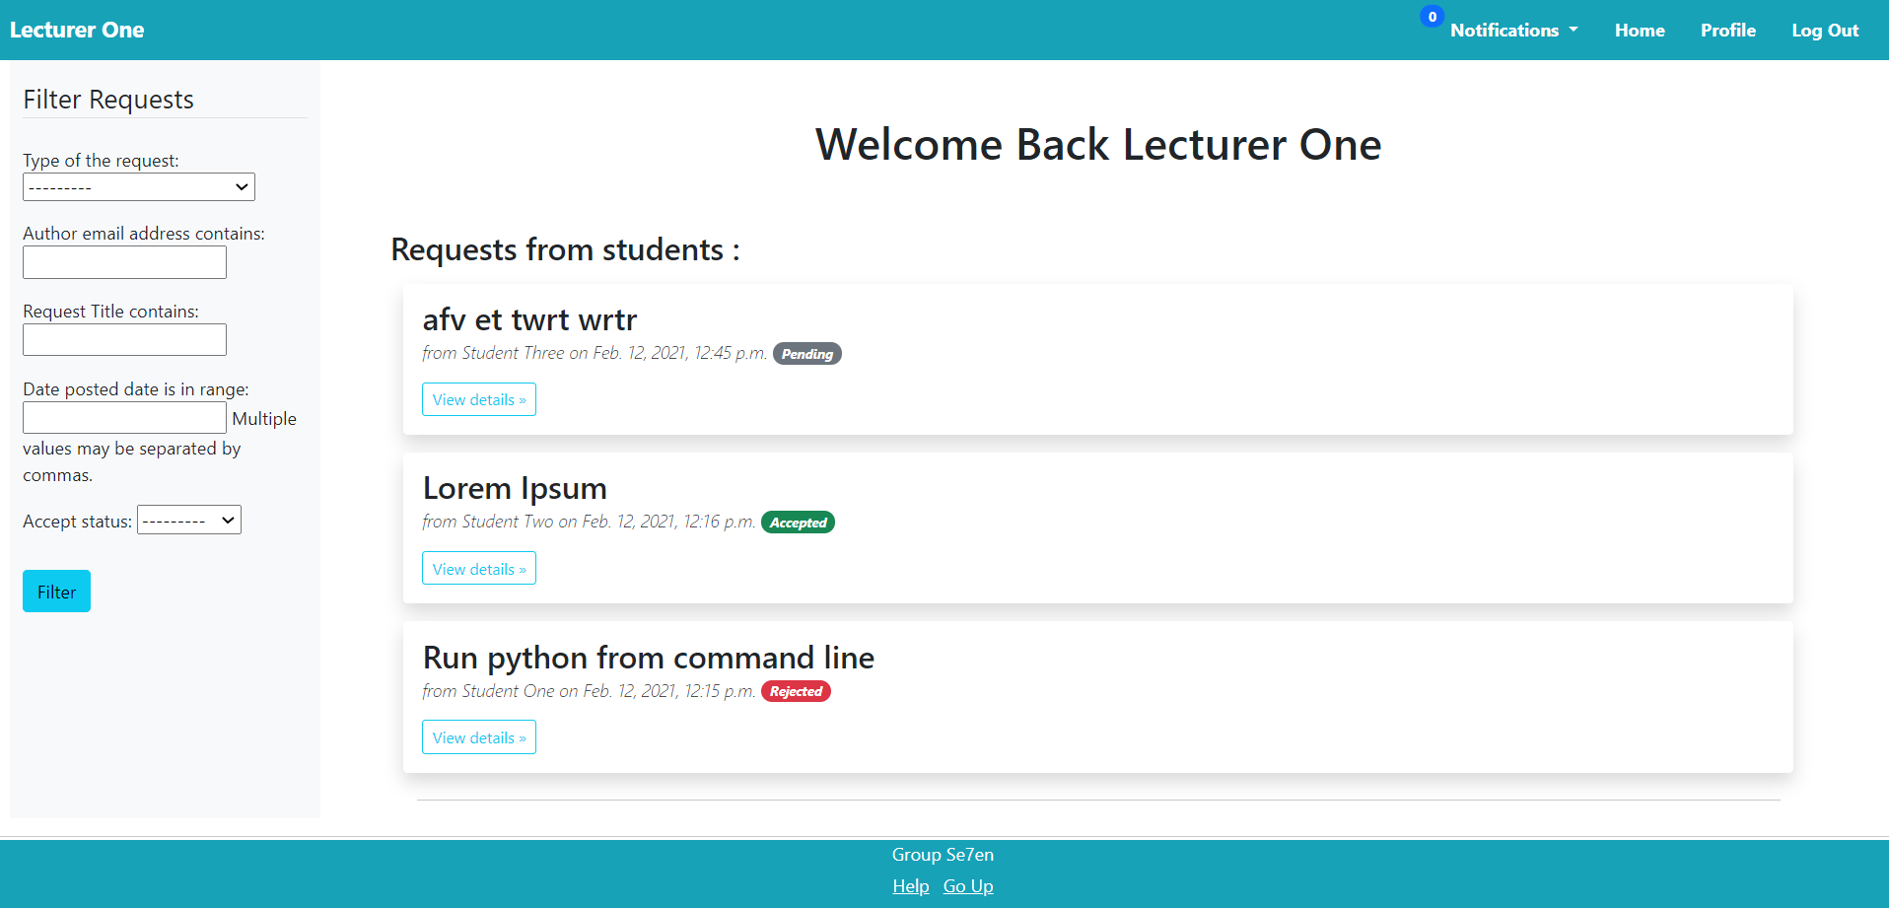

Figure 16

## ii) Lecturer Filter Requests

This is very much similar to the student filter requests in Figure 02. Here, the only difference is the second checkbox is uses the receiver email address while student filter requests take the author email address.

Figure 17

## iii) Lecturer Navigations

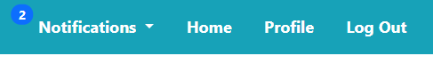 Lecturers’ navigations are very much similar to student’s one.

Figure 18

* Notifications – this displays when a student comment or reply to a request
* Home – this will take the lecturer to a similar page like figure 13 if he is on some other page. If he is already on that page, selecting this will refresh the page.
* Profile – Here lecturer’s details are included. More details are given below.
* Log Out – Lecturer can log out here. (meka wenas wenna onada?)

## iv) Lecturer Profile

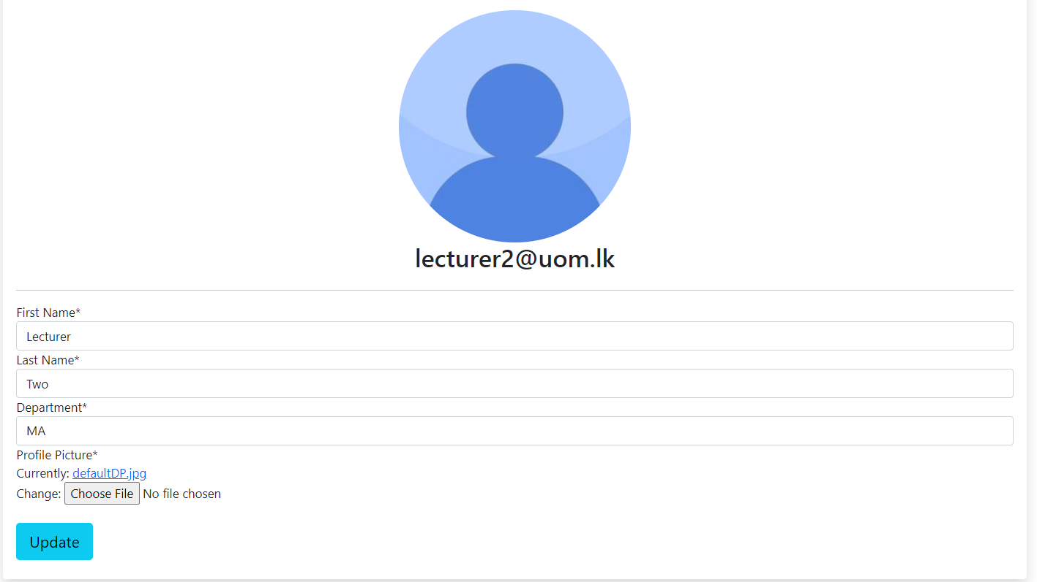

Figure 19

Figure 16 shows a dummy lecturer account. At first, these accounts are created by admins and then a lecturer can log in and update any details as they prefer. A lecturer can upload a profile picture by using the “Choose File” button. Otherwise “defaultDP.jpg” will be the profile picture.

After changing the necessary information, the lecturer can save those details by selecting the “Update” button.

## v) Student Requests //methanta danna wena honda namak theyeda?

The lecturer can see the requests sent by students after logged in. Students’ requests appear as in Figure 17 on the home page.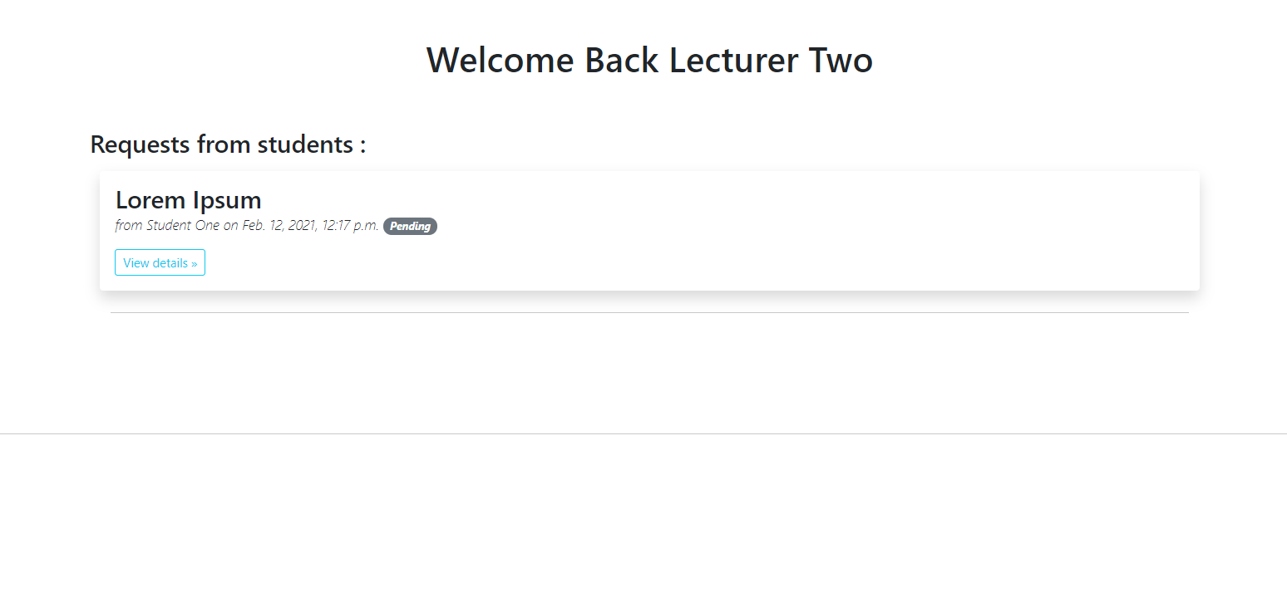

Figure 20

Under “requests from students:” all requests will appear one after the other. Here, requests appear with the request title, requested student, requested date and time, along with the response of the lecturer. The lecturer can view more details by selecting “View details”. It will direct the lecturer to a similar page in Figure 18.

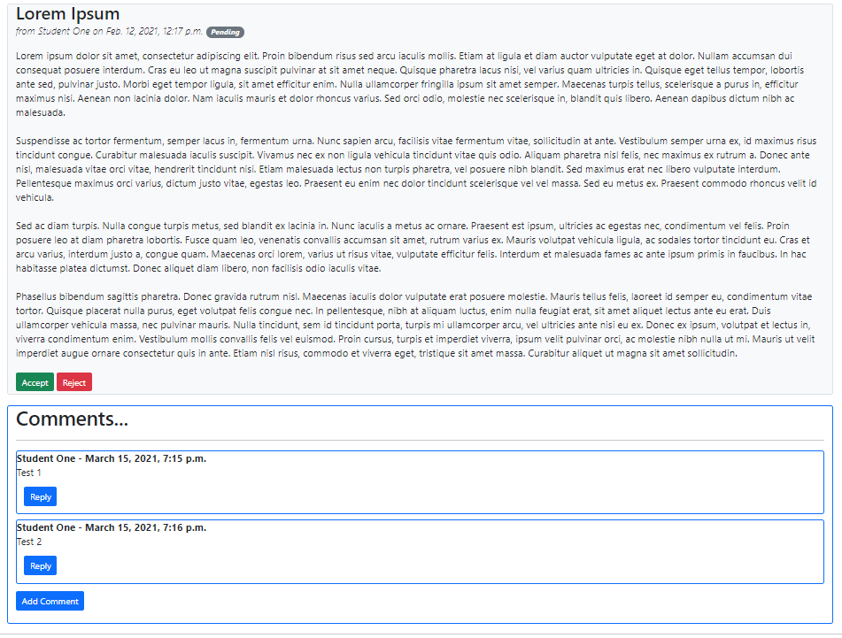

Figure 21

Other than the request details displayed on the home page. Here lecturer can see the full content of the request. Therefore lecturer can examine the request carefully and decide by selecting “Accept” or “Reject”. If a lecturer needs to ask for more detail or to reply to a student’s comment, that is also possible in the “Comments…” section.

### Lecturer add a comment.

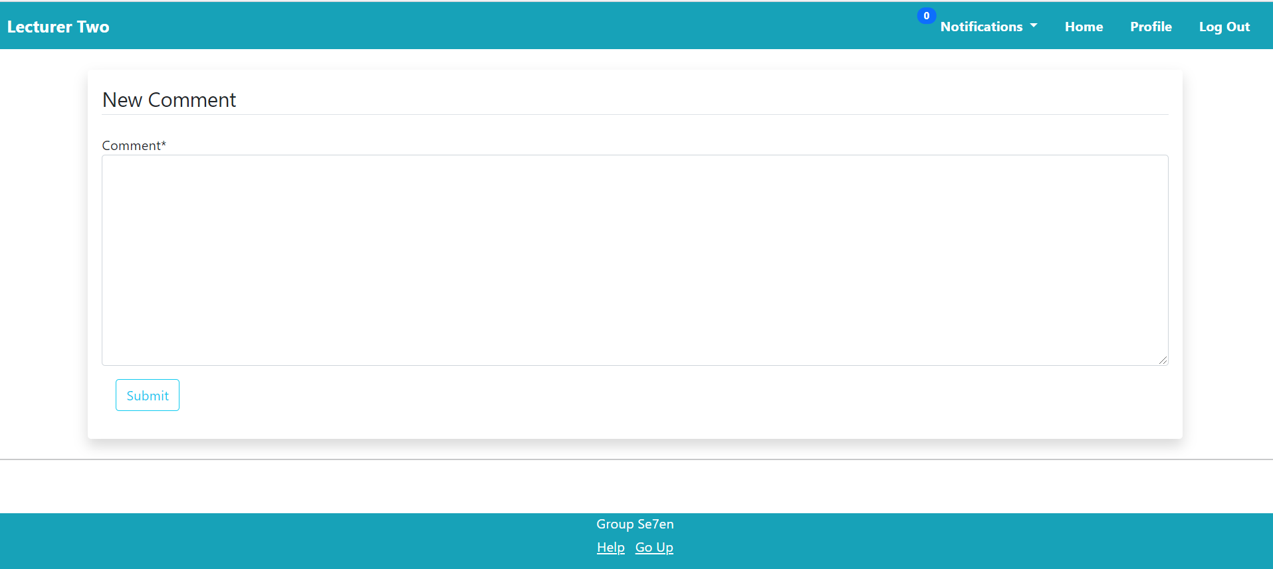

Figure 22

Once the lecturer goes to enter a comment, he or she will be taken to a similar page in Figure 19. There, the lecturer can type the comment and submit it.

### Lecturer reply a comment

A lecturer can also send a reply to a comment. The lecturer will be directed to a similar page like Figure 20 and there, the lecturer can enter the reply.

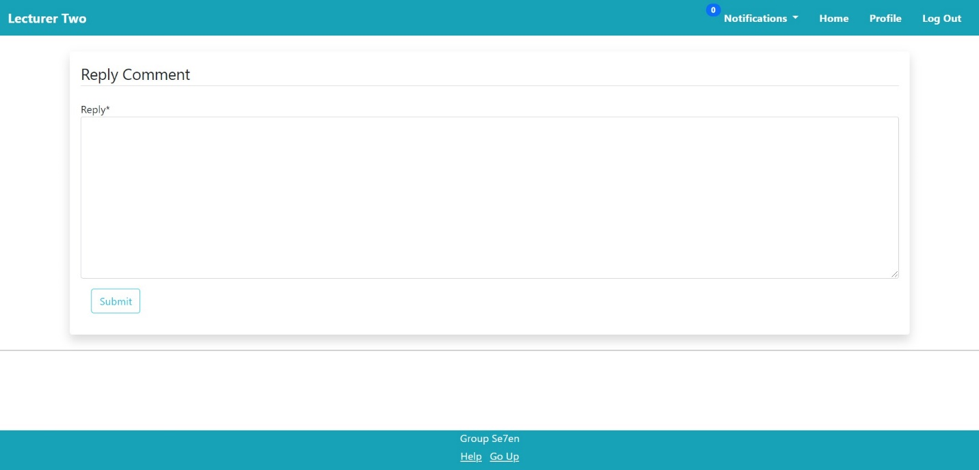

Figure 23