9/26/2026
Myeni Nelisiwe, Nkasi Charity, Lebona Lehlohonolo, Mamafha Mbulaheni, Ramaano Tebogo, Lahluma Maselana
Lifestyle square carwash
Version .03
Lifestyle Square Carwash Management system
Software Requirements Specifications
Revision History
Date | Version | Description | Author
8/08 | 0.1 | original | Nelisiwe Myeni
1/09 | 0.2 | Adjusted document layout | Nelisiwe Myeni
26/09 | 0.3 | Phase two additions | Nelisiwe Myeni

TABLE OF CONTENTS
Revision History ........................................................................ i
- Introduction .............................................................................
1.1 Executive Overview & Business Context ........................................
1.2 Problem Statement by Key Operational Focus Areas .............................
1.2.1 Risk and Liability Regarding Personal Belongings Left in Vehicles .......
1.2.2 Chaotic Customer Service Queue and Wash Bay Bottlenecks .................
1.2.3 Excessive Wash Times and Escalating Customer Complaints ..................
1.2.4 Unmanaged Weekday Booking Slots and Demand Imbalances....................
1.3 Problem Impact Matrix ..........................................................
1.4 Project Scope .....................................................................
- System Analysis & Design ..........................................................
2.1 Current Process Diagram .......................................................
2.1.1 Current Process Analysis ..................................................
2.2 Product Perspective ...........................................................
2.3 Main Product Functions .........................................................
- Requirements ..........................................................................
3.1 Functional Requirements .......................................................
3.2 Non-Functional Requirements ...................................................
3.3 System Requirements ...........................................................
3.4 Integration Requirements ......................................................
- Feasibility Study ....................................................................
4.1 Feasibility Analysis ..........................................................
4.2 Technical Feasibility .........................................................
4.3 Operational Feasibility .......................................................
4.4 Economic Feasibility ..........................................................
4.5 Schedule Feasibility ..........................................................
4.6 Legal Feasibility .............................................................
4.7 Ethical Feasibility ...........................................................
4.8 Overall Feasibility ...........................................................
4.9 Feasibility Summary ...........................................................
- Project Risk Register .............................................................
5.1 Risk Register ...................................................................
5.2 Review Highest Risk ...........................................................
- System Architecture Design ............................................................
6.1 System Architecture Diagram............................................
6.2 System Architecture Analysis..........................................................
6.2.1 Who uses the Flutter application?................................................... 6.2.2 Who uses ASP.NET applications? …………………………………………... 6.2.3 What is Supabase responsible for? ………………………………………... 6.2.4 How does the Flutter application communicate with Supabase?.......... 6.2.5 How does the ASP.NET application communicate with Supabase? ........ 6.2.6 How do the two applications form one integrated solution? .....................
- UML Design ..................................................................................................... 7.1 Use Case Diagram ..................................................................................... 7.1.1 Use Case Analysis ................................................................................... 7.2 Sequence Diagram Overview ....................................................................... 7.2.1 Flutter/Customer Sequence Diagram ........................................................ 7.2.2 Sequence Flow Explained ........................................................................ 7.2.3 ASP.NET/Staff Sequence Diagram ............................................................ 7.2.4 Sequence Flow Explained ........................................................................
- Database Design: Entity Relationship Diagram (ERD) .......................................... 8.1 Entity Relationship Diagram ......................................................................... 8.2 System Data Architecture Overview ............................................................ 8.2.1 Core Entities and Structural Details ..........................................................
- User Interface Design and Design Alignment ...................................................... 9.1 Flutter Wireframes ...................................................................................... 9.2 ASP.NET Wireframes ...................................................................................
- Microsoft Project Plan ...................................................................................... 10.1 Microsoft Project Plan Implementation......................................................
- Stakeholder Engagement .................................................................................. 11.1 Evidence of Stakeholder Engagement ........................................................ 11.2 Interview Audio File .................................................................................. 11.3 Message/ Call Correspondence .................................................................
- External Links .......................................................................
12.1 GitHub Repository Link ........................................................
12.2 Supabase Link ................................................................... 12.3 System Architecture Design Link .......................................................... 12.4 Use Case Design Link ................................................................. 12.5 Sequence Diagram_1 Design Link ........................................................... 12.6 Sequence Diagram_2 Design Link ................................................ 12.7 Entity Relationship Diagram Design Link ............................................... 12.8 Flutter Wireframe Figma Link ................................................................ 12.9 ASP.NET Wireframe Figma Link ............................................................
- Glossary .........................................................................
- Appendix ................................................................

Introduction

1.1 Executive Overview & Business Context

Positioned within a high-traffic commercial development, Lifestyle Square delivers high-end automotive washing and auto-valet services. Despite a steady inflow of vehicular traffic, the business faces significant operational complications, revenue leakage, and customer dissatisfaction arising from manual, unstructured administrative workflows. The primary objective of this document is to outline the key operational challenges across core focus areas, establish a clear Problem Statement to guide the design and implementation of an automated management and digital management system and outline the functional and non-functional requirements. This document is intended to be used by the development team and other stakeholders involved in the design, development and verification of the system.

  - Problem Statement by Key Operational Focus Areas

    - Risk and Liability Regarding Personal Belongings Left in Vehicles

• Background & Current Practice: Customers routinely leave personal items inside their vehicles upon handing them over for cleaning. These items range from low-value personal belongings to high-value electronics (laptops, phones), sunglasses, cash, and luxury items.
• Core Problem: Lifestyle Square currently lacks a standardised, legally binding intake audit protocol to document items present inside a vehicle prior to servicing. Consequently, when items are misplaced, damaged, or alleged stolen, management faces immense liability disputes.
• Impact on Business: False claims lead to unrecoverable financial losses or compromised reputation, while genuine employee theft damages customer trust. The absence of a digital check-in inventory list creates operational friction and exposes the business to legal exposure and brand erosion
1.2.2 Chaotic Customer Service Queue and Wash Bay Bottlenecks
• Background & Current Practice: Vehicle queuing relies on physical line placement and paper tickets or physical marker cones.
• Core Problem: Management lacks real-time visibility into wash bay utilisation, stage progress (Washing, Drying, Vacuuming, Polishing), and attendant efficiency. Vehicles are frequently serviced out of order, leading to severe traffic during peak hours at Lifestyle Square.
• Impact on Business: Unorganised queues block retail parking spaces at the commercial center, cause vehicle competing, increase risk of minor vehicle collisions on site, and generate significant customer anxiety as vehicle owners cannot monitor their vehicle's queue status.
1.2.3 Excessive Wash Times and Escalating Customer Complaints
• Background & Current Practice: Staff provide inaccurate, verbal estimated completion times upon arrival (e.g., 'It will take 20 minutes'), without factoring in current wash bay load or detailing depth.
• Core Problem: Actual turnaround times routinely exceed verbal estimates by 30 to 60 minutes. Because there is no automated notification system (SMS/WhatsApp/Digital Display), customers are forced to wait in person or repeatedly ask staff for updates.
• Impact on Business: Unsatisfied turnaround expectations lead to severe customer dissatisfaction, angry confrontations, negative public reviews, and lower repeat visit rates. Furthermore, labor productivity is diluted because staff constantly stop work to answer status inquiries.
1.2.4 Unmanaged Weekday Booking Slots and Demand Imbalances
• Background & Current Practice: Weekday operations experience extreme demand fluctuations, with underutilised capacity during morning hours and extreme spikes during lunchtime and late afternoon.
• Core Problem: LifeStyle Square currently operates predominantly on a first-come, first-served walk-in basis without a structured weekday slot booking system. Corporate or retail clients who wish to schedule a wash around their working hours cannot reserve fixed time slots.
• Impact on Business: Inactive staff and inactive bay capacity during off-peak morning hours burn fixed overheads, while peak hour rush causes customer turnaways and severe service slowdowns. The inability to level load weekday demand restricts overall daily throughput and revenue potential.

  - Problem Impact Matrix
Operational Area | Root Cause | Business Impact
1. Personal Belongings | Lack of check-in checklist & digital liability waiver | Liability exposure, theft claims, customer mistrust
2. Queue Management | Manual tracking with no real-time bay allocation | Congestion, disorganized workflow, safety/damage risk
3. Wash Time Complaints | Inaccurate verbal time estimates & zero status alerts | High customer frustration, negative reviews, wasted labor
4. Weekday Booking Slots | Absence of appointment scheduling; walk-in dependence | Unbalanced bay utilization, idle costs, missed corporate clients

  - Project Scope

The Lifestyle Square Car Wash Management System is a centralised digital platform designed to streamline vehicle servicing operations at Lifestyle Square Car Wash. The system will provide a Flutter mobile application for customers and an ASP.NET web application for staff, with a Supabase backend to store and manage system information.
The system will allow customers to provide vehicle information, complete the digital vehicle intake process, record and confirm personal belongings, accept the digital liability waiver, view vehicle service status, receive service notifications and make weekday service reservations. Staff will be able to manage vehicle intake, valuables records, the virtual service queue, service progress, wash bay utilisation, estimated completion times and weekday bookings.
The system aims to address the current operational challenges of liability disputes, queue congestion, inaccurate wash-time estimates and unbalanced weekday demand by providing a centralised and automated approach to managing car wash services.

2. System Analysis & Design

2.1 Current Process Diagram

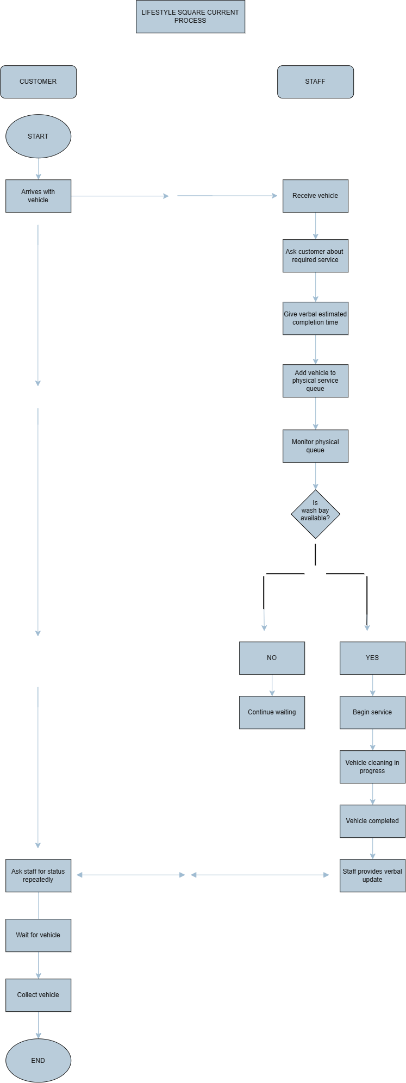
2.1.1 Current Process Analysis
The current process at Lifestyle Square Car Wash is largely manual and dependent on verbal communication between customers and staff. When a customer arrives, they hand their vehicle to a staff member, who asks about the required service and provides a verbal estimated completion time. The vehicle is then added to a physical service queue while staff monitor the queue and wait for an available wash bay.
The diagram shows that the wash-bay availability is a major decision point. If a bay is unavailable, the vehicle remains in the queue, and the customer continues waiting. If a bay becomes available, staff begin the service, after which the vehicle progresses through the cleaning process until it is completed.
A significant weakness is that customers have no direct way of monitoring the progress of their vehicle. Once the vehicle has been handed over, customers must repeatedly approach staff to ask for an update.
The physical queue also creates operational problems. The current queue relies on physical line placement, paper tickets and physical marker cones, with no real-time visibility of wash-bay utilisation or service progress. This can result in vehicles being serviced out of order, congestion during peak periods and increased risk of minor vehicle collisions.
Another limitation is that the process shown does not include a formal digital vehicle intake, valuables record or liability waiver. This is important because customers may leave valuable belongings inside their vehicles, while the business currently lacks a standardised intake audit procedure to document these items.
Overall, the current process is linear, manual and reactive. Staff are responsible for managing the queue, communicating estimated completion times and providing status updates, while customers have limited visibility of the process. These limitations contribute to queue congestion, inaccurate completion estimates, customer frustration, inefficient staff utilisation and liability risks.

2.2 Product Perspective

The proposed prototype will operate as one integrated Car Wash Management System for Lifestyle Square. The system will consist of a Flutter mobile application for customers, an ASP.NET web application for Lifestyle Square staff, and a Supabase backend for storing and managing system information.
The Flutter mobile application will provide customers with functions such as completing the digital vehicle intake process, recording personal belongings, confirming the liability waiver, viewing vehicle service status and making weekday reservations. The ASP.NET web application will allow staff to manage vehicle intake, valuables records, the virtual queue, wash bay status, service progress, estimated completion times and weekday bookings.
Both applications will connect to the same Supabase backend, which will store and manage customer, vehicle, valuables, waiver, queue and reservation information. This will allow information entered by customers or staff to be shared across the system and provide a centralised view of vehicle servicing operations.
The proposed system will therefore integrate the digital intake and valuables audit, real-time virtual queue, dynamic estimated completion time and weekday reservation functions into one system. These functions are intended to address the operational challenges identified by Lifestyle Square, including liability disputes, queue congestion, inaccurate wash-time estimates and unbalanced weekday demand.
2.3 Main Product Functions
Component | Main Function
Flutter mobile application | Allow customers to register, submit vehicle information, complete the digital valuables checklist, confirm the liability waiver, view vehicle queue status, receive service updates and make weekday reservations
ASP.NET web application | Allow Lifestyle Square staff to manage vehicle intake, record valuables, manage the virtual queue, update vehicle service stages, monitor wash bay utilisation, manage estimated completion times and manage weekday bookings.
Supabase backend | Store and manage customer, vehicle, valuables, waiver, queue, service and reservation information. Provide a shared backend for the Flutter and ASP.NET applications
Notification System | Send customers updates about vehicle status, estimated completion times and when their vehicle is ready for collection.

3. Requirements

3.1 Functional Requirements
- FR1: The system must allow staff to create a digital vehicle intake record when a customer submits a vehicle for servicing.
- FR2: The system must allow staff to record personal belongings identified inside the vehicle before servicing.
- FR3: The system must allow the customer to confirm the recorded belongings and digital liability waiver.
- FR4: The system must send the customer a digital copy of the item inventory and liability waiver.
- FR5: The system must allow staff to add a vehicle to the virtual service queue.
- FR6: The system must display the current status of each vehicle, including Queued, Washing, Polishing and Ready.
- FR7: The system must allow staff to update a vehicle's service stage as work progresses.
- FR8: The system must provide an estimated completion time based on the current service workload.
- FR9: The system must send the customer a notification when their vehicle is ready for collection.
- FR10: The system must allow customers to book available weekday service slots online.
- FR11: The system must prevent multiple customers from booking the same available weekday slot.
- FR12: The system must support incentive discounts for selected off-peak weekday booking slots.
3.2 Non-Functional Requirements
- NFR1: Only authorised staff must be able to create, update or manage vehicle service records.
- NFR2: Customer information and vehicle records must be protected from unauthorised access.
- NFR3: The queue status must be clear and easy for staff and customers to understand.
- NFR4: Customer notifications must provide clear information about vehicle progress and completion.
- NFR5: The system must provide accurate and understandable estimated completion times based on available operational information.
- NFR6: The prototype must use test customer and vehicle information rather than real customer personal information.
- NFR7: The system should reduce the need for staff to provide repeated manual vehicle status updates to customers.

3.3 System Requirements
- SR1: The customer mobile application must be developed using Flutter.
- SR2: The staff management web application must be developed using ASP.NET.
- SR3: The system must use Supabase as the centralised backend.
- SR4: The Flutter application must connect to Supabase to store and retrieve customer, vehicle, queue and reservation information.
- SR5: The ASP.NET application must connect to Supabase to manage vehicle, customer, queue and reservation information.
- SR6: Supabase must store the digital vehicle intake records, valuables inventory and liability waiver information.
- SR7: Supabase must store vehicle queue status and service progress information.
- SR8: Supabase must store weekday reservation and booking information.
- SR9: The system must support communication between the Flutter application, ASP.NET application and Supabase backend.
- SR10: The prototype must use test data rather than real customer information.

3.4 Integration Requirements
- IR1: Vehicle information captured during digital intake must be available to the queue management component.
- IR2: Vehicles added to the virtual queue must be associated with their corresponding intake and customer records.
- IR3: Changes to a vehicle's service status must be reflected in the virtual queue.
- IR4: The ECT function must use current queue, bay loading and staff availability information when calculating estimated completion times.
- IR5: Updated estimated completion times must be available to staff and communicated to customers where applicable.
- IR6: When a vehicle reaches the Ready status, the system must trigger a customer completion notification.
- IR7: Weekday reservations must be linked to the relevant customer and vehicle information.
- IR8: Booking information must be considered when managing available wash bay capacity.
- IR9: Off-peak booking incentives must be associated with the applicable weekday reservation slots.
- IR10: All major components must use the same centralised system so that vehicle, customer, queue and booking information remains consistent.

4. Feasibility Study

4.1 Feasibility Analysis
Feasibility analysis was conducted to determine whether the proposed Lifestyle Square Carwash Management System can realistically be developed and demonstrated within the available project constraints. The assessment considered the technical, operational, economic, schedule, legal and ethical feasibility of the proposed solution. The findings were based on the stakeholders’ identified operational problems, the proposed system architecture, the defined system requirements and the integration requirements contained in this SRS.
The proposed system consists of a Flutter mobile application for customers, an ASP.NET web application for Lifestyle Square staff and a Supabase backend for centralized data management. Together, these components will support digital vehicle intake, valuables recording, liability waiver confirmation, virtual queue management, service progress monitoring, estimated completion times and weekday reservations
4.2 Technical Feasibility
The proposed system is technically feasible with some limitations. The selected technologies provide an appropriate foundation for implementing the required prototype. Flutter will be used for the customer mobile application, ASP.NET for the staff management application and Supabase for centralized storage and management of system information. The SRS also defines the required communication between these components.
The main technical consideration identified is the integration of the three system components. Information captured during vehicle intake must remain associated with the correct customer and vehicle when the vehicle enters the virtual queue. Similarly, changes to service status must be reflected in the queue, while estimated completion times must use current queue, washing and staff information.
The group therefore found that the core technology stack is suitable for the proposed prototype, but successful implementation depends on maintaining consistent communication between Flutter, ASP.NET and Supabase. The integration
requirements represent the main technical area requiring careful development and testing.
Decision: Feasible with changes.
4.3 Operational Feasibility
The proposed system is operationally feasible because its functions correspond directly with the operational problems identified at Lifestyle Square.
The existing process relies on manual vehicle intake records, physical queue management and verbal estimates of completion times. These practices contribute to liability disputes, queue congestion, inaccurate customer expectations and inefficient weekday demand management.
The proposed system addresses these problems through a digital valuables audit, virtual queue, service-status updates, estimated completion times, customer notifications and weekday reservations. Customers will use the Flutter application to provide vehicle information, confirm recorded belongings and the liability waiver, monitor service progress and make weekday reservations. Staff will use the ASP.NET application to manage vehicle intake, valuables, queue status, service stages, wash-bay utilization, estimated completion times and bookings.
The group found that these functions fit the existing carwash workflow because they digitize and improve activities that are already performed during vehicle service. The proposed system therefore does not require complete replacement of the existing operational process.
Decision: Feasible.
4.4 Economic Feasibility
The proposed project is economically feasible for prototype development. The assessment focused on whether the resources required to develop and demonstrate the prototype are reasonably accessible rather than evaluating the full commercial cost of deploying the system.
The main resources considered were development computers, internet access, testing devices, development of software, Supabase resources and resources required for stakeholder engagement and project demonstration. The proposed architecture is primarily software-based and therefore does not require specialized physical infrastructure for the prototype.
The SRS also specifies that test customer and vehicle information will be used rather than real customer personal information during development. This reduces the resource and privacy requirements associated with obtaining and managing real customer information during the project.
Potential operational costs associated with future production implementation, such as hosting, notification services and system maintenance, fall outside the primary scope of the academic prototype.
Decision: Feasible.

4.5 Schedule Feasibility
The project is considered feasible with changes from a scheduling perspective.
The proposed prototype contains several connected functions, including digital vehicle intake, valuables recording, liability waiver confirmation, virtual queue management, service-stage updates, estimated completion times, customer notifications and weekday reservations.
The assessment identified integration and testing as significant contributors to the project's time requirements. The system cannot be evaluated only according to the time required to develop individual functions because several requirements depend on information being shared between different components. For example, vehicle intake information must connect with queue management, service-status changes must update the queue, estimated completion times must use operational information, and a Ready status must result in a customer notification.
The Microsoft Project schedule provides the basis for monitoring the project's development activities and available time. The feasibility assessment indicates that the core requirements can be completed within the project period if development remains focused on the approved system scope and sufficient time is retained for integration, testing, stakeholder feedback and corrections.
Decision: Feasible with changes.
4.6 Legal Feasibility
The proposed system is legally feasible if information is appropriately protected.
The system will manage customer, vehicle, valuables, liability waiver, queue and reservation information. The SRS requires authorized staff to manage vehicle service records and requires customer and vehicle information to be protected from unauthorized access.
The valuables inventory and liability waiver require particular attention because they document the condition and contents associated with a vehicle before servicing. Unauthorized access to this information could compromise customer confidentiality and the integrity of the records.
The project reduces this risk by using customer and vehicle information during prototype development rather than real customer personal information. Confidential stakeholder information and system credentials will also remain separate from publicly accessible project material.
Decision: Feasible with controls.

4.7 Ethical Feasibility
The proposed system is ethically feasible because its intended functions support transparency, accountability and improved communication between Lifestyle Square and its customers
The digital valuables checklist creates a clearer record of belongings identified before servicing, while the liability waiver provides a formal confirmation process. The virtual queue and service-status functions provide customers with clearer information about the progress of their vehicles and reduce reliance on uncertain verbal updates.
The assessment also identified the responsible use of information as an important ethical consideration. The system requirements limit the information managed by the prototype to information relevant to vehicle servicing, customer records, queue management and reservations. The prototype will use test data rather than real customer information.
The estimated completion time is also treated as an operational estimate rather than a guaranteed completion time. This supports realistic communication with customers and is consistent with the requirement for understandable completion estimates based on available operational information.
Decision: Feasible.
4.8 Overall Feasibility
Based on the assessment, the proposed Lifestyle Square Carwash Management System is feasible with changes.
The project has a suitable technical foundation through the use of Flutter, ASP.NET and Supabase, while the proposed functionality is closely aligned with the operational problems identified at Lifestyle Square. The digital intake and valuables audit addresses liability concerns, the virtual queue addresses congestion and service visibility, estimated completion times address inaccurate customer expectations, and weekday reservations address uneven demand.
The main limitations identified are the integration of the system components, the time required for development and testing, and the need to maintain appropriate information-security and privacy controls. These limitations do not prevent the project from proceeding but require the prototype scope to remain controlled.
The feasibility assessment therefore supports continuation of the project using the core requirements defined in this SRS. Development will focus on achieving the required Flutter, ASP.NET and Supabase integration, completing the specified system functions and allowing sufficient time for testing, stakeholder feedback and corrections. The project will use test information during development and maintain appropriate controls over confidential information throughout the implementation process
4.9 Feasibility Summary
Feasibility area | Decision | Finding
Technical | Feasible with changes | The selected Flutter, ASP.NET Supabase technologies are suitable, with integration representing the main technical challenge.
Operational | Feasible | The proposed functions directly address the stakeholder's identified problems with vehicle intake, queues, wash times and weekday bookings
Economic | Feasible | The resources required for prototype development are considered accessible and manageable
Schedule | Feasible with changes | The available project period is sufficient for the core prototype, but integration, testing and corrections require careful time management.
Legal | Feasible with control | Customer, vehicle, valuables and waiver information require appropriate confidentiality and access controls.
Ethical | Feasible | The proposed functions support transparency and accountability while limiting information collection to the system's intended purpose.

5. Project Risk Register

5.1 Risk Register
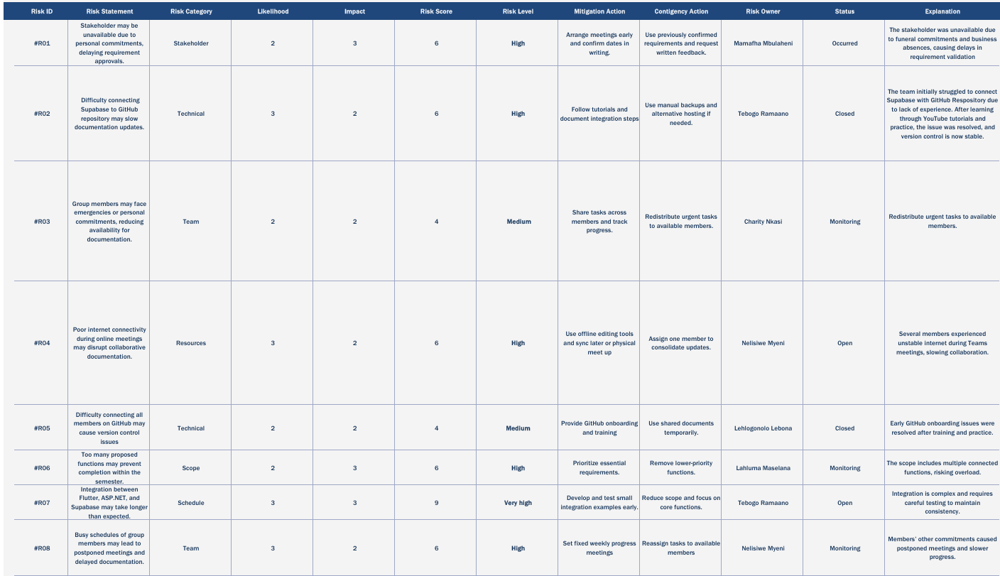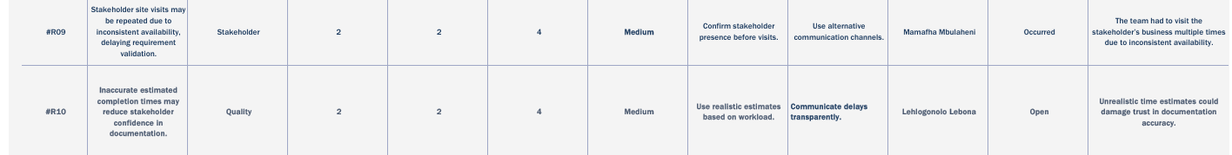
5.2 Review Highest Risk
Highest Risk | Why is this important | What must the group do now
Integration Delays Across Flutter, ASP.NET, and Supabase (R07) | The feasibility study highlighted integration as the most time‑consuming activity. Delays here will reduce available time for testing and stakeholder feedback, risking prototype quality | Focus development on core functions first, allocate extra time for integration testing, and reduce scope if necessary to ensure a working prototype.
Stakeholder Feedback Delays (R01/R09) | Stakeholder input is essential for validating requirements. Delays in feedback can cause misalignment between the system and actual business needs. | Maintain multiple communication channels (calls, visits, written requests), confirm stakeholder availability before meetings, and use previously validated requirements if feedback is delayed.
Inaccurate Estimated Completion Times (R10) | Unrealistic time estimates can reduce stakeholder trust in the documentation and system. If customers or stakeholders expect faster delivery than is possible, confidence in the project may be damaged. | Unrealistic time estimates can reduce stakeholder trust in the documentation and system. If customers or stakeholders expect faster delivery than is possible, confidence in the project may be damaged.

6. System Architecture Design

6.1 System Architecture Diagram
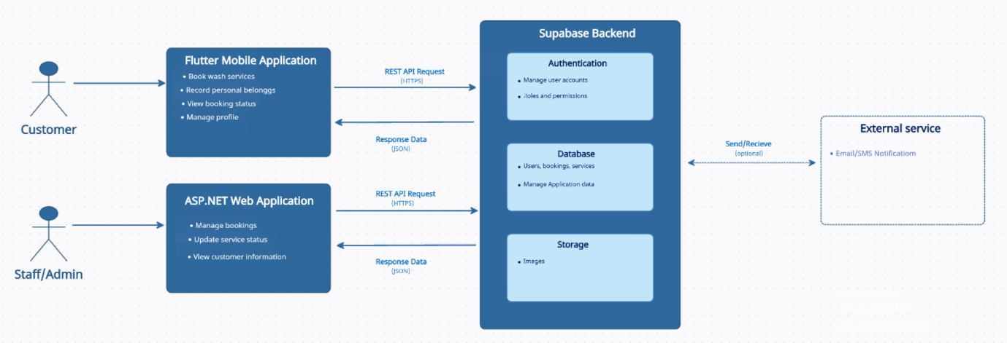

6.2 System Architecture Analysis
6.2.1 Who uses the Flutter application?
Customers use the Flutter mobile application to interact with the customer-facing side of the Lifestyle Square Car Wash Management System. Customers can provide their vehicle information, complete the digital vehicle intake process, record personal belongings inside the vehicle, and view their vehicle's service status. The Flutter application therefore provides customers with direct access to their vehicle service information without requiring them to repeatedly approach staff for updates
6.2.2 Who uses the ASP.NET application?
Lifestyle Square staff and administrators use the ASP.NET web application to manage the operational side of the car wash. The web application allows staff to manage vehicle intake, manage the virtual service queue, update vehicle service stages, monitor wash-bay utilisation, manage estimated completion times and manage weekday bookings. Staff authentication is also required before accessing the operational functions of the system.
6.2.3 What is Supabase responsible for?
Supabase acts as the shared backend of the system. It provides the central services that are used by both the Flutter Mobile Application and the ASP.NET Web Application.
The Authentication component is responsible for managing user accounts and controlling access to the system. This supports the requirement that only authorised staff should be able to create, update or manage vehicle service records.
The Database stores and manages the application's information. This includes customer, vehicle, valuables, queue, service and reservation information.
The Storage component shown in the diagram is intended for storing files or images where required.
6.2.4 How does the Flutter application communicate with Supabase?
The Flutter mobile application communicates with Supabase to store and retrieve customer, vehicle, queue and reservation information. When a customer submits or updates information through the mobile application, the information is transferred to the centralised Supabase backend. The Flutter application can also retrieve updated information, such as the current vehicle service status, estimated completion time and reservation information.
This communication allows information entered through the customer application to become available to the rest of the system.
6.2.5 How does the ASP.NET application communicate with Supabase?
The ASP.NET web application communicates with Supabase to retrieve and manage operational information required by Lifestyle Square staff. Through the shared backend, staff can manage vehicle intake records, valuables information, the virtual service queue, service progress, estimated completion times and weekday bookings.
For example, when staff update a vehicle's service stage, the updated status is stored in Supabase. The updated information can then be made available to the Flutter application so that the customer can view the progress of their vehicle. This supports the integration requirement that changes to a vehicle's service status must be reflected in the virtual queue and communicated to customers where applicable.
6.2.6 How do the two applications form one integrated solution?
The Flutter mobile application and ASP.NET web application form one integrated system by using the same centralised Supabase backend. The Flutter application provides the customer-facing functionality, while the ASP.NET application provides the staff-facing operational functionality. Both applications access shared information stored in Supabase rather than maintaining separate sets of vehicle, customer, queue and reservation information. This shared architecture allows the two applications to work together as a single int

UML Design

7.1 Use Case Diagram

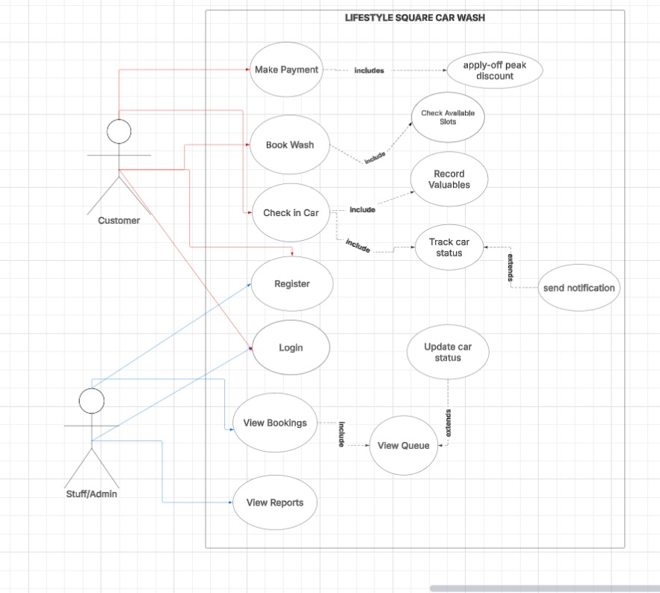
7.1.1 Use Case Analysis
1. Actors
There are two primary actors outside the system:
- Customer: The external user who brings a car for washing services.
- Staff/Admin: The internal user who works at the car wash and manages operations.
2. Use Cases for CUSTOMER
The Customer (represented by the red lines) can perform 5 main actions:
- Register: Create a new account on the system.
- Login: Authenticate and access their account.
- Book Wash: Book a slot to wash their car, it includes Check Available Slots -This is a mandatory included process. When booking, the system must check available slots and allow the customer to select from the free slots.
- Check in Car: Physically bring the car to the car wash for the service, this includes Record Valuables - When checking in, customers must record valuables left inside the car for safety and to prevent theft claims also includes Track car status - After check-in, the customer is able to track the progress of their car (e.g., Washing, Drying, Ready).
- Make Payment: Pay for the service after all processes are complete which includes apply-off peak discount -The system automatically checks the time and applies a discount if the service is booked during off-peak hours.
Additional Relationship:
- Track car status extends send notification: When the status of the car changes, this extended use case triggers and the system sends an SMS/App notification to the customer.
3. Use Cases for STAFF/ADMIN
The Staff/Admin (represented by the blue lines) can perform 5 main actions:
- Register: Create a new account on the system if they are a new staff member.
- Login: Log into the system if they are an existing user.
- View Bookings: View all bookings made by customers, which includes the View Queue. To view bookings effectively, the staff must view the queue of cars waiting to be washed.
- View Reports: View system reports such as daily sales, number of washes, and performance reports.
- Update car status: Change the status of a car in the system (e.g., from "In Queue" to "Washing" to "Ready for Collection"), which extends View Queue. This function extends View Queue, meaning the staff updates the status directly from the queue view.
Summary of Flow:
A Customer Registers and Logs in, Books a Wash (system checks slots), Checks in their Car (valuables are recorded), Staff Updates the car status from the queue, the customer tracks status and receives notifications, the customer makes payment (with a possible off-peak discount), and Staff manages the process through View Bookings, View Queue, and View Reports.
7.2 Sequence Diagram Overview
The Sequence Diagrams illustrate the dynamic interactions between the Customer, Staff, and the system components of the Lifestyle Square Car Wash Management System. It shows the chronological flow of messages exchanged between actors and objects to complete the main use cases: Registration/Login, Request Service, Join Queue, Manage Queue, Update Status, and Make a Payment.
The diagram focuses on the time-ordered sequence of events that occur when a customer requests a car wash service and staff manage the vehicle through the operational workflow.

7.2.1 Flutter/Customer Sequence Diagram

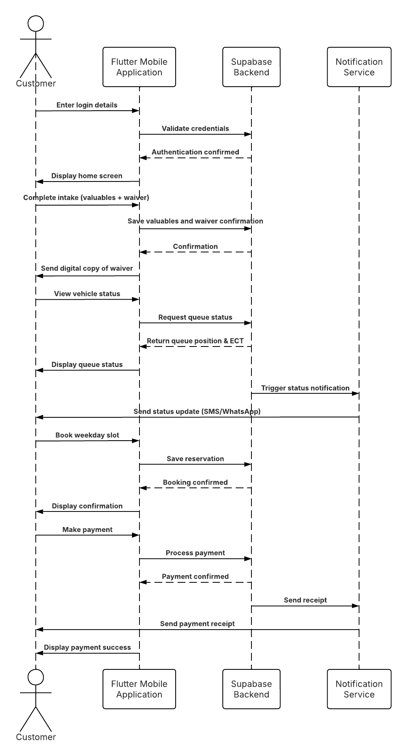
7.2.2 Sequence Flow Explained
    - Customer → Flutter App: Customer enters login details, which are validated by Supabase, and the home screen is displayed.
    - Customer → Flutter App → Supabase: Customer submits vehicle information, which is saved and confirmed.
    - Customer → Flutter App → Supabase: Customer completes the valuables checklist, which is saved and confirmed.
    - Customer → Flutter App: Customer confirms the digital liability waiver as mentioned in FR3.
    - Flutter App → Supabase: Waiver confirmation is saved and confirmed as mentioned in FR3.
    - Flutter App → Notification Service → Customer: A digital copy of the waiver and inventory is sent to the customer as mentioned in FR4.
    - Customer → Flutter App → Supabase: Customer views queue status; Supabase returns the queue position and ECT, which is displayed.
    - Supabase → Notification Service → Customer: A status update is triggered and sent to the customer.
    - Customer → Flutter App → Supabase: Customer books a weekday slot; the reservation is saved and confirmed.
    - Customer → Flutter App → Supabase: Customer makes a payment; Supabase processes it and triggers a receipt.
    - Notification Service → Customer: Payment receipt is sent, and the app displays payment success.
7.2.3 ASP.NET/Staff Sequence Diagram
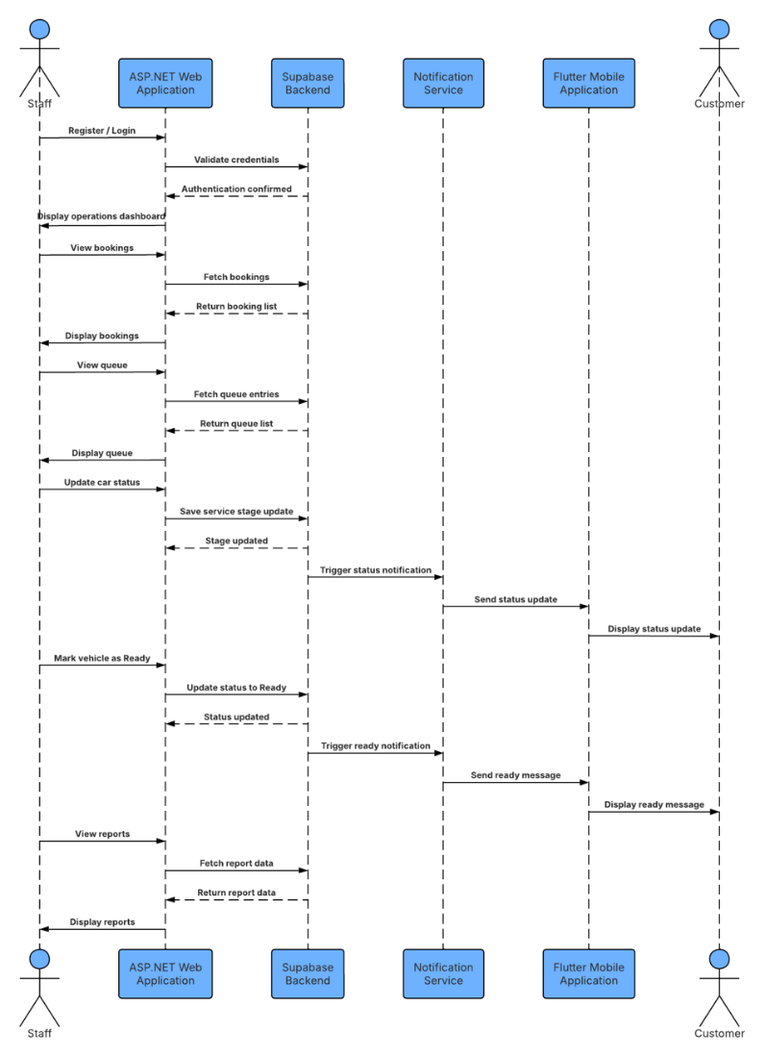
    - Sequence Flow Explained

- Staff → ASP.NET Web : Staff enters login credentials, which are validated by Supabase, and the operations dashboard is displayed.
- Staff → ASP.NET Web → Supabase: Staff views bookings, Supabase returns the booking list, which is displayed.
- Staff → ASP.NET Web → Supabase: Staff views the queue, Supabase returns the queue list, which is displayed.
- Staff → ASP.NET Web → Supabase: Staff updates the car's service stage, Supabase saves the update.
- Supabase → Notification Service → Flutter App → Customer: A status notification is sent to the Flutter App and then displayed to the Customer.
- Staff → ASP.NET Web App → Supabase: Staff marks the car as Ready, Supabase updates the status.
- Supabase → Notification Service → Flutter App → Customer: A "Ready for collection" message is sent to the Flutter App and then displayed to the Customer.
- Staff → ASP.NET Web App → Supabase: Staff views reports, Supabase returns the report data, which is displayed.

Database Design: Entity Relationship Diagram (ERD)

8.1 Entity Relationship Diagram
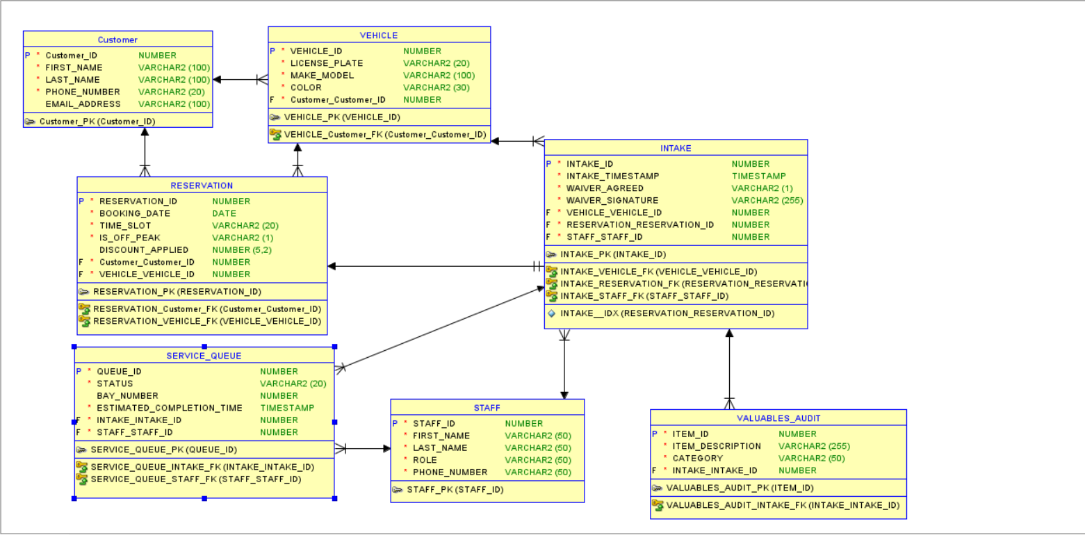
8.2 System Data Architecture Overview
The database schema for the Car Wash Management System consists of 7 core entities engineered to manage customer intake, vehicle tracking, service queueing, advanced scheduling, staff operations, and audit compliance. The design integrates the Flutter mobile application (used for customer self-service and check-ins) and the ASP.NET web dashboard (used by staff and administrators for operational control) through a shared Supabase PostgreSQL database backend.
8.2.1 Core Entities and Structural Details
Entity Name | Operational Purpose & Scope | Key Relationships
CUSTOMERS | Stores customer profile, contact details, and account metadata. Serves as the primary account entity across mobile and web interfaces. | Parent to VEHICLES (1:N), SERVICE_INTAKE (1:N), and RESERVATIONS (1:N)
VEHICLES | Tracks vehicle details including license plate, make, model, and colour registered to customers. | Child of CUSTOMERS (N:1); Parent to SERVICE_INTAKE (1:N)
STAFF | Manages employee profiles, authorisation roles, and daily operational task assignments. | Linked to SERVICE_INTAKE (1:N) and SERVICE_QUEUE for staff auditing
INTAKE | Captures initial vehicle check-ins, selected packages, waiver approvals, and baseline vehicle condition. | Child of CUSTOMERS, VEHICLES, STAFF; Parent to VALUABLES_AUDIT (1:1)
VALUABLES_AUDIT | Documents personal items inside vehicles before servicing to ensure legal compliance and accountability. | Child of SERVICE_INTAKE (1:1)
SERVICE_QUEUE | Tracks real-time bay assignment, queue sequence, live service progress, and estimated completion times. | Linked to SERVICE_INTAKE; feeds live updates to Flutter app & ASP.NET web portal
RESERVATION | Manages bookings and weekday time slot capacity to optimise bay throughput during peak hours. | Child of CUSTOMERS and VEHICLES

User Interface Design and Design Alignment

9.1 Flutter Wireframes
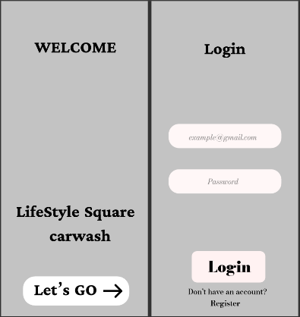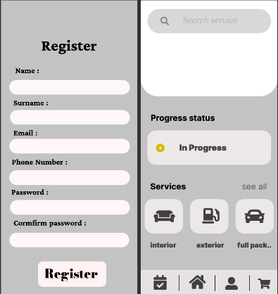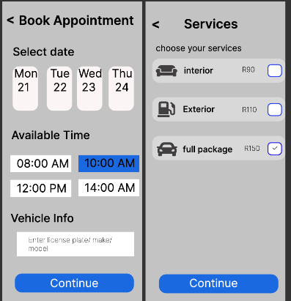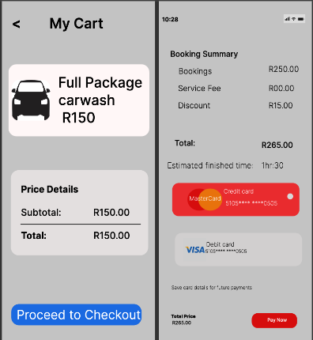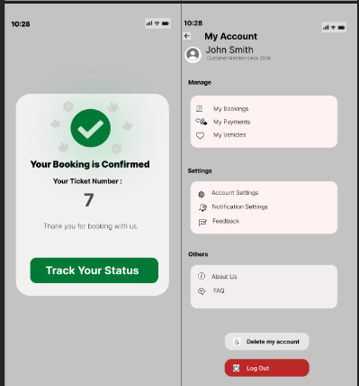
9.2 ASP.NET Wireframes

Microsoft Project Plan

10.1 Microsoft Project Plan Implementation
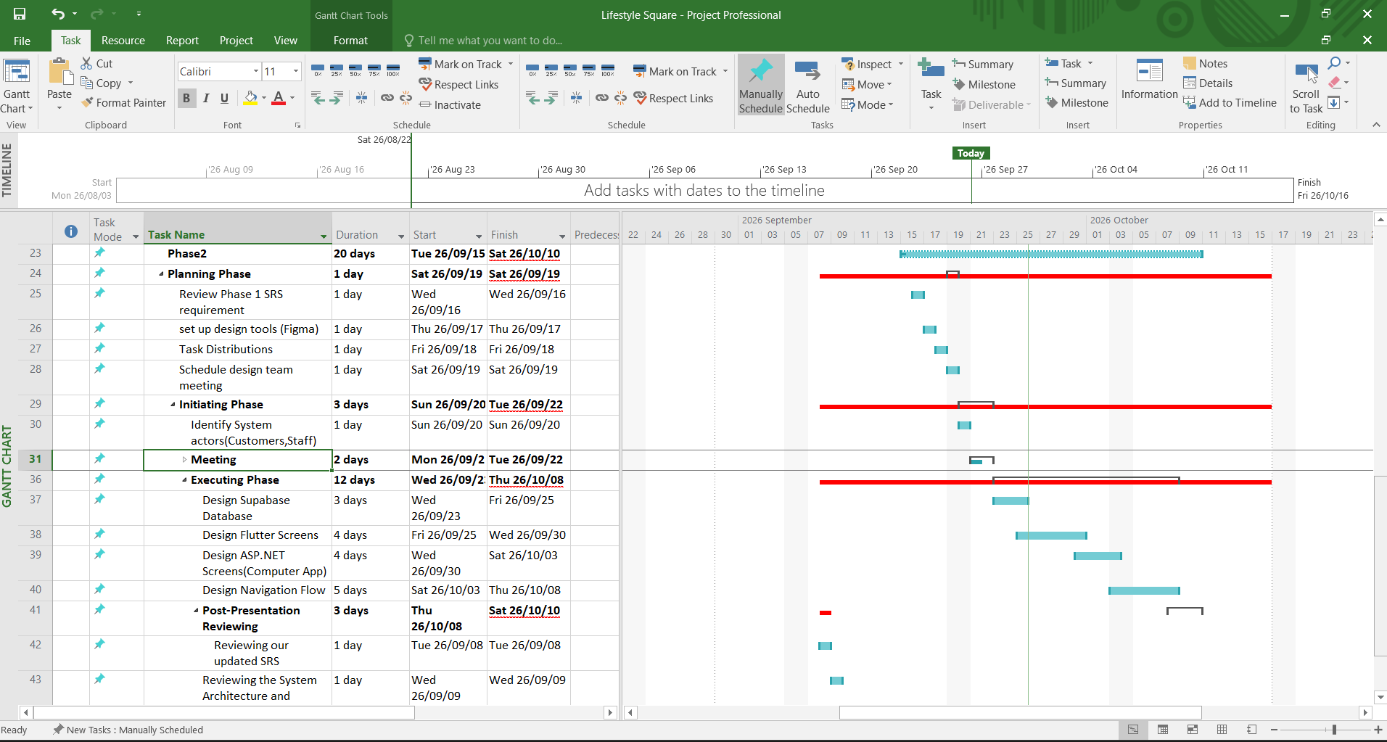
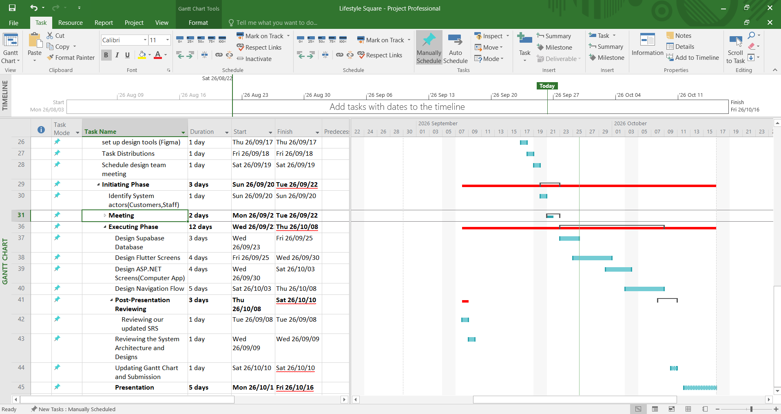

11. Stakeholder Engagement

11.1 Evidence of stakeholder engagement
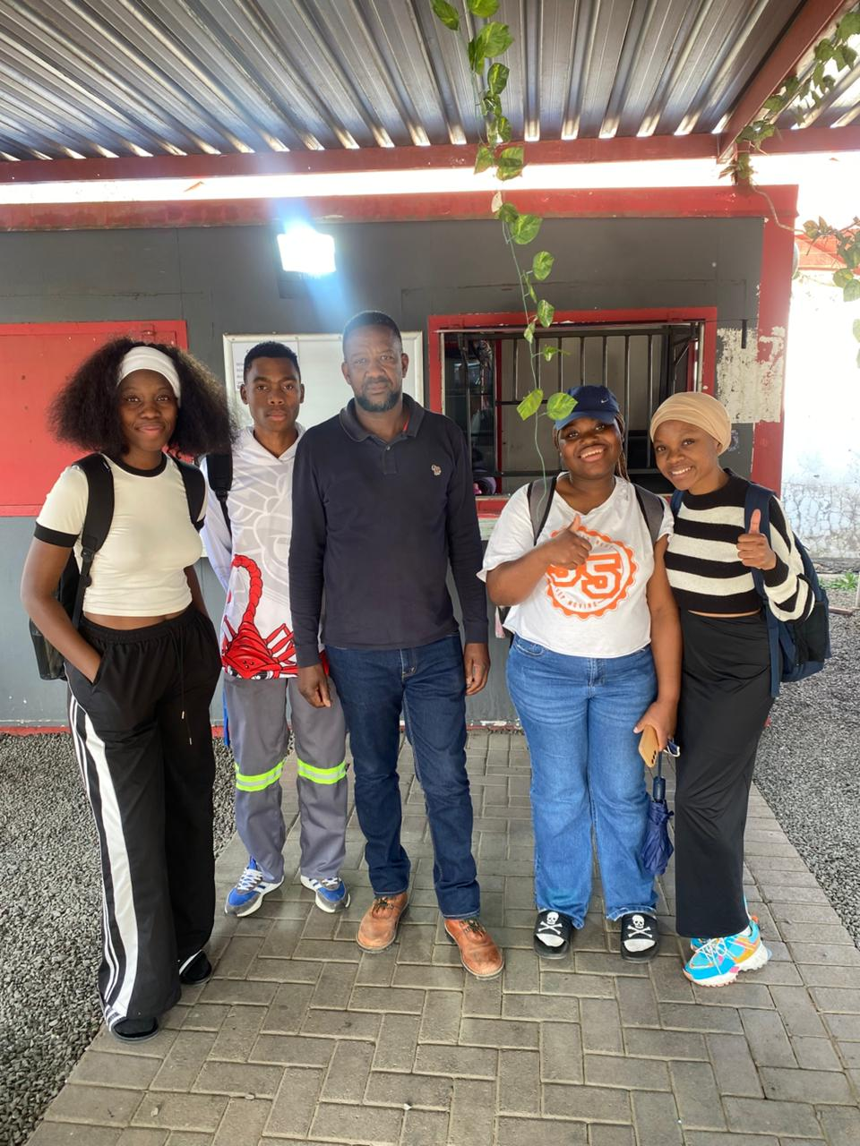
11.2 Interview audio File

11.3 Message/Call correspondence
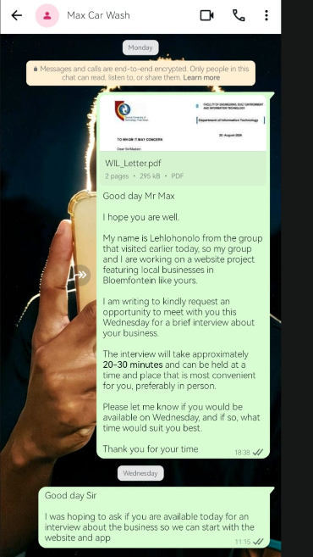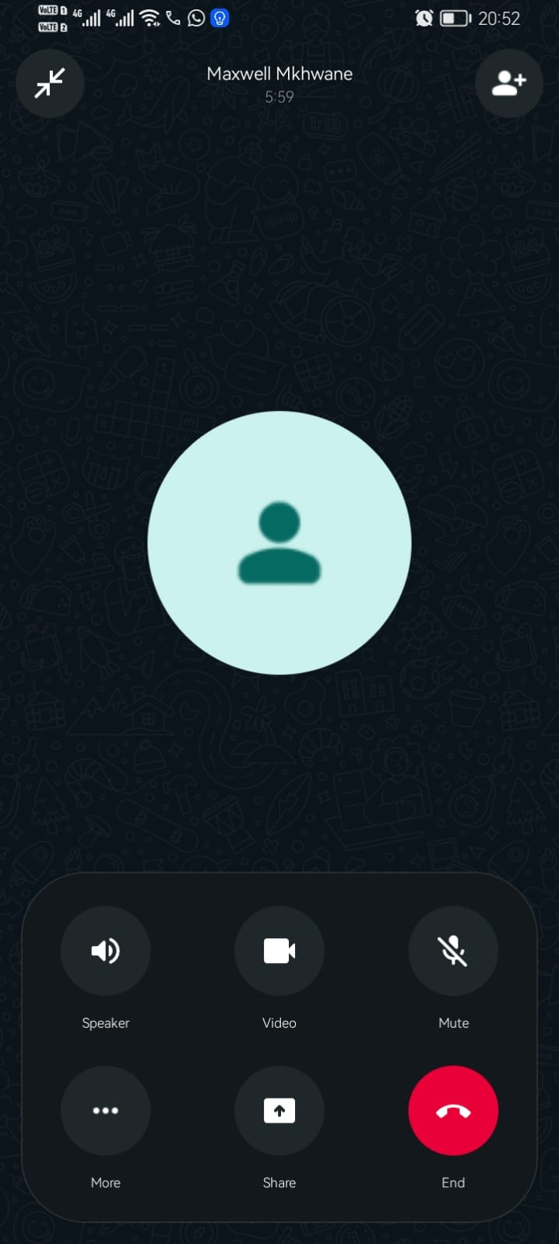

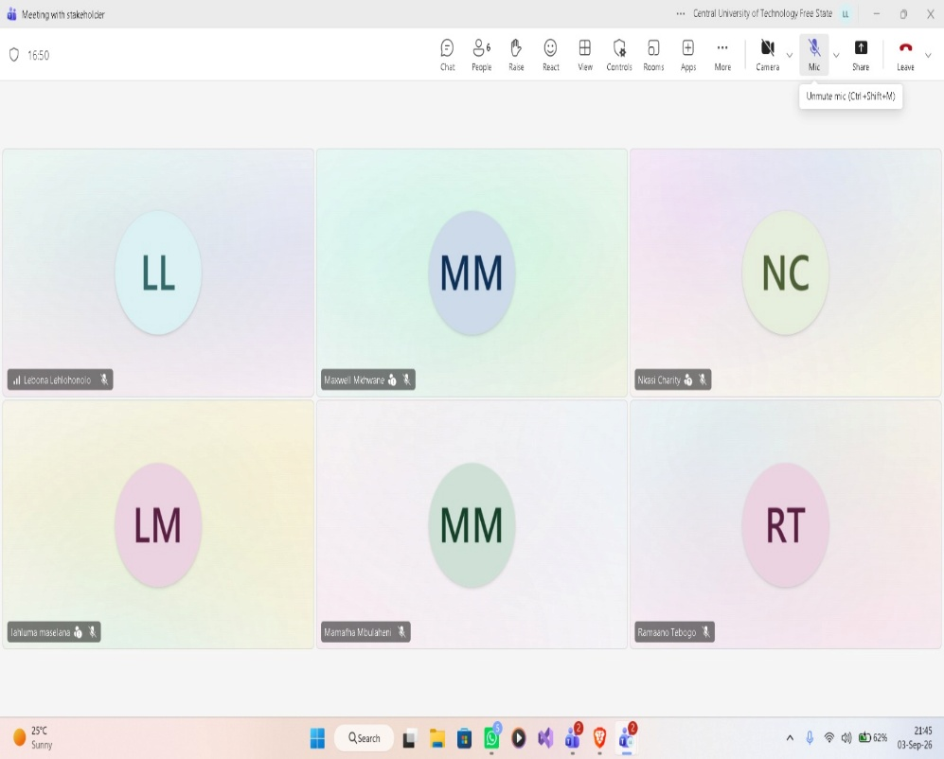

12. External Links

12.1 GitHub Repository Link

https://github.com/GroupW26/LifeStyle-Carwash-WIL-Project
12.2 Supabase Link

https://supabase.com/dashboard/project/kctvkqftoxlfbycptcot
12.3 System Architecture Design Link

https://app.creately.com/d/1aK5nNTFgPo/edit
12.4 Use Case Design Link

https://lucid.app/lucidchart/f8d4a778-4bb7-4db2-82c1-aa6f739ccbfb/edit?viewport_loc=-1345%2C-1214%2C5114%2C2662%2C0_0&invitationId=inv_0d392055-5ac3-467b-bceb-282571b0644e
12.5 Sequence Diagram_1 Design Link

https://lucid.app/lucidchart/ebd65c31-ab81-416f-a49d-c49d54538693/view

12.6 Sequence Diagram_2 Design Link

https://lucid.app/lucidchart/0828ef9f-e7e0-48d9-9d49-ea0897844e4f/view

12.7 Entity Relationship Diagram Design Link
editable file will be provided
12.8 Flutter Wireframe Figma Link

https://www.figma.com/design/1buQunHjTY3MvreGqHmpzD/Lifestyle-carwash-management-system?node-id=0-1&t=wI6oyMiRFMhX10E0-1

12.9 ASP.NET Wireframe Figma Link

https://www.figma.com/design/hgFXyGQvILkl039luE0bWg/ASP.NET-WIREFRAME?t=wI6oyMiRFMhX10E0-1

13. Glossary

  - Glossary
ASP.NET
A web application framework used in the Lifestyle Square Car Wash Management System to develop the staff-facing management application.
Digital Intake
The electronic process of recording vehicle information and documenting personal belongings inside a vehicle before servicing.
Digital Liability Waiver
An electronic agreement confirmed by the customer that records acknowledgement of the terms and liability associated with belongings left inside the vehicle.
Estimated Completion Time (ECT)
The estimated time at which a vehicle is expected to be ready for collection. The estimate is based on available operational information such as queue status, wash-bay loading and staff availability.
Functional Requirement (FR)
A requirement describing a specific function or behaviour that the system must provide, such as creating a vehicle intake record, managing the queue or sending customer notifications.
Flutter
A software development framework used to develop the customer-facing mobile application for the Lifestyle Square Car Wash Management System.
Integration Requirement (IR)
A requirement describing how different system components and functions must work together and share information.
Liability Waiver
A formal acknowledgement by the customer concerning responsibility for personal belongings left inside a vehicle during servicing.
Non-Functional Requirement (NFR)
A requirement describing qualities or constraints of the system, such as security, usability, information protection and clarity of notifications.
Off-Peak Booking
A weekday service booking made during periods of lower demand. The system may support incentive discounts for selected off-peak booking slots.
Project Scope
The defined boundaries of the proposed system, including the functions, technologies and operational problems that the project is intended to address.
Queue Management
The process of organising vehicles waiting for service and monitoring their movement through the car wash service process.
Supabase
The centralised backend platform used by the system to store and manage customer, vehicle, valuables, waiver, queue, service and reservation information.
System Requirement (SR)
A technical requirement describing the technologies and system-level capabilities required for implementation of the proposed solution.
Virtual Service Queue
A digital representation of vehicles waiting for service, allowing staff to manage vehicle order and monitor service progress.

Appendix

14.1 Appendix A: Current Process Diagram
14.2 Appendix B: Use Case Diagram
14.3 Appendix C: Stakeholder Engagement Evidence
14.4 Appendix D: Interview Audio File
14.5 Appendix E: Message and Call Correspondence
14.6 Appendix F: Feasibility Summary
14.7 Appendix G: Project Risk Register
14.8 Appendix H: GitHub Repository
14.9 Appendix I: Supabase Project

