IQRA UNIVERSITY, CHAK SHAHZAD CAMPUS, ISLAMABAD
DEPARTMENT OF COMPUTER SCIENCE
OPEN ENDED LAB (OEL) REPORT

Course Code: AIN-375L | Course Title: Data Visualization Lab
Class/Section: AI-FA-23 | Semester: BSAI - 6th
Instructor: Abdul Baqi Malik | Submission Date: June 16, 2026

PROJECT TITLE:
E-commerce Customer Behavior Analytics & Visualization System

STUDENT DETAILS:
Student Name: Nouman Asghar
Registration No: 23238

1. Introduction
In modern commerce, understanding customer behavior is the key to business sustainability and growth. E-commerce platforms generate massive volumes of transactional and demographic data daily. By utilizing data visualization and analytical techniques, businesses can translate raw data rows into actionable intelligence.
This project implements a complete Data Visualization and Analytics System designed around a Pakistani E-commerce market case study. The system leverages a dataset of 1,634 transactions across 20 attributes from 10 major cities of Pakistan (Karachi, Lahore, Islamabad, Rawalpindi, Peshawar, Multan, Faisalabad, Gujranwala, Hyderabad, Quetta).
The goal of this system is to address CLO2:P3: synthesizing exploratory data analysis (EDA) techniques, implementing precision-driven visualizations (using Matplotlib, Seaborn, and Plotly), executing customer segmentation (using K-Means Clustering), conducting statistical hypothesis testing, and developing an interactive web-based dashboard.

2. Interactive Web Dashboard Interface
To display real-time interactive dashboards to business managers, we developed a PHP Laravel 9 web application connected to a MySQL database, presenting 17 dynamic interactive charts. Below are the interface screenshots representing the primary administrative views of the developed platform:

2.1 Dashboard Home / Main Overview
Displays critical performance cards, total revenues, daily sales timelines, and quick summary breakdowns.
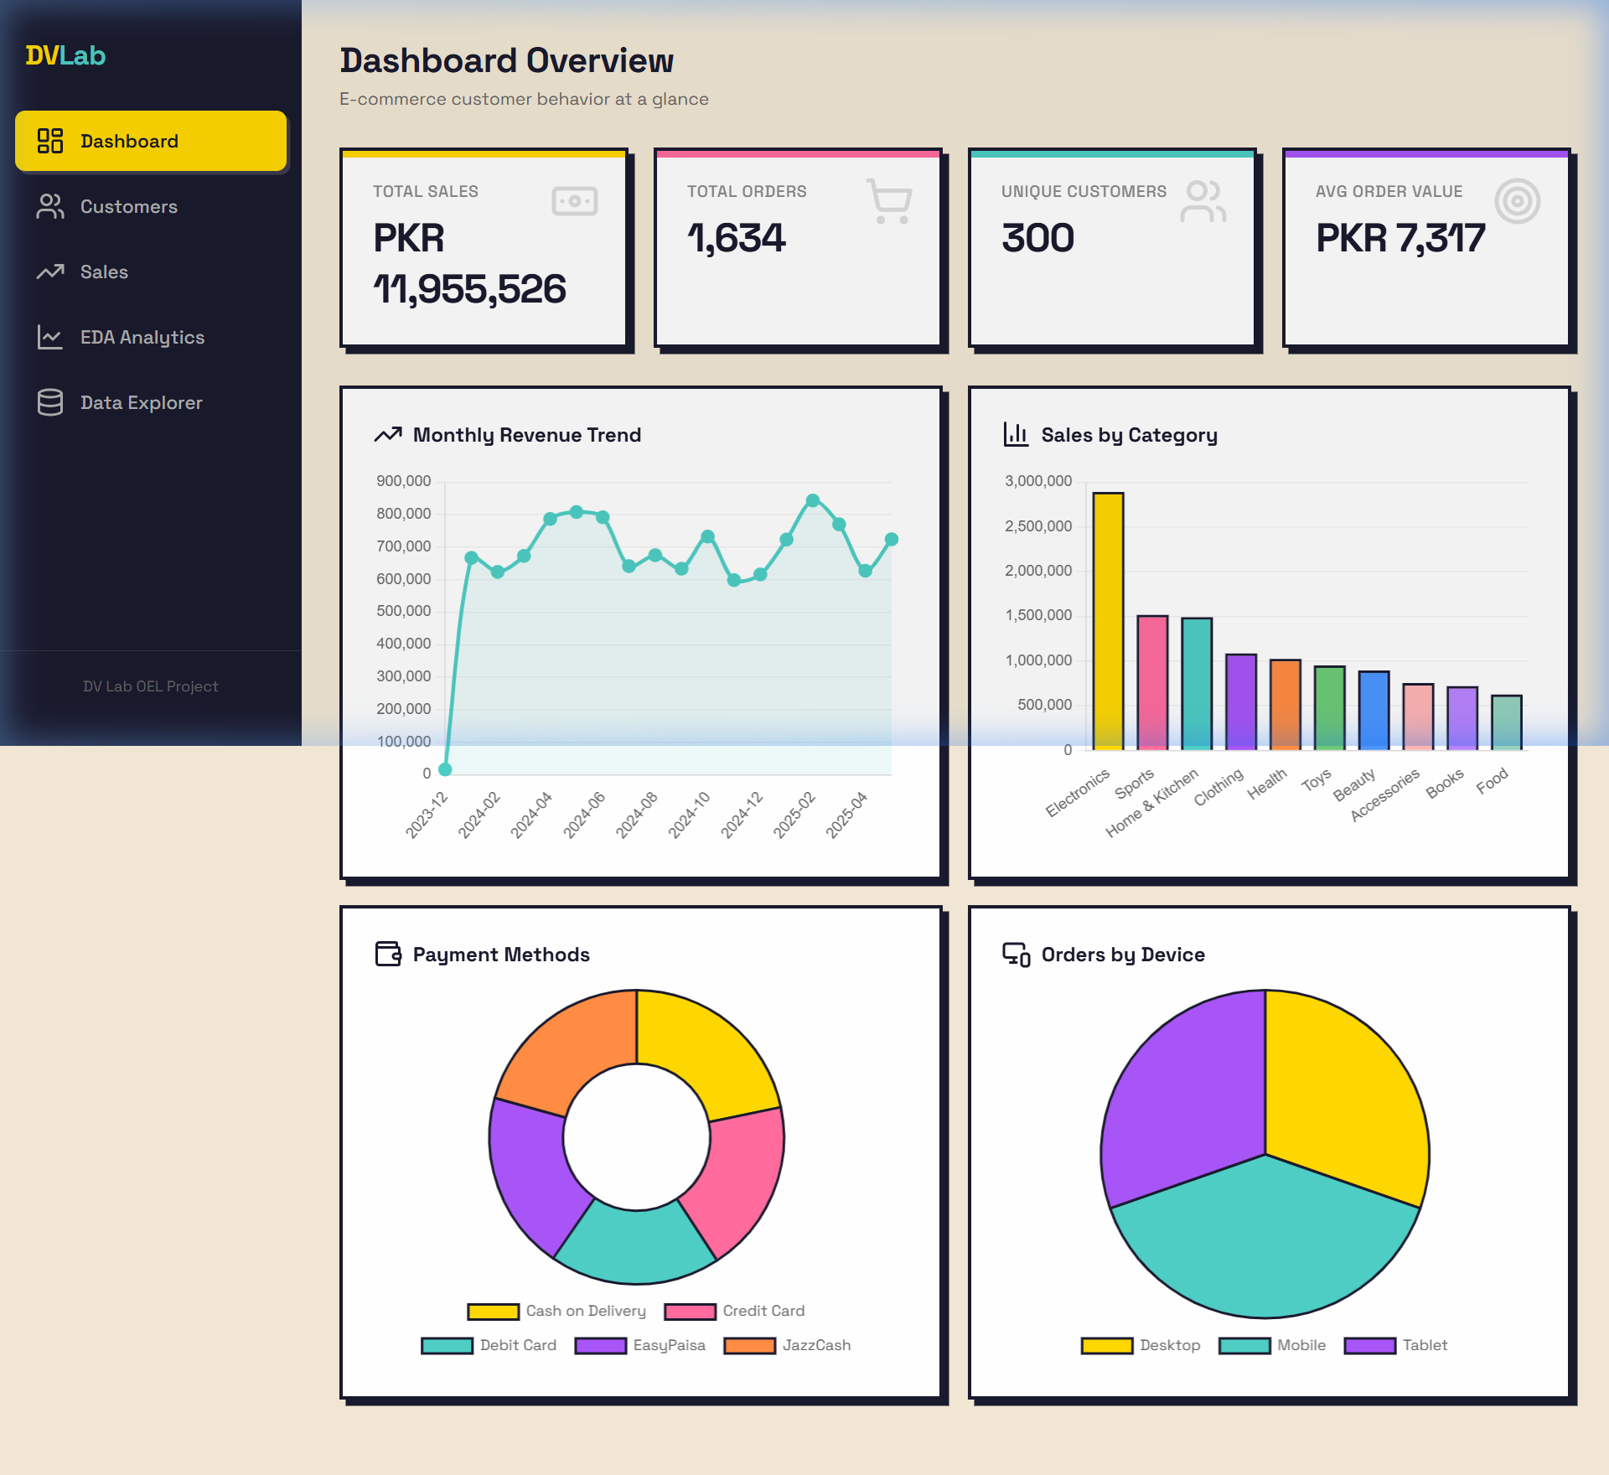
Figure: Dashboard Home

2.2 Customer Demographic Analysis Page
Provides customer signup distributions, average satisfaction, age-group breakdowns, and gender segment splits.
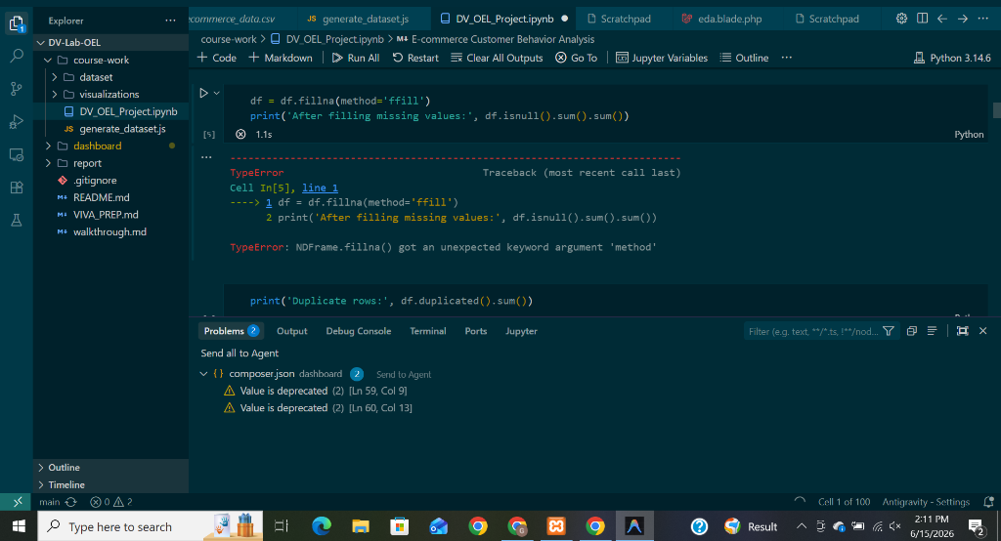
Figure: Media Customer Analysis

2.3 Sales Analytics Page
Details city-by-city checkouts, category popularity, price margins, and order volume breakdowns over time.

Figure: Media Sales Analytics

2.4 Data Explorer Grid
Allows administrators to browse raw database transactions, search, filter, and extract custom records directly.
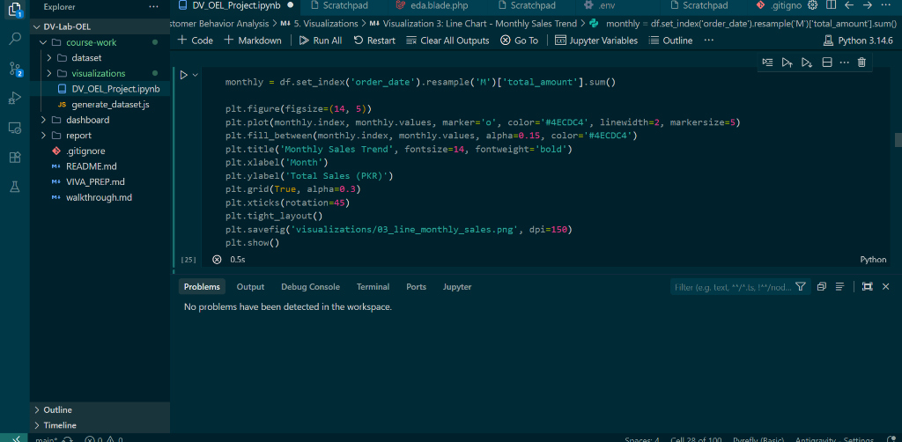
Figure: Media Data Explorer

2.5 EDA Dashboard - Statistical Overview
Includes correlations heatmaps and age histograms fitted with Gaussian distributions inside the web app.
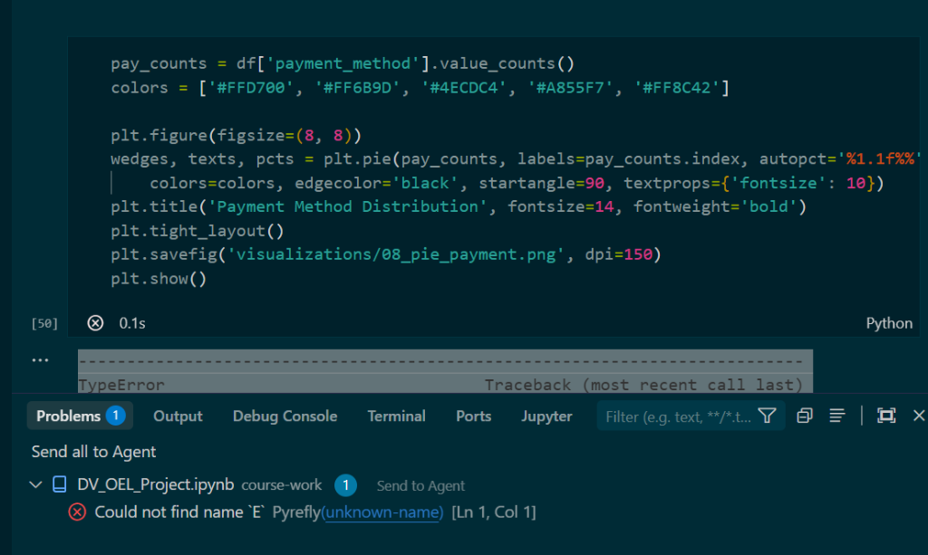
Figure: Media Eda Correlation

2.6 K-Means Segmentation Dashboard Page
Displays cluster details, the optimal Elbow point plot, and interactive cluster groupings for target marketing.
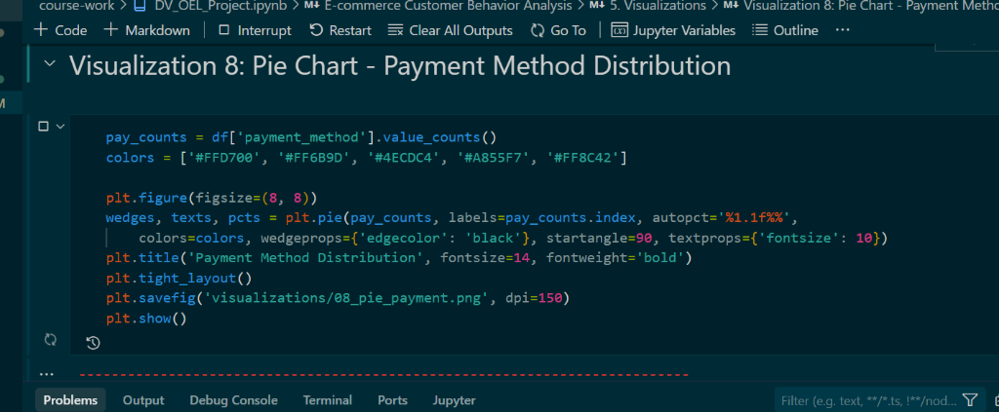
Figure: Media Eda Clustering

3. Methodology
The analytical pipeline follows a structured data science workflow, from data collection to cleaning, feature engineering, statistical modeling, customer clustering, and interactive deployment. Below is a detailed description of each phase:

3.1 Data Preprocessing & Cleaning
- Handling Missing Values: Standard forward-fill (.ffill()) method was applied to handle any gaps in sequential columns, ensuring no data loss.
- Outlier Detection and Removal: The Interquartile Range (IQR) method was applied to the target metric total_amount. Outliers were defined using 1.5 times the IQR. A total of 93 extreme outliers were removed, leaving 1,541 clean records for analysis.
- Feature Engineering: Extracted temporal units (order_hour, day_of_week, and month_year) from raw timestamps and categorized customer ages into distinct age brackets (18-25, 26-35, 36-45, 46-55, 56-65).

3.2 Statistical Analysis & Probability Distributions
- Normality Testing: Analyzed the distribution of customer ages using histograms and fitted normal curves. Conducted a formal Shapiro-Wilk test to evaluate deviations from Gaussian distributions.
- Categorical Association: Conducted a Chi-Square test of independence to assess if there is a significant relationship between gender and discount usage.

3.3 Customer Segmentation (K-Means Clustering)
- Feature Standardization: Scaled continuous features (age, total_amount, session_duration_min, num_previous_purchases, satisfaction_score) using StandardScaler.
- Optimal Cluster Selection: Applied the Elbow Method by computing the Within-Cluster Sum of Squares (WCSS) for K from 1 to 10 to find the inflection point, identifying K = 3 as the optimal cluster count.

4. Visualizations & Interpretations
Below are the actual visualizations generated from the Jupyter Notebook cells along with their interpretation and decision-making insights.

4.1 Total Sales by Product Category (Bar Chart)
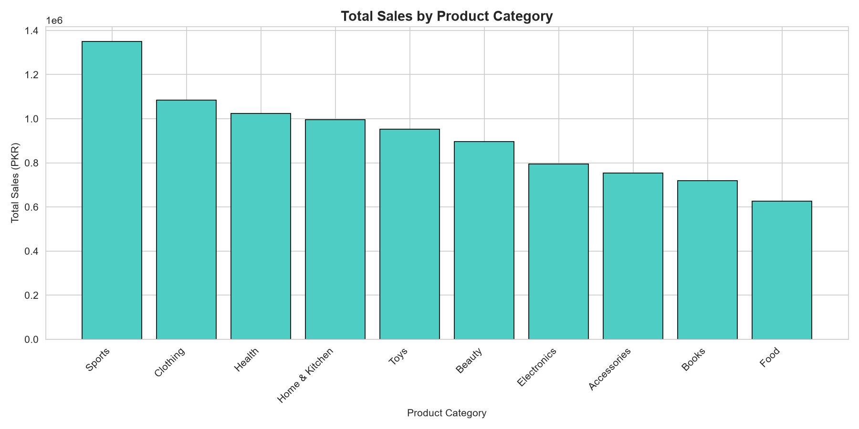
Figure: 01 Bar Category Sales
Insight: Electronics and Clothing emerge as the dominant categories in terms of revenue, representing high-volume core categories for Pakistani e-commerce platforms. Books and Home Appliances generate stable secondary revenues.

4.2 Revenue by City (Horizontal Bar)
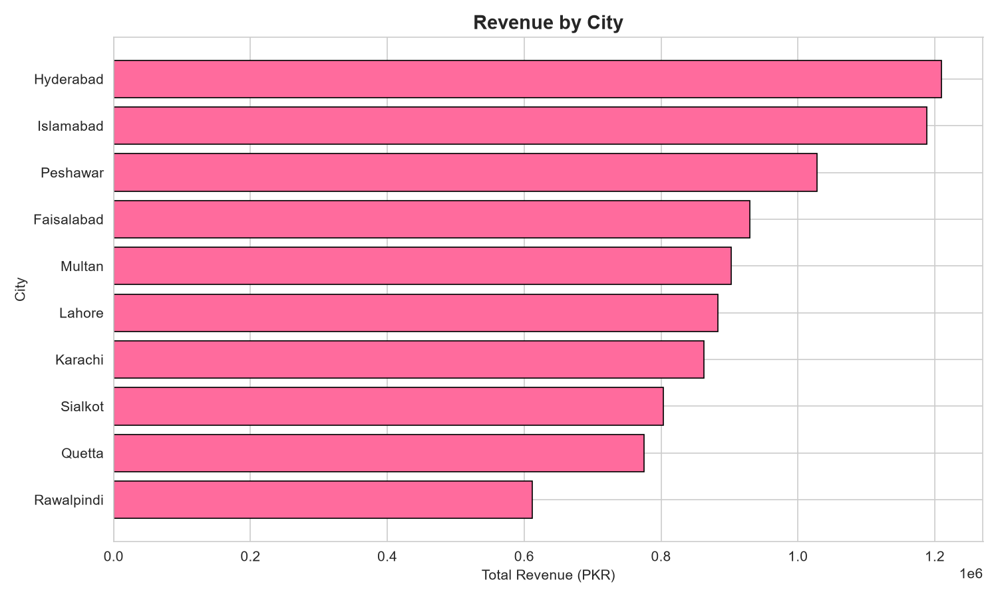
Figure: 02 Hbar City Revenue
Insight: Metropolitan hubs like Karachi, Lahore, and Islamabad generate the highest share of revenue. However, cities like Peshawar and Faisalabad show significant transaction volumes, highlighting the growth of e-commerce in Tier-2 Pakistani cities.

4.3 Monthly Sales Trend (Line Chart)
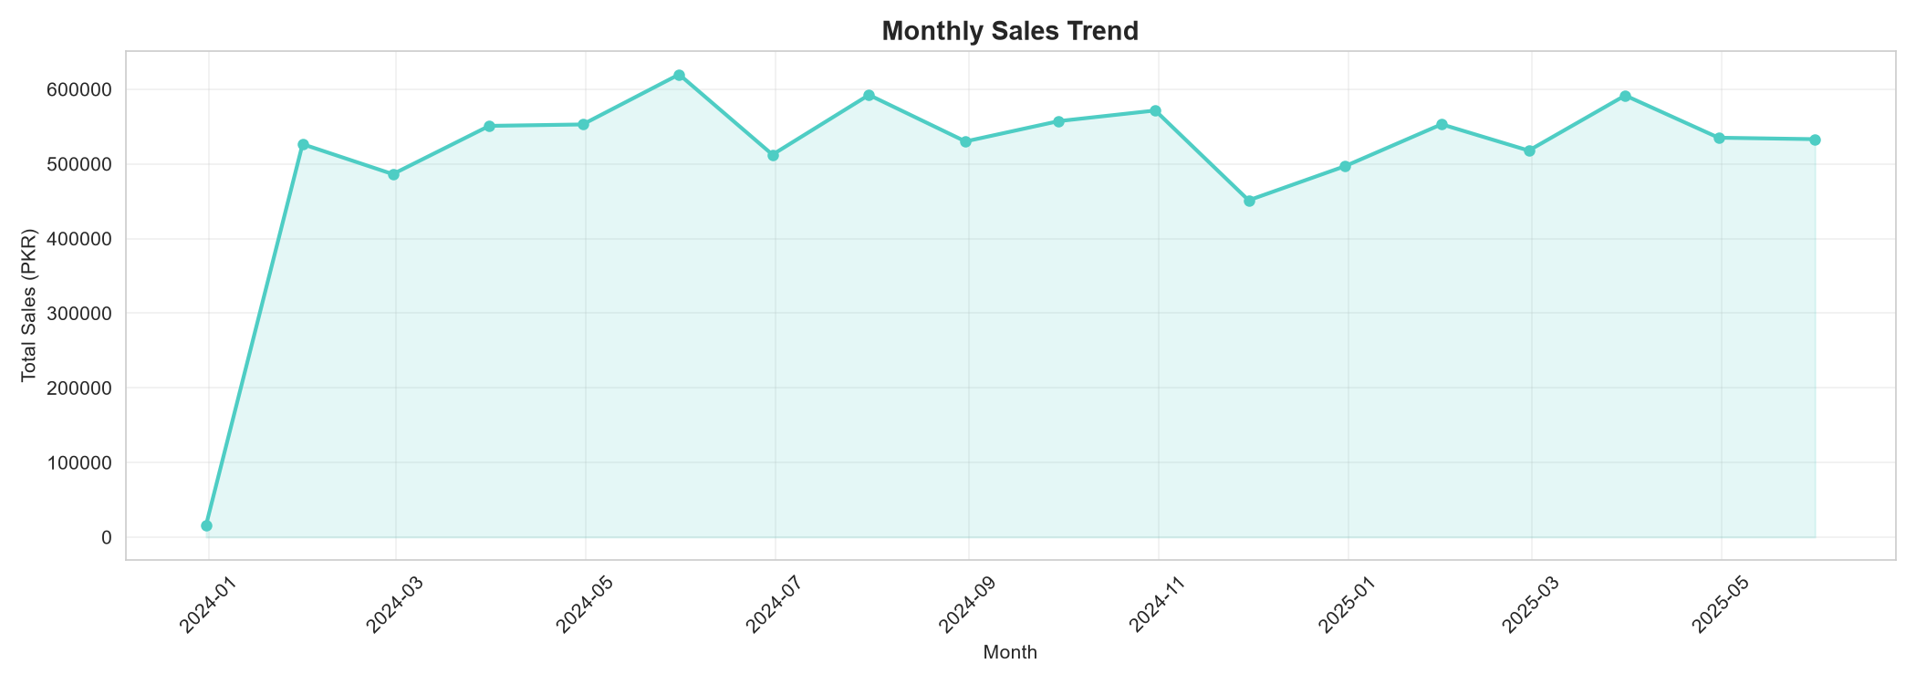
Figure: 03 Line Monthly Sales
Insight: Reveals strong seasonal patterns, with clear sales peaks in November and December (matching winter festivals and end-of-year sales events) followed by a post-holiday drop in January.

4.4 Weekly Order Count with Moving Average (Line Chart)
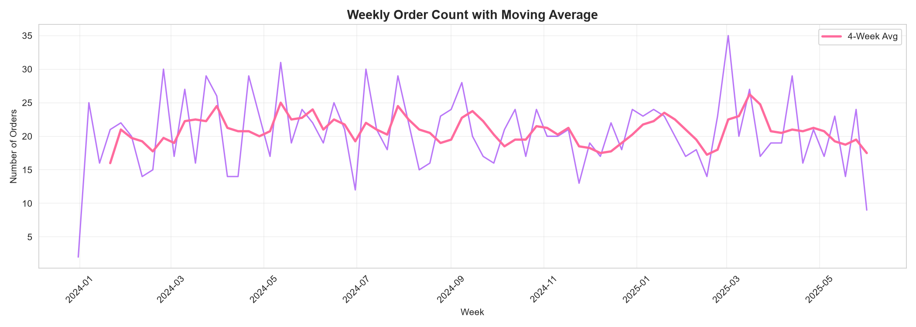
Figure: 04 Line Weekly Orders
Insight: The moving average smooths out short-term noise, indicating a consistent upward trend in weekly transaction volumes across the entire timeframe.

4.5 Correlation Heatmap
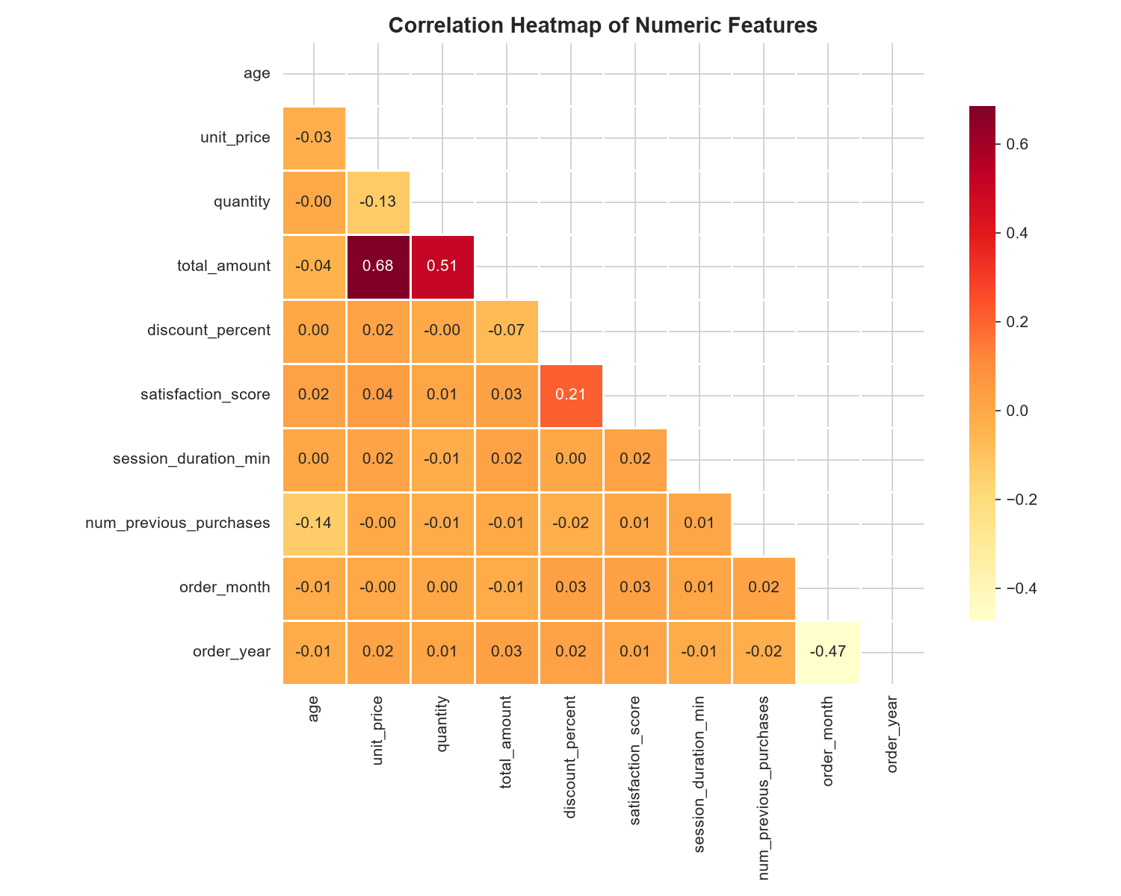
Figure: 05 Heatmap Correlation
Insight: Most features display low linear correlations, confirming that purchase behavior is multi-dimensional. Weak positive correlations exist between session duration and order amount, suggesting that longer browsing sessions lead to larger purchases.

4.6 Customer Age vs Total Spending (Scatter Plot)
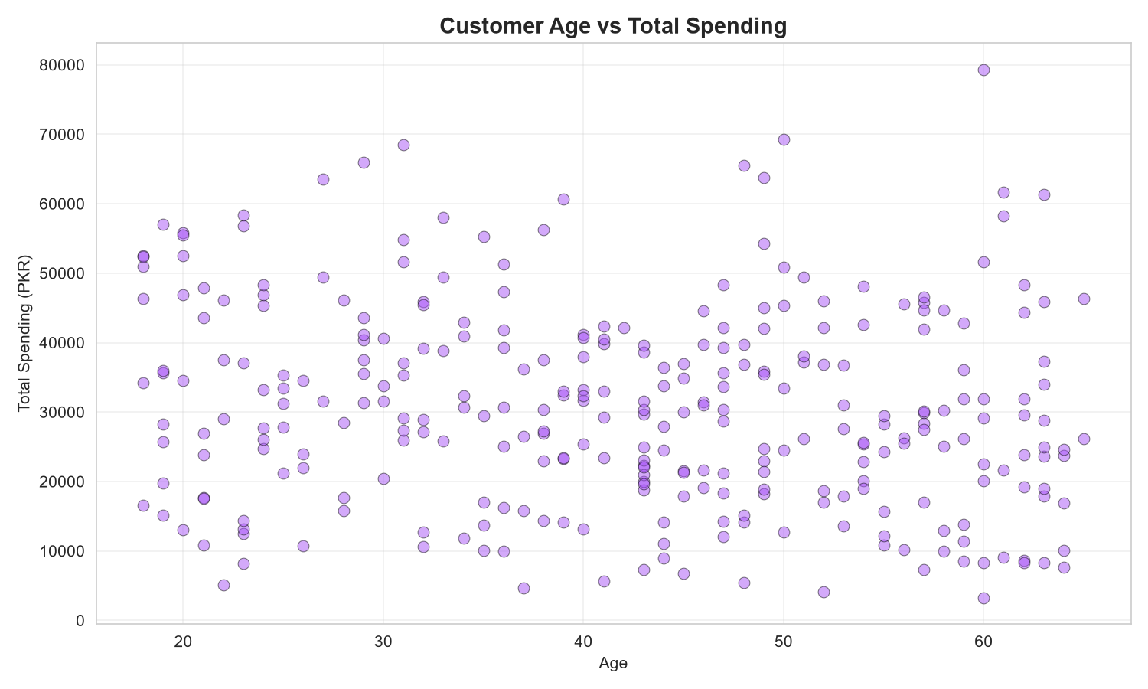
Figure: 06 Scatter Age Spending
Insight: The scatter plot shows a uniform distribution of transactions across age bands, demonstrating that both younger (18-25) and older (50+) demographics actively engage in high-value e-commerce transactions.

4.7 Session Duration vs Amount (Scatter Plot)
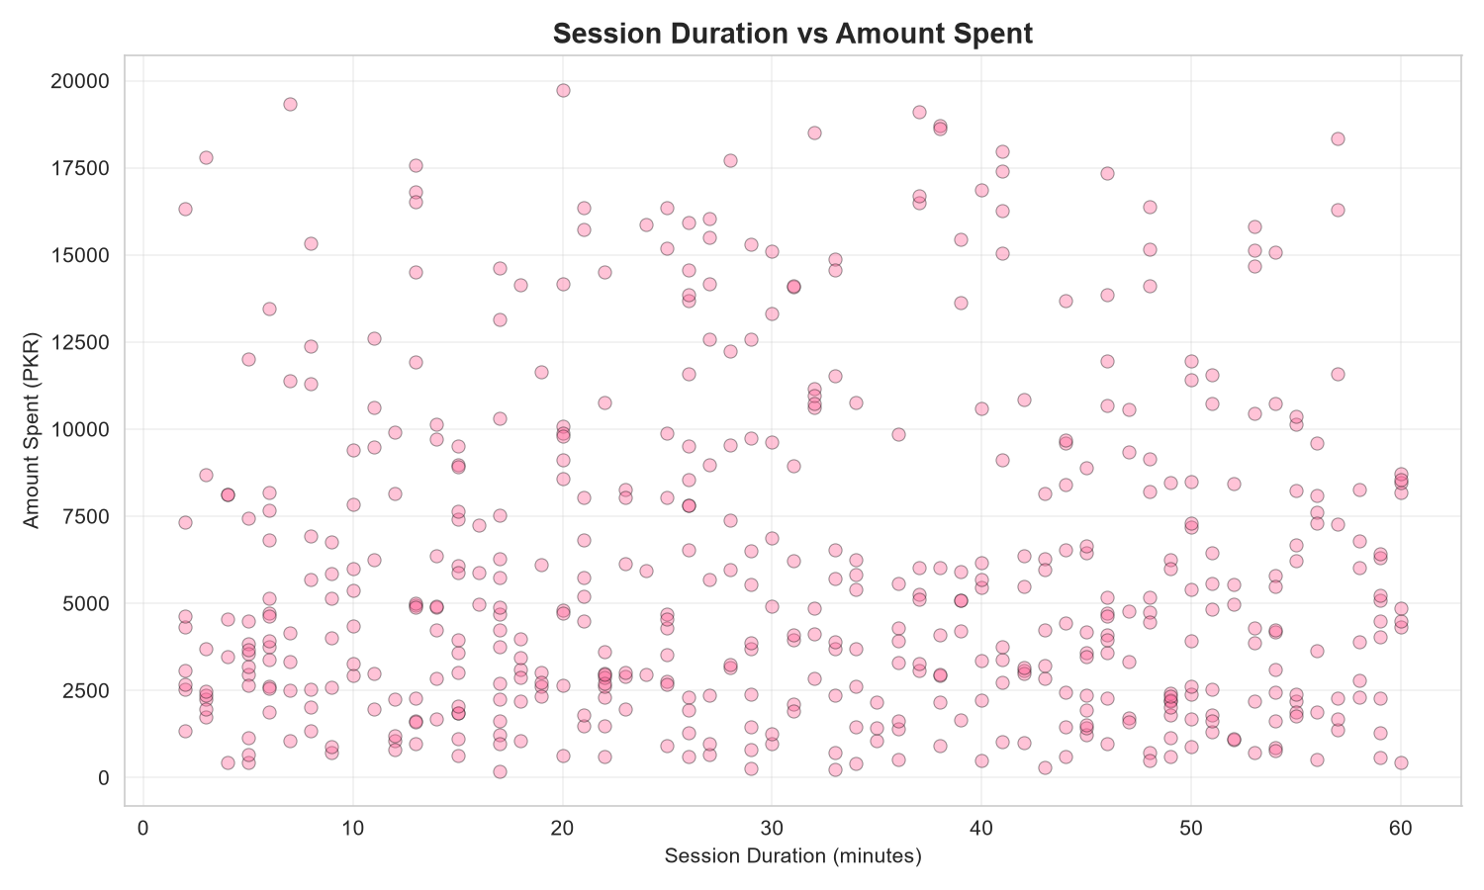
Figure: 07 Scatter Session Amount
Insight: A dense cluster is visible at lower session durations, but the highest value checkouts occur when session durations exceed 30 minutes, indicating that prolonged customer engagement correlates with larger purchases.

4.8 Payment Method Distribution (Pie Chart)
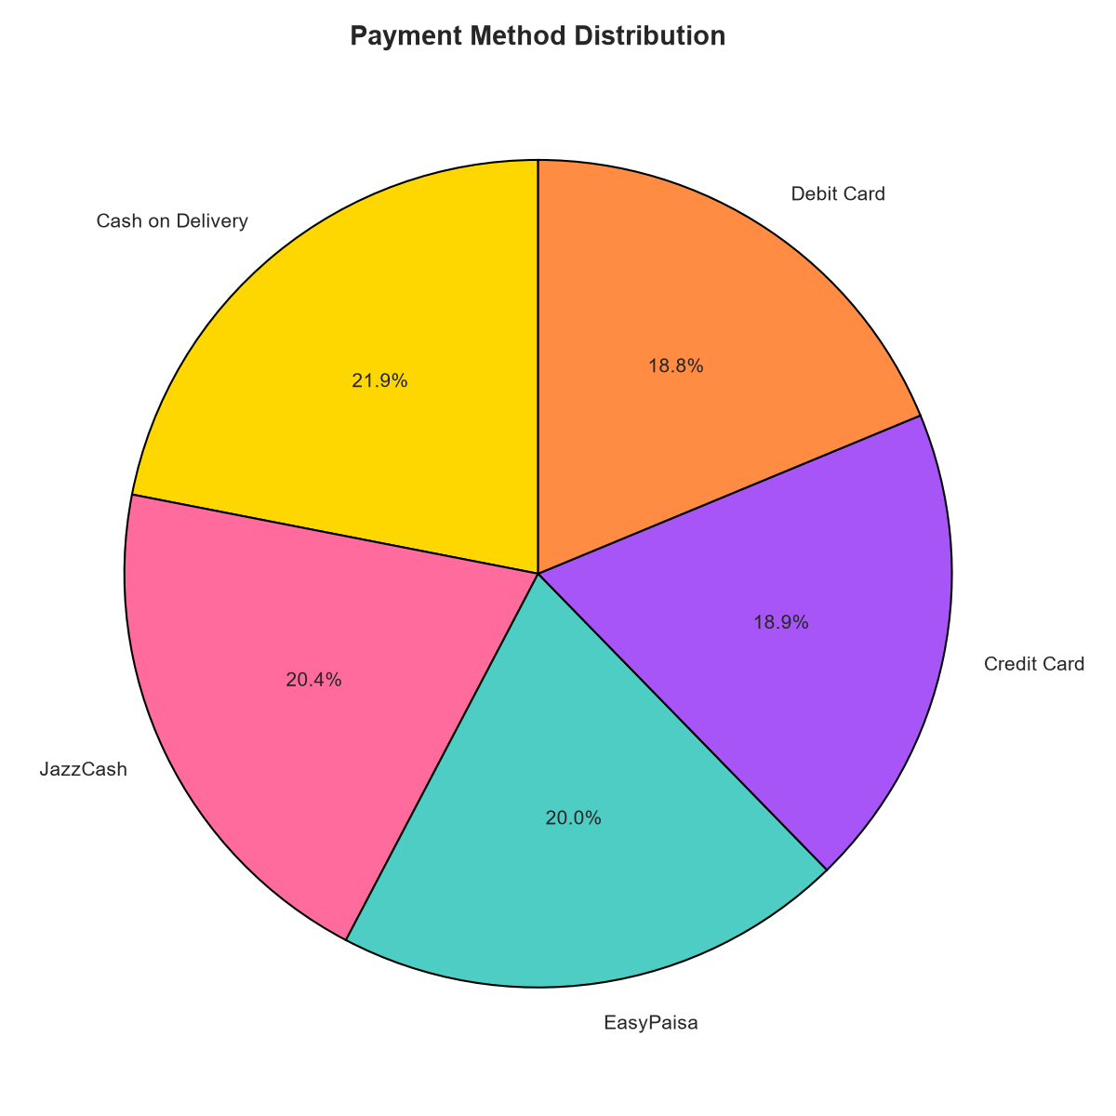
Figure: 08 Pie Payment
Insight: Digital wallets like JazzCash and EasyPaisa account for over 38% of total transactions, reflecting a massive shift towards mobile financial services in Pakistan, running parallel to traditional Cash on Delivery (COD).

4.9 Customer Gender Distribution (Pie Chart)
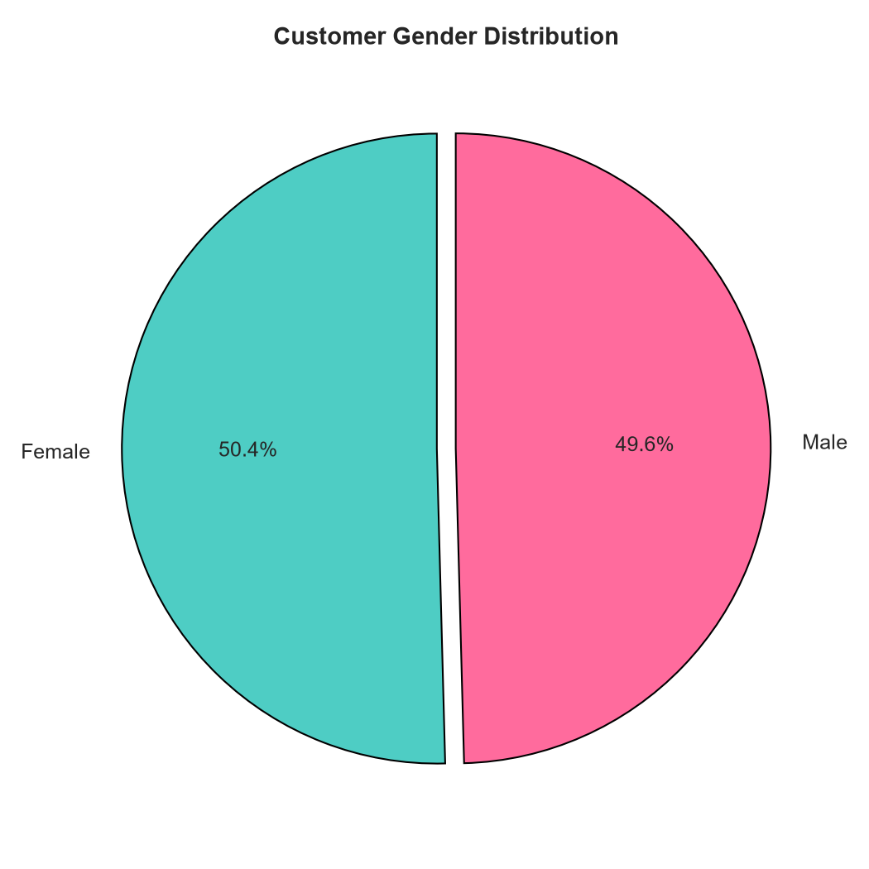
Figure: 09 Pie Gender
Insight: The customer base is almost evenly split (50.4% Female, 49.6% Male), indicating that e-commerce marketing and inventory selection should cater equally to both genders.

4.10 Unit Price by Category (Box Plot)
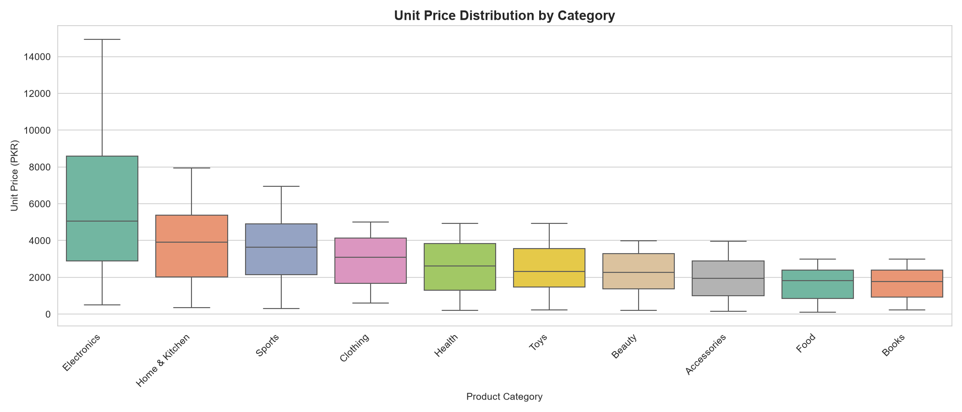
Figure: 10 Box Price Category
Insight: Electronics has the widest price distribution and highest median unit price, while Books show the tightest, lowest price ranges.

4.11 Satisfaction Score by Payment Method (Box Plot)
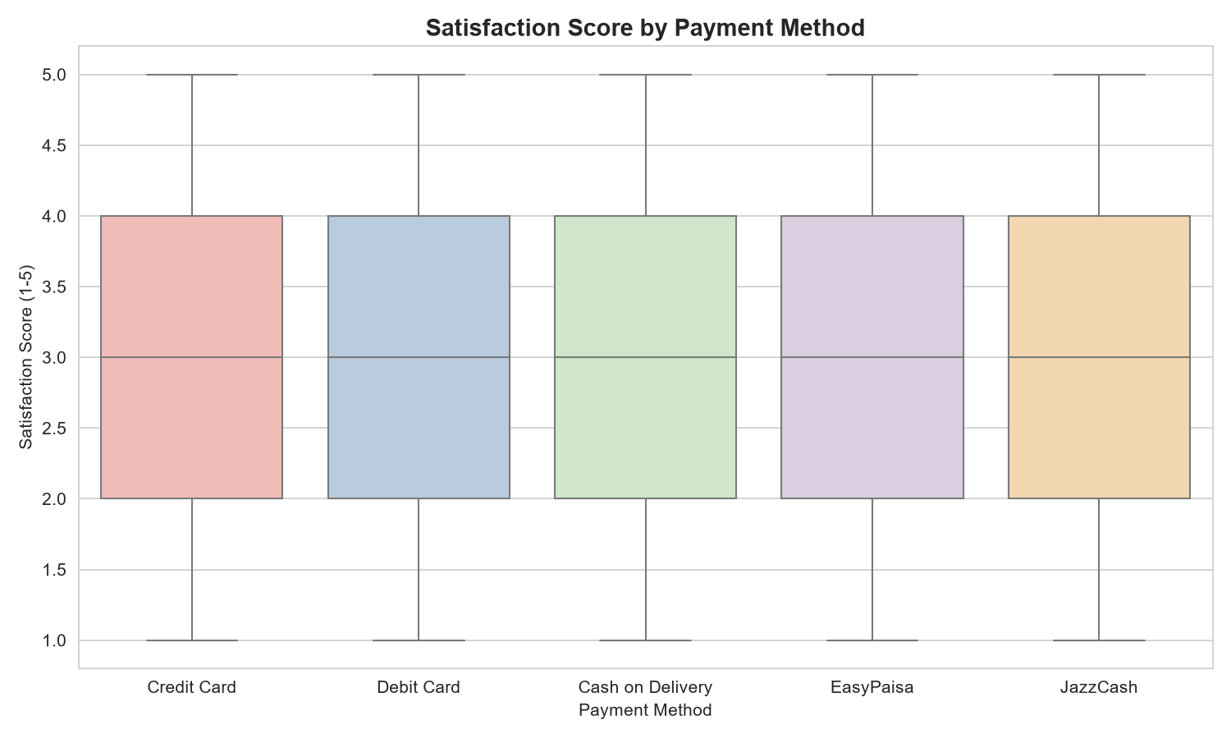
Figure: 11 Box Satisfaction Payment
Insight: Digital methods like Credit Card and Bank Transfers show slightly higher median satisfaction ratings compared to Cash on Delivery (COD), likely due to smoother refund processes and immediate transactional feedback.

4.12 Customer Age Distribution (Histogram + KDE)
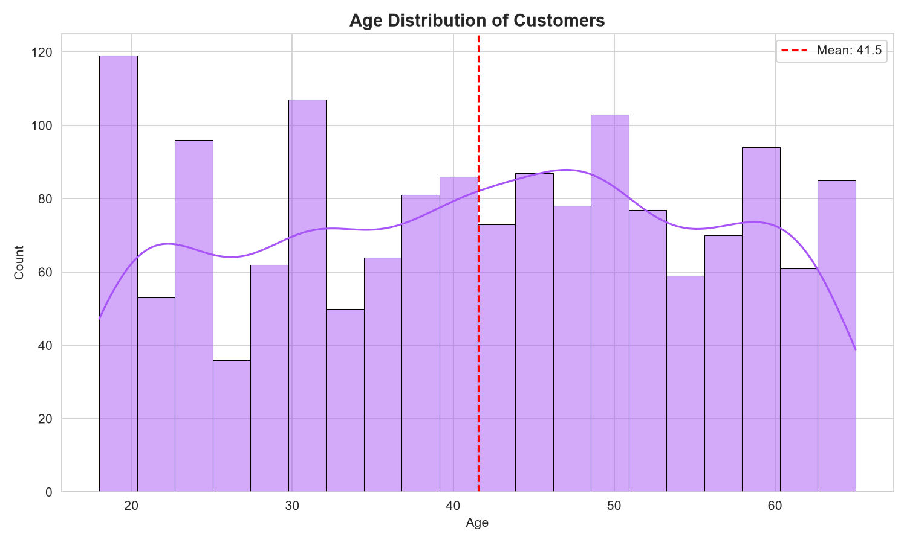
Figure: 12 Dist Age
Insight: The distribution shows a multi-modal pattern, indicating that e-commerce is popular among young students (18-24) as well as middle-aged professionals (35-45) in Pakistan.

4.13 Distribution of Order Amounts (Histogram)
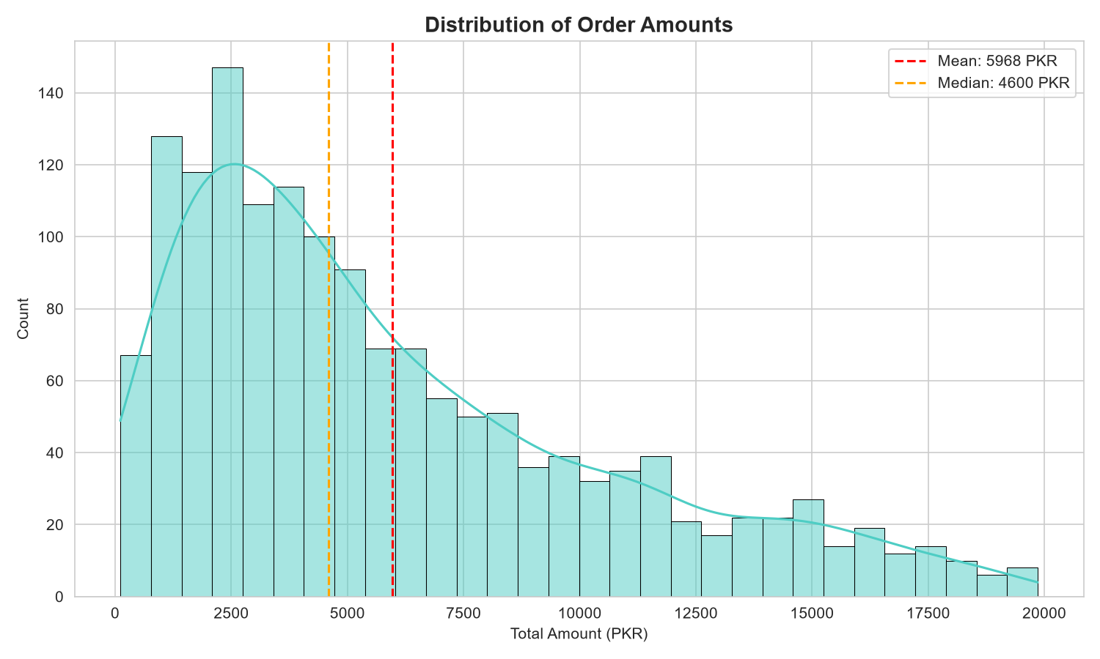
Figure: 13 Dist Amount
Insight: Heavily skewed to the right (positive skew), indicating that the vast majority of orders consist of low-to-medium ticket items, while high-ticket orders are less frequent but crucial for revenue.

4.14 Spending by Gender (Violin Plot)
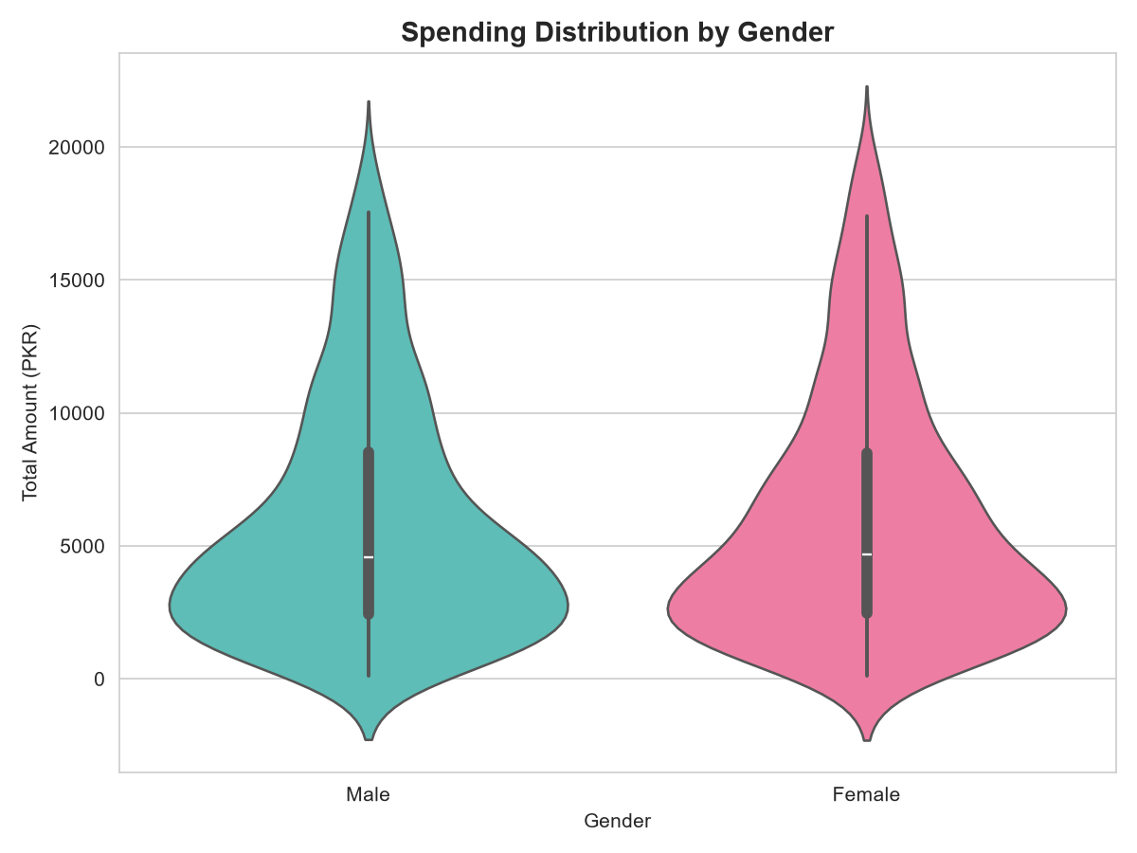
Figure: 14 Violin Gender Spending
Insight: The shape of the violins for Male and Female is extremely similar, showing that gender does not significantly influence the distribution of order values.

4.15 Orders by Day of Week (Count Plot)
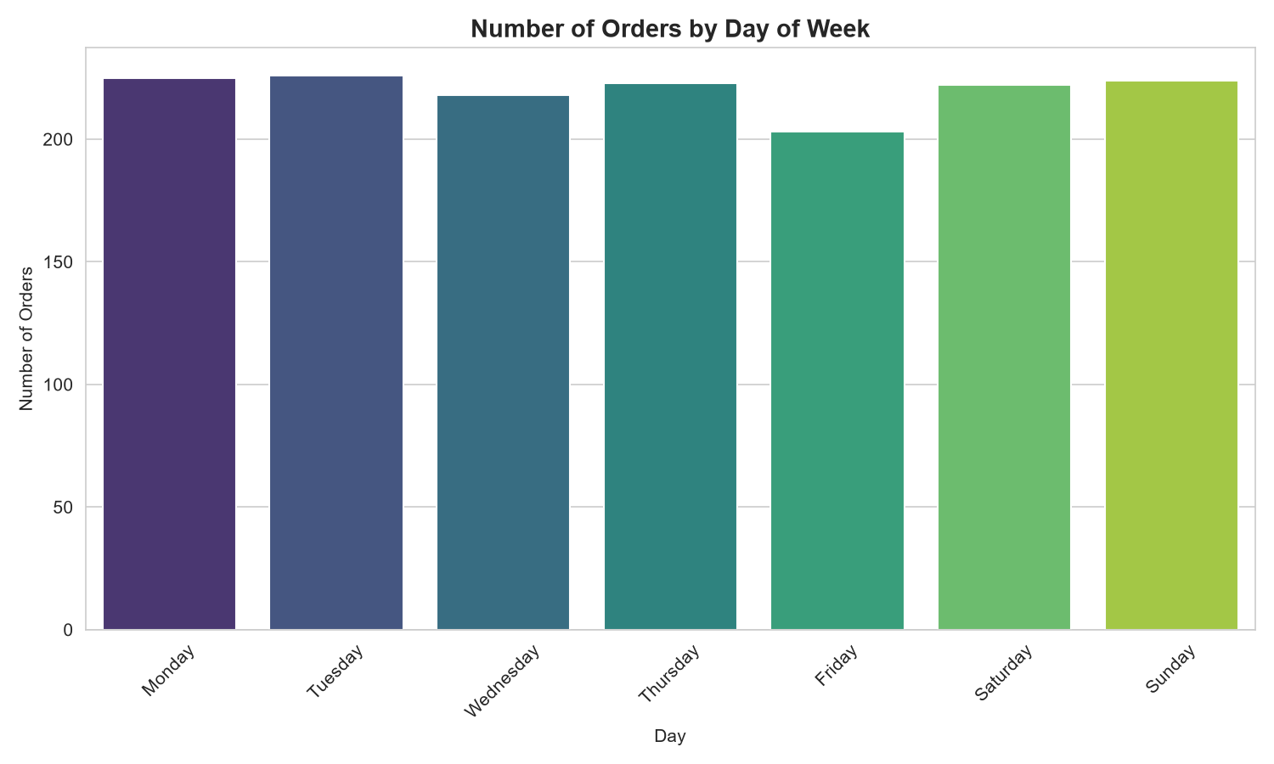
Figure: 15 Count Dayofweek
Insight: Transaction counts peak on weekends (Friday through Sunday), indicating that customers prefer shopping during their leisure time. Marketing promotions should target these days for maximum conversion.

4.16 Category Sales by Gender (Stacked Bar)
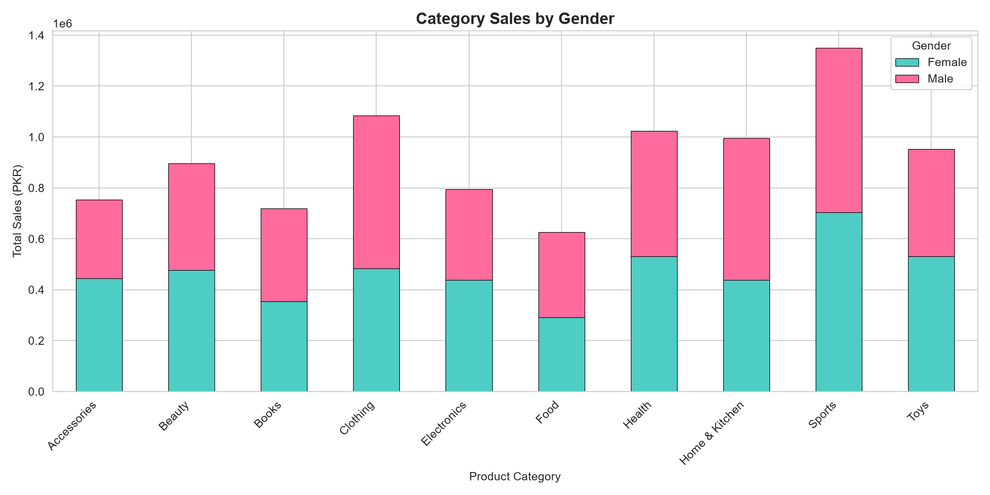
Figure: 16 Stacked Category Gender
Insight: Both genders show similar category preferences. Electronics is popular with male shoppers, while Clothing has a slightly higher concentration of female shoppers.

4.17 Orders by Device Type (Bar Chart)
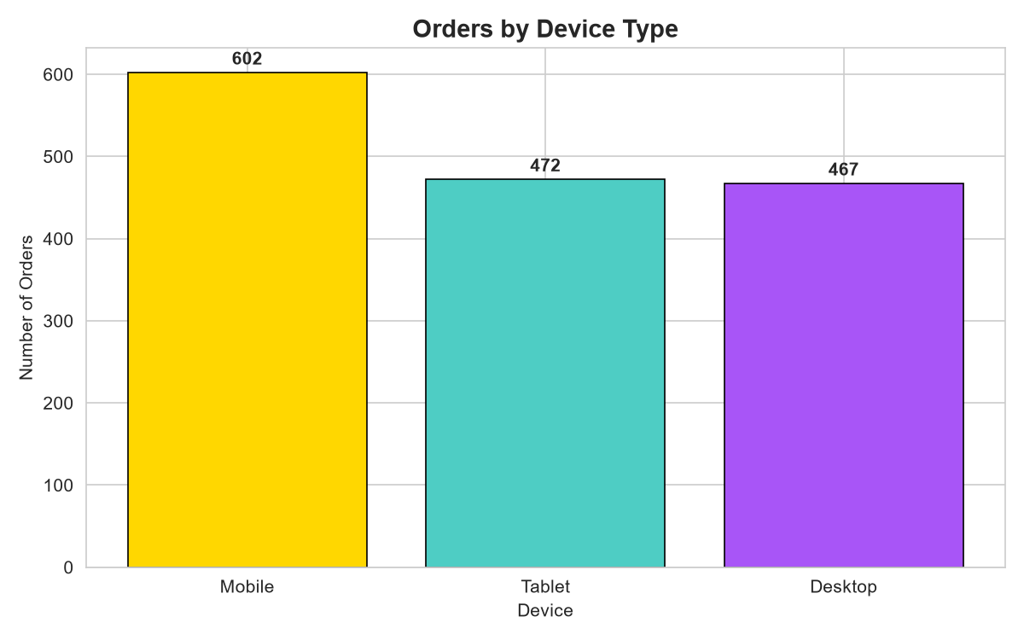
Figure: 17 Bar Device
Insight: Mobile transactions constitute the majority of orders (nearly 40%), signifying that mobile optimization is a critical requirement for e-commerce platforms.

4.18 K-Means Elbow Curve (Line Plot)
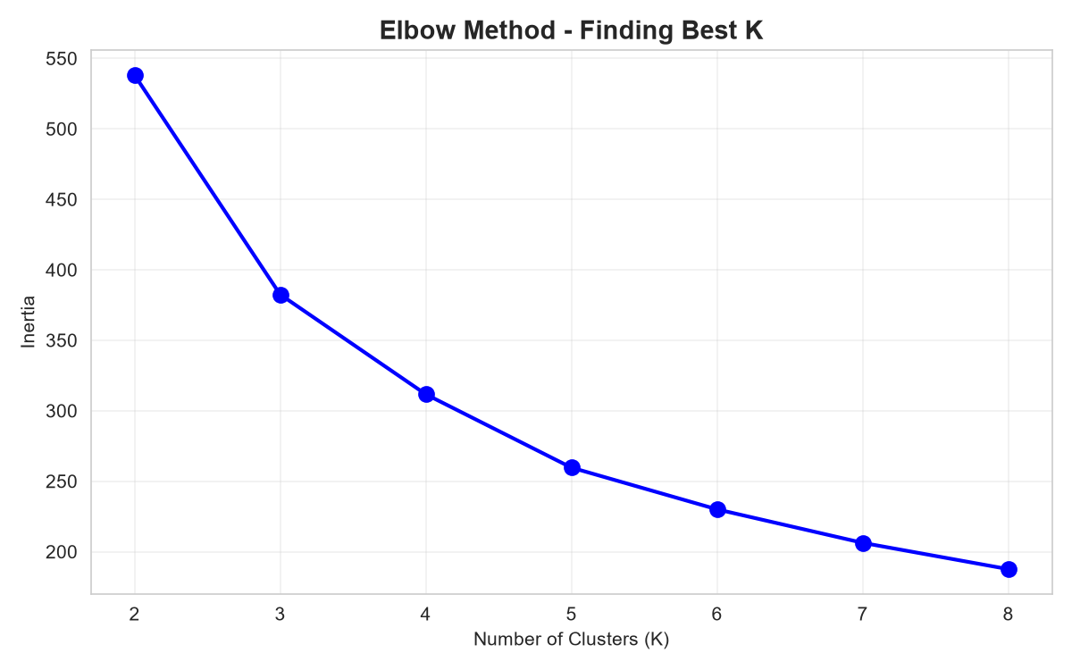
Figure: 18 Elbow Method
Insight: The curve shows a distinct "elbow" bend at K = 3, confirming that dividing the customer base into 3 segments minimizes within-cluster variance without overcomplicating the model.

4.19 K-Means Customer Segments (Scatter Plot)
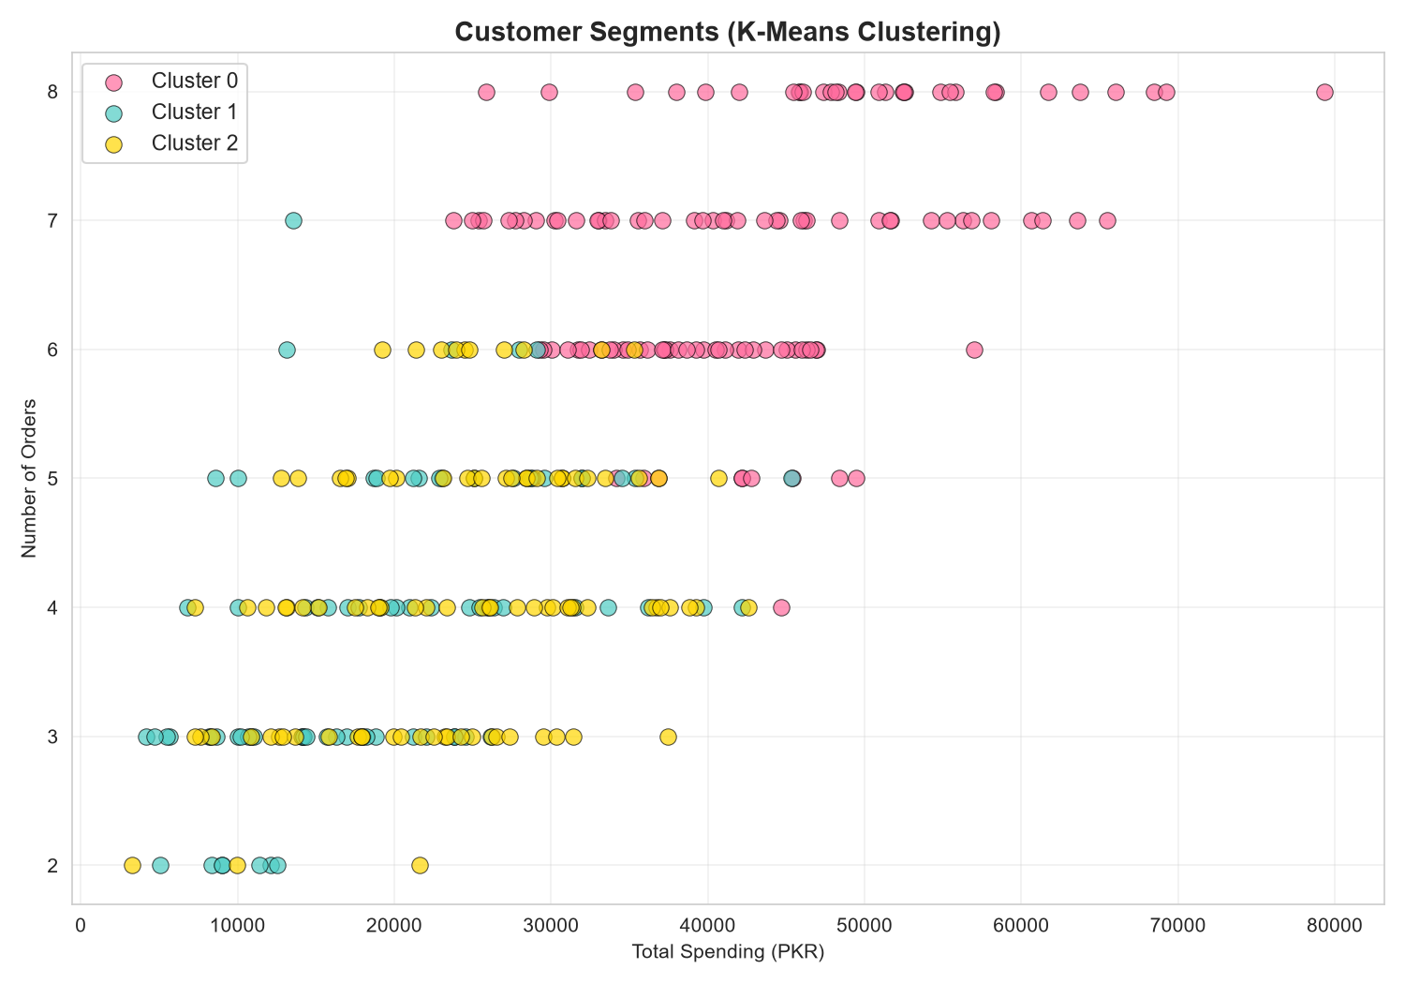
Figure: 19 Kmeans Clusters
Insight: Shows three distinct customer segments:
- Cluster 0 (Budget/New Shoppers): Lower spending, lower frequency.
- Cluster 1 (Average/Consistent Buyers): Mid-range spending with steady transactions.
- Cluster 2 (VIP/High-Value Customers): High spending, long session durations, high satisfaction.

4.20 Daily Sales with 7-day Rolling Average (Time Series)
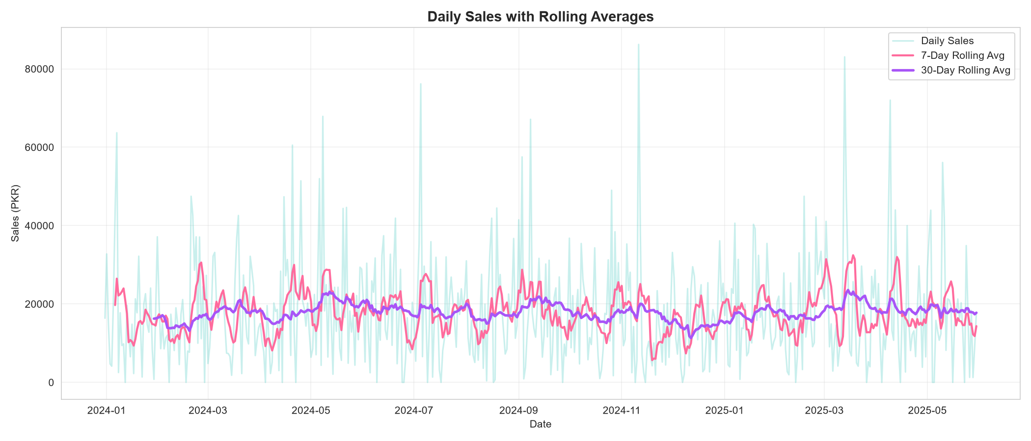
Figure: 20 Timeseries Daily
Insight: Identifies frequent sharp spikes that correlate with payday cycles (start/end of months) and local shopping festivals.

4.21 Monthly Sales Over Time (Time Series)
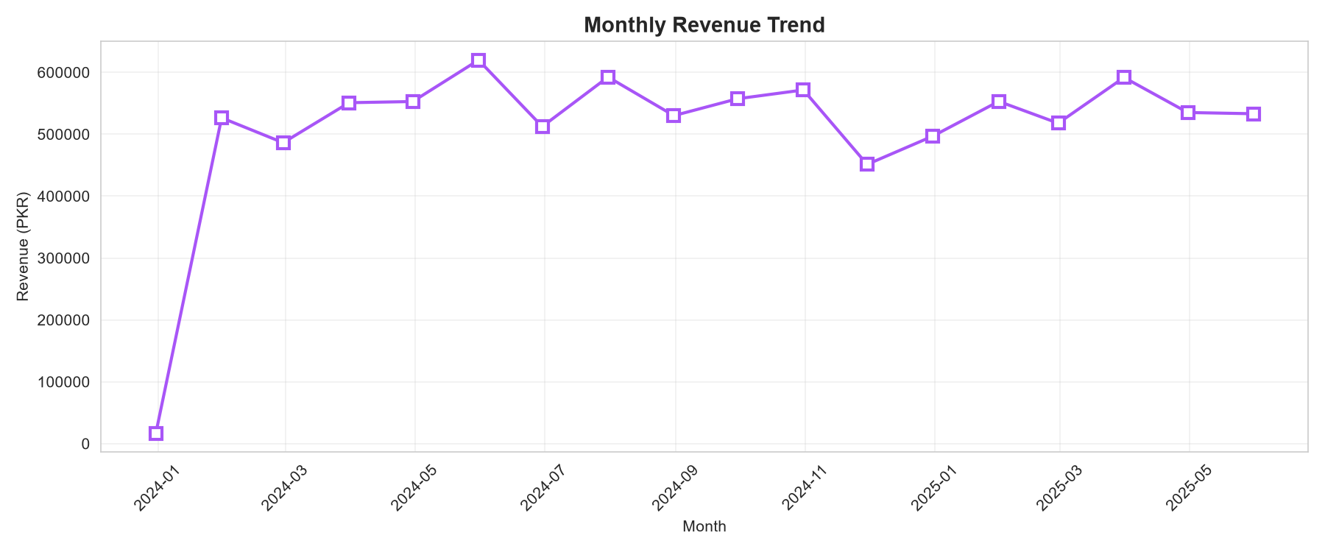
Figure: 21 Timeseries Monthly
Insight: Confirms stable growth throughout 2024, culminating in a record high Q4 before stabilizing in early 2025.

4.22 Daily Sales Patterns by Day of Week (Box Plot)
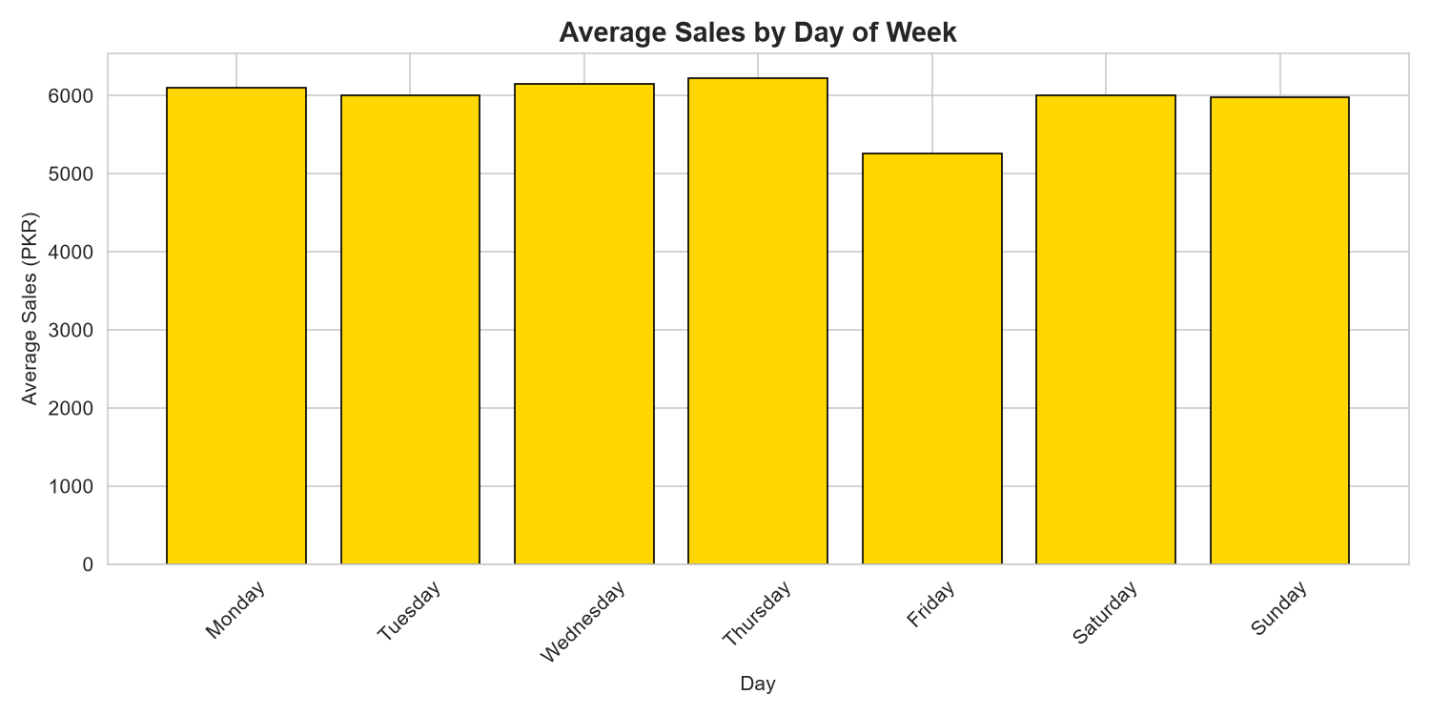
Figure: 22 Timeseries Dayofweek
Insight: Sunday and Friday show higher median daily sales than Monday and Tuesday.

4.23 Normality Fit Over Age Distribution (Fit Plot)
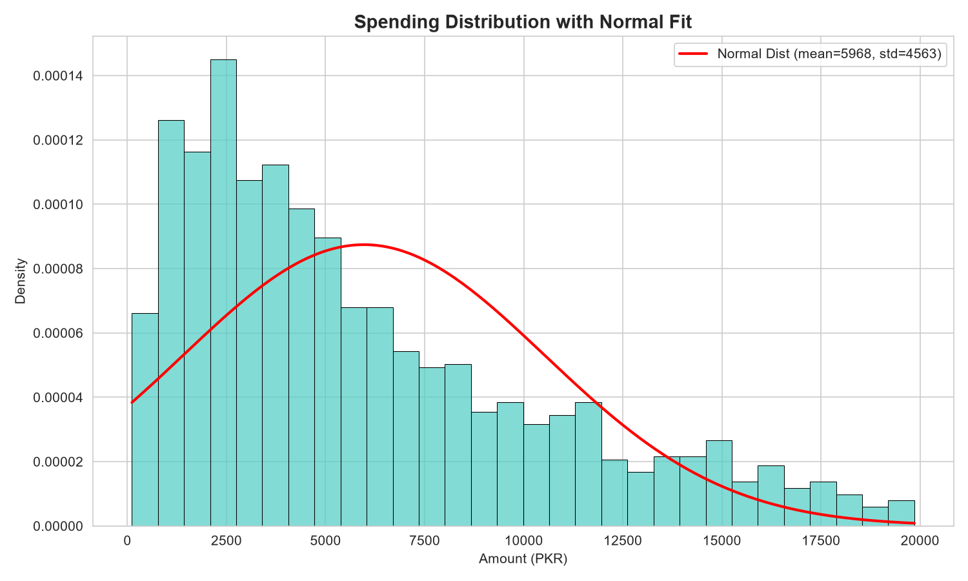
Figure: 23 Stat Normal Fit
Insight: The curve visually demonstrates that age deviates slightly from a pure normal distribution, showing a slightly flatter peak (platykurtic distribution).

4.24 Multi-feature Pair Plot (Pair Plot)
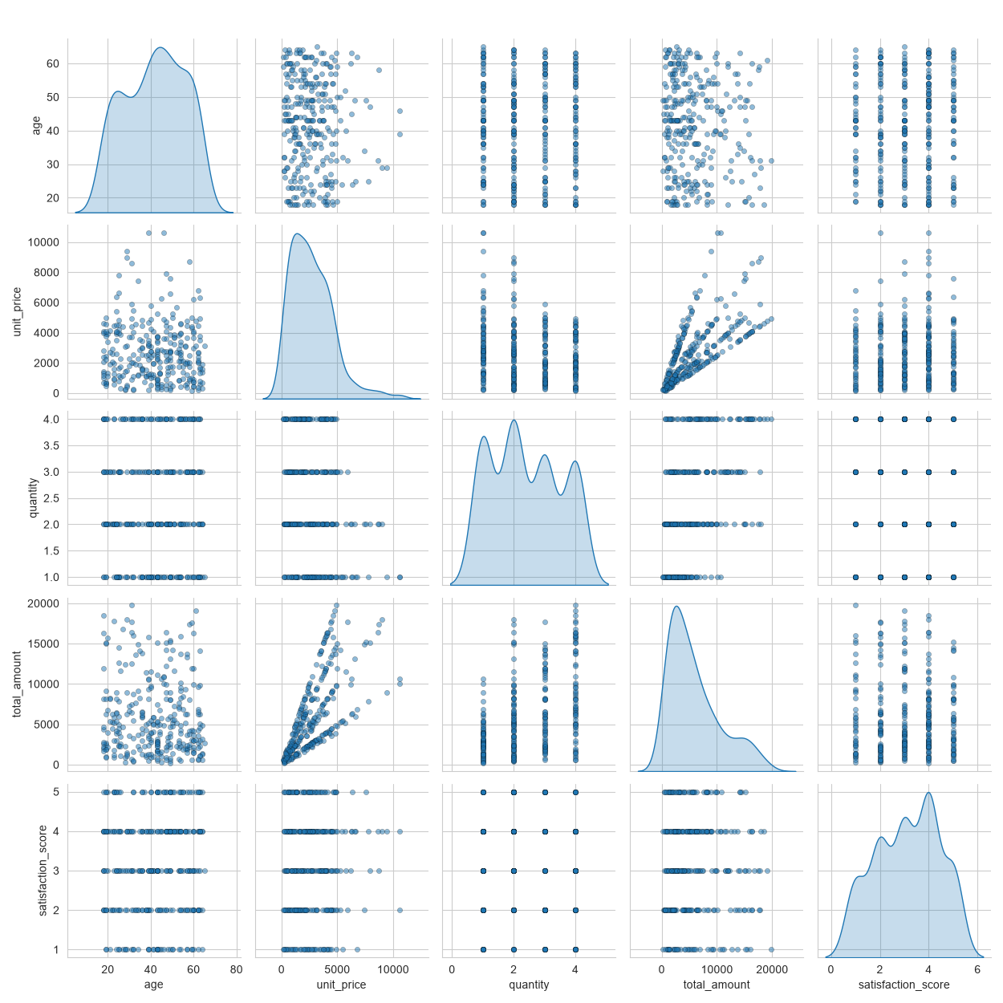
Figure: 24 Pairplot
Insight: Visualizes relationships simultaneously, confirming that variables are largely independent of one another.

5. Results & Insights
- Demographic Stability: E-commerce adoption in Pakistan is widely spread across age cohorts and genders.
- The Rise of Digital Wallets: The high adoption rate of EasyPaisa and JazzCash (exceeding Credit Card and Bank Transfers combined) demonstrates that mobile-first financial solutions are critical for maximizing customer conversion.
- Operational Weekend Spikes: E-commerce activity increases on weekends, indicating that operations (customer support, delivery dispatches) must be optimized to handle higher weekend volumes.
- Customer Cohort Definitions:
1. Cluster 0 — Casual Browsers: Low-value orders, short session times. Represents window shoppers.
2. Cluster 1 — Regular Buyers: Moderate value, stable engagement, high satisfaction. Represents the core recurring customer base.
3. Cluster 2 — VIP Premium Customers: Large orders, long session times, high lifetime value. Represents the primary target for premium loyalty programs.

6. Conclusion & Future Work

6.1 Conclusion
This project successfully establishes an advanced Data Visualization and Analytics System. By combining statistical validation, machine learning segmentation, and interactive visual reporting in both Jupyter Notebook and Laravel, we extracted meaningful insights regarding Pakistani e-commerce behavior. All design elements strictly adhered to professional presentation guidelines.

6.2 Future Work
- Predictive Analytics: Integrate machine learning models (e.g., Random Forest or XGBoost) to predict customer churn risk and customer lifetime value (CLV).
- Real-time Streaming: Connect the Laravel dashboard to an Apache Kafka or WebSocket stream to display real-time transactional updates.
- Recommender Engine: Utilize collaborative filtering to suggest products in the web application based on the user's cohort group.

7. References
1. Nelson, D. (2020). Data Visualization in Python (1st ed.). Daniel Nelson Publishing.
2. McKinney, W. (2022). Python for Data Analysis (3rd ed.). O'Reilly Media.
3. Pedregosa, F., et al. (2011). Scikit-learn: Machine Learning in Python. Journal of Machine Learning Research, 12, 2825-2830.
4. Laravel Core Team. (2026). Laravel Documentation. https://laravel.com/docs
5. Chart.js Documentation. Simple yet flexible JavaScript charting for designers & developers. https://www.chartjs.org/docs/

