**Flipped**

**Abstract** - Flipped is a Casual, Abstract 3D Puzzle Exploration game inspired by Sophie Houlden’s **BoxGame** - <http://www.sophiehoulden.com/games/boxgame/> - (used with permission). Most images used from **BoxGame**, with permission assumed for this internal document.

**Gameplay** - Flipped is presented as 4 quests, each with 8 progressively difficult stages. The player can choose any quest to complete the game as each quest is roughly of the same difficulty. The simultaneous availability of 4 quests allows the player to proceed down a different quest if they get stuck on passing a particular one.

Each stage is a simple piece of geometry with pathways that are either extruded or intruded.

*Here is a cube stage with extruded pathways (referenced from BoxGame).*

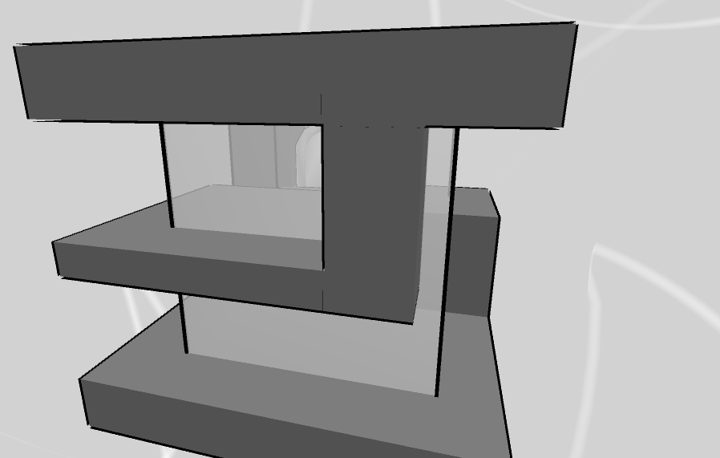

The player takes the role of a Blue or Pink 3D avatar that resembles the standard male or female restroom icons –



The avatar always moves parallel to the nearest adjacent wall (2d, planar movement).

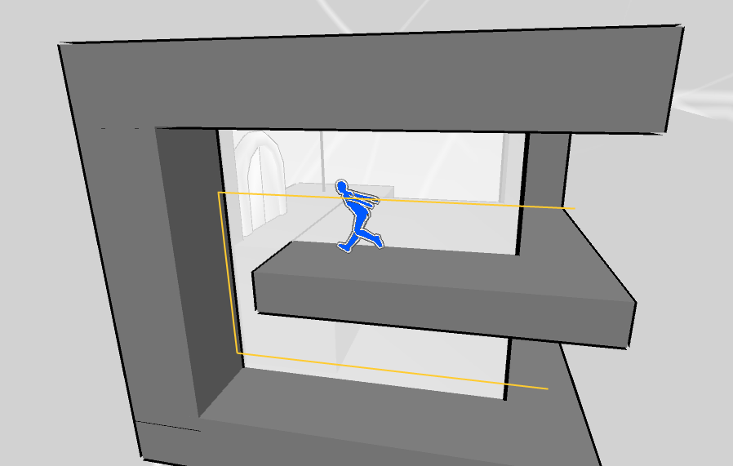

When the avatar navigates past a corner, either vertically or horizontally, the next wall becomes the nearest, and the movement plane rotates (in the below case, by 90 degrees on the Z axis) –

*Movement on the West side of the stage occurs along a plane parallel to the yellow lines, and movement on the South side occurs along a plane parallel to the pink lines.*

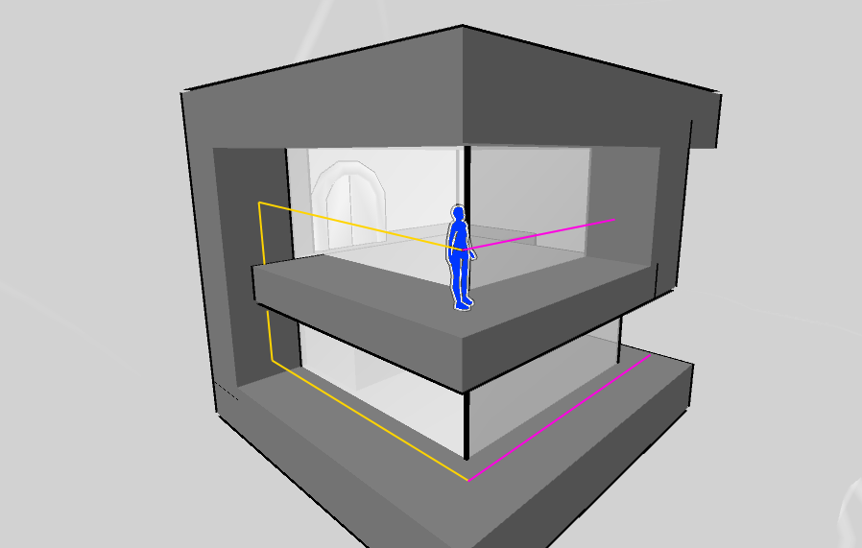

The player’s goal is to navigate the avatar around the stage to reach the Exit Door. Some Exit Doors are locked and require the avatar to find a Key before opening it.

Where Flipped gets interesting is how the stage rotates when the player cross a vertical corner – the Up vector flips.

*Here a vertical corner can be crossed by jumping…*

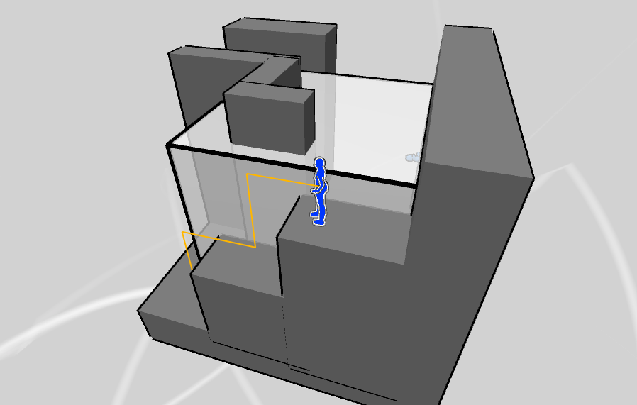

*…and by passing the vertical corner, the Up Vector changes, allowing the player to proceed!*

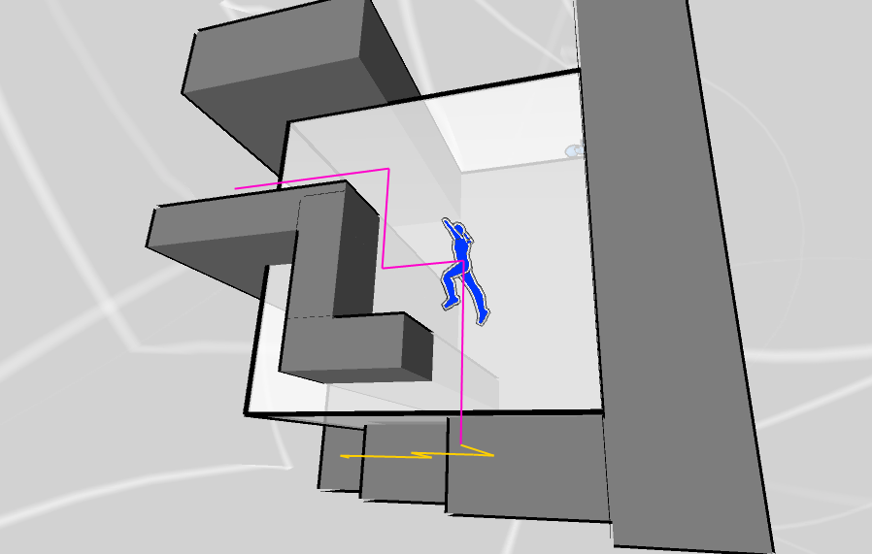

*Also, by flipping the Up Vector one or more times, you can navigate previous ground in new ways! Such tricks are necessary to navigate through Flipped’s many challenging stages.*

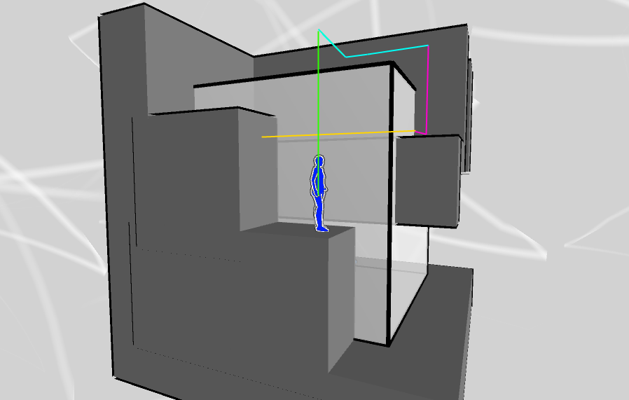

There are also more straight-forward ways of flipping the stages to your will – Flip Icons can be touched to either rotate the stage by a given amount of degrees, or to rotate the Up Vector in the direction an arrow on the Flip Icon is pointing.

Each stage has 3 Stars scattered about it that can be optionally collected. 4 Stars can be gathered for an extra chance (note the player starts with 3 chances). Each time the player finds a Key, a Star, or a Wearable item, their current progress through the stage is saved as a ‘Progress Point’. Some stages feature traps like spikes, that when touched, force the player to revert to a Progress Point with 1 chance subtracted from the total remaining chances. If the chances go to zero, the quest is over and the player must start it all over again.

Reverting progress sends the avatar back to a previous Progress Point in the stage. The player may choose to resume from any of the Progress Points reached in the current stage, not only the most recent one. Note, however, that returning to an earlier Progress Point discards all progress, collected Stars and Wearable items since then (effectively restoring the game to a previous state, minus 1 chance).

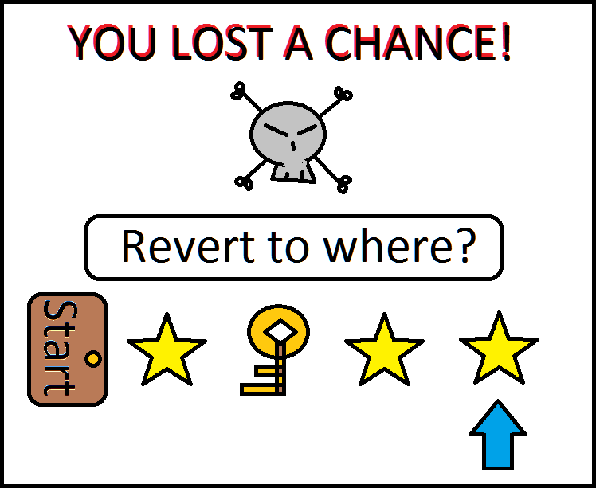

Sometimes, the player can get stuck (such as in a pit with no spikes), and may sacrifice a chance to revert similarly.