pytest tests/ -m auth --html=report_auth.html --self-contained-html

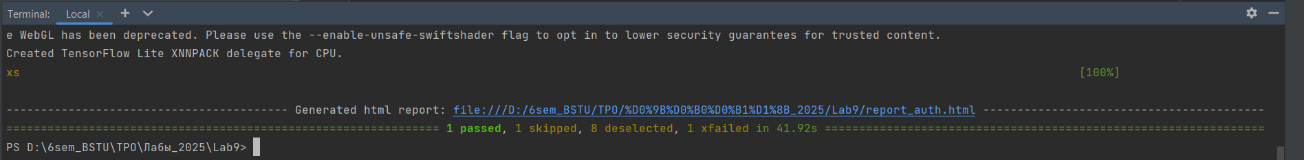

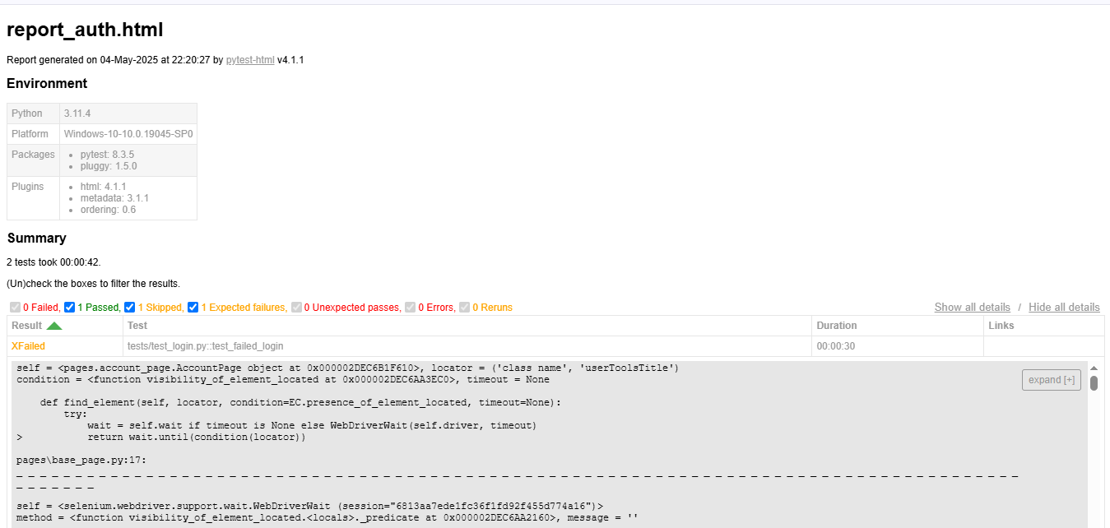

pytest tests/ -m "cart or search" --html=report_cart_search_and_cart.html --self-contained-html

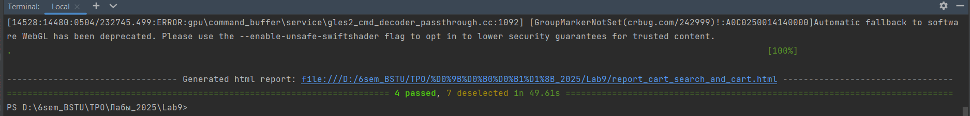

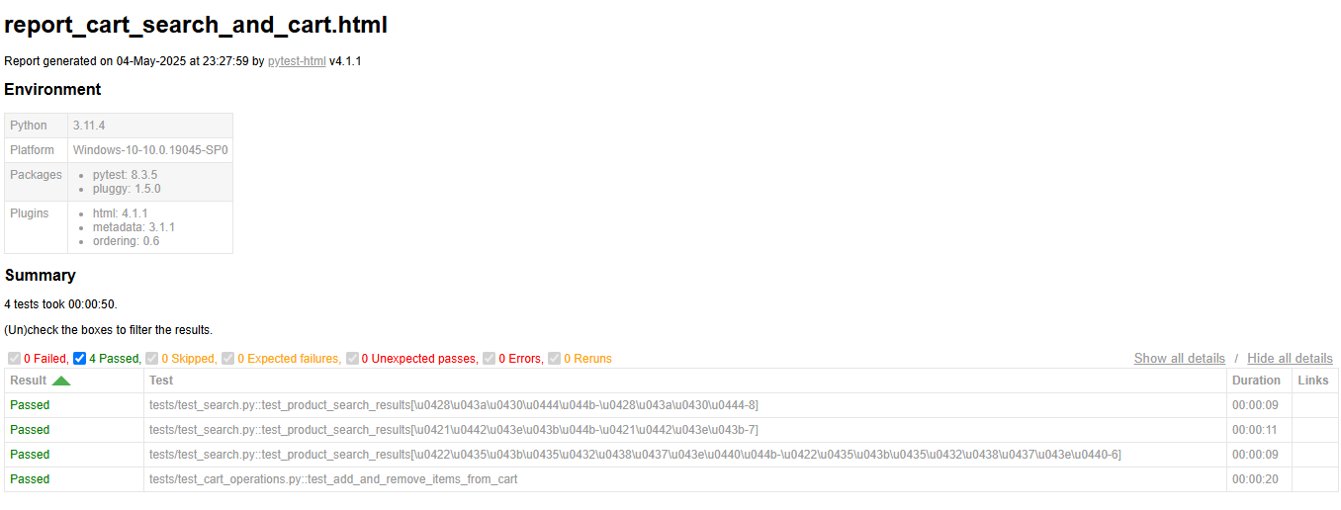

pytest tests/ -m "cart" --html=report_cart.html --self-contained-html

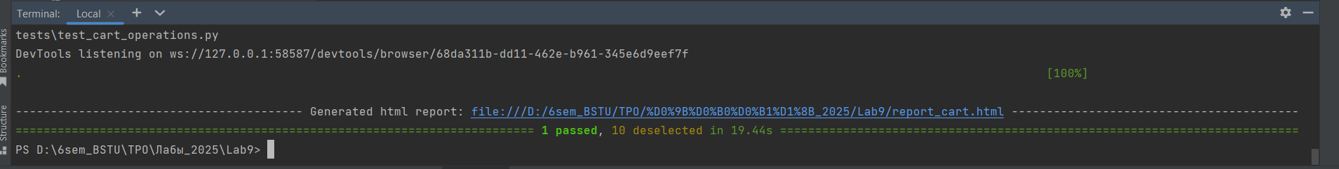

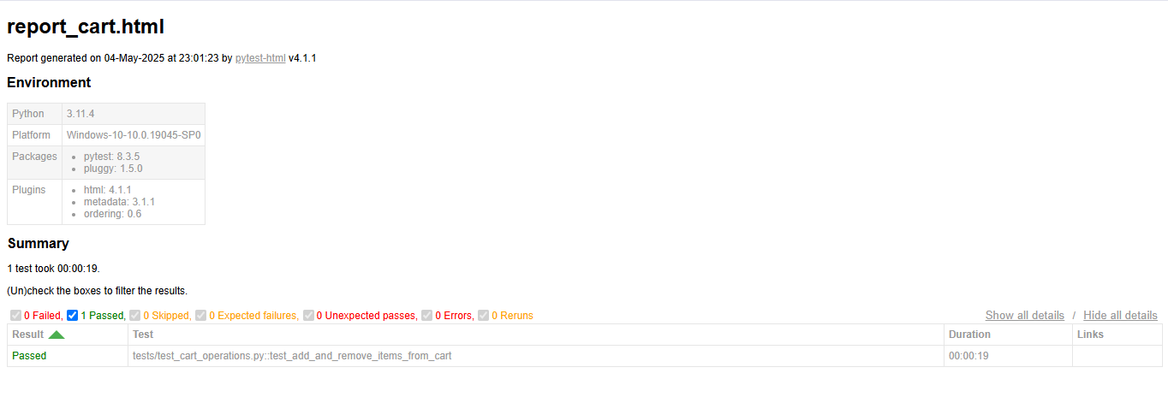

pytest tests/ -m "search" --html=report_cart_search.html --self-contained-html

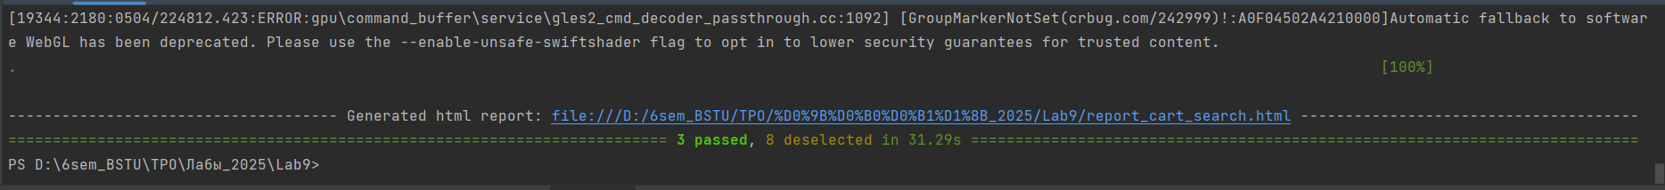

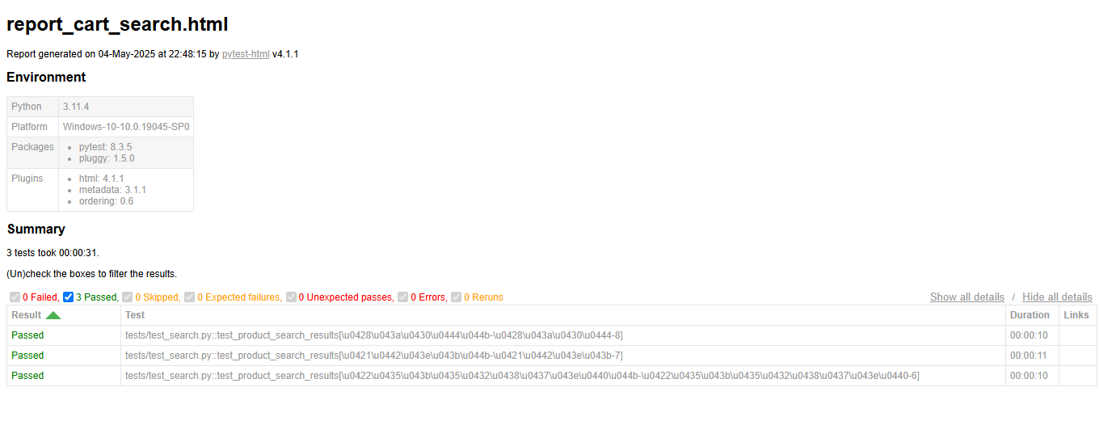

pytest tests/ -m "checkout" --html=report_checkout.html --self-contained-html

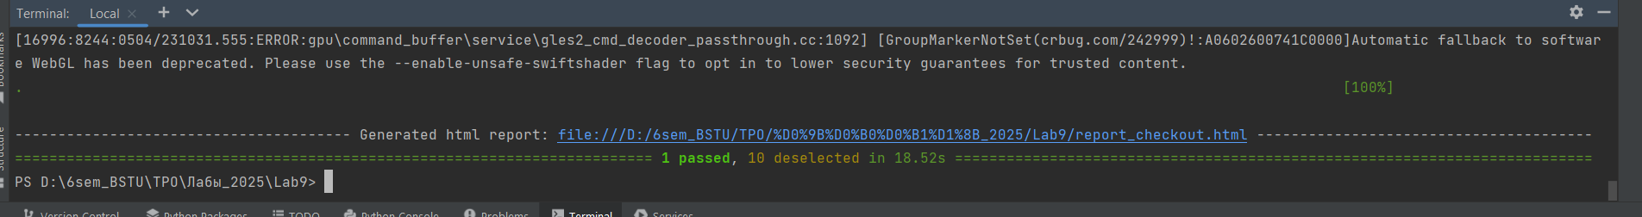

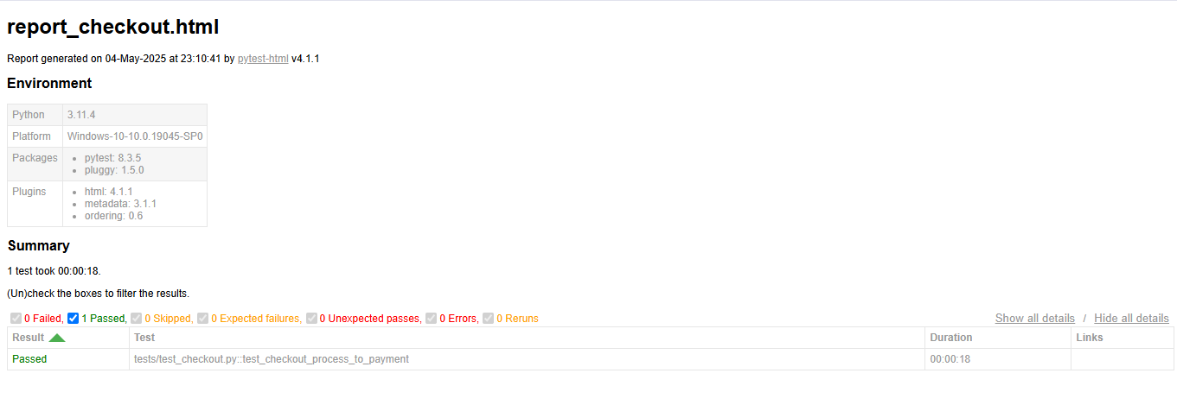

pytest tests/ -m "demoqa" --html=report_demoqa.html --self-contained-html

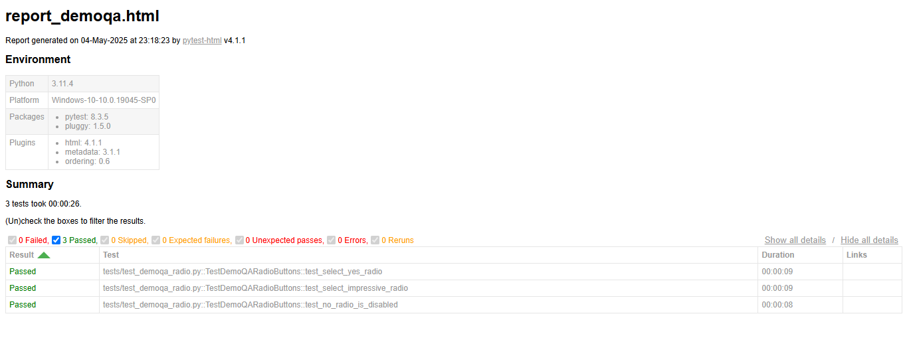

pytest tests/ --html=report.html --self-contained-html

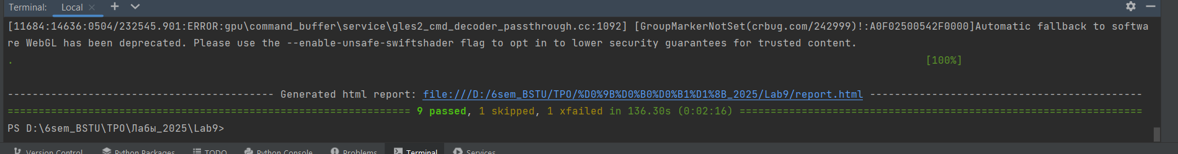

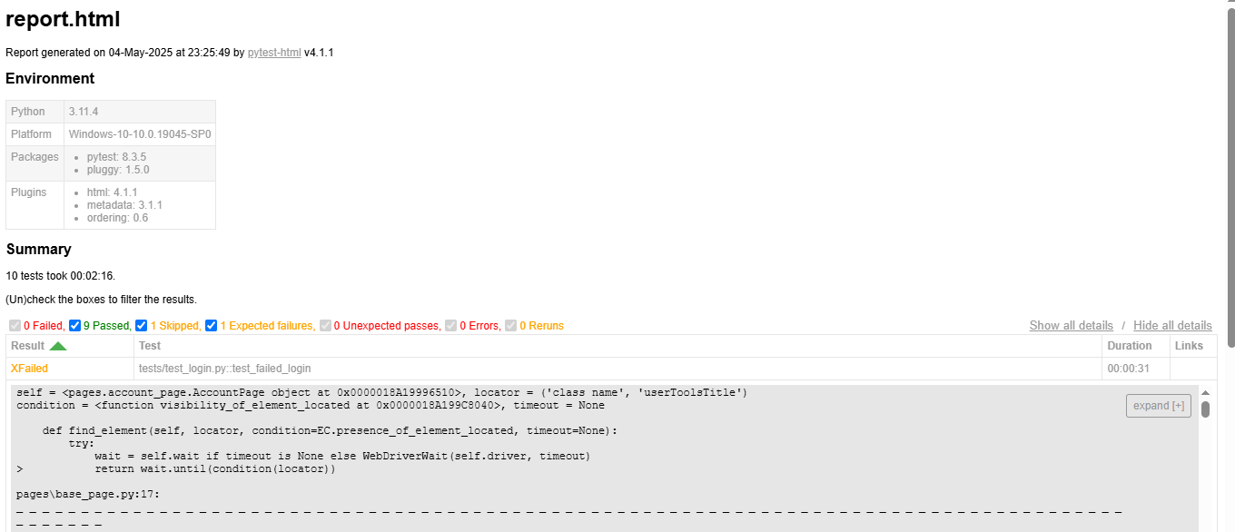

pytest tests/ --browser firefox --html=report_firefox.html --self-contained-html

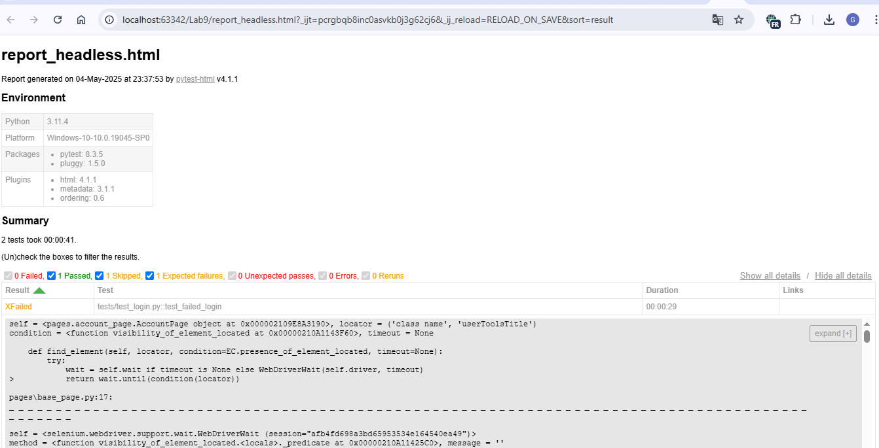

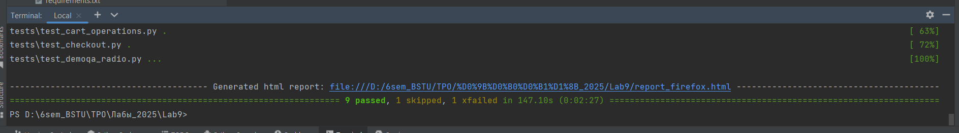

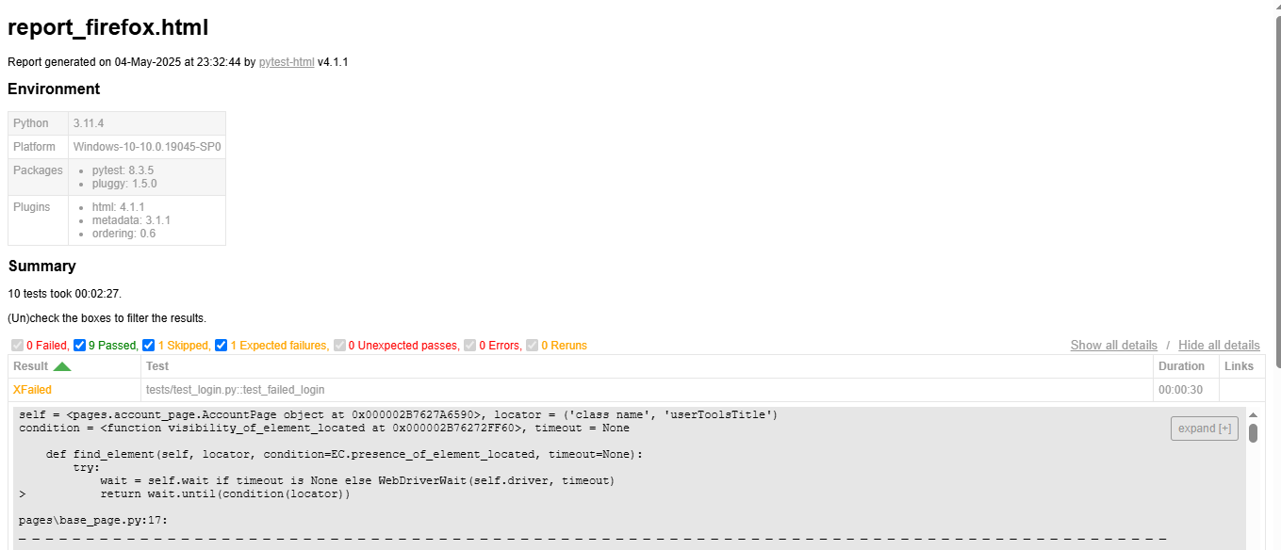

pytest tests/ -m auth --headless --html=report_headless.html --self-contained-html

