

SAKET GYANPEETH’S

SAKET COLLEGE OF ARTS, SCIENCE AND COMMERCE KALYAN (EAST)

ACADEMIC YEAR [2022 – 2023]

MSc. Information Technology SEMESTER – I
- Research in Computing

- Data Science

- Cloud Computing

- Soft Computing Techniques

SUBMITTED BY

ANSHUMAN GAURISHANKAR SINGH AS PRESCRIPED BY UNIVERSITY OF MUMBAI


RESEARCH IN COMPUTING

SAKET GYANPEETH’S

SAKET COLLEGE OF ARTS, SCIENCE, AND COMMERCE

(Permanently Affiliated to University of Mumbai) NAAC Accredited B Grade
Saket Vidyanagari Marg, Chinchpada Road, Katemanivali, Kalyan (East) – 421306, Dist.
Department of Information Technology
Thane (MAH)

CERTIFICATE

This is to certify that

ANSHUMAN GAURISHANKAR SINGH of MSc Information Technology Part-I Class has satisfactorily carried out the required practical in the subject.
RESEARCH IN COMPUTING

For the Academic year 2022 – 2023

Practical In-Charge Head of Department External Examiner

INDEX

Sr. No. | Aim | Sign
1 | Write a program for obtaining descriptive statistics of data
2 | Import data from different data source (from Excel, csv, mysql, sql, server, oracle to R/python/Excel)
3 | Design a survey from for a given case study, collect the primary data and analyse it
4 | Perform analysis of given secondary data
5 | Perform testing of hypothesis using one sample t-test
6 | Write a program for t-test comparing two means for independent samples
7 | Perform testing of hypothesis using paired t-test
8 | Perform testing of hypothesis using chi-squared godness-of- fit test

PRACTICAL-1
Aim: Write a program for obtaining descriptive statistics of data.
Step1: Program/Steps to obtain descriptive statistics of data. Using Excel Go to File Menu -> Options ->Add-Ins -> Select Analysis Tool Pak -> Press OK
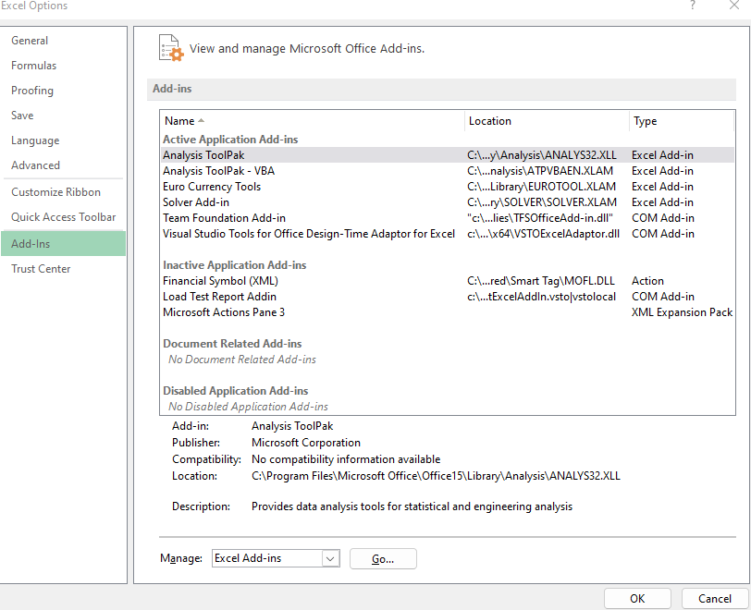
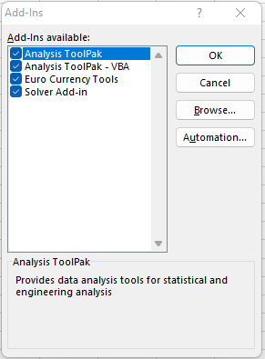

Step2: Go to Data Menu -> Data Analysis -> Descriptive Statistics ->and Select the Age Range
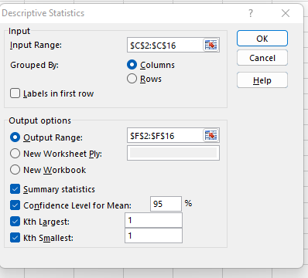

OUTPUT:
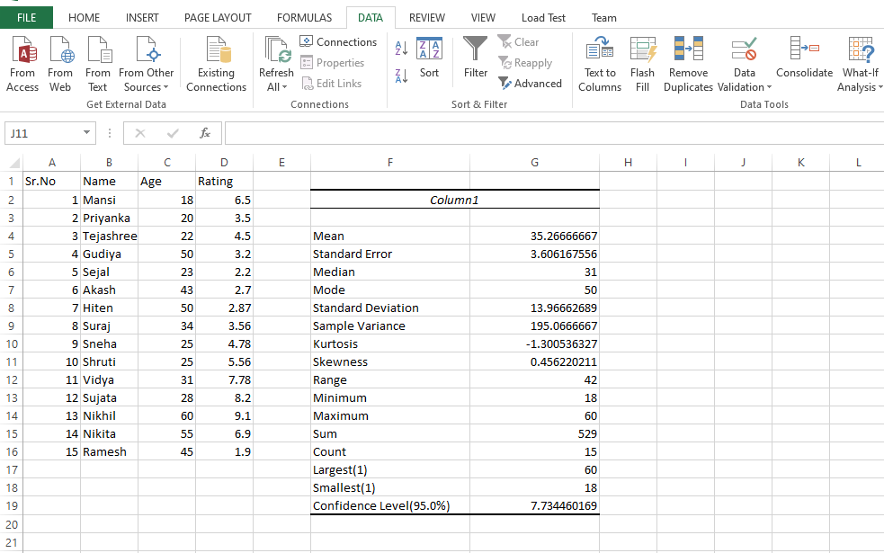

PRACTICAL -2

Aim: Import data from different data sources (from Excel, csv, mysql, sql server, oracle to R/Python/Excel)

- READ DATA FROM MYSQL
#Install Python-MySQL connector(Download from Resource folder
Click Start> MySQL CLI> Login > Create database > create table > Insert records in table
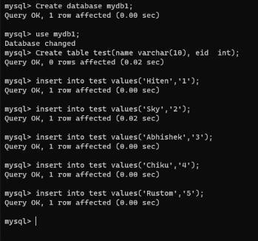

#To install pymysql package run pip command on cmd #pip3 install pymysql

CODE:
import pymysql
db = pymysql.connect(host='localhost',user='root',password='root',database='mydb1') cursor = db.cursor()
sql = """SELECT * from test""" try:
cursor.execute(sql)
results = cursor.fetchall() for row in results:
print(row)

print("success") db.commit()
except:
db.rollback() db.close()
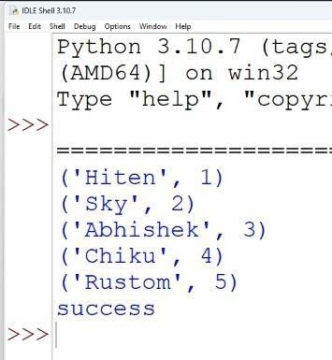

PRACTICAL-3
Aim: Design a survey form for a given case study, collect the primary data, and analyse it

Case 1:
A researcher wants to conduct a Survey in colleges on Use of ICT in higher education from Mumbai, Thane and Navi Mumbai. The survey focuses on access to and use of ICT in teaching and learning, as well as on attitudes towards the use of ICT in teaching and learning. Design questionnaire addressed to teachers seeks information about the target class, his experience using ICT for teaching, access to ICT infrastructure, support available, ICT based activities and material used, obstacles to the use of ICT in teaching, learning activities with the target class, your skills and attitudes to ICT, and some personal background information. Arrange question in following groups:
- Information about the target class you teach
- Experience with ICT for teaching
- ICT access for teaching
- Support to teachers for ICT use
- ICT based activities and material used for teaching
- Obstacles to using ICT in teaching and learning
- Learning activities with the target class
- Teacher skills
- Teacher opinions and attitudes
- Personal background information

Using the collected data for analysis

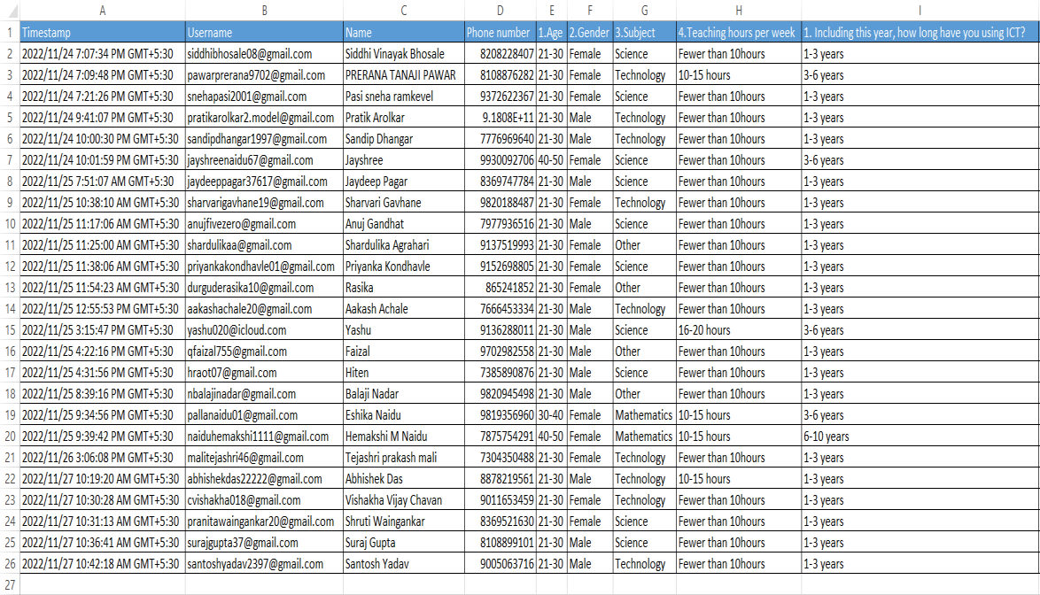

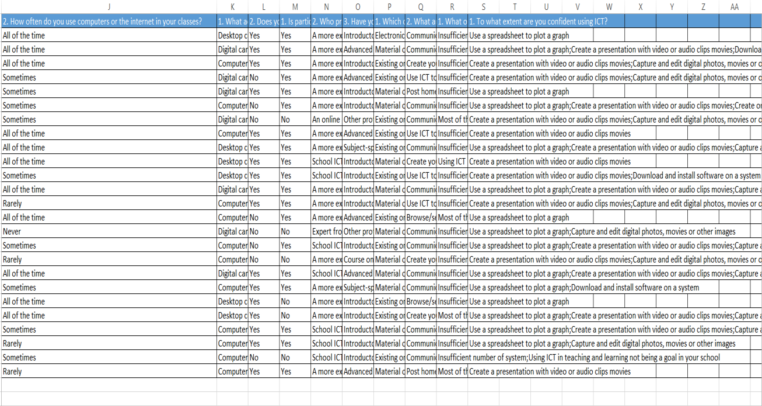

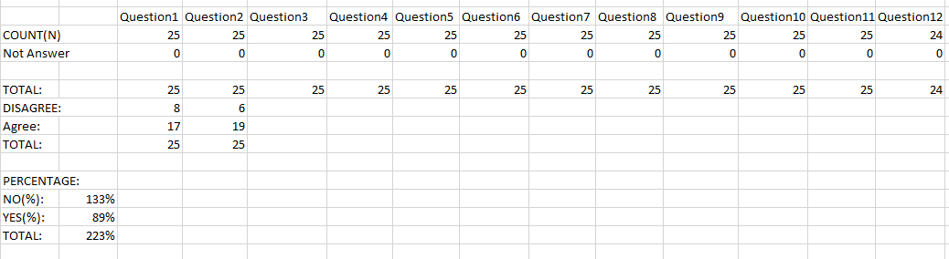

FORMULA FOR OPERATION:

count(N) = =COUNTA(H2:H26) Not Answer = =COUNT(H2:H26) Total =SUM(E29:E30)
YES =COUNTIF(L$2:L$26,$M24) NO= COUNTIF(L$2:L$26,$M25)
PERCENTAGE: YES= E34/F34 NO= E33/F33
TOTAL=SUM(D38:D39)

OUTPUT:


Use of ICT in higher education
30
25
20
15
10
5
0
DISAGREE:
Agree:
TOTAL:
PERCENTAGE:
NO(%):
YES(%):
TOTAL:
Series1 Series2 Series3

PRACTICAL 4

Aim: Perform analysis of given secondary data.
Steps in Secondary Data Analysis
- Determine your research question – Knowing exactly what you are looking for.
- Locating data– Knowing what is out there and whether you can gain access to it. A quick Internet search, possibly with the help of a librarian, will reveal a wealth of options.
- Evaluating relevance of the data – Considering things like the data’s original purpose, when it was collected, population, sampling strategy/sample, data collection protocols, operationalization of concepts, questions asked, and form/shape of the data.
- Assessing credibility of the data – Establishing the credentials of the original researchers, searching for full explication of methods including any problems encountered, determining how consistent the data is with data from other sources, and discovering whether the data has been used in any credible published research.
- Analysis – This will generally involve a range of statistical processes. Example: Analyse the given Population Census Data for Planning and Decision Making by using the size and composition of populations
Example: Analyse the given Population Census Data for Planning and Decision Making by using the size and composition of populations

OUTPUT:
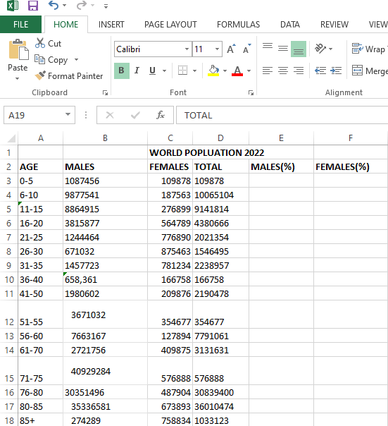

Put the cursor in cell B19 and click on the AutoSum and then click Enter. This will calculate the total population. Then copy the formula in cell D19 across the row 19. (Total_population)
To calculate the percent of males in cell E3, enter the formula

[ -1*100*Male_count*Total_population]

=-1*100*B3/$D$19

And copy the formula in cell E3 down to cell E18.
To calculate the percent of females in cell F3, enter the formula

[ 1*100*Female_count*Total_population]
=100*C3/$D$19. Copy the formula in cell F3 down to cell F18. This gives percentage in +ve for female and –ve for male.

To build the population pyramid, we need to choose a horizontal bar chart with two series of data (% male and % female) and the age labels in column A as the Category X-axis labels. Highlight the range A2:A18, hold down the CTRL key and highlight the range E2:F19

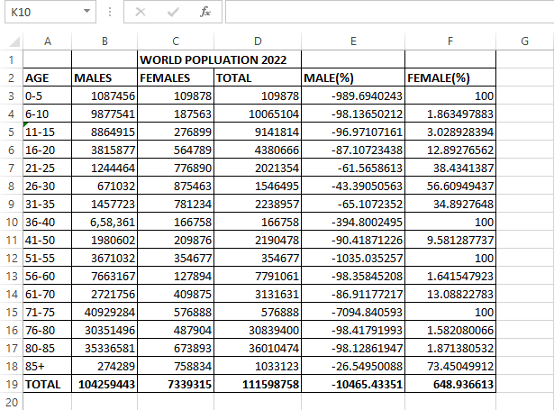

Under inset tab, under horizontal bar charts select clustered bar chart

Put the tip of your mouse arrow on the Y-axis (vertical axis) so it says “Category Axis”, right click and chose Format Axis
Choose Axis options tab and set the major and minor tick mark type to None, Axis labels to Low, and click OK.
Click on any of the bars in your pyramid, click right and select “format data series”. Set the Overlap to
100 and Gap Width to 0. Click OK.

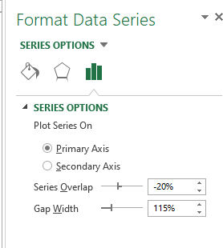
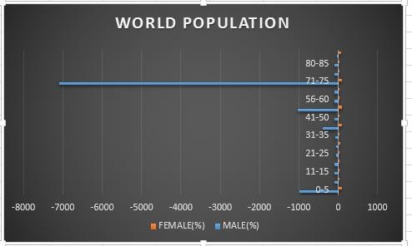

PRACTICAL 5
Aim: Perform testing of hypothesis using one-sample t-test.
One sample t-test : The One Sample t Test determines whether the sample mean is statistically
different from a known or hypothesized population mean. The One Sample t Test is a parametric test.

H0: Mean age of given sample is 30. H1: Mean age of given sample is not 30 #pip3 install scipy
#pip3 install numpy
from scipy.stats import ttest_1samp import numpy as np
ages = np.genfromtxt('ages.csv') print(ages)
ages_mean = np.mean(ages) print("Mean age:",ages_mean) print("Test 1: m=30")
tset, pval = ttest_1samp(ages, 30) print('p-values - ',pval)
if pval< 0.05:
print("we reject null hypothesis")

else:

print("we fail to reject null hypothesis"

OUTPUT:
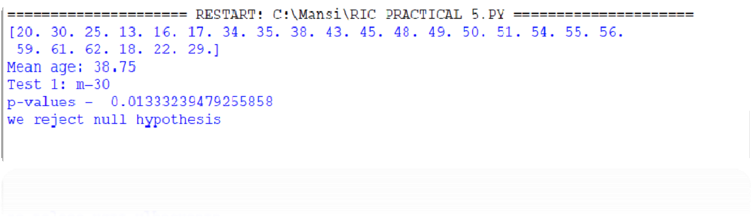

#TEST 2

H0: Mean age of given sample is 38. H1: Mean age of given sample not 38

from scipy.stats import ttest_1samp import numpy as np
ages = np.genfromtxt('ages.csv') print(ages)
ages_mean = np.mean(ages) print("Mean age:",ages_mean)print("Test 2: m=38")
tset, pval = ttest_1samp(ages, 38)print('p-values - ',pval)
if pval< 0.05:
print("we reject null hypothesis")
else:

print("we fail to reject null hypothesis")

OUTPUT:
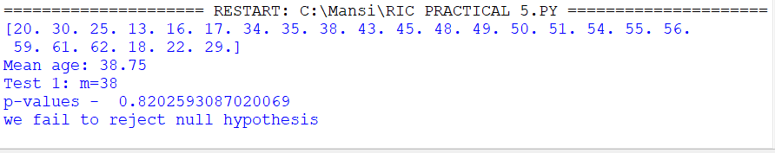

Practical 6

Aim: Write a program for t-test comparing two means for independent samples.

The t distribution provides a good way to perform one sample tests on the mean when the population variance is not known provided the population is normal or the sample is sufficiently large so that the Central Limit Theorem applies.

Two Sample t Test
Example: A college Principal informed classroom teachers that some of their students showed unusual potential for intellectual gains. One months later the students identified to teachers as having potential for unusual intellectual gains showed significantly greater gains performance on a test said to measure IQ than did students who were not so identified. Below are the data for the students:
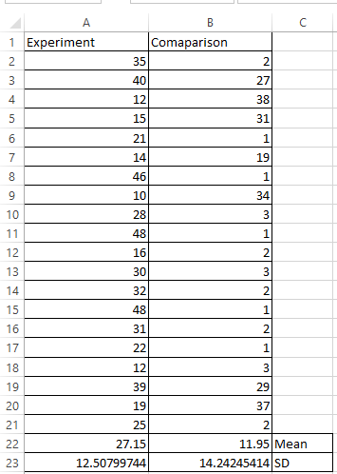

Experimental Data
To calculate Standard Mean go to cell A22 and type =SUM(A2:A21)/20
To calculate Standard Deviation go to cell A23 and type =STDEV(A2:A21) Comparison Data
To calculate Standard Mean go to cell B22 and type =SUM(B2:B21)/20
To calculate Standard Deviation go to cell B23 and type =STDEV(B2:B21) To find T-Test Statistics go to data Data Analysis

OUTPUT:
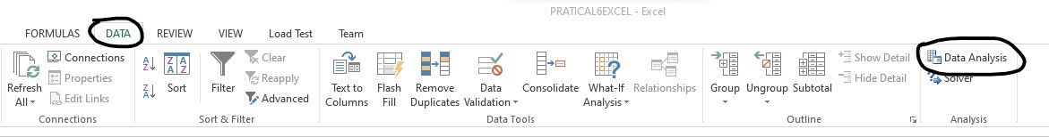

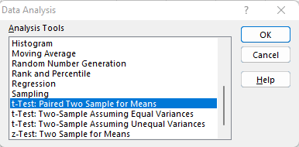
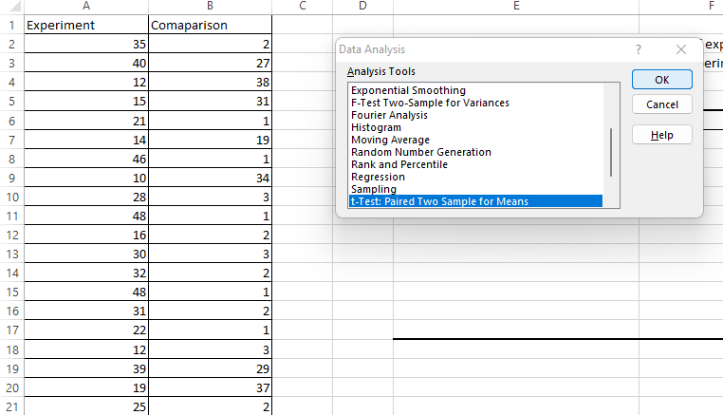
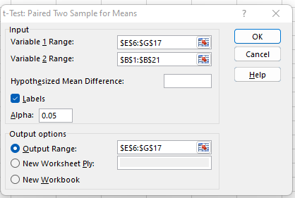

To calculate the T-Test square value go to cell E20 and type
=(A22-B22)/SQRT((A23*A23)/COUNT(A2:A21)+(B23*B23)/COUNT(A2:A21))

Now go to cell E20 and type
=IF(E20<E12,"H0 is Accepted", "H0 is Rejected and H1 is Accepted")
Our calculated value is larger than the tabled value at alpha = .01, so we reject the null hypothesis and accept the alternative hypothesis, namely, that the difference in gain scores is likely the result of the experimental treatment and not the result of chance variation.
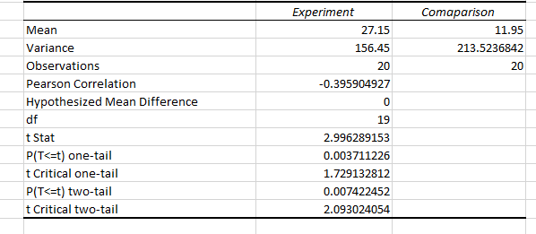

OUTPUT:
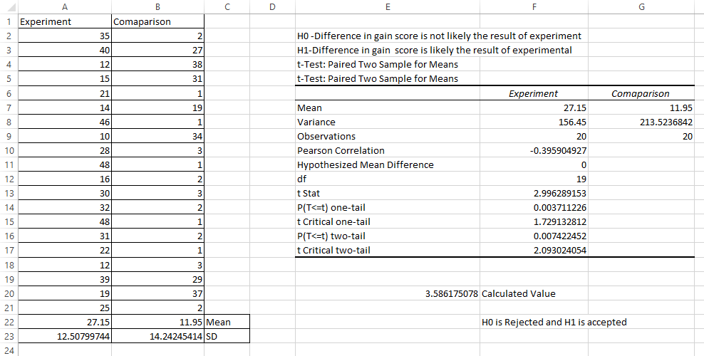

Practical 7

Aim: Perform testing of hypothesis using paired t-test.

The paired sample t-test is also called the dependent sample t-test. Ias an univariate test that tests for a significant difference between 2 related variables. An example of this is if you where to collect the blood pressure for an individual before and after some treatment, condition, or time point. The data set contains blood pressure readings before and after an intervention. These are variables “bp_before” and “bp_after”.

The hypothesis being tested is:
- H0 - The mean difference between sample 1 and sample 2 is equal to 0.
- H1 - The mean difference between sample 1 and sample 2 is not equal to 0

from scipy import stats import matplotlib.pyplot as plt import pandas as pd
df = pd.read_csv("blood_pressure.csv") print(df[['bp_before','bp_after']].describe())
tst,pval=stats.ttest_rel(df['bp_before'], df['bp_after']) if pval< 0.05:
print("we reject null hypothesis")
else:
print("we fail to reject null hypothesis")

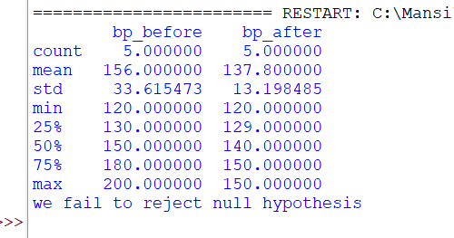
OUTPUT:

Practical 8

Aim: Perform testing of hypothesis using the chi-squared godness-of-fit test.
Problem in the system administrator needs to upgrade the computers for his division. He wants to knowwhat sort of computer system his workers prefer. He gives three choices: Windows, Mac, or Linux. Test the hypothesis or theory that an equal percentage of the population prefers each type of computer system.

Step 1: Creation of the data.
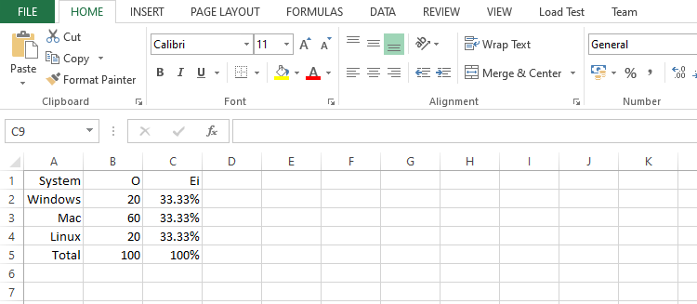

Step 2: Setting the value of H0 and HA
H0: The population distribution of the variable is the same as the proposed distribut
HA: The distributions are different to calculate the Chi – Square value for Windows go to cell D2 and type

Step 3:
To calculate the Chi – Square value for Windows go to cell D2 and type = ((B2-C2)*(B2-C2))/C2

Step: 4
To calculate the Chi – Square value for Mac go to cell D3 and type = ((B3-C3)*(B3-C3))/C3

Step: 5
To calculate the Chi – Square value for Mac go to cell D3 and type
= ((B4-C4)*(B4-C4))/C4

Step: 6
Go to Cell D5 for and type =SUM(D2:D4) To get the table value for Chi-Square for α = 0.05 and dof = 2,

Step: 7
Go to cell D7 and type =CHIINV(0.05,2) At cell D8 type =IF(D5>D7, "H0 Accepted","H0 Rejected”

OUTPUT:

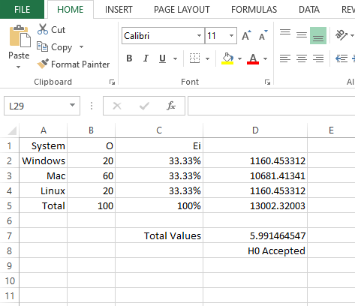

DATA SCIENCE

SAKET GYANPEETH’S

SAKET COLLEGE OF ARTS, SCIENCE AND COMMERCE

(Permanently Affiliated to University of Mumbai) NAAC Accredited B Grade
Saket Vidyanagari Marg, Chinchpada Road, Katemanivali, Kalyan (East) – 421306, Dist.
Department of Information Technology
Thane (MAH)

CERTIFICATE

This is to certify that

ANSHUMAN GAURISHANKAR SINGH of MSc Information Technology Part-I Class has satisfactory carried out the required practical in the subject.
DATA SCIENCE

For the Academic year 2022 – 2023

Practical In-Charge Head of Department External Examiner

Seat No.: 3254185

INDEX
Sr.No. | Aim | Sign
1 | - Csv To Hours  - Xml To Hours  - Json To Hours  - Mysql Database To Hours  - Picture (Jpeg) To Hours  - Video To Hours  - Audio To Hours
2 | - Utilities And Auditing  - Data Binning And Bucketing  - Averaging Of Data  - Outlier Detection Audit
3 | - Retrieve Superstep  - Program To Retrieve Different Attributes Of Data  - Data Pattern  - Loading Ip Data All
4 | Assessing Data  - Perform Error Management On The Given Data Using the Pandas Package.  - Write Python / R Program To Create The Network Routing Diagram From The Given Data on routers.  - Write A Python / R Program To Build a Directed Acyclic Graph.
5 | Processing Data  A. Build The Time Hub, Links, And Satellites.
6 | Transforming Data
7 | Organizing Data
22

PRACTICAL 1
- CSV TO HOURS

CODE:
# Utility Start CSV to HORUS =================================
# Standard Tools import pandas as pd
# Input Agreement ============================================
sInputFileName='C:/VKHCG/05-DS/9999-Data/Country_Code.csv' InputData=pd.read_csv(sInputFileName,encoding="latin-1")
print('Input Data Values ===================================')
print(InputData) print('=====================================================') # Processing Rules ===========================================
ProcessData=InputData
# Remove columns ISO-2-Code and ISO-3-CODE ProcessData.drop('ISO-2-CODE', axis=1,inplace=True) ProcessData.drop('ISO-3-Code', axis=1,inplace=True) # Rename Country and ISO-M49
ProcessData.rename(columns={'Country': 'CountryName'}, inplace=True) ProcessData.rename(columns={'ISO-M49': 'CountryNumber'}, inplace=True) # Set new Index
ProcessData.set_index('CountryNumber', inplace=True) # Sort data by CurrencyNumber
ProcessData.sort_values('CountryName', axis=0, ascending=False, inplace=True) print('Process Data Values =================================') print(ProcessData) print('=====================================================') # Output Agreement ===========================================
OutputData=ProcessData
sOutputFileName='C:/VKHCG/05-DS/9999-Data/HORUS-CSV-Country.csv' OutputData.to_csv(sOutputFileName, index = False)
print('CSV to HORUS - Done')
# Utility done ===============================================

OUTPUT:

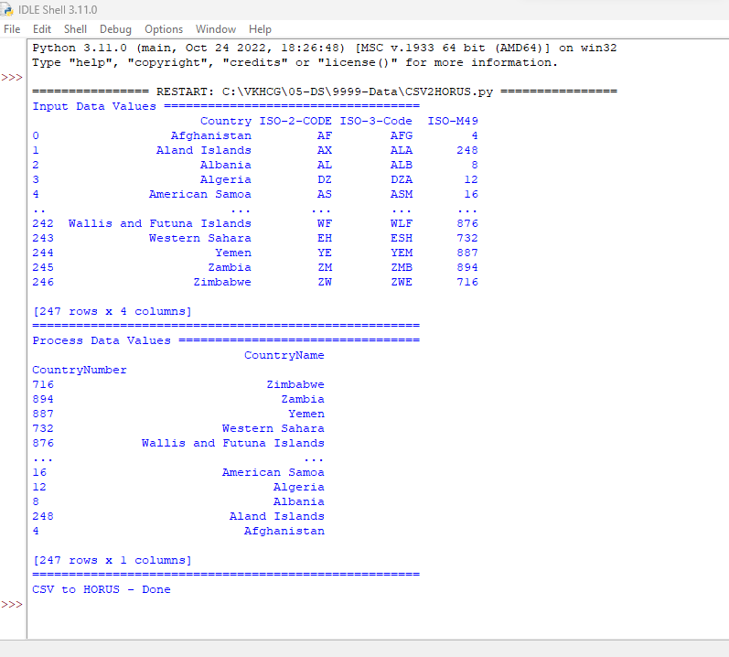

- XML TO HOURS

CODE:
# Utility Start XML to HORUS =================================
# Standard Tools import pandas as pd
import xml.etree.ElementTree as ET def df2xml(data):
header = data.columns root = ET.Element('root')
for row in range(data.shape[0]):
entry = ET.SubElement(root,'entry') for index in range(data.shape[1]):
schild=str(header[index])
child = ET.SubElement(entry, schild) if str(data[schild][row]) != 'nan':
child.text = str(data[schild][row])
else:
child.text = 'n/a' entry.append(child)
result = ET.tostring(root) return result
def xml2df(xml_data):
root = ET.XML(xml_data) all_records = []
for i, child in enumerate(root): record = {}

for subchild in child: record[subchild.tag] = subchild.text
all_records.append(record)
return pd.DataFrame(all_records)
# Input Agreement ============================================
sInputFileName='C:/VKHCG/05-DS/9999-Data/Country_Code.xml' InputData = open(sInputFileName).read()
print('=====================================================') print('Input Data Values ===================================') print('=====================================================')
print(InputData) print('=====================================================') # Processing Rules ===========================================
ProcessDataXML=InputData # XML to Data Frame
ProcessData=xml2df(ProcessDataXML)
# Remove columns ISO-2-Code and ISO-3-CODE ProcessData.drop('ISO-2-CODE', axis=1,inplace=True) ProcessData.drop('ISO-3-Code', axis=1,inplace=True) # Rename Country and ISO-M49
ProcessData.rename(columns={'Country': 'CountryName'}, inplace=True)
ProcessData.rename(columns={'ISO-M49': 'CountryNumber'}, inplace=True) # Set new Index
ProcessData.set_index('CountryNumber', inplace=True) # Sort data by CurrencyNumber
ProcessData.sort_values('CountryName', axis=0, ascending=False, inplace=True) print('=====================================================')
print('Process Data Values =================================') print('=====================================================')
print(ProcessData) print('=====================================================') # Output Agreement ===========================================
OutputData=ProcessData
sOutputFileName='C:/VKHCG/05-DS/9999-Data/HORUS-XML-Country.csv' OutputData.to_csv(sOutputFileName, index = False) print('=====================================================')
print('XML to HORUS - Done') print('=====================================================') # Utility done ===============================================

OUTPUT:
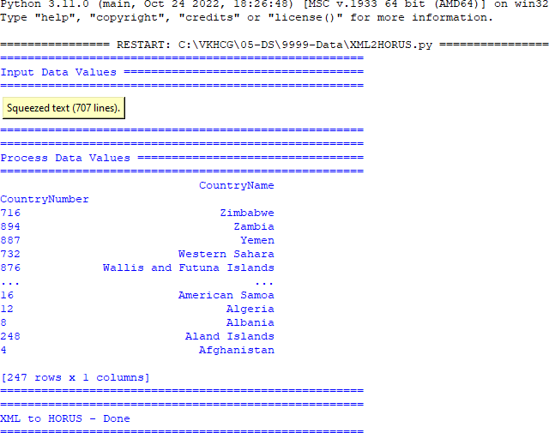

- JSON TO HOURS CODE:
# Utility Start JSON to HORUS =================================
# Standard Tools import pandas as pd
# Input Agreement ============================================
sInputFileName='C:/VKHCG/05-DS/9999-Data/Country_Code.json' InputData=pd.read_json(sInputFileName,
orient='index', encoding="latin-1")
print('Input Data Values ===================================')
print(InputData) print('=====================================================') # Processing Rules ===========================================
ProcessData=InputData
# Remove columns ISO-2-Code and ISO-3-CODE ProcessData.drop('ISO-2-CODE', axis=1,inplace=True) ProcessData.drop('ISO-3-Code', axis=1,inplace=True) # Rename Country and ISO-M49
ProcessData.rename(columns={'Country': 'CountryName'}, inplace=True) ProcessData.rename(columns={'ISO-M49': 'CountryNumber'}, inplace=True) # Set new Index
ProcessData.set_index('CountryNumber', inplace=True) # Sort data by CurrencyNumber
ProcessData.sort_values('CountryName', axis=0, ascending=False, inplace=True) print('Process Data Values =================================') print(ProcessData) print('=====================================================')

# Output Agreement ===========================================
OutputData=ProcessData
sOutputFileName='C:/VKHCG/05-DS/9999-Data/HORUS-JSON-Country.csv' OutputData.to_csv(sOutputFileName, index = False)
print('JSON to HORUS - Done')
# Utility done ===============================================

OUTPUT:
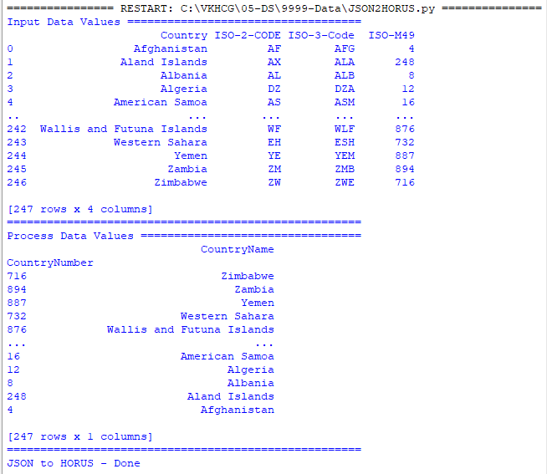
- MYSQL DATABASE TO HOURS CODE:
# Utility Start Database to HORUS ================================= # Standard Tools
import pandas as pd import sqlite3 as sq
# Input Agreement ============================================
sInputFileName='C:/VKHCG/05-DS/9999-Data/utility.db' sInputTable='Country_Code'
conn = sq.connect(sInputFileName)
sSQL='select * FROM ' + sInputTable + ';' InputData=pd.read_sql_query(sSQL, conn)
print('Input Data Values ===================================')
print(InputData) print('=====================================================') # Processing Rules ===========================================
ProcessData=InputData
# Remove columns ISO-2-Code and ISO-3-CODE ProcessData.drop('ISO-2-CODE', axis=1,inplace=True) ProcessData.drop('ISO-3-Code', axis=1,inplace=True) # Rename Country and ISO-M49
ProcessData.rename(columns={'Country': 'CountryName'}, inplace=True)

ProcessData.rename(columns={'ISO-M49': 'CountryNumber'}, inplace=True) # Set new Index
ProcessData.set_index('CountryNumber', inplace=True)
# Sort data by CurrencyNumber
ProcessData.sort_values('CountryName', axis=0, ascending=False, inplace=True) print('Process Data Values =================================') print(ProcessData)
print('=====================================================') # Output Agreement ===========================================
OutputData=ProcessData
sOutputFileName='C:/VKHCG/05-DS/9999-Data/HORUS-CSV-Country.csv' OutputData.to_csv(sOutputFileName, index = False)
print('Database to HORUS - Done')
# Utility done ===============================================

OUTPUT:
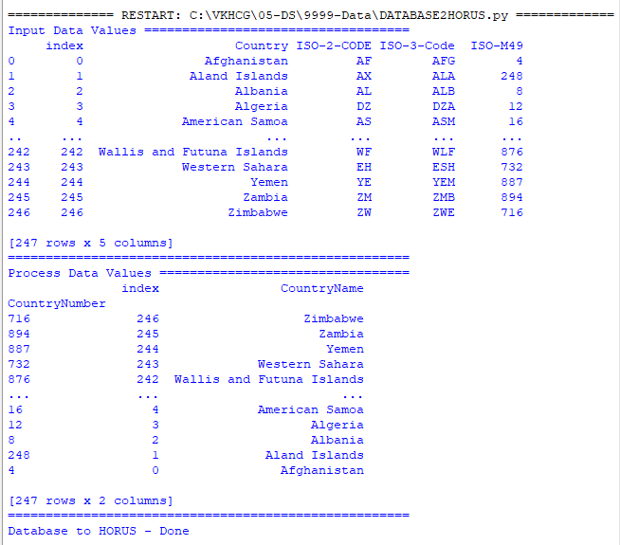
- PICTURE (JPEG) TO HOURS CODE:
# Utility Start Picture to HORUS ================================= # Standard Tools
import sys import os
#from scipy.misc import imread from skimage import io
import pandas as pd
import matplotlib.pyplot as plt import numpy as np
if sys.platform == 'linux': Base=os.path.expanduser('~') + '/VKHCG'

else:
Base='C:/VKHCG' print('################################')
print('Working Base :',Base, ' using ', sys.platform) print('################################')
# Input Agreement ============================================
sInputFileName=Base + '/05-DS/9999-Data/Angus.jpg'
InputData = io.imread(sInputFileName, as_gray=False, pilmode='RGBA') print('Input Data Values ===================================')
print('X: ',InputData.shape[0]) print('Y: ',InputData.shape[1]) print('RGBA: ', InputData.shape[2])
print('=====================================================') # Processing Rules ===========================================
ProcessRawData=InputData.flatten()
y=InputData.shape[2] + 2 x=int(ProcessRawData.shape[0]/y)
ProcessData=pd.DataFrame(np.reshape(ProcessRawData, (x, y))) sColumns= ['XAxis','YAxis','Red', 'Green', 'Blue','Alpha'] ProcessData.columns=sColumns
ProcessData.index.names =['ID']
print('Rows: ',ProcessData.shape[0]) print('Columns :',ProcessData.shape[1])
print('=====================================================')
print('Process Data Values =================================') print('=====================================================')
plt.imshow(InputData)
plt.show() print('=====================================================') # Output Agreement ===========================================
OutputData=ProcessData print('Storing File')
sOutputFileName=Base + '/05-DS/9999-Data/HORUS-Picture.csv'
OutputData.to_csv(sOutputFileName, index = False) print('=====================================================')
print('Picture to HORUS - Done') print('=====================================================') # Utility done ===============================================

OUTPUT:
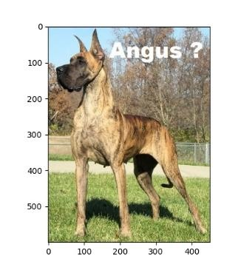
- VIDEO TO HOURS CODE:
MOVIE TO FRAMES
# Utility Start Movie to HORUS (Part 1) ====================== # Standard Tools
import os import shutil import cv2
#=============================================================
sInputFileName='C:/VKHCG/05-DS/9999-Data/dog.mp4' sDataBaseDir='C:/VKHCG/05-DS/9999-Data/temp'
if os.path.exists(sDataBaseDir): shutil.rmtree(sDataBaseDir)
if not os.path.exists(sDataBaseDir): os.makedirs(sDataBaseDir)
print('=====================================================')
print('Start Movie to Frames') print('=====================================================')
vidcap = cv2.VideoCapture(sInputFileName)
success,image = vidcap.read() count = 0
while success:
success,image = vidcap.read()
sFrame=sDataBaseDir + str('/dog-frame-' + str(format(count, '04d')) + '.jpg') print('Extracted: ', sFrame)
cv2.imwrite(sFrame, image)
if os.path.getsize(sFrame) == 0: count += -1 os.remove(sFrame) print('Removed: ', sFrame)
if cv2.waitKey(10) == 27: # exit if Escape is hit

break
if count > 100: # exit break
count += 1 print('=====================================================')
print('Generated : ', count, ' Frames')
print('=====================================================')
print('Movie to Frames HORUS - Done') print('=====================================================') # Utility done ===============================================

OUTPUT:
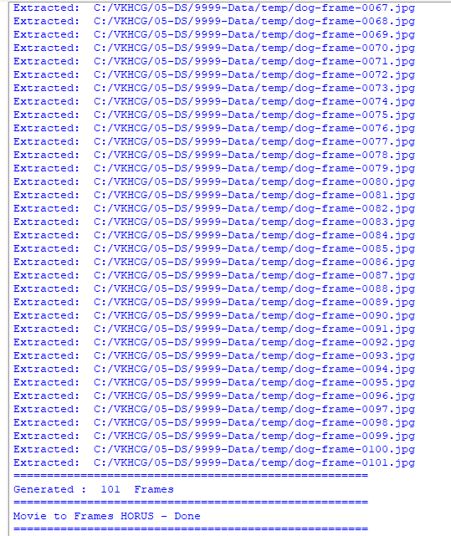

FRAMES TO HOURS:

CODE:
# Utility Start Movie to HORUS (Part 2)
====================== # Standard Tools from scipy.misc import imread
import pandas as pd
import matplotlib.pyplot as plt import numpy as np
import os
# Input Agreement ============================================
sDataBaseDir='C:/VKHCG/05-DS/9999-Data/temp' f=0
for file in os.listdir(sDataBaseDir):
if file.endswith(".jpg"):
f += 1
sInputFileName=os.path.join(sDataBaseDir, file)

print('Process : ', sInputFileName)
InputData = imread(sInputFileName, flatten=False, mode='RGBA') print('Input Data Values===================================')
print('X: ',InputData.shape[0])
print('Y:',InputData.shape[1]) print('RGBA: ', InputData.shape[2])
print('=====================================================')
# Processing Rules ===========================================
ProcessRawData=InputData.flatten() y=InputData.shape[2] + 2 x=int(ProcessRawData.shape[0]/y)
ProcessFrameData=pd.DataFrame(np.reshape(ProcessRawData, (x, y))) ProcessFrameData['Frame']=file print('=====================================================')
print('Process Data Values =================================') print('=====================================================')
plt.imshow(InputData) plt.show() if f == 1:
ProcessData=ProcessFrameData
else: ProcessData=ProcessData.append(ProcessFrameData) if f > 0:
sColumns= ['XAxis','YAxis','Red', 'Green', 'Blue','Alpha','FrameName'] ProcessData.columns=sColumns print('=====================================================')
ProcessFrameData.index.names =['ID'] print('Rows: ',ProcessData.shape[0]) print('Columns :',ProcessData.shape[1])
print('====================================================)
# Output Agreement
===========================================
OutputData=ProcessData print('Storing File')
sOutputFileName='C:/VKHCG/05-DS/9999-Data/HORUS-Movie-Frame.csv' OutputData.to_csv(sOutputFileName, index = False) print('=====================================================')
print('Processed ; ', f,' frames')
print('=====================================================')
print('Movie to HORUS - Done') print('=====================================================')

OUTPUT:
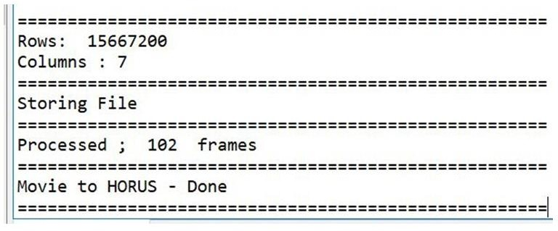

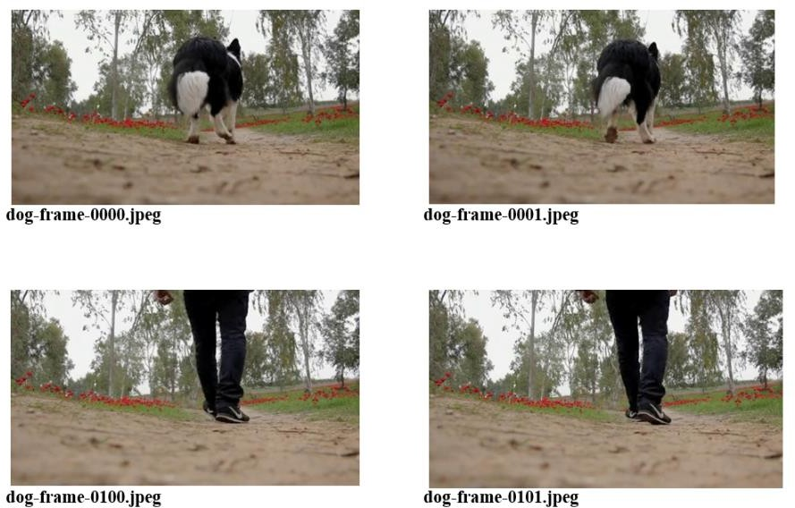
- AUDIO TO HOURS CODE:
# Utility Start Audio to HORUS ===============================
# Standard Tools #=============================================================
from scipy.io import wavfile import pandas as pd
import matplotlib.pyplot as plt import numpy as np
#=============================================================
def show_info(aname, a,r): print (' ') print ("Audio:", aname) print (' ') print ("Rate:", r)
print (' ') print ("shape:", a.shape)
print ("dtype:", a.dtype)
print ("min, max:", a.min(), a.max()) print (' ')
plot_info(aname, a,r) #=============================================================
def plot_info(aname, a,r):

sTitle= 'Signal Wave - '+ aname + ' at ' + str(r) + 'hz' plt.title(sTitle)
sLegend=[]
for c in range(a.shape[1]): sLabel = 'Ch' + str(c+1) sLegend=sLegend+[str(c+1)] plt.plot(a[:,c], label=sLabel)
plt.legend(sLegend) plt.show()
#=============================================================
sInputFileName='C:/VKHCG/05-DS/9999-Data/2ch-sound.wav' print('=====================================================')
print('Processing : ', sInputFileName) print('=====================================================')
InputRate, InputData = wavfile.read(sInputFileName)
show_info("2 channel", InputData,InputRate) ProcessData=pd.DataFrame(InputData) sColumns= ['Ch1','Ch2'] ProcessData.columns=sColumns OutputData=ProcessData
sOutputFileName='C:/VKHCG/05-DS/9999-Data/HORUS-Audio-2ch.csv'
OutputData.to_csv(sOutputFileName, index = False) #=============================================================
sInputFileName='C:/VKHCG/05-DS/9999-Data/4ch-sound.wav' print('=====================================================')
print('Processing : ', sInputFileName) print('=====================================================')
InputRate, InputData = wavfile.read(sInputFileName) show_info("4 channel", InputData,InputRate) ProcessData=pd.DataFrame(InputData)
sColumns= ['Ch1','Ch2','Ch3', 'Ch4'] ProcessData.columns=sColumns OutputData=ProcessData
sOutputFileName='C:/VKHCG/05-DS/9999-Data/HORUS-Audio-4ch.csv' OutputData.to_csv(sOutputFileName, index = False) #=============================================================
sInputFileName='C:/VKHCG/05-DS/9999-Data/6ch-sound.wav' print('=====================================================')
print('Processing : ', sInputFileName) print('=====================================================')
InputRate, InputData = wavfile.read(sInputFileName) show_info("6 channel", InputData,InputRate) ProcessData=pd.DataFrame(InputData)
sColumns= ['Ch1','Ch2','Ch3', 'Ch4', 'Ch5','Ch6']

ProcessData.columns=sColumns OutputData=ProcessData
sOutputFileName='C:/VKHCG/05-DS/9999-Data/HORUS-Audio-6ch.csv'
OutputData.to_csv(sOutputFileName, index = False) #=============================================================
sInputFileName='C:/VKHCG/05-DS/9999-Data/8ch-sound.wav' print('=====================================================')
print('Processing : ', sInputFileName) print('=====================================================')
InputRate, InputData = wavfile.read(sInputFileName) show_info("8 channel", InputData,InputRate) ProcessData=pd.DataFrame(InputData)
sColumns= ['Ch1','Ch2','Ch3', 'Ch4', 'Ch5','Ch6','Ch7','Ch8']
ProcessData.columns=sColumns OutputData=ProcessData
sOutputFileName='C:/VKHCG/05-DS/9999-Data/HORUS-Audio-8ch.csv' OutputData.to_csv(sOutputFileName, index = False) print('=====================================================')
print('Audio to HORUS - Done') print('=====================================================') #============================================================= # Utility done =============================================== #=============================================================

OUTPUT:

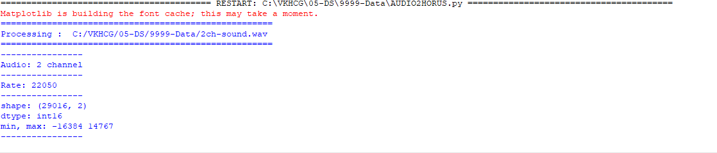

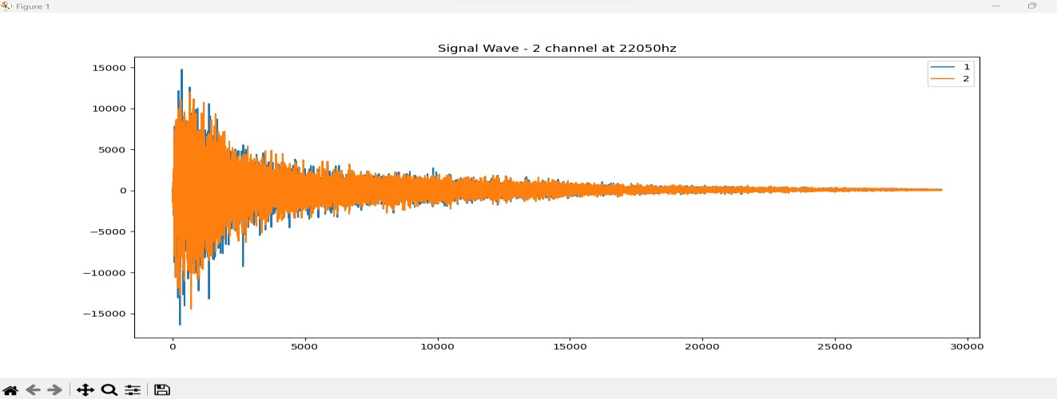
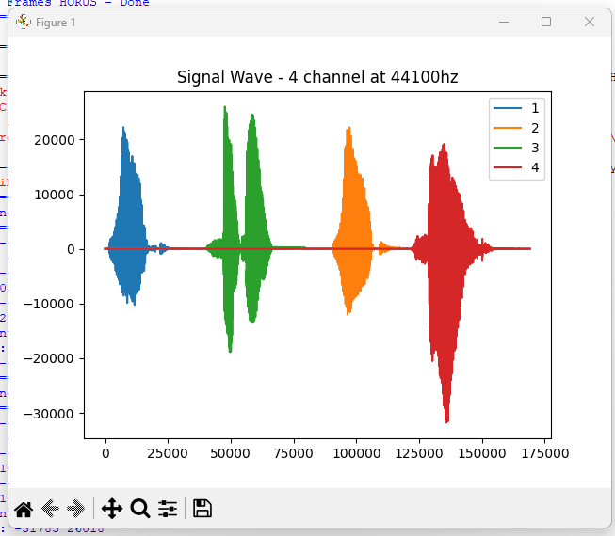

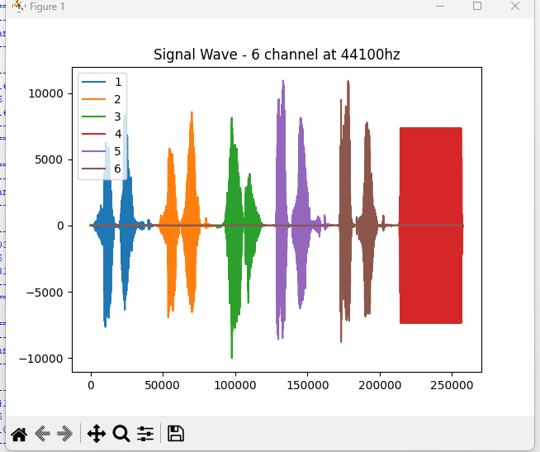

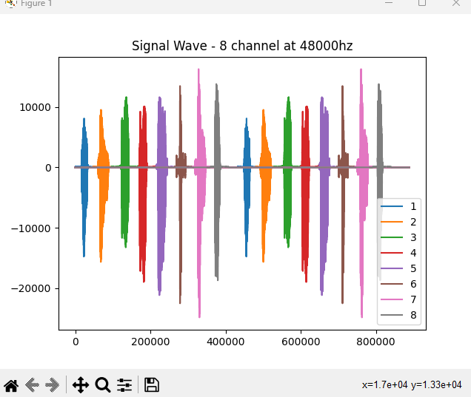

Audio to HORUS – Done

PRACTICAL 2
- UTILITIES AND AUDITING

CODE:
#---------------------------- Program to Demonstrate Fixers utilities -------------------
import string
import datetime as dt
# 1 Removing leading or lagging spaces from a data entry print('#1 Removing leading or lagging spaces from a data entry'); baddata = " Data Science with too many spaces is bad!!! " print('>',baddata,'<')
cleandata=baddata.strip()
print('>',cleandata,'<')
# 2 Removing nonprintable characters from a data entry print('#2 Removing nonprintable characters from a data entry') printable = set(string.printable)
baddata = "Data\x00Science with\x02 funny characters is \x10bad!!!" cleandata=''.join(filter(lambda x: x in string.printable,baddata)) print('Bad Data : ',baddata);
print('Clean Data : ',cleandata)
# 3 Reformatting data entry to match specific formatting criteria. # Convert YYYY/MM/DD to DD Month YYYY
print('# 3 Reformatting data entry to match specific formatting criteria.') baddate = dt.date(2019, 10, 31)
baddata=format(baddate,'%Y-%m-%d')
gooddate = dt.datetime.strptime(baddata,'%Y-%m-%d') gooddata=format(gooddate,'%d %B %Y')
print('Bad Data : ',baddata) print('Good Data : ',gooddata)

OUTPUT:
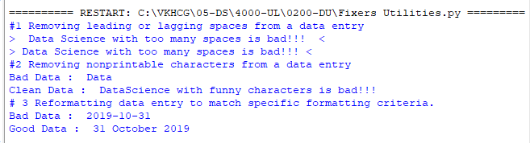

- Data Binning and Bucketing

CODE:
import numpy as np
import matplotlib.mlab as mlab import matplotlib.pyplot as plt import scipy.stats as stats np.random.seed(0)
# example data
mu = 90 # mean of distribution
sigma = 25 # standard deviation of distribution x = mu + sigma * np.random.randn(5000) num_bins = 25
fig, ax = plt.subplots()
# the histogram of the data
n, bins, patches = ax.hist(x, num_bins, density=1) # add a 'best fit' line
y = stats.norm.pdf(bins, mu, sigma) # mlab.normpdf(bins, mu, sigma) ax.plot(bins, y, '--') ax.set_xlabel('Example Data') ax.set_ylabel('Probability density')
sTitle=r'Histogram ' + str(len(x)) + ' entries into ' + str(num_bins) + ' Bins: $\mu=' + str(mu) + '$,
$\sigma=' + str(sigma) + '$' ax.set_title(sTitle)
fig.tight_layout()
sPathFig='C:/VKHCG/05-DS/4000-UL/0200-DU/DU-Histogram.png' fig.savefig(sPathFig)
plt.show()

OUTPUT:
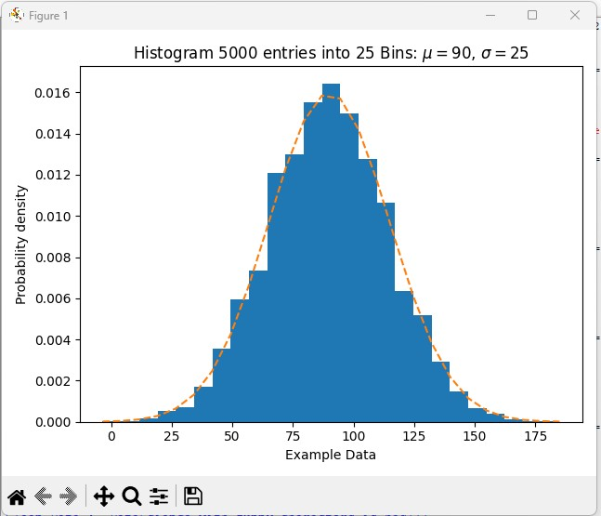

C. Averaging Of Data CODE:
import pandas as pd InputFileName='IP_DATA_CORE.csv' OutputFileName='Retrieve_Router_Location.csv' Base='C:/VKHCG' print('################################')
print('Working Base :',Base, ' using ')
print('################################')
sFileName=Base + '/01-Vermeulen/00-RawData/' + InputFileName print('Loading :',sFileName) IP_DATA_ALL=pd.read_csv(sFileName,header=0,low_memory=False, usecols=['Country','Place Name','Latitude','Longitude'], encoding="latin-1") IP_DATA_ALL.rename(columns={'Place Name': 'Place_Name'}, inplace=True) AllData=IP_DATA_ALL[['Country', 'Place_Name','Latitude']]
print(AllData)
MeanData=AllData.groupby(['Country', 'Place_Name'])['Latitude'].mean() print(Mean Data)

OUTPUT:
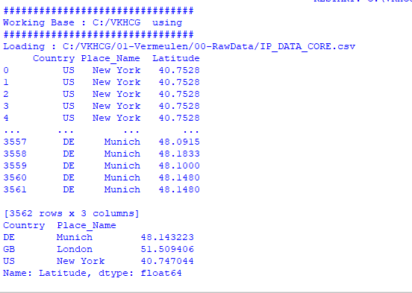

D. Outlier Detection CODE:
import pandas as pd InputFileName='IP_DATA_CORE.csv' OutputFileName='Retrieve_Router_Location.csv' Base='C:/VKHCG' print('################################')
print('Working Base :',Base) print('################################')
sFileName=Base + '/01-Vermeulen/00-RawData/' + InputFileName

print('Loading :',sFileName) IP_DATA_ALL=pd.read_csv(sFileName,header=0,low_memory=False, usecols=['Country','Place Name','Latitude','Longitude'], encoding="latin-1") IP_DATA_ALL.rename(columns={'Place Name': 'Place_Name'}, inplace=True) LondonData=IP_DATA_ALL.loc[IP_DATA_ALL['Place_Name']=='London'] AllData=LondonData[['Country', 'Place_Name','Latitude']]
print('All Data') print(AllData)
MeanData=AllData.groupby(['Country', 'Place_Name'])['Latitude'].mean()
StdData=AllData.groupby(['Country', 'Place_Name'])['Latitude'].std() print('Outliers')
UpperBound=float(MeanData+StdData) print('Higher than ', UpperBound)
OutliersHigher=AllData[AllData.Latitude>UpperBound] print(OutliersHigher)
LowerBound=float(MeanData-StdData) print('Lower than ', LowerBound)
OutliersLower=AllData[AllData.Latitude<LowerBound] print(OutliersLower)
print('Not Outliers')
OutliersNot=AllData[(AllData.Latitude>=LowerBound) & (AllData.Latitude<=UpperBound)] Print(OutliersNot)

OUTPUT:
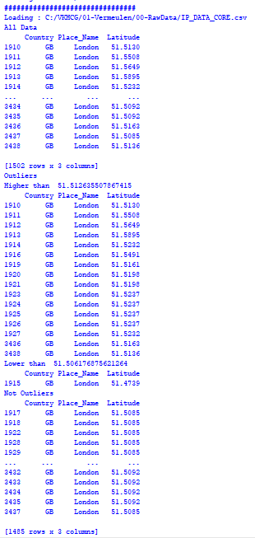

Audit CODE:
import sys import os import logging import uuid import shutil import time
Base='C:/VKHCG'
sCompanies=['01-Vermeulen','02-Krennwallner','03-Hillman','04-Clark']
sLayers=['01-Retrieve','02-Assess','03-Process','04-Transform','05-Organise','06-Report'] sLevels=['debug','info','warning','error']
for sCompany in sCompanies: sFileDir=Base + '/' + sCompany if not os.path.exists(sFileDir):
os.makedirs(sFileDir) for sLayer in sLayers:
log = logging.getLogger() # root logger
for hdlr in log.handlers[:]: # remove all old handlers log.removeHandler(hdlr)
sFileDir=Base + '/' + sCompany + '/' + sLayer + '/Logging' if os.path.exists(sFileDir):
shutil.rmtree(sFileDir) time.sleep(2)
if not os.path.exists(sFileDir): os.makedirs(sFileDir)
skey=str(uuid.uuid4())
sLogFile=Base + '/' + sCompany + '/' + sLayer + '/Logging/Logging_'+skey+'.log' print('Set up:',sLogFile)
# set up logging to file - see previous section for more details logging.basicConfig(level=logging.DEBUG,
format='%(asctime)s %(name)-12s %(levelname)-8s %(message)s',
datefmt='%m-%d %H:%M', filename=sLogFile,
filemode='w')
# define a Handler which writes INFO messages or higher to the sys.stderr console = logging.StreamHandler()
console.setLevel(logging.INFO)
# set a format which is simpler for console use
formatter = logging.Formatter('%(name)-12s: %(levelname)-8s %(message)s') # tell the handler to use this format
console.setFormatter(formatter)
# add the handler to the root logger logging.getLogger('').addHandler(console)

# Now, we can log to the root logger, or any other logger. First the root... logging.info('Practical Data Science is fun!.')
for sLevel in sLevels:
sApp='Apllication-'+ sCompany + '-' + sLayer + '-' + sLevel logger = logging.getLogger(sApp)
if sLevel == 'debug':
logger.debug('Practical Data Science logged a debugging message.') if sLevel == 'info':
logger.info('Practical Data Science logged information message.')
if sLevel == 'warning':
logger.warning('Practical Data Science logged a warning message.') if sLevel == 'error':
logger.error('Practical Data Science logged an error message.')

OUTPUT:
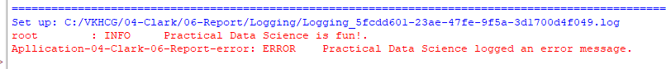

PRACTICAL 3

A Retrieve Superstep

The Retrieve superstep is a practical method for importing completely into the processing ecosystem a data lake consisting of various external data sources. The Retrieve superstep is the first contact between your data science and the source systems. I will guide you through a methodology of how to handle this discovery of the data up to the point you have all the data you need to evaluate the system you are working with, by deploying your data science skills. The successful retrieval of the data is a major stepping-stone to ensuring that you are performing good data science. Data lineage delivers the audit trail of the data elements at the lowest granular level, to ensure full data governance.
Data tagged in respective analytical models define the profile of the data that requires loading and guides
the data scientist to what additional processing is required.

library(readr)
IP_DATA_ALL <- read_csv("C:/VKHCG/01-Vermeulen/00-RawData/IP_DATA_ALL.csv") cols(
ID = col_double(),
Country = col_character(),
`Place Name` = col_character(),
`Post Code` = col_double(), Latitude = col_double(), Longitude = col_double(),
`First IP Number` = col_double(),
`Last IP Number` = col_double()
); View(IP_DATA_ALL)
spec(IP_DATA_ALL) cols(
ID = col_double(),
Country = col_character(),
`Place Name` = col_character(),
`Post Code` = col_double(), Latitude = col_double(), Longitude = col_double(),
`First IP Number` = col_double(),
`Last IP Number` = col_double()
);
library(tibble)
set_tidy_names(IP_DATA_ALL, syntactic = TRUE, quiet = FALSE) Place Name -> Place.Name
Post Code -> Post.Code
First IP Number -> First.IP.Number Last IP Number -> Last.IP.Number sapply(IP_DATA_ALL_FIX, typeof)

library(data.table)
hist_country=data.table(Country=unique(IP_DATA_ALL_FIX[is.na(IP_DATA_ALL_FIX ['Country'])==0,]$Country))
setorder(hist_country,'Country') hist_country_with_id=rowid_to_column(hist_country, var = "RowIDCountry") View(hist_country_fix)
IP_DATA_COUNTRY_FREQ=data.table(with(IP_DATA_ALL_FIX, table(Country))) View(IP_DATA_COUNTRY_FREQ)

OUTPUT:
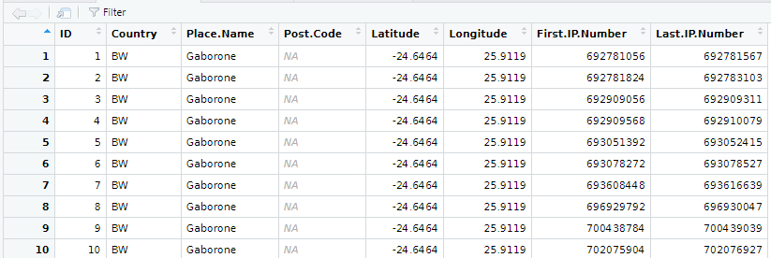

B: Program to retrieve different attributes of data
import sys import os
import pandas as pd Base='C:/VKHCG'
sFileName=Base + '/01-Vermeulen/00-RawData/IP_DATA_ALL.csv' print('Loading :',sFileName)
IP_DATA_ALL=pd.read_csv(sFileName,header=0,low_memory=False, encoding="latin-1") sFileDir=Base + '/01-Vermeulen/01-Retrieve/01-EDS/02-Python'
if not os.path.exists(sFileDir): os.makedirs(sFileDir)
print('Rows:', IP_DATA_ALL.shape[0]) print('Columns:', IP_DATA_ALL.shape[1])
print('### Raw Data Set #####################################')
for i in range(0,len(IP_DATA_ALL.columns)): print(IP_DATA_ALL.columns[i],type(IP_DATA_ALL.columns[i]))
print('### Fixed Data Set ###################################')
IP_DATA_ALL_FIX=IP_DATA_ALL
for i in range(0,len(IP_DATA_ALL.columns)): cNameOld=IP_DATA_ALL_FIX.columns[i] + ' ' cNameNew=cNameOld.strip().replace(" ", ".") IP_DATA_ALL_FIX.columns.values[i] = cNameNew

print(IP_DATA_ALL.columns[i],type(IP_DATA_ALL.columns[i])) #print(IP_DATA_ALL_FIX.head())
print('Fixed Data Set with ID')
IP_DATA_ALL_with_ID=IP_DATA_ALL_FIX IP_DATA_ALL_with_ID.index.names = ['RowID'] #print(IP_DATA_ALL_with_ID.head()) sFileName2=sFileDir + '/Retrieve_IP_DATA.csv'
IP_DATA_ALL_with_ID.to_csv(sFileName2, index = True, encoding="latin-1") Print(‘###Done!!#############################################’)

OUTPUT:
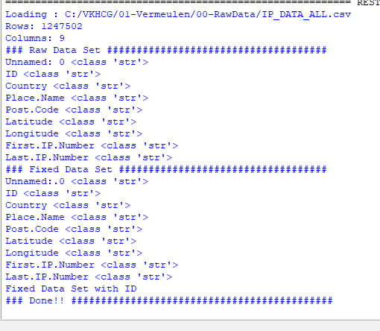

C. DATA PATTERN
To determine a pattern of the data values, Replace all alphabet values with an uppercase case A, all numbers with an uppercase N, and replace any spaces with a lowercase letter b and all other unknown characters with a lowercase u. As a result, “Good Book 101” becomes AAAAbAAAAbNNNu”. This pattern creation is beneficial for designing any specific assess rules. This pattern view of data is a quick way to identify common patterns or determine standard layouts.

library(readr) library(data.table)
FileName=paste0('c:/VKHCG/01-Vermeulen/00-RawData/IP_DATA_ALL.csv') IP_DATA_ALL <- read_csv(FileName) hist_country=data.table(Country=unique(IP_DATA_ALL$Country))
pattern_country=data.table(Country=hist_country$Country, PatternCountry=hist_country$Country)
oldchar=c(letters,LETTERS) newchar=replicate(length(oldchar),"A") for (r in seq(nrow(pattern_country))){ s=pattern_country[r,]$PatternCountry;
for (c in seq(length(oldchar))){

s=chartr(oldchar[c],newchar[c],s)
};
for (n in seq(0,9,1)){ s=chartr(as.character(n),"N",s)
};
s=chartr(" ","b",s)
s=chartr(".","u",s) pattern_country[r,]$PatternCountry=s;
};
View(pattern_country)

OUTPUT:
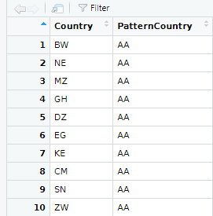

Example 2: This is a common use of patterns to separate common standards and structures. Pattern can be loaded in separate retrieve procedures. If the same two patterns, NNNNuNNuNN and uuNNuNNuNN, are found, you can send NNNNuNNuNN directly to be converted into a date, while uuNNuNNuNN goes through a quality-improvement process to then route back to the same queue as NNNNuNNuNN, once it complies.

library(readr) library(data.table) Base='C:/VKHCG'
FileName=paste0(Base,'/01-Vermeulen/00-RawData/IP_DATA_ALL.csv') IP_DATA_ALL <- read_csv(FileName) hist_latitude=data.table(Latitude=unique(IP_DATA_ALL$Latitude)) pattern_latitude=data.table(latitude=hist_latitude$Latitude,
Patternlatitude=as.character(hist_latitude$Latitude)) oldchar=c(letters,LETTERS) newchar=replicate(length(oldchar),"A")
for (r in seq(nrow(pattern_latitude))){ s=pattern_latitude[r,]$Patternlatitude; for (c in seq(length(oldchar))){ s=chartr(oldchar[c],newchar[c],s)
};

for (n in seq(0,9,1)){ s=chartr(as.character(n),"N",s)
};
s=chartr(" ","b",s)
s=chartr("+","u",s)
s=chartr("-","u",s)
s=chartr(".","u",s) pattern_latitude[r,]$Patternlatitude=s;
};
setorder(pattern_latitude,latitude) View(pattern_latitude[1:3])

OUTPUT:
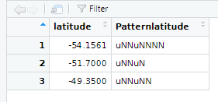

D.Loading IP_DATA_ALL:
This data set contains all the IP address allocations in the world. It will help you to locate your customers when interacting with them online.
Create a new Python script file and save it as Retrieve-IP_DATA_ALL.py in directory

import sys import os
import pandas as pd Base='C:/VKHCG'
sFileName=Base + '/01-Vermeulen/00-RawData/IP_DATA_ALL.csv' print('Loading :',sFileName)
IP_DATA_ALL=pd.read_csv(sFileName,header=0,low_memory=False, encoding="latin-1") sFileDir=Base + '/01-Vermeulen/01-Retrieve/01-EDS/02-Python'
if not os.path.exists(sFileDir): os.makedirs(sFileDir)
print('Rows:', IP_DATA_ALL.shape[0]) print('Columns:', IP_DATA_ALL.shape[1])
print('### Raw Data Set #####################################')
for i in range(0,len(IP_DATA_ALL.columns)): print(IP_DATA_ALL.columns[i],type(IP_DATA_ALL.columns[i]))

print('### Fixed Data Set ###################################')
IP_DATA_ALL_FIX=IP_DATA_ALL
for i in range(0,len(IP_DATA_ALL.columns)): cNameOld=IP_DATA_ALL_FIX.columns[i] + ' '
cNameNew=cNameOld.strip().replace(" ", ".") IP_DATA_ALL_FIX.columns.values[i] = cNameNew print(IP_DATA_ALL.columns[i],type(IP_DATA_ALL.columns[i])) print(IP_DATA_ALL_FIX.head())
print('Fixed Data Set with ID')
IP_DATA_ALL_with_ID=IP_DATA_ALL_FIX IP_DATA_ALL_with_ID.index.names = ['RowID'] #print(IP_DATA_ALL_with_ID.head()) sFileName2=sFileDir + '/Retrieve_IP_DATA.csv'
IP_DATA_ALL_with_ID.to_csv(sFileName2, index = True, encoding="latin-1") print('### Done!! ############################################')

OUTPUT:
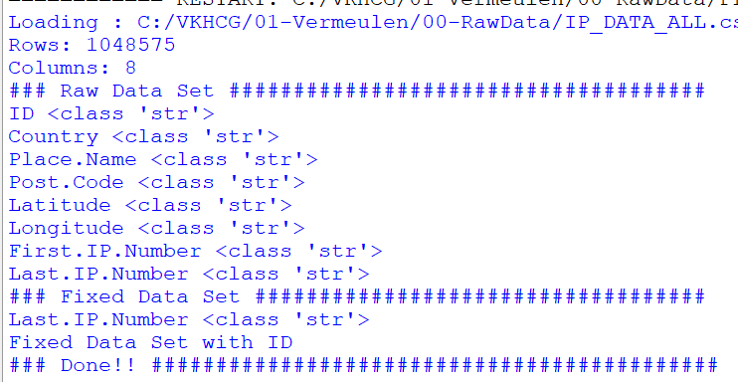

PRACTICAL 4

ASSESSING DATA

Assess Superstep
Data quality refers to the condition of a set of qualitative or quantitative variables. Data quality is a multidimensional measurement of the acceptability of specific data sets. In business, data quality is measured to determine whether data can be used as a basis for reliable intelligence extraction for supporting organizational decisions. Data profiling involves observing in your data sources all the viewpoints that the information offers. The main goal is to determine if individual viewpoints are accurate and complete. The Assess superstep determines what additional processing to apply to the entries that are non-compliant.

Errors
Typically, one of four things can be done with an error to the data.
- Accept the Error
- Reject the Error
- Correct the Error
- Create a Default Value

Perform error management on the given data using the pandas package.
Python pandas package enables several automatic error-management features.
File Location: C:\VKHCG\01-Vermeulen\02-Assess

Missing Values in Pandas:
    - Drop the Columns Where All Elements Are Missing Values

CODE :
################### Assess-Good-Bad-01.py########################
# -*- coding: utf-8 -*- import sys
import os
import pandas as pd Base='C:/VKHCG'
print('################################')
print('Working Base :',Base, ' using ', sys.platform) print('################################')
sInputFileName='Good-or-Bad.csv' sOutputFileName='Good-or-Bad-01.csv' Company='01-Vermeulen' Base='C:/VKHCG'
sFileDir=Base + '/' + Company + '/02-Assess/01-EDS/02-Python' if not os.path.exists(sFileDir):
os.makedirs(sFileDir) ### Import Warehouse
sFileName=Base + '/' + Company + '/00-RawData/' + sInputFileName print('Loading :',sFileName) RawData=pd.read_csv(sFileName,header=0) print('################################')
print('## Raw Data Values') print('################################')

print(RawData) print('################################')
print('## Data Profile')
print('################################')
print('Rows :',RawData.shape[0]) print('Columns :',RawData.shape[1]) print('################################')
sFileName=sFileDir + '/' + sInputFileName RawData.to_csv(sFileName, index = False) TestData=RawData.dropna(axis=1, how='all') print('################################')
print('## Test Data Values') print('################################')
print(TestData) print('################################')
print('## Data Profile') print('################################')
print('Rows :',TestData.shape[0]) print('Columns :',TestData.shape[1]) print('################################')
sFileName=sFileDir + '/' + sOutputFileName
TestData.to_csv(sFileName, index = False) print('################################') print('### Done!! #####################') print('################################')

OUTPUT:
>>>
======= RESTART: C:\VKHCG\01-Vermeulen\02-Assess\Assess-Good-Bad-01.py ======= Working Base : C:/VKHCG using win32
Loading : C:/VKHCG/01-Vermeulen/00-RawData/Good-or-Bad.csv ## Raw Data Values
ID FieldA FieldB FieldC FieldD FieldE FieldF FieldG 0 1.0 Good Better Best 1024.0 NaN 10241.0 1
1 2.0 Good NaN Best 512.0 NaN 5121.0 2
- 3.0 Good Better NaN 256.0 NaN 256.0 3
- 4.0 Good Better Best NaN NaN 211.0 4
- 5.0 Good Better NaN 64.0 NaN 6411.0 5
- 6.0 Good NaN Best 32.0 NaN 32.0 6
- 7.0 NaN Better Best 16.0 NaN 1611.0 7
- 8.0 NaN NaN Best 8.0 NaN 8111.0 8
- 9.0 NaN NaN NaN 4.0 NaN 41.0 9
9 10.0 A B C 2.0 NaN 21111.0 10
10 NaN NaN NaN NaN NaN NaN NaN 11

11 10.0 Good Better Best 1024.0 NaN 102411.0 12
12 10.0 Good NaN Best 512.0 NaN 512.0 13
13 10.0 Good Better NaN 256.0 NaN 1256.0 14
- 10.0 Good Better Best NaN NaN NaN 15
- 10.0 Good Better NaN 64.0 NaN 164.0 16
16 10.0 Good NaN Best 32.0 NaN 322.0 17
17 10.0 NaN Better Best 16.0 NaN 163.0 18
18 10.0 NaN NaN Best 8.0 NaN 844.0 19
19 10.0 NaN NaN NaN 4.0 NaN 4555.0 20
20 10.0 A B C 2.0 NaN 111.0 21
## Data Profile Rows : 21
Columns : 8
## Test Data Values
ID FieldA FieldB FieldC FieldD FieldF FieldG 0 1.0 Good Better Best 1024.0 10241.0 1
1 2.0 Good NaN Best 512.0 5121.0 2
2 3.0 Good Better NaN 256.0 256.0 3
3 4.0 Good Better Best NaN 211.0 4
4 5.0 Good Better NaN 64.0 6411.0 5
5 6.0 Good NaN Best 32.0 32.0 6
6 7.0 NaN Better Best 16.0 1611.0 7
7 8.0 NaN NaN Best 8.0 8111.0 8
8 9.0 NaN NaN NaN 4.0 41.0 9
9 10.0 A B C 2.0 21111.0 10
10 NaN NaN NaN NaN NaN NaN 11
11 10.0 Good Better Best 1024.0 102411.0 12
12 10.0 Good NaN Best 512.0 512.0 13
13 10.0 Good Better NaN 256.0 1256.0 14
14 10.0 Good Better Best NaN NaN 15
15 10.0 Good Better NaN 64.0 164.0 16
16 10.0 Good NaN Best 32.0 322.0 17
17 10.0 NaN Better Best 16.0 163.0 18
18 10.0 NaN NaN Best 8.0 844.0 19
19 10.0 NaN NaN NaN 4.0 4555.0 20
20 10.0 A B C 2.0 111.0 21
## Data Profile Rows: 21
Columns : 7
### Done!! #####################

>>>
All of column E has been deleted, owing to the fact that all values in that column were missing values/errors.

ii Drop the Columns Where Any of the Elements Is Missing Values

Code:
################## Assess-Good-Bad-02.py###########################
# -*- coding: utf-8 -*- import sys
import os
import pandas as pd Base='C:/VKHCG'
sInputFileName='Good-or-Bad.csv' sOutputFileName='Good-or-Bad-02.csv' Company='01-Vermeulen' Base='C:/VKHCG'
print('################################')
print('Working Base :',Base, ' using ', sys.platform) print('################################')
sFileDir=Base + '/' + Company + '/02-Assess/01-EDS/02-Python'
if not os.path.exists(sFileDir): os.makedirs(sFileDir)
### Import Warehouse
sFileName=Base + '/' + Company + '/00-RawData/' + sInputFileName print('Loading :',sFileName) RawData=pd.read_csv(sFileName,header=0) print('################################')
print('## Raw Data Values') print('################################')
print(RawData) print('################################')
print('## Data Profile')
print('################################')
print('Rows :',RawData.shape[0]) print('Columns :',RawData.shape[1]) print('################################')
sFileName=sFileDir + '/' + sInputFileName RawData.to_csv(sFileName, index = False) TestData=RawData.dropna(axis=1, how='any') print('################################')
print('## Test Data Values') print('################################')
print(TestData) print('################################')
print('## Data Profile') print('################################')
print('Rows :',TestData.shape[0])

print('Columns :',TestData.shape[1]) print('################################')
sFileName=sFileDir + '/' + sOutputFileName
TestData.to_csv(sFileName, index = False) print('################################') print('### Done!! #####################') print('################################')

OUTPUT:
>>>
======= RESTART: C:\VKHCG\01-Vermeulen\02-Assess\Assess-Good-Bad-02.py ======= Working Base : C:/VKHCG using win32
Loading : C:/VKHCG/01-Vermeulen/00-RawData/Good-or-Bad.csv ## Raw Data Values
ID FieldA FieldB FieldC FieldD FieldE FieldF FieldG 0 1.0 Good Better Best 1024.0 NaN 10241.0 1
1 2.0 Good NaN Best 512.0 NaN 5121.0 2
- 3.0 Good Better NaN 256.0 NaN 256.0 3
- 4.0 Good Better Best NaN NaN 211.0 4
- 5.0 Good Better NaN 64.0 NaN 6411.0 5
- 6.0 Good NaN Best 32.0 NaN 32.0 6
- 7.0 NaN Better Best 16.0 NaN 1611.0 7
- 8.0 NaN NaN Best 8.0 NaN 8111.0 8
- 9.0 NaN NaN NaN 4.0 NaN 41.0 9
9 10.0 A B C 2.0 NaN 21111.0 10
10 NaN NaN NaN NaN NaN NaN NaN 11
11 10.0 Good Better Best 1024.0 NaN 102411.0 12
12 10.0 Good NaN Best 512.0 NaN 512.0 13
13 10.0 Good Better NaN 256.0 NaN 1256.0 14
- 10.0 Good Better Best NaN NaN NaN 15
- 10.0 Good Better NaN 64.0 NaN 164.0 16
16 10.0 Good NaN Best 32.0 NaN 322.0 17
17 10.0 NaN Better Best 16.0 NaN 163.0 18
18 10.0 NaN NaN Best 8.0 NaN 844.0 19
19 10.0 NaN NaN NaN 4.0 NaN 4555.0 20
20 10.0 A B C 2.0 NaN 111.0 21
## Data Profile Rows : 21
Columns : 8
## Test Data Values FieldG
0 1
1 2
2 3

3 4
4 5
5 6
6 7
7 8
8 9
9 10
10 11
11 12
12 13
13 14
14 15
15 16
16 17
17 18
18 19
19 20
20 21
## Data Profile Rows : 21
Columns : 1
### Done!! #####################
>>>

iii. Keep Only the Rows That Contain a Maximum of Two Missing Values
##################### Assess-Good-Bad-03.py ################
# -*- coding: utf-8 -*- import sys
import os
import pandas as pd sInputFileName='Good-or-Bad.csv' sOutputFileName='Good-or-Bad-03.csv' Company='01-Vermeulen' Base='C:/VKHCG'
print('################################')
print('Working Base :',Base, ' using Windows ~~~~') print('################################')
sFileDir=Base + '/' + Company + '/02-Assess/01-EDS/02-Python' if not os.path.exists(sFileDir):
os.makedirs(sFileDir) ### Import Warehouse
sFileName=Base + '/' + Company + '/00-RawData/' + sInputFileName print('Loading :',sFileName) RawData=pd.read_csv(sFileName,header=0)

print('################################')
print('## Raw Data Values') print('################################')
print(RawData) print('################################')
print('## Data Profile') print('################################')
print('Rows :',RawData.shape[0]) print('Columns :',RawData.shape[1]) print('################################')
sFileName=sFileDir + '/' + sInputFileName RawData.to_csv(sFileName, index = False) TestData=RawData.dropna(thresh=2) print('################################')
print('## Test Data Values')
print('################################')
print(TestData) print('################################')
print('## Data Profile') print('################################')
print('Rows :',TestData.shape[0])
print('Columns :',TestData.shape[1]) print('################################')
sFileName=sFileDir + '/' + sOutputFileName TestData.to_csv(sFileName, index = False) print('################################') print('### Done!! #####################') print('################################') OUTPUT:
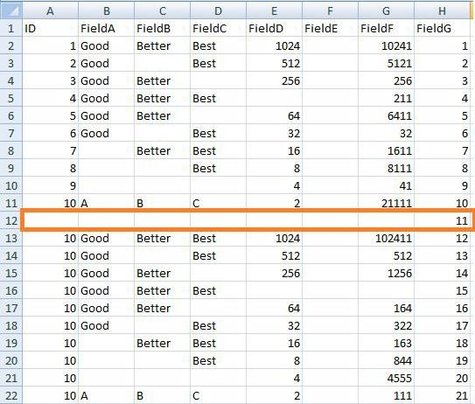

Before
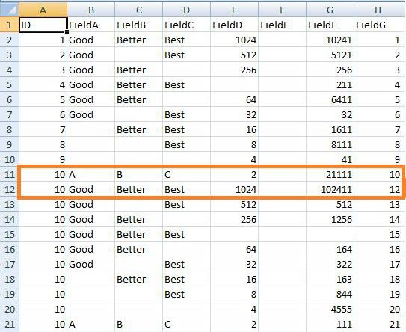
After
Row with more than two missing values got deleted.
The next step along the route is to generate a full network routing solution for the company, to resolve the data issues in the retrieve data.

Write a Python / R program to create the network routing diagram from the given data On routers.
Code:
########## Assess-Network-Routing-Company.py ##################### import sys
import os
import pandas as pd pd.options.mode.chained_assignment = None Base='C:/VKHCG' print('################################')
print('Working Base :',Base, ' using Windows') print('################################')
sInputFileName1='01-Retrieve/01-EDS/01-R/Retrieve_Country_Code.csv' sInputFileName2='01-Retrieve/01-EDS/02-Python/Retrieve_Router_Location.csv' sInputFileName3='01-Retrieve/01-EDS/01-R/Retrieve_IP_DATA.csv' sOutputFileName='Assess-Network-Routing-Company.csv'
Company='01-Vermeulen'
### Import Country Data
sFileName=Base + '/' + Company + '/' + sInputFileName1 print('################################')
print('Loading :',sFileName) print('################################')
CountryData=pd.read_csv(sFileName,header=0,low_memory=False, encoding="latin-1")

print('Loaded Country:',CountryData.columns.values) print('################################')
## Assess Country Data
print('################################')
print('Changed :',CountryData.columns.values) CountryData.rename(columns={'Country': 'Country_Name'}, inplace=True) CountryData.rename(columns={'ISO-2-CODE': 'Country_Code'}, inplace=True) CountryData.drop('ISO-M49', axis=1, inplace=True)
CountryData.drop('ISO-3-Code', axis=1, inplace=True)
CountryData.drop('RowID', axis=1, inplace=True) print('To :',CountryData.columns.values) print('################################')
### Import Company Data
sFileName=Base + '/' + Company + '/' + sInputFileName2 print('################################')
print('Loading :',sFileName) print('################################')
CompanyData=pd.read_csv(sFileName,header=0,low_memory=False, encoding="latin-1") print('Loaded Company :',CompanyData.columns.values) print('################################')
## Assess Company Data
print('################################')
print('Changed :',CompanyData.columns.values) CompanyData.rename(columns={'Country': 'Country_Code'}, inplace=True) print('To :',CompanyData.columns.values) print('################################')
### Import Customer Data
sFileName=Base + '/' + Company + '/' + sInputFileName3 print('################################')
print('Loading :',sFileName) print('################################')
CustomerRawData=pd.read_csv(sFileName,header=0,low_memory=False, encoding="latin-1") print('################################')
print('Loaded Customer :',CustomerRawData.columns.values) print('################################')
CustomerData=CustomerRawData.dropna(axis=0, how='any') print('################################')
print('Remove Blank Country Code')
print('Reduce Rows from', CustomerRawData.shape[0],' to ', CustomerData.shape[0]) print('################################') print('################################')
print('Changed :',CustomerData.columns.values)
CustomerData.rename(columns={'Country': 'Country_Code'}, inplace=True) print('To :',CustomerData.columns.values)

print('################################') print('################################')
print('Merge Company and Country Data') print('################################')
CompanyNetworkData=pd.merge(CompanyData, CountryData,how='inner'on='Country_Code') print('################################')
print('Change ',CompanyNetworkData.columns.values) for i in CompanyNetworkData.columns.values:
j='Company_'+i
CompanyNetworkData.rename(columns={i: j}, inplace=True) print('To ', CompanyNetworkData.columns.values) print('################################')
sFileDir=Base + '/' + Company + '/02-Assess/01-EDS/02-Python' if not os.path.exists(sFileDir):
os.makedirs(sFileDir)
sFileName=sFileDir + '/' + sOutputFileName print('################################')
print('Storing :', sFileName) print('################################')
CompanyNetworkData.to_csv(sFileName, index = False, encoding="latin-1") print('################################')
print('### Done!! #####################')
print('################################')

OUTPUT:
Go to C:\VKHCG\01-Vermeulen\02-Assess\01-EDS\02-Python folder and open Assess-Network-Routing-Company.csv
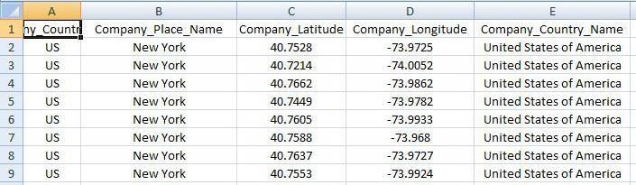

Next, Access the the customers location using network router location ####################Assess-Network-Routing-Customer.py ###################### import sys
import os
import pandas as pd pd.options.mode.chained_assignment = None Base='C:/VKHCG' print('################################')
print('Working Base :',Base, ' using ', sys.platform) print('################################')

sInputFileName=Base+'/01-Vermeulen/02-Assess/01-EDS/02-Python/Assess-Network-Routing- Customer.csv'
sOutputFileName='Assess-Network-Routing-Customer.gml'
Company='01-Vermeulen' ### Import Country Data sFileName=sInputFileName
print('################################')
print('Loading :',sFileName) print('################################')
CustomerData=pd.read_csv(sFileName,header=0,low_memory=False, encoding="latin-1") print('Loaded Country:',CustomerData.columns.values) print('################################')
print(CustomerData.head()) print('################################') print('### Done!! #####################') print('################################')

OUTPUT:
Assess-Network-Routing-Customer.csv
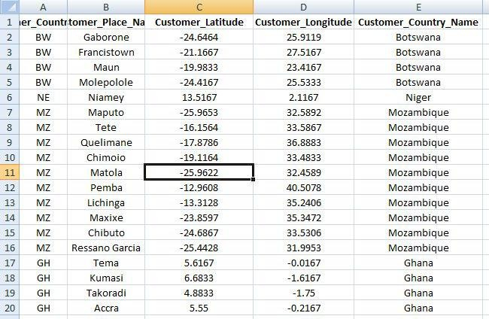

Assess-Network-Routing-Node.py
import sys import os
import pandas as pd pd.options.mode.chained_assignment = None Base='C:/VKHCG' print('################################')
print('Working Base :',Base, ' using ', sys.platform)
print('################################')
sInputFileName='01-Retrieve/01-EDS/02-Python/Retrieve_IP_DATA.csv'

sOutputFileName='Assess-Network-Routing-Node.csv' Company='01-Vermeulen'
### Import IP Data
sFileName=Base + '/' + Company + '/' + sInputFileName print('################################')
print('Loading :',sFileName) print('################################')
IPData=pd.read_csv(sFileName,header=0,low_memory=False, encoding="latin-1") print('Loaded IP :', IPData.columns.values) print('################################') print('################################')
print('Changed :',IPData.columns.values) IPData.drop('RowID', axis=1, inplace=True) IPData.drop('ID', axis=1, inplace=True)
IPData.rename(columns={'Country': 'Country_Code'}, inplace=True)
IPData.rename(columns={'Place.Name': 'Place_Name'}, inplace=True) IPData.rename(columns={'Post.Code': 'Post_Code'}, inplace=True) IPData.rename(columns={'First.IP.Number': 'First_IP_Number'}, inplace=True) IPData.rename(columns={'Last.IP.Number': 'Last_IP_Number'}, inplace=True) print('To :',IPData.columns.values) print('################################') print('################################')
print('Change ',IPData.columns.values) for i in IPData.columns.values:
j='Node_'+i
IPData.rename(columns={i: j}, inplace=True) print('To ', IPData.columns.values) print('################################')
sFileDir=Base + '/' + Company + '/02-Assess/01-EDS/02-Python' if not os.path.exists(sFileDir):
os.makedirs(sFileDir)
sFileName=sFileDir + '/' + sOutputFileName print('################################')
print('Storing :', sFileName) print('################################')
IPData.to_csv(sFileName, index = False, encoding="latin-1") print('################################')
print('### Done!! #####################') print('################################')

OUTPUT:
C:/VKHCG/01-Vermeulen/02-Assess/01-EDS/02-Python/Assess-Network-Routing-Node.csv
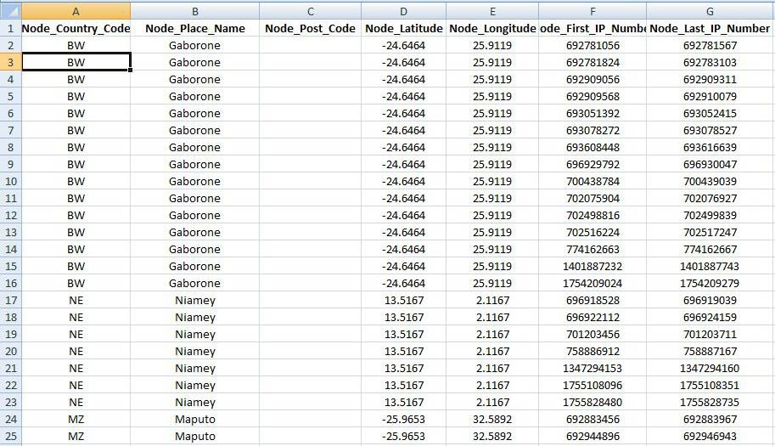

Directed Acyclic Graph (DAG)
A directed acyclic graph is a specific graph that only has one path through the graph.

Write a Python / R program to build directed acyclic graph.
Open your python editor and create a file named Assess-DAG-Location.py in directory C:\VKHCG\01-Vermeulen\02-Assess
import networkx as nx
import matplotlib.pyplot as plt import sys
import os
import pandas as pd Base='C:/VKHCG'
print('################################')
print('Working Base :',Base, ' using ', sys.platform) print('################################')
sInputFileName='01-Retrieve/01-EDS/02-Python/Retrieve_Router_Location.csv' sOutputFileName1='Assess-DAG-Company-Country.png' sOutputFileName2='Assess-DAG-Company-Country-Place.png'
Company='01-Vermeulen' ### Import Company Data
sFileName=Base + '/' + Company + '/' + sInputFileName print('################################')
print('Loading :',sFileName) print('################################')

CompanyData=pd.read_csv(sFileName,header=0,low_memory=False, encoding="latin-1") print('Loaded Company :',CompanyData.columns.values) print('################################')
print(CompanyData) print('################################')
print('Rows : ',CompanyData.shape[0]) print('################################')
G1=nx.DiGraph() G2=nx.DiGraph()
for i in range(CompanyData.shape[0]): G1.add_node(CompanyData['Country'][i])
sPlaceName= CompanyData['Place_Name'][i] + '-' + CompanyData['Country'][i] G2.add_node(sPlaceName)
print('################################')
for n1 in G1.nodes():
for n2 in G1.nodes():
if n1 != n2:
print('Link :',n1,' to ', n2) G1.add_edge(n1,n2)
print('################################') print('################################')
print("Nodes of graph: ") print(G1.nodes()) print("Edges of graph: ") print(G1.edges())
print('################################')
sFileDir=Base + '/' + Company + '/02-Assess/01-EDS/02-Python' if not os.path.exists(sFileDir):
os.makedirs(sFileDir)
sFileName=sFileDir + '/' + sOutputFileName1 print('################################')
print('Storing :', sFileName) print('################################')
nx.draw(G1,pos=nx.spectral_layout(G1), nodecolor='r',edge_color='g', with_labels=True,node_size=8000,
font_size=12)
plt.savefig(sFileName) # save as png plt.show() # display print('################################')
for n1 in G2.nodes(): for n2 in G2.nodes(): if n1 != n2:
print('Link :',n1,' to ', n2)

G2.add_edge(n1,n2) print('################################') print('################################')
print("Nodes of graph: ") print(G2.nodes()) print("Edges of graph: ") print(G2.edges())
print('################################')
sFileDir=Base + '/' + Company + '/02-Assess/01-EDS/02-Python' if not os.path.exists(sFileDir):
os.makedirs(sFileDir)
sFileName=sFileDir + '/' + sOutputFileName2 print('################################')
print('Storing :', sFileName) print('################################')
nx.draw(G2,pos=nx.spectral_layout(G2), nodecolor='r',edge_color='b', with_labels=True,node_size=8000,
font_size=12)
plt.savefig(sFileName) # save as png plt.show() # display

OUTPUT:
Rows : 150 Link : US to DE
Link : US to GB Link : DE to US Link : DE to GB Link : GB to US Link : GB to DE Nodes of graph:
['US', 'DE', 'GB']
Edges of graph:
[('US', 'DE'), ('US', 'GB'), ('DE', 'US'), ('DE', 'GB'), ('GB', 'US'), ('GB', 'DE')]
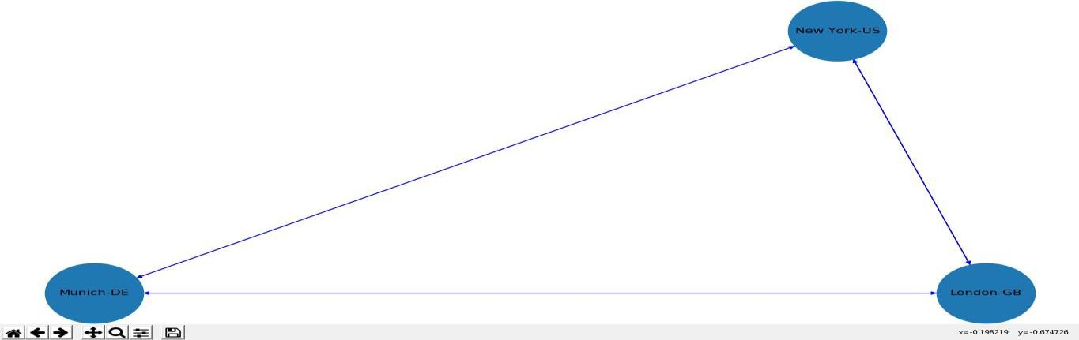

Open your Python editor and create a file named Assess-DAG-GPS.py in directory C:\VKHCG\01-Vermeulen\02-Assess.
import networkx as nx
import matplotlib.pyplot as plt import sys
import os
import pandas as pd Base='C:/VKHCG'
print('################################')
print('Working Base :',Base, ' using ', sys.platform) print('################################')
sInputFileName='01-Retrieve/01-EDS/02-Python/Retrieve_Router_Location.csv' sOutputFileName='Assess-DAG-Company-GPS.png'
Company='01-Vermeulen' ### Import Company Data
sFileName=Base + '/' + Company + '/' + sInputFileName print('################################')
print('Loading :',sFileName) print('################################')
CompanyData=pd.read_csv(sFileName,header=0,low_memory=False, encoding="latin-1") print('Loaded Company :',CompanyData.columns.values) print('################################')
print(CompanyData) print('################################')
print('Rows : ',CompanyData.shape[0]) print('################################')
G=nx.Graph()
for i in range(CompanyData.shape[0]): nLatitude=round(CompanyData['Latitude'][i],2) nLongitude=round(CompanyData['Longitude'][i],2) if nLatitude < 0:
sLatitude = str(nLatitude*-1) + ' S' else:
sLatitude = str(nLatitude) + ' N' if nLongitude < 0:
sLongitude = str(nLongitude*-1) + ' W' else:
sLongitude = str(nLongitude) + ' E' sGPS= sLatitude + '-' + sLongitude G.add_node(sGPS)
print('################################')
for n1 in G.nodes(): for n2 in G.nodes(): if n1 != n2:

print('Link :',n1,' to ', n2) G.add_edge(n1,n2)
print('################################')
print('################################')
print("Nodes of graph: ") print(G.number_of_nodes())

OUTPUT:
=== RESTART: C:\VKHCG\01-Vermeulen\02-Assess\Assess-DAG-GPS-unsmoothed.py === Working Base : C:/VKHCG using win32
Loading : C:/VKHCG/01-Vermeulen/01-Retrieve/01-EDS/02-Python/Retrieve_Router_Location.csv Loaded Company : ['Country' 'Place_Name' 'Latitude' 'Longitude']
Country Place_Name Latitude Longitude 0 US New York 40.7528 -73.9725
1 US New York 40.7214 -74.0052
-
-
-
Link : 48.15 N-11.74 E to 48.15 N-11.46 E Link : 48.15 N-11.74 E to 48.09 N-11.54 E Link : 48.15 N-11.74 E to 48.18 N-11.75 E Link : 48.15 N-11.74 E to 48.1 N-11.47 E
Nodes of graph:
117
Edges of graph:
6786
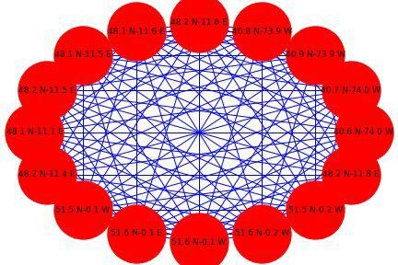

D. Write a Python / R program to build directed acyclic graph.
Open your python editor and create a file named Assess-DAG-Location.py in directory C:\VKHCG\01-Vermeulen\02-Assess
import networkx as nx
import matplotlib.pyplot as plt

import sys import os
import pandas as pd
Base='C:/VKHCG' print('################################')
print('Working Base :',Base, ' using ', sys.platform) print('################################')
sInputFileName='01-Retrieve/01-EDS/02-Python/Retrieve_Router_Location.csv' sOutputFileName1='Assess-DAG-Company-Country.png' sOutputFileName2='Assess-DAG-Company-Country-Place.png'
Company='01-Vermeulen' ### Import Company Data
sFileName=Base + '/' + Company + '/' + sInputFileName print('################################')
print('Loading :',sFileName)
print('################################')
CompanyData=pd.read_csv(sFileName,header=0,low_memory=False, encoding="latin-1") print('Loaded Company :',CompanyData.columns.values) print('################################')
print(CompanyData) print('################################')
print('Rows : ',CompanyData.shape[0]) print('################################')
G1=nx.DiGraph() G2=nx.DiGraph()
for i in range(CompanyData.shape[0]): G1.add_node(CompanyData['Country'][i])
sPlaceName= CompanyData['Place_Name'][i] + '-' + CompanyData['Country'][i] G2.add_node(sPlaceName)
print('################################')
for n1 in G1.nodes():
for n2 in G1.nodes():
if n1 != n2:
print('Link :',n1,' to ', n2) G1.add_edge(n1,n2) print('################################') print('################################')
print("Nodes of graph: ") print(G1.nodes()) print("Edges of graph: ") print(G1.edges())
print('################################')
sFileDir=Base + '/' + Company + '/02-Assess/01-EDS/02-Python' if not os.path.exists(sFileDir):

os.makedirs(sFileDir)
sFileName=sFileDir + '/' + sOutputFileName1 print('################################')
print('Storing :', sFileName) print('################################')
nx.draw(G1,pos=nx.spectral_layout(G1), nodecolor='r',edge_color='g', with_labels=True,node_size=8000,
font_size=12)
plt.savefig(sFileName) # save as png plt.show() # display print('################################')
for n1 in G2.nodes():
for n2 in G2.nodes():
if n1 != n2:
print('Link :',n1,' to ', n2) G2.add_edge(n1,n2) print('################################') print('################################')
print("Nodes of graph: ") print(G2.nodes()) print("Edges of graph: ") print(G2.edges())
print('################################')
sFileDir=Base + '/' + Company + '/02-Assess/01-EDS/02-Python' if not os.path.exists(sFileDir):
os.makedirs(sFileDir)
sFileName=sFileDir + '/' + sOutputFileName2 print('################################')
print('Storing :', sFileName) print('################################')
nx.draw(G2,pos=nx.spectral_layout(G2), nodecolor='r',edge_color='b', with_labels=True,node_size=8000,
font_size=12)
plt.savefig(sFileName) # save as png plt.show()

OUTPUT:

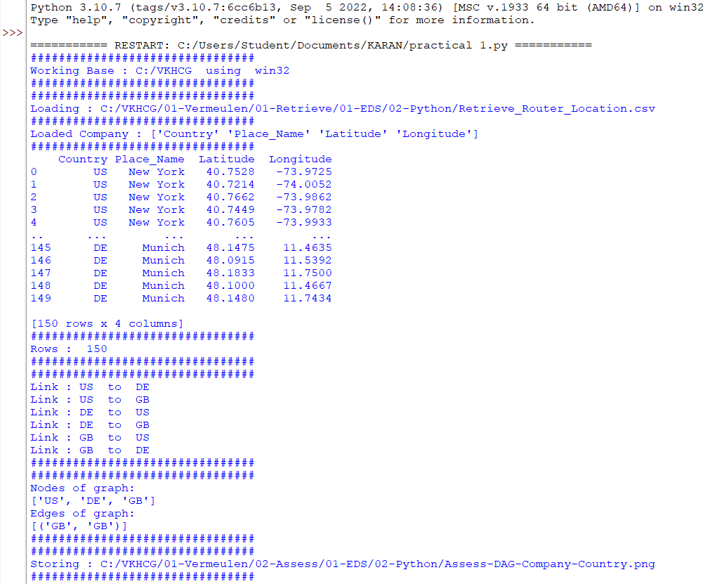

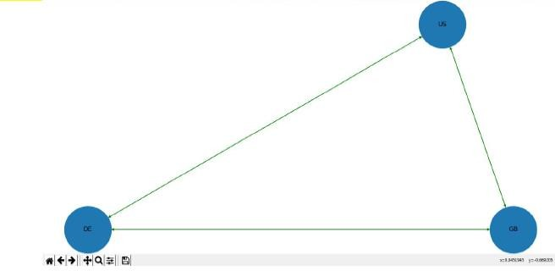

Practical 5

Processing Data

A. Build the time hub, links, and satellites.
Open your Python editor and create a file named Process_Time.py. Save it into directory C:\VKHCG\01-Vermeulen\03-Process.
# -*- coding: utf-8 -*-
import sys import os
from datetime import datetime from datetime import timedelta
from pytz import timezone, all_timezones import pandas as pd
import sqlite3 as sq
from pandas.io import sql import uuid
pd.options.mode.chained_assignment = None if sys.platform == 'linux': Base=os.path.expanduser('~') + '/VKHCG' else:
Base='C:/VKHCG' print('################################')
print('Working Base :',Base, ' using ', sys.platform) print('################################')
Company='01-Vermeulen'
InputDir='00-RawData' InputFileName='VehicleData.csv'
sDataBaseDir=Base + '/' + Company + '/03-Process/SQLite' if not os.path.exists(sDataBaseDir): os.makedirs(sDataBaseDir) sDatabaseName=sDataBaseDir + '/Hillman.db'
conn1 = sq.connect(sDatabaseName) sDataVaultDir=Base + '/88-DV'
if not os.path.exists(sDataBaseDir): os.makedirs(sDataBaseDir) sDatabaseName=sDataVaultDir + '/datavault.db' conn2 = sq.connect(sDatabaseName)
base = datetime(2018,1,1,0,0,0) numUnits=10*365*24
date_list = [base - timedelta(hours=x) for x in range(0, numUnits)] t=0
for i in date_list: now_utc=i.replace(tzinfo=timezone('UTC')) sDateTime=now_utc.strftime("%Y-%m-%d %H:%M:%S")

print(sDateTime) sDateTimeKey=sDateTime.replace(' ','-').replace(':','-') t+=1
IDNumber=str(uuid.uuid4()) TimeLine=[('ZoneBaseKey', ['UTC']),
('IDNumber', [IDNumber]), ('nDateTimeValue', [now_utc]), ('DateTimeValue', [sDateTime]), ('DateTimeKey', [sDateTimeKey])] if t==1:
TimeFrame = pd.DataFrame.from_items(TimeLine) else:
TimeRow = pd.DataFrame.from_items(TimeLine) TimeFrame = TimeFrame.append(TimeRow)
TimeHub=TimeFrame[['IDNumber','ZoneBaseKey','DateTimeKey','DateTimeValue']]
TimeHubIndex=TimeHub.set_index(['IDNumber'],inplace=False) TimeFrame.set_index(['IDNumber'],inplace=True)
sTable = 'Process-Time'
print('Storing :',sDatabaseName,' Table:',sTable) TimeHubIndex.to_sql(sTable, conn1, if_exists="replace") sTable = 'Hub-Time'
print('Storing :',sDatabaseName,' Table:',sTable) TimeHubIndex.to_sql(sTable, conn2, if_exists="replace") active_timezones=all_timezones
z=0
for zone in active_timezones:
t=0
for j in range(TimeFrame.shape[0]): now_date=TimeFrame['nDateTimeValue'][j] DateTimeKey=TimeFrame['DateTimeKey'][j] now_utc=now_date.replace(tzinfo=timezone('UTC')) sDateTime=now_utc.strftime("%Y-%m-%d %H:%M:%S") now_zone = now_utc.astimezone(timezone(zone)) sZoneDateTime=now_zone.strftime("%Y-%m-%d %H:%M:%S") print(sZoneDateTime)
t+=1 z+=1
IDZoneNumber=str(uuid.uuid4()) TimeZoneLine=[('ZoneBaseKey', ['UTC']), ('IDZoneNumber', [IDZoneNumber]), ('DateTimeKey', [DateTimeKey]), ('UTCDateTimeValue', [sDateTime]), ('Zone', [zone]),
('DateTimeValue', [sZoneDateTime])]

if t==1:
TimeZoneFrame = pd.DataFrame.from_items(TimeZoneLine) else:
TimeZoneRow = pd.DataFrame.from_items(TimeZoneLine) TimeZoneFrame = TimeZoneFrame.append(TimeZoneRow)
TimeZoneFrameIndex=TimeZoneFrame.set_index(['IDZoneNumber'],inplace=False) sZone=zone.replace('/','-').replace(' ','')
sTable = 'Process-Time-'+sZone
print('Storing :',sDatabaseName,' Table:',sTable) TimeZoneFrameIndex.to_sql(sTable, conn1, if_exists="replace") sTable = 'Satellite-Time-'+sZone
print('Storing :',sDatabaseName,' Table:',sTable) TimeZoneFrameIndex.to_sql(sTable, conn2, if_exists="replace") print('################')
print('Vacuum Databases')
sSQL="VACUUM;"
sql.execute(sSQL,conn1) sql.execute(sSQL,conn2) print('################')
print('### Done!! ############################################')

You have built your first hub and satellites for time in the data vault.
The data vault has been built in directory ..\ VKHCG\88-DV\datavault.db. You can access it with your SQLite Tools
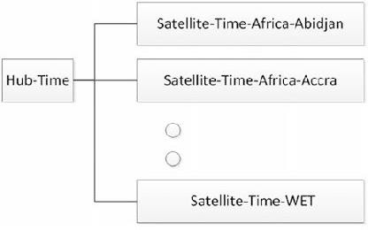

Golden Nominal
A golden nominal record is a single person’s record, with distinctive references for use by all systems. This gives the system a single view of the person. I use first name, other names, last name, and birth date as my golden nominal. The data we have in the assess directory requires a birth date to become a golden nominal. The proram will generate a golden nominal using our sample data set.
Open your Python editor and create a file called Process-People.py in the

C:\VKHCG\04-Clark\03-Process directory.

Code:
import sys import os
import sqlite3 as sq import pandas as pd
from pandas.io import sql
from datetime import datetime, timedelta from pytz import timezone, all_timezones from random import randint
import uuid
if sys.platform == 'linux':
Base=os.path.expanduser('~') + '/VKHCG' else:
Base='C:/VKHCG' print('################################')
print('Working Base :',Base, ' using ', sys.platform) print('################################')
Company='04-Clark'
sInputFileName='02-Assess/01-EDS/02-Python/Assess_People.csv' sDataBaseDir=Base + '/' + Company + '/03-Process/SQLite'
if not os.path.exists(sDataBaseDir):
os.makedirs(sDataBaseDir) sDatabaseName=sDataBaseDir + '/clark.db' conn1 = sq.connect(sDatabaseName) sDataVaultDir=Base + '/88-DV'
if not os.path.exists(sDataBaseDir): os.makedirs(sDataBaseDir) sDatabaseName=sDataVaultDir + '/datavault.db' conn2 = sq.connect(sDatabaseName)
### Import Female Data
sFileName=Base + '/' + Company + '/' + sInputFileName print('################################')
print('Loading :',sFileName)
print('################################')
print(sFileName)
RawData=pd.read_csv(sFileName,header=0,low_memory=False, encoding="latin-1") RawData.drop_duplicates(subset=None, keep='first', inplace=True)
start_date = datetime(1900,1,1,0,0,0) start_date_utc=start_date.replace(tzinfo=timezone('UTC')) HoursBirth=100*365*24 RawData['BirthDateUTC']=RawData.apply(lambda row: (start_date_utc + timedelta(hours=randint(0, HoursBirth)))
,axis=1) zonemax=len(all_timezones)-1

RawData['TimeZone']=RawData.apply(lambda row: (all_timezones[randint(0, zonemax)]),axis=1) RawData['BirthDateISO']=RawData.apply(lambda row: row["BirthDateUTC"].astimezone(timezone(row['TimeZone'])),axis=1) RawData['BirthDateKey']=RawData.apply(lambda row:
row["BirthDateUTC"].strftime("%Y-%m-%d %H:%M:%S"),axis=1) RawData['BirthDate']=RawData.apply(lambda row: row["BirthDateISO"].strftime("%Y-%m-%d %H:%M:%S") ,axis=1) RawData['PersonID']=RawData.apply(lambda row:str(uuid.uuid4()),axis=1) Data=RawData.copy()
Data.drop('BirthDateUTC', axis=1,inplace=True) Data.drop('BirthDateISO', axis=1,inplace=True) indexed_data = Data.set_index(['PersonID']) print('################################') print('################')
sTable='Process_Person'
print('Storing :',sDatabaseName,' Table:',sTable) indexed_data.to_sql(sTable, conn1, if_exists="replace") print('################')
PersonHubRaw=Data[['PersonID','FirstName','SecondName','LastName','BirthDateKey']] PersonHubRaw['PersonHubID']=RawData.apply(lambda row:
str(uuid.uuid4())
,axis=1) PersonHub=PersonHubRaw.drop_duplicates(subset=None, \ keep='first',\
inplace=False)
indexed_PersonHub = PersonHub.set_index(['PersonHubID']) sTable = 'Hub-Person'
print('Storing :',sDatabaseName,' Table:',sTable) indexed_PersonHub.to_sql(sTable, conn2, if_exists="replace") PersonSatelliteGenderRaw=Data[['PersonID','FirstName','SecondName','LastName'\
,'BirthDateKey','Gender']] PersonSatelliteGenderRaw['PersonSatelliteID']=RawData.apply(lambda row: str(uuid.uuid4())
,axis=1) PersonSatelliteGender=PersonSatelliteGenderRaw.drop_duplicates(subset=None, \ keep='first', \
inplace=False)
indexed_PersonSatelliteGender = PersonSatelliteGender.set_index(['PersonSatelliteID']) sTable = 'Satellite-Person-Gender'
print('Storing :',sDatabaseName,' Table:',sTable)
indexed_PersonSatelliteGender.to_sql(sTable, conn2, if_exists="replace") PersonSatelliteBirthdayRaw=Data[['PersonID','FirstName','SecondName','LastName',\ 'BirthDateKey','TimeZone','BirthDate']] PersonSatelliteBirthdayRaw['PersonSatelliteID']=RawData.apply(lambda row:

str(uuid.uuid4())
,axis=1) PersonSatelliteBirthday=PersonSatelliteBirthdayRaw.drop_duplicates(subset=None, \ keep='first',\
inplace=False)
indexed_PersonSatelliteBirthday = PersonSatelliteBirthday.set_index(['PersonSatelliteID']) sTable = 'Satellite-Person-Names'
print('Storing :',sDatabaseName,' Table:',sTable) indexed_PersonSatelliteBirthday.to_sql(sTable, conn2, if_exists="replace") sFileDir=Base + '/' + Company + '/03-Process/01-EDS/02-Python'
if not os.path.exists(sFileDir):
os.makedirs(sFileDir) sOutputFileName = sTable + '.csv'
sFileName=sFileDir + '/' + sOutputFileName print('################################')
print('Storing :', sFileName) print('################################')
RawData.to_csv(sFileName, index = False) print('################################') print('################')
print('Vacuum Databases')
sSQL="VACUUM;"
sql.execute(sSQL,conn1) sql.execute(sSQL,conn2) print('################')
print('### Done!! ############################################')

OUTPUT :
It will apply golden nominal rules by assuming nobody born before January 1, 1900, droping to two ISO complex date time structures, as the code does not translate into SQLite’s data types and saves your new golden nominal to a CSV file.

Load the person into the data vault
========== RESTART: C:\VKHCG\04-Clark\03-Process\Process-People.py ========== Working Base : C:/VKHCG using win32
Loading : C:/VKHCG/04-Clark/02-Assess/01-EDS/02-Python/Assess_People.csv C:/VKHCG/04-Clark/02-Assess/01-EDS/02-Python/Assess_People.csv
Storing : C:/VKHCG/88-DV/datavault.db Table: Process_Person
Storing : C:/VKHCG/88-DV/datavault.db Table: Satellite-Person-Gender Storing : C:/VKHCG/88-DV/datavault.db Table: Satellite-Person-Names
Storing : C:/VKHCG/04-Clark/03-Process/01-EDS/02-Python/Satellite-Person-Names.csv Vacuum Databases
### Done!! ############################################

Vehicles
The international classification of vehicles is a complex process. There are standards, but these are not universally applied or similar between groups or countries. Let’s load the vehicle data for Hillman Ltd

into the data vault, as we will need it later. Create a new file named Process-Vehicle-Logistics.py in the Python editor in directory ..\VKHCG\03-Hillman\03-Process.
# -*- coding: utf-8 -*- import sys
import os
import pandas as pd import sqlite3 as sq
from pandas.io import sql import uuid
pd.options.mode.chained_assignment = None if sys.platform == 'linux':
Base=os.path.expanduser('~') + '/VKHCG' else:
Base='C:/VKHCG' print('################################')
print('Working Base :',Base, ' using ', sys.platform) print('################################')
Company='03-Hillman' InputDir='00-RawData' InputFileName='VehicleData.csv'
sDataBaseDir=Base + '/' + Company + '/03-Process/SQLite' if not os.path.exists(sDataBaseDir): os.makedirs(sDataBaseDir) sDatabaseName=sDataBaseDir + '/Hillman.db'
conn1 = sq.connect(sDatabaseName) sDataVaultDir=Base + '/88-DV'
if not os.path.exists(sDataBaseDir): os.makedirs(sDataBaseDir) sDatabaseName=sDataVaultDir + '/datavault.db' conn2 = sq.connect(sDatabaseName)
sFileName=Base + '/' + Company + '/' + InputDir + '/' + InputFileName print('###########')
print('Loading :',sFileName) VehicleRaw=pd.read_csv(sFileName,header=0,low_memory=False, encoding="latin-1") sTable='Process_Vehicles'
print('Storing :',sDatabaseName,' Table:',sTable) VehicleRaw.to_sql(sTable, conn1, if_exists="replace") VehicleRawKey=VehicleRaw[['Make','Model']].copy() VehicleKey=VehicleRawKey.drop_duplicates() VehicleKey['ObjectKey']=VehicleKey.apply(lambda row:
str('('+ str(row['Make']).strip().replace(' ', '-').replace('/', '-').lower() +')-('
+(str(row['Model']).strip().replace(' ', '-').replace(' ', '-').lower())+')'),axis=1) VehicleKey['ObjectType']=VehicleKey.apply(lambda row: 'vehicle' ,axis=1) VehicleKey['ObjectUUID']=VehicleKey.apply(lambda row:str(uuid.uuid4()),axis=1)

### Vehicle Hub #
VehicleHub=VehicleKey[['ObjectType','ObjectKey','ObjectUUID']].copy()
VehicleHub.index.name='ObjectHubID' sTable = 'Hub-Object-Vehicle'
print('Storing :',sDatabaseName,' Table:',sTable) VehicleHub.to_sql(sTable, conn2, if_exists="replace") ### Vehicle Satellite
#
VehicleSatellite=VehicleKey[['ObjectType','ObjectKey','ObjectUUID','Make','Model']].copy() VehicleSatellite.index.name='ObjectSatelliteID'
sTable = 'Satellite-Object-Make-Model' print('Storing :',sDatabaseName,' Table:',sTable)
VehicleSatellite.to_sql(sTable, conn2, if_exists="replace") ### Vehicle Dimension
sView='Dim-Object'
print('Storing :',sDatabaseName,' View:',sView) sSQL="CREATE VIEW IF NOT EXISTS [" + sView + "] AS" sSQL=sSQL+ " SELECT DISTINCT"
sSQL=sSQL+ " H.ObjectType,"
sSQL=sSQL+ " H.ObjectKey AS VehicleKey," sSQL=sSQL+ " TRIM(S.Make) AS VehicleMake," sSQL=sSQL+ " TRIM(S.Model) AS VehicleModel" sSQL=sSQL+ " FROM"
sSQL=sSQL+ " [Hub-Object-Vehicle] AS H" sSQL=sSQL+ " JOIN"
sSQL=sSQL+ " [Satellite-Object-Make-Model] AS S"
sSQL=sSQL+ " ON"
sSQL=sSQL+ " H.ObjectType=S.ObjectType" sSQL=sSQL+ " AND"
sSQL=sSQL+ " H.ObjectUUID=S.ObjectUUID;" sql.execute(sSQL,conn2) print('################')
print('Loading :',sDatabaseName,' Table:',sView) sSQL=" SELECT DISTINCT"
sSQL=sSQL+ " VehicleMake," sSQL=sSQL+ " VehicleModel" sSQL=sSQL+ " FROM" sSQL=sSQL+ " [" + sView + "]" sSQL=sSQL+ " ORDER BY"
sSQL=sSQL+ " VehicleMake" sSQL=sSQL+ " AND"
DimObjectData=pd.read_sql_query(sSQL, conn2) DimObjectData.index.name='ObjectDimID'

DimObjectData.sort_values(['VehicleMake','VehicleModel'],inplace=True, ascending=True) print('################')
print(DimObjectData)
print('################')
print('Vacuum Databases') sSQL="VACUUM;"
sql.execute(sSQL,conn1) sql.execute(sSQL,conn2) print('################')
conn1.close() conn2.close()
#print('### Done!! ############################################')

OUTPUT:
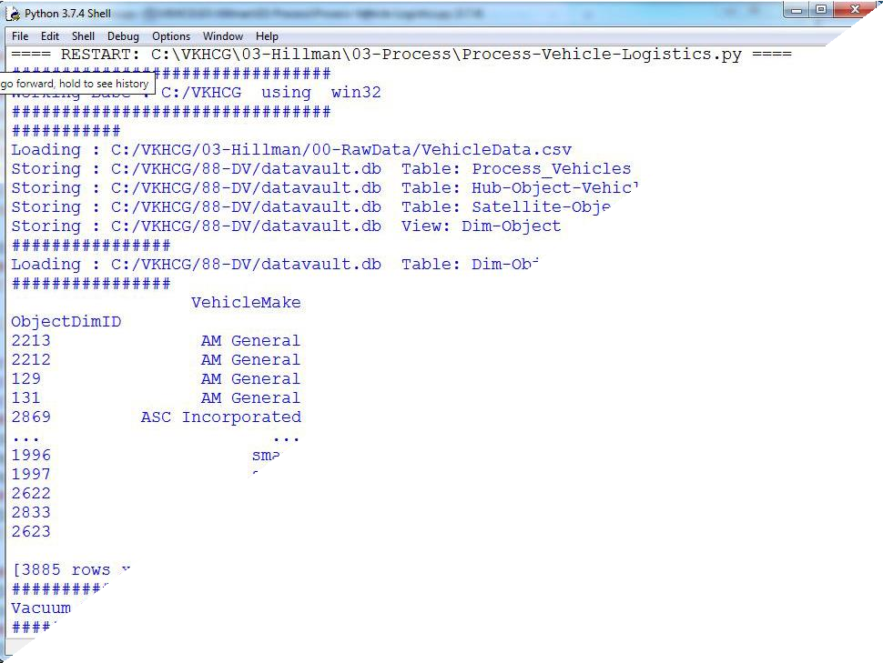

Human-Environment Interaction
The interaction of humans with their environment is a major relationship that guides people’s behavior and the characteristics of the location. Activities such as mining and other industries, roads, and landscaping at a location create both positive and negative effects on the environment, but also on humans. A location earmarked as a green belt, to assist in reducing the carbon footprint, or a new interstate change its current and future characteristics. The location is a main data source for the data science, and, normally, we find unknown or unexpected effects on the data insights. In the Python editor, open a new file named Process_Location.py in
directory ..\VKHCG\01-Vermeulen\03-Process. # -*- coding: utf-8 -*-
import sys import os
import pandas as pd import sqlite3 as sq

from pandas.io import sql import uuid Base='C:/VKHCG'
print('################################')
print('Working Base :',Base, ' using ', sys.platform) print('################################')
Company='01-Vermeulen' InputAssessGraphName='Assess_All_Animals.gml' EDSAssessDir='02-Assess/01-EDS' InputAssessDir=EDSAssessDir + '/02-Python' sFileAssessDir=Base + '/' + Company + '/' + InputAssessDir if not os.path.exists(sFileAssessDir): os.makedirs(sFileAssessDir)
sDataBaseDir=Base + '/' + Company + '/03-Process/SQLite' if not os.path.exists(sDataBaseDir): os.makedirs(sDataBaseDir) sDatabaseName=sDataBaseDir + '/Vermeulen.db'
conn1 = sq.connect(sDatabaseName) sDataVaultDir=Base + '/88-DV'
if not os.path.exists(sDataBaseDir): os.makedirs(sDataBaseDir) sDatabaseName=sDataVaultDir + '/datavault.db' conn2 = sq.connect(sDatabaseName)
t=0 tMax=360*180
for Longitude in range(-180,180,10):
for Latitude in range(-90,90,10):
t+=1
IDNumber=str(uuid.uuid4())
LocationName='L'+format(round(Longitude,3)*1000, '+07d') +\ '-'+format(round(Latitude,3)*1000, '+07d')
print('Create:',t,' of ',tMax,':',LocationName) LocationLine=[('ObjectBaseKey', ['GPS']), ('IDNumber', [IDNumber]),
('LocationNumber', [str(t)]), ('LocationName', [LocationName]), ('Longitude', [Longitude]),
('Latitude', [Latitude])] if t==1:
LocationFrame = pd.DataFrame.from_items(LocationLine)
else:
LocationRow = pd.DataFrame.from_items(LocationLine) LocationFrame = LocationFrame.append(LocationRow)
LocationHubIndex=LocationFrame.set_index(['IDNumber'],inplace=False)

sTable = 'Process-Location'
print('Storing :',sDatabaseName,' Table:',sTable) LocationHubIndex.to_sql(sTable, conn1, if_exists="replace") sTable = 'Hub-Location'
print('Storing :',sDatabaseName,' Table:',sTable) LocationHubIndex.to_sql(sTable, conn2, if_exists="replace") print('################')
print('Vacuum Databases') sSQL="VACUUM;"
sql.execute(sSQL,conn1) sql.execute(sSQL,conn2) print('################')
print('### Done!! ############################################')

OUTPUT:
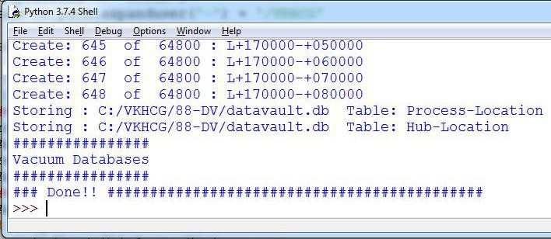

Forecasting
Forecasting is the ability to project a possible future, by looking at historical data. The datavault enables these types of investigations, owing to the complete history it collects as itprocesses the source’s systems data. A data scientist supply answers to such questions as the following:
- What should we buy?
- What should we sell?
- Where will our next business come from?
People want to know what you calculate to determine what is about to happen.
Open a new file in your Python editor and save it as Process-Shares-Data.py in directory C: \VKHCG\04-Clark\03-Process. I will guide you through this
process. You will require a library called quandl

type pip install quandl in cmd
import sys import os

import sqlite3 as sq import quandl import pandas as pd Base='C:/VKHCG'
print('################################')
print('Working Base :',Base, ' using ', sys.platform) print('################################')
Company='04-Clark'
sInputFileName='00-RawData/VKHCG_Shares.csv' sOutputFileName='Shares.csv'
sDataBaseDir=Base + '/' + Company + '/03-Process/SQLite' if not os.path.exists(sDataBaseDir): os.makedirs(sDataBaseDir)
sFileDir1=Base + '/' + Company + '/01-Retrieve/01-EDS/02-Python' if not os.path.exists(sFileDir1):
os.makedirs(sFileDir1)
sFileDir2=Base + '/' + Company + '/02-Assess/01-EDS/02-Python' if not os.path.exists(sFileDir2):
os.makedirs(sFileDir2)
sFileDir3=Base + '/' + Company + '/03-Process/01-EDS/02-Python' if not os.path.exists(sFileDir3):
os.makedirs(sFileDir3) sDatabaseName=sDataBaseDir + '/clark.db' conn = sq.connect(sDatabaseName)
### Import Share Names Data
sFileName=Base + '/' + Company + '/' + sInputFileName print('################################')
print('Loading :',sFileName) print('################################')
RawData=pd.read_csv(sFileName,header=0,low_memory=False, encoding="latin-1") RawData.drop_duplicates(subset=None, keep='first', inplace=True)
print('Rows :',RawData.shape[0]) print('Columns:',RawData.shape[1]) print('################')
sFileName=sFileDir1 + '/Retrieve_' + sOutputFileName print('################################')
print('Storing :', sFileName) print('################################')
RawData.to_csv(sFileName, index = False) print('################################')
sFileName=sFileDir2 + '/Assess_' + sOutputFileName print('################################')
print('Storing :', sFileName)

RawData.to_csv(sFileName, index = False) print('################################')
sFileName=sFileDir3 + '/Process_' + sOutputFileName
print('################################')
print('Storing :', sFileName) print('################################')
RawData.to_csv(sFileName, index = False) print('################################')
### Import Shares Data Details
nShares=RawData.shape[0] #nShares=6
for sShare in range(nShares): sShareName=str(RawData['Shares'][sShare]) ShareData = quandl.get(sShareName) UnitsOwn=RawData['Units'][sShare]
ShareData['UnitsOwn']=ShareData.apply(lambda row:(UnitsOwn),axis=1) ShareData['ShareCode']=ShareData.apply(lambda row:(sShareName),axis=1) print('################')
print('Share :',sShareName) print('Rows :',ShareData.shape[0]) print('Columns:',ShareData.shape[1]) print('################') print('################')
sTable=str(RawData['sTable'][sShare]) print('Storing :',sDatabaseName,' Table:',sTable) ShareData.to_sql(sTable, conn, if_exists="replace") print('################')
sOutputFileName = sTable.replace("/","-") + '.csv' sFileName=sFileDir1 + '/Retrieve_' + sOutputFileName print('################################')
print('Storing :', sFileName) print('################################')
ShareData.to_csv(sFileName, index = False)
print('################################')
sOutputFileName = sTable.replace("/","-") + '.csv' sFileName=sFileDir2 + '/Assess_' + sOutputFileName print('################################')
print('Storing :', sFileName) print('################################')
ShareData.to_csv(sFileName, index = False)
print('################################')
sOutputFileName = sTable.replace("/","-") + '.csv' sFileName=sFileDir3 + '/Process_' + sOutputFileName

print('Storing :', sFileName) print('################################')
ShareData.to_csv(sFileName, index = False)
print('################################')
print('### Done!! ############################################')

OUTPUT:
======== RESTART: C:\VKHCG\04-Clark\03-Process\Process-Shares-Data.py ======== Working Base : C:/VKHCG using win32
Loading : C:/VKHCG/04-Clark/00-RawData/VKHCG_Shares.csv Rows : 10
Columns: 3
Storing : C:/VKHCG/04-Clark/01-Retrieve/01-EDS/02-Python/Retrieve_Shares.csv Storing : C:/VKHCG/04-Clark/02-Assess/01-EDS/02-Python/Assess_Shares.csv Storing : C:/VKHCG/04-Clark/03-Process/01-EDS/02-Python/Process_Shares.csv Share : WIKI/GOOGL
Rows : 3424
Columns: 14
Storing : C:/VKHCG/04-Clark/03-Process/SQLite/clark.db Table: WIKI_Google
Storing : C:/VKHCG/04-Clark/01-Retrieve/01-EDS/02-Python/Retrieve_WIKI_Google.csv Storing : C:/VKHCG/04-Clark/02-Assess/01-EDS/02-Python/Assess_WIKI_Google.csv Storing : C:/VKHCG/04-Clark/03-Process/01-EDS/02-Python/Process_WIKI_Google.csv Share : WIKI/MSFT
Rows : 8076
Columns: 14
Storing : C:/VKHCG/04-Clark/03-Process/SQLite/clark.db Table: WIKI_Microsoft
Storing : C:/VKHCG/04-Clark/01-Retrieve/01-EDS/02-Python/Retrieve_WIKI_Microsoft.csv Storing : C:/VKHCG/04-Clark/02-Assess/01-EDS/02-Python/Assess_WIKI_Microsoft.csv Storing : C:/VKHCG/04-Clark/03-Process/01-EDS/02-Python/Process_WIKI_Microsoft.csv Share : WIKI/UPS
Rows : 4622
Columns: 14
Storing : C:/VKHCG/04-Clark/03-Process/SQLite/clark.db Table: WIKI_UPS
Storing : C:/VKHCG/04-Clark/01-Retrieve/01-EDS/02-Python/Retrieve_WIKI_UPS.csv Storing : C:/VKHCG/04-Clark/02-Assess/01-EDS/02-Python/Assess_WIKI_UPS.csv Storing : C:/VKHCG/04-Clark/03-Process/01-EDS/02-Python/Process_WIKI_UPS.csv Share : WIKI/AMZN
Rows : 5248
Columns: 14
Storing : C:/VKHCG/04-Clark/03-Process/SQLite/clark.db Table: WIKI_Amazon
Storing : C:/VKHCG/04-Clark/01-Retrieve/01-EDS/02-Python/Retrieve_WIKI_Amazon.csv Storing : C:/VKHCG/04-Clark/02-Assess/01-EDS/02-Python/Assess_WIKI_Amazon.csv Storing : C:/VKHCG/04-Clark/03-Process/01-EDS/02-Python/Process_WIKI_Amazon.csv Share : LOCALBTC/USD

Rows : 1863
Columns: 6
Storing : C:/VKHCG/04-Clark/03-Process/SQLite/clark.db Table: LOCALBTC_USD
Storing : C:/VKHCG/04-Clark/01-Retrieve/01-EDS/02-Python/Retrieve_LOCALBTC_USD.csv Storing : C:/VKHCG/04-Clark/02-Assess/01-EDS/02-Python/Assess_LOCALBTC_USD.csv Storing : C:/VKHCG/04-Clark/03-Process/01-EDS/02-Python/Process_LOCALBTC_USD.csv Share : PERTH/AUD_USD_M
Rows : 340
Columns: 8
Storing : C:/VKHCG/04-Clark/03-Process/SQLite/clark.db Table: PERTH_AUD_USD_M
Storing : C:/VKHCG/04-Clark/01-Retrieve/01-EDS/02-Python/Retrieve_PERTH_AUD_USD_M.csv Storing : C:/VKHCG/04-Clark/02-Assess/01-EDS/02-Python/Assess_PERTH_AUD_USD_M.csv Storing : C:/VKHCG/04-Clark/03-Process/01-EDS/02-Python/Process_PERTH_AUD_USD_M.csv Share : PERTH/AUD_USD_D
Rows : 7989
Columns: 8
Storing : C:/VKHCG/04-Clark/03-Process/SQLite/clark.db Table: PERTH_AUD_USD_D
Storing : C:/VKHCG/04-Clark/01-Retrieve/01-EDS/02-Python/Retrieve_PERTH_AUD_USD_D.csv Storing : C:/VKHCG/04-Clark/02-Assess/01-EDS/02-Python/Assess_PERTH_AUD_USD_D.csv Storing : C:/VKHCG/04-Clark/03-Process/01-EDS/02-Python/Process_PERTH_AUD_USD_D.csv Share : FRED/GDP
Rows : 290
Columns: 3
Storing : C:/VKHCG/04-Clark/03-Process/SQLite/clark.db Table: FRED/GDP
Storing : C:/VKHCG/04-Clark/01-Retrieve/01-EDS/02-Python/Retrieve_FRED-GDP.csv Storing : C:/VKHCG/04-Clark/02-Assess/01-EDS/02-Python/Assess_FRED-GDP.csv Storing : C:/VKHCG/04-Clark/03-Process/01-EDS/02-Python/Process_FRED-GDP.csv Share : FED/RXI_US_N_A_UK
Rows : 49
Columns: 3
Storing : C:/VKHCG/04-Clark/03-Process/SQLite/clark.db Table: FED_RXI_US_N_A_UK
Storing : C:/VKHCG/04-Clark/01-Retrieve/01-EDS/02-Python/Retrieve_FED_RXI_US_N_A_UK.csv Storing : C:/VKHCG/04-Clark/02-Assess/01-EDS/02-Python/Assess_FED_RXI_US_N_A_UK.csv Storing : C:/VKHCG/04-Clark/03-Process/01-EDS/02-Python/Process_FED_RXI_US_N_A_UK.csv Share : FED/RXI_N_A_CA
Rows : 49
Columns: 3
Storing : C:/VKHCG/04-Clark/03-Process/SQLite/clark.db Table: FED_RXI_N_A_CA
Storing : C:/VKHCG/04-Clark/01-Retrieve/01-EDS/02-Python/Retrieve_FED_RXI_N_A_CA.csv Storing : C:/VKHCG/04-Clark/02-Assess/01-EDS/02-Python/Assess_FED_RXI_N_A_CA.csv Storing : C:/VKHCG/04-Clark/03-Process/01-EDS/02-Python/Process_FED_RXI_N_A_CA.csv ### Done!! ############################################

Practical 6
TRANSFORMING DATA

Transform Superstep
The Transform superstep allows you, as a data scientist, to take data from the data vault and formulate answers to questions raised by your investigations. The transformation step is the data science process that converts results into insights. It takes standard data science techniques and methods to attain insight and knowledge about the data that then can be transformed into actionable decisions, which, through storytelling, you can explain to non-data scientists what you have discovered in the data lake.
To illustrate the consolidation process, the example shows a person being borne. Open a new file in the Python editor and save it as Transform-Gunnarsson_is_Born.py in the directory
C: \VKHCG\01-Vermeulen\04-Transform. # -*- coding: utf-8 -*-
import sys import os
from datetime import datetime from pytz import timezone import pandas as pd
import sqlite3 as sq import uuid
pd.options.mode.chained_assignment = None Base='C:/VKHCG' print('################################')
print('Working Base :',Base, ' using ', sys.platform)
print('################################')
Company='01-Vermeulen' InputDir='00-RawData' InputFileName='VehicleData.csv'
sDataBaseDir=Base + '/' + Company + '/04-Transform/SQLite' if not os.path.exists(sDataBaseDir): os.makedirs(sDataBaseDir)
sDatabaseName=sDataBaseDir + '/Vermeulen.db' conn1 = sq.connect(sDatabaseName) sDataVaultDir=Base + '/88-DV'
if not os.path.exists(sDataVaultDir): os.makedirs(sDataVaultDir) sDatabaseName=sDataVaultDir + '/datavault.db' conn2 = sq.connect(sDatabaseName) sDataWarehouseDir=Base + '/99-DW'
if not os.path.exists(sDataWarehouseDir): os.makedirs(sDataWarehouseDir) sDatabaseName=sDataWarehouseDir + '/datawarehouse.db' conn3 = sq.connect(sDatabaseName) print('\n#################################')
print('Time Category')

print('UTC Time')
BirthDateUTC = datetime(1960,12,20,10,15,0) BirthDateZoneUTC=BirthDateUTC.replace(tzinfo=timezone('UTC')) BirthDateZoneStr=BirthDateZoneUTC.strftime("%Y-%m-%d %H:%M:%S") BirthDateZoneUTCStr=BirthDateZoneUTC.strftime("%Y-%m-%d %H:%M:%S (%Z) (%z)") print(BirthDateZoneUTCStr)
print('#################################')
print('Birth Date in Reykjavik :') BirthZone = 'Atlantic/Reykjavik'
BirthDate = BirthDateZoneUTC.astimezone(timezone(BirthZone)) BirthDateStr=BirthDate.strftime("%Y-%m-%d %H:%M:%S (%Z) (%z)") BirthDateLocal=BirthDate.strftime("%Y-%m-%d %H:%M:%S") print(BirthDateStr)
print('#################################')
IDZoneNumber=str(uuid.uuid4()) sDateTimeKey=BirthDateZoneStr.replace(' ','-').replace(':','-') TimeLine=[('ZoneBaseKey', ['UTC']),
('IDNumber', [IDZoneNumber]), ('DateTimeKey', [sDateTimeKey]), ('UTCDateTimeValue', [BirthDateZoneUTC]), ('Zone', [BirthZone]),
('DateTimeValue', [BirthDateStr])]
TimeFrame = pd.DataFrame.from_items(TimeLine) TimeHub=TimeFrame[['IDNumber','ZoneBaseKey','DateTimeKey','DateTimeValue']] TimeHubIndex=TimeHub.set_index(['IDNumber'],inplace=False)
sTable = 'Hub-Time-Gunnarsson' print('\n#################################')
print('Storing :',sDatabaseName,'\n Table:',sTable) print('\n#################################')
TimeHubIndex.to_sql(sTable, conn2, if_exists="replace") sTable = 'Dim-Time-Gunnarsson' TimeHubIndex.to_sql(sTable, conn3, if_exists="replace")
TimeSatellite=TimeFrame[['IDNumber','DateTimeKey','Zone','DateTimeValue']]
TimeSatelliteIndex=TimeSatellite.set_index(['IDNumber'],inplace=False) BirthZoneFix=BirthZone.replace(' ','-').replace('/','-')
sTable = 'Satellite-Time-' + BirthZoneFix + '-Gunnarsson' print('\n#################################')
print('Storing :',sDatabaseName,'\n Table:',sTable) print('\n#################################')
TimeSatelliteIndex.to_sql(sTable, conn2, if_exists="replace")
sTable = 'Dim-Time-' + BirthZoneFix + '-Gunnarsson' TimeSatelliteIndex.to_sql(sTable, conn3, if_exists="replace") print('\n#################################')
print('Person Category')

FirstName = 'Guðmundur' LastName = 'Gunnarsson' print('Name:',FirstName,LastName) print('Birth Date:',BirthDateLocal) print('Birth Zone:',BirthZone)
print('UTC Birth Date:',BirthDateZoneStr) print('#################################')
IDPersonNumber=str(uuid.uuid4()) PersonLine=[('IDNumber', [IDPersonNumber]), ('FirstName', [FirstName]),
('LastName', [LastName]),
('Zone', ['UTC']),
('DateTimeValue', [BirthDateZoneStr])]
PersonFrame = pd.DataFrame.from_items(PersonLine) TimeHub=PersonFrame TimeHubIndex=TimeHub.set_index(['IDNumber'],inplace=False) sTable = 'Hub-Person-Gunnarsson' print('\n#################################')
print('Storing :',sDatabaseName,'\n Table:',sTable) print('\n#################################')
TimeHubIndex.to_sql(sTable, conn2, if_exists="replace")
sTable = 'Dim-Person-Gunnarsson' TimeHubIndex.to_sql(sTable, conn3, if_exists="replace")

OUTPUT :
Guðmundur Gunnarsson was born on December 20, 1960, at 9:15 in Landspítali,Hringbraut 101, 101 Reykjavík, Iceland.

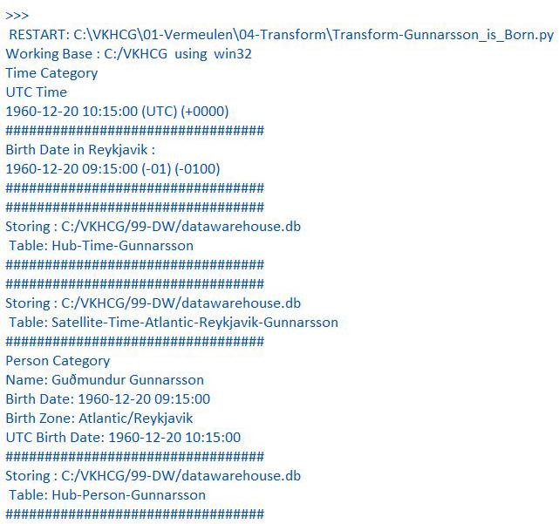

You must build three items: dimension Person, dimension Time, and factPersonBornAtTime. Open your Python editor and create a file named Transform-Gunnarsson-Sun-Model.py in directory C:\VKHCG\01-Vermeulen\04-Transform.
# -*- coding: utf-8 -*- import sys
import os
from datetime import datetime from pytz import timezone import pandas as pd
import sqlite3 as sq import uuid
pd.options.mode.chained_assignment = None if sys.platform == 'linux':
Base=os.path.expanduser('~') + '/VKHCG' else:
Base='C:/VKHCG' print('################################')
print('Working Base :',Base, ' using ', sys.platform) print('################################')
Company='01-Vermeulen'
sDataBaseDir=Base + '/' + Company + '/04-Transform/SQLite' if not os.path.exists(sDataBaseDir):
os.makedirs(sDataBaseDir) sDatabaseName=sDataBaseDir + '/Vermeulen.db' conn1 = sq.connect(sDatabaseName) sDataWarehousetDir=Base + '/99-DW'
if not os.path.exists(sDataWarehousetDir): os.makedirs(sDataWarehousetDir) sDatabaseName=sDataWarehousetDir + '/datawarehouse.db' conn2 = sq.connect(sDatabaseName) print('\n#################################')
print('Time Dimension') BirthZone = 'Atlantic/Reykjavik'
BirthDateUTC = datetime(1960,12,20,10,15,0) BirthDateZoneUTC=BirthDateUTC.replace(tzinfo=timezone('UTC')) BirthDateZoneStr=BirthDateZoneUTC.strftime("%Y-%m-%d %H:%M:%S") BirthDateZoneUTCStr=BirthDateZoneUTC.strftime("%Y-%m-%d %H:%M:%S (%Z) (%z)") BirthDate = BirthDateZoneUTC.astimezone(timezone(BirthZone)) BirthDateStr=BirthDate.strftime("%Y-%m-%d %H:%M:%S (%Z) (%z)") BirthDateLocal=BirthDate.strftime("%Y-%m-%d %H:%M:%S") IDTimeNumber=str(uuid.uuid4())
TimeLine=[('TimeID', [IDTimeNumber]), ('UTCDate', [BirthDateZoneStr]), ('LocalTime', [BirthDateLocal]),

('TimeZone', [BirthZone])]
TimeFrame = pd.DataFrame.from_items(TimeLine) DimTime=TimeFrame DimTimeIndex=DimTime.set_index(['TimeID'],inplace=False) sTable = 'Dim-Time' print('\n#################################')
print('Storing :',sDatabaseName,'\n Table:',sTable) print('\n#################################')
DimTimeIndex.to_sql(sTable, conn1, if_exists="replace")
DimTimeIndex.to_sql(sTable, conn2, if_exists="replace") print('\n#################################')
print('Dimension Person') print('\n#################################')
FirstName = 'Guðmundur' LastName = 'Gunnarsson' IDPersonNumber=str(uuid.uuid4())
PersonLine=[('PersonID', [IDPersonNumber]), ('FirstName', [FirstName]),
('LastName', [LastName]),
('Zone', ['UTC']),
('DateTimeValue', [BirthDateZoneStr])]
PersonFrame = pd.DataFrame.from_items(PersonLine) DimPerson=PersonFrame DimPersonIndex=DimPerson.set_index(['PersonID'],inplace=False) sTable = 'Dim-Person' print('\n#################################')
print('Storing :',sDatabaseName,'\n Table:',sTable)
print('\n#################################')
DimPersonIndex.to_sql(sTable, conn1, if_exists="replace") DimPersonIndex.to_sql(sTable, conn2, if_exists="replace") print('\n#################################')
print('Fact - Person - time') print('\n#################################')
IDFactNumber=str(uuid.uuid4()) PersonTimeLine=[('IDNumber', [IDFactNumber]), ('IDPersonNumber', [IDPersonNumber]), ('IDTimeNumber', [IDTimeNumber])]
PersonTimeFrame = pd.DataFrame.from_items(PersonTimeLine) FctPersonTime=PersonTimeFrame FctPersonTimeIndex=FctPersonTime.set_index(['IDNumber'],inplace=False) sTable = 'Fact-Person-Time' print('\n#################################')
print('Storing :',sDatabaseName,'\n Table:',sTable) print('\n#################################')

FctPersonTimeIndex.to_sql(sTable, conn1, if_exists="replace") FctPersonTimeIndex.to_sql(sTable, conn2, if_exists="replace")

OUTPUT:

Building a Data Warehouse
Open the Transform-Sun-Models.py file from directory C:\VKHCG\01-Vermeulen\04-Transform. # -*- coding: utf-8 -*-
import sys import os
from datetime import datetime from pytz import timezone import pandas as pd
import sqlite3 as sq import uuid
pd.options.mode.chained_assignment = None if sys.platform == 'linux': Base=os.path.expanduser('~') + '/VKHCG' else:
Base='C:/VKHCG' print('################################')
print('Working Base :',Base, ' using ', sys.platform) print('################################')
Company='01-Vermeulen'
sDataBaseDir=Base + '/' + Company + '/04-Transform/SQLite' if not os.path.exists(sDataBaseDir):

os.makedirs(sDataBaseDir) sDatabaseName=sDataBaseDir + '/Vermeulen.db' conn1 = sq.connect(sDatabaseName) sDataVaultDir=Base + '/88-DV'
if not os.path.exists(sDataVaultDir):
os.makedirs(sDataVaultDir) sDatabaseName=sDataVaultDir + '/datavault.db' conn2 = sq.connect(sDatabaseName) sDataWarehouseDir=Base + '/99-DW'
if not os.path.exists(sDataWarehouseDir): os.makedirs(sDataWarehouseDir) sDatabaseName=sDataWarehouseDir + '/datawarehouse.db' conn3 = sq.connect(sDatabaseName)
sSQL=" SELECT DateTimeValue FROM [Hub-Time];" DateDataRaw=pd.read_sql_query(sSQL, conn2) DateData=DateDataRaw.head(1000)
print(DateData) print('\n#################################')
print('Time Dimension') print('\n#################################')
t=0
mt=DateData.shape[0] for i in range(mt):
BirthZone = ('Atlantic/Reykjavik','Europe/London','UCT') for j in range(len(BirthZone)):
t+=1
print(t,mt*3)
BirthDateUTC = datetime.strptime(DateData['DateTimeValue'][i],"%Y-%m-%d %H:%M:%S") BirthDateZoneUTC=BirthDateUTC.replace(tzinfo=timezone('UTC')) BirthDateZoneStr=BirthDateZoneUTC.strftime("%Y-%m-%d %H:%M:%S") BirthDateZoneUTCStr=BirthDateZoneUTC.strftime("%Y-%m-%d %H:%M:%S (%Z) (%z)") BirthDate = BirthDateZoneUTC.astimezone(timezone(BirthZone[j])) BirthDateStr=BirthDate.strftime("%Y-%m-%d %H:%M:%S (%Z) (%z)") BirthDateLocal=BirthDate.strftime("%Y-%m-%d %H:%M:%S") IDTimeNumber=str(uuid.uuid4())
TimeLine=[('TimeID', [str(IDTimeNumber)]), ('UTCDate', [str(BirthDateZoneStr)]), ('LocalTime', [str(BirthDateLocal)]), ('TimeZone', [str(BirthZone)])]
if t==1:
TimeFrame = pd.DataFrame.from_items(TimeLine) else:
TimeRow = pd.DataFrame.from_items(TimeLine) TimeFrame=TimeFrame.append(TimeRow)

DimTime=TimeFrame DimTimeIndex=DimTime.set_index(['TimeID'],inplace=False) sTable = 'Dim-Time' print('\n#################################')
print('Storing :',sDatabaseName,'\n Table:',sTable) print('\n#################################')
DimTimeIndex.to_sql(sTable, conn1, if_exists="replace") DimTimeIndex.to_sql(sTable, conn3, if_exists="replace") sSQL=" SELECT " + \
" FirstName," + \
" SecondName," + \ " LastName," + \
" BirthDateKey " + \
" FROM [Hub-Person];" PersonDataRaw=pd.read_sql_query(sSQL, conn2) PersonData=PersonDataRaw.head(1000) print('\n#################################')
print('Dimension Person') print('\n#################################')
t=0 mt=DateData.shape[0] for i in range(mt):
t+=1
print(t,mt)
FirstName = str(PersonData["FirstName"]) SecondName = str(PersonData["SecondName"]) if len(SecondName) > 0:
SecondName=""
LastName = str(PersonData["LastName"]) BirthDateKey = str(PersonData["BirthDateKey"]) IDPersonNumber=str(uuid.uuid4()) PersonLine=[('PersonID', [str(IDPersonNumber)]), ('FirstName', [FirstName]),
('SecondName', [SecondName]), ('LastName', [LastName]), ('Zone', [str('UTC')]),
('BirthDate', [BirthDateKey])] if t==1:
PersonFrame = pd.DataFrame.from_items(PersonLine) else:
PersonRow = pd.DataFrame.from_items(PersonLine) PersonFrame = PersonFrame.append(PersonRow)
DimPerson=PersonFrame print(DimPerson)

DimPersonIndex=DimPerson.set_index(['PersonID'],inplace=False) sTable = 'Dim-Person' print('\n#################################')
print('Storing :',sDatabaseName,'\n Table:',sTable) print('\n#################################')
DimPersonIndex.to_sql(sTable, conn1, if_exists="replace") DimPersonIndex.to_sql(sTable, conn3, if_exists="replace")

OUTPUT:
You have successfully performed data vault to data warehouse transformation.

Simple Linear Regression
Linear regression is used if there is a relationship or significant association between the variables. This can be checked by scatterplots. If no linear association appears between the variables, fitting a linear regression model to the data will not provide a useful model. A linear regression line has equations in the following form:Y = a + bX,
Where, X = explanatory variable and Y = dependent variable
b = slope of the line & a = intercept (the value of y when x = 0) # -*- coding: utf-8 -*-
import sys import os
import pandas as pd import sqlite3 as sq
import matplotlib.pyplot as plt import numpy as np
from sklearn import datasets, linear_model
from sklearn.metrics import mean_squared_error, r2_score Base='C:/VKHCG' print('################################')
print('Working Base :',Base, ' using ', sys.platform) print('################################')
Company='01-Vermeulen'
sDataBaseDir=Base + '/' + Company + '/04-Transform/SQLite' if not os.path.exists(sDataBaseDir): os.makedirs(sDataBaseDir)
sDatabaseName=sDataBaseDir + '/Vermeulen.db' conn1 = sq.connect(sDatabaseName) sDataVaultDir=Base + '/88-DV'
if not os.path.exists(sDataVaultDir): os.makedirs(sDataVaultDir) sDatabaseName=sDataVaultDir + '/datavault.db' conn2 = sq.connect(sDatabaseName) sDataWarehouseDir=Base + '/99-DW'
if not os.path.exists(sDataWarehouseDir): os.makedirs(sDataWarehouseDir)

sDatabaseName=sDataWarehouseDir + '/datawarehouse.db' conn3 = sq.connect(sDatabaseName)
t=0
tMax=((300-100)/10)*((300-30)/5)
for heightSelect in range(100,300,10):
for weightSelect in range(30,300,5):
height = round(heightSelect/100,3) weight = int(weightSelect)
bmi = weight/(height*height)
if bmi <= 18.5:
BMI_Result=1
elif bmi > 18.5 and bmi < 25:
BMI_Result=2
elif bmi > 25 and bmi < 30:
BMI_Result=3 elif bmi > 30:
BMI_Result=4 else:
BMI_Result=0 PersonLine=[('PersonID', [str(t)]),
('Height', [height]),
('Weight', [weight]),
('bmi', [bmi]),
('Indicator', [BMI_Result])] t+=1
print('Row:',t,'of',tMax) if t==1:
PersonFrame = pd.DataFrame.from_items(PersonLine) else:
PersonRow = pd.DataFrame.from_items(PersonLine) PersonFrame = PersonFrame.append(PersonRow) DimPerson=PersonFrame
DimPersonIndex=DimPerson.set_index(['PersonID'],inplace=False)
sTable = 'Transform-BMI' print('\n#################################')
print('Storing :',sDatabaseName,'\n Table:',sTable) print('\n#################################')
DimPersonIndex.to_sql(sTable, conn1, if_exists="replace") sTable = 'Person-Satellite-BMI' print('\n#################################')
print('Storing :',sDatabaseName,'\n Table:',sTable) print('\n#################################')
DimPersonIndex.to_sql(sTable, conn2, if_exists="replace") sTable = 'Dim-BMI'

print('\n#################################')
print('Storing :',sDatabaseName,'\n Table:',sTable) print('\n#################################')
DimPersonIndex.to_sql(sTable, conn3, if_exists="replace") fig = plt.figure() PlotPerson=DimPerson[DimPerson['Indicator']==1] x=PlotPerson['Height']
y=PlotPerson['Weight'] plt.plot(x, y, ".")
PlotPerson=DimPerson[DimPerson['Indicator']==2] x=PlotPerson['Height']
y=PlotPerson['Weight'] plt.plot(x, y, "o")
PlotPerson=DimPerson[DimPerson['Indicator']==3] x=PlotPerson['Height']
y=PlotPerson['Weight'] plt.plot(x, y, "+")
PlotPerson=DimPerson[DimPerson['Indicator']==4] x=PlotPerson['Height']
y=PlotPerson['Weight'] plt.plot(x, y, "^") plt.axis('tight') plt.title("BMI Curve") plt.xlabel("Height(meters)") plt.ylabel("Weight(kg)") plt.plot()
# Load the diabetes dataset diabetes = datasets.load_diabetes() # Use only one feature
diabetes_X = diabetes.data[:, np.newaxis, 2] diabetes_X_train = diabetes_X[:-30] diabetes_X_test = diabetes_X[-50:] diabetes_y_train = diabetes.target[:-30] diabetes_y_test = diabetes.target[-50:]
regr = linear_model.LinearRegression() regr.fit(diabetes_X_train, diabetes_y_train)
diabetes_y_pred = regr.predict(diabetes_X_test) print('Coefficients: \n', regr.coef_)
print("Mean squared error: %.2f"
% mean_squared_error(diabetes_y_test, diabetes_y_pred))
print('Variance score: %.2f' % r2_score(diabetes_y_test, diabetes_y_pred)) plt.scatter(diabetes_X_test, diabetes_y_test, color='black') plt.plot(diabetes_X_test, diabetes_y_pred, color='blue', linewidth=3) plt.xticks(())

plt.yticks(()) plt.axis('tight') plt.title("Diabetes") plt.xlabel("BMI") plt.ylabel("Age") plt.show()

OUTPUT:
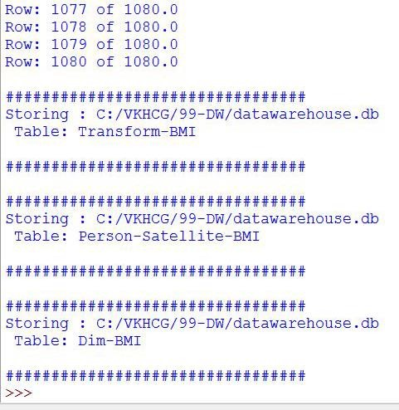
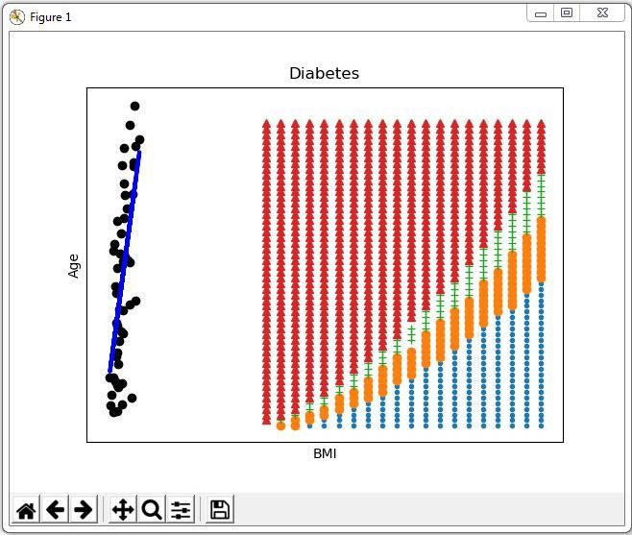

Practical 7

ORGANIZING DATA

Organize Superstep
The Organize superstep takes the complete data warehouse you built at the end of the Transform superstep and subsections it into business-specific data marts. A data mart is the access layer of the data warehouse environment built to expose data to the users. The data mart is a subset of the data warehouse and is generally oriented to a specific business group.

Horizontal Style
Performing horizontal-style slicing or subsetting of the data warehouse is achieved by applying a filter technique that forces the data warehouse to show only the data for a specific preselected set of filtered outcomes against the data population. The horizontal-style slicing selects the subset of rows from the population while preserving the columns. That is, the data science tool can see the complete record for the records in the subset of records.

C:\VKHCG\01-Vermeulen\05-Organise\ Organize-Horizontal.py
# -*- coding: utf-8 -*- import sys
import os
import pandas as pd import sqlite3 as sq Base='C:/VKHCG'
print('################################')
print('Working Base :',Base, ' using ', sys.platform) print('################################')
Company='01-Vermeulen' sDataWarehouseDir=Base + '/99-DW'
if not os.path.exists(sDataWarehouseDir): os.makedirs(sDataWarehouseDir) sDatabaseName=sDataWarehouseDir + '/datawarehouse.db' conn1 = sq.connect(sDatabaseName) sDatabaseName=sDataWarehouseDir + '/datamart.db' conn2 = sq.connect(sDatabaseName) print('################')
sTable = 'Dim-BMI'
print('Loading :',sDatabaseName,' Table:',sTable) sSQL="SELECT * FROM [Dim-BMI];"
PersonFrame0=pd.read_sql_query(sSQL, conn1) print('################')
sTable = 'Dim-BMI'
print('Loading :',sDatabaseName,' Table:',sTable)
sSQL="SELECT PersonID,\ Height,\Weight,\bmi,\ Indicator\FROM [Dim-BMI]\WHERE \Height > 1.5 \ and Indicator = 1\ORDER BY \Height,\Weight;"PersonFrame1=pd.read_sql_query(sSQL, conn1) DimPerson=PersonFrame1
DimPersonIndex=DimPerson.set_index(['PersonID'],inplace=False)

sTable = 'Dim-BMI' print('\n#################################')
print('Storing :',sDatabaseName,'\n Table:',sTable)
print('\n#################################')
#DimPersonIndex.to_sql(sTable, conn2, if_exists="replace") print('################')
sTable = 'Dim-BMI'
print('Loading :',sDatabaseName,' Table:',sTable) sSQL="SELECT * FROM [Dim-BMI];"
PersonFrame2=pd.read_sql_query(sSQL, conn2) print('Full Data Set (Rows):', PersonFrame0.shape[0]) print('Full Data Set (Columns):', PersonFrame0.shape[1])
print('Horizontal Data Set (Rows):', PersonFrame2.shape[0]) print('Horizontal Data Set (Columns):', PersonFrame2.shape[1])

OUTPUT:
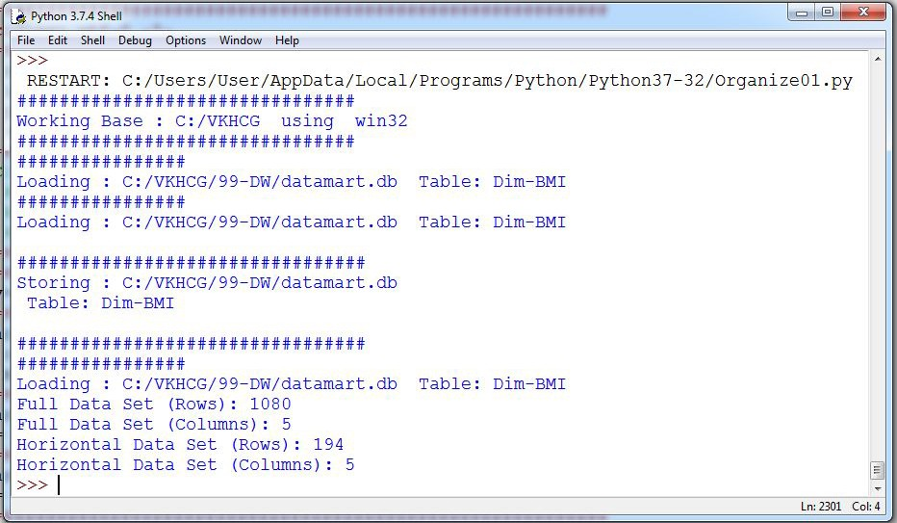
The horizontal-style slicing selects the 194 subset of rows from the 1080 rows while preserving the columns

Vertical Style
Performing vertical-style slicing or subsetting of the data warehouse is achieved by applying a filter technique that forces the data warehouse to show only the data for specific preselected filtered outcomes against the data population. The vertical-style slicing selects the subset of columns from the population, while preserving the rows. That is, the data science tool can see only the preselected columns from a record for all the records in the population.

C:\VKHCG\01-Vermeulen\05-Organise\ Organize-Vertical.py
# -*- coding: utf-8 -*- import sys
import os
import pandas as pd import sqlite3 as sq

Base='C:/VKHCG' print('################################')
print('Working Base :',Base, ' using ', sys.platform)
print('################################')
Company='01-Vermeulen' sDataWarehouseDir=Base + '/99-DW'
if not os.path.exists(sDataWarehouseDir): os.makedirs(sDataWarehouseDir) sDatabaseName=sDataWarehouseDir + '/datawarehouse.db' conn1 = sq.connect(sDatabaseName) sDatabaseName=sDataWarehouseDir + '/datamart.db' conn2 = sq.connect(sDatabaseName) print('################################')
sTable = 'Dim-BMI'
print('Loading :',sDatabaseName,' Table:',sTable) sSQL="SELECT * FROM [Dim-BMI];"
PersonFrame0=pd.read_sql_query(sSQL, conn1) print('################################')
sTable = 'Dim-BMI'
print('Loading :',sDatabaseName,' Table:',sTable) print('################################') sSQL="SELECT \
Height,\ Weight,\

Indicator\
FROM [Dim-BMI];"
PersonFrame1=pd.read_sql_query(sSQL, conn1) DimPerson=PersonFrame1 DimPersonIndex=DimPerson.set_index(['Indicator'],inplace=False) sTable = 'Dim-BMI-Vertical' print('\n#################################')
print('Storing :',sDatabaseName,'\n Table:',sTable)
print('\n#################################')
DimPersonIndex.to_sql(sTable, conn2, if_exists="replace") print('################')
sTable = 'Dim-BMI-Vertical'
print('Loading :',sDatabaseName,' Table:',sTable) sSQL="SELECT * FROM [Dim-BMI-Vertical];"
PersonFrame2=pd.read_sql_query(sSQL, conn2)
print('################################')
print('Full Data Set (Rows):', PersonFrame0.shape[0]) print('Full Data Set (Columns):', PersonFrame0.shape[1]) print('################################')

print('Horizontal Data Set (Rows):', PersonFrame2.shape[0]) print('Horizontal Data Set (Columns):', PersonFrame2.shape[1]) print('################################')

OUTPUT:
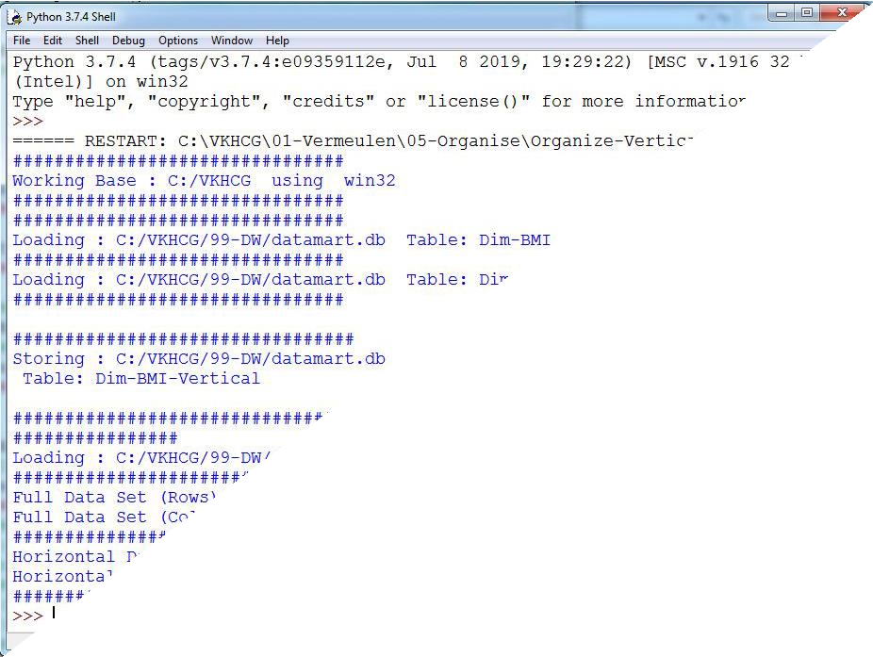

The vertical-style slicing selects 3 of 5 from the population, while preserving the rows [1080]. Island Style
Performing island-style slicing or subsetting of the data warehouse is achieved by applying a combination of horizontal- and vertical-style slicing. This generates a subset of specific rows and specific columns reduced at the same time.

C:\VKHCG\01-Vermeulen\05-Organise\ Organize-Island.py
# -*- coding: utf-8 -*- import sys
import os
import pandas as pd import sqlite3 as sq Base='C:/VKHCG'
print('################################')
print('Working Base :',Base, ' using ', sys.platform) print('################################')
Company='01-Vermeulen' sDataWarehouseDir=Base + '/99-DW'
if not os.path.exists(sDataWarehouseDir):
os.makedirs(sDataWarehouseDir) sDatabaseName=sDataWarehouseDir + '/datawarehouse.db'

conn1 = sq.connect(sDatabaseName) sDatabaseName=sDataWarehouseDir + '/datamart.db' conn2 = sq.connect(sDatabaseName) print('################')
sTable = 'Dim-BMI'
print('Loading :',sDatabaseName,' Table:',sTable) sSQL="SELECT * FROM [Dim-BMI];"
PersonFrame0=pd.read_sql_query(sSQL, conn1) print('################')
sTable = 'Dim-BMI'
print('Loading :',sDatabaseName,' Table:',sTable)
sSQL="SELECT \Height,\Weight,\Indicator\FROM [Dim-BMI]\WHERE Indicator > 2\ORDER BY Height,\Weight;"PersonFrame1=pd.read_sql_query(sSQL, conn1)
DimPerson=PersonFrame1 DimPersonIndex=DimPerson.set_index(['Indicator'],inplace=False) sTable = 'Dim-BMI-Vertical' print('\n#################################')
print('Storing :',sDatabaseName,'\n Table:',sTable) print('\n#################################')
DimPersonIndex.to_sql(sTable, conn2, if_exists="replace") print('################################')
sTable = 'Dim-BMI-Vertical'
print('Loading :',sDatabaseName,' Table:',sTable) print('################################') sSQL="SELECT * FROM [Dim-BMI-Vertical];"
PersonFrame2=pd.read_sql_query(sSQL, conn2) print('################################')
print('Full Data Set (Rows):', PersonFrame0.shape[0]) print('Full Data Set (Columns):', PersonFrame0.shape[1]) print('################################')
print('Horizontal Data Set (Rows):', PersonFrame2.shape[0]) print('Horizontal Data Set (Columns):', PersonFrame2.shape[1]) print('################################')

OUTPUT:

Secure Vault Style
The secure vault is a version of one of the horizontal, vertical, or island slicing techniques, but the outcome is also attached to the person who performs the query. This is common in multi-security environments, where different users are allowed to see different data sets.
This process works well, if you use a role-based access control (RBAC) approach to restricting system access to authorized users. The security is applied against the “role,” and a person can then, by the security system, simply be added or removed from the role, to enable or disable access.

C:\VKHCG\01-Vermeulen\05-Organise\ Organize-Secure-Vault.py
# -*- coding: utf-8 -*- import sys
import os
import pandas as pd import sqlite3 as sq Base='C:/VKHCG'
print('################################')
print('Working Base :',Base, ' using ', sys.platform) print('################################')
Company='01-Vermeulen' sDataWarehouseDir=Base + '/99-DW'
if not os.path.exists(sDataWarehouseDir): os.makedirs(sDataWarehouseDir) sDatabaseName=sDataWarehouseDir + '/datawarehouse.db' conn1 = sq.connect(sDatabaseName) sDatabaseName=sDataWarehouseDir + '/datamart.db' conn2 = sq.connect(sDatabaseName) print('################')
sTable = 'Dim-BMI'
print('Loading :',sDatabaseName,' Table:',sTable) sSQL="SELECT * FROM [Dim-BMI];"
PersonFrame0=pd.read_sql_query(sSQL, conn1)

print('################')
sTable = 'Dim-BMI'
print('Loading :',sDatabaseName,' Table:',sTable)
sSQL="SELECT \Height,\Weight,\Indicator,\CASE Indicator\WHEN 1 THEN 'Pip'\
WHEN 2 THEN 'Norman'\WHEN 3 THEN 'Grant'\ELSE 'Sam'\END AS Name\FROM [Dim-BMI]\ WHERE Indicator > 2\ORDER BY \Height,\Weight;"
PersonFrame1=pd.read_sql_query(sSQL, conn1) DimPerson=PersonFrame1 DimPersonIndex=DimPerson.set_index(['Indicator'],inplace=False) sTable = 'Dim-BMI-Secure' print('\n#################################')
print('Storing :',sDatabaseName,'\n Table:',sTable) print('\n#################################')
DimPersonIndex.to_sql(sTable, conn2, if_exists="replace") print('################################')
sTable = 'Dim-BMI-Secure'
print('Loading :',sDatabaseName,' Table:',sTable) print('################################')
sSQL="SELECT * FROM [Dim-BMI-Secure] WHERE Name = 'Sam';"
PersonFrame2=pd.read_sql_query(sSQL, conn2) print('################################')
print('Full Data Set (Rows):', PersonFrame0.shape[0]) print('Full Data Set (Columns):', PersonFrame0.shape[1]) print('################################')
print('Horizontal Data Set (Rows):', PersonFrame2.shape[0]) print('Horizontal Data Set (Columns):', PersonFrame2.shape[1]) print('Only Sam Data')
print(PersonFrame2.head()) print('################################')

OUTPUT:

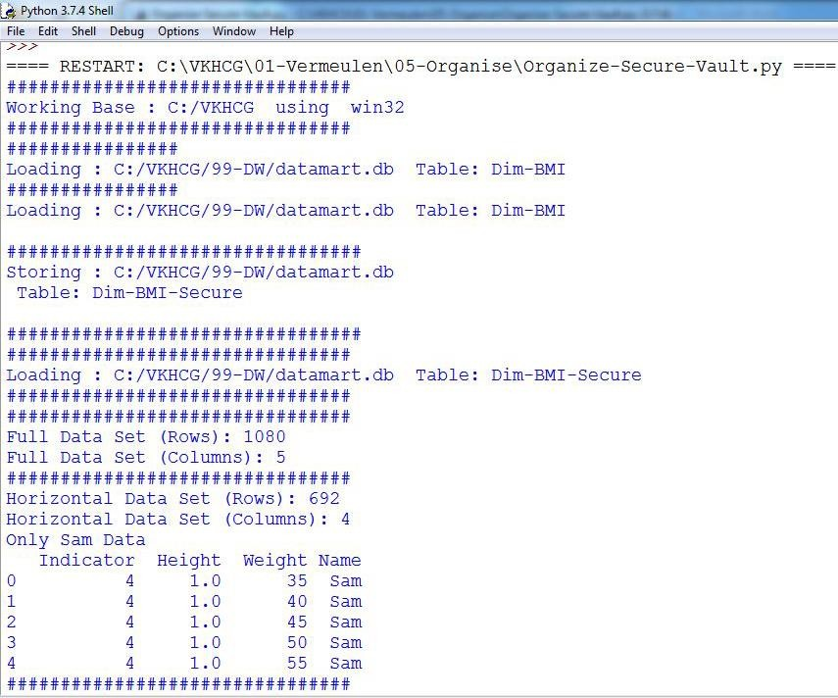

Association Rule Mining
Association rule learning is a rule-based machine-learning method for discovering interesting relations between variables in large databases, similar to the data you will find in a data lake. The technique enables you to investigate the interaction between data within the same population. Lift is simply estimated by the ratio of the joint probability of two items x and y, divided by the product of their individual probabilities:

C:\VKHCG\01-Vermeulen\05-Organise\ Organize-Association-Rule.py
# -*- coding: utf-8 -*- import sys
import os
import pandas as pd
from mlxtend.frequent_patterns import apriori
from mlxtend.frequent_patterns import association_rules Base='C:/VKHCG' print('################################')
print('Working Base :',Base, ' using ', sys.platform) print('################################')
Company='01-Vermeulen' InputFileName='Online-Retail-Billboard.xlsx' EDSAssessDir='02-Assess/01-EDS' InputAssessDir=EDSAssessDir + '/02-Python'
sFileAssessDir=Base + '/' + Company + '/' + InputAssessDir if not os.path.exists(sFileAssessDir): os.makedirs(sFileAssessDir)
sFileName=Base+'/'+ Company + '/00-RawData/' + InputFileName df = pd.read_excel(sFileName)
print(df.shape)
df['Description'] = df['Description'].str.strip()

df.dropna(axis=0, subset=['InvoiceNo'], inplace=True) df['InvoiceNo'] = df['InvoiceNo'].astype('str')
df = df[~df['InvoiceNo'].str.contains('C')]
basket = (df[df['Country'] =="France"]
.groupby(['InvoiceNo', 'Description'])['Quantity']
.sum().unstack().reset_index().fillna(0)
.set_index('InvoiceNo')) def encode_units(x):
if x <= 0:
return 0 if x >= 1:
return 1
basket_sets = basket.applymap(encode_units) basket_sets.drop('POSTAGE', inplace=True, axis=1)
frequent_itemsets = apriori(basket_sets, min_support=0.07, use_colnames=True)
rules = association_rules(frequent_itemsets, metric="lift", min_threshold=1) print(rules.head())
rules[ (rules['lift'] >= 6) & (rules['confidence'] >= 0.8) ]
sProduct1='ALARM CLOCK BAKELIKE GREEN'
print(sProduct1) print(basket[sProduct1].sum())
sProduct2='ALARM CLOCK BAKELIKE RED'
print(sProduct2) print(basket[sProduct2].sum())
basket2 = (df[df['Country'] =="Germany"]
.groupby(['InvoiceNo', 'Description'])['Quantity']
.sum().unstack().reset_index().fillna(0)
.set_index('InvoiceNo'))
basket_sets2 = basket2.applymap(encode_units) basket_sets2.drop('POSTAGE', inplace=True, axis=1)
frequent_itemsets2 = apriori(basket_sets2, min_support=0.05, use_colnames=True) rules2 = association_rules(frequent_itemsets2, metric="lift", min_threshold=1) print(rules2[ (rules2['lift'] >= 4) &
(rules2['confidence'] >= 0.5)])
print('### Done!! ############################################')

OUTPUT:

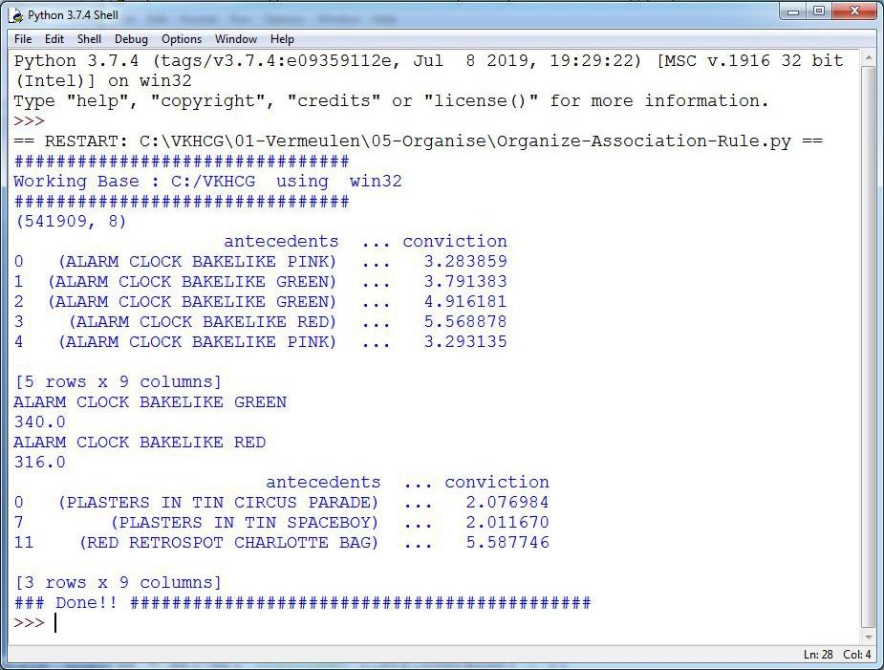

Create a Network Routing Diagram
I will guide you through a possible solution for the requirement, by constructing an island -style Organize superstep that uses a graph data model to reduce the records and the columns on the data set.

C:\VKHCG\01-Vermeulen\05-Organise\ Organise-Network-Routing-Company.py
import sys import os
import pandas as pd import networkx as nx
import matplotlib.pyplot as plt
pd.options.mode.chained_assignment = None Base='C:/VKHCG' print('################################')
print('Working Base :',Base, ' using ', sys.platform) print('################################')
sInputFileName='02-Assess/01-EDS/02-Python/Assess-Network-Routing-Company.csv'
sOutputFileName1='05-Organise/01-EDS/02-Python/Organise-Network-Routing-Company.gml' sOutputFileName2='05-Organise/01-EDS/02-Python/Organise-Network-Routing-Company.png' Company='01-Vermeulen'
### Import Country Data
sFileName=Base + '/' + Company + '/' + sInputFileName print('################################')
print('Loading :',sFileName) print('################################')
CompanyData=pd.read_csv(sFileName,header=0,low_memory=False, encoding="latin-1") print('################################')
print(CompanyData.head()) print(CompanyData.shape)

G=nx.Graph()
for i in range(CompanyData.shape[0]):
for j in range(CompanyData.shape[0]): Node0=CompanyData['Company_Country_Name'][i] Node1=CompanyData['Company_Country_Name'][j] if Node0 != Node1:
G.add_edge(Node0,Node1)
for i in range(CompanyData.shape[0]): Node0=CompanyData['Company_Country_Name'][i]
Node1=CompanyData['Company_Place_Name'][i] + '('+ CompanyData['Company_Country_Name'][i] + ')'
if Node0 != Node1:
G.add_edge(Node0,Node1) print('Nodes:', G.number_of_nodes()) print('Edges:', G.number_of_edges())
sFileName=Base + '/' + Company + '/' + sOutputFileName1 print('################################')
print('Storing :',sFileName) print('################################')
nx.write_gml(G, sFileName)
sFileName=Base + '/' + Company + '/' + sOutputFileName2 print('################################')
print('Storing Graph Image:',sFileName) print('################################')
plt.figure(figsize=(15, 15)) pos=nx.spectral_layout(G,dim=2)
nx.draw_networkx_nodes(G,pos, node_color='k', node_size=10, alpha=0.8)
nx.draw_networkx_edges(G, pos,edge_color='r', arrows=False, style='dashed') nx.draw_networkx_labels(G,pos,font_size=12,font_family='sans-serif',font_color='b') plt.axis('off')
plt.savefig(sFileName,dpi=600) plt.show()
print('################################')
print('### Done!! #####################') print('################################')

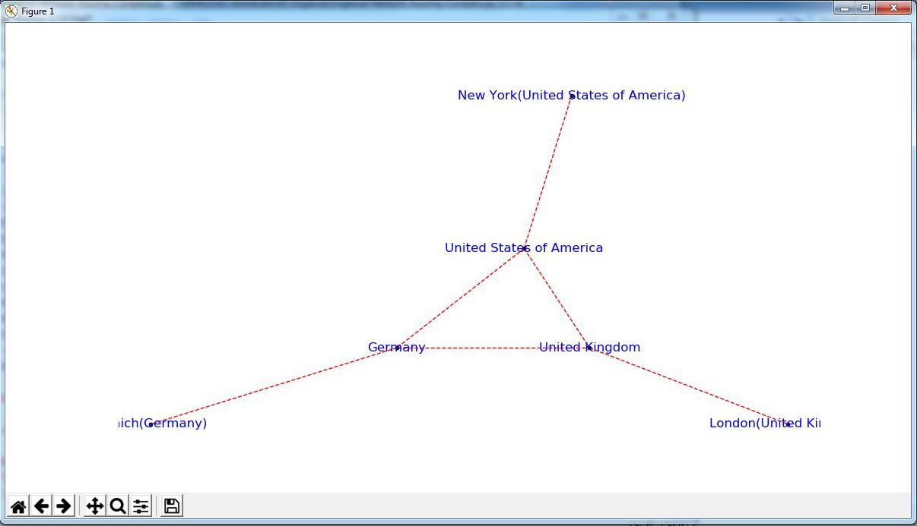

Picking Content for Billboards
To enable the marketing salespeople to sell billboard content, they will require a diagram to show what billboards connect to which office content publisher. Each of Krennwallner’s billboards has a proximity sensor that enables the content managers to record when a registered visitor points his/her smartphone at the billboard content or touches the near-field pad with a mobile phone.
Program will assist you in building an organized graph of the billboa rds’ locations data to help you to gain insights into the billboard locations and content picking process.

C:\VKHCG\02-Krennwallner\05-Organise\ Organise-billboards.py Code:
import sys import os
import pandas as pd
import networkx as nx
import matplotlib.pyplot as plt import numpy as np
pd.options.mode.chained_assignment = None Base='C:/VKHCG' print('################################')
print('Working Base :',Base, ' using ', sys.platform) print('################################')
sInputFileName='02-Assess/01-EDS/02-Python/Assess-DE-Billboard-Visitor.csv' sOutputFileName1='05-Organise/01-EDS/02-Python/Organise-Billboards.gml' sOutputFileName2='05-Organise/01-EDS/02-Python/Organise-Billboards.png' Company='02-Krennwallner'
### Import Company Data
sFileName=Base + '/' + Company + '/' + sInputFileName print('################################')
print('Loading :',sFileName) print('################################')
BillboardDataRaw=pd.read_csv(sFileName,header=0,low_memory=False, encoding="latin-1")
print('################################')
print(BillboardDataRaw.head())

print(BillboardDataRaw.shape) BillboardData=BillboardDataRaw sSample=list(np.random.choice(BillboardData.shape[0],20)) G=nx.Graph()
for i in sSample:
for j in sSample:
Node0=BillboardData['BillboardPlaceName'][i] + '('+ BillboardData['BillboardCountry'][i] + ')' Node1=BillboardData['BillboardPlaceName'][j] + '('+ BillboardData['BillboardCountry'][i] + ')' if Node0 != Node1:
G.add_edge(Node0,Node1) for i in sSample:
Node0=BillboardData['BillboardPlaceName'][i] + '('+ BillboardData['VisitorPlaceName'][i] + ')' Node1=BillboardData['BillboardPlaceName'][i] + '('+ BillboardData['VisitorCountry'][i] + ')'
if Node0 != Node1:
G.add_edge(Node0,Node1) print('Nodes:', G.number_of_nodes()) print('Edges:', G.number_of_edges())
sFileName=Base + '/02-Krennwallner/' + sOutputFileName1 print('################################')
print('Storing :',sFileName) print('################################')
nx.write_gml(G, sFileName)
sFileName=Base + '/02-Krennwallner/' + sOutputFileName2 print('################################')
print('Storing Graph Image:',sFileName) print('################################')
plt.figure(figsize=(15, 15))
pos=nx.circular_layout(G,dim=2)
nx.draw_networkx_nodes(G,pos, node_color='k', node_size=150, alpha=0.8) nx.draw_networkx_edges(G, pos,edge_color='r', arrows=False, style='solid') nx.draw_networkx_labels(G,pos,font_size=12,font_family='sans-serif',font_color='b') plt.axis('off')
plt.savefig(sFileName,dpi=600)
plt.show() print('################################') print('### Done!! #####################') print('################################')

OUTPUT :

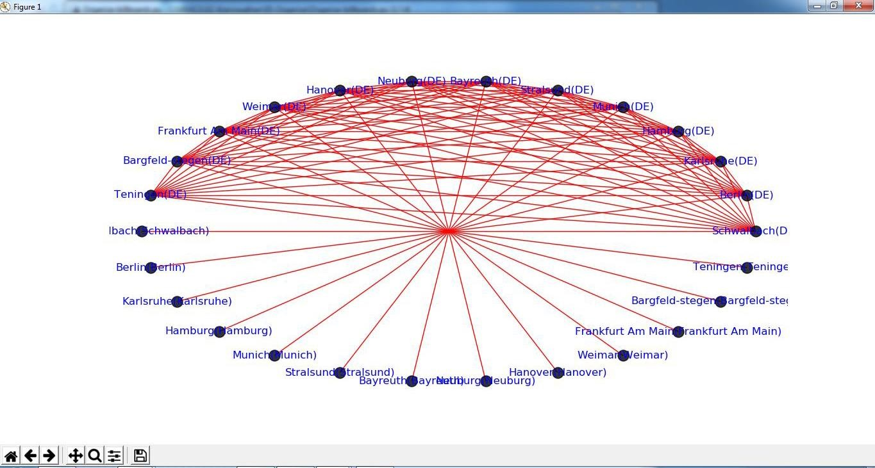

Create a Delivery Route
Hillman requires a new delivery route plan from HQ-KA13’s delivery region. The managing director has to know the following:
- What his most expensive route is, if the cost is £1.50 per mile and two trips are planned per day
- What the average travel distance in miles is for the region per 30 -daymonth
With your newfound knowledge in building the technology stack for turning data lakes into business assets, can you convert the graph stored in the Assess step called
“Assess_Best_Logistics” into the shortest path between the two points?

C:\VKHCG\03-Hillman\05-Organise\Organise-Routes.py
# -*- coding: utf-8 -*- import sys
import os
import pandas as pd Base='C:/VKHCG'
print('################################')
print('Working Base :',Base, ' using ', sys.platform) print('################################')
sInputFileName='02-Assess/01-EDS/02-Python/Assess_Shipping_Routes.txt' sOutputFileName='05-Organise/01-EDS/02-Python/Organise-Routes.csv' Company='03-Hillman'
### Import Routes Data
sFileName=Base + '/' + Company + '/' + sInputFileName print('################################')
print('Loading :',sFileName) print('################################')
RouteDataRaw=pd.read_csv(sFileName,header=0,low_memory=False, sep='|', encoding="latin-1")
print('################################')

RouteStart=RouteDataRaw[RouteDataRaw['StartAt']=='WH-KA13'] RouteDistance=RouteStart[RouteStart['Cost']=='DistanceMiles'] RouteDistance=RouteDistance.sort_values(by=['Measure'], ascending=False) RouteMax=RouteStart["Measure"].max() RouteMaxCost=round((((RouteMax/1000)*1.5*2)),2) print('################################')
print('Maximum (£) per day:') print(RouteMaxCost) print('################################')
RouteMean=RouteStart["Measure"].mean() RouteMeanMonth=round((((RouteMean/1000)*2*30)),6) print('################################')
print('Mean per Month (Miles):') print(RouteMeanMonth) print('################################')

OUTPUT:
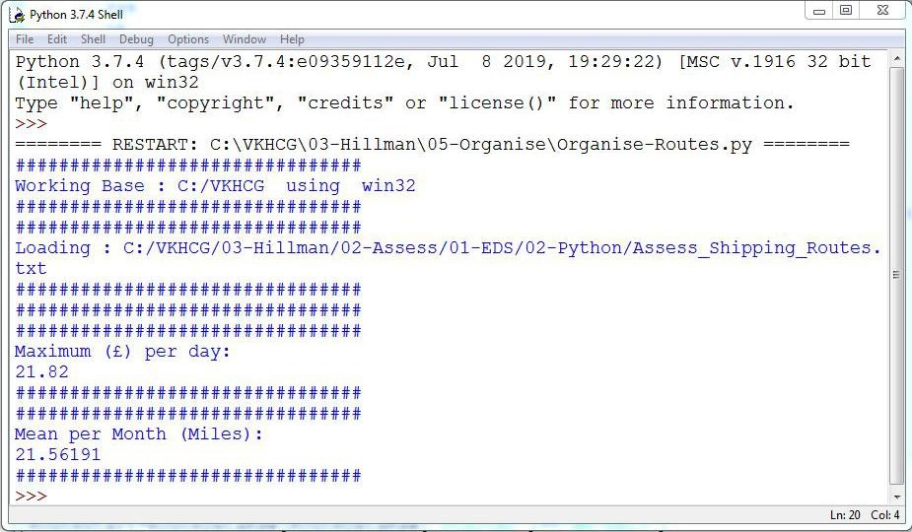

Clark Ltd
Our financial services company has been tasked to investigate the options to convert 1 million pounds sterling into extra income. Mr. Clark Junior suggests using the simple variance in the daily rate between the British pound sterling and the US dollar, to generate extra income from trading. Does your chief
financial officer wants to know if this is fesible?

Simple Forex Trading Planner
Your challenge is to take 1 million US dollars or just over six hundred thousand pounds sterling and, by simply converting it between pounds sterling and US dollars, achieve a profit. Are you up to this

challenge?
The Program will help you how to model this problem and achieve a positive outcome. The forex data has been collected on a daily basis by Clark’s accounting department, from previous overseas transactions.

C:\VKHCG\04-Clark\05-Organise\Organise-Forex.py
# -*- coding: utf-8 -*- import sys
import os
import pandas as pd import sqlite3 as sq import re Base='C:/VKHCG'
print('################################')
print('Working Base :',Base, ' using ', sys.platform) print('################################')
sInputFileName='03-Process/01-EDS/02-Python/Process_ExchangeRates.csv' sOutputFileName='05-Organise/01-EDS/02-Python/Organise-Forex.csv' Company='04-Clark'
sDatabaseName=Base + '/' + Company + '/05-Organise/SQLite/clark.db' conn = sq.connect(sDatabaseName)
#conn = sq.connect(':memory:') ### Import Forex Data
sFileName=Base + '/' + Company + '/' + sInputFileName
print('################################')
print('Loading :',sFileName) print('################################')
ForexDataRaw=pd.read_csv(sFileName,header=0,low_memory=False, encoding="latin-1") print('################################')
ForexDataRaw.index.names = ['RowID']
sTable='Forex_All'
print('Storing :',sDatabaseName,' Table:',sTable) ForexDataRaw.to_sql(sTable, conn, if_exists="replace")
sSQL="SELECT 1 as Bag\, CAST(min(Date) AS VARCHAR(10)) as Date \,CAST(1000000.0000000 as
NUMERIC(12,4)) as Money \,'USD' as Currency \FROM Forex_All \;" sSQL=re.sub("\s\s+", " ", sSQL)
nMoney=pd.read_sql_query(sSQL, conn) nMoney.index.names = ['RowID'] sTable='MoneyData'
print('Storing :',sDatabaseName,' Table:',sTable) nMoney.to_sql(sTable, conn, if_exists="replace") sTable='TransactionData'
print('Storing :',sDatabaseName,' Table:',sTable) nMoney.to_sql(sTable, conn, if_exists="replace")
ForexDay=pd.read_sql_query("SELECT Date FROM Forex_All GROUP BY Date;", conn) t=0

for i in range(ForexDay.shape[0]):
sDay1=ForexDay['Date'][i] sDay=str(sDay1)
sSQL='\SELECT M.Bag as Bag, \F.Date as Date, \round(M.Money * F.Rate,6) AS Money, \ F.CodeIn AS PCurrency, \F.CodeOut AS Currency \FROM MoneyData AS M \JOIN \( \SELECT \
CodeIn, CodeOut, Date, Rate \FROM \Forex_All \WHERE\CodeIn = "USD" AND CodeOut = "GBP" \ UNION \SELECT \CodeOut AS CodeIn, CodeIn AS CodeOut, Date, (1/Rate) AS Rate \FROM \ Forex_All \WHERE\CodeIn = "USD" AND CodeOut = "GBP" \) AS F ON \M.Currency=F.CodeIn \ AND \F.Date ="' +sDay + '";'sSQL=re.sub("\s\s+", " ", sSQL) ForexDayRate=pd.read_sql_query(sSQL, conn)
for j in range(ForexDayRate.shape[0]): sBag=str(ForexDayRate['Bag'][j]) nMoney=str(round(ForexDayRate['Money'][j],2)) sCodeIn=ForexDayRate['PCurrency'][j] sCodeOut=ForexDayRate['Currency'][j] sSQL='UPDATE MoneyData SET Date= "' + sDay + '", '
sSQL= sSQL + ' Money = ' + nMoney + ', Currency="' + sCodeOut + '"' sSQL= sSQL + ' WHERE Bag=' + sBag + ' AND Currency="' + sCodeIn + '";' sSQL=re.sub("\s\s+", " ", sSQL)
cur = conn.cursor() cur.execute(sSQL) conn.commit() t+=1
print('Trade :', t, sDay, sCodeOut, nMoney)
sSQL=' \INSERT INTO TransactionData ( \RowID, \Bag, \Date, \Money, \Currency \) \ SELECT ' + str(t) + ' AS RowID, \Bag, \Date, \Money, \Currency \
FROM MoneyData \;'
sSQL=re.sub("\s\s+", " ", sSQL) cur = conn.cursor() cur.execute(sSQL) conn.commit()
sSQL="SELECT RowID, Bag, Date, Money, Currency FROM TransactionData ORDER BY RowID;"
sSQL=re.sub("\s\s+", " ", sSQL) TransactionData=pd.read_sql_query(sSQL, conn) OutputFile=Base + '/' + Company + '/' + sOutputFileName TransactionData.to_csv(OutputFile, index = False)

OUTPUT:
Save the Assess-Forex.py file, then compile and execute with your Python compiler. This will produce a set of demonstrated values onscreen.

CLOUD COMPUTING

SAKET GYANPEETH’S

SAKET COLLEGE OF ARTS, SCIENCE AND COMMERCE

(Permanently Affiliated to University of Mumbai) NAAC Accredited B Grade
Saket Vidyanagari Marg, Chinchpada Road, Katemanivali, Kalyan (East) – 421306, Dist.
Department of Information Technology
Thane (MAH)

CERTIFICATE

This is to certify that

ANSHUMAN GAURISHANKAR SINGH of MSc Information Technology Part-I Class has satisfactory carried out the required practical in the subject.
CLOUD COMPUTING

For the Academic year 2022 – 2023

Practical In-Charge Head of Department External Examiner

INDEX

Sr.No. | Aim | Sign
1 | VMware Tutorial: Install ESXi Hypervisor
2 | Write a program for implementing Client Server  communication model using TCP
3 | Write a program for implementing Client Server  communication model using UDP
4 | A multicast Socket example
5 | Write a program to show the Date using RMI
6 | Write a program to convert digit using RMI
7 | Implement Virtualization using VMware ESXi Server and  managing with vCenter
8 | Develop application for Google App Engine

PRACTICAL 1

VMware Tutorial: Install ESXi Hypervisor

A hypervisor is software that allows a server to run multiple operating systems. It allows you to create virtual machines (VM), which enables users to customize hardware resources and perform actions such as taking a VM snapshot and migrating virtual machines to other hosts without downtime.

VMware ESXi is one of the most commonly used type-1 hypervisors in a data center environment. It runs directly using the host’s hardware, rather than acting as a standard Windows or Mac application.

Do you know that you can install ESXi hypervisors at home for experimental purposes? This article introduces the steps to install VMware ESXi hypervisor on a virtual machine created in VMware Workstation.

Step 1: Download VMware ESXi Hypervisor and VMware Workstation

Head over to VMware’s official website to download an evaluation version (ISO version) of VMware vSphere. Note that you will need to register a free account to download the ISO.

https://www.vmware.com/try-vmware.html
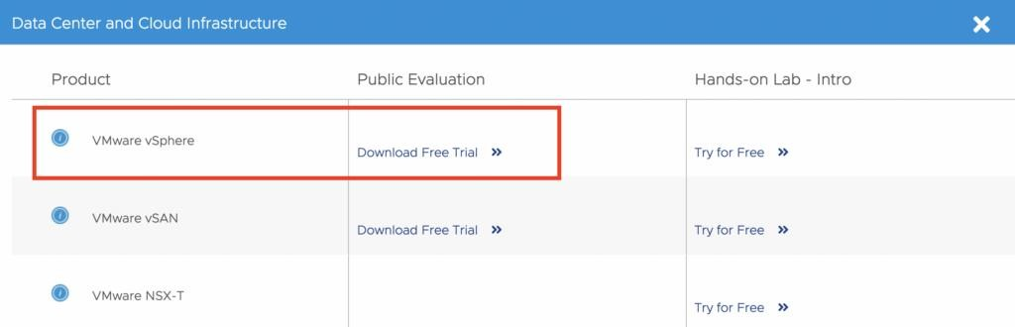
Download VMware vSphere ESXi
For ease of installation, you can install VMware Workstation (a type-2 hypervisor, also known as VMware Fusion on macOS platform) on your operating system to create a virtual machine, and install ESXi hypervisor (a type-1 hypervisor) on the VM.

https://www.vmware.com/products/workstation-pro.html

Tips #1: If your computer does not have enough processing power, or if you prefer to skip the installation step, I would recommend you to try out VMware Hands-on Lab. It provides an interactive interface for you to use ESXi software on a web browser – without the need to install any software. You can register a free account by visiting the below website.

https://hol.vmware.com/

Tips #2: If you would like to use the evaluation software for an extended period, consider joining VMware User Group (VMUG) and upgrading to Advantage membership. You can get 365 -day evaluation licenses for most VMware products including ESXi, vCenter, NSX, etc. for an annual membership fee.

https://www.vmug.com/

Step 2: Create a virtual machine for ESXi installation on VMware Workstation

Start by creating a VM using the “New Virtual Machine Wizard” on VMware Workstation.
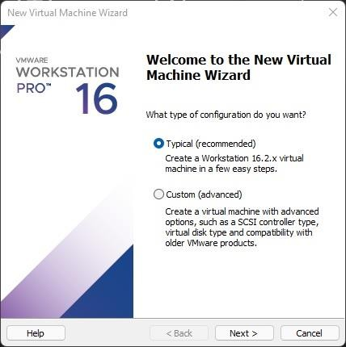
Create a new Virtual Machine
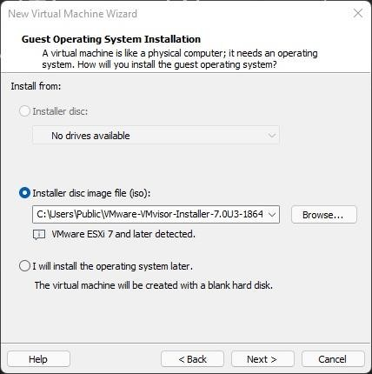

Select the ESXi ISO
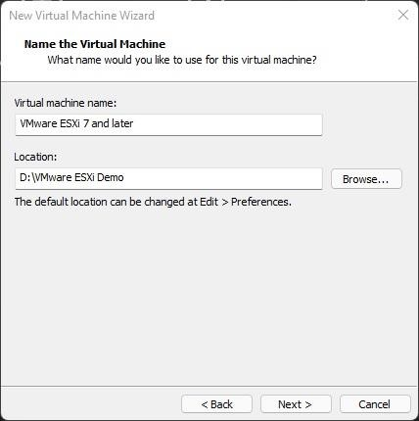

Define VM Name and Location
Refer to the official documentation for the minimum hardware requirements for ESXi 7.0 (eg. 4GB ram, 2 CPU cores, and 32GB disk space)
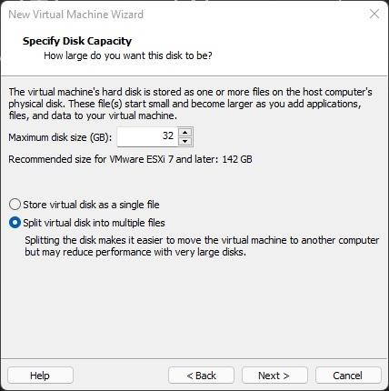

Specify Disk Capacity
Note that you can select “Bridged” mode for the Network Adapter setting if you wish to access the ESXi host client from devices other than your host PC after installation.

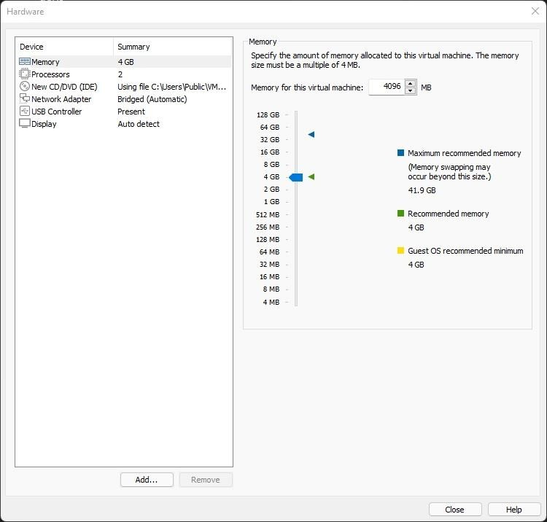
Customize VM Hardware
Step 3: Power on Virtual Machine and proceed with installation

After creating the virtual machine, power on the VM to continue the ESXi installation.
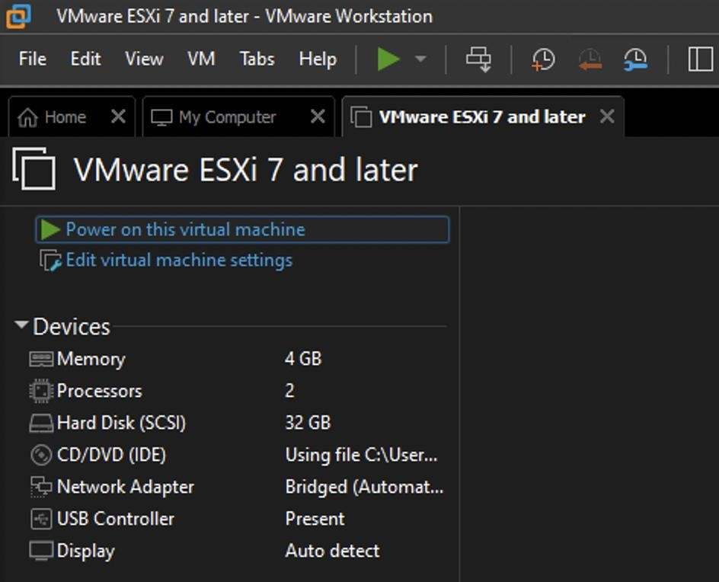
Power on Virtual Machine

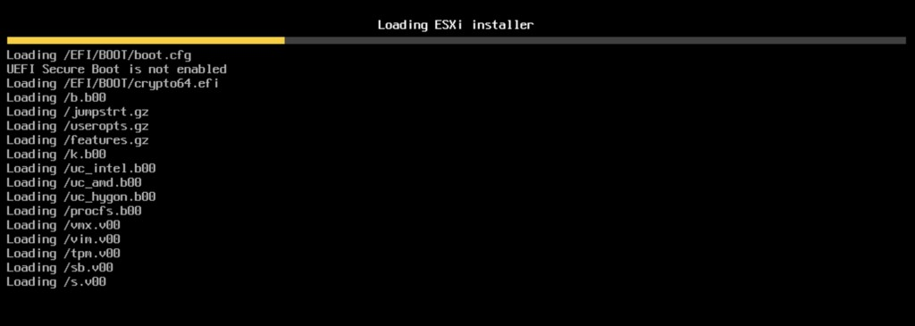

ESXi Installer #1
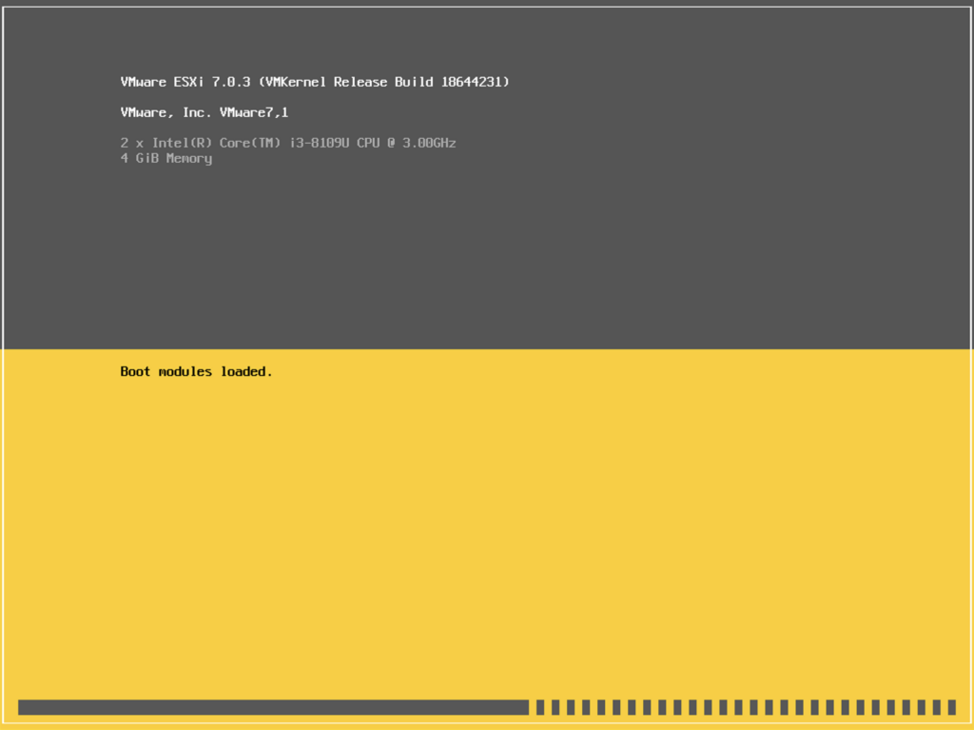
ESXi Installer #2
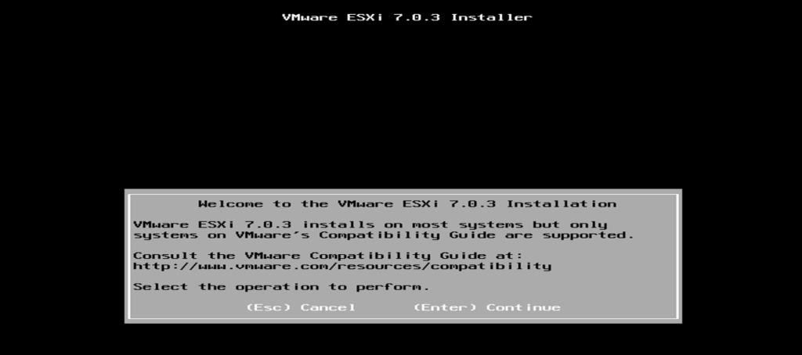

ESXi Installer Start Wizard
After starting the installation, you will be asked to select a disk location to install ESXi. As the VM is configured with a single local 32GB hard disk (which is the minimum amount of disk space for ESXi 7.0 installation), it is the only storage device displayed on the ESXi installation wizard. Continue by selecting the disk.
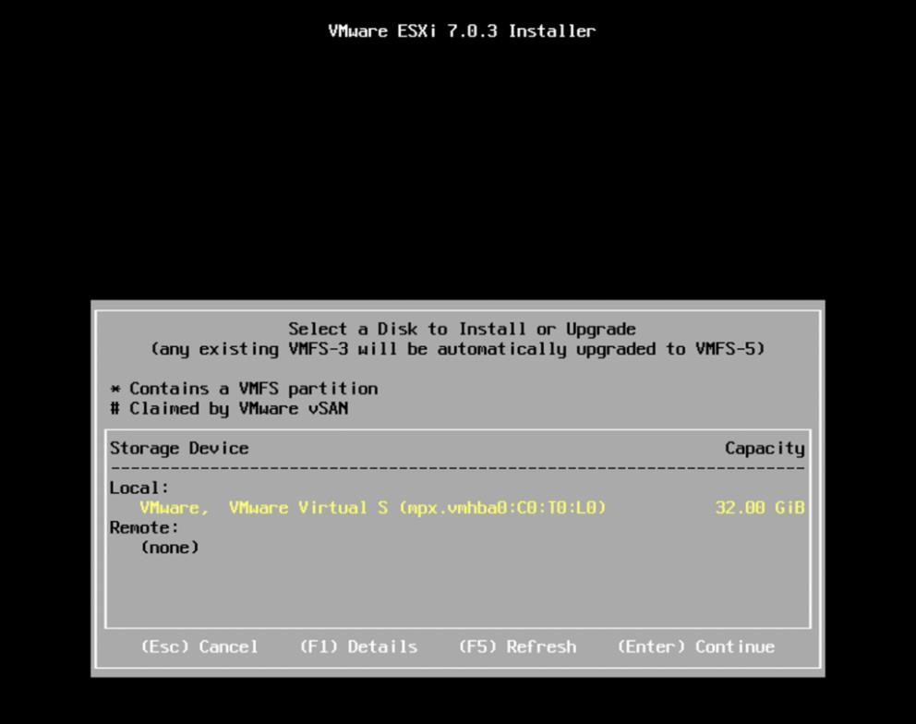

ESXi Installer Select Disk
Upon selecting the storage device for the installation, you will be asked to enter an ESXi root password, which you can later use to log in to the ESXi host client, as well as the Direct Console User Interface (DCUI).
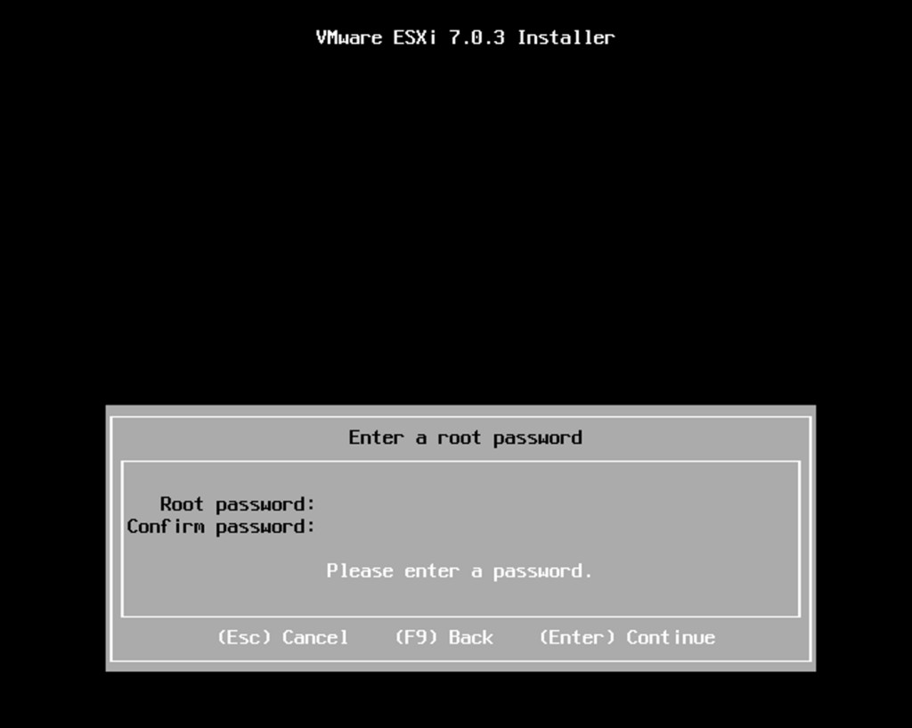

ESXi Installer Enter Root Password
Press F11 to confirm installing ESXi on the selected disk location:
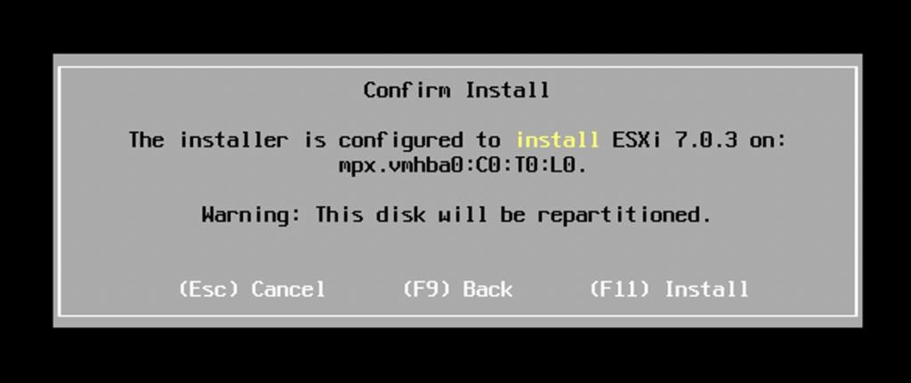
ESXi Installer Confirm Install
After installation has been completed, select “configure hardware” on VMware Workstation, remove the ESXi installation media (e.g. CD Rom, USB drive), and press “Enter” to reboot into .
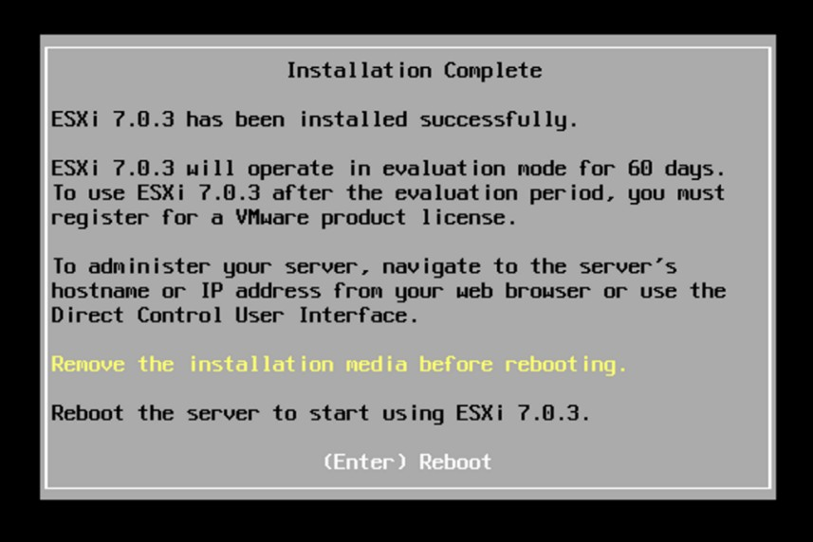

ESXi Installation Completed
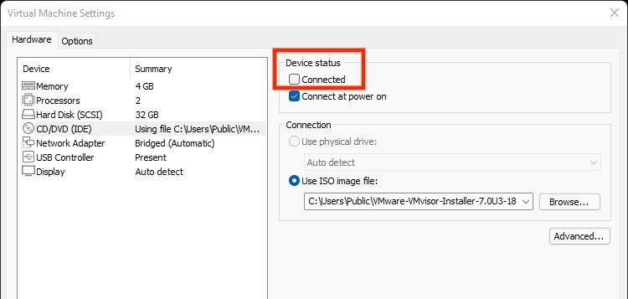

Disconnect CD/DVD from the Virtual Machine
Post-installation: Access Direct Console User Interface (DCUI) and ESXi Host Client #1) Access Direct Console User Interface (DCUI) on the Connected Display Device
After installing ESXi and rebooting, you can view the Direct Console User Interface (DCUI). Basic
information including ESXi version, CPU, memory, and management IP address will be shown. Note that DCUI offers limited configuration as it is not designed for daily operation. For most use cases, system admins only access DCUI via Integrated Management Module (IMM) to perform tasks such as changing ESXi management IP and checking system status when the network connection to the ESXi is lost. For performing most operational and management tasks, you will need to use the ESXi host client on a web browser.
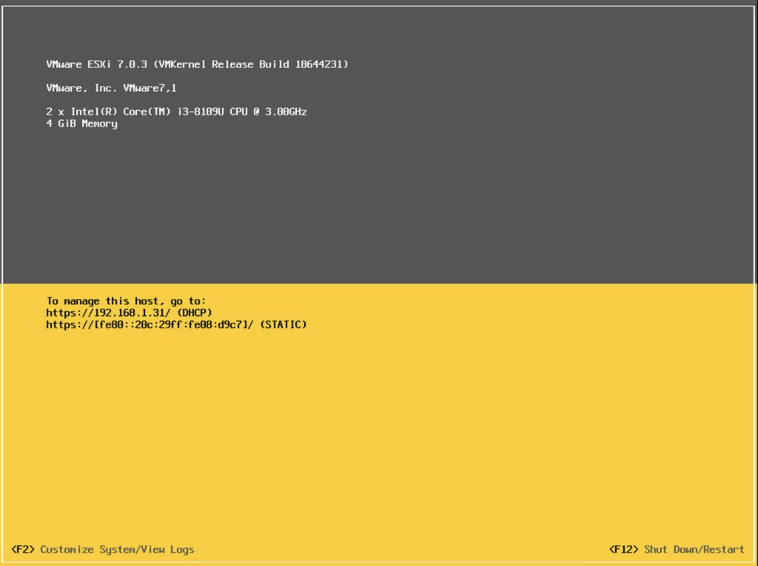
VMware ESXi Direct Console User Interface (DCUI)
For customization such as configuring the management IP address, press F2 and enter the root user credential you entered during the ESXi installation.
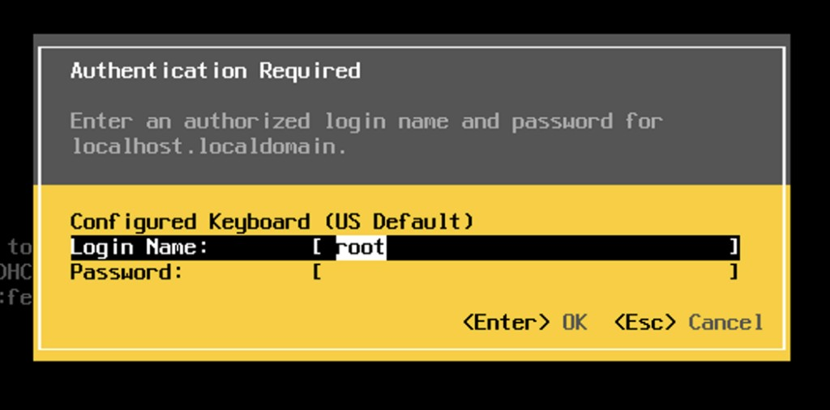

VMware ESXi DCUI Login
After logging in as a root user, you can perform various configurations on the DCUI including changing the ESXi root password and the management network (e.g. assign a static management IP).
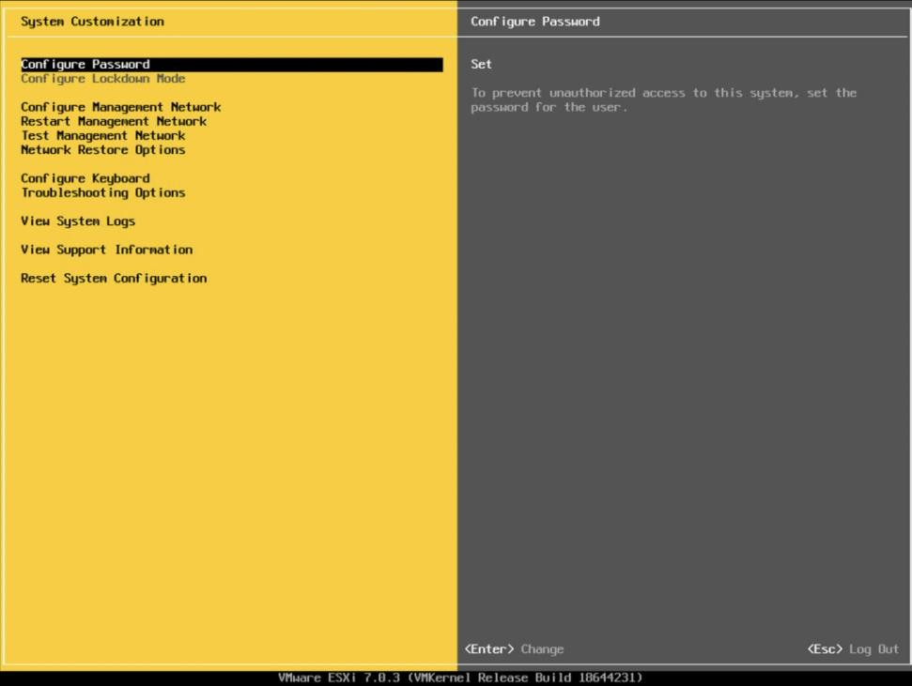

VMware ESXi DCUI Settings
#2) Access ESXi Host Client via a Remote Web Browser

You can also access the ESXi management console by entering the management IP of the ESXi on a web browser. This is the preferred way to perform management tasks including datastore and VM
configuration etc.
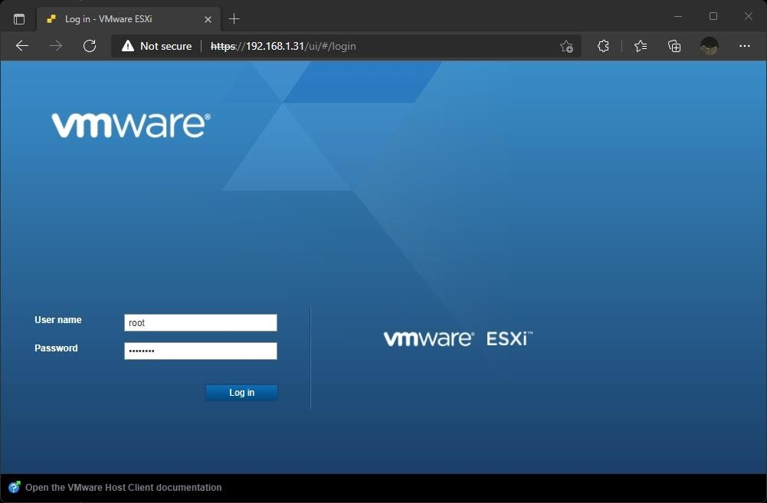

ESXi Host Client Login Page
After login, you can view the system information and perform management tasks.
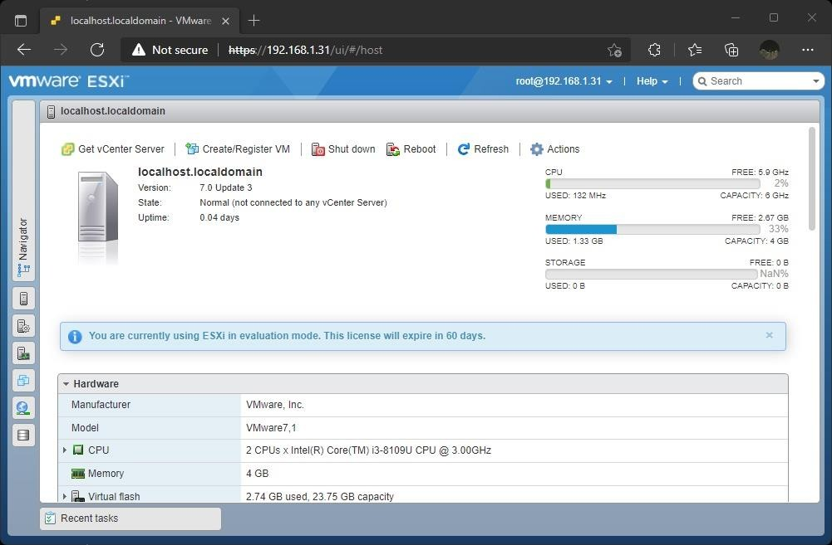

ESXi Host Client UI Conclusion

ESXi hypervisor provides a virtualized computing platform where multiple operating systems can be run on a single host. It offers many more capabilities including the ability to provision virtual machines with customized hardware and the option to create a snapshot for the temporary preservation of VM state and data. Installing the ESXi hypervisor is the first step to creating a software-defined data center (SDDC), where computing resources can be pooled to provide a centralized platform for hosting enterprise applications efficiently. Stay tuned for more tutorials on cloud computing and system administration topics.

PRACTICAL 2
- Write a program for implementing Client Server communication model using TCP.

Aim: Write a program for implementing Client Server communication model using TCP. Practical 2A: A client server based program using TCP to find if the number entered is prime. Code:

tcpServerPrime.java
import java.net.*; import java.io.*; class tcpServerPrime
{
public static void main(String args[])
{
try
{
ServerSocket ss = new ServerSocket(8001); System.out.println("Server Started ");
Socket s = ss.accept(); DataInputStream in = new
DataInputStream(s.getInputStream()); int x= in.readInt(); DataOutputStream otc = new DataOutputStream(s.getOutputStream()); int y = x/2;
if(x ==1 || x ==2 || x ==3)
{
otc.writeUTF(x + "is Prime"); System.exit(0);
}
for(int i=2; i<=y; i++)
{
if(x%i != 0)
{
otc.writeUTF(x + " is Prime");
}
else
{
otc.writeUTF(x + " is not Prime");
}
}
}
catch(Exception e)
{
System.out.println(e.toString());
}
}

}

  - tcpClientPrime.java import java.net.*; import java.io.*; class tcpClientPrime
{
public static void main(String args[])
{
try
{
Socket cs = new Socket("LocalHost",8001);
BufferedReader infu = new BufferedReader(new InputStreamReader(System.in)); System.out.println("Enter a number : ");
int a = Integer.parseInt(infu.readLine()); DataOutputStream out = new DataOutputStream(cs.getOutputStream()); out.writeInt(a);
DataInputStream in = new DataInputStream(cs.getInputStream()); System.out.println(in.readUTF()); cs.close();
}
catch(Exception e)
{
System.out.println(e.toString());
}
}
}

OUTPUT:
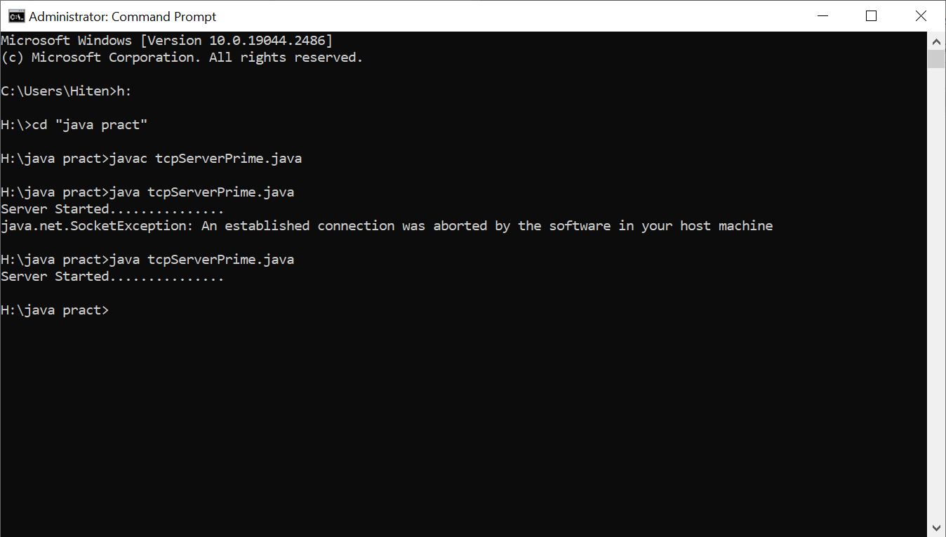

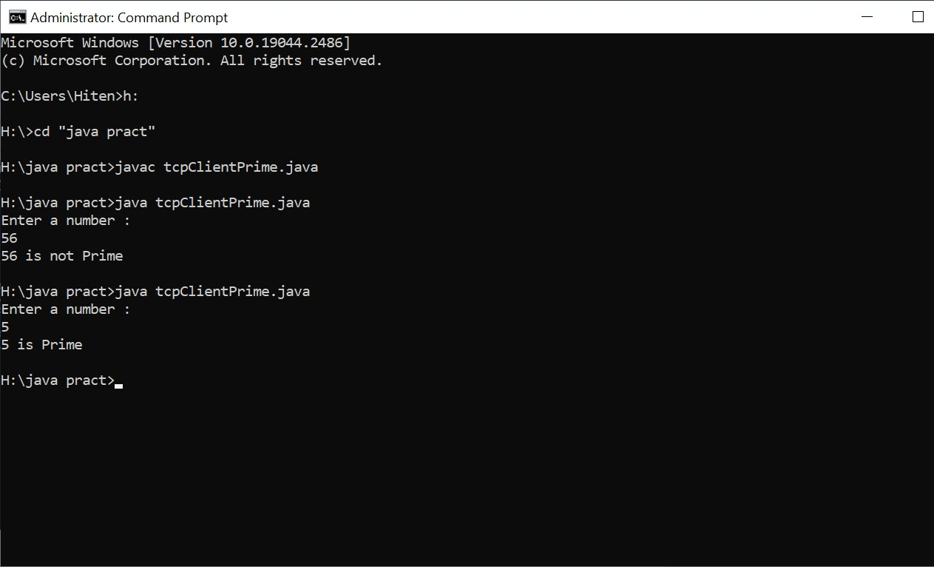

Practical 2B: A client server TCP based chatting application.

Code:
- ChatServer.java: import java.net.*; import java.io.*; class ChatServer
{
public static void main(String args[])
{
try
{
ServerSocket ss = new ServerSocket(8000); System.out.println("Waiting for client to connect.."); Socket s = ss.accept();
BufferedReader br = new
BufferedReader(new InputStreamReader(System.in)); DataOutputStream out = new DataOutputStream(s.getOutputStream()); DataInputStream in = new DataInputStream(s.getInputStream()); String receive, send; while((receive = in.readLine()) != null)
{
if(receive.equals("STOP")) break;
System.out.println("Client Says : "+receive); System.out.print("Server Says : ");
send = br.readLine();
out.writeBytes(send+"\n");

}
br.close();
in.close();
out.close();
s.close();
}
catch(Exception e)
{
e.printStackTrace();
}
}
}

- ChatClient.java import java.net.*; import java.io.*; class ChatClient
{
public static void main(String args[])
{
try
{
Socket s = new Socket("Localhost",8000);
BufferedReader br = new BufferedReader(new InputStreamReader(System.in)); DataOutputStream out = new
DataOutputStream(s.getOutputStream()); DataInputStream in = new DataInputStream(s.getInputStream()); String msg; System.out.println("To stop chatting with server type
STOP"); System.out.print("Client Says: "); while((msg =
br.readLine()) != null)
{
out.writeBytes(msg+"\n"); if(msg.equals("STOP")) break;
System.out.println("Server Says : "+in.readLine());
System.out.print("Client Says : ");
}
br.close();
in.close();
out.close();
s.close();
}
catch(Exception e)

{
e.printStackTrace();
}
}
}

OUTPUT:
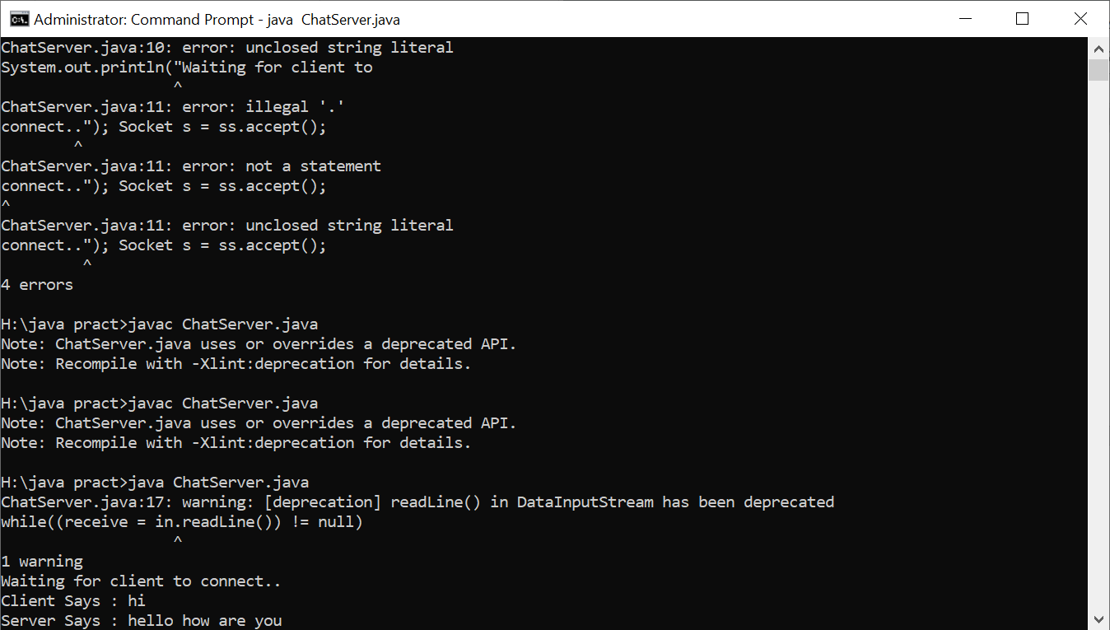
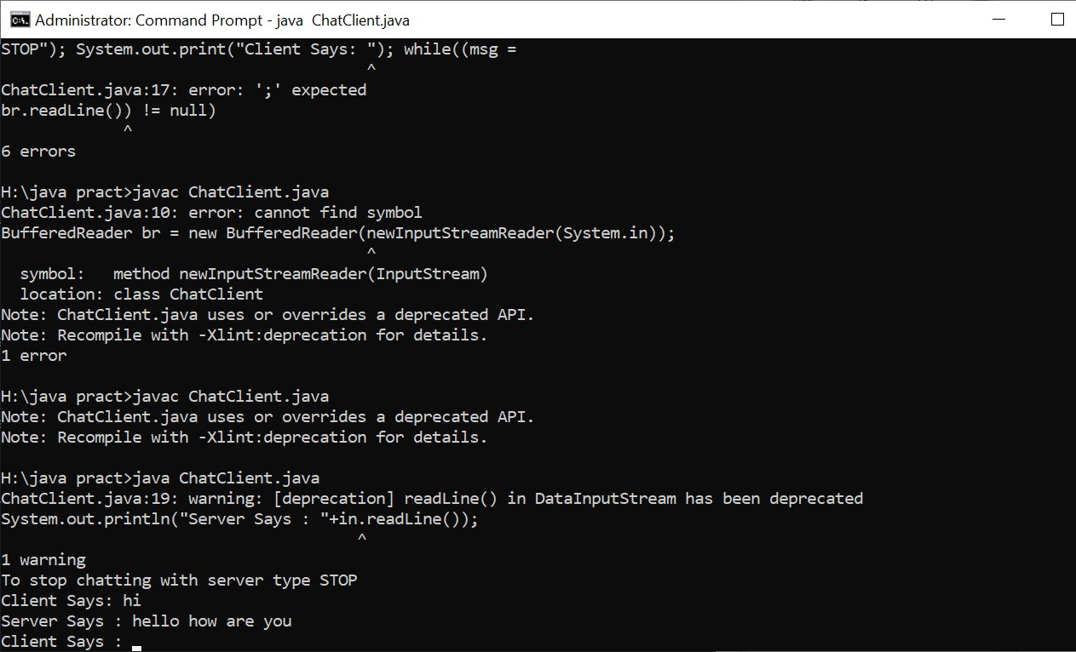

PRACTICAL 3
- Write a program for implementing Client Server communication model using UDP. Aim: Write a program for implementing Client Server communication model using UDP.
Practical 3A: A client server based program using UDP to find if the number entered is even or odd.

Code:
  - udpServerEO.java import java.io.*; import java.net.*;
public class udpServerEO
{
public static void main(String args[])
{
try
{
DatagramSocket ds = new DatagramSocket(2000); byte b[] = new byte[1024];
DatagramPacket dp = new DatagramPacket(b,b.length);
ds.receive(dp); String str = new
String(dp.getData(),0,dp.getLength()); System.out.println(str);
int a= Integer.parseInt(str);
String s= new String(); if (a%2 == 0)
s = "Number is even"; else
s = "Number is odd";
byte b1[] = new byte[1024]; b1 = s.getBytes(); DatagramPacket dp1 = new
DatagramPacket(b1,b1.length,InetAddress.getLocalHost(),1000); ds.send(dp1);
}
catch(Exception e)
{
e.printStackTrace();
}
}
}

  - udpClientEO.java import java.io.*; import java.net.*;
public class udpClientEO
{
public static void main(String args[])
{
try
{
DatagramSocket ds = new DatagramSocket(1000); BufferedReader br = new BufferedReader(new InputStreamReader(System.in)); System.out.println("Enter a number : ");
String num = br.readLine(); byte b[] = new byte[1024]; b=num.getBytes(); DatagramPacket dp = new
DatagramPacket(b,b.length,InetAddress.getLocalHost(),2000); ds.send(dp);
byte b1[] = new byte[1024]; DatagramPacket dp1 = new
DatagramPacket(b1,b1.length); ds.receive(dp1); String str = new String(dp1.getData(),0,dp1.getLength()); System.out.println(str);
}
catch(Exception e)
{
e.printStackTrace();
}
}
}

OUTPUT:
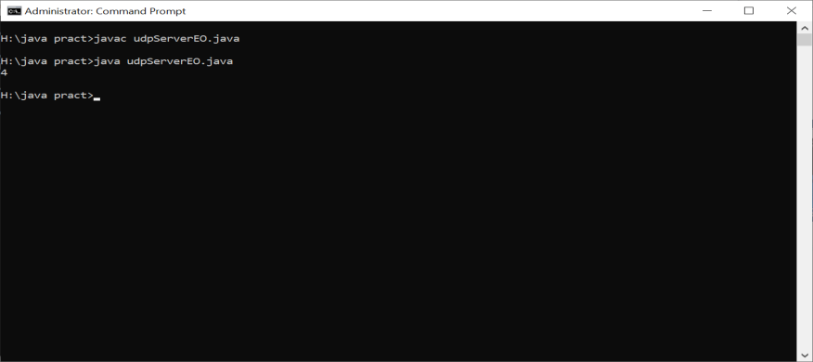

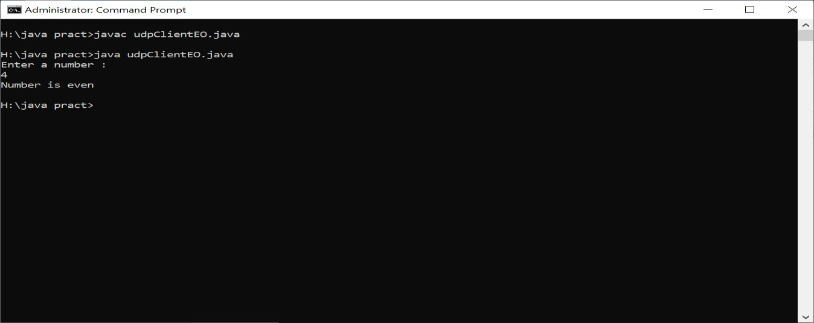

Practical 3B: A client server based program using UDP to find the factorial of the entered number. Code:
- udpServerFact.java import java.io.*; import java.net.*;
public class udpServerFact
{
public static void main(String args[])
{
try
{
DatagramSocket ds = new DatagramSocket(2000); byte b[] = new byte[1024];
DatagramPacket dp = new DatagramPacket(b,b.length);
ds.receive(dp); String str = new
String(dp.getData(),0,dp.getLength()); System.out.println(str);
int a= Integer.parseInt(str);
int f = 1, i;
String s= new String(); for(i=1;i<=a;i++)
{
f=f*i;
}
s=Integer.toString(f);
String str1 = "The Factorial of " + str + " is : " + f; byte b1[] = new byte[1024]; b1 = str1.getBytes();

DatagramPacket dp1 = new DatagramPacket(b1,b1.length,InetAddress.getLocalHost(),1000); ds.send(dp1);
}
catch(Exception e)
{
e.printStackTrace();
}
}
}
- udpClientFact.java import java.io.*; import java.net.*;
public class udpClientFact
{
public static void main(String args[])
{
try
{
DatagramSocket ds = new DatagramSocket(1000); BufferedReader br = new BufferedReader(new InputStreamReader(System.in)); System.out.println("Enter a number : ");
String num = br.readLine(); byte b[] = new byte[1024]; b=num.getBytes(); DatagramPacket dp = new
DatagramPacket(b,b.length,InetAddress.getLocalHost(),2000); ds.send(dp);
byte b1[] = new byte[1024];
DatagramPacket dp1 = new DatagramPacket(b1,b1.length); ds.receive(dp1);
String str = new String(dp1.getData(),0,dp1.getLength()); System.out.println(str);
}
catch(Exception e)
{
e.printStackTrace();
}
}

}

OUTPUT:
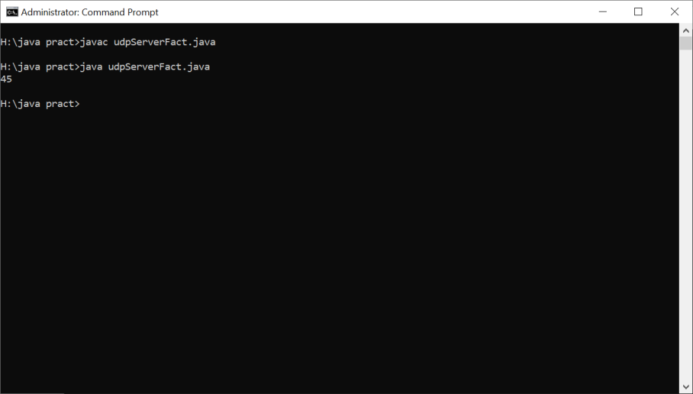
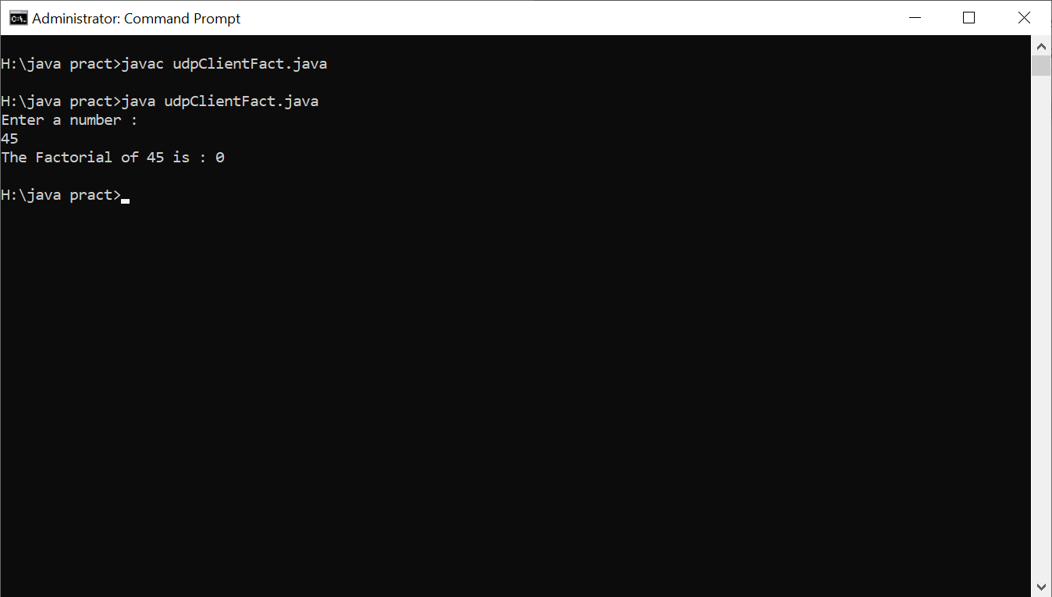

Practical 3C:A program to implement simple calculator operations like addition, subtraction, multiplication and division.

Code:
- RPCServer.java import java.util.*; import java.net.*; class RPCServer
{
DatagramSocket ds; DatagramPacket dp;
String str,methodName,result; int val1,val2;
RPCServer()

try
{
ds=new DatagramSocket(1200); byte b[]=new byte[4096]; while(true)
{
dp=new DatagramPacket(b,b.length); ds.receive(dp);
str=new String(dp.getData(),0,dp.getLength()); if(str.equalsIgnoreCase("q"))
{
System.exit(1);
}
else
{
StringTokenizer st = new StringTokenizer(str," "); int i=0;
while(st.hasMoreTokens())
{
String token=st.nextToken(); methodName=token;
val1 = Integer.parseInt(st.nextToken()); val2 = Integer.parseInt(st.nextToken());
}
}
System.out.println(str);
InetAddress ia = InetAddress.getLocalHost(); if(methodName.equalsIgnoreCase("add"))
{
result= "" + add(val1,val2);
}
else if(methodName.equalsIgnoreCase("sub"))
{
result= "" + sub(val1,val2);
}
else if(methodName.equalsIgnoreCase("mul"))
{
result= "" + mul(val1,val2);
}
else if(methodName.equalsIgnoreCase("div"))

result= "" + div(val1,val2);
}
byte b1[]=result.getBytes();
DatagramSocket ds1 = new DatagramSocket(); DatagramPacket dp1 = new
DatagramPacket(b1,b1.length,InetAddress.getLocalHost(), 1300); System.out.println("result :
"+result+"\n"); ds1.send(dp1);
}
}
catch (Exception e)
{
e.printStackTrace();
}
}
public int add(int val1, int val2)
{
return val1+val2;
}
public int sub(int val3, int val4)
{
return val3-val4;
}
public int mul(int val3, int val4)
{
return val3*val4;
}
public int div(int val3, int val4)
{
return val3/val4;
}
public static void main(String[] args)
{
new RPCServer();
}
}
- RPCClient.java import java.io.*; import java.net.*;
class RPCClient

RPCClient()
{
try
{
InetAddress ia = InetAddress.getLocalHost(); DatagramSocket ds = new DatagramSocket(); DatagramSocket ds1 = new DatagramSocket(1300); System.out.println("\nRPC Client\n");
System.out.println("Enter method name and parameter like add 3 4\n"); while (true)
{
BufferedReader br = new
BufferedReader(new InputStreamReader(System.in)); String str = br.readLine();
byte b[] = str.getBytes(); DatagramPacket dp = new DatagramPacket(b,b.length,ia,1200); ds.send(dp);
dp = new DatagramPacket(b,b.length); ds1.receive(dp);
String s = new String(dp.getData(),0,dp.getLength());
System.out.println("\nResult = " + s + "\n");
}
}
catch (Exception e)
{
e.printStackTrace();
}
}
public static void main(String[] args)
{
new RPCClient();
}
}

OUTPUT:
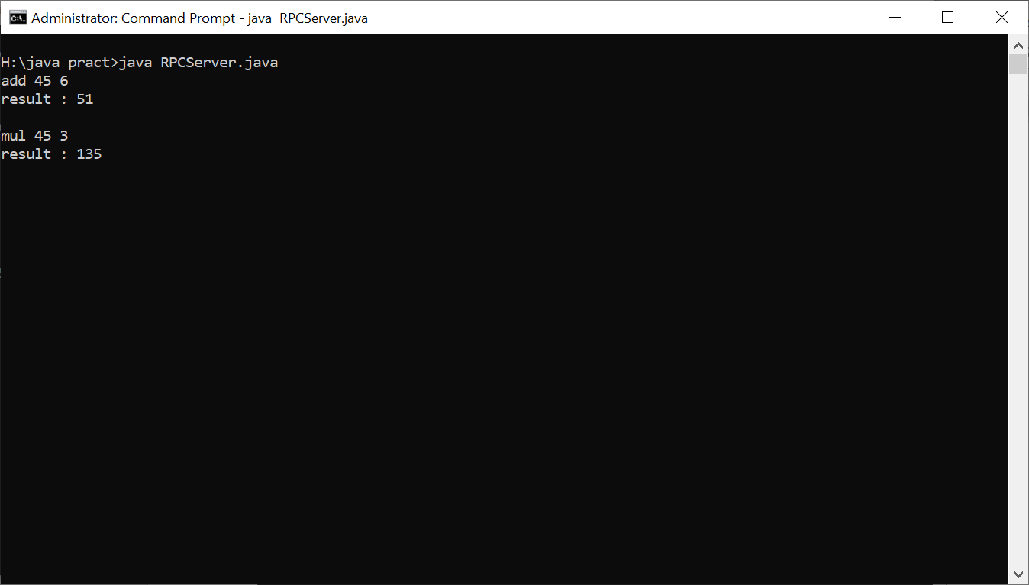
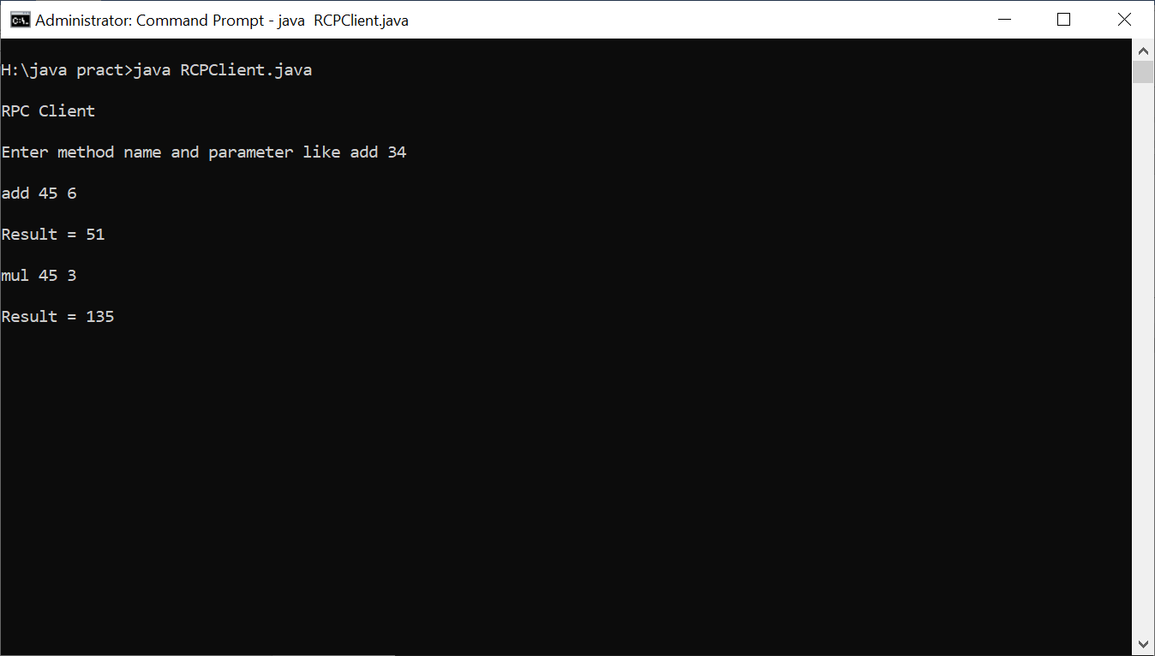

PRACTICAL 4

4. A multicast Socket example Aim: A multicast Socket example. Code:

BroadcastServer.java
import java.net.*; import java.io.*; import java.util.*;
public class BroadcastServer
{
public static final int PORT = 1234;
public static void main(String args[])throws Exception {
MulticastSocket socket; DatagramPacket packet; InetAddress address;
// set the multicast address to your local subnet address = InetAddress.getByName("239.1.2.3"); socket = new MulticastSocket();
// join a Multicast group and send the group messages socket.joinGroup(address); byte[] data = null;
for(;;)
{
Thread.sleep(10000); System.out.println("Sending "); String str = ("This is Neha Calling ");
data = str.getBytes();
packet = new DatagramPacket(data, str.length(),address,PORT);
// Sends the packet socket.send(packet);
} // end for
} // end main
} // end class BroadcastServer

- BroadcastClient.java import java.net.*; import java.io.*;
public class BroadcastClient
{
public static final int PORT = 1234;
public static void main(String args[])throws Exception {

MulticastSocket socket; DatagramPacket packet; InetAddress address;
// set the mulitcast address to your local subnet address = InetAddress.getByName("239.1.2.3"); socket = new MulticastSocket(PORT);
//join a Multicast group and wait for a message socket.joinGroup(address); byte[] data = new byte[100];
packet = new DatagramPacket(data,data.length); for(;;)
{
// receive the packets socket.receive(packet);
String str = new String(packet.getData()); System.out.println("Message received from "+
packet.getAddress() + "Message is : "+str);
} // for
} // main
} // end BroadcastClient

OUTPUT:
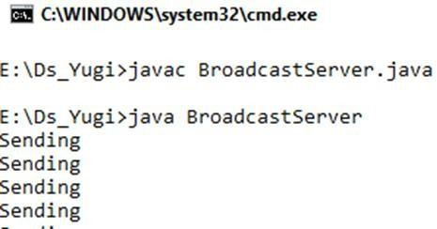

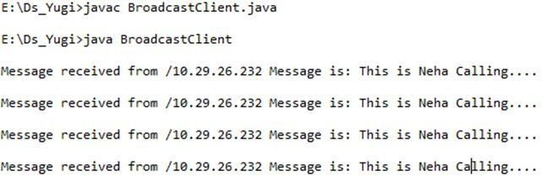

PRACTICAL 5
5. Write a program to show the Date using RMI. Aim: Write a program to show the Date using RMI. Code:

InterDate.java
import java.rmi.*;
public interface InterDate extends Remote
{
public String display() throws Exception;
}
- ServerDate.java import java.rmi.*; import java.rmi.server.*;
import java.util.*;
public class ServerDate extends UnicastRemoteObject implements InterDate {
public ServerDate() throws Exception
{
}
public String display() throws Exception
{
String str = "";
Date d = new Date(); str = d.toString(); return str;
}
public static void main(String args[]) throws Exception {
ServerDate s1 = new ServerDate();
Naming.bind("DS",s1); System.out.println("Object registered ");
}
}
- ClientDate.java import java.rmi.*; import java.io.*;
public class ClientDate
{
public static void main(String args[]) throws Exception {
String s1;
InterDate h1 = (InterDate)Naming.lookup("DS");

s1 = h1.display(); System.out.println(s1);
}
}

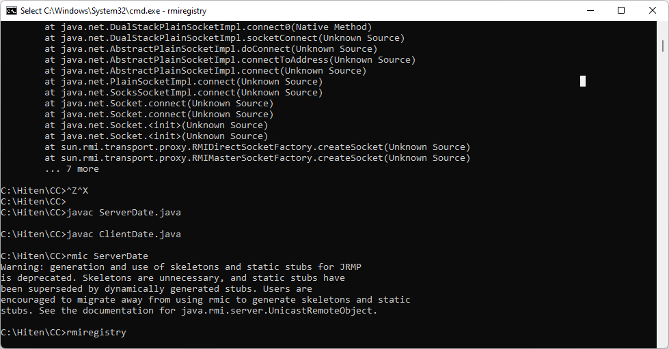
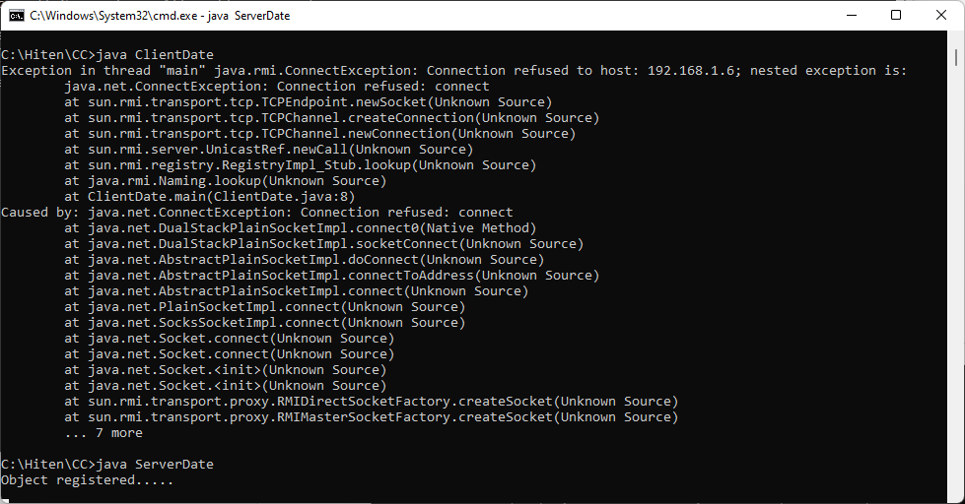
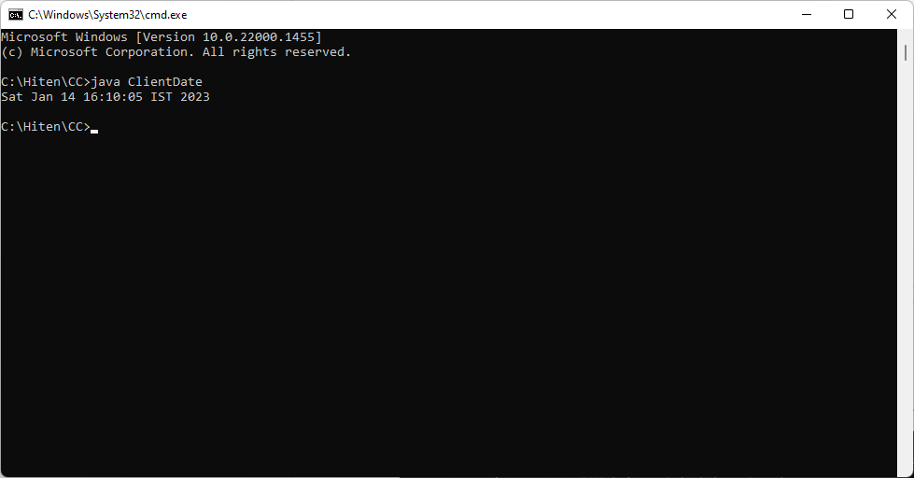
OUTPUT:

PRACTICAL 6
6. Write a program to convert digit using RMI. Aim: Write a program to convert digit using RMI. Code:

InterDate.java
import java.rmi.*;
public interface InterConvert extends Remote
{
public String convertDigit(String no) throws Exception;
}

- ServerDate.java import java.rmi.*; import java.rmi.server.*;
public class ServerConvert extends UnicastRemoteObject implements InterConvert {
public ServerConvert() throws Exception
{
}
public String convertDigit(String no) throws Exception
{
String str = "";
for(int i = 0; i < no.length(); i++)
{
int p = no.charAt(i); if( p == 48)
{
str += "zero ";
}
if( p == 49)
{
str += "one ";
}
if( p == 50)
{
str += "two ";
}
if( p == 51)
{
str += "three ";
}
if( p == 52)
{
str += "four ";

}
if( p == 53)
{
str += "five ";
}
if( p == 54)
{
str += "six ";
}
if( p == 55)
{
str += "seven ";
}
if( p == 56)
{
str += "eight ";
}
if( p == 57)
{
str += "nine ";
}
}
return str;
}
public static void main(String args[]) throws Exception {
ServerConvert s1 = new ServerConvert();
Naming.bind("Wrd",s1); System.out.println("Object registered ");
}
}

- ClientDate.java import java.rmi.*; import java.io.*;
public class ClientConvert
{
public static void main(String args[]) throws Exception {
InterConvert h1 = (InterConvert)Naming.lookup("Wrd"); BufferedReader br = new BufferedReader(new InputStreamReader(System.in));
System.out.println("Enter a number : \t"); String no = br.readLine();

String ans = h1.convertDigit(no);
System.out.println("The word representation of the entered digit is : " +ans);
}
}

OUTPUT:
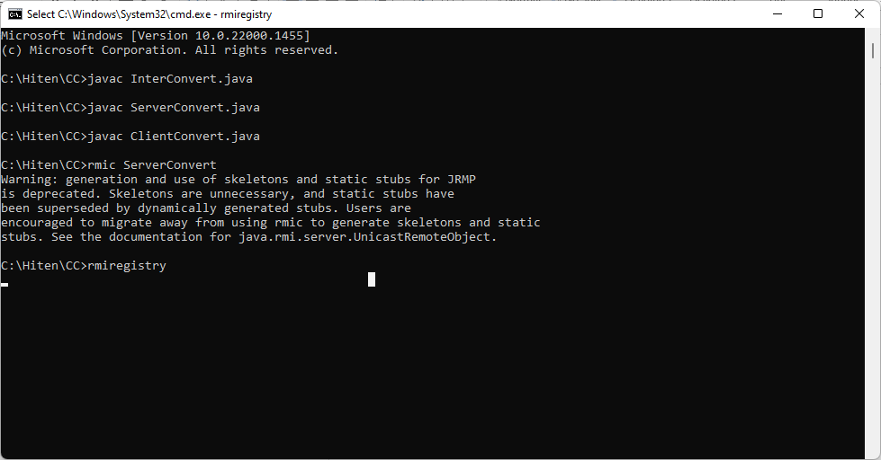

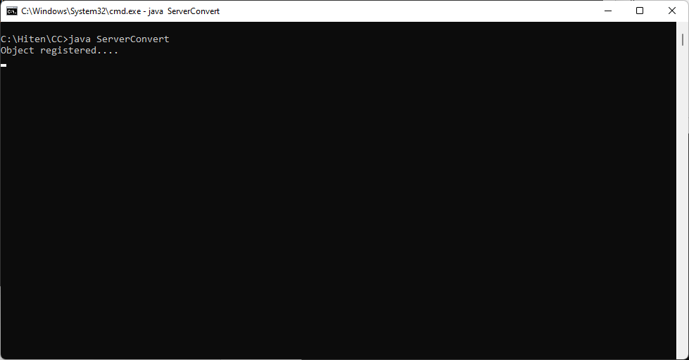

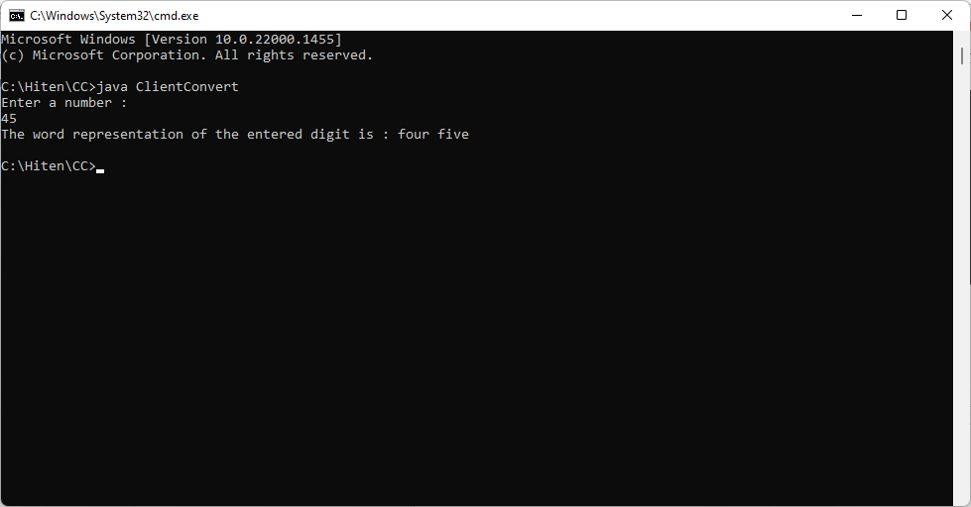

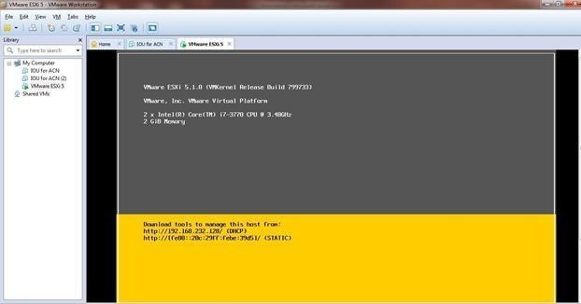

PRACTICAL 7
  - Implement virtualization using VMWare ESXi Server and managing with vCenter Aim: Implement virtualization using VMWare ESXi Server and managing with vCenter Steps:
Install ESXi iso in VMWare workstation. Install VMware vSphere Client
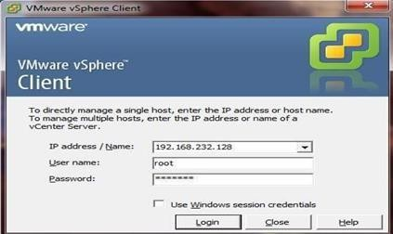

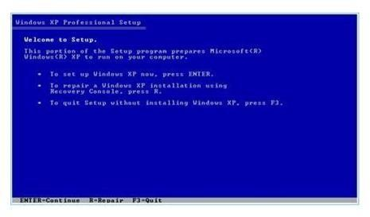
In vSphere create new Virtual Machine. Install Windows XP iso file and open it

PRACTICAL 8

  - Develop application for Google App Engine Aim: Develop application for Google App Engine
    - Open Eclipse Luna. Go to Help Menu Install New Software…
    - In Install window Click on the “Add” button besides the Work with textbox. AddRepository window appears. Enter the Location as “https://dl.google.com/eclipse/plugin/4.4” and click on “OK” button.
    - From the available softwares select the required softwares and tools as shown in thebelow image for the GAE. Then click on the “Next” button.
    - In the Install Details window click on “Next” button.
    - In the Next Window "Review the Items to be Installed" then click on “Next”
    - In the next window for Review Licenses select the option “I accept……” and click on “Finish Button.
    - After Installation you will get option to "Restart Eclipse", click on
Yes. So that the software you selected gets updated...
    - Now, go to File Menu_New_Other.
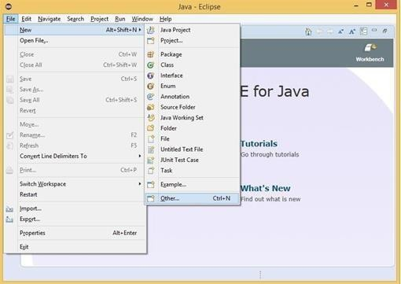

In the New window select Google Web Application Project and click on “Next” button.

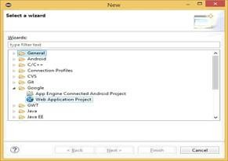
Enter the details for the new Web application project. Deselect the Use Google Web Toolkit
option under the section Google SDKs. Click on the “Finish” button.
From the Package Explorer open the .java file (Here it is “Google_App_EngineServlet.java”).
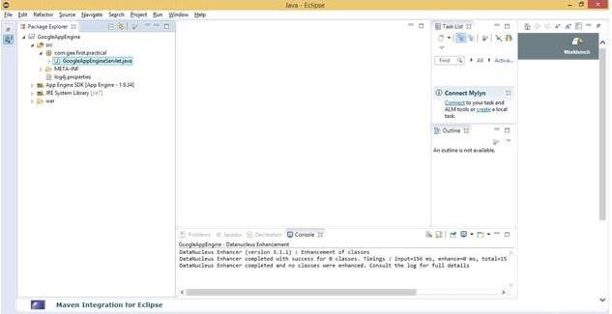

Edit the file as required (Unedited file too can be used. Here the editing is done to “what should be displayed” on the browser). Save the file. Click on the Run option available on the Tools bar.

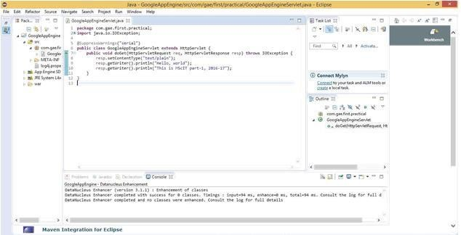

In the browser (Here, Google Chrome) type the address as “localhost:8888” which is "Default".

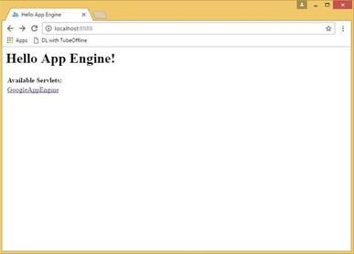
In localhost:8888 the link to the Google_App_EngineServlet.java file as Google_App_Engine is displayed. Click on this link. It will direct you to “localhost:8888/Google_App_Engine”.

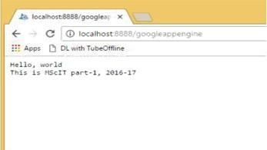

The output text entered in the java program is displayed as the output when clicked the link “Google App Engine”

SOFT COMPUTING TECHNIQUES

SAKET GYANPEETH’S

SAKET COLLEGE OF ARTS, SCIENCE AND COMMERCE

(Permanently Affiliated to University of Mumbai) NAAC Accredited B Grade
Saket Vidyanagari Marg, Chinchpada Road, Katemanivali, Kalyan (East) – 421306, Dist.
Department of Information Technology
Thane (MAH)

CERTIFICATE

This is to certify that

ANSHUMAN GAURISHANKAR SINGH of MSc Information Technology Part-I Class has satisfactory carried out the required practical in the subject.
SOFT COMPUTING TECHNIQUES

For the Academic year 2022 – 2023

Practical In-Charge Head of Department External Examiner

INDEX

Sr. No. | Aim | Sign
1 | To implement Perceptron Algorithm
2 | To implement Back Propagation Algorithm
3 | To implement Hebb’s Rule in C++
4 | To implement McCulloh Pits model for XOR gate
5 | To implement Maxnet
6 | To implement BAM using python
7 | Find the ratios using fuzzy logic
8 | Fuzzy logic for tipping

PRACTICAL 1
AIM: To implement Perceptron Algorithm

CODE:
from sklearn import datasets import matplotlib.pyplot as plt import numpy as np
X, y = datasets.make_blobs(n_samples=150,n_features=2, centers=2,cluster_std=1.05, random_state=2)
X, y = datasets.make_blobs(n_samples=150,n_features=2, centers=2,cluster_std=1.05, random_state=2)
fig = plt.figure(figsize=(10,8))
plt.plot(X[:, 0][y == 0], X[:, 1][y == 0], 'r^')
plt.plot(X[:, 0][y == 1], X[:, 1][y == 1], 'bs')
plt.xlabel("feature 1")
plt.ylabel("feature 2")
plt.title('Random Classification Data with 2 classes')
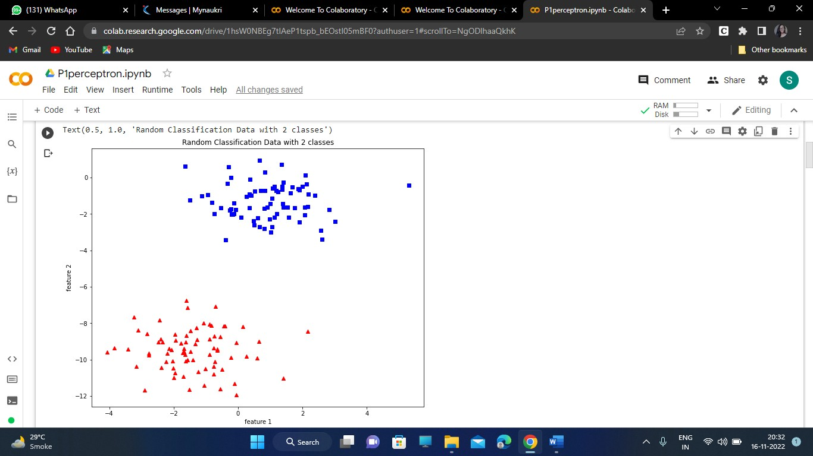

def step_func(z):
return 1.0 if (z > 0) else 0.0 # looping for every example.
for idx, x_i in enumerate(X):
# Insering 1 fordef perceptron(X, y, lr, epochs): # X --> Inputs.

# y --> labels/target. # lr --> learning rate.
# epochs --> Number of iterations.

# m-> number of training examples # n-> number of features
m, n = X.shape

# Initializing parapeters(theta) to zeros. # +1 in n+1 for the bias term.
theta = np.zeros((n+1,1))

# Empty list to store how many examples were # misclassified at every iteration.
n_miss_list = []

# Training.
for epoch in range(epochs):

# variable to store #misclassified. n_miss = 0
bias, X0 = 1.
x_i = np.insert(x_i, 0, 1).reshape(-1,1)

# Calculating prediction/hypothesis. y_hat = step_func(np.dot(x_i.T, theta))

# Updating if the example is misclassified. if (np.squeeze(y_hat) - y[idx]) != 0:
theta += lr*((y[idx] - y_hat)*x_i)

# Incrementing by 1. n_miss += 1

# Appending number of misclassified examples # at every iteration. n_miss_list.append(n_miss)

return theta, n_miss_list
def plot_decision_boundary(X, theta):

# X --> Inputs
# theta --> parameters

# The Line is y=mx+c
# So, Equate mx+c = theta0.X0 + theta1.X1 + theta2.X2 # Solving we find m and c
x1 = [min(X[:,0]), max(X[:,0])]
m = -theta[1]/theta[2] c = -theta[0]/theta[2] x2 = m*x1 + c

# Plotting
fig = plt.figure(figsize=(10,8)) plt.plot(X[:, 0][y==0], X[:, 1][y==0], "r^")
plt.plot(X[:, 0][y==1], X[:, 1][y==1], "bs")
plt.xlabel("feature 1")
plt.ylabel("feature 2") plt.title('Perceptron Algorithm') plt.plot(x1, x2, 'y-')
theta, miss_l = perceptron(X, y, 0.5, 100) plot_decision_boundary(X, theta)

OUTPUT:
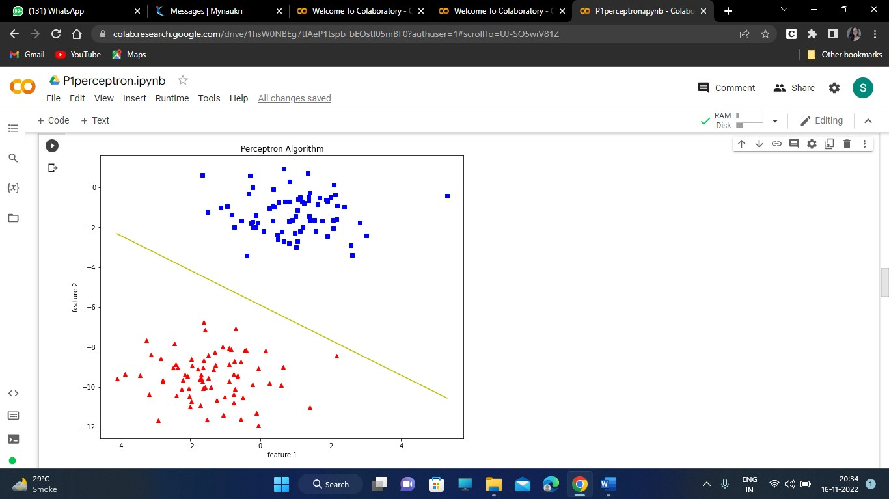

CONCLUSION: Thus implemented the experiment successfully.

PRACTICAL 2
AIM: To implement Back Propagation Algorithm

CODE:
# Import Libraries import numpy as np import pandas as pd
from sklearn.datasets import load_iris
from sklearn.model_selection import train_test_split import matplotlib.pyplot as plt
# Load dataset data = load_iris()
# Get features and target
X=data.data y=data.target
# Get dummy variable
y = pd.get_dummies(y).values y[:3]
Output: array([[1, 0, 0], [1, 0, 0], [1, 0, 0]], dtype=uint8) #Split data into train and test data
X_train, X_test, y_train, y_test = train_test_split(X, y, test_size=20, random_state=4)
# Initialize variables learning_rate = 0.1
iterations = 5000 N = y_train.size
# number of input features input_size = 4
# number of hidden layers neurons hidden_size = 2
# number of neurons at the output layer output_size = 3
results = pd.DataFrame(columns=["mse", "accuracy"]) # Initialize weights
np.random.seed(10)
# initializing weight for the hidden layer
W1 = np.random.normal(scale=0.5, size=(input_size, hidden_size)) # initializing weight for the output layer
W2 = np.random.normal(scale=0.5, size=(hidden_size , output_size)) def sigmoid(x):
return 1 / (1 + np.exp(-x))
def mean_squared_error(y_pred, y_true):
return ((y_pred - y_true)**2).sum() / (2*y_pred.size) def accuracy(y_pred, y_true):

acc = y_pred.argmax(axis=1) == y_true.argmax(axis=1) return acc.mean()
for itr in range(iterations):
# feedforward propagation # on hidden layer
Z1 = np.dot(X_train, W1) A1 = sigmoid(Z1)
# on output layer
Z2 = np.dot(A1, W2) A2 = sigmoid(Z2)
# Calculating error
mse = mean_squared_error(A2, y_train) acc = accuracy(A2, y_train)
results=results.append({"mse":mse, "accuracy":acc},ignore_index=True ) # backpropagation
E1 = A2 - y_train
dW1 = E1 * A2 * (1 - A2)
E2 = np.dot(dW1, W2.T) dW2 = E2 * A1 * (1 - A1)
# weight updates
W2_update = np.dot(A1.T, dW1) / N W1_update = np.dot(X_train.T, dW2) / N W2 = W2 - learning_rate * W2_update W1 = W1 - learning_rate * W1_update
results.mse.plot(title="Mean Squared Error")
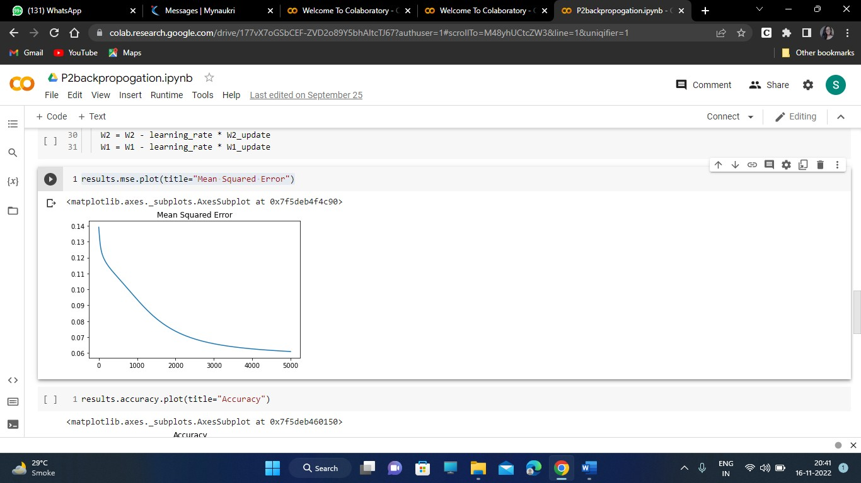
results.accuracy.plot(title="Accuracy")

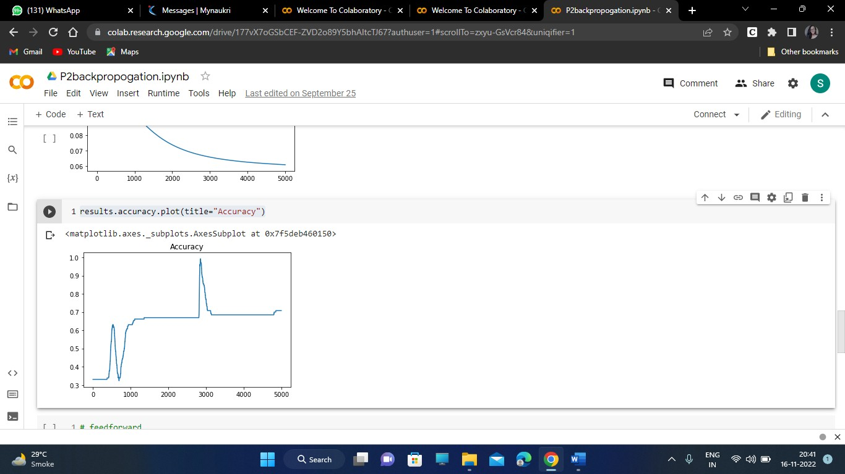
# feedforward
Z1 = np.dot(X_test, W1) A1 = sigmoid(Z1)
Z2 = np.dot(A1, W2)
A2 = sigmoid(Z2)
acc = accuracy(A2, y_test) print("Accuracy: {}".format(acc))

OUTPUT: Accuracy: 0.8
CONCLUSION: Thus implemented the experiment successfully.

PRACTICAL 3

AIM: To implement Hebb’s Rule in C++

CODE:
#include<iostream> using namespace std; int main()
{
int m,n;
cout<<"enter no.of features and no.of training datasets: \n"; cin>> m>>n;
int wt1[m], wt2[m];
int input[n][m];
cout<<"enter the input matrix row wise "<<endl; for(int i=0;i<n;i++)
{
for(int j=0;j<m;j++)
{
cin>>input[i][j];
}
}

int target1[n], target2[n];
cout<<" Enter the target in binary : "<<endl; for(int i=0;i<n;i++)
{
cin>>target1[i];
}
cout<<"Enter the target in bipolar: "<<endl; for(int i=0;i<n;i++)
{
cin>>target2[i];
}
for(int i=0;i<m;i++)
{
wt1[i]=0; //step 1: initialise all wts to 0 wt2[i]=0;
}
for(int j=0;j<n;j++)
{
cout<<"###########j="<<j<<endl; for(int i=0; i<m;i++)
{
wt1[i]+= (input[j][i]*target1[j]);

cout<<"weight1 at i="<<i<<" is "<<wt1[i]<<endl; wt2[i]+= (input[j][i]*target2[j]);
cout<<"wt2 at i="<<i<<" is "<<wt2[i]<<endl;
}
}
cout<<"************OUTPUT**************\nafter 1 epoch: binary weights: "<<endl; for (int i = 0; i < m; ++i)
{
/* code */ cout<<wt1[i]<<" ";
}
cout<<"\nafter 1 epoch: bipolar weights: "<<endl; for (int i = 0; i < m; ++i)
{
/* code */ cout<<wt2[i]<<" ";
}
return 0;
}

Output:
enter no.of features and no.of training datasets: 3 4
enter the input matrix row wise
-1 -1 1
-1 1 1
1 1 -1
1 1 1
Enter the target in binary : 0
0
0
1
Enter the target in bipolar:
-1
-1
-1
1 ###########j=0
weight1 at i=0 is 0 wt2 at i=0 is 1 weight1 at i=1 is 0 wt2 at i=1 is 1 weight1 at i=2 is 0

wt2 at i=2 is -1 ###########j=1
weight1 at i=0 is 0
wt2 at i=0 is 2 weight1 at i=1 is 0 wt2 at i=1 is 0 weight1 at i=2 is 0 wt2 at i=2 is -2 ###########j=2
weight1 at i=0 is 0 wt2 at i=0 is 1 weight1 at i=1 is 0 wt2 at i=1 is -1 weight1 at i=2 is 0 wt2 at i=2 is -1 ###########j=3
weight1 at i=0 is 1 wt2 at i=0 is 2 weight1 at i=1 is 1 wt2 at i=1 is 0 weight1 at i=2 is 1 wt2 at i=2 is 0
************OUTPUT************** after 1 epoch: binary weights:
1 1 1
after 1 epoch: bipolar weights:
2 0 0

** Process exited - Return Code: 0 **

CONCLUSION: Thus implemented the experiment successfully.

PRACTICAL 4
AIM: To implement McCulloh Pits model for XOR gate

CODE:
# import Python Libraries import numpy as np
from matplotlib import pyplot as plt
# Sigmoid Function def sigmoid(z):
return 1 / (1 + np.exp(-z))
# Initialization of the neural network parameters
# Initialized all the weights in the range of between 0 and 1 # Bias values are initialized to 0
def initializeParameters(inputFeatures, neuronsInHiddenLayers, outputFeatures): W1 = np.random.randn(neuronsInHiddenLayers, inputFeatures)
W2 = np.random.randn(outputFeatures, neuronsInHiddenLayers) b1 = np.zeros((neuronsInHiddenLayers, 1))
b2 = np.zeros((outputFeatures, 1)) parameters = {"W1" : W1, "b1": b1,
"W2" : W2, "b2": b2}
return parameters
# Forward Propagation
def forwardPropagation(X, Y, parameters): m = X.shape[1]
W1 = parameters["W1"]
W2 = parameters["W2"] b1 = parameters["b1"] b2 = parameters["b2"] Z1 = np.dot(W1, X) + b1 A1 = sigmoid(Z1)
Z2 = np.dot(W2, A1) + b2
A2 = sigmoid(Z2)
cache = (Z1, A1, W1, b1, Z2, A2, W2, b2)
logprobs = np.multiply(np.log(A2), Y) + np.multiply(np.log(1 - A2), (1 - Y)) cost = -np.sum(logprobs) / m
return cost, cache, A2 # Backward Propagation
def backwardPropagation(X, Y, cache): m = X.shape[1]
(Z1, A1, W1, b1, Z2, A2, W2, b2) = cache dZ2 = A2 - Y
dW2 = np.dot(dZ2, A1.T) / m
db2 = np.sum(dZ2, axis = 1, keepdims = True) dA1 = np.dot(W2.T, dZ2)
dZ1 = np.multiply(dA1, A1 * (1- A1))

dW1 = np.dot(dZ1, X.T) / m
db1 = np.sum(dZ1, axis = 1, keepdims = True) / m gradients = {"dZ2": dZ2, "dW2": dW2, "db2": db2,
"dZ1": dZ1, "dW1": dW1, "db1": db1}
return gradients
# Updating the weights based on the negative gradients
def updateParameters(parameters, gradients, learningRate): parameters["W1"] = parameters["W1"] - learningRate * gradients["dW1"] parameters["W2"] = parameters["W2"] - learningRate * gradients["dW2"] parameters["b1"] = parameters["b1"] - learningRate * gradients["db1"] parameters["b2"] = parameters["b2"] - learningRate * gradients["db2"] return parameters
# Model to learn the XOR truth table
X = np.array([[0, 0, 1, 1], [0, 1, 0, 1]]) # XOR input
Y = np.array([[0, 1, 1, 0]]) # XOR output # Define model parameters
neuronsInHiddenLayers = 2 # number of hidden layer neurons (2) inputFeatures = X.shape[0] # number of input features (2) outputFeatures = Y.shape[0] # number of output features (1)
parameters = initializeParameters(inputFeatures, neuronsInHiddenLayers, outputFeatures) epoch = 100000
learningRate = 0.01
losses = np.zeros((epoch, 1)) for i in range(epoch):
losses[i, 0], cache, A2 = forwardPropagation(X, Y, parameters) gradients = backwardPropagation(X, Y, cache)
parameters = updateParameters(parameters, gradients, learningRate)
# Evaluating the performance plt.figure()
plt.plot(losses) plt.xlabel("EPOCHS") plt.ylabel("Loss value") plt.show()
# Testing
X = np.array([[1, 1, 0, 0], [0, 1, 0, 1]]) # XOR input
cost, _, A2 = forwardPropagation(X, Y, parameters) prediction = (A2 > 0.5) * 1.0
# print(A2) print(prediction)

OUTPUT:

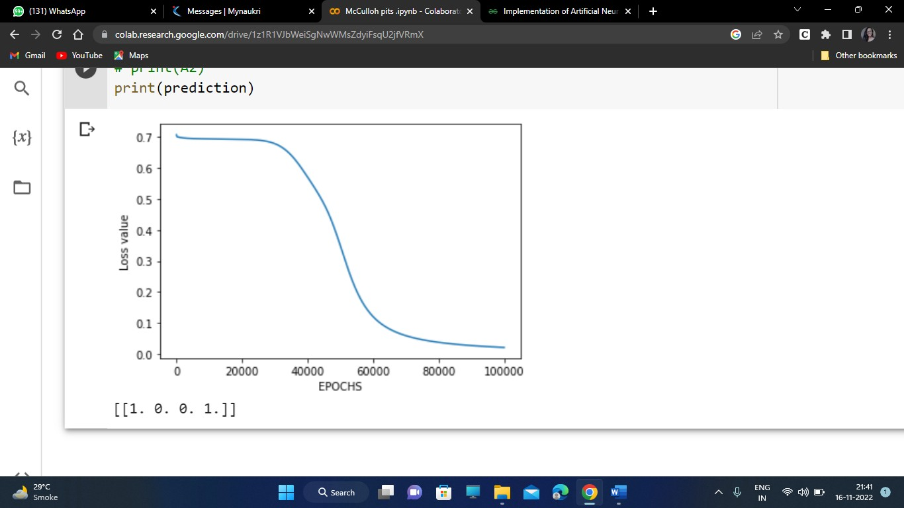

CONCLUSION: Thus implemented the experiment successfully.

PRACTICAL 5

AIM: To implement Maxnet

CODE:
def winner(mylist): a=[]
for i in range(0,len(mylist)): if mylist[i]>0:
a.append(i) return a
m=0 delta=0 yin=[0] epoch=0
f=open("maxnet_input.txt") linenumber=0
while True:
line=f.readline() line=line.rstrip('\n') if len(line)==0:
break linenumber+=1 word=line.split('=') if linenumber==1:
m=int(word[1]) yin=yin*m
if linenumber==3: x=word[1].split(',')
for i in range(x.__len__()): yin[i]=float(x[i])
if linenumber==2: delta=float(word[1])
f.close(); while True:
epoch+=1 yout=[]
for i in range(0,m): if yin[i]>=0:
yout.append(yin[i])
else:
yout.append(0)
if len(winner(yout))==1:
print('winner unit is : ',winner(yout)[0]+1) break

for i in range(0,m):
yin[i]=yout[i]-(sum(yout)-yout[i])*delta if epoch==100:
break

OUTPUT: winner unit is : 4

CONCLUSION: Thus implemented the experiment successfully.

PRACTICAL 6
AIM: To implement BAM using python

CODE:
# Import Python Libraries import numpy as np
# Take two sets of patterns:
# Set A: Input Pattern
x1 = np.array([1, 1, 1, 1, 1, 1]).reshape(6, 1)
x2 = np.array([-1, -1, -1, -1, -1, -1]).reshape(6, 1)
x3 = np.array([1, 1, -1, -1, 1, 1]).reshape(6, 1)
x4 = np.array([-1, -1, 1, 1, -1, -1]).reshape(6, 1) # Set B: Target Pattern
y1 = np.array([1, 1, 1]).reshape(3, 1)
y2 = np.array([-1, -1, -1]).reshape(3, 1)
y3 = np.array([1, -1, 1]).reshape(3, 1)
y4 = np.array([-1, 1, -1]).reshape(3, 1) '''
print("Set A: Input Pattern, Set B: Target Pattern")
print("\nThe input for pattern 1 is") print(x1)
print("\nThe target for pattern 1 is") print(y1)
print("\nThe input for pattern 2 is") print(x2)
print("\nThe target for pattern 2 is") print(y2)
print("\nThe input for pattern 3 is") print(x3)
print("\nThe target for pattern 3 is") print(y3)
print("\nThe input for pattern 4 is") print(x4)
print("\nThe target for pattern 4 is") print(y4)
print("\n ")
'''
# Calculate weight Matrix: W
inputSet = np.concatenate((x1, x2, x3, x4), axis = 1) targetSet = np.concatenate((y1.T, y2.T, y3.T, y4.T), axis = 0) print("\nWeight matrix:")
weight = np.dot(inputSet, targetSet) print(weight)
print("\n ") # Testing Phase

# Test for Input Patterns: Set A print("\nTesting for input patterns: Set A") def testInputs(x, weight):
# Multiply the input pattern with the weight matrix # (weight.T X x)
y = np.dot(weight.T, x) y[y < 0] = -1
y[y >= 0] = 1
return np.array(y) print("\nOutput of input pattern 1") print(testInputs(x1, weight)) print("\nOutput of input pattern 2") print(testInputs(x2, weight)) print("\nOutput of input pattern 3") print(testInputs(x3, weight)) print("\nOutput of input pattern 4") print(testInputs(x4, weight))
# Test for Target Patterns: Set B print("\nTesting for target patterns: Set B") def testTargets(y, weight):
# Multiply the target pattern with the weight matrix
# (weight X y)
x = np.dot(weight, y) x[x <= 0] = -1
x[x > 0] = 1
return np.array(x)
print("\nOutput of target pattern 1") print(testTargets(y1, weight)) print("\nOutput of target pattern 2") print(testTargets(y2, weight)) print("\nOutput of target pattern 3") print(testTargets(y3, weight)) print("\nOutput of target pattern 4") print(testTargets(y4, weight))

OUTPUT:
Weight matrix: [[4 0 4]
[4 0 4]
[0 4 0]
[0 4 0]
[4 0 4]
[4 0 4]]

Testing for input patterns: Set A Output of input pattern 1
[[1]
[1]
[1]]
Output of input pattern 2 [[-1]
[-1]
[-1]]
Output of input pattern 3 [[ 1]
[-1]
[ 1]]
Output of input pattern 4 [[-1]
[ 1]
[-1]]
Testing for target patterns: Set B Output of target pattern 1
[[1]
[1]
[1]
[1]
[1]
[1]]
Output of target pattern 2 [[-1]
[-1]
[-1]
[-1]
[-1]
[-1]]
Output of target pattern 3 [[ 1]
[ 1]
[-1]
[-1]
[ 1]
[ 1]]
Output of target pattern 4 [[-1]
[-1]

[ 1]
[ 1]
[-1]
[-1]]

CONCLUSION: Thus implemented the experiment successfully.

PRACTICAL 7
AIM: Find the ratios using fuzzy logic

CODE:
!pip install fuzzywuzzy
!pip install python-Levenshtein from fuzzywuzzy import fuzz
from fuzzywuzzy import process s1 = "I love fuzzysforfuzzys"
s2 = "I am loving fuzzysforfuzzys"
print ("FuzzyWuzzy Ratio:", fuzz.ratio(s1, s2))
print ("FuzzyWuzzy PartialRatio: ", fuzz.partial_ratio(s1, s2))
print ("FuzzyWuzzy TokenSortRatio: ", fuzz.token_sort_ratio(s1, s2)) print ("FuzzyWuzzy TokenSetRatio: ", fuzz.token_set_ratio(s1, s2)) print ("FuzzyWuzzy WRatio: ", fuzz.WRatio(s1, s2),'\n\n')
# for process library, query = 'fuzzys for fuzzys'
choices = ['fuzzy for fuzzy', 'fuzzy fuzzy', 'g. for fuzzys'] print ("List of ratios: ")
print (process.extract(query, choices), '\n')
print ("Best among the above list: ",process.extractOne(query, choices))

OUTPUT:
FuzzyWuzzy Ratio: 86
FuzzyWuzzy PartialRatio: 86
FuzzyWuzzy TokenSortRatio: 86
FuzzyWuzzy TokenSetRatio: 87
FuzzyWuzzy WRatio: 86 List of ratios:
[('g. for fuzzys', 95), ('fuzzy for fuzzy', 94), ('fuzzy fuzzy', 86)] Best among the above list: ('g. for fuzzys', 95)

CONCLUSION: Thus implemented the experiment successfully.

PRACTICAL 8
AIM: Fuzzy logic for tipping

CODE:
!pip install scikit-fuzzy import numpy as np import skfuzzy as fuzz
from skfuzzy import control as ctrl
# New Antecedent/Consequent objects hold universe variables and membership # functions
quality = ctrl.Antecedent(np.arange(0, 11, 1), 'quality')
service = ctrl.Antecedent(np.arange(0, 11, 1), 'service')
tip = ctrl.Consequent(np.arange(0, 26, 1), 'tip') quality.automf(3)
service.automf(3)
tip['low'] = fuzz.trimf(tip.universe, [0, 0, 13])
tip['medium'] = fuzz.trimf(tip.universe, [0, 13, 25])
tip['high'] = fuzz.trimf(tip.universe, [13, 25, 25]) quality['average'].view()
service.view() tip.view()
rule1 = ctrl.Rule(quality['poor'] | service['poor'], tip['low']) rule2 = ctrl.Rule(service['average'], tip['medium'])
rule3 = ctrl.Rule(service['good'] | quality['good'], tip['high']) rule1.view()
tipping_ctrl = ctrl.ControlSystem([rule1, rule2, rule3]) tipping = ctrl.ControlSystemSimulation(tipping_ctrl) tipping.input['quality'] = 6.5
tipping.input['service'] = 9.8 tipping.compute()
print (tipping.output['tip'])
tip.view(sim=tipping)

OUTPUT:

19.847607361963192

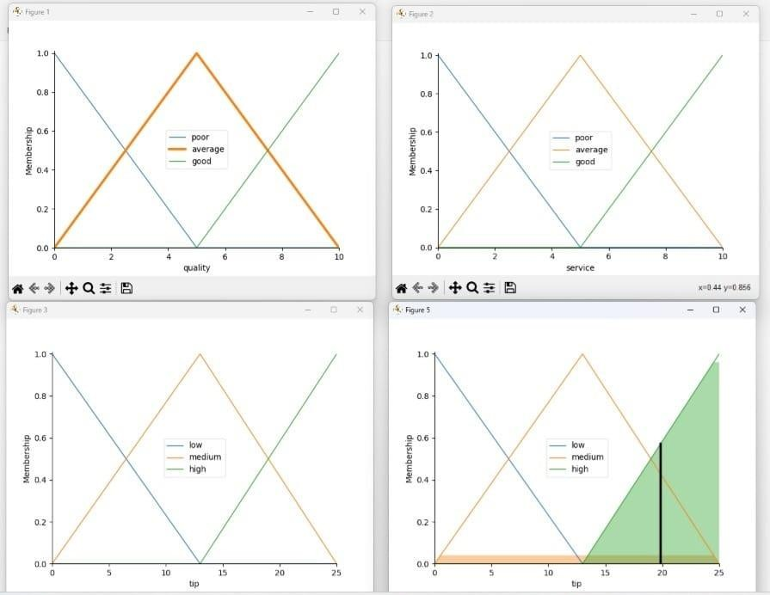
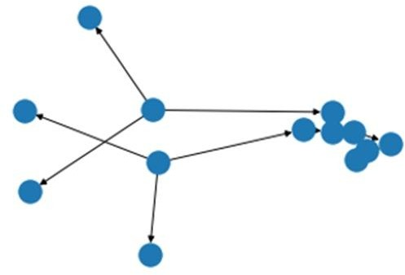

CONCLUSION: Thus implemented the experiment successfully.

