**Capstone Design**

**Project Proposal**



**Chung-Ang University**

**Team Groza**

**Dog Nose Recognition**

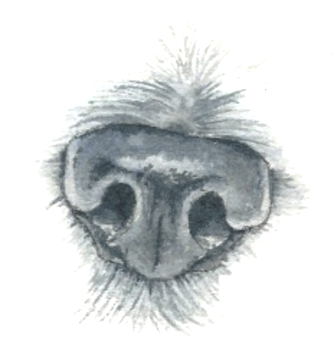 Schedule

|  |  |
| --- | --- |
| Week | To-Do (can be changed) |
| **Week 1** | Project goal setting |
| **Week 2** | Propose project |
| **Week 3** | Design: User Interface, System Architectures  Setting : Development Environment, |
| **Week 4** | Workshop for collecting data set( Dog cafe, park, .. etc)  Hong : Launching AWS server environment  Chan : Applying Design to Android Studio  Paeng : Develop Pre-processing Method and apply it to Fingerprint picture. |
| **Week 5** | Hong : build the basic code in the server  Chan : Develop Android Application  Paeng : Apply Pre-processing method to the dog’s nose picture using python opencv. |
| **Week 6** | Hong : Complete the developing basic Server Core  Chan : Develop Android Application  Paeng : Develop Feature Detecting & Matching |
| **Week 7** | Hong : connect the server and application  Chan : Complete Android Application  Paeng : Refactoring Code to get good performance |
| **Week 8** | Midterm Examination |

|  |  |
| --- | --- |
| Week | To-Do (can be changed) |
| **Week 9** | Hold a meeting and make a Plan based on Midterm Demonstration. |
| **Week 10** | **Android** : Image Upload Function.  **Server** : Add a image data column in database and link with python code.  **Python** : Link to the server |
| **Week 11** | **Android** : E-mail Certification function.  **Server** : link to python code completely and buy a server.  **Python** : Find the way to save the feature template in database. |
| **Week 12** | **Android** : Complete the detail function. (Edit Profile, etc...)  **Server** : Divide the mode of the function in server.  **Python** : Code refactoring and enhance the performance. |
| **Week 13** | **Android** : Debugging and error fixing.  **Server** : Move the data to the database that we bought, and refactor.  **Python** : Code refactoring and enhance the performance. |
| **Week 14** | **Android** : Release the Beta Version and unit testing by users.  **Server** : Error fixing, and managing the server.  **Python** : Code refactoring and enhance the performance. |
| **Week 15** | **Final Demonstration** |
| **Week 16** | Final Examination |