

**Total Energy and Emissions Analysis for Marine Systems (TEAMS) Module for GREET**

The Lab for Environmental Computing and Decision Making

Rochester, New York

**USER GUIDE**

Version 1.0: May 2014

**TEAMS Module and User Guide were developed by:**

James J. Winebrake, Ph.D.

Director, Center for Energy and Environmental Analysis

Chair, Department of Science, Technology & Society/Public Policy

Rochester Institute of Technology

Rochester, NY

James J. Corbett, Ph.D.

Marine Policy Program

University of Delaware

Newark, DE

Patrick E. Meyer

Center for Energy and Environmental Policy

University of Delaware

Newark, DE

**Work Sponsored by:**

United States Department of Transportation,

Research and Special Programs Administration

Center for Climate Change Research

Under project number DTRS56-04-BAA-0001

**Special Thanks to:**

Mr. Daniel Yuska

Office of Environmental Activities

Maritime Administration

United States Department of Transportation

Thanks to Christopher Meyer for designing the TEAMS logo.

The authors would also like to thank members of the Technical Review Group who provided invaluable feedback related to the development of the TEAMS Model.



This report is printed on recycled paper.

**Table of Contents**

1. **Overview……………………………………………………………………1**
2. **Installation………………………………………………………………….2**
3. **User Input Sheet……...……………………………………….……………4**
4. **Results Sheet………………………………………………………………..9**
5. **Interpreting Results………………………………………………………10**
6. **Editing Resource Variables………………………………………………12**
7. **Editing Pathways…………………………………………………………...1**
8. **Saving/Viewing Results…………………………………………………….1**
9. **Test Cases…………………………………………………………………...1**
10. **Future Developers………………...……………………………………….1**
11. **Overview**

**________________________________________________________________**

In this guide we will detail the purpose, and usage of the TEAMS Module developed at the RIT Lab for Environmental Computing and Decision Making. This piece of software is based on the TEAMS Spreadsheet Model, and is adapted to work in conjunction with the 2013 release of Argonne National Laboratory’s “GREET” Model for energy and emissions calculations. The way the software essentially works is that upon its installation, the user is able to define the conditions that dictate how a given nautical vessel will operate. The user will then be given a choice of six different fuels, with a number of pathways for each, and may choose any for both the main and auxiliary engines of the vessel. There will then be generated a number of results for the ship that represent the energy used to power the ship, as well as the emissions that are created in the trip that was defined by the user.

The results are calculated using a combination of formulas that are derived from those in the original TEAMS model, as well as variables pulled from the GREET model on top of which this module sits. In order to edit anything related to the fuel pathways, or variables that rest on the fuel itself (Density, heating Values etc.) you must interact with the GREET interface itself, and then those values will find themselves into the TEAMS module. This software is means to be used as a tool for research of the effects that different combinations of ships, fuels, and pathways can have on the lifecycle emissions and energy usage of a nautical vessel. If a user wishes to change almost any aspect of the process in order to compare results, it is meant to be possible within this module, and easily saved for later viewing.

1. **Installation**

**__________________________________________________________________**

Steps for installing the TEAMS Module for GREET are as follows:

1. Install the .NET version of the GREET Model (Found here <https://greet.es.anl.gov/greet/setup2013/> )
2. After installing GREET, you’re going to need to open up the program and open the “About” tab on the top of the screen. Then click the “About…” button at the bottom of the menu.

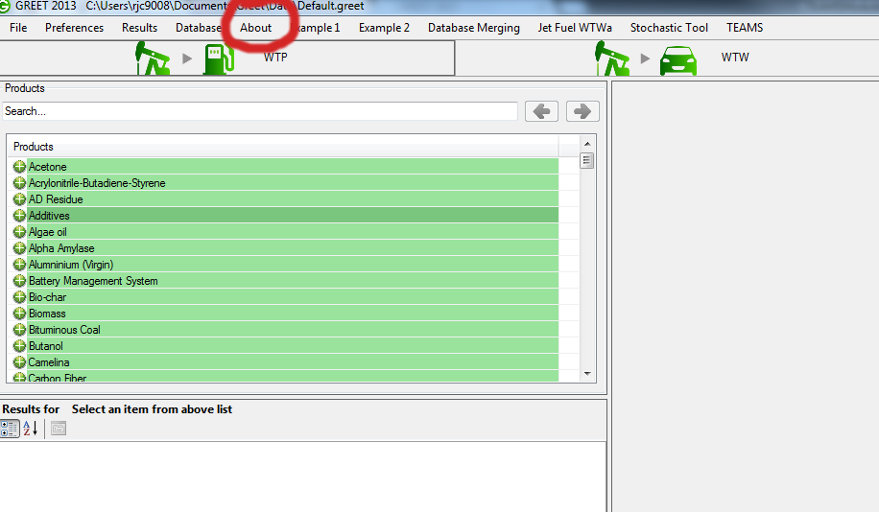

*(Figure 2.1 Shows the GREET program with the “About” tab highlighted)*

1. Once the about menu is open, you will see a string of text you can highlight next to “Installation path.” You should copy this and paste it into your windows explorer in order to open the GREET installation folder. It is important at this point to **CLOSE** the GREET program out, as you cannot install a module while the program is still running.

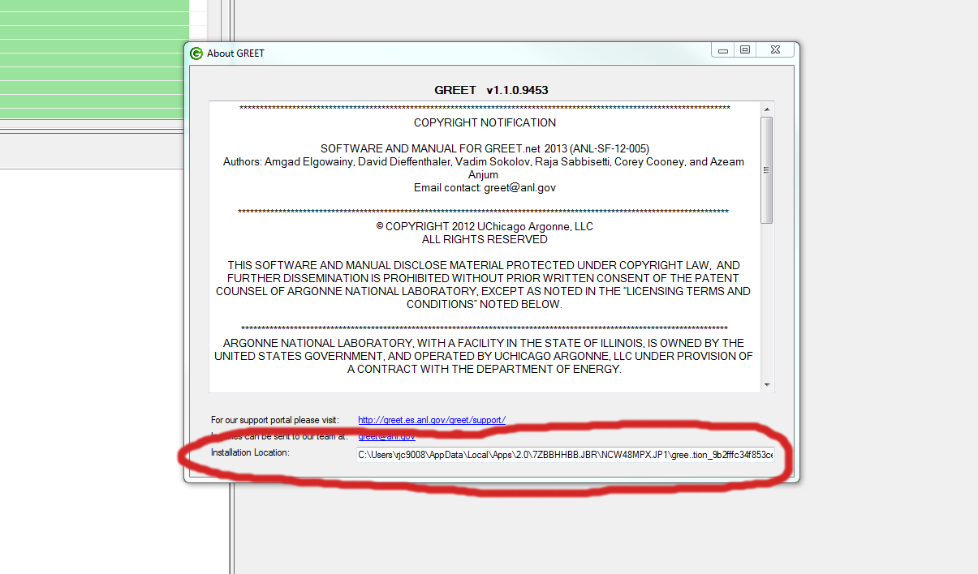

*(Figure 2.2 Shows the about menu with the Installation Path highlighted)*

1. Now that you have the installation folder open, you should open a new window for windows explorer and navigate to the folder that contains your downloaded “TEAMS.dll” file, as well as “EPPlus.dll”
2. You now simply copy the two .dll files into the greet folder we opened in step 3, and once they have transferred the installation is complete.
3. In order to check and make sure that the installation was successful, you should run GREET again and there should be a TEAMS tab now located on the toolbar at the top of the screen.

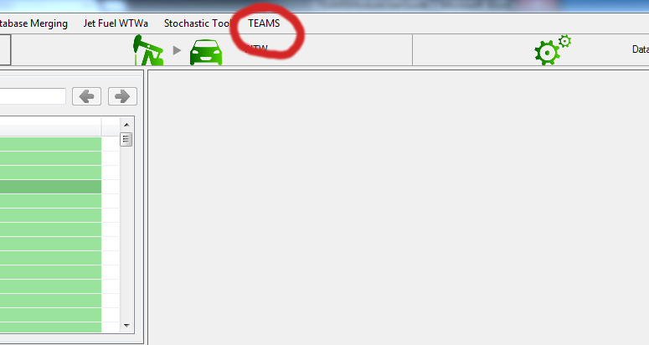

*(Figure 2.3 Shows the TEAMS tab now present on the toolbar)*

1. **User Input Sheet**

**__________________________________________________________________**

The User Input Sheet in the TEAMS Module should be the first page you are able to access after hitting start and accepting the license agreement. This sheet is where you will be able to input all of the information about the specific vessel you are testing for, in order for the results that you get later to be an accurate representation of how the different fuel choices would affect your test case.

**Input Sheet Breakdown: Main Engine** 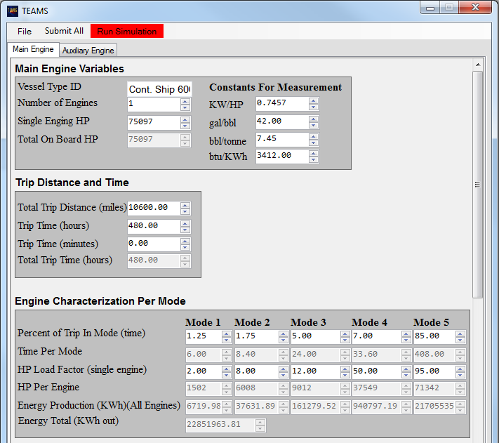*(Figure 3.1 Shows the top of the Main Engine User Input Sheet in the TEAMS Module)*

* **Main Engine Variables –** This section essentially defines the characteristics of the main engine(s) for the vessel you are testing. All values that are not grayed out can be altered by the user in order to tweak the simulation to conditions that more accurately represent the case you wish to test. The grayed out values are those that are calculated based on other user defined data, so you cannot manually alter these, but if you change a related variable and hit either the “Submit All” button at the top of this image, or the “Do Calculations and Submit Data” button at the bottom of Figure 3.2, you will observe that the values have changed.
* **Trip Distance and Time –** Relatively self-explanatory, this is the section in which you enter the information regarding how far your vessel will be traveling, as well as how much time it will take it to get there.
* **Engine Characterization Per Mode –** This section is for the user to define how their trip will be broken up in terms of modes of travel. In the traditional TEAMS model the modes would be Idle, Maneuvering, Precautionary, Slow Cruise, and Full Cruise. However in this version of the model, the modes were left intentionally undefined so that the user could make them represent whatever was desired in the simulation of their vessel.

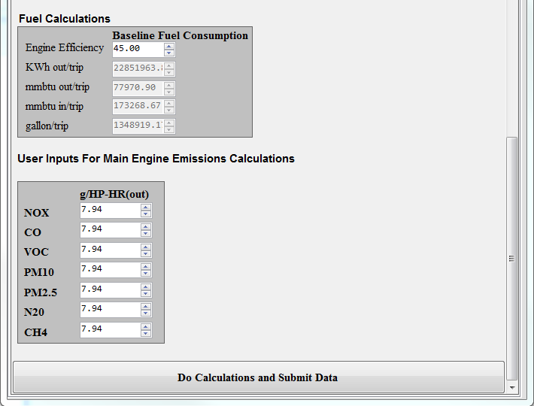*(Figure 3.2 shows the bottom of the Main Engine User Input Sheet in the TEAMS Module)*

* **Fuel Calculations –** In this part, you simply enter the efficiency of the main engine, and the model will calculate an estimation of the gallons of fuel you will use per trip by using conventional diesel as a baseline. That number is later recalculated based on what fuel you choose to use for your main engine.
* **User Inputs for Main Engine Emissions Calculations –** This section is tremendously critical to getting accurate results. Here you are asked to give a number in grams per Horsepower per Hour, which stands as the emissions factor for each of the different types of emission in the section. This number will dictate how much of each of those emissions will be found in the environment following the trip taken with the vessel.

**Input Sheet Breakdown: Auxiliary Engine**

**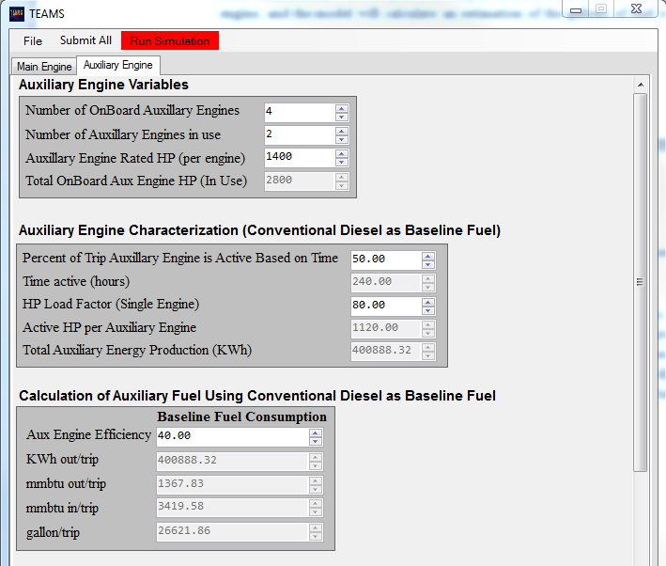***(Figure 3.3 shows the top of the Auxiliary Engine User Input Sheet in the TEAMS Module)*

* **Auxiliary Engine Variables –** This section is a simple breakdown of the basic facts for the Auxiliary engines that are going to be in use for the vessel. Simply how many of them there are, how many will be in use, and their rated HP.
* **Auxiliary Engine Characterization –** This is functionally the same as the Engine Characterization per Mode from Figure 3.1. Except it does not rely on the per mode analysis to generate the data, as the Auxiliary engines are either operational or not, and do not have variables for anything otherwise to worry about.
* **Calculation of Auxiliary Fuel Using Conventional Diesel as a Baseline Fuel –** This is functionally the same as the Fuel Calculations section of Figure 3.2 in the sense that it present just to give a rough estimation of how much fuel will actually be used in order to complete the trip that is being presented. It does so similarly by looking at conventional diesel and making a calculation of how many gallons of that specific fuel there would be in the trip. (This is also recalculated by the model in order to get results later on.)

**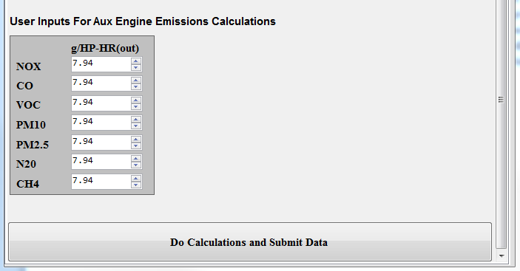***(Figure 3.4 shows the bottom of the Auxiliary Engine User Input Sheet in the TEAMS Module)*

* **User Inputs for Aux Engine Emissions Calculations –** Same as the replica section in Figure 3.2, but for the Auxiliary engine.

**Input Sheet Breakdown: Instructions for Use**

1. Make sure all of the values in the Main Engines sheet are as you would like them (Remember that you cannot directly edit grayed out boxes, but you will get the desired results if you properly handle your other variables)
2. Check your numbers, and then scroll to the bottom of the page and press the “Do Calculations and Submit” button.
3. Move on to tab 2 and fill out the Auxiliary Engine sheet
4. Submit the Aux Engine calculations
5. Upon submitting both sheets (Or just hitting the “Submit All” button on the top) the run simulation button will become active so you can open the results sheet based on your defined simulation parameters
6. Hit the run simulation button, or go back and change results, making sure to hit “Submit All” or “Do Calculations and Submit” before trying to move onto the results phase
7. **Results Sheet**

**__________________________________________________________________**

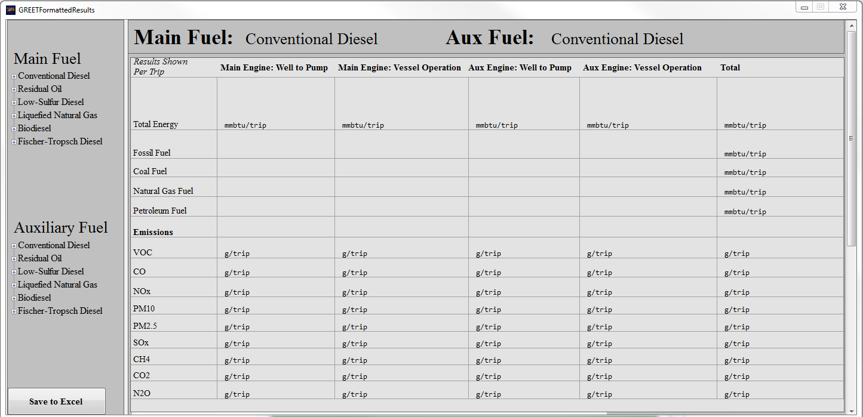*(Figure 4.1 shows the Results Sheet as it appears when initially opened)*

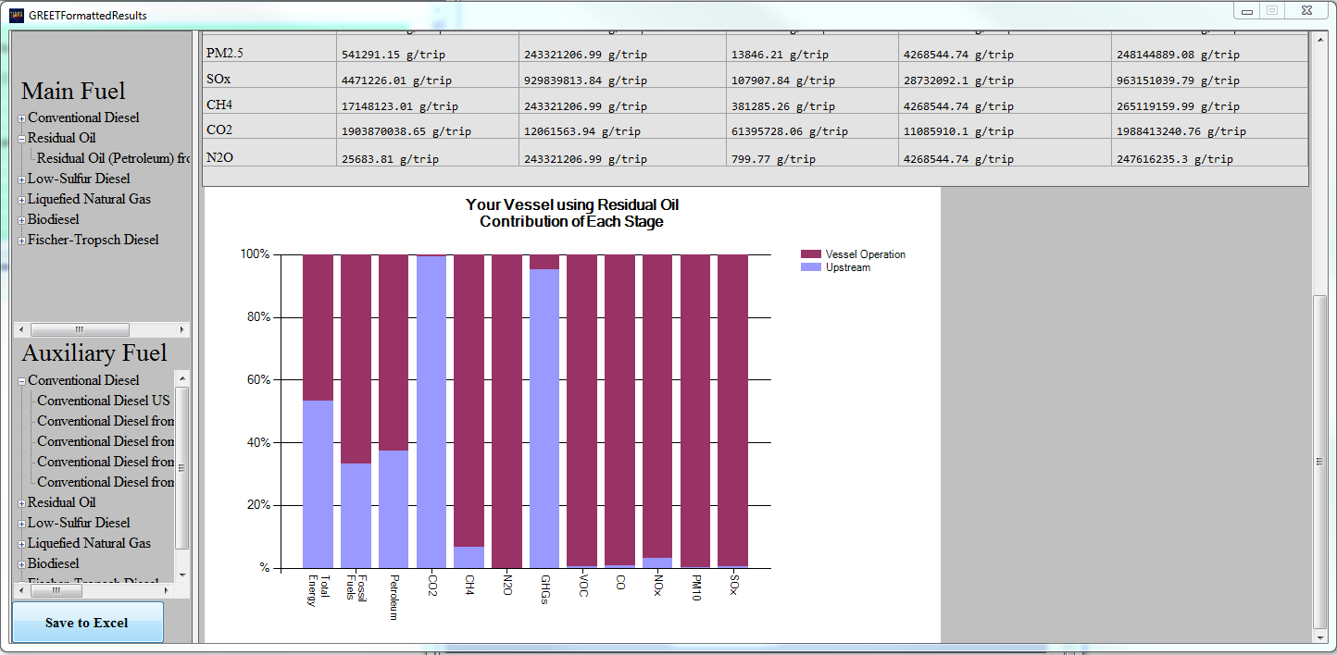*(Figure 4.2 shows the Results Sheet section that contains the stacked bar chart)*

The TEAMS Results sheet is essentially the meat of what is valuable about this particular piece of software. It is the intersection of working with nautical vessel calculations, and using the wealth of data that GREET provides to streamline the simulation of vessel emissions to a point that was not possible with a spreadsheet model. The essential workflow for using the results sheet is as follows.

1. Click on the drop down for the fuel type that you wish to use for main fuel
2. Select the pathway that you wish to use for your vessel’s fuel choice
3. Repeat steps one and two for the Auxiliary fuel
4. When you do the above, results will appear on the sheet that represent emissions and energy use for your vessel taking the trip that you defined on the input sheet.
5. If you scroll down you will see the chart that is shown in figure 4.2
6. You can either use these results as they are, or you can save them to a spreadsheet by clicking on the save to excel button on the sheet, which will generate an .xls that can be read with OpenOffice calc, or with Microsoft Office Excel.
7. **Interpreting Results _____________________________________________________________**

The purpose of the TEAMS Module is to allow a user to get at valuable data for a given nautical vessel without having to painstakingly maintain a spreadsheet of accurate data about the well to pump emissions for different fuel pathways. There are a number of different, important results on the results sheet of the module, and understanding how to read them effectively can assist in making this tool more useful. As such, here are some notes on how the results sheet was put together that may help to expedite the process of using it.

1. On the top left corner of the table that contains the results it is noted that ***RESULTS SHOWN PER TRIP*** this is crucial to understanding how the software comes to your results, and why you needed to input so much data about your voyage earlier on. Essentially the simulation is being run in order to determine the emissions for your vessel if it were to take the trip you define in the user input section. If your trip is not correct, your results won’t be either so you should check multiple times that your inputs are in line with the voyage you want to calculate.
2. At this time the results sheet is broken up into two basic sections: Energy, and Emissions as shown in Figures 5.1, and 5.2 respectively. These two sections represent very different aspects of the calculation, and as such have different units accompanying the answers (mmbtu/trip for energy, and g/trip for emissions.)

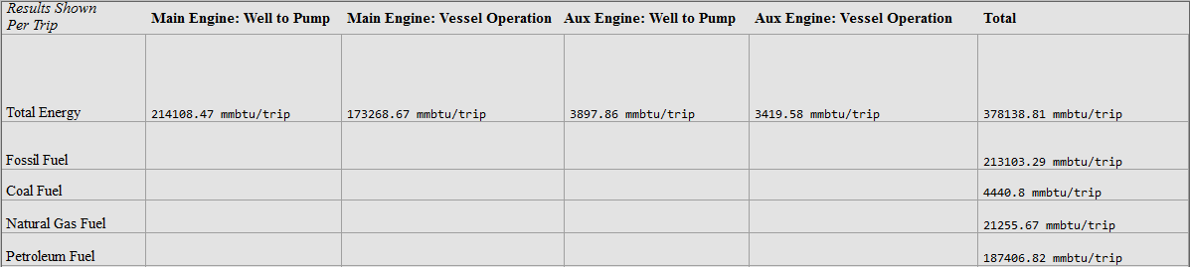*(Figure 5.1 shows the energy half of the results sheet)*

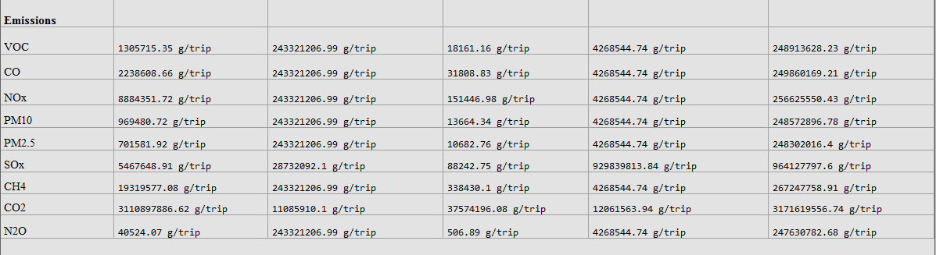*(Figure 5.2 shows the emissions half of the results sheet)*

1. Another important sectioning off of the sheet is the Two **Well to Pump** sections opposed to the two **Vessel Operation** sections. The WTP is the section that shows how much energy or emissions were expended and generated respectively, from the process of getting the fuel processed and into the tank of the ship. The Vessel Operation is just that, the expenditure from the ship actually operating.
2. It bears mentioning that the Total column is the summation of those columns to the left of it. So if you are curious as to how that number is being achieved, it is through adding together all five of the cells to the left in whatever emission you are looking at.
3. **Editing Resource Variables**

**________________________________________________________________**

The resources that are provided as part of the GREET database are some of the most accurate representations of the properties of different types of fuel that are available for this sort of research. However, in many cases a user may want to edit the characteristics of a fuel in order to better represent their individual simulation parameters. There is a way to do this, however it isn’t the simplest process so instructions are provided below.

**Example: Changing the Lower Heating Value of Conventional Diesel**

1. Open up the GREET application
2. Navigate to the “Data Editors” tab as shown in Figure 6.1

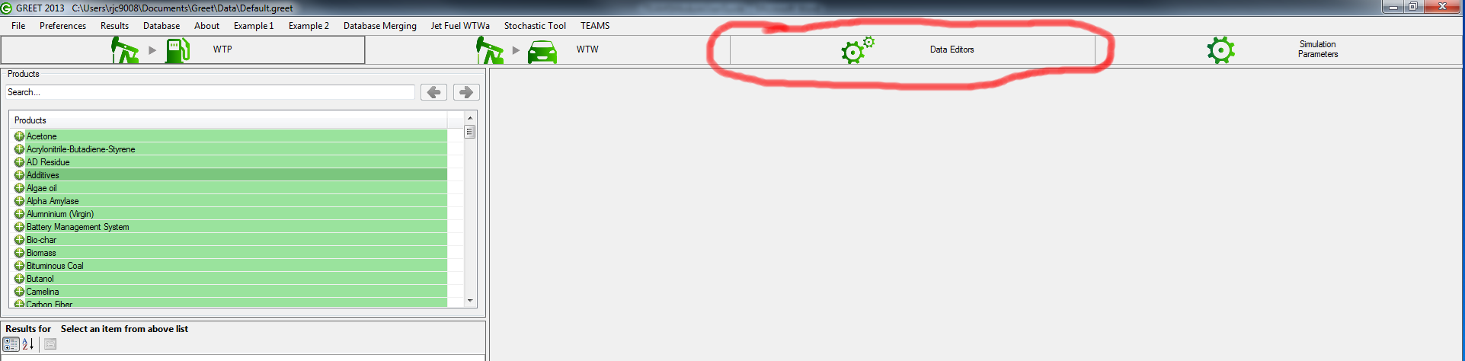*(Figure 6.1 Shows the GREET application with Data Editors highlighted)*

1. Once you are in the Data Editor you should select the “Resources” tab shown in Figure 6.2 and select “Modify Resource”

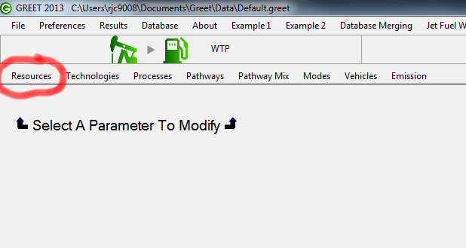*(Figure 6.2 Shows the Data Editors screen with Resources highlighted)*

1. Once you are in the selection menu for resources, you have to find the resource you are looking to alter the properties of. In this case it would be Conventional Diesel so we navigate to that resource and double click it.

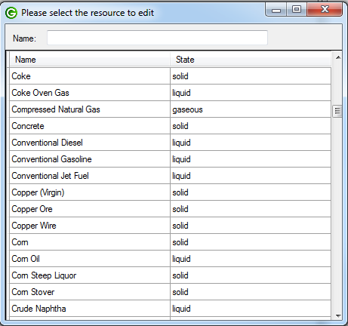

*(Figure 6.3 shows the resource selection screen)*

1. Now that you are looking at the screen shown in Figure 6.4, you find the property you wish to edit and input your preferred value. It is important to note that you **CANNOT USE A VALUE OF 0** or it will not take in your new value. You then hit enter and the number will turn red, and it is ready for you to hit the apply button that is highlighted in Figure 6.4

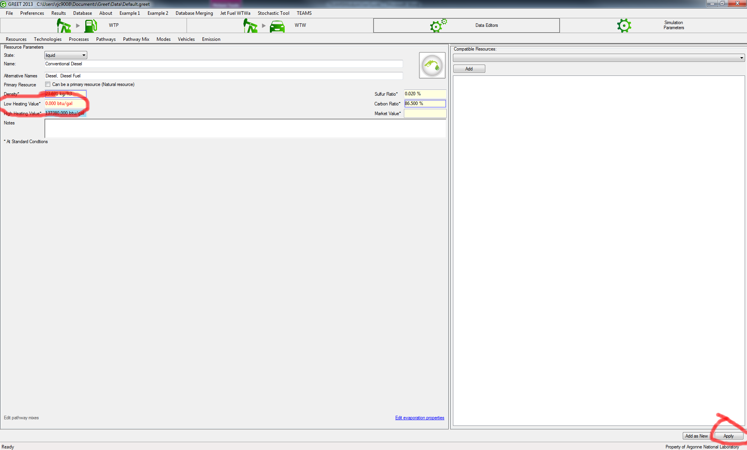*(Figure 6.4 shows the resource editor with Lower Heating Value and Apply highlighted)*

1. Now that you hit apply, when you open up the TEAMS Module the Conventional Diesel resource will now simply have the properties you set forth in this exercise.

NOTE: If you edit a resource in GREET and save your GREET project, that new resource variable will still be a part of the simulation. Your best bet if you wish to run multiple tests or undo something you’ve changed would be to save as a new GREET project, or reopen the default GREET project by clicking on “File”, “Open a project”, and choosing “Default.greet”

1. **Editing Pathways**

**__________________________________________________________________**

While using the TEAMS Module there may be pathways for the resources that you’re using that may be specific to your test case or important in order to accurately represent the needs to your simulation. For example you might be using Conventional Diesel and using the pathway “Conventional Diesel U.S. Refineries Average.” In this pathway (Shown in Figure 7.1) there is a portion wherein the Diesel has to travel through a pipeline before it arrives at the destination and can be put into a ship.

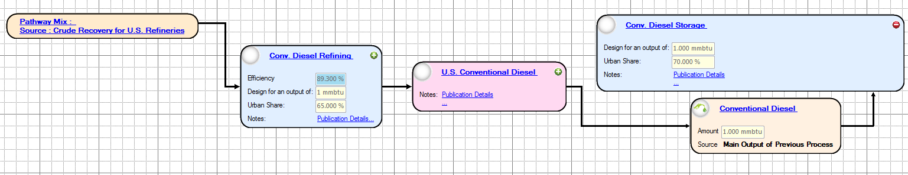 *(Figure 7.1 Shows the Conventional Diesel US Refineries Average: Pathway)*

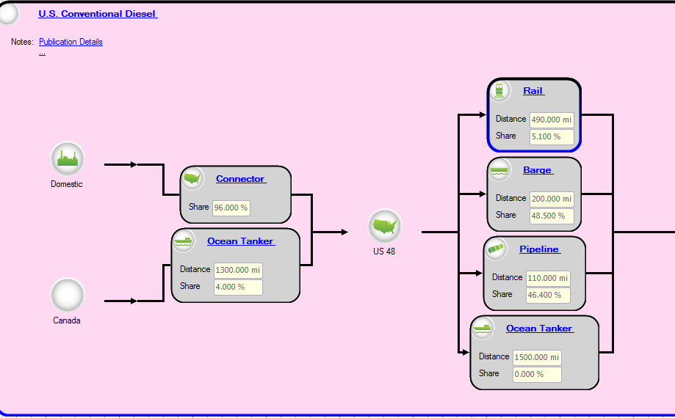

*(Figure 7.2 Shows the pipeline portion of the pathway from 7.1)*

Given the nature of the software, there is a way to change the pipeline distance (Or any other variables) in this pathway, as well as to potentially create an entirely new pathway. Instructions for both techniques are shown below.

1. Select the “Data Editors” tab in GREET
2. On the top row of the page, you should see a button that says “Pathways” select this
3. Now choose “Modify Pathway”
4. Find on the list of pathways the one that is closest to the one you want to represent, or the one you want to tweak and double click it. In our case “Conventional Diesel U.S. Refineries Average.”
5. Now that we have the pathway we need to edit, we have to edit the pieces of it individually. This can be done by selecting the blue titles of each of the pieces shown in Figure 7.1 and editing the different technologies and processes for the pathway. In our case we need to select “U.S. Conventional Diesel” and edit that particular transportation process.

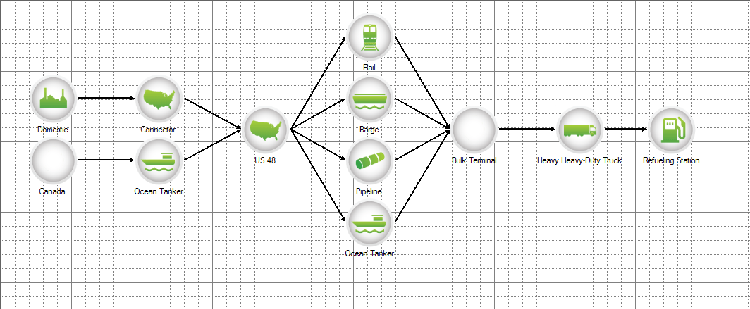

*(Figure 7.3 shows the transportation process of U.S. Conventional Diesel*

1. In this case, we will now double click on “Pipeline” and edit the distance that comes up and hit “Apply”
2. We then hit the apply button on the bottom of the Transportation diagram, and a prompt will appear that informs you of which pathways will be affected. You agree to that, and now the pathway you were editing will have the new pipeline information, changing the properties if you try and use it for a TEAMS calculation.
3. Alternatively, you can repeat step 7 but hit “Add as new” instead of apply. Then when you get back to the pathway diagram, you can delete the process you were editing, and instead add the new one that you’ve created. You can then save the new pathway, and it will appear in the TEAMS fuel pathway selection, as an alternative to the original or the edited version of the base pathway. This way you can try different variations in order to reflect different options you may have in the pathway analysis for your vessel fuels.

NOTE: If you need additional information about how to edit a fuel pathway, the GREET user guide has a more in depth guide to that as it pertains to using the main model on top of which our module is resting. This can be found at <https://greet.es.anl.gov/publication-greet-manual>

1. **Saving/Viewing Results**

**__________________________________________________________________**

Saving a results sheet in TEAMS is a tremendously simple process. Essentially when you are on the TEAMS results sheet (Shown in Figure 8.1) you just hit the “Save to Excel” button and your results sheet will be saved to a spreadsheet that you name (Shown in Figure 8.2)

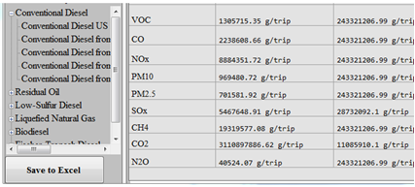

*(Figure 8.1 shows the Results sheet “Save to Excel” button)*

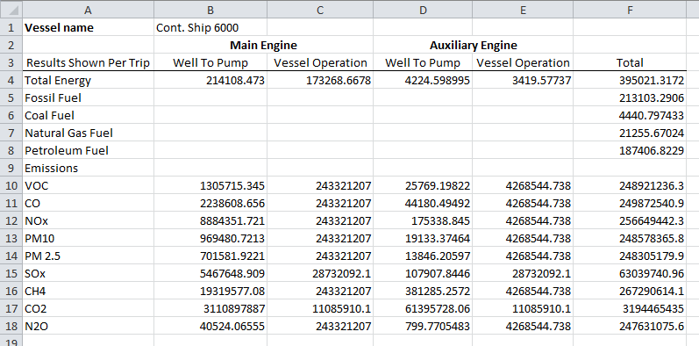

*(Figure 8.2 shows the Results sheet in Excel)*

1. **Test Cases**

**__________________________________________________________________**

1. **Future Developers**

**__________________________________________________________________**