<https://www.w3schools.com/tags/ref_standardattributes.asp>

<https://link.springer.com/chapter/10.1007%2F978-3-642-16321-0_4>

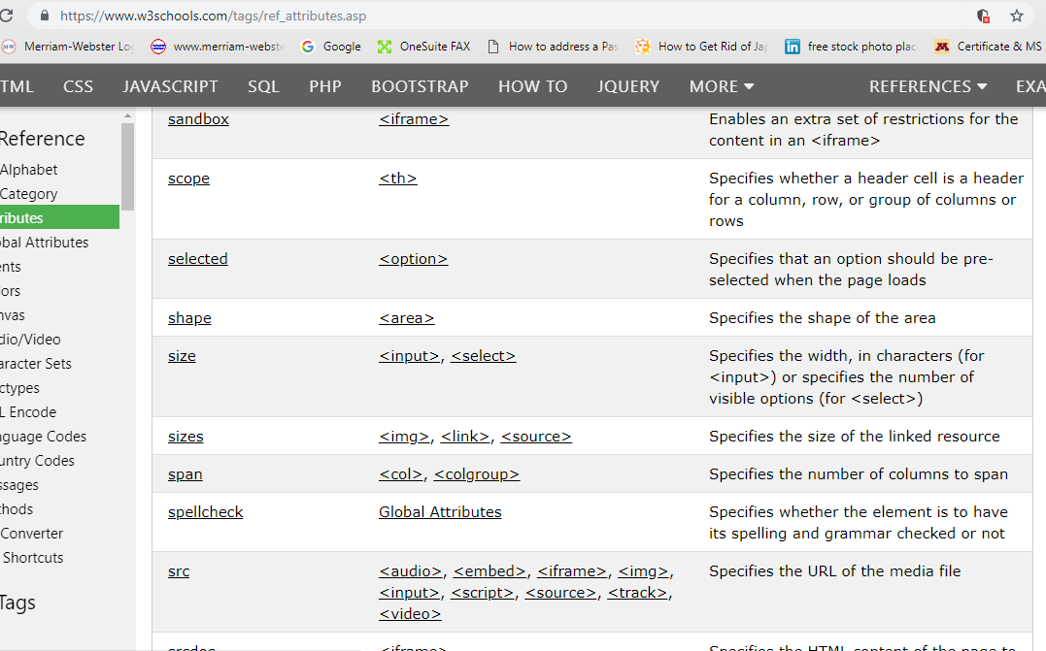

<https://www.w3schools.com/tags/tryit.asp?filename=tryhtml5_global_spellcheck>

<https://www.w3.org/TR/1998/REC-html40-19980424/html40.pdf>

htReferences

Major, D. (2010). How Computer Editing Responds to Types of Writing Errors. *Issues in Writing*, *18*(2), 146–167. Retrieved from <http://login.ezproxy.lib.umn.edu/login?url=http://search.ebscohost.com/login.aspx?direct=true&AuthType=ip,uid&db=eue&AN=71931005&site=ehost-live>

http://login.ezproxy.lib.umn.edu//login?url=http://search.ebscohost.com/login.aspx?direct=true&AuthType=ip.uid&db=eue&AN=7191005&site=ehost-live

tps://www.w3.org/TR/html5/https://www.w3.org/standards/

<https://www.thoughtco.com/spellchecker-1692122?print>

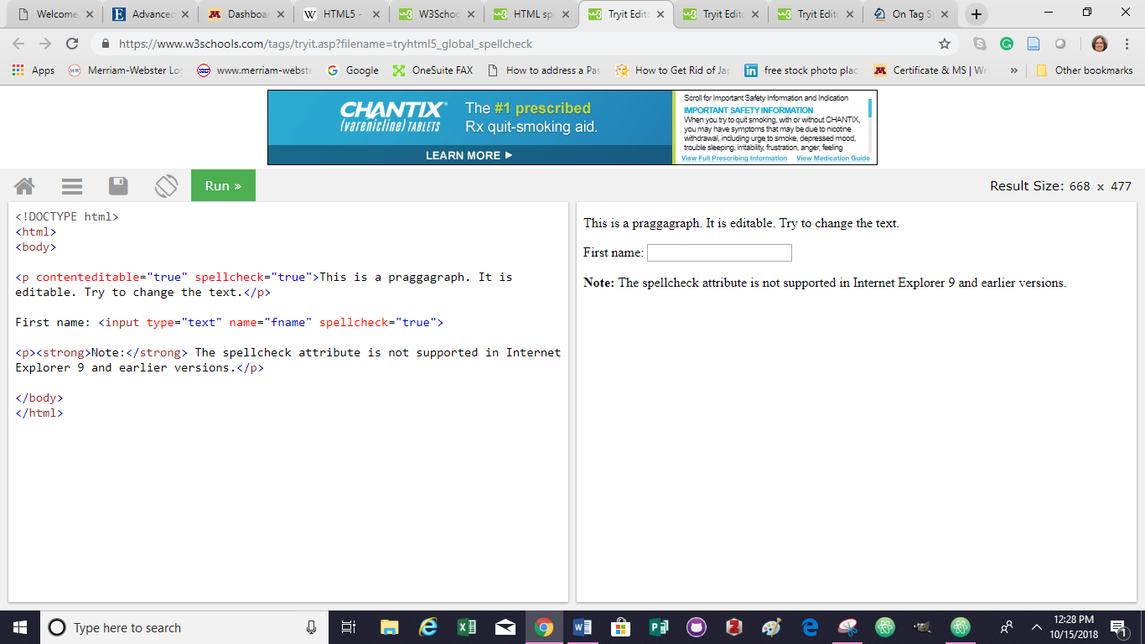

<https://www.w3.org/TR/html5/>

<https://developer.mozilla.org/en-US/docs/Web/HTML/Global_attributes/spellcheck>

<https://jsfiddle.net/0GiS0/ZU74B/> example code

<https://www.totalvalidator.com/help/spellchecking.html> use with specific langruages

<https://blog.whatwg.org/the-road-to-html-5-spellchecking#examples> ****https://blog.whatwg.org/the-road-to-html-5-spellchecking#examples

**A Proofreading Tool Using Brute Force Techniques by Olsen, K and Indredavik, B.**

**Published in:**[IEEE Potentials](https://ieeexplore-ieee-org.ezp3.lib.umn.edu/xpl/RecentIssue.jsp?punumber=45) ( Volume: 30 , [Issue: 4](https://ieeexplore-ieee-org.ezp3.lib.umn.edu/xpl/tocresult.jsp?isnumber=5962021) , July-Aug. 2011 )

**Page(s):**18 - 22

**Date of Publication:** 25 July 2011

**ISSN Information:**

**INSPEC Accession Number:**12136008

**DOI:**[10.1109/MPOT.2011.940378](https://doi-org.ezp3.lib.umn.edu/10.1109/MPOT.2011.940378)

**Publisher:**IEEE

**Sponsored by:**[IEEE](http://www.ieee.org.ezp3.lib.umn.edu/)

<https://ieeexplore-ieee-org.ezp3.lib.umn.edu/document/5962053>

Madraso, J. (1993). Proofreading: The skill we've neglected to teach.*English Journal, 82*(2), 32. Retrieved from http://login.ezproxy.lib.umn.edu/login?url=https://search-proquest-com.ezp2.lib.umn.edu/docview/237291020?accountid=14586