Greg Grube
3/18/22

Geography 777: Project 2 - Implementation Plan

The park that I chose is officially two parks, but run as one park administratively: Sequoia National Park and Kings Canyon National Park (abbrevated within the Park Service as SEKI). The user story of my map revolves around creating a tree inventory application, specifically to collect tree data for the Giant Sequoia, the most massive type of tree in the world. While the Giant Sequoia has always adapted to fire conditions, because of changing climate conditions and fire supression methods, they are at great risk ofdestructive fires, including in the summer of 2021. As a result, the park has decided to task both its own staff and volunteers to inventory all of the Giant Sequoias within the known groves in the park.

I am tasked with creating an interactive, mobile friendly map that can be used to collect tree data and also allow inventory takers to navigate around the park.

Implementation Steps:

- Gather data and put together implementation plan
- Research and decide which application stack to use (ArcGIS Online and Javascript API)
- Create database and prepare data for application
- Design basic map in Javascript
- Design editor tool and intgrate with tree dataset
- Add other tool functionality to the map
- Work on design elements / overall look and feel.
- Test Functionality
- Prepare report and demo video

E-R Diagram:

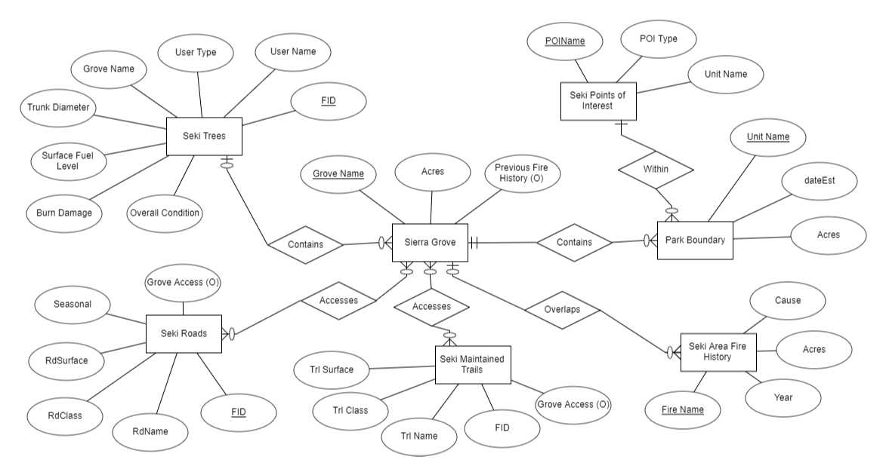

Logical Schema:

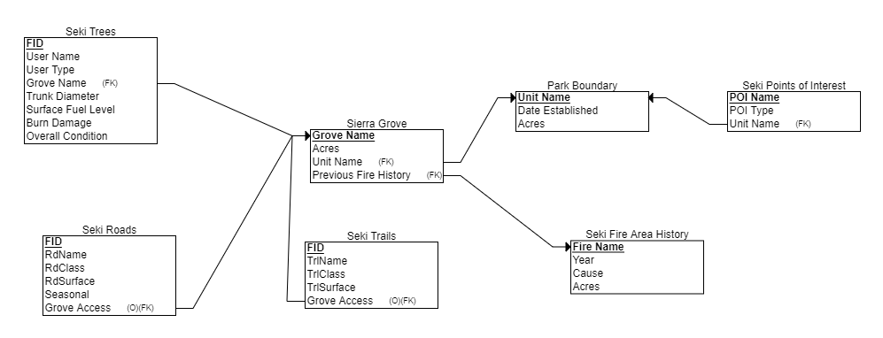
Implementation Diagram:

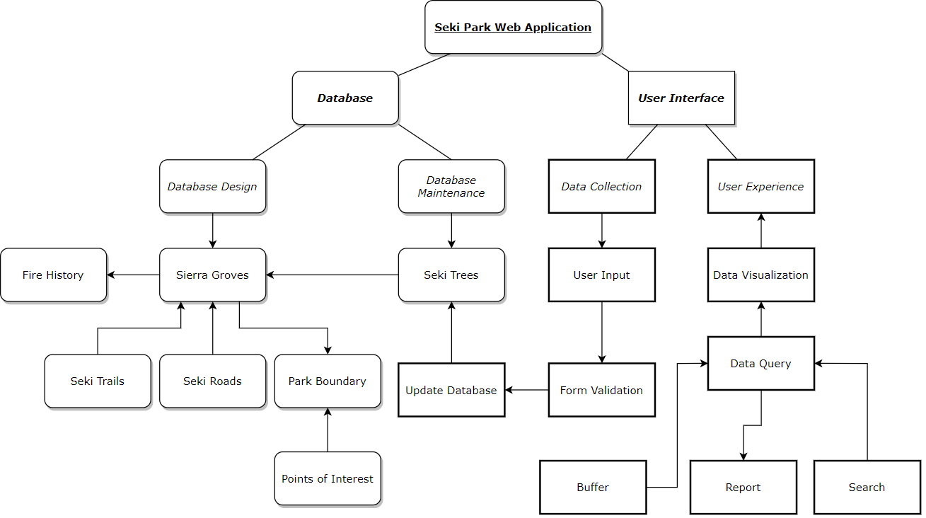

Tenative Project Schedule:

3/15 – 3/21 – Complete Implementation Plan and Database Design
3/22 – 3/28 – Select application style, load data and begin working on site
3/29 – 4/4 – Continue working on site and implement basic functions for beta demo
4/5 – 4/11 – Finalize functions and editor functionality, test site
4/12 – 4/18 – Work on project report and record final demo presentation

