Final Year Project Report

Electricity Conservation and Speculation
BESE (Batch: 2012-13)
Project Advisor
Dr Najmi Haider
Chairman of CS and IT Department
NEDUET
Submitted by
M. Aamir Ali SE-067
Nida Masood SE-044



DEPARTMENT OF COMPUTER SCIENCE & INFORMATION TECHNOLOGY
NED University of Engineering and Technology, Karachi.

Preface
The project aims to conserve electricity by informing the electricity consumer about the way he/she uses it, because the main reason people get over budget electrical bills is that they don't know how they're using it, and hence , the project analyzes the trend in your electrical consumption and builds a formula-like model for it. In Pakistan people are unaware of what makes their electricity meters tick, from large industries to small factories, people are facing difficulties with their electricity budget; hence if we are able to see something coming, we can very much prepare for it if we receive an early warning of something rather than to suffer from unforeseen consequences.
An industry has to have precise reports, and a close eye regarding expenses therefore using prediction models for electrical consumptions will change the way we look at our expenses, the way we estimate or forecast current liabilities, because the better we understand so, the better we can utilize something.

ACknowledgment
(Comments: Use the below layout and write your own acknowledgment. Remove the comments in original. This is just a sample. Make sure to acknowledge in same order as given)

First of all, we thank Almighty Allah who gives us the strength and ability to think, work and deliver what we are assigned to do. Secondly, we must be grateful to our internal supervisor Dr./Mr./Ms ________________ who guided us in this project. We also acknowledge our teachers who guided, taught and helped us during our study period. We would also like to thank all departmental staff and university staff, who had assisted us during our stay at the university.

group Members

Back-end developer, database designer, systems-interconnector, Hardware designer and developer, and system tester.
Achievements: Developed Android Open Source Project OS, ITEC Python Experts Manager (2015), developed EMOS with Amjad Ali (2015)

Muhammad Aamir Ali SE-067
Arduino programmer, Python developer and hardware designer
Immediate Contact: (+923452108041, aamir00@hotmail.com)

(Professional photograph of student-n)
Nida Masood Se-044
Web User Interface designer and developer
Immediate Contact: (+923333666019, nidaakhan35@gmail.com)

NED University of Engineering and Technology, Karachi
DEPARTMENT OF COMPUTER SCIENCE &
INFORMATION TECHNOLOGY
CERTIFICATE OF COMPLETION
This is to certify that the following students
M Aamir Ali SE-067
Nida Masood SE-044

have successfully completed their final year project titled

Electricity conservation and speculation

in the partial fulfillment for the requirements of the Degree of Bachelor of Computer Science & Information Technology/Bachelor of Software Engineering during the academic session 2012-2013.

_____________ _____________________
Name of Advisor Name of Chairman
Abstract

This report aims to explain the working of the final year project Electricity conservation and speculation.
The introduction section of the report describes the understanding of systems and subsystems used in this project, so that the reader may grasp the point of view of the writer, as it contains the information on the hardware and software used and why was it used. Moreover, it describes why was the project needed, where can it be used and it features the type of inputs the project needs in order to fulfill it's requirements along with the outputs generated
The second section of the report, which is chapter 3 and 4, will lead to and show the usage scenario of the project; about where and how does the project exactly fit, such as what tasks does it perform. The further we go in this section, details of what the system is composed of as a big picture followed by the decomposition of its components and why were they needed, data handling, data flow , inner working and mechanism of overall architecture.
The third section of report, consisting of chapters 5 through 8, focus on the outputs of the system in detail, it's performance, and why was prototyping necessary, what challenges and system limitations compelled us to build it.

PREFACE
- ACKNOWLEDGEMENTS
- INTRODUCTION TO GROUP MEMBERS
- CERTIFICATE OF COMPLETION BY PROJECT ADVISOR
- CERTIFICATE OF COMPLETION BY CHAIRMAN OF DEPARTMENT
- CERTIFICATE OF COMPLETION BY EXTERNAL ORGANIZATION (IF EXTERNAL PROJECT)
- ABSTRACT
- TABLE OF CONTENTS
- LIST OF FIGURES
- LIST OF TABLES

All the headings above must be included in Table of Contents (TOC) according to correct page numbers. Provided below is an exemplary TOC.
Provided After TOC is MAIN-BODY of Report .Select the heading or text and write your material in place of it. Don’t change the style and format
Some heading are generic and can be molded according to your heading name
Try to begin the chapter with new page. See that all chapters get mentioned in the header

Contents

Chapter 1 Theoretical Background

  - Overview 2
  - Objective 2
  - Abstract 3
  - Theoretical Background
  - Technology and Tools
    - Raspberry-Pi
    - Python
    - Java Script
    - Mongo DB
    - Arduino

Chapter 2 Usage Scheme

- Users
  - User Profiles
  - Use cases
  - Special Usage Considerations
    - Limitations
    - Assumptions

Chapter 3 System Composition
- Users
  - Functional and Data Description
    - System Architecture
    - Data Acquisition
      - Data Flow
    - Python Time Series
    - Sub-systems' interconnection

- Introduction

  - Goals and objectives

The objective of this project is to conserve electrical consumption by providing a means of review and control on consumption by forecasting the electricity consumption based on its history. This project uses the Python Time Series and constructs a usage model using historical data and then simulating the data on that model, and to also generate future bill for the subjected electrical appliances.
  - System statement of scope

The project monitors the load of electrical devices that run on mains' supply by taking voltage and current in real-time using Hall Effect sensors for alternating current and AC-AC adapter for voltage readings. The readings are then stored into a database so that it can be analyzed and visualized.
Arduino handles the sensors such that the sensors provide with analog values and they have to be digital so that it can be analyzed, hence it converts analog data into digital stream of bits; it acts as an intermediary between sensors and Raspberry-pi. The data is then elicited from the database and visualized using GUI, and so is the fore-casted data. Future bill of electricity consumption is then generated by interception of speculation data by entering a given date. The project can also compare the subjected devices' loads and suggesting what devices to run in order to tessellate the bill into given budget
  - System context

The value of the project can be gaged by the fact that it can be used by various type of electricity consumers, which may include residential, commercial, industrial consumer.
The project is based on an idea that is neither popular nor new, however this kind of venture has never been accomplished before, nor hence we had to design and model a whole new system, and connect it through various underlying systems.
- The project had to go through a whole new development process, specially the initial steps; yielded a road map and drive the fulfillment during ramp-up.
- The identification and realization of system requirements; which are monitoring of electrical measures (the hardware part)
- The project, with help of different scripts, that are a system of their own, were combined using a Web UI, since the Web UI can run scripts and handle all of the operations in a single instance.
- The web UI allows visualization of the “Speculation” part of the project and it also carries it out.
- The feasibility of the project had to be explored before even beginning of the intent of the project because we had to complete it in our own budget, since we had no sponsors.
- The project is more of a product engineering instead of business process because of designing, development and assembly. The project flies off the tangent of Business process because the idea of ‘Linking tasks’ is far-fetched due to minimal interaction of users, namely a single user only to print and deliver reports to the higher ups such as management and owners.
The system is placed in a business or product line context. Strategic issues relevant to context are discussed. The intent is for the reader to understand the "big picture”. In this section discuss what are the prospects of system in market? In which domain it is best suited.

  - Theoretical Background

Over the years several projects aimed at electricity conservation, have provided mostly an overview of the crisis of energy, but the main idea in this project was to predict the consumption so that we can plan ahead and avoid overuse of electricity.
One way to forecast the consumption was to use Python Time Series Modeling. (Jain, 2016)
Among the less known skills in the analytics space, Time Series (TS) is considered to be one of it, which is why it should be deeply understood. Our focus would be on the Python and no other resources of Time Series in R, due to the fact that we have used Python in the project.
Specialty of Time Series:
The collection at constant time intervals, of data points is defined as time series. In order to generate forecast and other forms of analysis, the data points are analyzed. Two factors differ Time Series form others. That are:
1) Its dependability upon time. So, fundamentally, a linear regression model is dependent upon the observation.
2) Seasonality trends are observed in most of the Time Series, along with the increment and decrement in trends. Seasonality is defined as 'variations specific to a particular time frame'. As an example, if sales of heavy clothing is observed over the years, higher sales will be observed in the season of winter.
  - Technology & Tools/hardware components (used in the Project)

The project is capable of using almost any of the Linux or Windows based system, but for detailed testing and in-depth analysis of data flow/generation and accumulation, we have used the Raspberry-Pi. The development of the project required precise hands-on approach on serial data manipulation such that the data acquired from physical world (analog data), can be done using a standalone microprocessor or Arduino as analog to digital converter. The reason for using specific processor is discussed in detail in following sub-headings.
1.5.1 Raspberry-pi
The raspberry-pi is a standard system-on-chip, with a decent processor and RAM on a chipboard only size of a credit card. It is system that runs using a Linux operating system called Raspbian-Jessie, capable of delivering exactly as any other personal computer running Linux with some exceptions:
The Raspberry-Pi is not capable of multi-threading specially the variation used in the project
- Does not have its own power supply
- Does not have a big processor, that is, only 1 GHz
- It is not capable of generating high level graphics
Exceptions aside, it has a unique feature, and that feature is why we used it.
General Purpose Input Output Pins (GPIO)
The raspberry-pi has input/output pins on its board that are its link to the outside or physical world. They function as an interface that could be either a switch at its simplest or a communication link between other hardware such as relays, cameras, sensors of numerous types and even other processors.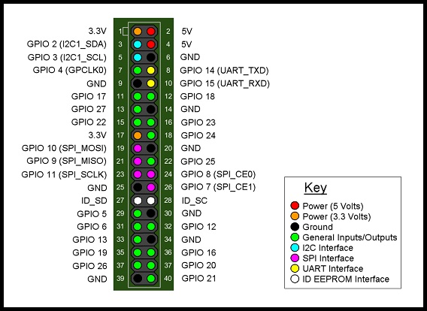
These pins are bidirectional, hence they can be used as both, input and output (not both simultaneously). They can be programmed using one of several programming language including C and Python, by opening their interfaces using the python configuration file, known as the Raspberry-Pi's BIOS.
1.5.2 Python
Python is an interpreted programming language that is dynamic in nature and high-level. The idea behind its design emphasizes in code readability, and the syntax allows us to use fewer lines of code for than we would have in other languages, furthermore it's native functions allows us to produce small scripts or modules, each for a designated task, to constitute a larger system.
Python was used in this project for almost all of the back-end coding that doesn't concern the user, for example, the acquiring of data from Arduino, storing data into database.
1.5.3 Java Script
Java Script is also a high-level interpreted programming language that works dynamically. It is one of the core programming languages that make up most of the web pages, with the exception of storage, graphics, networking and Input/output techniques.
Java Script was used in this project for data visualization and data fetching from database and for invoking modules of Python using the web pages built for User Interface.
1.5.4 Mongo Database
Mongo DB is an open source database that uses a report situated information display.
Mongo DB is one of a few database sorts to emerge in the mid-2000s under the “NoSQL” standard. Rather than utilizing tables and columns as a part of social databases, Mongo DB is based on a design of accumulations and reports. Archives include sets of key-esteem matches and are the essential unit of information in Mongo DB. Accumulations contain sets of archives and capacity as what might as well be called social database tables.
Mongo DB was used in the project as a flexible non-relational database that can import and export data as JSON.
1.5.5 Arduino
Arduino is an open-source extend that made micro-controller-based units for building computerized gadgets and intelligent articles that can detect and control physical devices.
This venture depends on micro-controller board plans, delivered by a few consignors, utilizing different micro-controllers. These frameworks give sets of advanced and simple info/yield (I/O) sticks that can interface to different development sheets (named shields) and different circuits. The sheets highlight serial correspondence interfaces, including Universal Serial Bus (USB) on a few models, for stacking programs from PCs. For programming the micro-controllers, the Arduino extend gives a coordinated advancement environment (IDE) in view of a programming dialect named Processing, which additionally bolsters the dialects C and C++.
- Usage Scenario / User Interaction

  - User profiles
The project is an isolated system that is not capable of modifying the input data from the user end, hence there is not much need for user access control (UAC) and therefore no user or user based scenario was included.
The only role of user is so comprehensive that people with no knowledge of electricity can operate it and actually understand the outputs, it may even eliminate the role of budget incorporation of electrical consumption. The only thing a user need to do (after installation) is to provide the system with an estimate of the amount of budget subjected electrical appliances and the system will generate a report for what devices need what duty cycles to befit that budget.
As for the forecast, it is generated and stored into database, with exception of historical predictions and forecast, the user may only provide system with a date of interception (end date for upper limit of forecast) and the process will begin.
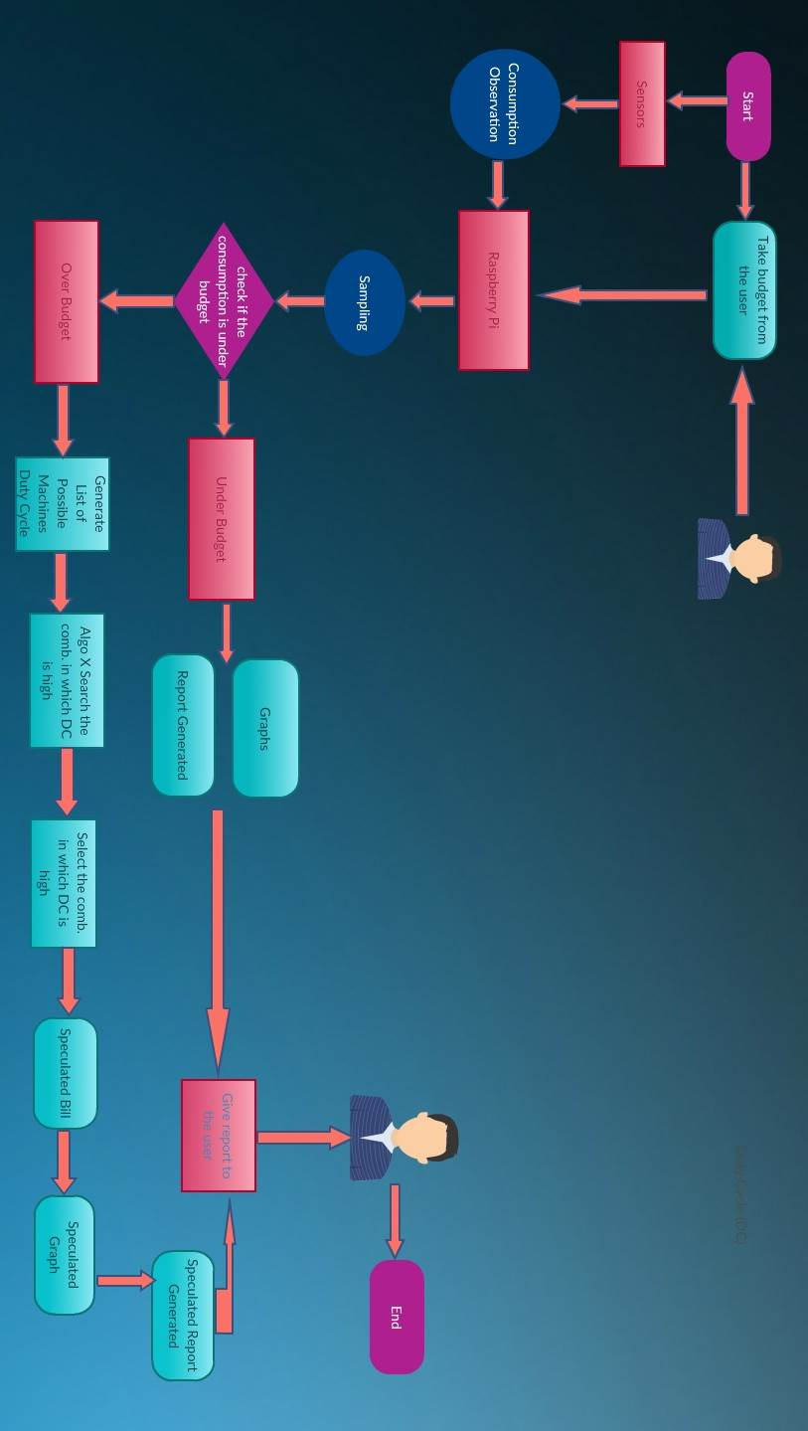
  - Use-cases

The above diagram shows how a simple user can input the budget and the system passes objects of data to sub-systems and what modules perform the given tasks. The end user only receives the generated reports so that it can delivered to higher-ups and organization's accountants, for incorporation into their finances.
  - Special usage considerations
The project requires installation into either a dedicated panel for that device or group of devices, connection to devices must be in parallel for the voltage sensor and in series for the current sensor.
The Arduino (prototype) and the Micro-controller only requires 5v 1000 mA of power supply to operate and sense values accurately.
The raspberry-pi also requires 5v of supply but with 2000 mA requiring no additional hardware other than keyboard, mouse and a display. The project can also function on any other computer running Linux, having the standard python libraries but then micro-controllers cannot be used as a typical computer does not have General Input Output Pins.

- Functional and Data Description

  - System Architecture

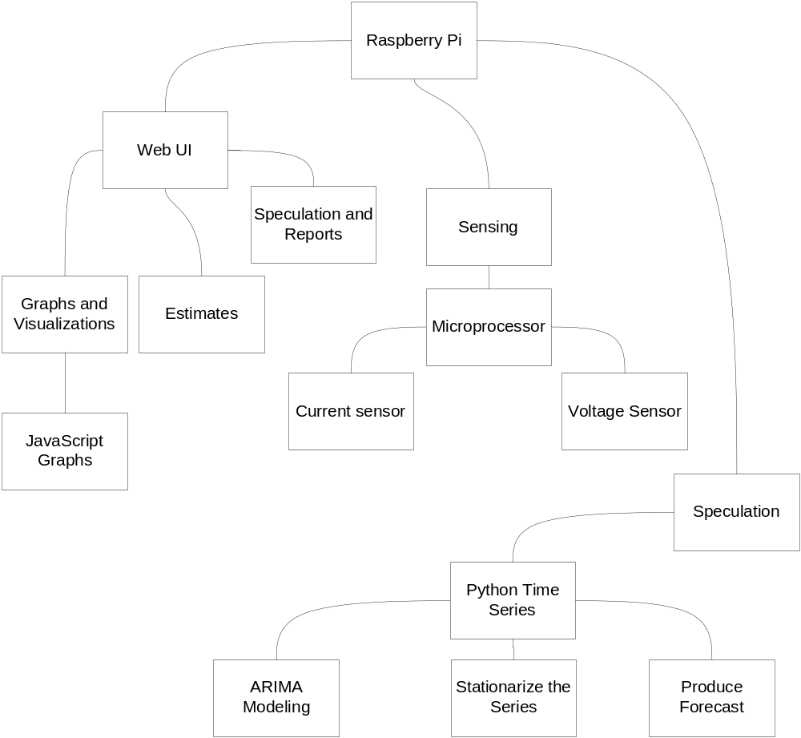
The diagram above represents the overall architecture of the system.
The main components of the system as shown here are:
- Raspberry-pi
It provides the actual platform for the sub-systems to interact with each other and with the processing power of a typical computer. It also handles all the data that is poured into the system, from the user end till the each output of every module the project is constituent of.
- Web UI
A simple means of representing data to the user after it is processed. It is no more than a user interface that plays an extensive role, by taking user inputs, feeding it into the back-end code and invokes requested modules. It is the abstract point where all the subsystems are housed.
- Sensing
Sensory equipment that inputs all the data from subjected devices. It can be called the monitoring part of the system, where analog data is injected into the system.
- Speculation
It may be the most sophisticated part of the project as it implements Auto Regressive Moving Average (ARMA) on the historical data to forecast future data with respect to time.

    - Architecture model
The following diagram is the representation of roles of sub-systems with respect to physical and abstract parts of the system.
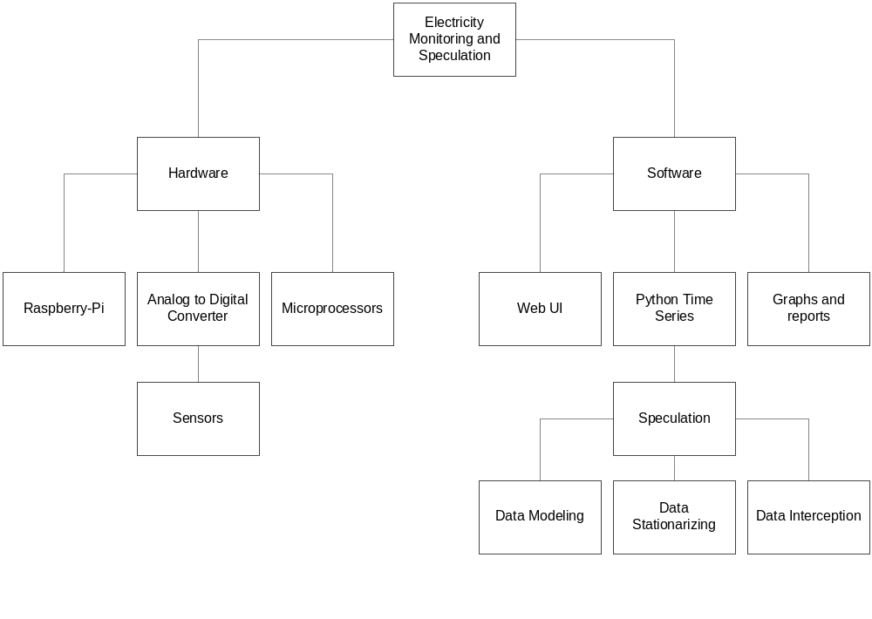

The system, as shown above has two parts, hardware and software, each counterpart has different setups, such as raspberry-pi requires being plugged into a Analog to Digital converter so that data from sensors can be parsed as data objects need recognition in order to be processed, hence sensors require to be connected to Analog to Digital Converter (ADC) and ADC itself to the main processor here that is raspberry-pi.

3.1.1.1 Micro-controller

A micro-controller is an even smaller version of a computer, the only exception being that it is on a single integrated circuit. The integrated circuit contains all the necessary components such as processor core, memory, programmable input and outputs for it's peripherals, RAM, and flash. Micro-controllers are significantly small in a way such that their original purpose is use in embedded systems.
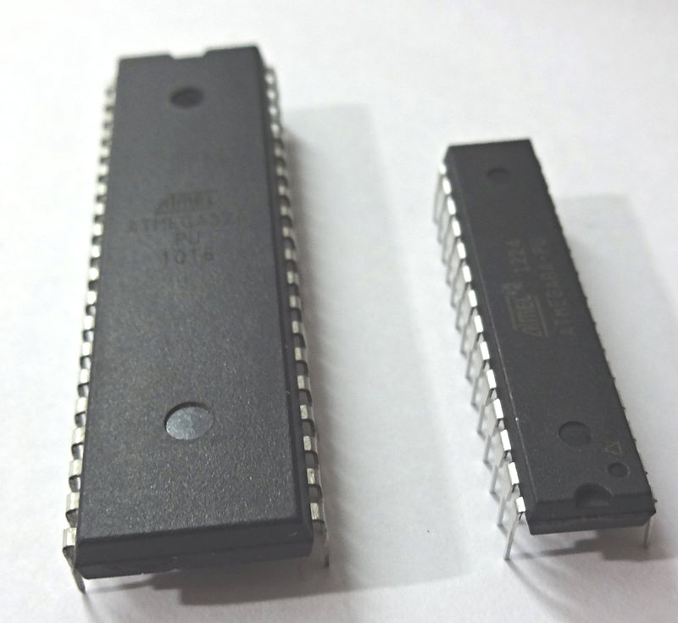
They are used in automatically controlled or smart appliances such as washing machines and smart refrigerators.

The role of micro-controller in this project is to deliver analog data to main processor in real-time while converting it into digital at the same time.
3.1.1.2 Arduino

Arduino as an open-source project, created micro-controllers' kit that are used for construction of digital devices and devices that are interactive, such as RF-ID keys, or smart solar switches.
These micro-controllers are embedded into yet another credit card sized chip board with simple digital and analog input output pins; while the difference being that these pins have a threshold of up to 5 volts, each pin having from 0 to 1023 bandwidth, meaning if we make a pin do something, we have 1024 values to choose from for each of pulse width off of pulse width modulation or PWM pins (digital). The analog part of these pins is to handle physical data, whether they are output or input, each signal will have a width of 1024, it is safe to assume that they have an accuracy of 0.0048 which makes them fairly good for sensing current and voltage, the way we have in this project.
The Arduino variation used in this project has a micro-controller based on ATmega 2560, it has a 16 MHz crystal oscillator and the circuitry to make it work, including ICSP header, reset button, power input jack, and USB connector. The set of pins provided in it are a total of 54, 15 of them are PWM capable, 16 can be used as analog input and 4 UART (Universal Asynchronous receiver/transmitter).
The purpose of Arduino in this project is convert analog data, by taking analog input from sensors as a value (out of those 1024 mentioned above) and convert them into digital signals (serial data) that can be made use of by the Raspberry-Pi, and is used only in the prototype version of the project.
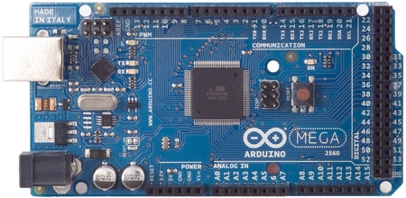

3.1.1.3 Raspberry-Pi

The raspberry-pi is a standard system-on-chip, with a decent processor and RAM on a chipboard only size of a credit card. It is system that runs using a Linux operating system called Raspbian-Jessie, capable of delivering exactly as any other personal computer running Linux with some exceptions:
The Raspberry-Pi is not capable of multi-threading specially the variation used in the project
Does not have its own power supply
Does not have a big processor, that is, only 1 GHz
It is not capable of generating high level graphics
Exceptions aside, it has a unique feature, and that feature is why we used it.

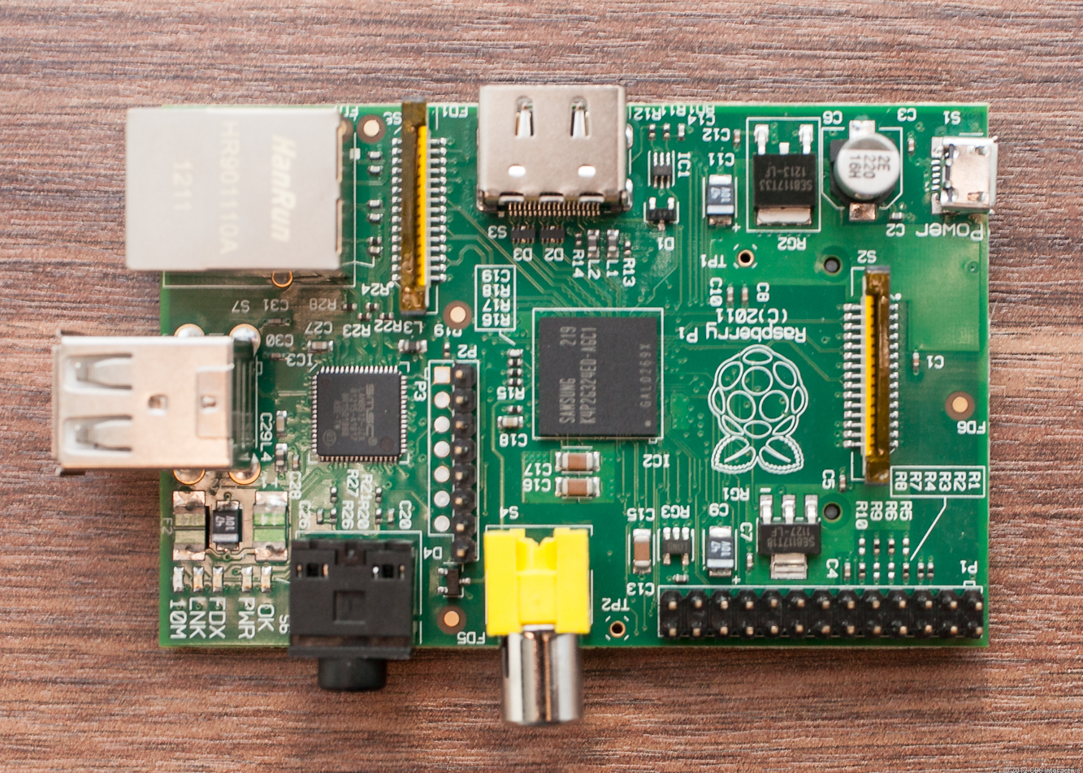

General Purpose Input Output Pins (GPIO)

The raspberry-pi has input/output pins on its board that are it's link to the outside or physical world. They function as an interface that could be either a switch at its simplest or a communication link between other hardware such as relays, cameras, sensors of numerous types and even other processors.
These pins are bidirectional, hence they can be used as both, input and output (not both simultaneously). They can be programmed using one of several programming language including C and Python, by opening their interfaces using the python configuration file, known as the raspberry-pi's BIOS.

    - Subsystem/modules overview
This system of system is composed of Python modules designed and developed for dedicated tasks, there is only one sub system that is the interface that has Java Script modules, combined into a subsystem of its own.
- Stream Encoder; resides in Arduino made using C language,
- Stream Parser and storage; uses Python Script to analyze and store stream,
- Web UI; houses almost all subsystems in one place, and invokes them, also provides data visualization,
- Python Time Series; Analytics’ method for Electrical Usage and forecast.
  - Data Description

Since this project's aim was to only predict electricity consumption, the only data in the database was electricity related, meaning voltages, currents and fore-casted consumption, however discussed and shown here is the data object that originates from the very low level, Arduino program, not much of it was required.
The user input of his budget is kept in the session, using Java Script, due to the fact that reports and intercepts keep on changing, the real-time nature of data entries make it infeasible for us to have stored the user's estimate into the database, and to keep the system efficient because if the user needs his historical data he can view it by using the Web UI, and the data that can be stored can range from the past year to the future month (of prediction) already.
In order to perform ARMA (Jaine,2016) modeling database needs indexing with respect to time, because the machine learning and modeling process requires a unified scripture, such as date-time in this case, to be able to utilize the data.
    - Major data objects
The only “Data Object” that is stored is generated by the Arduino (Micro- controller in final version) at the instant of when a reading is taken, which is every 10 seconds , contains only the reading of current and voltage of different devices.

    - System level data model
Data Flow Diagram
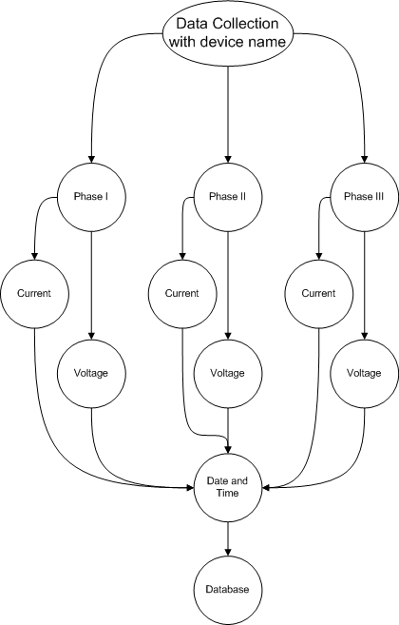
As the diagram suggests that data is collected In accordance with the name of device that is being monitored. A data base entry is generated when a reading is taken, the reading can be from all three phases of the device at the point of data collection, it is when the Arduino (micro-controller in case of final version) reads from the sensors, converts the analog readings to digital, and envelopes it into a JSON stream, where the only data is; in it's raw from, a field name and a parameter (a data value), per device.
An example of data element before being enveloped:
{
“current1” : 2.25,
“volt1” : 235
}
An example of data element after envelop:
[
{
"cur3 ": 2.41,
“volt1”: 240,
"time": "2016=10-16 04:33:57"
}
]
Since the Arduino is not capable of keeping time, without additional hardware (time shield) the date-time parameter is added by the receiving end, or Raspberry-Pi in this case.

Shown below is simplified version of data flow
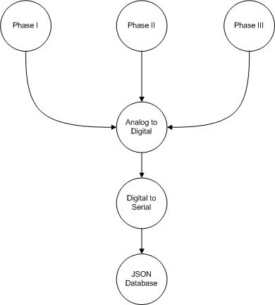
The JSON object, after being received is injected with date-time and inserted as a record with respect to the given time into Mongo DB.
The Mongo DB is not a relational database, but it is records can be encapsulated into JSON stream. This method was chosen to avoid errors that may occur while parsing the stream, such events can occur when the sending end has already begun sending but the receiving end is either not ready or stream begins at a different instant than the intended beginning of stream. If this method was not implemented, we would have needed synchronous data transmission, introducing yet another complexity in the hardware.

  - System Interface Description

    - External machine interfaces
The Raspberry-Pi is our actual system, the part which the user needs to see or interact with at any point in the project’s life cycle
    - External system interfaces
The project draws its data from the outside world, data elements are formed from readings of other electrical appliances, and these appliances can be anything if they follow the sensor specified ratings.
    - System Limitations
The data collected by monitoring device for speculation purposes does not deviate more than 50% of its average, because then the speculation may be thrown off course and the targeted budget will not be properly accomplished by following suggestions of the system. The sensors be built, being able to sense at least 10 Amps of current.
The whole software part of the system must be able to run on minimal hardware requirements such as at least 256 MB of RAM and 1 GHz of processing power. The volume of software part is not to exceed 500 MB of storage because the system is meant to be portable and flexible i.e. run on different devices that aren’t running Microsoft Windows.
The device one which it runs has a browser capable of running Python Scripts and has essential Python libraries including matplotlib, numpy, the time series, stats models and tkinter.

- Subsystem/module Description
As mentioned earlier, each subsystem was combined into a single project, using the Web UI. Details of how this was done are provided under heading Subsystem Interconnections.
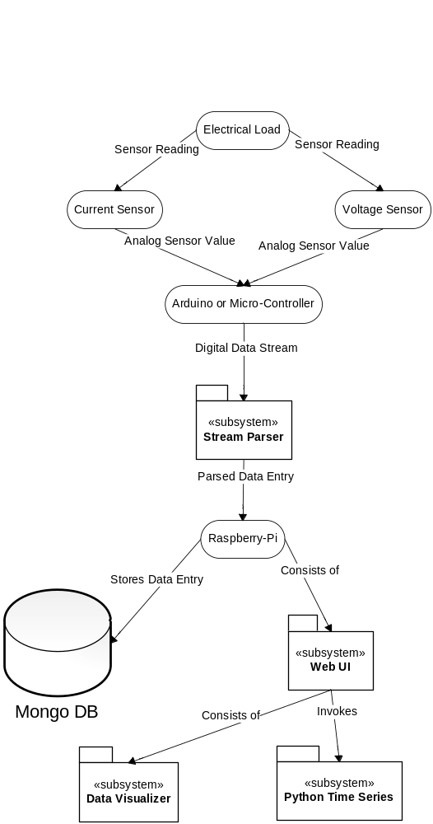
The diagram shows what subsystems are used and how are they connected.

  - Web UI
The purpose of the web UI was to house each and every single python module, a module as a subsystem of it’s own.
    - Subsystem scope
A statement of scope for subsystem ‘n’ is presented.
    - Subsystem flow diagram/ desired UML diagram
A diagram showing the flow of information through the subsystem and the transformation that it undergoes is presented. Block diagrams of specific subsystem can be put here.
    - Subsystem ‘n’ components
An overview for each component of subsystem ‘n’ is presented. omit the section if not applicable
    - Description for sub system ‘n’ Component ‘k’
A detailed description and diagram (if applicable) of each sub system component contained within the architecture is presented. Section 4.2 is repeated for each of (k) components.
      - Component ‘k’ interface description.
A detailed description of the input and output interfaces for the component is presented.
      - Restrictions/limitations
      - Performance issues
      - Design constraints
- Behavioral Model and Description
A description of the behavior of the System is presented.
  - Description for system behavior
A detailed description of major events and states is presented in this section.
    - Events/interrupts
A listing of events (control, items) that will cause behavioral change within the system is presented.
    - States
A listing of states (modes of behavior) that will result as a consequence of events is presented.
  - State Transition Diagrams
Depict the overall behavior of the system.
  - Control specification
Depict the manner in which control is managed by the system

- System Prototype Modeling and Simulation Results
If system modeling and simulation and/or prototyping is conducted, these are specified here.
  - Description of system modeling approach (if used)
The system modeling approach (including tools and/or mathematical models) is described.
  - Simulation results
The results of any system simulation are presented with specific emphasis on data throughput, timing, performance, and/or system behavior.
  - Special performance issues
Special performance issues are identified.
  - Prototyping requirements
If a system prototyping is built, its specification and implementation environment are described here.
- System Estimates and Actual Outcome
This section provides cost estimates for the project
  - Historical data used for estimates
Describes the historical data that is relevant to the estimates is presented. Historical data includes legacy data or data from past experience or reference to some authentic research etc e.g LOC estimation uses such kind of data. For OOD based system refer to COCOMO 2
  - Estimation techniques applied and results
A description of each cost estimation technique and the resultant estimates are presented here.
    - Estimation technique ‘m’
Tables or equations associated with estimation technique m are presented. Section 7.2.1 is repeated for each of ‘m’ techniques.
    - Estimate for technique ‘m’
Estimate generated for technique ‘m’.
  - Actual Results and Deviation from Estimates
The final cost for the project (at this point in time) is presented here. A deviation chart should be presented to illustrate the comparison between actual cost of system and estimated cost.
  - System Resources (Required and Used)
People, hardware, software, tools, and other resources proposed to build the software are noted here. On the bases of which cost estimations were performed
    - System Resources Required
    - System Resources Used
- Test Plan
This section describes the overall testing strategy and issues that are required to properly execute effective tests. At least one of the testing strategy should be followed.
  - System Test and Procedure
Since this project is a large collection of other sub-systems, and the feasibility and performance of each subsystem had to taken into consideration. The system, was tested in isolated environments, that is, each subsystem was provided with dummy data at first and it was run without any interconnection among other subsystems.

###The System tested is identified by name. Exclusions are noted explicitly.
  - Testing strategy
The overall strategy for software testing is described.
    - Unit testing
The strategy and brief procedure for unit tested is described. This includes an indication of the components that went under unit tests.
    - Integration testing
The integration testing strategy and procedure is specified. This section includes a discussion of the order of integration by System function.
    - Validation testing
The validation testing strategy and procedure is specified. This section includes a discussion of the order of validation by system.
    - High-order testing (a.k.a. System Testing)
Over all system testing strategy and procedure is described
      - Security testing
      - Stress testing
  - Testing resources and staffing
Specialized testing resources are described and staffing is defined.
  - Test metrics
A description of all test metrics to be used during the testing activity is noted here.
  - Testing tools and environment
A description of the test environment, including tools, simulators, specialized hardware, and test files, and other resources is presented here.
  - Test record keeping and test log
Mechanisms for storing and evaluating test results are specified. The test log is used to maintain a chronological record of all tests and their results.
- Future Enhancements and Recommendations
There are several future enhancements and extensions to choose from that will make the system less of a mess the first and foremost being implementation of Power line communication.
Sensors can be connected using a small ATtiny micro-controller with Power line communication module and a filter. This way the sensors can send data through the very electrical grid they are monitoring. The usual electricity grid provides more than 600 Mbps of data bandwidth, which is a lot more than enough.
This extension can also allow communication of over 10 sensors, technically, up to 65536 asynchronous sensors if they are using baud rate of 9600 bits per second.
600 x 1024 x 1024 = 629145600
629145600 / 9600 = 65536

- Conclusion / Summary
This section includes the end results achieved and various observations which were monitored while deploying the system

- Appendices
- Project Schedule
This section presents an overview of project tasks and the output of a project scheduling tool.
Timeline chart / Gantt Chart
A project timeline chart is presented. This may include a time line for the entire project or for each staff member.
Project Group Organization / Work Load Distribution
The manner in which group is organized and the mechanisms for reporting are noted.
- Working Session / Snap shots of deployed system
Labeled Graphical User Interface (GUI) snapshots of any one work session is presented If no GUI exist than this section can be omitted or if exist, provide actual snap shots of deployed system.

- Reference
List and number all bibliographical references at the end of your proposal. When referenced in the text, enclose the citation number in square brackets, for example [1]. Where appropriate, include the name(s) of editors of referenced books.
[1] A.B. Smith, C.D. Jones, and E.F. Roberts, “Article Title”, Journal, Publisher, Location, Date, pp. 1-10.
[2] Jones, C.D., A.B. Smith, and E.F. Roberts, Book Title, Publisher, Location, Date.
- Glossary (Small definitions of terminology used in your report)

(CD COVER LAYOUT AND CONTENT LIST INCLUDING FOLDER HIRARCHY)

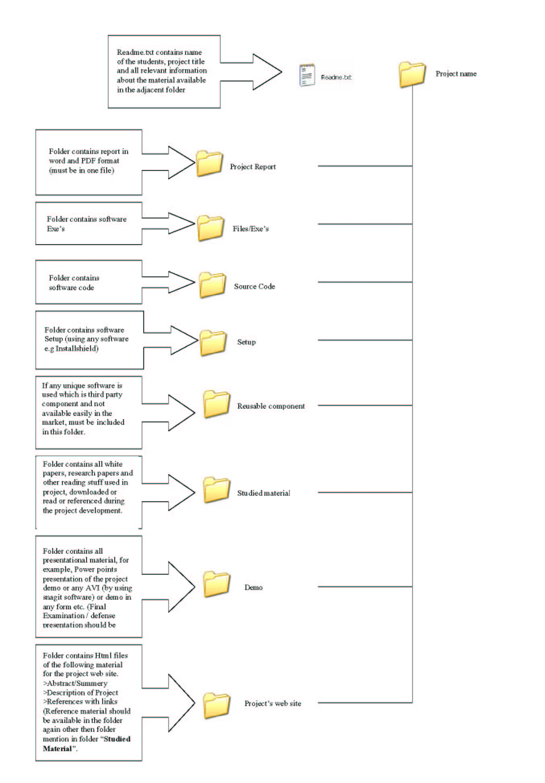
NOTE: The following must be submitted at the time of final presentation:
a) Complete Software of the project (source code and an installable version of software along the readme.txt file)
b)A User Manual of the software
c) 3 bound Project Reports (1 master copy with color diagrams and two photocopies)
d) project demonstration Video.
e) PowerPoint Presentation
f) A project website is optional.

