Workbook

Information Systems Engineering
(SE – 483)



Name | M Aamir Ali and Nida Khan
Roll No | BESE – 067 and BESE - 044
Batch | 12-13
Year | Final (fourth)
Department | Software Engineering

Workbook

Information Systems Engineering
(SE – 483)

Prepared by

Dr. Sh. M. Wahabuddin Usmani

Approved by

Chairman
Department of Computer Science & Information Technology
Table of Contents

S. No | Object | Page No | Signatures
1. | Business process / product engineering | 3
2. | System Engineering Hierarchy | 5
3. | System Modeling | 7
4. | Data Architecture | 9
5. | Application Architecture | 12
6. | Technology Infrastructure | 13
7. | Business Process Hierarchy | 14
8. | Product Engineering Hierarchy | 17

PRACTICAL No: 01

Business Process / Product Engineering

Software engineering occurs as a consequence of a process called system engineering. Instead of concentrating solely on software, system engineering focuses on a variety of elements, analyzing, designing, and organizing those elements into a system that can be a product, a service, or a technology for the transformation of information or control.

The system engineering process is called business process engineering when the context of the engineering work focuses on a business enterprise. When a product (in this context, a product includes everything from a wireless telephone to an air traffic control system) is to be built, the process is called product engineering.

Both business process engineering and product engineering attempt to bring order to the development of computer-based systems. Although each is applied in a different application domain, both strive to put software into context.

That is, both business process engineering and product engineering work to allocate a role for computer software and, at the same time, to establish the links that tie software to other elements of a computer-based system.

Required:

With reference to your final year project, explain in which area, Business Process/Product engineering it falls and why?

Energy Monitoring and Speculation falls into the category of Product engineering. The reasons are as follows:
- The project is based on an idea that is either not popular or new, this kind of venture has never been accomplished before, and hence we had to design and model a whole new system, and connect it through various underlying systems.
- The project had to go through a whole development process, specially the initial steps, and the rest of steps, except for maintenance; yielded road map and drive the fulfillment during ramp-up.
- The identification and realization of system requirements; which are monitoring of electrical measures (the hardware part)
- The project, with help of different scripts, that are a system of their own, were combined using a Web UI, since the Web UI can run scripts and handle all of the operations in a single instance.
- The web UI allows visualization of the “Speculation” part of the project and it also carries it out.
- The feasibility of the project had to be explored before even beginning of the intent of the project because we had to complete it in our own budget, since we had no sponsors.
Conclusion
The project is more of a product engineering instead of business process because of designing, development and assembly. The project flies off the tangent of Business process because the idea of ‘Linking tasks’ is farfetched due to minimal interaction of users, namely a single user only to print and deliver reports to the higher ups such as management and owners.
PRACTICAL No: 02
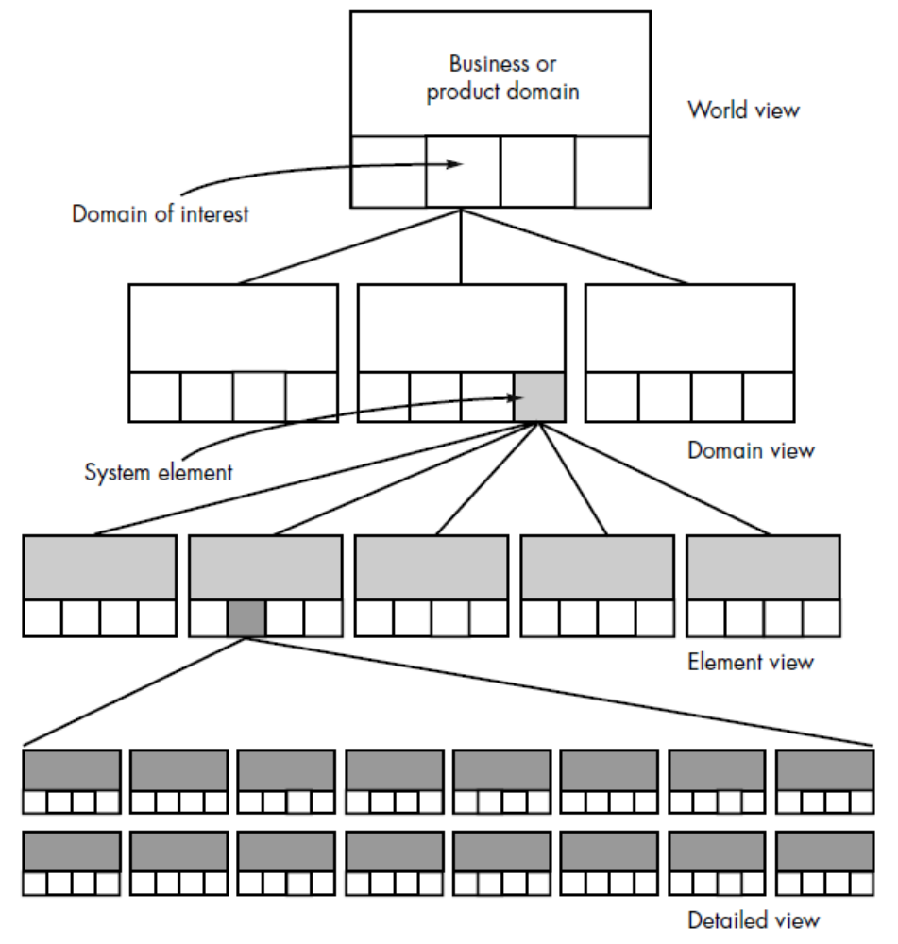
System Engineering Hierarchy
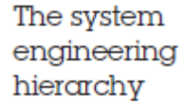
Required:

Draw the system engineering hierarchy diagram for your project

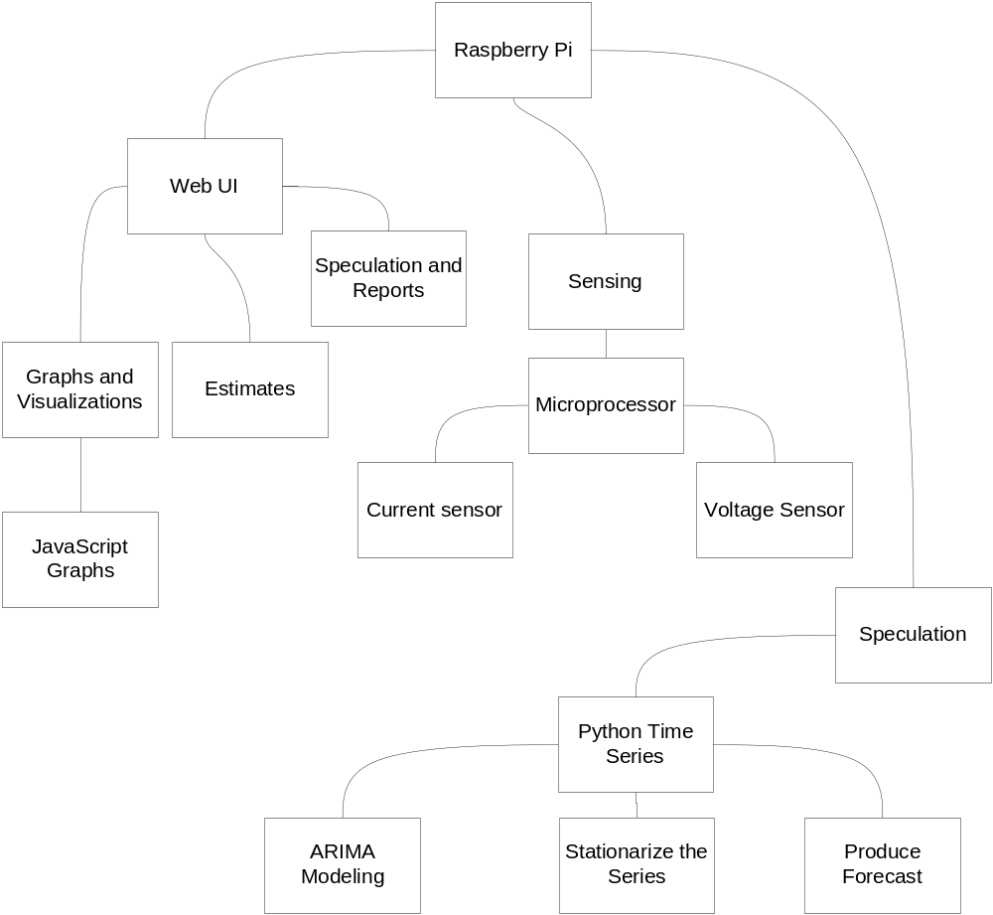

PRACTICAL No: 03
System Modeling

To construct a system model, the engineer should consider a number of restraining factors:

1. Assumptions that reduce the number of possible permutations and variations, thus enabling a model to reflect the problem in a reasonable manner. As an example, consider a three-dimensional rendering product used by the entertainment industry to create realistic animation. One domain of the product enables the representation of 3D human forms. Input to this domain encompasses
the ability to specify movement from a live human actor, from video, or by the creation of graphical models. The system engineer makes certain assumptions about the range of allowable human movement (e.g., legs cannot be wrapped around the torso) so that the range of inputs and processing can be limited.

2. Simplifications that enable the model to be created in a timely manner. To illustrate, consider an office products company that sells and services a broad range of copiers, faxes, and related equipment. The system engineer is modeling the needs of the service organization and is working to understand the flow of information that spawns a service order. Although a service order can
be derived from many origins, the engineer categorizes only two sources: internal demand and external request. This enables a simplified partitioning of input that is required to generate the service order.

3. Limitations that help to bound the system. For example, an aircraft avionics system is being modeled for a next generation aircraft. Since the aircraft will be a two-engine design, the monitoring domain for propulsion will be modeled to accommodate a maximum of two engines and associated redundant systems.

4. Constraints that will guide the manner in which the model is created and the approach taken when the model is implemented. For example, the technology infrastructure for the three-dimensional rendering system described previously is a single G4-based processor. The computational complexity of problems must be constrained to fit within the processing bounds imposed by the processor.

5. Preferences that indicate the preferred architecture for all data, functions, and technology. The preferred solution sometimes comes into conflict with other restraining factors. Yet, customer satisfaction is often predicated on the degree to which the preferred approach is realized. The resultant system model (at any view) may call for a completely automated solution, a semi-automated solution, or a non-automated approach. In fact, it is often possible to characterize models of each type that serve as alternative solutions to the problem at hand. In essence, the system engineer simply modifies the relative influence of different system elements (people, hardware, software) to derive models of each type.

Required:

Describe the restraining factors mentioned above for your final year project

Assumptions
The project is being used by an industry to monitor it’s machinery’s electrical consumption. There is only one user who checks the output of the reports that are generated in real-time. The device is monitoring at least one machine which is single phase and the data to the main processor is noiseless.
The devices subjected to monitoring are using standard 220-240 Volts.

Simplifications
The data is collected by sensors and passed to the raspberry-pi, for speculation and other data analysis such as visualization of which channel is using the most and the least energy. The UI is web based and runs on the raspberry-pi or any other Linux-Debian environment. Speculation will only show the user what the budget will be, by the end of the month.
Limitations
The data collected by monitoring device for speculation purposes does not deviate more than 50% of it’s average, because then the speculation may be thrown off course and the targeted budget will not be properly accomplished by following suggestions of the system. The sensors be built, being able to sense at least 10 Amps of current
Constraints
The whole software part of the system must be able to run on minimal hardware requirements such as at least 256 MB of RAM and 1 GHz of processing power. The volume of software part is not to exceed 500 MB of storage because the system is meant to be portable and flexible i.e. run on different devices that aren’t running Microsoft Windows.
The device one which it runs has a browser capable of running Python Scripts and has essential Python libraries including matplotlib, numpy, the time series and tkinter.
Preferences
The preferred data architecture for data is JSON, it is a standard format for web UI. The other data types like CSV can also be used but the system sensors’ microprocessor generates JSON much more reliably than a CSV.
The device used to run speculations should be a raspberry-pi because the sensors and monitors are made for a 3.3 v serial interface and can use General Purpose Input/output (GPIO) pins for interfacing with them. It could be a usual PC but then the number of devices being monitored will be very limited and adding devices will become very expensive.

PRACTICAL No: 04
Goals of System Modeling – Data Architecture

The goal of business process engineering (BPE) is to define architectures that will enable a business to use information effectively.

However, the price for this change is largely borne by the IT [information technology] organizations that must support this polyglot configuration. Today, each IT organization must become, in effect, its own systems integrator and architect. It must design, implement, and support its own unique configuration of heterogeneous computing resources, distributed logically and geographically throughout the enterprise, and connected by an appropriate enterprise-wide networking scheme.

Moreover, this configuration can be expected to change continuously, but unevenly, across the enterprise, due to changes in business requirements and in computing technology. These diverse and incremental changes must be coordinated across a distributed environment consisting of hardware and software supplied by dozens, if not hundreds, of vendors. And, of course, we expect these changes to be seamlessly incorporated without disrupting normal operations and to scale gracefully as those operations expand.

When taking a world view of a company’s information technology needs, there is little doubt that system engineering is required. Not only is the specification of the appropriate computing architecture required, but the software architecture that populates the “unique configuration of heterogeneous computing resources” must be developed. Business process engineering is one approach for creating an overall plan for implementing the computing architecture.

Three different architectures must be analyzed and designed within the context of business objectives and goals:

• data architecture
• applications architecture
• technology infrastructure

The data architecture provides a framework for the information needs of a business or business function. The individual building blocks of the architecture are the data objects that are used by the business. A data object contains a set of attributes that define some aspect, quality, characteristic, or descriptor of the data that are being described. For example, an information engineer might define the data object customer. To more fully describe customer, the following attributes are defined:

Object: Customer
Attributes:
name
company name
job classification and purchase authority
business address and contact information
product interest(s)
past purchase(s)
date of last contact
status of contact

Once a set of data objects is defined, their relationships are identified. A relationship indicates how objects are connected to one another. As an example, consider the objects: customer, and product A. The two objects can be connected by the relationship purchases; that is, a customer purchases product A or product A is purchased by a customer. The data objects (there may be hundreds or even thousands for a major business activity) flow between business functions, are organized within a database, and are transformed to provide information that serves the needs of the business.

Required:

For your project as described above construct Data Architecture.

Simplistic view of overall data flow
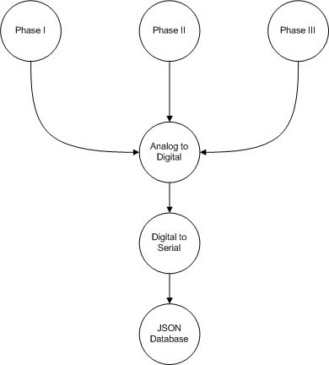

Data Architecture according to software
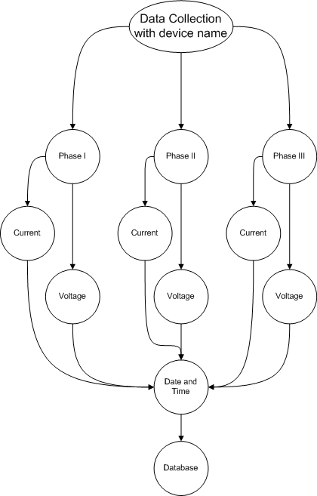
{
“device”:”Device1”,
“phase1voltage”:”240”
“phase1current”:”8.76”
“time”:”DD/MM/YYY”
}

PRACTICAL No: 05
Goals of System Modeling – Application Architecture

The application architecture encompasses those elements of a system that transform objects within the data architecture for some business purpose. In the context of this book, we consider the application architecture to be the system of programs (software) that performs this transformation. However, in a broader context, the application architecture might incorporate the role of people (who are information transformers and users) and business procedures that have not been automated.

Required:

For your project describe the Application Architecture.

Application Architecture
As discussed earlier that the whole project is encapsulated into a web UI, capable of executing scripts. The web UI is just a website, which will run locally, as a standalone application. It comprises of all the components of the project:
- The UI itself; where the user can see all of the outputs, visualization of data and can even set the overall target budget of electricity.
- The serial interface; the bridge that connects actual physical hardware and the software, set to figure out what port is the hardware on and commune with it. The communication in only input from the microprocessors of the sensors but it is in digital form, i.e. series of 1s and 0s.
- Data writing mechanism; the data from the microprocessor is already in JSON, all that is needed now is to catch and parse that stream into meaningful data for the graphing and visualization.
- Data fetch; data reading and implementing analysis of speculation
- Speculation; consisting of Python Time series, this layer itself is the main attraction of the project, it applies auto-regression and ARIMA modeling. This part transforms data objects for self-analysis and predicts the load on a certain date of the month

PRACTICAL No: 06
Goals of System Modeling – Technology Infrastructure

The technology infrastructure provides the foundation for the data and application architectures. The infrastructure encompasses the hardware and software that are used to support the application and data. This includes computers, operating systems, networks, telecommunication links, storage technologies, and the architecture (e.g., client/server) that has been designed to implement these technologies

Required:

Describe Technology Infrastructure for your project.

There are three levels at which this project works, each using a different technology, since we have to transcend from a very low level programming, from the physical world (sensing) to the abstract (speculation and GUI). It took the concepts of software engineering to combine all three of them:
- Arduino or Microprocessors
A very low level tool used to interact with the physical world. It’s sole purpose is to take physical values from the sensor and convert it into the digital signals to be parsed. Arduino or AT mega processors are the same thing because they do the same tasks with only difference being that Arduino is mounted on a board and AT mega processors need to be manually built into a board.
Both above mentioned technologies use “C” as their programming language and can manipulate even individual 1s and 0s of a digital signal. They send signals in serial binary to any other device, their interfaces can differ such as sometimes as simple as USB and sometimes as Rx and Tx for additional functionality and minimal hardware requirements.

- Central Processor
The raspberry-pi is used as a central processor to analyze and visualize the data, so that a user can understand it and provide Web UI along the way. The Raspberry-Pi is also a small device with greater functionality, as it runs a whole platform of Raspbian Jessie.
The Raspbian Jessie is a lightweight flavor of Linux offering almost same functionality as a personal computer but with additional General Purpose Input/output pins. The Raspberry-Pi can be programmed using any programming language, furthermore it can also run several instances of a program at a time.

- Backend Programming
Python is used as a high level programming language for prediction and forecasting purposes. It offers easy manipulation of (relatively small amounts of) data including serial and real-time streams. For databases python is using the Mongo DB which is flexible database.

PRACTICAL No: 07
Business Process Engineering Hierarchy

To model the system architectures described earlier, a hierarchy of business process engineering activities is defined. Referring to Figure, the world view is achieved through information strategy planning (ISP). ISP views the entire business as an entity and isolates the domains of the business (e.g., engineering, manufacturing, marketing, finance, sales) that are important to the overall enterprise. ISP defines the data objects that are visible at the enterprise level, their relationships, and how they flow between the business domains.

The domain view is addressed with a BPE activity called business area analysis (BAA). Hares describes BAA in the following manner:

BAA is concerned with identifying in detail data (in the form of entity [data object] types) and function requirements (in the form of processes) of selected business areas [domains] identified during ISP and ascertaining their interactions (in the form of matrices). It is only concerned with specifying what is required in a business area.

As the system engineer begins BAA, the focus narrows to a specific business domain. BAA views the business area as an entity and isolates the business functions and procedures that enable the business area to meet its objectives and goals. BAA, like ISP, defines data objects, their relationships, and how data flow. But at this level, these characteristics are all bounded by the business area being analyzed. The outcome of BAA is to isolate areas of opportunity in which information systems may support the business area.

Once an information system has been isolated for further development, BPE makes a transition into software engineering. By invoking a business system design (BSD) step, the basic requirements of a specific information system are modeled and these requirements are translated into data architecture, applications architecture, and technology infrastructure.

The final BPE step—construction and integration focuses on implementation detail. The architecture and infrastructure are implemented by constructing an appropriate database and internal data structures, by building applications using software components, and by selecting appropriate elements of a technology infrastructure to support the design created during BSD. Each of these system components must then be integrated to form a complete information system or application. The integration activity also places the new information system into the business area context, performing all user training and logistics support to achieve a smooth transition.

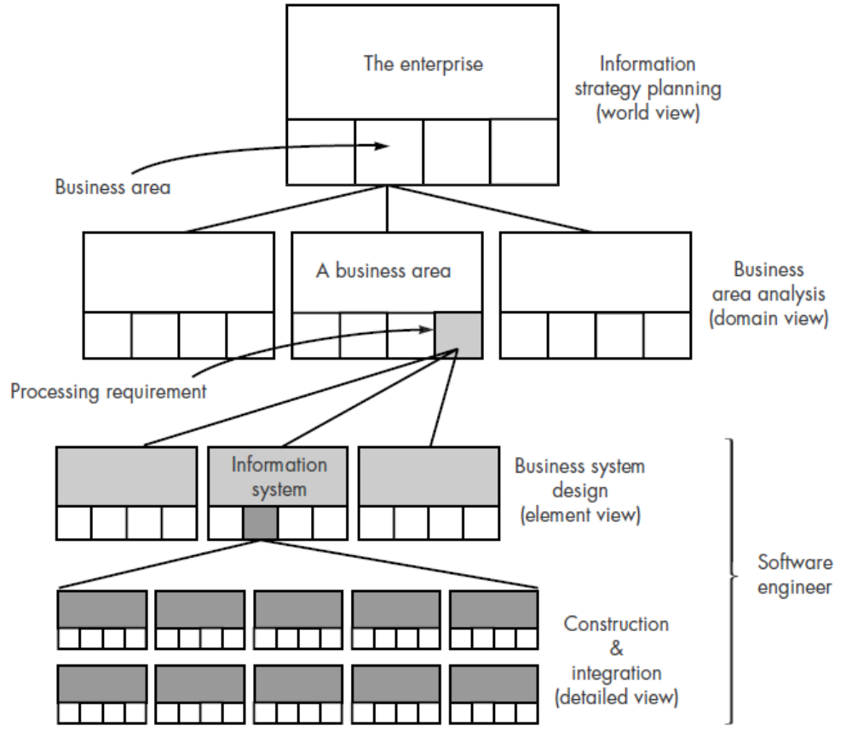
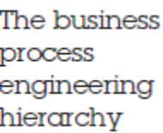

Required:

Construct the Business Hierarchy Diagram for your project.

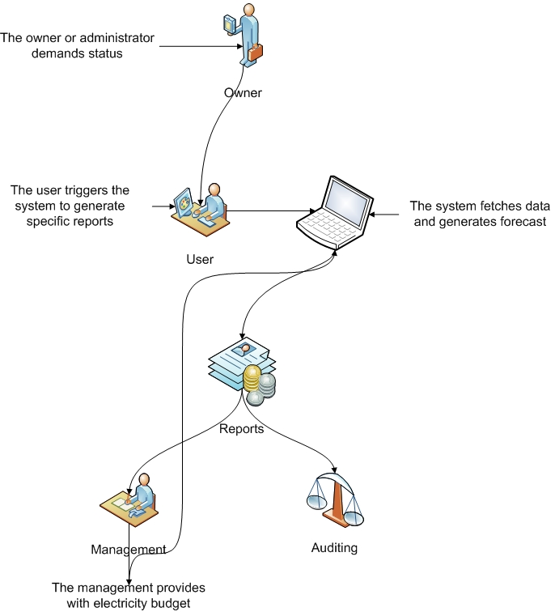
PRACTICAL No: 08
Product Engineering Hierarchy

The goal of product engineering is to translate the customer’s desire for a set of defined capabilities into a working product. To achieve this goal, product engineering—like business process engineering—must derive architecture and infrastructure. The architecture encompasses four distinct system components: software, hardware, data (and
databases), and people. A support infrastructure is established and includes the technology required to tie the components together and the information (e.g., documents,
CD-ROM, video) that is used to support the components.

Referring to Figure, the world view is achieved through requirements engineering. The overall requirements of the product are elicited from the customer. These requirements encompass information and control needs, product function and behavior, overall product performance, design and interfacing constraints, and other special needs. Once these requirements are known, the job of requirements engineering is to allocate function and behavior to each of the four components noted earlier.

Once allocation has occurred, system component engineering commences. System component engineering is actually a set of concurrent activities that address each of the system components separately: software engineering, hardware engineering, human engineering, and database engineering. Each of these engineering disciplines takes a domain-specific view, but it is important to note that the engineering disciplines must establish and maintain active communication with one another. Part of the role of requirements engineering is to establish the interfacing mechanisms that will enable this to happen.

The element view for product engineering is the engineering discipline itself applied to the allocated component. For software engineering, this means analysis and design modeling activities (covered in detail in later chapters) and construction and integration activities that encompass code generation, testing, and support steps. The analysis step models allocated requirements into representations of data, function, and behavior. Design maps the analysis model into data, architectural, interface, and software component-level designs.

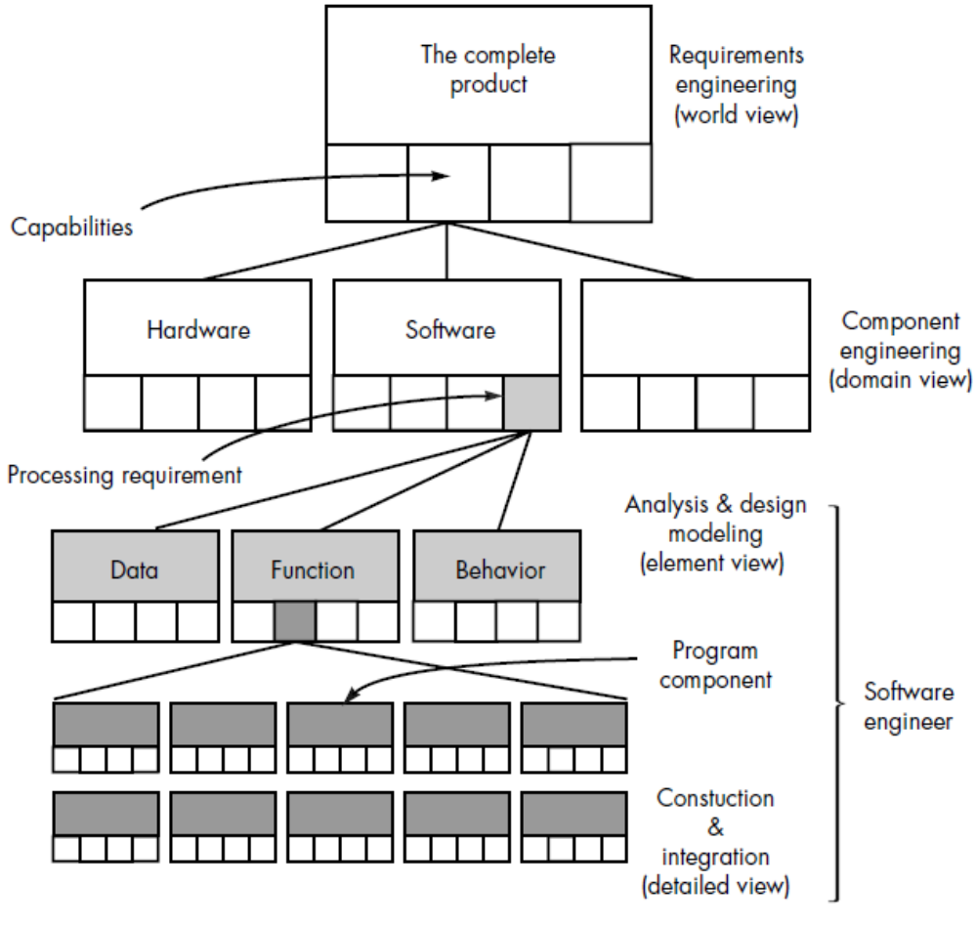
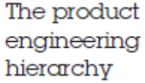

Required:

Construct Product Engineering Hierarchy Diagram for your project.
