Multi Purpose GUI

User Readme

Author: Gruftikus
This Readme refers to v2.00 of MPGUI

I. Introduction

MPGUI (Multi Purpose GUI) is a graphical frontend mainly for tes4ll but also other various command-line based tools such as Lightwaves TESAnnwyn or TES4qLOD. In order to be more flexible for possible future versions of tes4ll, MPGUI does not use hard coded elements, but it is based on a scripting language (Multi Purpose Batch, or just “batch”).

This short Readme describes how to install and use MPGUI.

II. Installation

The package comes with an installer. Just double-click on the Setup.exe or on MPGUI-Setup.msi

The installer will guide you through the installation. For the installation path, any possible directory can be chosen. It is not required to install MPGUI in one of the game pathes (although it is not forbidden to do so).

Keep in mind, that MPGUI is just a front-end for command-line based tools, so you will have to install at least one additional tool.

At the time being, MPGUI supports the following tools:

- Lightwaves TESAnnwyn: http://projectmanager.f2s.com/morrowind/TESAnnwyn.html
- Lightwaves TES4qLOD: http://projectmanager.f2s.com/morrowind/TES4qLOD.html
- My tes4ll: http://www.tesnexus.com/downloads/file.php?id=40549
(in addition also the Fallout3/NV and Skyrim editions of tes4ll)

For the first 2 tools, batch files are provided (they are installed in the subdirectory “templates” found in MPGUI installation directory), for tes4ll the game-dependent batch file(s) come within this package itself, in order to stay up to date. After the installation, MPGUI can be started either directly, or by double-clicking on the *.mpb file which came with tes4ll.

III. Usage

As mentioned above, the GUI itself is just empty, if no batch file has been loaded:

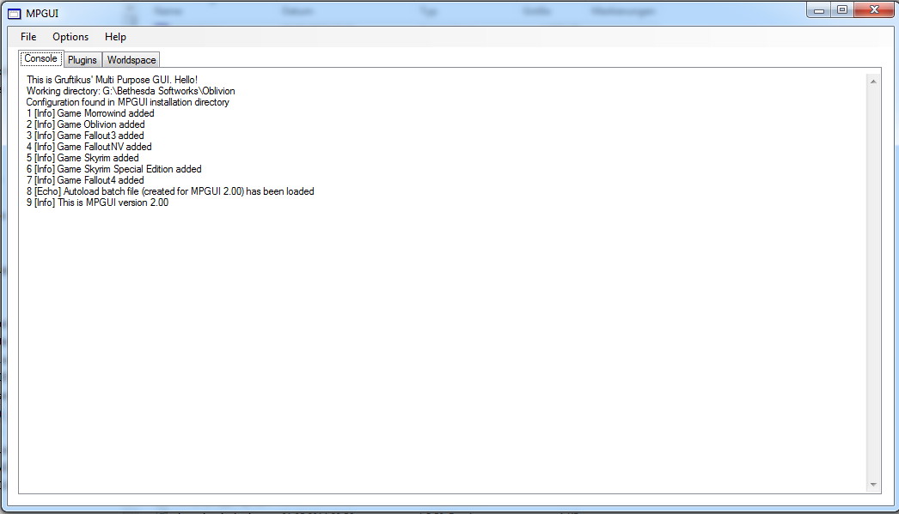
MPGUI needs a configuration file in order to know what it has to show and what it has to do. These configuration files are called “batch”, and their appendix is *.mpb (multi purpose batch). One of the methods to start MPGUI is to double-click on one of the batch files. The other is to use the File → Open batch menu. (e.g.: oblivion\Data\ini\tes4ll and open tes4ll_all.mpb)(never open mpgui_autoload.mpb, it stores some basic game configuration only):

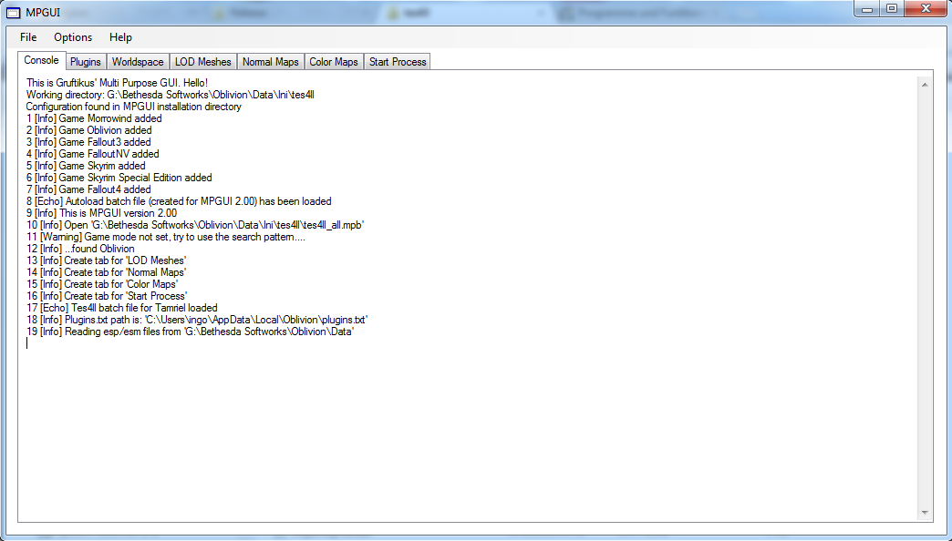
The major effect is that new tabs appear after the loading of the mpb file. Also, the Plugins tab is now accessible. The list of the plugins found here depend on the game which has selected, either during start-up, or manually via the options. A click on “Plugins.txt” allows you to apply the normal plugin list, as they have been selected for your game.

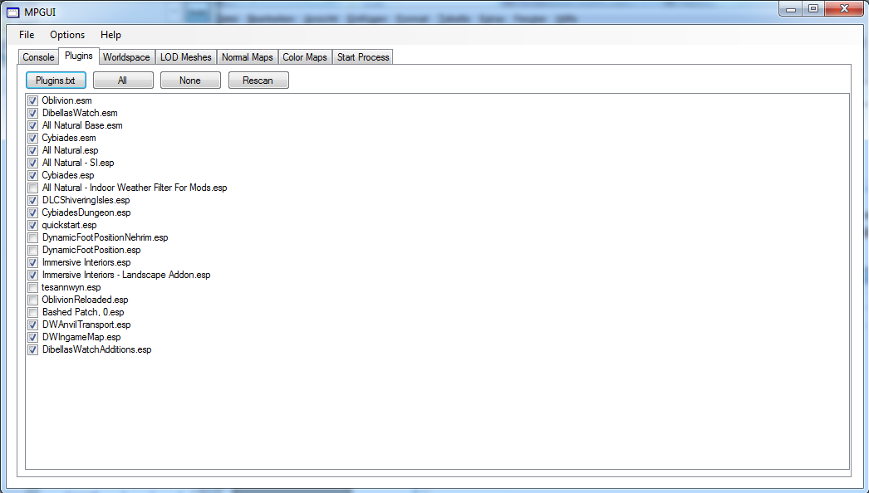
It is also possible to change this selection. The selection is only used for the tool, not for the game settings.This changes do not apply to the standard Plugins.txt, so it does not work like a mod manager.

The next step is to go to the Worldspace tab:

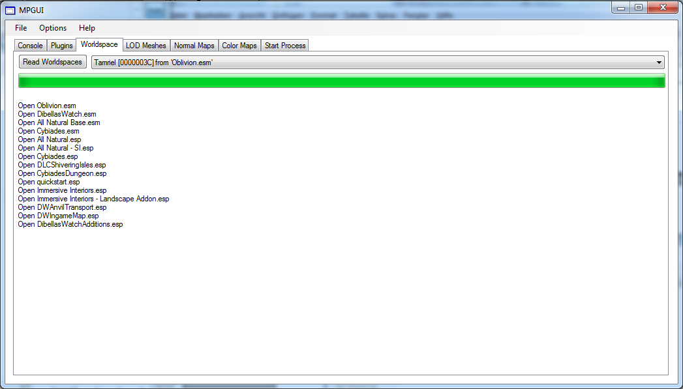
A click on “Read Worldspaces” scans all selected files for all available world spaces. For each game, the standard worldspace (like Tamriel) will be selected. However, the drop down menu allows to exchange the worldspace.

One can now proceed with the other new tabs. Their appearance are not part of the GUI, and therefore not hard-coded and might look different depending on tool, version and game. For details of all the options there, one should take a look to the description of the tool (like tes4ll). The are also help banners available by moving over the option.

After all options have been set, one can go to the last tab and click on “Click me if you are ready”. The GUI switches now back to the console, and starts the tool, like tes4ll:

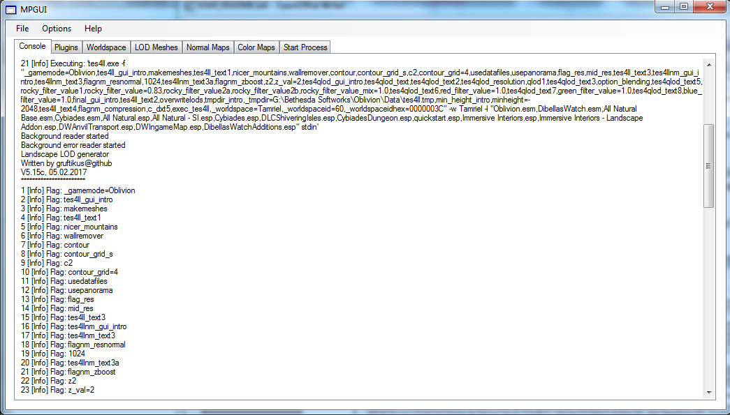
The GUI switches back to the console, and start the tool. Basically, all the options which have been selected with MPGUI are now converted to a shell command and the tool (tes4ll.exe) is executed with all the options.

MPGUI has also some options which can be selected via the menu.

File → Open batch allows to open a batch file.

File → Save batch stores the complete configuration: all tabs, the plugin selection and the current world space. This allows to re-start the tool using the same configuration.

File → Cancel process allows to stop a running tool.

Options → “Game mode” can be used to select or change the game mode (N.B. This will not switch the batch file).

Options → “Load order” can be used to change the load order scheme. Normally this is done automatically for each game.

Options → “Choose mod path”: Here one can select a game path which is not the standard installation path of the game. The path should be the one which contains the esm/esm files as well as the tool executable. This should allow to maintain more than one game installation.

IV. Credits

Lightwave for TES4qLOD (I used the source code as the world space reader) and for TESAnnwyn.

Tested under Windows 7 and Windows 10.
For adapting MPGUI to other tools (which is possible), please take a look to the reference manual which can be found on Github

