Deliverable 1

Group: The Architects
Members: Jacob Grum, Rasmus Ole Routh Herskind & Thor Liam Møller Clausen


System description

Overall functionality
Imagine the following; Kevin wants to bet on Holger winning his tennis match. He checks his usual site, which gives odds 1.8. But his mate next to him scuffs at him “you should check out my site, it gives odds 1.9”. Kevin quickly realizes that he is not loyal to his site, he is mostly interested in placing on any site with the best odds available - Introducing BestBets:
Shows the best odds available on any site, for any match.
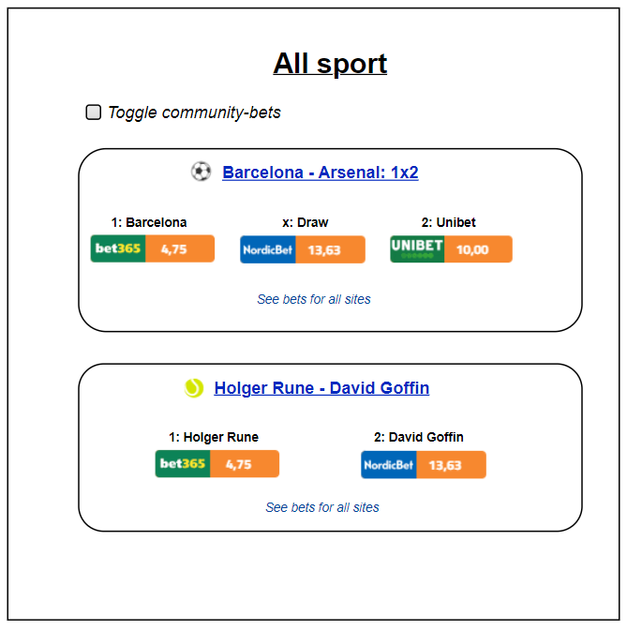
Plenty of stock-like features! Trigger order, when a certain game reaches certain odds.
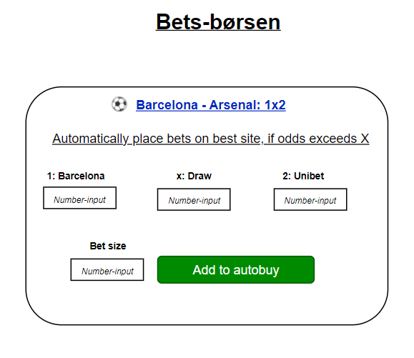

Similar market conditions as stocks. You don’t want to search for the best offer from a bank, you trade on a shared market (Børsen). That means you only need to have money in one central place, to be able to purchase from all bookmakers! In short. If you have 200 kr on BestBets, you can place 200 kr on ANY bookmaker, without having a saving of 200 kr on each bookmaker.
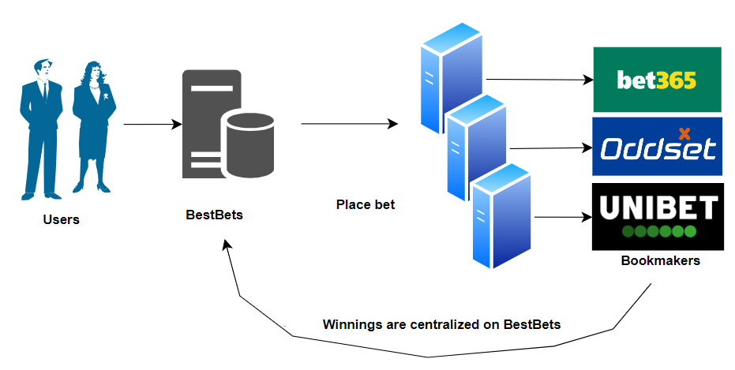
Similar to shorting a stock. Think the best odds are bad? Open your own position, and act like the bookmaker!
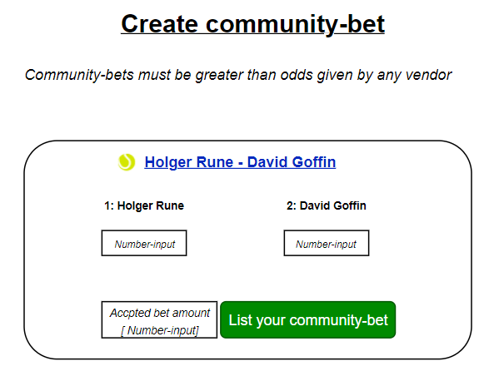

Quickly register for any bookmaker, through a saved formula, to get consistent information across multiple sites, and to always be ready to place on the best odds possible.
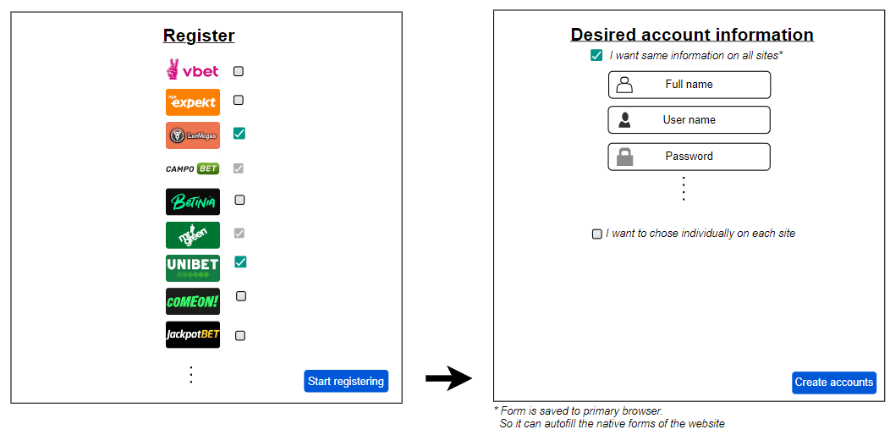
Get an instant overview of current bets, accounts and bonuses!
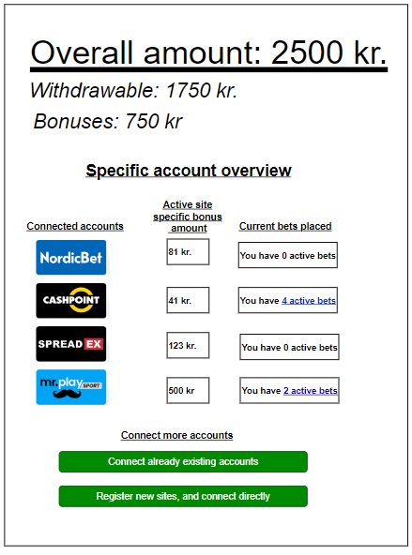

Various settings to ensure only your favorite sports are shown, to ease navigation and usage.
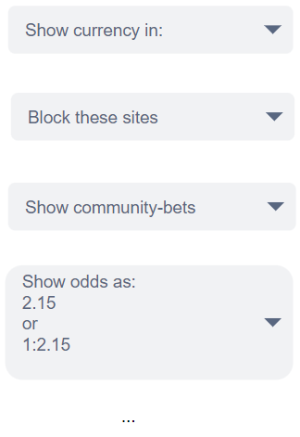

Context diagrams

Informal diagram

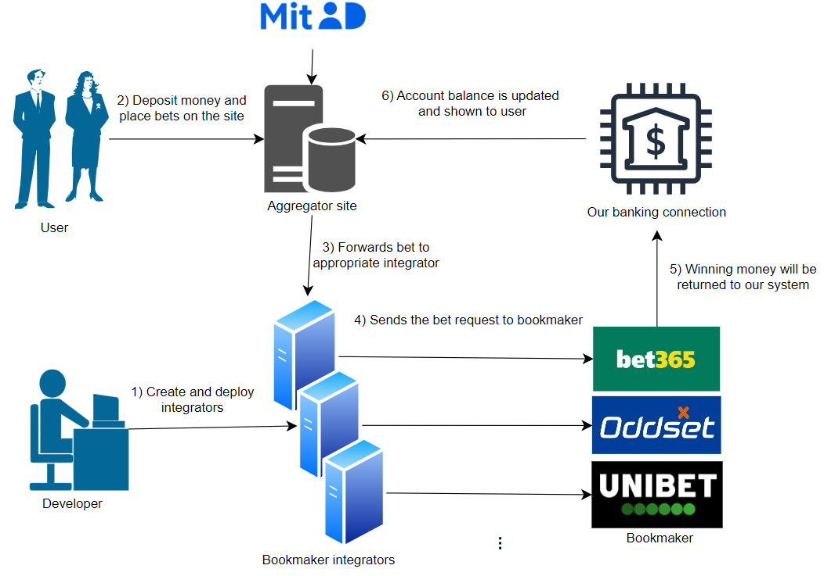

Formal diagram

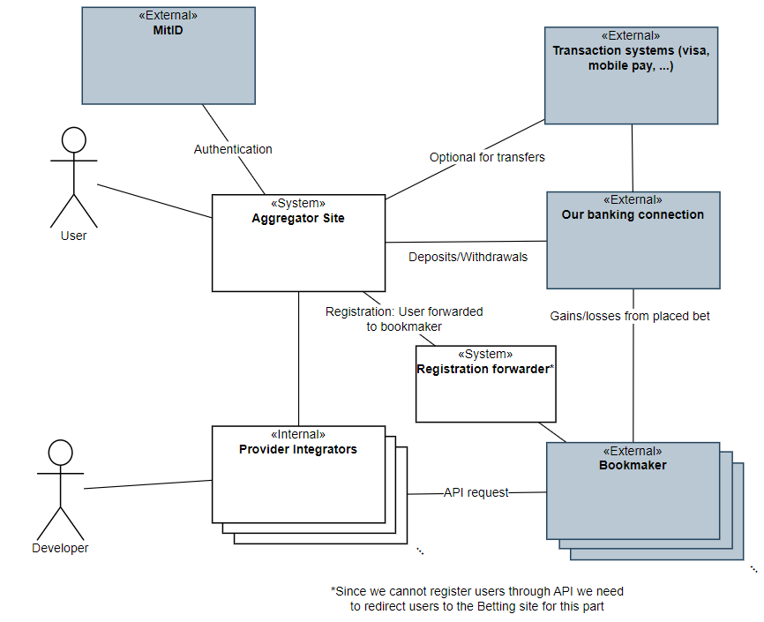

Architectural analysis

Identification of Architectural Drivers

The numbers in parenthesis is the number of points given in our stakeholder role play.
- Modifiability Requirement:
  - Handle new bookmakers (11)
The architecture shall be modifiable so that when a new bookmaker becomes available or an existing one ceases operation, support for that bookmaker can be added or removed with minimal impact on the overall system.
- Availability Requirement:
  - Available during high demand (12)
The system must remain available even during periods of high user demand (e.g., during high-traffic sporting events) to ensure continuous access to betting data.
- Performance Requirements:
  - Low Latency (14)
The system shall fetch and display betting odds from multiple providers in real-time or near-real-time. Delays in page loads or data updates must be minimized to prevent users from missing favorable odds.
  - Efficient Data Processing (14)
The system must process large volumes of betting data rapidly (especially during peak activity such as major finals) so that performance remains robust under load.
- Safety Requirement:
  - Safely handle odds changes (10)
The system shall ensure safety during the bet placement and acceptance process. If betting odds change between the time a bet is placed and accepted, the system must reject the altered odds and prompt the customer to re-confirm their bet under the new conditions.
- Usability Requirements:
  - Intuitive Navigation (12):
Users shall be able to quickly and easily find the best odds for a match.
  - Responsive Design (11):
The interface must adapt seamlessly to various devices (mobile, tablet, desktop) to accommodate users checking odds on the go.
  - Support for Specific Scenarios (12):
Filtering. Only tennis, only matches in Austrilian Open, that ends within 12 hours.
  - Consistent design (12). A bet placed on bookmaker A must have same mechanics and appearance as on bookmaker B.

- Security Requirement:
  - The system must ensure robust security (9):
User data and communications must be safeguarded using secure handling mechanisms.
Given that customers place real money on bets, the system must ensure that all financial and personal data are protected from unauthorized access.

Most important ones:
- Performance (14)
  - Low latency: Provide fresh odds.
  - Efficient Data Processing: During many bets placed during big event
- Availability(13)
  - System must work and respond during high traffic for big events
- Usability (12)
  - Intuitive design. Our aggregator must provide an interface that does not get affected by what bookmaker the bets are offered from. Betting on A should look the same as betting on B, where A and B are two different bookmakers.
- Modifiability (11)
  - In case many new bookmakers open or others close, it must be handled without too much trouble.
- Safety (10)
  - With money being handled, the user must not be prone to make mistakes.

Stakeholder roles

Often directly in touch with the system
- Betting sites, also referred to as “Bookmakers”
- Developers/Architects
- Users
Various gambling related governmental instances
- Spillemyndigheden: https://www.spillemyndigheden.dk/gaming-og-gambling
- Ludomani støtteforeninger: https://www.stopspillet.dk/
Various partners and affiliates:
- Sport-event industry (Arenas, leagues, etc).
- Sport clubs
- Sports news (magazines, blogs, etc.)
- Sports apparel and merchandise
- Sport streaming & channels

Quality Attribute Scenarios

Performance
Refined Scenario 1: Real-Time Betting Odds Update
Scenario: The system updates betting odds in real-time during a high-profile sports event.
Relevant quality: Performance
Stimulus source: External betting data providers.
Stimulus: A sudden surge in updated odds from multiple providers as a major match reaches a critical point.
Environment: System is running high traffic during live, high-stakes sports events.
Artifact (if known): The module(s) that fetches live data from betting sites and updates our site.
Response: Fetch and process incoming data rapidly and update the user interface with minimal delay.
Response measure: Updated odds are displayed within 500 milliseconds of detected change, sustaining throughput of up to 100.000 updates per minute without performance degradation.
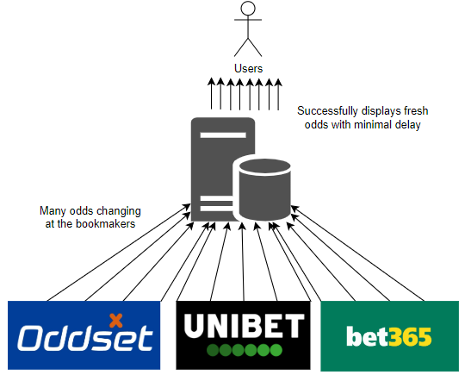
Refined Scenario 2: Massive user surge during the Champions League final
Scenario: The system responds to a lot of users during Champions League final with little delay.
Relevant quality: Performance/Scalability
Stimulus source: A lot of end users (100.000) logging in at the same time.
Stimulus: Number of users logged in increases from 1000 to 100.000 in the span of 10 minutes.
Environment: System running normally.
Artifact (if known):
Response: The system continues to serve updated odds without errors or significant delays
Response measure: Pages load within 2 seconds for 95% of requests. Odds update within 3 seconds of provider feed changes.
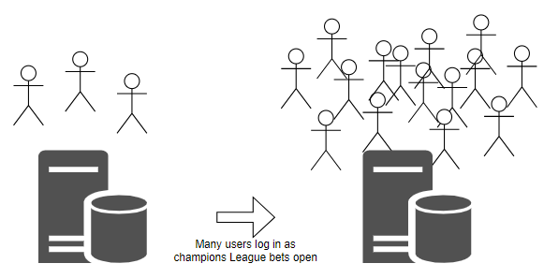
Refined Scenario 3: Massive surge of placed bets during prep for a mayor sports match
Scenario: The systems handles a lot of bets placed within a short time span with little delay.
Relevant quality: Performance
Stimulus source: A lot of end users (100.000) placing bets.
Stimulus: 100.000 bets being placed per 5 minutes.
Environment: The system running at high capacity with many users logged in.
Artifact (if known): The module(s) handling the forwarding of bets to the betting sites, and module(s) receiving confirmation from the sites.
Response: The system successfully forwards the bet placements without creating bottlenecks.
Response measure: With 100.000 bets per 5 minutes the average latency should be below 1 second from user confirms in our system to the bet being successfully forwarded to the respective betting site.
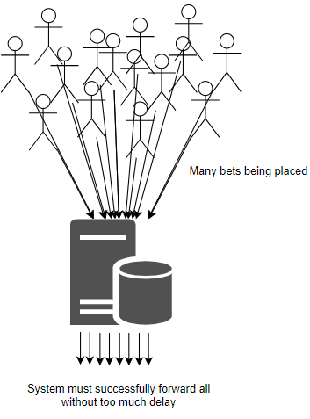
In short:
1: Handle external updates of odds.
2: Many users logs into our internal site.
3: Many bets are placed.

Availability

Refined Scenario 1: Continuous Availability Under Traffic Spike
Scenario: The platform remains fully available during an unexpected surge in user traffic.
Relevant quality: Availability
Stimulus source: End users accessing the site during a major sporting event.
Stimulus: 100.000 users simultaneously accessing and interacting with the platform.
Environment: System running on high capacity from the many logged in users.
Artifact (if known): The modules handling user activity (front end, server, load balancers, auto-scaling infrastructure).
Response: The system dynamically scales resources and distributes the load to maintain service availability.
Response measure: Achieves 99.9% uptime during peak load with 95% of requests served in under 500 milliseconds.

Refined Scenario 2: Site remains available during betting site outages
Scenario: The system handles the failure of one or more betting sites without affecting overall availability.
Relevant quality: Availability
Stimulus source: Betting sites failing to respond to requests (ping).
Stimulus: Ping requests without a response within 2 seconds from one or more betting sites.
Environment: System running normally with logged in end users.
Artifact (if known): Modules communicating with betting sites (fetching data, checking for activity).
Response: The system continues to display odds from other providers and clearly labels outed providers as “unavailable”.
Response measure: The system has a 99.99% uptime with up to 100% of betting sites unavailable.
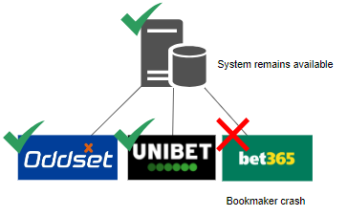
Refined Scenario 3: The integration of a new betting site does not affect availability
Scenario: A new betting site has been integrated in the system and gets deployed without affecting active users.
Relevant quality: Availability
Stimulus source: The developers deploying a new betting site opportunity in the system.
Stimulus: Initiation of the deployment of the new betting site integration.
Environment: System running normally with logged in end users.
Artifact (if known): The modules interacting with the betting site integrations/the aggregator.
Response: The system switches seamlessly to the updated version without service disruption.
Response measure: Zero downtime is observed; the switchover is completed seamlessly with monitoring confirming uninterrupted service.
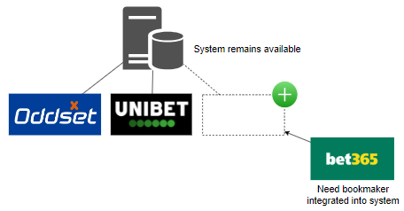

Usability

Refined Scenario 1: Consistent Navigation Across Devices
Scenario: The system provides a uniform and consistent user experience across various devices.
Relevant quality: Usability
Stimulus source: End users accessing the system on desktops, tablets, and mobile devices.
Stimulus: A user transitions between devices and expects the interface to behave consistently.
Environment: System running normally.
Artifact (if known): User interface.
Response: The user interface maintains consistent layout, design, and navigation regardless of the device.
Response measure: Less than 15% difference in the speed of user interaction across device.

Refined Scenario 2: Intuitive Filtering and Search
Scenario: Users quickly locate and filter betting events to find their preferred matches.
Relevant quality: Usability
Stimulus source: End users utilizing search and filtering tools.
Stimulus: A user applies filters (e.g., for tennis matches or events ending within 12 hours) to quickly locate relevant betting options.
Environment: System running normally with search/filter options implemented.
Artifact (if known): UI components and logical components managing search and filtering.
Response: The system delivers relevant results promptly, making it easy for users to narrow down options.
Response measure: At least 90% of search queries return results within 300 milliseconds; user feedback on the filtering process is overwhelmingly positive (95% satisfaction).

Refined Scenario 3: Streamlined, Consistent Bet Placement Process
Scenario: The bet placement workflow is intuitive and consistent across different sections of the site.
Relevant quality: Usability
Stimulus source: A user wanting to place a bet on several different betting sites using our system.
Stimulus: The user navigating through the system to place their bets.
Environment: System running normally.
Artifact (if known): The UI allowing for bet placement.
Response: The user successfully placing their bets without much delay in between bets.
Response measure: 90% of users successfully placing bets in less than 2 minutes on average and in case of multiple bets, at most 1 minute between bets on average.

Modifiability

Refined Scenario 1: Adding a New Betting Provider
Scenario: The system integrates a new betting provider with minimal disruption.
Relevant quality: Modifiability
Stimulus source: A business decision to expand service offerings.
Stimulus: Announcement of a new betting provider entering the market.
Environment: Development and production environments.
Artifact (if known): Aggregator codebase (API integration modules)
Response: Development team implements the new provider interface, tests it, and deploys it with minimal disruption, and minimal changes to the existing code base.
Response measure: Completed integration within 5 developer days. No existing functionality broken (automated tests pass). Less than 5% of the existing code base changed.

Refined Scenario 2: Removing an Existing Betting Provider
Scenario: The system gracefully removes support for a provider that is ceasing operations.
Relevant quality: Modifiability
Stimulus source: External betting site shutting down.
Stimulus: An existing betting provider has been decided to be removed from the system.
Environment: The system running with multiple integrated betting sites.
Artifact (if known): The modules interacting with the betting site integrations/the aggregator.
Response: The betting site integration is isolated for safe removal.
Response measure: Integration removal is executed in under 24 hours with zero system downtime.

Refined Scenario 3: Adapting to Changing Provider APIs
Scenario: The system is modified to handle betting provider’s changed API with minimal impact on overall functionality.
Relevant quality: Modifiability
Stimulus source: External betting provider API.
Stimulus: The betting provider releases a new version of its API.
Environment: System running with multiple integrated betting providers.
Artifact (if known): API adapter for external services.
Response: The API adapter is updated to accommodate the API changes while keeping the core system unaffected.
Response measure: The required modifications are completed and fully tested within 48 hours with only localized changes in the adapter code.

Safety

Refined Scenario 1: Acceptance of changed odds
Scenario: There is a difference in the odds between the time the user enters its desired bet, and when the bet is being confirmed at the vendor
Relevant quality: Safety/Usability
Stimulus source: External betting provider.
Stimulus: A user enters a bet and, immediately afterward, the betting odds change before confirmation.
Environment: System is running normally
Artifact (if known): Module(s) handling placement of bets.
Response: The initial desired bet is rejected, and user is asked if they want to place a new bet at the changed odds.
Response measure: 100% of bets affected by odds changes are safely rejected and re-confirmed, with user prompts issued within 1 second of detecting the change.
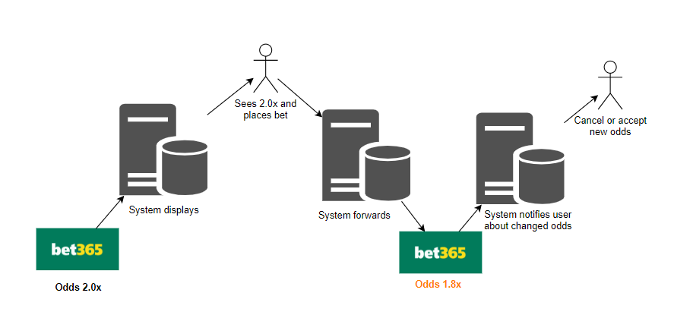
Refined Scenario 2: Impossible bets can't be placed.
Scenario: A user enters a desired bet, on a site that between confirmation and placement, gets removed from the external vendor.
Relevant quality: Safety
Stimulus source: External betting provider.
Stimulus: A user enters a bet and, immediately afterward, the bet is completely unavailable
Environment: System is running normally
Artifact (if known): Module(s) handling placement of bets.
Response: The initial desired bet is rejected. User is warned that no bet has been made, and is presented the highest available bet from another vendor.
Response measure: 100% of bets affected by removal are safely rejected, with a warning issued within 1 second of detection.

Refined Scenario 3: External betting site errors does not cause faulty behavior
Scenario: A betting provider is responding with error messages or not at all.
Relevant quality: Safety
Stimulus source: External betting providers.
Stimulus: Error responses when trying to communicate with betting provider.
Environment: System running normally.
Artifact (if known): Model(s) interacting with external betting providers.
Response: Our system continues to run without errors or faulty behaviour.
Response measure: 0 error detected in our system in the case of errors from external providers.

Architectural synthesis

Module view

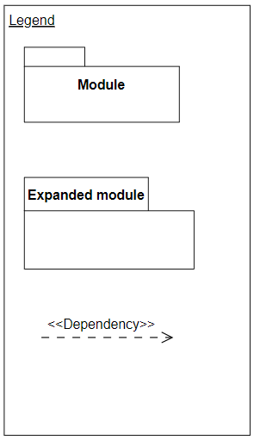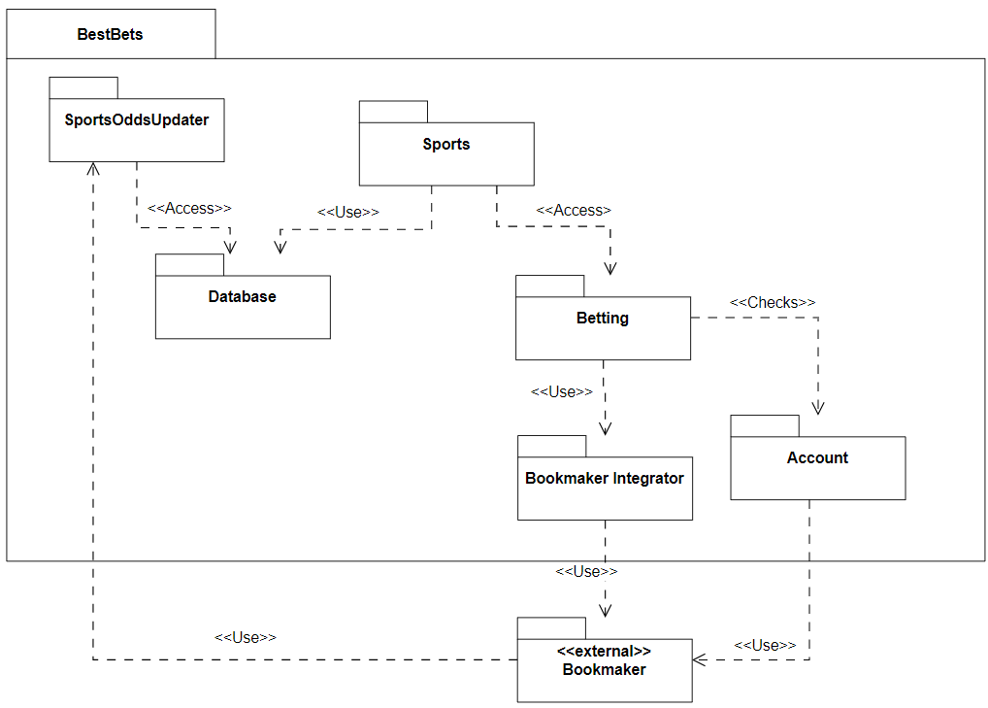
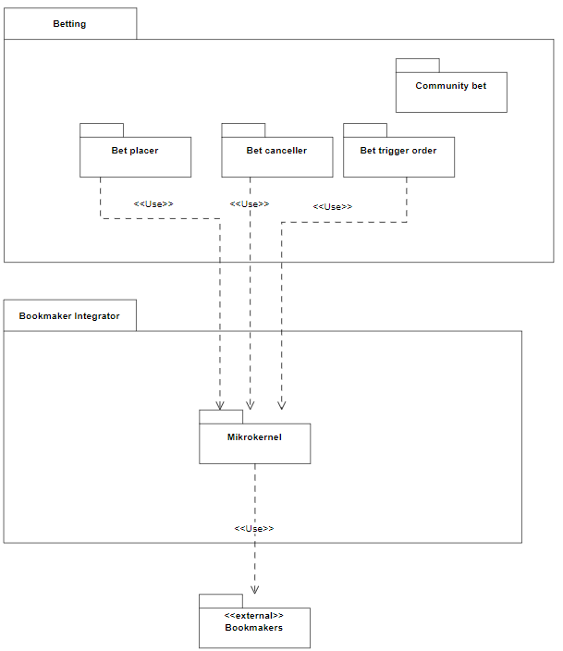

Component & connector view

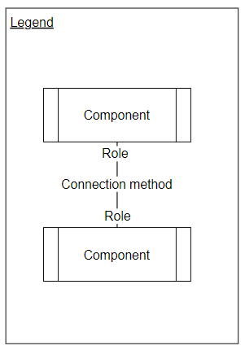
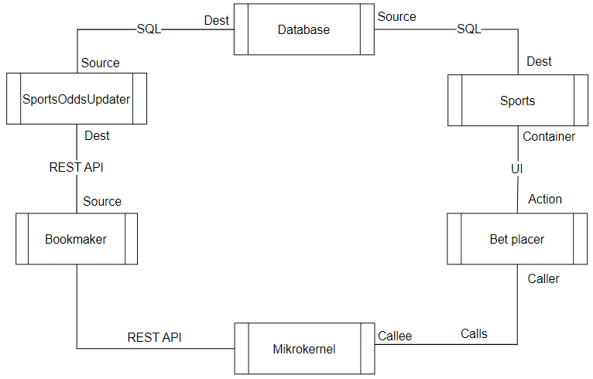

Deployment view

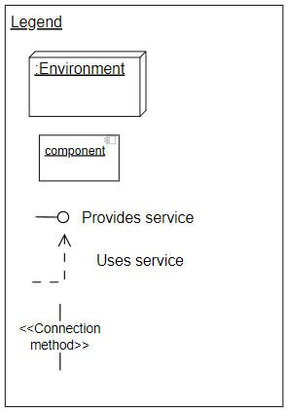
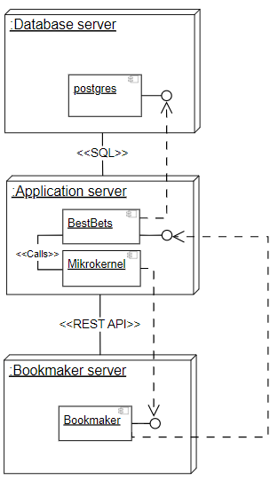

Design decisions regarding Tactics & Patterns

Overall structure
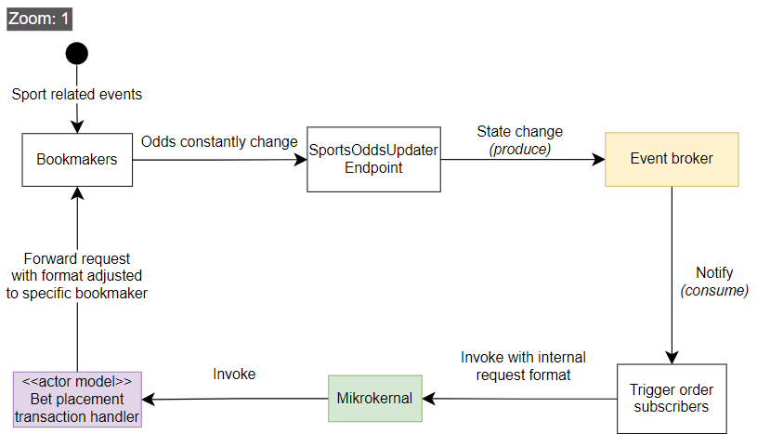

Event broker zoomed in view

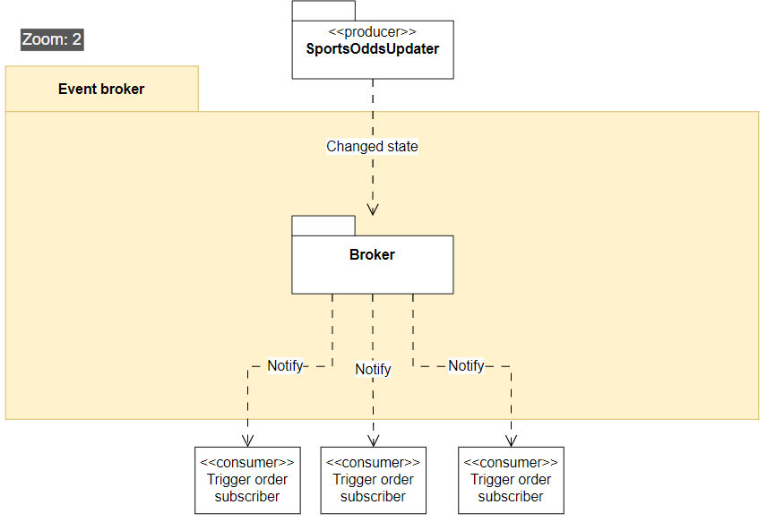Figure 1: What happens inside the event broker

Microkernel zoomed in view
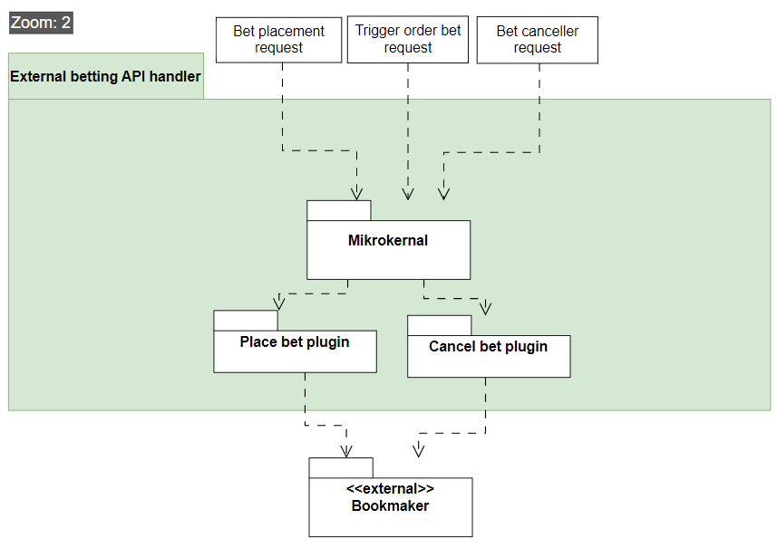Figure 2: What happens inside the microkernel

Plugin actor model zoomed in view
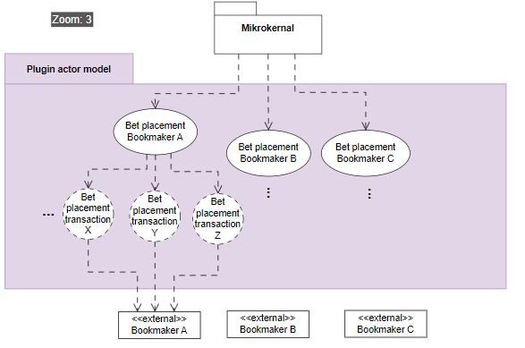
Figure 3: What happens inside the plugins that communicate with the bookmakers

Performance

Performance Patterns
A. Event broker [figure 1]
Pros
- The event broker can allow for low latency between odds being changed and the odds being displayed to our user. Each channel in the broker will be a specific match ID. Trigger orders will then act as subscribers on specific channels, using specific criteria being the odds and money placement.
Cons
- As the number of channels and subscribers increases, the broker can struggle to efficiently manage all connections, especially if channels are highly active. This can reduce performance.
- Traffic might be heavily unbalanced, as one channel might represent a local sports-match with 4 people in the audience and another represent the grand final match watched by millions. This can reduce performance.
- It can be difficult to ensure a correct ordering. In case we end up deciding that bigger bets should be prioritized higher than small bets. This can reduce usability.
- The broker might be the bottleneck, and a single point of failure. This can reduce availability.
B. Message Queuing using the Actor model [figure 3]
Pros
- Spinning up an actor to handle each transaction ensures greater resource utilization as they can work in parallel.
- Decoupling from other bookmaker, as each actor is designed to only communicate with a specific bookmaker. As thus, if the bookmaker changes the API, only a specific actor implementation is affected.
- This will also enhance safety qualities. Each actor will function as a “bet transaction”, handling cases where the bookmaker reject the bet due to odds changing, and then re-send the bet is within the users threshold setting for odds changing during placement.
- The actor model is suitable for horizontal scaling. Example by adding more “LeoVegas bookmaker actors”, in case there is high traffic on bet placements for LeoVegas.
Cons
- Spinning up actors introduces some time overhead.
- Inter-actor communication can introduce additional latency, thus reducing performance.

Performance Tactics
Control Resource Demand
Techniques: Prioritize events:
Pros:
- Events like trigger orders working with higher sums of real money should be prioritized compared to someone betting with fun-money or placing a small bet below 100 kr. This can be achieved with the event broker having a prioritization list. This will improve usability for the customer segment more important to us (The whales).
Cons:
- Less important events like updating the UI, gets higher latency.

Manage Resources
Techniques: Introduce concurrency:
Pros:
- Process multiple streams of betting data in parallel. This can be achieved with the actor model when handling bet placements. Each actor can act completely independent of other bookmaker actors, making their work “embarrassingly parallelizable”
Cons:
- Increased complexity in ensuring we don’t accidentally spin up two actors for the same task and places 2 bets etc.

Availability

Availability Patterns
A. Actor model [figure 3]
Pros
- The actor model can help preventing errors that causes the whole system to crash, by having the actors crash instead. Having a monitor on the actors lets the system know so it can notify the user or try again.
Cons
- Lots of communication handling is needed, which may introduce computation and complexity overhead.

Availability Tactics
Detect Faults
Techniques: Heartbeat:
Pros
- Regularly check the availability of external betting providers. Improves usability, if we can up-front tell a user that they can't place a bet at LeoVegas right now, compared to them trying to place a bet and afterwards getting told they can't do it.
Cons:
- Increases network traffic and monitoring overhead.

Recover from Faults
Techniques: Graceful degradation:
Pros
- When one provider fails, continue serving data from other providers. Achieved with actor model.
Cons
- Users may encounter reduced functionality in terms of bet placement options, which can lead to confusion or dissatisfaction.

Modifiability

Modifiability Patterns
A. Microkernel [figure 2]
Pros
- Provides a handler that supports placing/canceling bets on various external bookmaker API’s. This way if new bookmakers appear or change, we only have to handle the change in the microkernel logic while the rest of the system remains the same. Thus improving modifiability by decoupling different bookmakers, and isolating the system affected by external changes.
Cons
- Extra abstraction layers may lead to performance overhead.

Modifiability Tactics
Increase Cohesion & Reduce Coupling
Techniques: Split Module & Encapsulate External Calls
Pros
- Having different actors [figure 3] for different bookmakers increases cohesion and since they work independently they have low coupling.
- Letting the event broker [figure 1] encapsulate by handle detecting odds. changes
Cons:
- Split module may decrease performance, because it adds more steps to the data-flow.
- Encapsulating in one place may introduce a bottleneck or single point of failure.

Safety

Safety Patterns
A. Actor model with message passing [figure 3]
(See performance section for more info). The actor handles the transaction process and makes sure it either succeeds or quickly detects if odds have changed, so the user can be notified.

Safety Tactics
Techniques: Exception Detection, Exception Handling & Input validation:
Pros:
- Monitoring the actors to ensure crashes are handled, will avoid major faults.
- Immediately reject and rollback transactions if anomalies are detected.
- Making sure invalid bets cannot be placed by having the actors closely communicate with the bookmaker API.
Cons:
- Additional processing may introduce minor delays.
- Complex exception logic can decrease maintainability, by making it harder to make changes will maintaining a growing exception handling system.

Architectural Prototyping

Architectural issue
When designing our prototype we would like to investigate how some of our identified important architectural qualities affects one another in an experimental manner. Specifically we would like to investigate how performance, modifiability and safety impact each other in the microkernel module. To facilitate this our prototype needs to be able to distribute bets in a way that simulates how the system would function in the real world. That is, we need to be able to handle uneven betting loads if e.g. a specific site has a good offer and gets disproportionately higher amount of bets than other bookmakers.

Designs
We will experiment with two different design variations: The actor model and a load balancer. We assume the former provides us with lower coupling between different actors and hereby ensuring better modifiability and safety. However, we want to explore the possible performance benefits of using a load balancer instead, and take a stand on whether the system is better suited with a load balancer or an actor model. The two designs are illustrated in Figure 4.
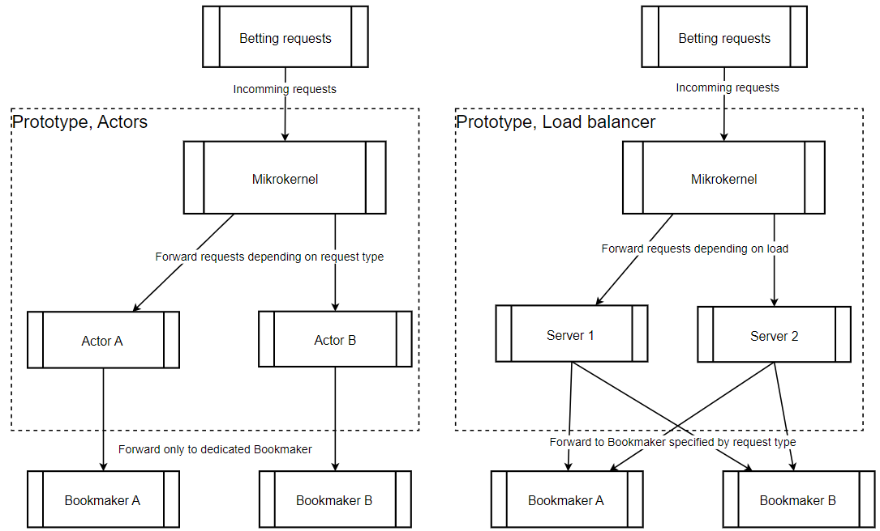Figure 4: Actor Model and Load Balancer
In the following we will describe the two systems and highlight their pros and cons.

Actor model
In this design there is an actor for each bookmaker. The microkernel forwards betting requests to the actors based on the request type. If it is a Bet365 request, it will be forwarded to the actor that handles Bet365 requests etc.
Pro: Each actor is specialized to their given bookmaker. This ensures that the different logics/interfaces for different bookmakers are isolated, creating lower coupling and better modifiability. And if something goes wrong it only affects requests to the specific bookmaker, meaning we get higher safety.
Con: The actor handles all request for said bookmaker, so uneven load between bookmakers might overwork some actors and starve others leading to poor performance.

Load balancer
There are x (2 in our prototype, but more in real world) servers that be can distributed to. Each server can handle every kind of requests because the requests are distributed based on load. The least loaded server gets the next request.
Pro: With requests being distributed based on load instead of request type, we ensure even workload among the servers. Furthermore, it is easy to scale out horizontally by adding more servers, thereby always ensuring high performance.
Con: Each server must be able to handle requests for each bookmaker. This increases complexity, which can lead to errors and make it harder to modify when new bookmakers appear.

Prototyping setup and implementation
The code for our prototype can be found at: https://github.com/Grumlebob/Architecture/tree/main/Prototyping
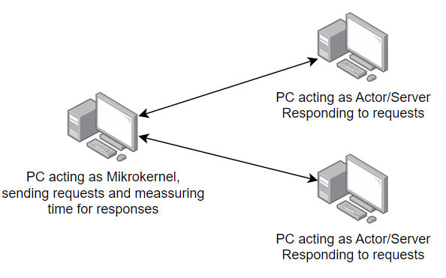Figure 5: Our setup involves three PC's.
As seen in figure 5 we have one PC (A) acting as the microkernel. It simulates forwarding requests by sending requests with message parsing to two other PC’s (B and C). The other PC’s simply print to the console and respond to the requests, nothing else.
PC A has two implementations.
- Actor model. PC A sends requests to B and C based on the type of the request. Type B goes to PC B and type C to PC C.
- Load balancer. It keeps count of how many unanswered messages has been sent to each “server” and sends the next request to the one with fewest unanswered messages.
To simulate uneven workload we make 10 times more requests of type B than of type C. PC A performs the benchmarking based on how long it takes from requests are sent to responses are received. We used both a benchmarking library and our own implemented benchmarker.

Prototyping evaluation and conclusion
This is the printed result from the benchmark library (it was too slow with 10000 requests):
| Method | TotalRequests | Mean | Error | StdDev | Allocated |
|------------------------ |-------------- |-----------:|--------- :|---------:|-----------:|
| RunActorBenchmark | 100 | 254.1 ms | 5.73 ms | 16.53 ms | 204.23 KB |
| RunActorBenchmark | 1000 | 2,308.8 ms | 44.52 ms | 41.65 ms | 2045.02 KB |

| Method | TotalRequests | Mean | Error | StdDev | Allocated |
|------------------------- |-------------- |-----------:|--------- :|----------:|-----------:|
| RunLoadBalancerBenchmark | 100 | 248.9 ms | 23.58 ms | 66.13 ms | 228.59 KB |
| RunLoadBalancerBenchmark | 1000 | 2,098.3 ms | 44.36 ms | 128.70 ms | 2287.53 KB |

This is the results from our own benchmark implementation:
Approach | Requests | Fastest (ms) | Slowest (ms) | Average (ms) | Q1 (ms) | Median (ms) | Q3 (ms)
Actor | 100 | 17,11 | 263,57 | 148,11 | 90,29 | 152,06 | 212,26
LoadBalancer | 100 | 4,76 | 122,87 | 66,18 | 37,20 | 67,72 | 94,95
Actor | 1000 | 2,62 | 2278,65 | 1055,93 | 423,49 | 1031,34 | 1694,64
LoadBalancer | 1000 | 2,28 | 1273,27 | 646,01 | 321,39 | 663,64 | 970,55
Actor | 10000 | 3,25 | 26505,02 | 11940,40 | 4215,14 | 11515,58 | 19142,97
LoadBalancer | 10000 | 9,37 | 13584,77 | 7132,18 | 4032,39 | 7340,09 | 10421,72

As expected the load balancer is faster, giving us a performance gain of roughly 45% on average. This is a significant performance improvement to the actor model. Of cause these numbers may look different in the real world, but the question is whether the gain outweighs the potential costs of choosing this solution.
In our Architectural Analysis we identified performance as the most critical quality of our system with a score 14 from our stakeholder role-play. While modifiability and safety also hold importance with scores of 11 and 10 respectively, we think the clear priority on performance justifies the decision to chose the load balancer for our system. This approach aligns with our primary system goal of high performance, however it being at the cost of both modifiability and safety. This necessitates future work to make sure we still maintain a safe and modifiable system while maintaining high performance.

Architectural Evaluation (aSQA Method)
For the final evaluation of BestBets’ architecture, we chose the aSQA method. The aSQA technique is a lightweight, metrics-driven approach for continuous architecture evaluation. It is well-suited to our agile, iterative process, with constant new lectures, feedback and learning - because it quantifies quality attribute levels and identifies focus areas with relatively little overhead. By contrast, ATAM is a scenario-based method that, while thorough, is resource-intensive and yields qualitative results (utility trees and risk themes) that can be harder to directly compare or prioritize.

The steps of aSQA

Metrics and levels
We will evaluate the each of the key architectural quality attributes that we identified in the beginning of the project. Performance, Modifiability, Safety, Availability, and Usability. We will use the scenarios we have defined for each, to base the scores off of.
We follow the same levels (1-5) as they used in the paper (Christensen et al.).
- 1: Unacceptable.
- 3: Acceptable.
- 5: Excellent.

Components
We will make an evaluation of some of the important components shown in diagrams in deliverable 2, our prototypes in deliverable 3 aswell as an evaluation of our exploratory result of delivarable 3, which consists of combining our two prototypes into a single combined component.

In short our focus is on the following components:
- Deliverable 2:
  - Event broker for bla bla
  - Odds updater for external updates
- Deliverable 3:
  - Actor model & Actor plugin (Microkernel)
  - Load balancer
- Exploratory result of deliverable 3:
  - Combination of actor model and load balancer.

Evaluation
We made our tables such that each shows the scores for a quality attribute – This is mostly for our own sake, to make it easier to convert to a powerpoint later.

Performance
Component | Target (T) | Current (C) | Health (H) | Importance (I) | Focus (F)
Event Broker | 2 | 5
Odds Updater
Actor model (plugin) | 4 | 2 | 3 | 5
Load Balancer | 4 | 4 | 5 | 5
Combo (deliverable 3) | (5) | (2) | (2) | (4) | (3)

Modifiability
Component | Target (T) | Current (C) | Health (H) | Importance (I) | Focus (F)
Event Broker
Odds Updater
Actor model (plugin)
Load Balancer |  |  | – | – | –
Combo (deliverable 3)

Safety
Component | Target (T) | Current (C) | Health (H) | Importance (I) | Focus (F)
Event Broker | 3
Odds Updater
Actor model (plugin) | 4
Load Balancer |  |  | – | – | –
Combo (deliverable 3)

Availability
Component | Target (T) | Current (C) | Health (H) | Importance (I) | Focus (F)
Event Broker
Odds Updater
Actor model (plugin)
Load Balancer |  |  | – | – | –
Combo (deliverable 3)

Usability
Component | Target (T) | Current (C) | Health (H) | Importance (I) | Focus (F)
Event Broker
Odds Updater
Actor model (plugin)
Load Balancer |  |  | – | – | –
Combo (deliverable 3)

Overall evaluations
In general we found that XYZ

Performance Evaluation

Modifiability Evaluation
- Event Broker: Importance: Moderate. While not the primary vehicle for modifiability, the event broker should accommodate new event types or changes with minimal fuss. Target: 4 (we need it fairly flexible, though it’s largely a generic mechanism already). Current: 4. The event channels and subscribers are configurable, and adding new types of events (e.g., new sports or triggers) is straightforward (just new channel topics). Health = 5 (actually meeting target), Focus = 1 (no concern). The revised design didn’t change the event broker, so this remains the same.
- Microkernel: Importance: Very high. This is the linchpin for modifiability – all new providers or changes funnel through here. Target: 5 (we want it to handle change with minimal impact). Current (orig): 4. In the first design, the microkernel structure already provided a good separation of concerns, as noted – you mostly add new plugins for new providers, with only minor adjustments in microkernel logic (like routing rules). We consider that acceptable but not perfect (there might be some hard-coded mapping or not completely dynamic loading, so not a full 5). Health = 4, Focus = 2 (some improvement possible, but generally good). Current (revised): 4. The introduction of the load balancer did not fundamentally change how the microkernel is extended for new providers – we have to ensure the microkernel knows to direct a given provider’s requests to the LB, but that’s likely a one-time change that is generic. There is a slight concern that we must manage an extra piece (the LB configuration) when adding a provider, but we plan to mitigate that with a generic approach. So we still rate modifiability of microkernel as 4. Health = 4, Focus = 2. No regression, and still a relatively low focus item (just keep microkernel code clean and perhaps consider dynamic plugin loading in future to reach a 5).
- Provider Actors (Plugins): Importance: Very high. Each actor module encapsulates a provider integration, so modifiability here means ease of implementing a new actor or updating one when a provider changes their API. Target: 5 (we want to plug in new providers or update APIs in minimal time, which was an explicit requirement). Current: 4 for both designs. In the initial design, the actor plugin mechanism is the main reason modifiability is strong – it’s already largely satisfying the requirement (as evidenced by the scenario: new provider in ~5 days​
file-4e1k5jjrsbks6ivudwhrwr
, which seems attainable). We didn’t give it a 5 because there’s always room to streamline (maybe further automate the integration or standardize it more). After revision, this essentially stays the same; the load balancer doesn’t change the internal structure of an actor plugin, and our prototype didn’t indicate any need to change how plugins are written. So Current remains 4. Health = 4, Focus = 2. This means modifiability is in good shape in our architecture – both core and plugins have no major issues (Focus 2 items are relatively minor priority). If anything, to reach an ideal 5, we might consider improvements like scripting common parts of provider integration or using a standardized interface definition to generate plugin code, but those are optimizations beyond architecture scope.
- Load Balancer: Importance: Low for modifiability (the load balancer is infrastructure – we don’t expect frequent changes to it when requirements change). Target: 3 (just need it to be configurable and maintainable). Current: 3. We introduced it in the revised design, and it’s fairly generic. Changing the balancing strategy or adding providers is a configuration task. We rate that acceptable. Health = 5 (meets target), Focus = 1 (no issue).

In summary, the Modifiability evaluation shows that both iterations of the design scored well on modifiability, as intended. The microkernel + plugin pattern effectively achieves its purpose. All components have high Health (mostly 4 or 5) and correspondingly low Focus (1 or 2) for modifiability. Notably, the revised design did not compromise modifiability – an important check, since adding a load balancer could have made things more complex. Our analysis indicates it didn’t; modifiability remains a strength of the architecture. This aligns with our qualitative judgment that the microkernel pattern decouples external variations nicely​
file-4e1k5jjrsbks6ivudwhrwr
, and as long as the load balancer is handled as a transparent routing mechanism, the ability to add or modify features is not significantly hindered.

Safety (Fault Handling) Evaluation
- Event Broker: Importance: Medium. By “Safety” here we mean the ability to handle or avoid faults/exceptions. The event broker mostly just passes messages; a failure in it would primarily affect trigger functionality. Target: 4 (it should handle failures gracefully – e.g., if it goes down, it shouldn’t crash the whole system, and maybe it can recover or be restarted without major impact). Current: 3. In the initial design, the broker had potential to be a single point of failure; if it crashes, triggers might not fire, but betting (through microkernel) could still continue. It likely doesn’t have sophisticated failure recovery in our design yet. So we mark it slightly below target. Health = 4, Focus = 2 (a minor issue – mainly to consider making the broker robust or redundant). This remains unchanged in the new design (no modifications were made in this area for Deliverable 3). We still intend to ensure the broker failing won’t cascade (which it shouldn’t, since it’s decoupled – worst case, trigger bets pause). So safety of event broker is a low priority item (Focus 2).
- Microkernel: Importance: Very high. If the microkernel encounters an unhandled exception or crashes, the whole system’s core goes down. Safety for the microkernel means it must be resilient to bad inputs or issues coming from plugins. Target: 5 (never fail catastrophically). Current: We rated 3 initially. At that point, the microkernel was simple but had no redundancy and limited internal fault recovery (beyond delegating to actors). For example, if an unexpected error bubbled up from an actor or an out-of-memory error occurred in the microkernel, that would be a single point of failure. Health = 3, Focus = 3. This signaled a moderate risk – not as dire as performance was, but something to improve (e.g., by adding error-handling around calls to actors, which we did conceptually, or by ensuring the microkernel process is stable). In the revised design, we did not explicitly add new safety nets for the microkernel (we focused on performance). So we consider Current still ~3. Health = 3, Focus = 3 remains. This indicates microkernel reliability is a concern we still need to address. It’s functional (Focus 3 is moderate), but given its importance, we likely should plan additional measures: for instance, running the microkernel in a supervised environment where it can be restarted quickly if it fails, or splitting responsibilities so a failure is less likely. This will be addressed in our initiatives.
- Provider Actors: Importance: Very high. Each actor must handle all sorts of anomalies interacting with its provider: network timeouts, odds changes, rejection errors, etc. Safety here means not only preventing a crash, but also ensuring consistency (no incorrect bets). Target: 5 (we want each actor to either complete a bet successfully or fail safely every time). Current (orig): 3. In the initial design, we had planned these safety tactics (exception handling, etc.)​
file-4e1k5jjrsbks6ivudwhrwr
but they were not implemented yet. So at that point, the architecture provided the capability (the actor boundary) but the actual mechanisms (like retry or rollback logic) needed to be built. Hence current rating 3 – some safety measures identified, but not fully there. Health = 3, Focus = 3 (we need to implement and refine those mechanisms). Current (rev): 4. By Deliverable 3, we had prototyped some fault handling (e.g., the actor detecting odds changes and aborting) and confirmed the actor model isolates failures. We likely have a better idea of how to implement robust error handling now. So we bump the actor safety to 4 – meaning we’re closer to our goal, with standard strategies in mind (monitoring, retries, user notifications). Health = 4, Focus = 2. This improvement indicates that the revised design is safer in terms of how actors handle errors. Also, introducing multiple actor instances with a load balancer adds a layer of redundancy – if one actor instance crashes, another can take over new requests, which increases fault tolerance for that provider. This contributes to a higher current level. So actor safety went from a moderate focus to a low focus item.
- Load Balancer: Importance: High. The load balancer’s role in safety: it must route correctly and deal with node failures. Target: 4 (it should handle an actor being down without failing, etc.). Current: 2. At this stage, our load balancer design is basic; it likely doesn’t have sophisticated health checks yet (an actor failure could result in some lost requests until detection). And if the balancer itself fails, we currently have no failover. We intentionally rate this low to highlight needed work. Health = 3 (since target 4, difference 2), Focus = 3. This is a new area of concern introduced by the revised design – previously we had no balancer. Now we must ensure the balancer doesn’t become a weak link in reliability. Focus 3 means we need to address it, though it’s on par with microkernel safety in urgency.
Summarizing Safety: The architecture’s safety and fault tolerance improved slightly mainly in the area of provider handling (actor isolation and logic). The microkernel and new load balancer remain points that need attention. The microkernel’s lack of redundancy and the load balancer’s initial lack of fault-handling both show up as Focus 3 (medium-high). These are not catastrophic at this moment – thanks to the actor model, most typical faults (like external errors) are contained – but they are the next things to harden. For instance, the Microkernel and Load Balancer could each be made redundant (running multiple instances with failover) to elevate their safety to the target level. We plan initiatives around this, as discussed later.

Availability Evaluation
- Event Broker: Importance: High (though a broker failure doesn’t stop core betting, it does stop trigger functionality and possibly live updates, which is a significant part of the user experience). Target: 4 (we expect occasional partial degradation is acceptable, e.g., if triggers fail, manual betting still works). Current: 2. As noted, the event broker is a single point in our design and we have not implemented any redundancy for it. If it crashes or becomes overloaded, those features become unavailable until it’s restarted. We gave it a low current score of 2 to reflect that vulnerability. Health = 3, Focus = 3. This is a moderate availability risk: not as crucial as the microkernel, but still something to improve (for example, by clustering the broker or ensuring it can recover state on restart so triggers aren’t lost). This situation is unchanged in the revised design (no changes were made to broker availability yet), so it remains an issue.
- Microkernel: Importance: Critical (5). If the microkernel is down, the entire BestBets service is down (users cannot place any bets). Target: 5 (it should ideally have 100% uptime or close, through redundancy or fault tolerance). Current: 2. In both designs, currently, we have a single microkernel instance with no failover. This is the one major aspect where our architecture is still vulnerable. If that server process goes down (due to crash, maintenance, hardware failure, etc.), BestBets is completely unavailable. Health = 2 (far from target), Focus = 4. This was the case initially and remains true after the second iteration – we addressed performance via the load balancer but did not yet introduce a solution for microkernel high availability. The analysis identifies Microkernel availability as a top focus area (Focus 4) that demands attention. It’s essentially the highest Focus in the revised architecture alongside the load balancer’s availability (see below). We absolutely need to plan redundancy or quick-recovery strategies here.
- Provider Actors: Importance: High (4). If a provider-specific actor is down, only that provider’s functionality is lost; the system overall is still available for other providers. Target: 4 (we accept that one provider might be unavailable as long as the system continues, which is graceful degradation). Current: 4 initially. Thanks to the actor model, an actor crash doesn’t crash others. The system can continue with other providers – this meets our target of graceful degradation. Also, actor frameworks typically can restart actors automatically. We considered that essentially achieving what we need (hence health=5, focus=1 for original design on actor availability). In the revised design, we even improve this: with multiple actor instances per provider, even if one instance fails, others can continue serving that provider. We rated Current = 5 (nearly continuous availability for each provider cluster). Health = 5, Focus = 1. In short, provider availability is very good in our architecture – losing one actor or even one provider doesn’t take down the system. The system can recover from or tolerate such failures (e.g., if Bet365 integration fails, users can still bet on others; once Bet365’s actor restarts or is fixed, it rejoins). This was a goal scenario and our design achieves it​
file-4e1k5jjrsbks6ivudwhrwr
.
- Load Balancer: Importance: Critical (5). With the revised design, the load balancer is in the main request flow. If it fails, the Microkernel cannot route requests to providers, effectively halting betting capability. Target: 5 (it should be as available as the microkernel – ideally never a single point of failure). Current: 2. As of now, we have implemented a single load balancer instance with no backup. This is a new single point of failure introduced. We rate it low (2) to reflect that vulnerability. Health = 2, Focus = 4, identical to the Microkernel in significance. The analysis clearly flags Load Balancer availability as a top focus (Focus 4), alongside the microkernel. We have traded one critical component (microkernel alone) for two critical components (microkernel + LB). Each individually is a risk; together, our availability is now contingent on two points not failing. This is something we must mitigate going forward (e.g., by clustering the load balancer or using a highly available load balancing service).
In summary of Availability: The good news is that the design handles localized failures well – one provider going down doesn’t take down the system, fulfilling the graceful degradation goal. However, the bad news is that the core routing components (Microkernel and now Load Balancer) are themselves single points of failure. The aSQA evaluation highlights this starkly: both have Focus = 4, the highest of any factors in our revised architecture. This means improving availability of those components is the most critical action item remaining. We effectively doubled the redundancy problem: originally only the microkernel needed redundancy, now the load balancer also does. This isn’t a regression in overall system availability per se (the system is not less available than before, since previously microkernel was a single point anyway), but it means there are two critical components to make fault-tolerant. We will prioritize this in our initiatives and backlog (see Section 7).

Usability (and Other Qualities) Evaluation
While not explicitly demanded in the assignment, we briefly assessed Usability as it was an architectural concern in some scenarios (ease of use, timely feedback). We did not quantify usability with the same rigor (it’s somewhat subjective), but qualitatively: the architecture supports good usability by providing quick responses (performance contributes to this) and designing for clear failure handling (the system can notify users immediately if a provider is down or odds changed – e.g., using the heartbeat tactic to inform the UI in advance​
file-4e1k5jjrsbks6ivudwhrwr
). We’d rate usability as generally acceptable. One usability risk is if the system fails to inform the user of issues (like silent failures). Our design mitigates that by surfacing errors (safety mechanisms) and maintaining responsiveness. We would give most components a usability importance of medium and current levels around acceptable (3 or 4), with no critical usability focus points identified (likely Focus 1 or 2 at most). In short, as long as performance and availability requirements are met, we anticipate the system will be perceived as responsive and reliable by users, which is key for usability.
Security was not formally evaluated earlier, but given the addition of the central wallet, security becomes crucial. We note that our architecture will need to integrate secure communication (e.g., encryption between components and external providers), proper authentication (MitID integration), and robust authorization checks (ensuring users can only access their own data and bets). These are implementation concerns more than structural, but they will be added to the backlog. The architecture is flexible enough to accommodate security modules (e.g., an authentication service, or secure token passing through the microkernel to actors). The focus for security would be high if evaluated (because of money involved), and current design would need improvements (we haven’t yet implemented those features), so this is a future work area rather than a current architectural shortfall.

Key Findings from aSQA
The aSQA evaluation of BestBets’ architecture yields a clear picture of our design’s health and the areas requiring focus. Key findings include:
- Performance: The initial performance bottlenecks in the architecture have been successfully alleviated in the revised design. The Microkernel and provider handling went from poor (Focus 4 critical issue) to healthy (Focus 2 or 1). No component in the revised design has a Performance focus higher than 2, indicating that, architecture-wise, we are well-prepared to meet our performance requirements. This validates the decision to introduce the Load Balancer and confirms that our event-driven, actor-based approach is efficient. We should continue to monitor the Event Broker and Load Balancer performance as load grows, but no immediate redesign is needed there.
- Modifiability: The architecture scores very well on modifiability. All primary components have low Focus (1-2) for modifiability, with the microkernel and actors – the core of our extensibility – being largely on target (Health 4 of 5). This means the design is flexible and future-proof with respect to changes like adding or removing betting providers, changing business rules, etc. The microkernel + plugin (actor) pattern is indeed fulfilling its purpose. The inclusion of the Load Balancer did not hinder this; our approach to keep it generic has preserved modifiability. We have high confidence that as new requirements emerge (e.g., new types of bets, new providers, different odds formats), the architecture can accommodate them without drastic changes.
- Safety/Reliability: The system’s design ensures that most failures are contained and handled, thanks to the actor model and defensive tactics. The evaluation shows improvement in the safety of the provider interaction part (actors). However, it also underscores that core component reliability needs work – the Microkernel and Load Balancer themselves must be made more robust so they don’t become single points of failure or sources of crashes. In essence, local failures (external or within a plugin) are well-managed, but global failures (in core components) are a remaining risk. The focus ratings (3 for microkernel safety, 3 for LB safety) mean these are important but not as urgent as some availability issues – likely because the difference between current and target is not enormous (we have some measures in place, just need to augment them).
- Availability: This is the Achilles’ heel of the current architecture. Both the Microkernel and the new Load Balancer are critical single points with low current availability (no redundancy). They stand out with Focus 4 each – the highest in the whole analysis. This finding is not surprising, but the aSQA numbers make it clear: if we were to prioritize one improvement above all now, it would be to tackle these availability issues. On the positive side, the architecture localizes these concerns to just those two components; everything else is either already redundant by design (actors) or its failure is tolerable (event broker to some degree). So the problem is well-scoped: improve fault tolerance of Microkernel and Load Balancer. Once we do that, we expect the availability health of those to rise toward the target, and the focus to drop significantly. Achieving, say, a Health of 4 for microkernel availability (via a secondary instance or rapid recovery) with Importance 5 would reduce its Focus from 4 to 2 or 3 – a big improvement.
- Trade-off Balance: The evaluation highlights the classic trade-off between performance and availability in our design decisions. We introduced the Load Balancer to solve a performance problem (and it did), but it created an availability problem. We will need to invest in availability (through redundancy) which might add some complexity or overhead, but that’s the next logical step. Importantly, modifiability remained strong throughout, and we didn’t have to sacrifice it for performance – a big win for our architecture. Safety and availability are also somewhat trade-off: we kept the system simpler (single microkernel) which is easier to maintain (modifiability) but at the cost of redundancy (availability). Now that modifiability and performance are in a good place, we can afford to add some redundancy mechanisms without complicating the design unmanageably.
- Focus Areas: Concretely, the critical focus areas that emerge are:
  - Microkernel – Availability: How to eliminate it as a single point of failure (SPoF).
  - Load Balancer – Availability: How to eliminate or mitigate it as a SPoF.
  - Microkernel – Safety: Ensure robust error handling and containment in the core (so a bad input or unexpected condition doesn’t crash it).
  - Load Balancer – Safety: Implement health checks and failover for actor instances, and ensure the balancer itself fails gracefully if at all.
  - Event Broker – Scalability & Fault Tolerance: While not as high focus, we should plan for scaling or replicating the broker if usage grows, and possibly making it redundant so trigger functionality isn’t lost (this is a secondary focus compared to the above).
  - Finalize Prototype Decisions: We should solidify how the load balancer will be integrated (e.g., will we use an off-the-shelf solution or custom, how to configure it dynamically) and ensure that does not hamper modifiability or safety – essentially addressing the backlog concern about LB and safety/modifiability​
file-4e1k5jjrsbks6ivudwhrwr
with concrete design resolutions.
Each of these focus areas leads to specific improvement initiatives, which we outline next. The aSQA analysis essentially gives us a to-do list ranked by what’s most crucial for architectural health.

7. Conclusion
Design Confidence: After multiple iterations of analysis, synthesis, prototyping, and now evaluation, we are increasingly confident in the BestBets architecture. The design addresses the primary quality attribute requirements: it offers a high-performance, scalable solution for aggregating bets (validated by analysis and prototype), and it maintains a flexible structure for evolution (the microkernel + plugin approach has proven its worth in modifiability). The use of established patterns (Microkernel, Event Broker, Actor model) provides a solid backbone that is well-understood in terms of behavior and trade-offs. With the latest improvements, many initial uncertainties – such as how to handle high load or how to integrate diverse external APIs – have been resolved or significantly clarified. We now have concrete strategies in place for each of our major quality drivers.
Missing Pieces: The evaluation did illuminate a few gaps that remain. Notably, high availability measures are not yet implemented – the architecture needs enhancement to eliminate single points of failure (microkernel, load balancer). Until this is addressed, there is a risk to reliability if the core component fails. This is a known to-do item rather than a design flaw; we have solutions identified (redundancy, failover mechanisms) and will proceed to implement them. Additionally, security considerations, while recognized, have not been deeply embedded into the architecture yet. We have an outline (central wallet, MitID, etc.), but details like how authentication flows through the system or how we partition security responsibilities could be fleshed out more. These will be tackled as we move into implementation (e.g., introducing an authentication service module interfacing with the microkernel). On the functional side, some auxiliary features (such as real-time notifications to the UI, or advanced trigger conditions) are planned but not yet detailed; these might introduce minor components (e.g., a WebSocket notification service) which our current architecture can accommodate.
Next Steps: The next step is to implement the remaining initiatives from the backlog: primarily, setting up the infrastructure for redundancy and thoroughly testing failure scenarios. We will likely conduct another round of prototyping or simulation specifically for the high-availability mechanisms (e.g., simulate microkernel failover) to ensure our approach works as intended. Concurrently, we will integrate the central wallet and security components into the design at a more detailed level, involving perhaps collaboration with a security expert to ensure nothing is overlooked. As these pieces come together, updating the documentation and diagrams to reflect the final refined architecture will be important for clarity. Finally, an end-to-end review with stakeholders (possibly a lightweight ATAM-style walkthrough or just a demo) could be done to validate that all concerns have been addressed to their satisfaction.
In conclusion, we believe the BestBets architecture, as it stands after this evaluation, is feasible and robust for implementation. We have high confidence in the design’s ability to meet the business and quality requirements: it will allow BestBets to offer a fast, convenient, and reliable betting aggregation service. The main architectural risk areas are now well-understood and have clear mitigation plans. As long as those plans are executed (which our timeline and backlog account for), we foresee a smooth transition from design to development. This iterative architecture process has ensured that by the time we freeze the design, we have already vetted it against the most critical challenges, leaving us with a solid foundation to build on.

Architecture backlog
3. Maintain and report on an architecture backlog. The backlog should contain decisions you have to make, work you need to do, issues you have etc. all in the scope of the system and not the project.

Our guide to our logs
1. Always remember to set dates.
2. Some idea might fit multiple logs/headers. It is not super important which is chosen, what is important is that it is written down.
3. Avoid merge conflicts of this Libre Office file by:
- If alone, write it down in your own local file first, then meet with group to get it merged.
- If with group, ensure only 1 is changing the log, then commit updates and notify group, so no concurrency issues arise.
4. If the idea is heavily conflicted by the group. Still write it down, but note down the disagreement.
5. Colors:
- Green: Finished / implemented / done
- black: Being worked on / being discussed
- Red: Turned out to be irrelevant / discarded

Ideas related to business

10.02.2025

Should we be a bookmaker, or only an aggregator?
- If we are an aggregator showing the "best odds", it would be tough for us to take a margin, as that margin would possibly reduce the odds such that it isn't no longer the best odds, only due to our cut.
- Alternatively, we could do something like a subscriber model for our product. But i suspect that people would quickly calculate that as a percentage cut of their bettings as well, and therefore again reduce the chance that the customer would perceive it as the best odds available. Therefore, we think it would be easier to take a cut, on a service usually not available on other sides, which is acting as a stock broker just for betting. Meaning that people themselves would be able to open a position on some bet, and therefore act as the bookmaker themselves, for other people to buy their odds. This would cost a fee, quite similar to the ordinary fees one pays on the stock market.

Conclusion / What happened (04.03.2025): We are mostly an aggregator. We don't act as our own bookmaker, BUT we do allow our customers to act as individual bookmakers through our site, known as “community bets”.

Does this concept give a total increase in new customers across betting sites, or does it eat from the existing customer base.
- So one of the biggest podcasts our there from Conan O' Brian, who is mainly on Spotify with audio only. They are now experimenting with putting episodes on Youtube with video as well. But they are afraid that it won't give more customers, instead people will migrate from Spotify to Youtube. This is a concern for the betting vendors as well, where there are mainly two scenarios:
  - Best case: Some customer who only uses X, instead now uses our platform and therefore indirectly ends up using A, B, C, D.... who never had a chance before to be used by this customer. They all see an increase, because this customer who now have more options and advantages starts betting 250 % more. So even though site X will see a decrease from this customer, there might be other customers who only uses A, that will now also start using X.
  - Worst case: Some customer who only bets 50 kr. each month on X, will now still only place 50 kr each month, but now on A, B, X. Thus no additional revenue would be added to the pot.

Should our concept only serve sport?
Most of these sites also have:
- Bingo
- Casino & Live casino
- Poker & other card games
- Raffles
- eSport (One might claim they are the same)
- Quizzes and giveaways
While these might make sense in our business scope, it will be too much for this 1 year project, therefore we only focus on sport - not because it is the best choice, but it is feasible within our scope of this course.
But alternatively, we can implement casino easily through casino providers. So ALL of the betting sites we checked with danish license (42), all used external casino vendors, such as pragmatic.com As such, we can easily an efficiently have a casino page as well, using external vendors. There is no "down-payment", as we act merely as affiliate, and get a provision from the vendors. This might be of conflict for our own betting site key partners, as if they start using our site, the potential income generated on slot-machines, will be reduced from our partners, as we eventually eat their customers. Alternatively is we don't provide casino (slots, live roulette etc.), as to please our key partners.
Conclusion / What happened (17.02.2025): We limit ourselves to sports bets for this project.

Special offers & bonuses
Is it feasible for our site to have offers, such as a welcome bonus?
This might be rough, because that would give the customers multiple stacked welcome bonuses, one from our site, as well as one from the site they are placing the bet on.
Or they might have to be designed in a smart way, we currently can’t think of.

Follow the best users, opt-in, always on, or never show?
Should we allow people to see the most successful users so they can mirror their bets? If so, should this feature always be on, or something the user opts for.

We must show betting limitations
The UI must show the limitations of bets. "This bet gives odds 1.8 but max bet amount is 75kr."

Legal concerns
There must be compliance of "Rofus" and "Stop Spillet". Furthermore, there must be a timer that makes the user aware of their time spent betting. All of these and additional requirements from Spillemyndighederne must be implemented.

Separate withdraw-able cash and bonus
Bonus money staying in the betting site acts differently than cash that can be withdrawn directly. The site must display how much is bonus and how much is not.
Bonuses must remain on the bookmaker, and can’t be transferred to our site.

Forum?
Having a forum on the site will act as marketing when users encourage each other to place bets.

Streaming?
We could use streaming through for example bet365 so users who want to watch matches live can be satisfied, without having to invest in our own streaming setup with people filming the match.

BetBørs is apparently already a thing
Our “community bets” idea already exist on BetFair. We thought it was a unique idea. Even though it already exists, we are going to continue with the idea, as we think the idea is great for showcasing various software architecture concepts.

International?
Could this be expanded to be used outside of Denmark? Could this site easily be operated in USA as well?

Two customer profiles
We actually have at least two customer segments.
- Users who want to bet.
- Bookmakers. Imagine a newly created bookmaker, who wants to make a splash and quickly attract new users. They could sign up through us, and “out-bid” other vendors with odds, to quickly reach a massive audience.

EU wallet
Should this site serve EU customers, through the newly EU created product “EU Wallet” – This means that we should alternatively mark our diagrams as “MitID / EU Wallet”.

Where is the money
Having them place money on our site makes it easier for the user to just put 200 and then bet where ever, instead of having to place 200 on multiple site. The down side is that we now need to handle security and all the behind the scenes transactions. But this idea proposal, is one of the key differences between just “googling the best odds” and having a central betting platform, taking care of various quirks, such as minimal down-payment for the customers.
Conclusion / What happened (04.03.2025): We included a bank to our architecture so we can hold the money, this way the user does not need to deposit money on every site.

Cancel bets
Users should be able to “cash out”, cancel their bet, etc.
This system should work very similar to placing bets, such as getting rejected and prompted in case they are trying to cash-out and the odds have changed during the process.
Conclusion / What happened (04.03.2025): The microkernel can forward cancel requests as well as bet placement requests.

Ideas related to patterns

10.02.2025

Pattern for registering many different vendors through our site.
We need a system that handles our external bookmakers different processes, as to minimize the pain of the user, needing to create a profile on multiple sites.
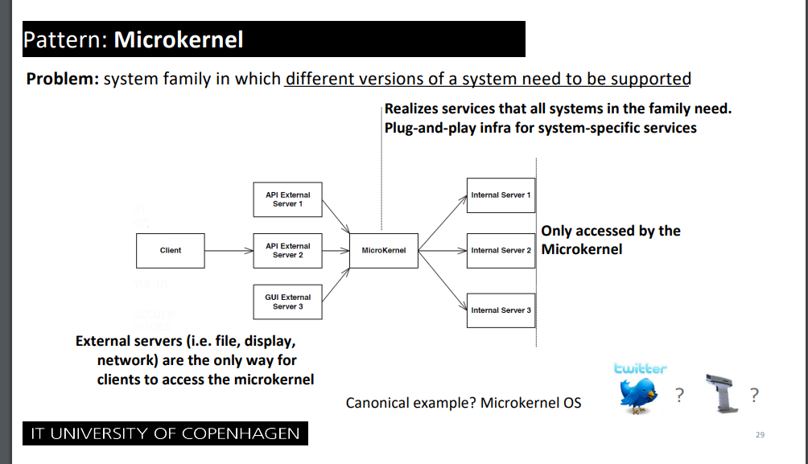
Conclusion / What happened (04.03.2025): Implemented in our diagrams.

For trigger order like a stock broker, when odds reach X < Y
If a user wants to place a bet on a match reaching above 2.0 in odds, it needs to be done quickly when the odds change. Thus the customer should “subscribe” to a match, where the “publisher” is the odds. If odds reach a certain threshold, the subscriber pipeline should automatically place the relevant bets.
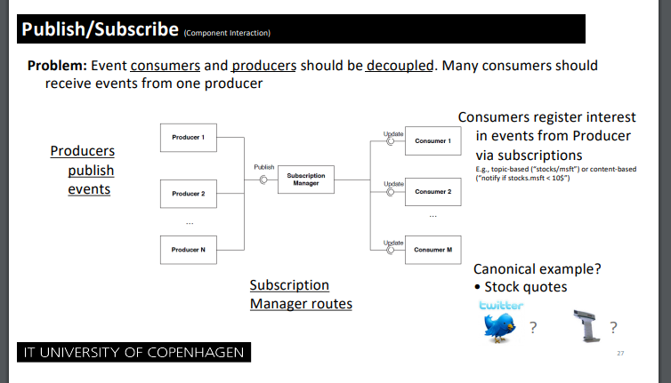
Alternatively, we want to also look at:
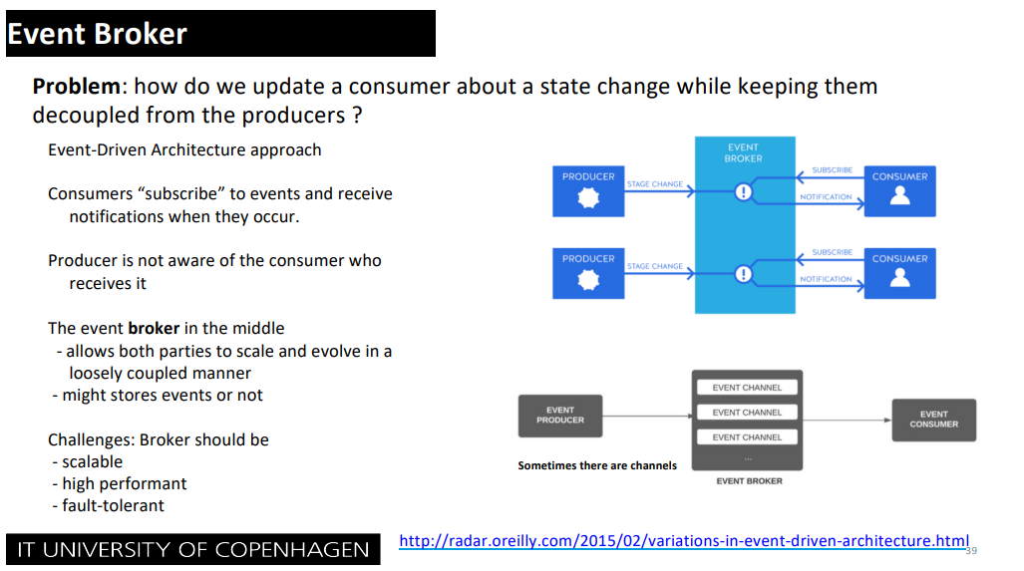

Conclusion / What happened (03.03.2025):
We decided to go with:
Trigger orders uses Event broker. The producer are “the changed odds on events”, and subscriber are the customers placing trigger orders.
This will then get forwarded to our Microkernel responsible for communicating with the different Actor models using message passing to attempt to place the bet for the customer and handling errors in case the odds have changed, by checking the odds-changed-treshold on the customer, and reattempts if within border, otherwise cancels – acting as a “transaction”.

03.03.2025

Should we have multiple copies of the database?

We could envision something like this:
1. Bookmakers update their odds.
2. The updates odds gets sent to our API endpoint, which updates our odds database.
3. The odds database could have a replicated read-only database.
4. Our sports-overview uses only the read-only version.

If so, what do we actually gain from this – we need to prototype this.

We need to show a diagram for what happens AFTER a placement is made
Such as updating account information, sending confirmations, etc.

05.03.2025

Compare actor model against alternatives
Experimental prototyping will reveal more about whether the overhead of actors will be worth the benefits.
Conclusion / What happened (10.03.2025): See section about architectural prototyping.

Ideas related to tactics

10.02.2025

Availability
We need to monitor the health of a lot of different external sites, and should use tactics such as “heartbeat”
Conclusion / What happened (04.03.2025): Added in the tactics section for deliverable 2.

03.03.2025

Should we prioritize certain bets?

Such as, should a bet placement of 1,1 million be prioritized above a freebet of 50 kr.
If so we might want to look at: Tactic: Performance: Control Resource demand: Prioritize events.
Conclusion / What happened (04.03.2025): Added in the tactics section for deliverable 2.

Confirmed Decisions

10.02.2025

Fictitious project
We have made some fictitious assumptions, to make this project interesting to work with.
- All danish bookmakers have agreed to be part of BestBets.
- All bookmakers already have some API for placing/canceling bets.
- There are no legal troubles, such as not complying with various laws from Spillemyndighederne
- Transfers can be made between various bookmakers, and our own bank, as to avoid the restriction of “transfers must be through a MitId provider og NemKonto”.

Discarded decisions

10.02.2025

Placing multiple bets where one fails
On ordinary betting sites users can place multiple bets “in a package”, where the site is able to reject the whole package if one bet fails (such as a rapid change in odds). Our system will not be able to handle this, because the package might contain different sites, and as such we can’t cancel a bet on site A, if a bet fails on site B. As such it would be easier to not support package bets on our site.

11.02.2025

API og Data-scraping
We are not going to do data-scraping. If we do data-scraping, it would be hard to actually place bets on the respective sites, without proper confirmations etc. It would also be insanely resource intensive, to data-scrape a bunch of sites and also expect data to be completely fresh for the user. To avoid complications of legal situations and latency, we are going to make an assumption, that all bookmakers are willing to participate and already have an API giving the necessary data.

Work/issues needing to be done

11.02.2025

MitID integration
As we are doing betting, we need a license from "Spillemyndighederne", and follow their related laws. That includes MitID integration, for logging in, and also for getting payments out. Should we spent a lot of time and illustrations showing this, or is it simply "given" by the case, and illustration is not really necessary??

17.02.2025

Diagram showing bounds of our own bank connection and various payment providers
It can be a bit confusing, when and where the user is going directly through our banking connection, and when the user is going through a payment provider such as Visa & MasterCard.
Such as, what is the trace of money, when a user:
- Deposits money
- Places a bet
  - The bet loses
  - The bet wins.
- Withdraws money

Statistics
Most sites support statistics, such as RTP on a specific feature that last X days. We should show general statistics, such as RTP, win-rate, etc.

11.03.2025

Update all relevant diagrams after prototyping
Once we have settled on how our forwarding from the microkernel should be handled, we need to update the diagrams in section about synthesis and perhaps overview.

17.03.2025

How should the load balancer approach safety and modifiability concerns
If we choose to use a load balancer instead of an actor model we sacrifice modifiability and safety. How do we ensure that it doesn’t become too much a problem. How should we handle errors and new bookmakers?

Given we have not implemented the combo solution yet, we have evaluated it in a hypothetical scenario where it is implemented. All hypothetical evaluations are in parentesis eg. “(3)”

