Deliverable 1

Group: The Architects
Members: Jacob Grum, Rasmus Ole Routh Herskind & Thor Liam Møller Clausen


System description

Overall functionality
Imagine the following. Kevin wants to bet on Holger winning his tennis match. He checks his usual site, which gives odds 1.8. But his mate next to him scuffs at him “you should check out my site, it gives odds 1.9”. Kevin quickly realizes that he is not loyal to his site, he is mostly interested in placing on any site with the best odds available - Introducing BestBets:
Shows the best odds available on any site, for any match.
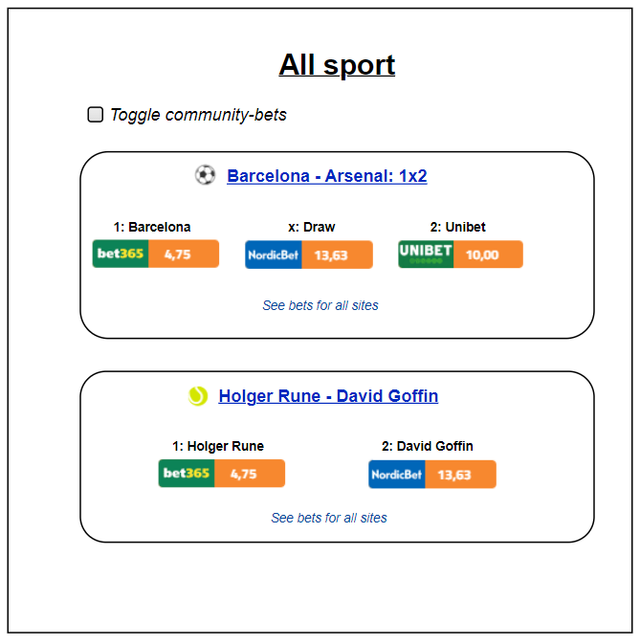
Plenty of stock-like features! Trigger order, when a certain game reaches certain odds.
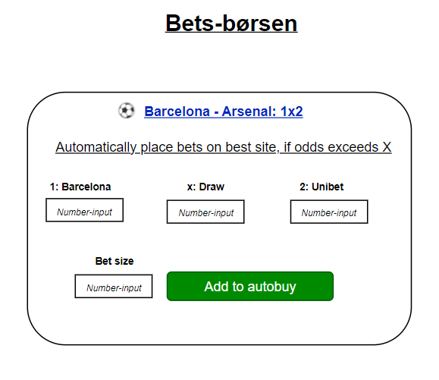

Similar market conditions as stocks. You don’t want to search for the best offer from a bank, you trade on a shared market (Børsen). That means you only need to have money in one central place, to be able to purchase from all bookmakers! In short. If you have 200 kr on BestBets, you can place 200 kr on ANY bookmaker, without having a saving of 200 kr on each bookmaker.
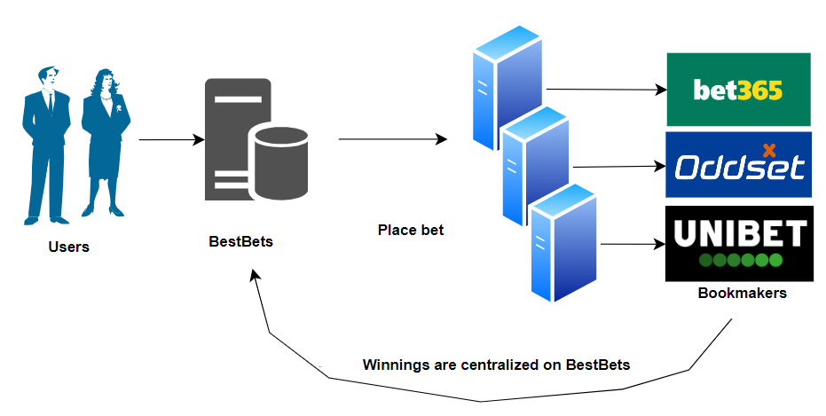
Similar to shorting a stock. Think the best odds are bad? Open your own position, and act like the bookmaker!
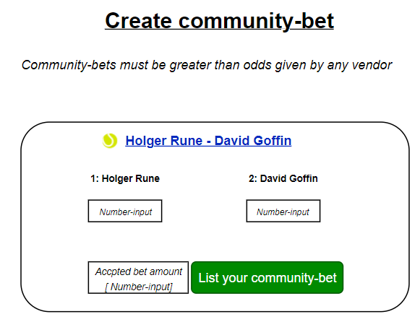

Quickly register for any bookmaker, through a saved formula, to get consistent information across multiple sites, and to always be ready to place on the best odds possible.
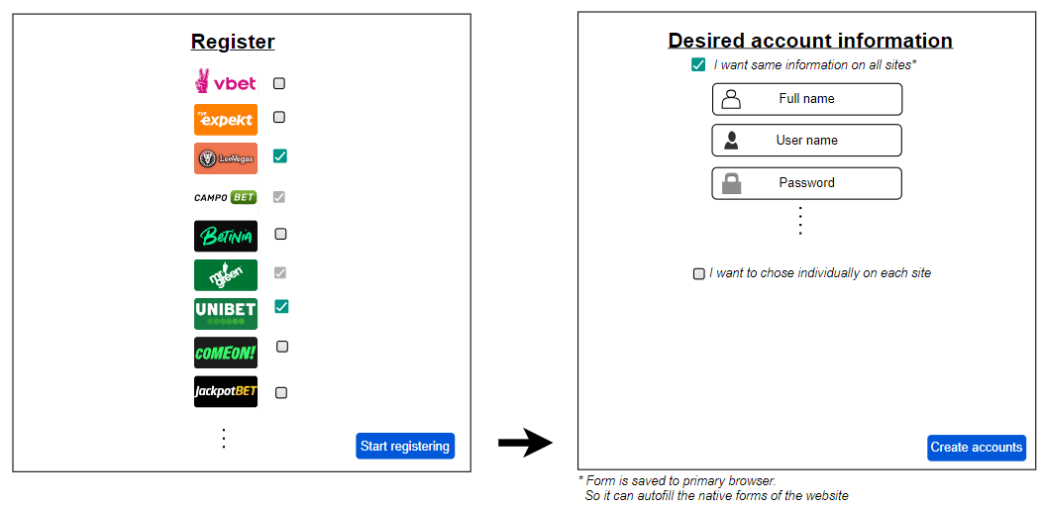
Get an instant overview of current bets, accounts and bonuses!
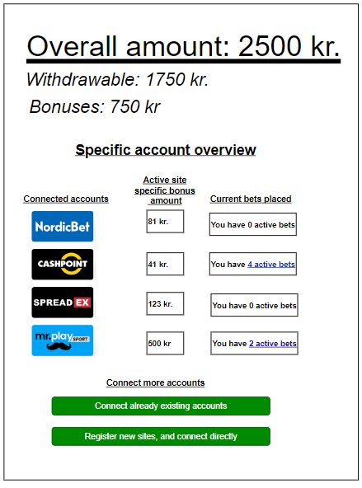

Various settings to ensure only your favorite sports are shown, to ease navigation and usage.
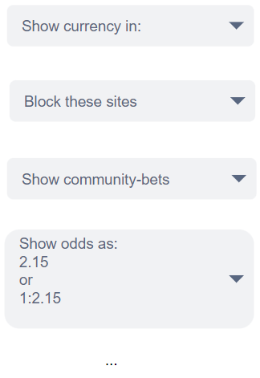

Context diagrams

Informal diagram

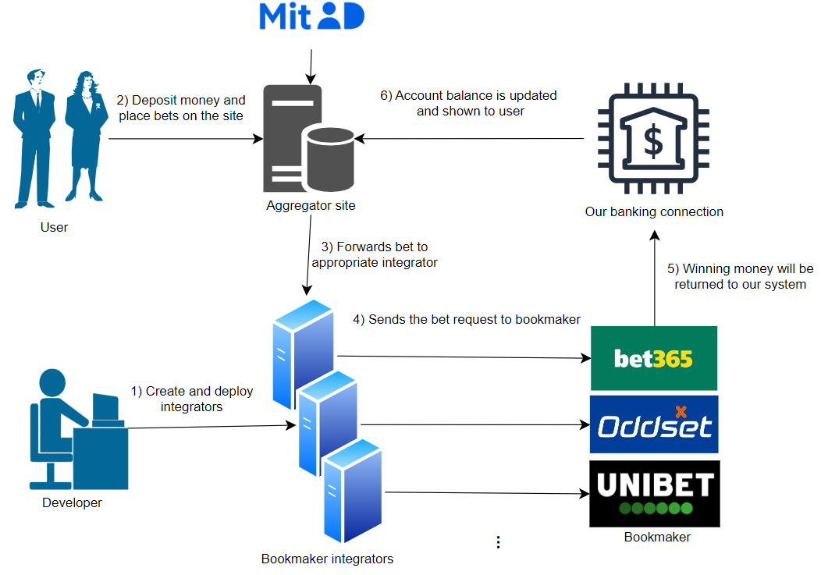

Formal diagram

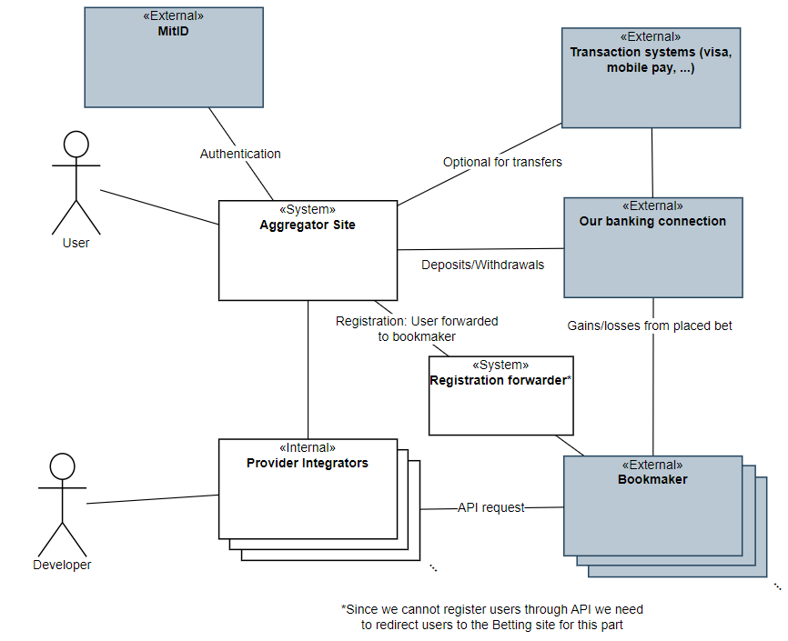

Architectural analysis

Identification of Architectural Drivers

The numbers in parenthesis is the number of points given in our stakeholder role play.
- Modifiability Requirement:
  - Handle new bookmakers (11)
The architecture shall be modifiable so that when a new bookmaker becomes available or an existing one ceases operation, support for that bookmaker can be added or removed with minimal impact on the overall system.
- Availability Requirement:
  - Available during high demand (12)
The system must remain available even during periods of high user demand (e.g., during high-traffic sporting events) to ensure continuous access to betting data.
- Performance Requirements:
  - Low Latency (14)
The system shall fetch and display betting odds from multiple providers in real-time or near-real-time. Delays in page loads or data updates must be minimized to prevent users from missing favorable odds.
  - Efficient Data Processing (14)
The system must process large volumes of betting data rapidly (especially during peak activity such as major finals) so that performance remains robust under load.
- Safety Requirement:
  - Safely handle odds changes (10)
The system shall ensure safety during the bet placement and acceptance process. If betting odds change between the time a bet is placed and accepted, the system must reject the altered odds and prompt the customer to re-confirm their bet under the new conditions.
- Usability Requirements:
  - Intuitive Navigation (12):
Users shall be able to quickly and easily find the best odds for a match.
  - Responsive Design (11):
The interface must adapt seamlessly to various devices (mobile, tablet, desktop) to accommodate users checking odds on the go.
  - Support for Specific Scenarios (12):
Filtering. Only tennis, only matches in Austrilian Open, that ends within 12 hours.
  - Consistent design (12). A bet placed on bookmaker A must have same mechanics and appearance as on bookmaker B.

- Security Requirement:
  - The system must ensure robust security (9):
User data and communications must be safeguarded using secure handling mechanisms.
Given that customers place real money on bets, the system must ensure that all financial and personal data are protected from unauthorized access.

Most important ones:
- Performance (14)
  - Low latency: Provide fresh odds.
  - Efficient Data Processing: During many bets placed during big event
- Availability(13)
  - System must work and respond during high traffic for big events
- Usability (12)
  - Intuitive design. Our aggregator must provide an interface that does not get affected by what bookmaker the bets are offered from. Betting on A should look the same as betting on B, where A and B are two different bookmakers.
- Modifiability (11)
  - In case many new bookmakers open or others close, it must be handled without too much trouble.
- Safety (10)
  - With money being handled, the user must not be prone to make mistakes.

Stakeholder roles

Betting sites, also referred to as “Bookmakers”
Developers/Architects
Users
Spillemyndigheden: https://www.spillemyndigheden.dk/gaming-og-gambling
Ludomani støtteforeninger: https://www.stopspillet.dk/
Various partners and affiliates:
Sport-event industry (Arenas, leagues, etc).
Sport clubs
Sports news (magazines, blogs, etc.)
Sports apparel and merchandise
Sport streaming & channels

Quality Attribute Scenarios

Performance
Refined Scenario 1: Real-Time Betting Odds Update
Scenario: The system updates betting odds in real-time during a high-profile sports event.
Relevant quality: Performance
Stimulus source: External betting data providers.
Stimulus: A sudden surge in updated odds from multiple providers as a major match reaches a critical point.
Environment: System is running high traffic during live, high-stakes sports events.
Artifact (if known): The module(s) that fetches live data from betting sites and updates our site.
Response: Fetch and process incoming data rapidly and update the user interface with minimal delay.
Response measure: Updated odds are displayed within 500 milliseconds of detected change, sustaining throughput of up to 100.000 updates per minute without performance degradation.
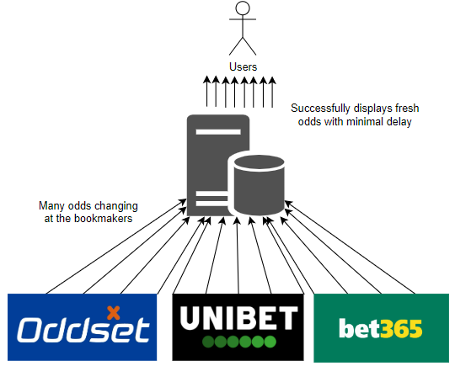
Refined Scenario 2: Massive user surge during the Champions League final
Scenario: The system responds to a lot of users during Champions League final with little delay.
Relevant quality: Performance/Scalability
Stimulus source: A lot of end users (100.000) logging in at the same time.
Stimulus: Number of users logged in increases from 1000 to 100.000 in the span of 10 minutes.
Environment: System running normally.
Artifact (if known):
Response: The system continues to serve updated odds without errors or significant delays
Response measure: Pages load within 2 seconds for 95% of requests. Odds update within 3 seconds of provider feed changes.
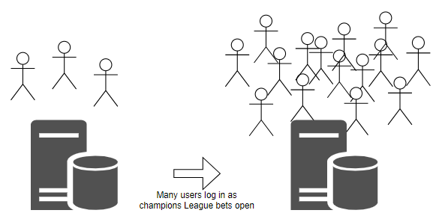
Refined Scenario 3: Massive surge of placed bets during prep for a mayor sports match
Scenario: The systems handles a lot of bets placed within a short time span with little delay.
Relevant quality: Performance
Stimulus source: A lot of end users (100.000) placing bets.
Stimulus: 100.000 bets being placed per 5 minutes.
Environment: The system running at high capacity with many users logged in.
Artifact (if known): The module(s) handling the forwarding of bets to the betting sites, and module(s) receiving confirmation from the sites.
Response: The system successfully forwards the bet placements without creating bottlenecks.
Response measure: With 100.000 bets per 5 minutes the average latency should be below 1 second from user confirms in our system to the bet being successfully forwarded to the respective betting site.
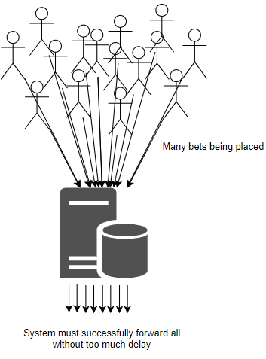
In short:
1: Handle external updates of odds.
2: Many users logs into our internal site.
3: Many bets are placed.

Availability

Refined Scenario 1: Continuous Availability Under Traffic Spike
Scenario: The platform remains fully available during an unexpected surge in user traffic.
Relevant quality: Availability
Stimulus source: End users accessing the site during a major sporting event.
Stimulus: 100.000 users simultaneously accessing and interacting with the platform.
Environment: System running on high capacity from the many logged in users.
Artifact (if known): The modules handling user activity (front end, server, load balancers, auto-scaling infrastructure).
Response: The system dynamically scales resources and distributes the load to maintain service availability.
Response measure: Achieves 99.9% uptime during peak load with 95% of requests served in under 500 milliseconds.

Refined Scenario 2: Site remains available during betting site outages
Scenario: The system handles the failure of one or more betting sites without affecting overall availability.
Relevant quality: Availability
Stimulus source: Betting sites failing to respond to requests (ping).
Stimulus: Ping requests without a response within 2 seconds from one or more betting sites.
Environment: System running normally with logged in end users.
Artifact (if known): Modules communicating with betting sites (fetching data, checking for activity).
Response: The system continues to display odds from other providers and clearly labels outed providers as “unavailable”.
Response measure: The system has a 99.99% uptime with up to 100% of betting sites unavailable.
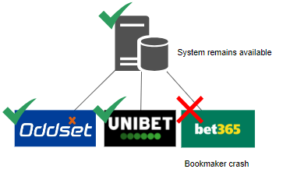
Refined Scenario 3: The integration of a new betting site does not affect availability
Scenario: A new betting site has been integrated in the system and gets deployed without affecting active users.
Relevant quality: Availability
Stimulus source: The developers deploying a new betting site opportunity in the system.
Stimulus: Initiation of the deployment of the new betting site integration.
Environment: System running normally with logged in end users.
Artifact (if known): The modules interacting with the betting site integrations/the aggregator.
Response: The system switches seamlessly to the updated version without service disruption.
Response measure: Zero downtime is observed; the switchover is completed seamlessly with monitoring confirming uninterrupted service.
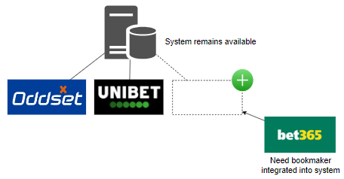

Usability

Refined Scenario 1: Consistent Navigation Across Devices
Scenario: The system provides a uniform and consistent user experience across various devices.
Relevant quality: Usability
Stimulus source: End users accessing the system on desktops, tablets, and mobile devices.
Stimulus: A user transitions between devices and expects the interface to behave consistently.
Environment: System running normally.
Artifact (if known): User interface.
Response: The user interface maintains consistent layout, design, and navigation regardless of the device.
Response measure: Less than 15% difference in the speed of user interaction across device.

Refined Scenario 2: Intuitive Filtering and Search
Scenario: Users quickly locate and filter betting events to find their preferred matches.
Relevant quality: Usability
Stimulus source: End users utilizing search and filtering tools.
Stimulus: A user applies filters (e.g., for tennis matches or events ending within 12 hours) to quickly locate relevant betting options.
Environment: System running normally with search/filter options implemented.
Artifact (if known): UI components and logical components managing search and filtering.
Response: The system delivers relevant results promptly, making it easy for users to narrow down options.
Response measure: At least 90% of search queries return results within 300 milliseconds; user feedback on the filtering process is overwhelmingly positive (95% satisfaction).

Refined Scenario 3: Streamlined, Consistent Bet Placement Process
Scenario: The bet placement workflow is intuitive and consistent across different sections of the site.
Relevant quality: Usability
Stimulus source: A user wanting to place a bet on several different betting sites using our system.
Stimulus: The user navigating through the system to place their bets.
Environment: System running normally.
Artifact (if known): The UI allowing for bet placement.
Response: The user successfully placing their bets without much delay in between bets.
Response measure: 90% of users successfully placing bets in less than 2 minutes on average and in case of multiple bets, at most 1 minute between bets on average.

Modifiability

Refined Scenario 1: Adding a New Betting Provider
Scenario: The system integrates a new betting provider with minimal disruption.
Relevant quality: Modifiability
Stimulus source: A business decision to expand service offerings.
Stimulus: Announcement of a new betting provider entering the market.
Environment: Development and production environments.
Artifact (if known): Aggregator codebase (API integration modules)
Response: Development team implements the new provider interface, tests it, and deploys it with minimal disruption, and minimal changes to the existing code base.
Response measure: Completed integration within 5 developer days. No existing functionality broken (automated tests pass). Less than 5% of the existing code base changed.

Refined Scenario 2: Removing an Existing Betting Provider
Scenario: The system gracefully removes support for a provider that is ceasing operations.
Relevant quality: Modifiability
Stimulus source: External betting site shutting down.
Stimulus: An existing betting provider has been decided to be removed from the system.
Environment: The system running with multiple integrated betting sites.
Artifact (if known): The modules interacting with the betting site integrations/the aggregator.
Response: The betting site integration is isolated for safe removal.
Response measure: Integration removal is executed in under 24 hours with zero system downtime.

Refined Scenario 3: Adapting to Changing Provider APIs
Scenario: The system is modified to handle betting provider’s changed API with minimal impact on overall functionality.
Relevant quality: Modifiability
Stimulus source: External betting provider API.
Stimulus: The betting provider releases a new version of its API.
Environment: System running with multiple integrated betting providers.
Artifact (if known): API adapter for external services.
Response: The API adapter is updated to accommodate the API changes while keeping the core system unaffected.
Response measure: The required modifications are completed and fully tested within 48 hours with only localized changes in the adapter code.

Safety

Refined Scenario 1: Acceptance of changed odds
Scenario: There is a difference in the odds between the time the user enters its desired bet, and when the bet is being confirmed at the vendor
Relevant quality: Safety/Usability
Stimulus source: External betting provider.
Stimulus: A user enters a bet and, immediately afterward, the betting odds change before confirmation.
Environment: System is running normally
Artifact (if known): Module(s) handling placement of bets.
Response: The initial desired bet is rejected, and user is asked if they want to place a new bet at the changed odds.
Response measure: 100% of bets affected by odds changes are safely rejected and re-confirmed, with user prompts issued within 1 second of detecting the change.
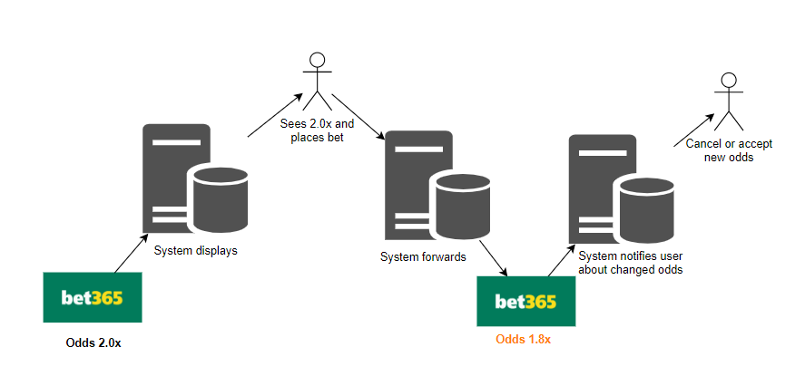
Refined Scenario 2: Impossible bets can't be placed.
Scenario: A user enters a desired bet, on a site that between confirmation and placement, gets removed from the external vendor.
Relevant quality: Safety
Stimulus source: External betting provider.
Stimulus: A user enters a bet and, immediately afterward, the bet is completely unavailable
Environment: System is running normally
Artifact (if known): Module(s) handling placement of bets.
Response: The initial desired bet is rejected. User is warned that no bet has been made, and is presented the highest available bet from another vendor.
Response measure: 100% of bets affected by removal are safely rejected, with a warning issued within 1 second of detection.

Refined Scenario 3: External betting site errors does not cause faulty behavior
Scenario: A betting provider is responding with error messages or not at all.
Relevant quality: Safety
Stimulus source: External betting providers.
Stimulus: Error responses when trying to communicate with betting provider.
Environment: System running normally.
Artifact (if known): Model(s) interacting with external betting providers.
Response: Our system continues to run without errors or faulty behaviour.
Response measure: 0 error detected in our system in the case of errors from external providers.

Architectural synthesis

Module view

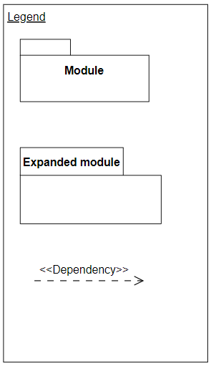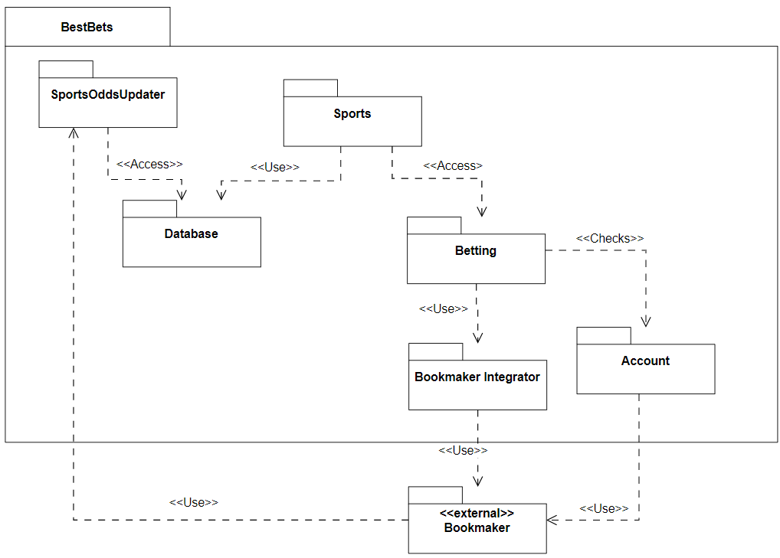
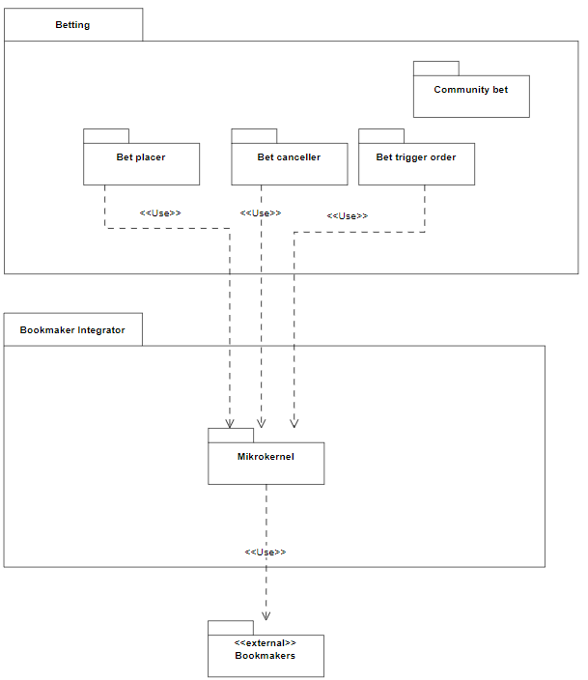

Component & connector view

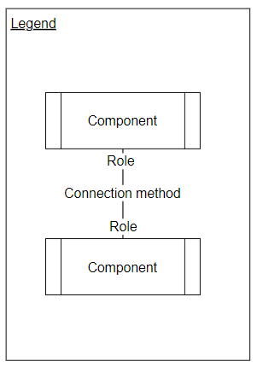
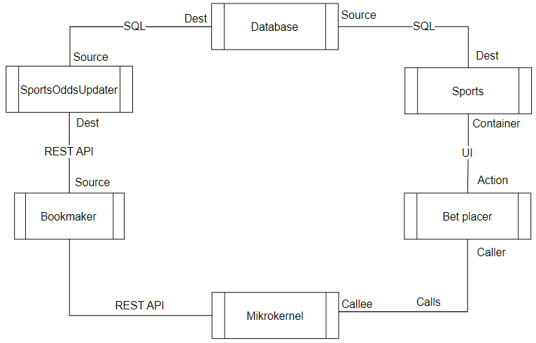

Deployment view

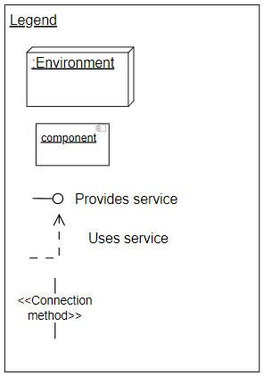
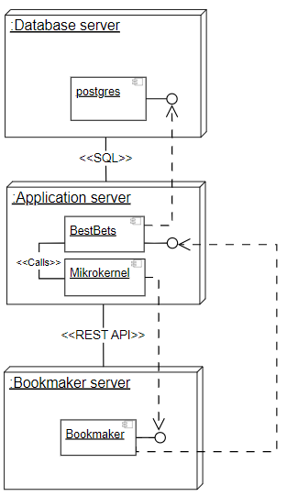

Design decisions regarding Tactics & Patterns

Overall structure
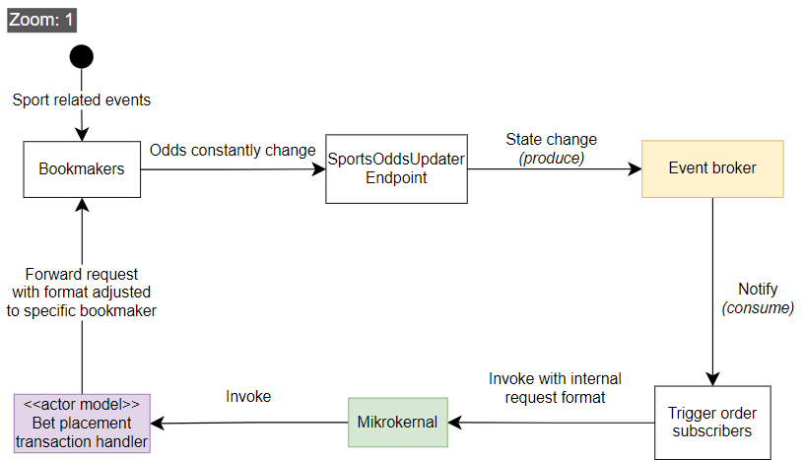

Event broker zoomed in view

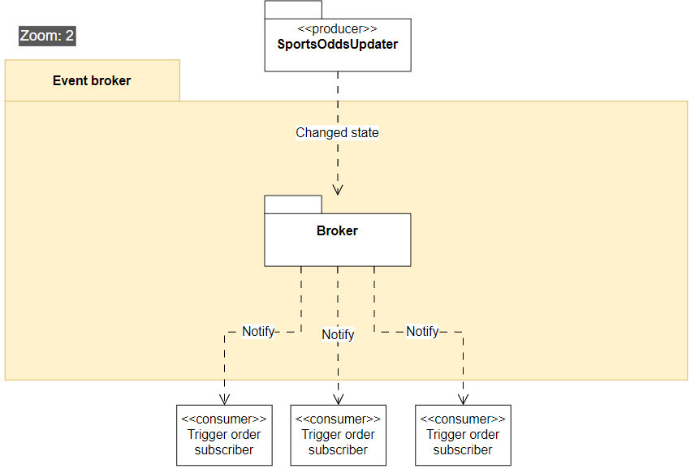Figure 1: What happens inside the event broker

Mikrokernel zoomed in view
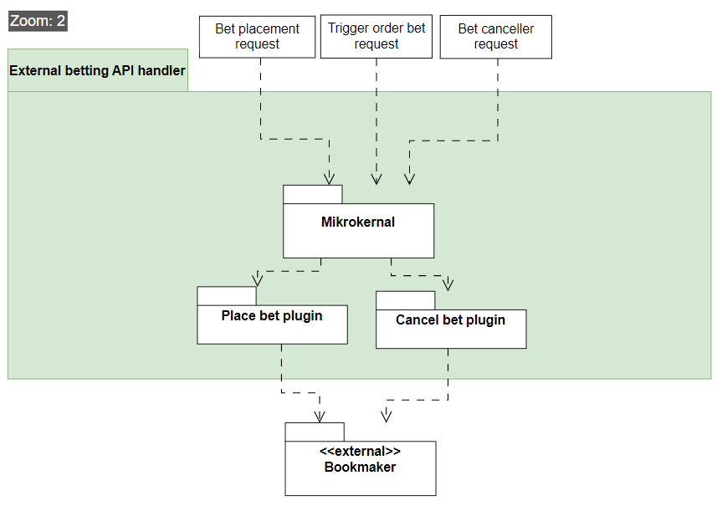Figure 2: What happens inside the mikrokernel

Plugin actor model zoomed in view
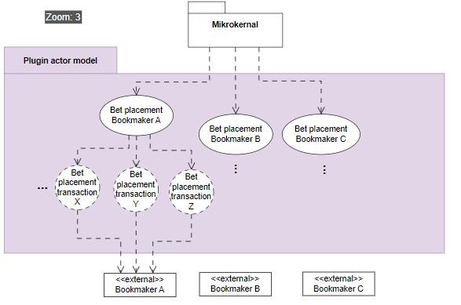
Figure 3: What happens inside the plugins that communicate with the bookmakers

Performance

Patterns
A. Event broker [figure 1]
The event broker can allow for low latency between odds being changed and the odds being displayed to our user.
Cons
• If there are many subscribers and the broker cannot keep up, it may end as a bottleneck.
B. Actor model [figure 3]
Spinning up an actor to handle each transaction ensures greater resource utilization as they can work in parallel.
Cons
• Spinning up actors introduces some time overhead.

Tactics
Control Resource Demand
Techniques:
– Prioritize events: Events like trigger orders working with real money should be prioritized, so they don’t miss out on a good betting opportunity. This can be achieved with the event broker having a prioritization list.
Cons:
• Less important events like updating the UI, gets higher latency.

Manage Resources
Techniques:
– Introduce concurrency: Process multiple streams of betting data in parallel. This can be achieved with the actor model when handling bet placements.
Cons:
• Increased complexity in ensuring we don’t accidentally spin up two actors for the same task and places 2 bets etc.

Availability

Patterns
A. Actor model [figure 3]
The actor model can help preventing errors that causes the whole system to crash, by having the actors crash instead. Having a monitor on the actors lets the system know so it can notify the user or try again.
Cons
• Lots of communication handling is needed, which may introduce computation and complexity overhead.

Tactics
Detect Faults
Techniques:
– Heartbeat: Regularly check the availability of external betting providers.
Cons:
• Increases network traffic and monitoring overhead.

Recover from Faults
Techniques:
– Graceful degradation: When one provider fails, continue serving data from other providers. Achieved with actor model.

Modifiability

Patterns
A. Microkernel [figure 2]
Provides a handler that supports placing/canceling bets on various external bookmaker API’s. This way if new bookmakers appear or change, we only have to handle the change in the mikrokernel logic while the rest of the system remains the same.
Cons
• Extra abstraction layers may lead to performance overhead.

Tactics
Increase Cohesion & Reduce Coupling
Techniques:
– Split Module: Having different actors [figure 3] for different bookmakers increases cohesion and since they work independently they have low coupling.
– Encapsulate External Calls: Let the event broker [figure 1] encapsulate by handle detecting odds. changes
Cons:
• Split module may decrease performance, because it adds more steps to the dataflow.
• Encapsulating in one place may introduce a bottleneck or single point of failure.

Safety

Patterns
A. Actor model with message passing [figure 3]
The actor handles the transaction process and makes sure it either succeeds or quickly detects if odds have changed, so the user can be notified.

Tactics
Techniques:
– Exception Detection: Monitoring the actors to ensure crashes are handled, will avoid major faults.
– Exception Handling: Immediately reject and rollback transactions if anomalies are detected.
– Input validation: Making sure invalid bets cannot be placed by having the actors closely communicate with the bookmaker api.
Cons:
• Additional processing may introduce minor delays.
• Complex exception logic can decrease maintainability.

Architecture backlog
3. Maintain and report on an architecture backlog. The backlog should contain decisions you have to make, work you need to do, issues you have etc. all in the scope of the system and not the project.

Our guide to our logs
1. Always remember to set dates.
2. Some idea might fit multiple logs/headers. It is not super important which is chosen, what is important is that it is written down.
3. Avoid merge conflicts of this Libre Office file by:
- If alone, write it down in your own local file first, then meet with group to get it merged.
- If with group, ensure only 1 is changing the log, then commit updates and notify group, so no concurrency issues arise.
4. If the idea is heavily conflicted by the group. Still write it down, but note down the disagreement.
5. Colors:
- Green: Finished / implemented / done
- black: Being worked on / being discussed
- Red: Turned out to be irrelevant / discarded

Ideas related to business

10.02.2025

Should we be a bookmaker, or only an aggregator?
- If we are an aggregator showing the "best odds", it would be tough for us to take a margin, as that margin would possibly reduce the odds such that it isn't no longer the best odds, only due to our cut.
- Alternatively, we could do something like a subscriber model for our product. But i suspect that people would quickly calculate that as a percentage cut of their bettings as well, and therefore again reduce the chance that the customer would perceive it as the best odds available. Therefore, we think it would be easier to take a cut, on a service usually not available on other sides, which is acting as a stock broker just for betting. Meaning that people themselves would be able to open a position on some bet, and therefore act as the bookmaker themselves, for other people to buy their odds. This would cost a fee, quite similar to the ordinary fees one pays on the stock market.

Conclusion / What happened (04.03.2025): We are mostly an aggregator. We don't act as our own bookmaker, BUT we do allow our customers to act as individual bookmakers through our site, known as “community bets”.

Does this concept give a total increase in new customers across betting sites, or does it eat from the existing customer base.
- So one of the biggest podcasts our there from Conan O' Brian, who is mainly on Spotify with audio only. They are now experimenting with putting episodes on Youtube with video as well. But they are afraid that it won't give more customers, instead people will migrate from Spotify to Youtube. This is a concern for the betting vendors as well, where there are mainly two scenarios:
  - Best case: Some customer who only uses X, instead now uses our platform and therefore indirectly ends up using A, B, C, D.... who never had a chance before to be used by this customer. They all see an increase, because this customer who now have more options and advantages starts betting 250 % more. So even though site X will see a decrease from this customer, there might be other customers who only uses A, that will now also start using X.
  - Worst case: Some customer who only bets 50 kr. each month on X, will now still only place 50 kr each month, but now on A, B, X. Thus no additional revenue would be added to the pot.

Should our concept only serve sport?
Most of these sites also have:
- Bingo
- Casino & Live casino
- Poker & other card games
- Raffles
- eSport (One might claim they are the same)
- Quizzes and giveaways
While these might make sense in our business scope, it will be too much for this 1 year project, therefore we only focus on sport - not because it is the best choice, but it is feasible within our scope of this course.
But alternatively, we can implement casino easily through casino providers. So ALL of the betting sites we checked with danish license (42), all used external casino vendors, such as pragmatic.com As such, we can easily an efficiently have a casino page as well, using external vendors. There is no "down-payment", as we act merely as affiliate, and get a provision from the vendors. This might be of conflict for our own betting site key partners, as if they start using our site, the potential income generated on slot-machines, will be reduced from our partners, as we eventually eat their customers. Alternatively is we don't provide casino (slots, live roulette etc.), as to please our key partners.
Conclusion / What happened (17.02.2025): We limit ourselves to sports bets for this project.

Special offers & bonuses
Is it feasible for our site to have offers, such as a welcome bonus?
This might be rough, because that would give the customers multiple stacked welcome bonuses, one from our site, as well as one from the site they are placing the bet on.
Or they might have to be designed in a smart way, we currently can’t think of.

Follow the best users, opt-in, always on, or never show?
Should we allow people to see the most successful users so they can mirror their bets? If so, should this feature always be on, or something the user opts for.

We must show betting limitations
The UI must show the limitations of bets. "This bet gives odds 1.8 but max bet amount is 75kr."

Legal concerns
There must be compliance of "Rofus" and "Stop Spillet". Furthermore, there must be a timer that makes the user aware of their time spent betting. All of these and additional requirements from Spillemyndighederne must be implemented.

Separate withdraw-able cash and bonus
Bonus money staying in the betting site acts differently than cash that can be withdrawn directly. The site must display how much is bonus and how much is not.
Bonuses must remain on the bookmaker, and can’t be transferred to our site.

Forum?
Having a forum on the site will act as marketing when users encourage each other to place bets.

Streaming?
We could use streaming through for example bet365 so users who want to watch matches live can be satisfied, without having to invest in our own streaming setup with people filming the match.

BetBørs is apparently already a thing
Our “community bets” idea already exist on BetFair. We thought it was a unique idea. Even though it already exists, we are going to continue with the idea, as we think the idea is great for showcasing various software architecture concepts.

International?
Could this be expanded to be used outside of Denmark? Could this site easily be operated in USA as well?

Two customer profiles
We actually have at least two customer segments.
- Users who want to bet.
- Bookmakers. Imagine a newly created bookmaker, who wants to make a splash and quickly attract new users. They could sign up through us, and “out-bid” other vendors with odds, to quickly reach a massive audience.

EU wallet
Should this site serve EU customers, through the newly EU created product “EU Wallet” – This means that we should alternatively mark our diagrams as “MitID / EU Wallet”.

Where is the money
Having them place money on our site makes it easier for the user to just put 200 and then bet where ever, instead of having to place 200 on multiple site. The down side is that we now need to handle security and all the behind the scenes transactions. But this idea proposal, is one of the key differences between just “googling the best odds” and having a central betting platform, taking care of various quirks, such as minimal down-payment for the customers.
Conclusion / What happened (04.03.2025): We included a bank to our architecture so we can hold the money, this way the user does not need to deposit money on every site.

Cancel bets
Users should be able to “cash out”, cancel their bet, etc.
This system should work very similar to placing bets, such as getting rejected and prompted in case they are trying to cash-out and the odds have changed during the process.
Conclusion / What happened (04.03.2025): The mikrokernel can forward cancel requests as well as bet placement requests.

Ideas related to patterns

10.02.2025

Pattern for registering many different vendors through our site.
We need a system that handles our external bookmakers different processes, as to minimize the pain of the user, needing to create a profile on multiple sites.
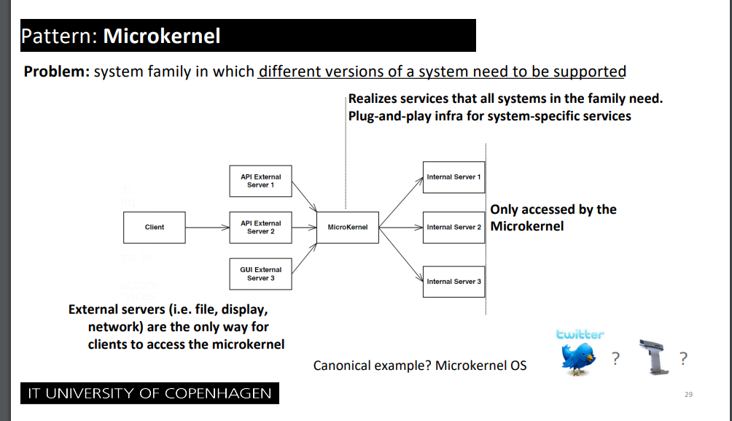
Conclusion / What happened (04.03.2025): Implemented in our diagrams.

For trigger order like a stock broker, when odds reach X < Y
If a user wants to place a bet on a match reaching above 2.0 in odds, it needs to be done quickly when the odds change. Thus the customer should “subscribe” to a match, where the “publisher” is the odds. If odds reach a certain threshold, the subscriber pipeline should automatically place the relevant bets.
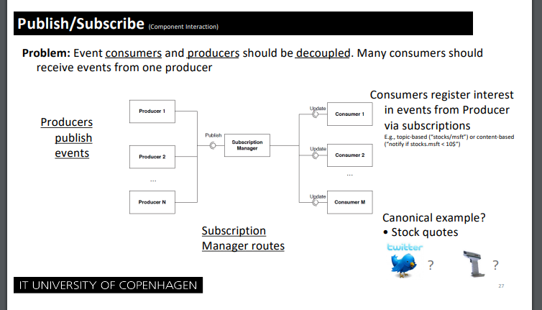
Alternatively, we want to also look at:
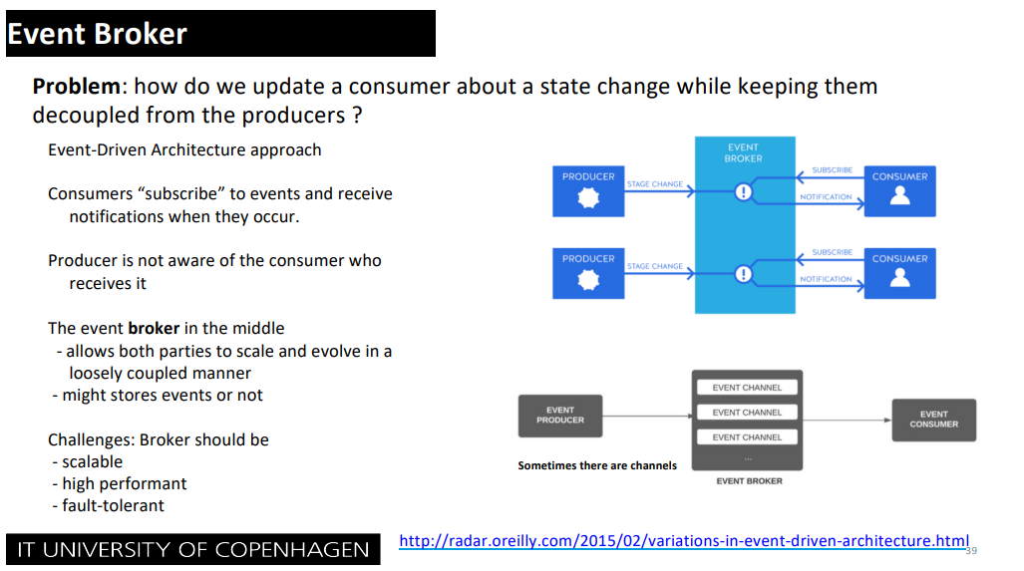

Conclusion / What happened (03.03.2025):
We decided to go with:
Trigger orders uses Event broker. The producer are “the changed odds on events”, and subscriber are the customers placing trigger orders.
This will then get forwarded to our Microkernel responsible for communicating with the different Actor models using message passing to attempt to place the bet for the customer and handling errors in case the odds have changed, by checking the odds-changed-treshold on the customer, and reattempts if within border, otherwise cancels – acting as a “transaction”.

03.03.2025

Should we have multiple copies of the database?

We could envision something like this:
1. Bookmakers update their odds.
2. The updates odds gets sent to our API endpoint, which updates our odds database.
3. The odds database could have a replicated read-only database.
4. Our sports-overview uses only the read-only version.

If so, what do we actually gain from this – we need to prototype this.

We need to show a diagram for what happens AFTER a placement is made
Such as updating account information, sending confirmations, etc.

Ideas related to tactics

10.02.2025

Availability
We need to monitor the health of a lot of different external sites, and should use tactics such as “heartbeat”
Conclusion / What happened (04.03.2025): Added in the tactics section for deliverable 2.

03.03.2025

Should we prioritize certain bets?

Such as, should a bet placement of 1,1 million be prioritized above a freebet of 50 kr.
If so we might want to look at: Tactic: Performance: Control Resource demand: Prioritize events.
Conclusion / What happened (04.03.2025): Added in the tactics section for deliverable 2.

Confirmed Decisions

10.02.2025

Fictitious project
We have made some fictitious assumptions, to make this project interesting to work with.
- All danish bookmakers have agreed to be part of BestBets.
- All bookmakers already have some API for placing/canceling bets.
- There are no legal troubles, such as not complying with various laws from Spillemyndighederne
- Transfers can be made between various bookmakers, and our own bank, as to avoid the restriction of “transfers must be through a MitId provider og NemKonto”.

Discarded decisions

10.02.2025

Placing multiple bets where one fails
On ordinary betting sites users can place multiple bets “in a package”, where the site is able to reject the whole package if one bet fails (such as a rapid change in odds). Our system will not be able to handle this, because the package might contain different sites, and as such we can’t cancel a bet on site A, if a bet fails on site B. As such it would be easier to not support package bets on our site.

11.02.2025

API og Data-scraping
We are not going to do data-scraping. If we do data-scraping, it would be hard to actually place bets on the respective sites, without proper confirmations etc. It would also be insanely resource intensive, to data-scrape a bunch of sites and also expect data to be completely fresh for the user. To avoid complications of legal situations and latency, we are going to make an assumption, that all bookmakers are willing to participate and already have an API giving the necessary data.

03.03.2025

Discarded patterns and tactics.

Work/issues needing to be done

11.02.2025

MitID integration

As we are doing betting, we need a license from "Spillemyndighederne", and follow their related laws. That includes MitID integration, for logging in, and also for getting payments out. Should we spent a lot of time and illustrations showing this, or is it simply "given" by the case, and illustration is not really necessary??

17.02.2025

Diagram showing bounds of our own bank connection and various payment providers
It can be a bit confusing, when and where the user is going directly through our banking connection, and when the user is going through a payment provider such as Visa & MasterCard.
Such as, what is the trace of money, when a user:
- Deposits money
- Places a bet
  - The bet loses
  - The bet wins.
- Withdraws money

Statistics
Most sites support statistics, such as RTP on a specific feature that last X days. We should show general statistics, such as RTP, win-rate, etc.

