Architecture backlog

Guide to logs
1. Always remember to set dates.
2. Some idea might fit multiple logs/headers. It is not super important which is chosen, what is important is that it is written down.
3. Avoid merge conflicts of this Libre Office file by:
- If alone, write it down in your own local file first, then meet with group to get it merged.
- If with group, ensure only 1 is changing the log, then commit updates and notify group, so no concurrency issues arise.
4. If the idea is heavily conflicted by the group. Still write it down, but note down the disagreement.

Ideas related to business

10.02.2025

Should we be a bookmaker, or only an aggregator?
- If we are an aggregator showing the "best odds", it would be tough for us to take a margin, as that margin would possibly reduce the odds such that it isn't no longer the best odds, only due to our cut.
- Alternatively, we could do something like a subscriber model for our product. But i suspect that people would quickly calculate that as a percentage cut of their bettings as well, and therefore again reduce the chance that the customer would perceive it as the best odds available. Therefore, we think it would be easier to take a cut, on a service usually not available on other sides, which is acting as a stock broker just for betting. Meaning that people themselves would be able to open a position on some bet, and therefore act as the bookmaker themselves, for other people to buy their odds. This would cost a fee, quite similar to the ordinary fees one pays on the stock market.

Does this concept give a total increase in new customers across betting sites, or does it eat from the existing customer base.
- So one of the biggest podcasts our there from Conan O' Brian, who is mainly on Spotify with audio only. They are now experimenting with putting episodes on Youtube with video as well. But they are afraid that it won't give more customers, instead people will migrate from Spotify to Youtube. This is a concern for the betting vendors as well, where there are mainly two scenarios:
  - Best case: Some customer who only uses X, instead now uses our platform and therefore indirectly ends up using A, B, C, D.... who never had a chance before to be used by this customer. They all see an increase, because this customer who now have more options and advantages starts betting 250 % more. So even though site X will see a decrease from this customer, there might be other customers who only uses A, that will now also start using X.
  - Worst case: Some customer who only bets 50 kr. each month on X, will now still only place 50 kr each month, but now on A, B, X. Thus no additional revenue would be added to the pot.

Should our concept only serve sport?
Most of these sites also have:
- Bingo
- Casino & Live casino
- Poker & other card games
- Raffles
- eSport (One might claim they are the same)
- Quizzes and giveaways
While these might make sense in our business scope, it will be too much for this 1 year project, therefore we only focus on sport - not because it is the best choice, but it is feasible within our scope of this course.
But alternatively, we can implement casino easily through casino providers. So ALL of the betting sites we checked with danish license (42), all used external casino vendors, such as pragmatic.com As such, we can easily an efficiently have a casino page as well, using external vendors. There is no "down-payment", as we act merely as affiliate, and get a provision from the vendors. This might be of conflict for our own betting site key partners, as if they start using our site, the potential income generated on slot-machines, will be reduced from our partners, as we eventually eat their customers. Alternatively is we don't provide casino (slots, live roulette etc.), as to please our key partners.

Special offers & bonuses
Is it feasible for our site to have offers, such as a welcome bonus?
This might be rough, because that would give the customers multiple stacked welcome bonuses, one from our site, as well as one from the site they are placing the bet on.
Or they might have to be designed in a smart way, we currently can’t think of.

Follow the best users, opt-in, always on, or never show?
Should we allow people to see the most successful users so they can mirror their bets? If so, should this feature always be on, or something the user opts for.

We must show betting limitations
The UI must show the limitations of bets. "This bet gives odds 1.8 but max bet amount is 75kr."

Legal concerns
There must be compliance of "Rofus" and "Stop Spillet". Furthermore, there must be a timer that makes the user aware of their time spent betting. All of these and additional requirements from Spillemyndighederne must be implemented.

Separate withdraw-able cash and bonus
Bonus money staying in the betting site acts differently than cash that can be withdrawn directly. The site must display how much is bonus and how much is not.
Bonuses must remain on the bookmaker, and can’t be transferred to our site.

Forum?
Having a forum on the site will act as marketing when users encourage each other to place bets.

Streaming?
We could use streaming through for example bet365 so users who want to watch matches live can be satisfied, without having to invest in our own streaming setup with people filming the match.

BetBørs is apparently already a thing
Our “community bets” idea already exist on BetFair. We thought it was a unique idea. Even though it already exists, we are going to continue with the idea, as we think the idea is great for showcasing various software architecture concepts.

International?
Could this be expanded to be used outside of Denmark? Could this site easily be operated in USA as well?

Two customer profiles
We actually have at least two customer segments.
- Users who want to bet.
- Bookmakers. Imagine a newly created bookmaker, who wants to make a splash and quickly attract new users. They could sign up through us, and “out-bid” other vendors with odds, to quickly reach a massive audience.

EU wallet
Should this site serve EU customers, through the newly EU created product “EU Wallet” – This means that we should alternatively mark our diagrams as “MitID / EU Wallet”.

Where is the money
Having them place money on our site makes it easier for the user to just put 200 and then bet where ever, instead of having to place 200 on multiple site. The down side is that we now need to handle security and all the behind the scenes transactions. But this idea proposal, is one of the key differences between just “googling the best odds” and having a central betting platform, taking care of various quirks, such as minimal down-payment for the customers.

Should we be a bookmaker?
Would it be feasible, for both our key partners, and the site, to act as bookmaker itself. Meaning that a customer would be able to place a bet directly through us, if we provide the best odds on some match.

Cancel bets
Users should be able to “cash out”, cancel their bet, etc.
This system should work very similar to placing bets, such as getting rejected and prompted in case they are trying to cash-out and the odds have changed during the process.

Ideas related to patterns

10.02.2025

Pattern for registering many different vendors through our site.
We need a system that handles our external bookmakers different processes, as to minimize the pain of the user, needing to create a profile on multiple sites.
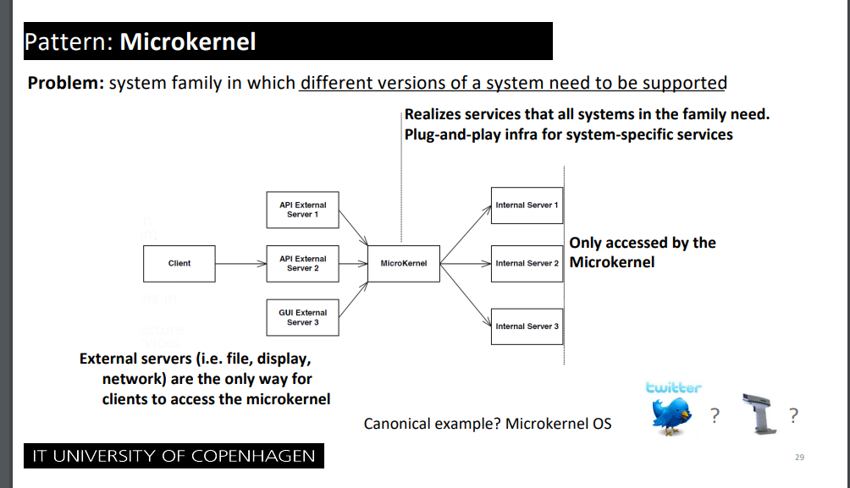

For trigger order like a stock broker, when odds reach X < Y
If a user wants to place a bet on a match reaching above 2.0 in odds, it needs to be done quickly when the odds change. Thus the customer should “subscribe” to a match, where the “publisher” is the odds. If odds reach a certain threshold, the subscriber pipeline should automatically place the relevant bets.
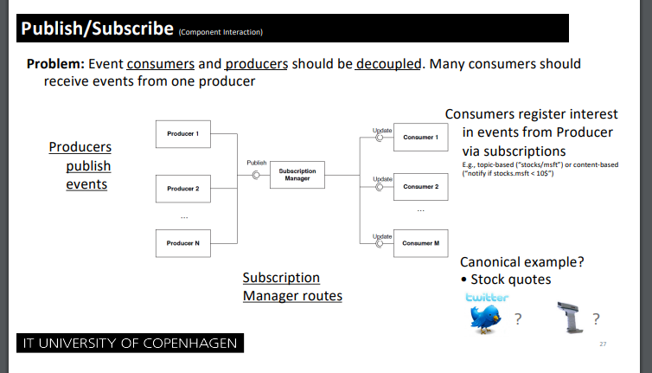
Alternatively, we want to also look at:
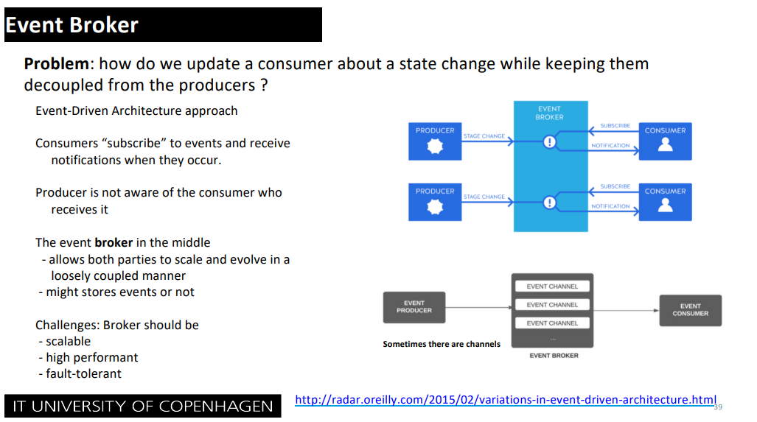

Ideas related to tactics

10.02.2025

Availability
We need to monitor the health of a lot of different external sites, and should use tactics such as “heartbeat”

Confirmed Decisions

10.02.2025

Fictitious project
We have made some fictitious assumptions, to make this project interesting to work with.
- All danish bookmakers have agreed to be part of BestBets.
- All bookmakers already have some API for placing/canceling bets.
- There are no legal troubles, such as not complying with various laws from Spillemyndighederne
- Transfers can be made between various bookmakers, and our own bank, as to avoid the restriction of “transfers must be through a MitId provider og NemKonto”.

Discarded decisions

10.02.2025

Placing multiple bets where one fails
On ordinary betting sites users can place multiple bets “in a package”, where the site is able to reject the whole package if one bet fails (such as a rapid change in odds). Our system will not be able to handle this, because the package might contain different sites, and as such we can’t cancel a bet on site A, if a bet fails on site B. As such it would be easier to not support package bets on our site.

11.02.2025

API og Data-scraping
We are not going to do data-scraping. If we do data-scraping, it would be hard to actually place bets on the respective sites, without proper confirmations etc. It would also be insanely resource intensive, to data-scrape a bunch of sites and also expect data to be completely fresh for the user. To avoid complications of legal situations and latency, we are going to make an assumption, that all bookmakers are willing to participate and already have an API giving the necessary data.

17.02.2025

Only sport
We are not doing casino, live casino, bingo, etc.

Work/issues needing to be done

11.02.2025

MitID integration

As we are doing betting, we need a license from "Spillemyndighederne", and follow their related laws. That includes MitID integration, for logging in, and also for getting payments out. Should we spent a lot of time and illustrations showing this, or is it simply "given" by the case, and illustration is not really necessary??

17.02.2025

Diagram showing bounds of our own bank connection and various payment providers
It can be a bit confusing, when and where the user is going directly through our banking connection, and when the user is going through a payment provider such as Visa & MasterCard.
Such as, what is the trace of money, when a user:
- Deposits money
- Places a bet
  - The bet loses
  - The bet wins.
- Withdraws money

Statistics
Most sites support statistics, such as RTP on a specific feature that last X days. We should show general statistics, such as RTP, win-rate, etc.

Uncategorized

Ideas related to ASR's

