Deliverable 1

Group: The Architects
Members: Jacob Grum, Rasmus Ole Routh Herskind & Thor Liam Møller Clausen



Table of Contents
System description 5
Overall functionality 5
Context diagrams 9
Informal diagram 9
Formal diagram 10
Architectural analysis 11
Identification of Architectural Drivers 11
Stakeholder roles 13
Quality Attribute Scenarios 14
Performance 14
Availability 17
Usability 19
Modifiability 20
Safety 21
Architectural synthesis 23
Module view 23
Component & connector view 25
Deployment view 26
Design decisions regarding Tactics & Patterns 27
Overall structure 27
Event broker zoomed in view 28
Microkernel zoomed in view 29
Plugin actor model zoomed in view 30
Performance 31
Performance Patterns 31
Performance Tactics 32
Availability 33
Availability Patterns 33
Availability Tactics 33
Modifiability 34
Modifiability Patterns 34
Modifiability Tactics 34
Safety 35
Safety Patterns 35
Safety Tactics 35
Architectural Prototyping 36
Architectural issue 36
Designs 36
Actor model 36
Load balancer 37
Prototyping setup and implementation 37
Prototyping evaluation and conclusion 38
Architectural Evaluation (aSQA Method) 39
The steps of aSQA 39
Metrics and levels 39
Components 39
Evaluation 40
Performance 40
Modifiability 40
Safety 41
Overall evaluation 41
Conclusion 41
Architecture backlog 43
Our guide to our logs 43
Ideas related to business 44
10.02.2025 44
Should we be a bookmaker, or only an aggregator? 44
Does this concept give a total increase in new customers across betting sites, or does it eat from the existing customer base. 44
Should our concept only serve sport? 45
Special offers & bonuses 45
Follow the best users, opt-in, always on, or never show? 45
We must show betting limitations 45
Legal concerns 45
Separate withdraw-able cash and bonus 45
Forum? 46
Streaming? 46
BetBørs is apparently already a thing 46
International? 46
Two customer profiles 46
EU wallet 46
Where is the money 46
Cancel bets 47
Ideas related to patterns 48
10.02.2025 48
Pattern for registering many different vendors through our site. 48
For trigger order like a stock broker, when odds reach X < Y 49
03.03.2025 50
Should we have multiple copies of the database? 50
We need to show a diagram for what happens AFTER a placement is made 50
05.03.2025 50
Compare actor model against alternatives 50
06.05.2025 51
Need to make every decision regarding the database 51
Ideas related to tactics 52
10.02.2025 52
Availability 52
03.03.2025 52
Should we prioritize certain bets? 52
Confirmed Decisions 53
10.02.2025 53
Fictitious project 53
Discarded decisions 53
10.02.2025 53
Placing multiple bets where one fails 53
11.02.2025 53
API og Data-scraping 53
Work/issues in general needing to be done 54
11.02.2025 54
MitID integration 54
17.02.2025 54
Diagram showing bounds of our own bank connection and various payment providers 54
Statistics 54
11.03.2025 54
Update all relevant diagrams after prototyping 54
17.03.2025 55
How should the load balancer approach safety and modifiability concerns 55

System description

Overall functionality
Imagine the following; Kevin wants to bet on Holger winning his tennis match. He checks his usual site, which gives odds 1.8. But his mate next to him scuffs at him “you should check out my site, it gives odds 1.9”. Kevin quickly realizes that he is not loyal to his site, he is mostly interested in placing on any site with the best odds available - Introducing BestBets
BestBets is an online betting odds aggregator that provides users with a unified interface to find and place bets at the best available odds across multiple bookmakers. It eliminates the need for users to manually check different betting sites by collecting odds data from various providers in real time and allowing bets to be placed through one central platform.

Key features of BestBets

- Shows the best odds available from any bookmaker for any match. (Fig 1)
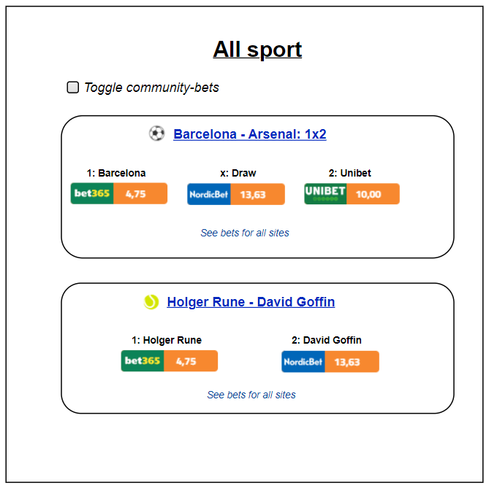Figure 1: Simple example match overview, showing the current best odds from various bookmakers
- Plenty of stock-like features! Trigger orders, when a certain game reaches certain odds
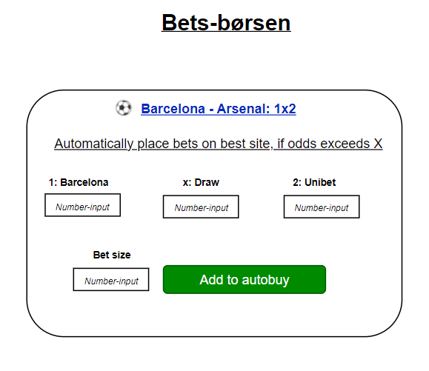Figure 2: Simple example of placing a trigger order on a specific match
- Similar market conditions as stocks, where you don’t want to search for the best offer from a bank, instead you trade on a shared market (Børsen). That means you only need to have money in one central place, to be able to purchase from all bookmakers! If you have 200 kr on BestBets, you can place 200 kr on ANY bookmaker, without having individual savings placed on each bookmaker.
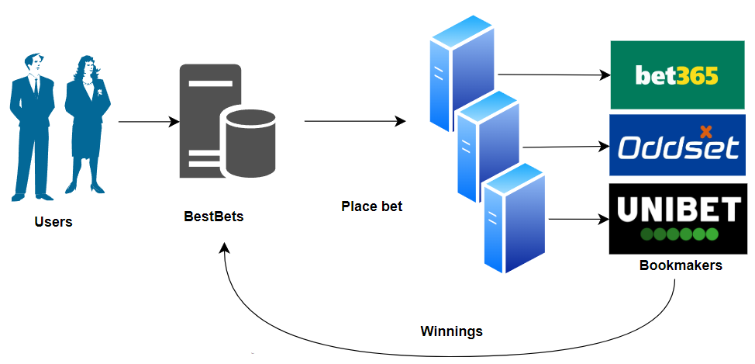Figure 3: Illustration of how all money is centralized on BestBets both when placing bets and winning money
- Similar to shorting a stock. Think the best odds are bad? Open your own position, and act like the bookmaker!
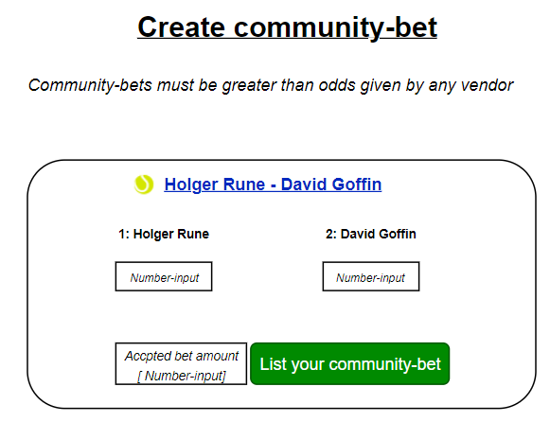Figure 4: Simple example of how one can open their own odds on a specific match, and as such acts as their own bookmaker
- Quickly register for any bookmaker, through a saved formula, to get consistent information across multiple sites, and to always be ready to place on the best odds possible.
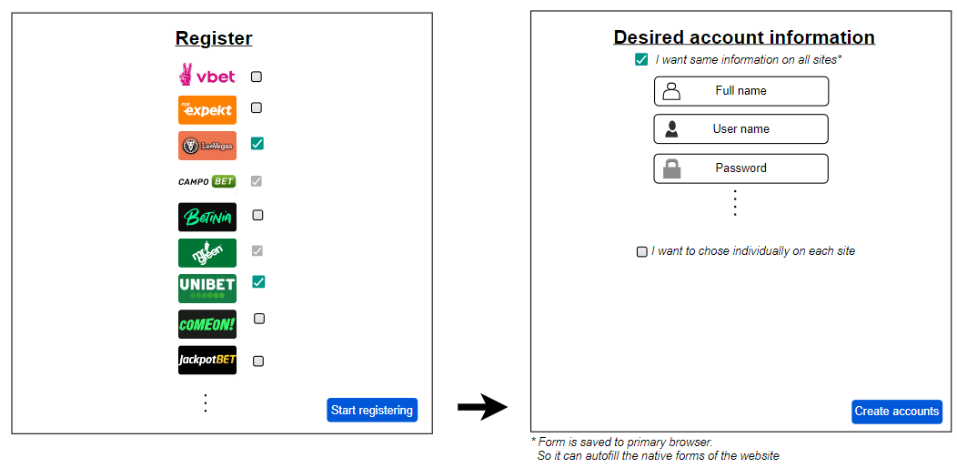Figure 5: Simple example of how a user can quickly register with consistent information across various bookmakers
- Get an instant overview of current bets, accounts and bonuses!
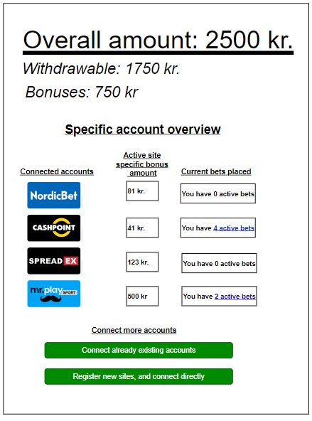Figure 6: Simple account overview example, showing the most important betting information, such as bonuses and active bets
- Various settings to ensure only your favorite sports are shown, to ease navigation and usage.
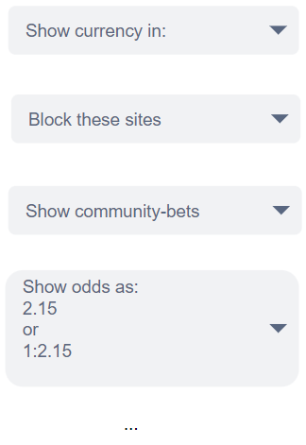Figure 7: Simple example of various common settings found on betting sites

Context diagrams

Informal diagram
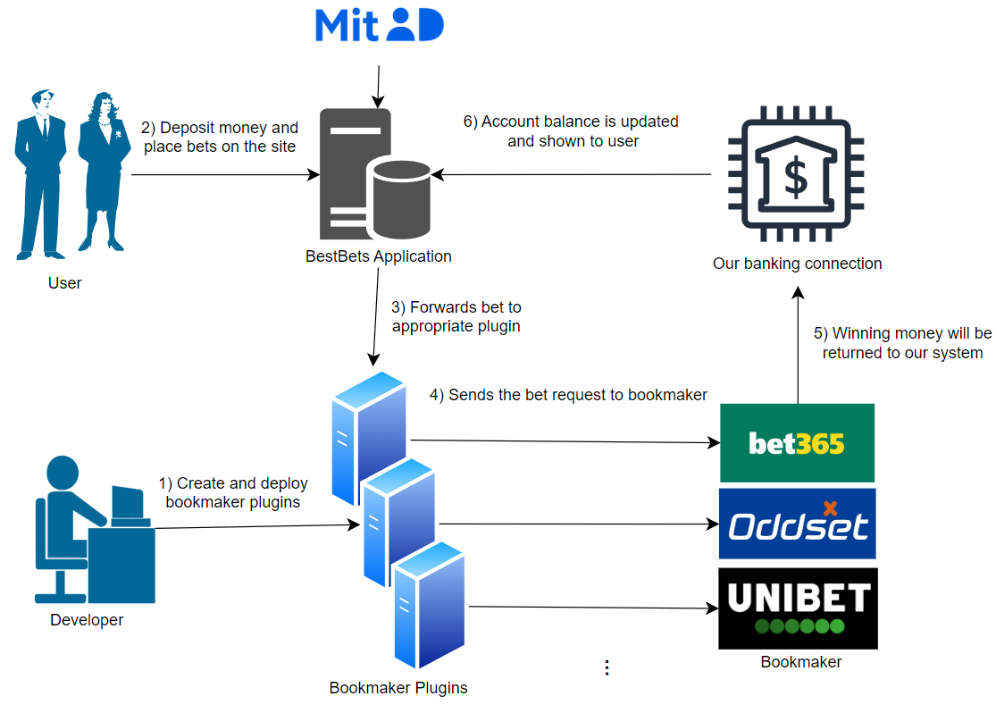
In short. Users only interact with our site. We forward the correct placements/winnings, so they are always centralized on BestBets. They only time they see another bookmaker, is during registration (not shown above).

Formal diagram
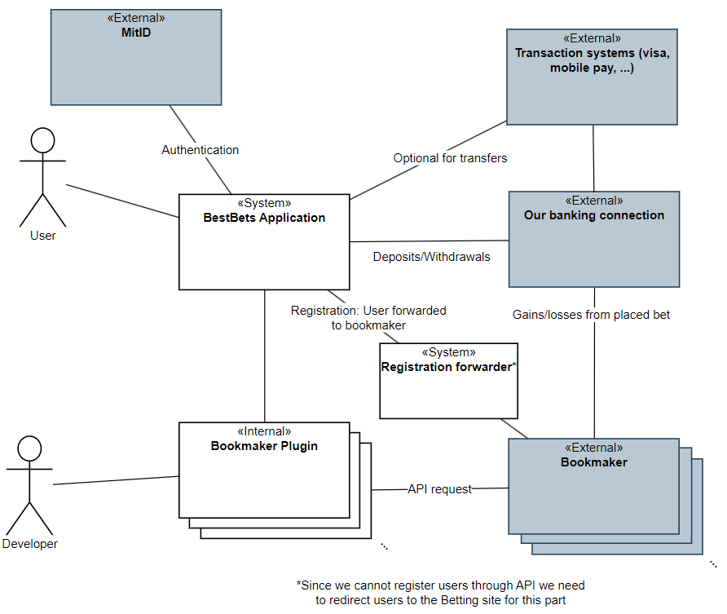Figure 8: Formal context diagram of BestBets, that details the actors (developers, users, external bookmakers), and interfaces they use
In short. As we are a gambling platform we are subjected to various laws from Spillemyndighederne, as such we are required to involve MitId during authentication. It is also quite common for these sites to offer a wide range of payment options. So we utilize both a banking connection for banking transfers, as well as payment providers such as mobilepay, visa / mastercard – Regardless of payment method, the money is kept in our external banking connection.

Architectural analysis

Identification of Architectural Drivers

The numbers in parenthesis is the number of points given in our stakeholder role play.
- Modifiability Requirement:
  - Handle new bookmakers (11)
The architecture shall be modifiable so that when a new bookmaker becomes available or an existing one ceases operation, support for that bookmaker can be added or removed with minimal impact on the overall system.
- Availability Requirement:
  - Available during high demand (12)
The system must remain available even during periods of high user demand (e.g., during high-traffic sporting events) to ensure continuous access to betting data.
- Performance Requirements:
  - Low Latency (14)
The system shall fetch and display betting odds from multiple providers in real-time or near-real-time. Delays in page loads or data updates must be minimized to prevent users from missing favorable odds.
  - Efficient Data Processing (14)
The system must process large volumes of betting data rapidly (especially during peak activity such as major finals) so that performance remains robust under load.
- Safety Requirement:
  - Safely handle odds changes (10)
The system shall ensure safety during the bet placement and acceptance process. If betting odds change between the time a bet is placed and accepted, the system must reject the altered odds and prompt the customer to re-confirm their bet under the new conditions.
- Usability Requirements:
  - Intuitive Navigation (12):
Users shall be able to quickly and easily find the best odds for a match.
  - Responsive Design (11):
The interface must adapt seamlessly to various devices (mobile, tablet, desktop) to accommodate users checking odds on the go.
  - Support for Specific Scenarios (12):
Filtering. Only tennis, only matches in Austrilian Open, that ends within 12 hours.
  - Consistent design (12). A bet placed on bookmaker A must have same mechanics and appearance as on bookmaker B.

- Security Requirement:
  - The system must ensure robust security (9):
User data and communications must be safeguarded using secure handling mechanisms.
Given that customers place real money on bets, the system must ensure that all financial and personal data are protected from unauthorized access.

In summary, the most important ones are:
- Performance (14)
  - Low latency: Provide fresh odds.
  - Efficient Data Processing: During many bets placed during big event
- Availability(13)
  - System must work and respond during high traffic for big events
- Usability (12)
  - Intuitive design. Our aggregator must provide an interface that does not get affected by what bookmaker the bets are offered from. Betting on A should look the same as betting on B, where A and B are two different bookmakers.
- Modifiability (11)
  - In case many new bookmakers open or others close, it must be handled without too much trouble.
- Safety (10)
  - With money being handled, the user must not be prone to make mistakes.

Stakeholder roles

Often directly in touch with the system
- Betting sites, also referred to as “Bookmakers”
- Developers/Architects
- Users
Various gambling related governmental instances
- Spillemyndigheden: https://www.spillemyndigheden.dk/gaming-og-gambling
- Ludomani støtteforeninger: https://www.stopspillet.dk/
Various partners and affiliates:
- Sport-event industry (Arenas, leagues, etc).
- Sport clubs
- Sports news (magazines, blogs, etc.)
- Sports apparel and merchandise
- Sport streaming & channels

Quality Attribute Scenarios

Performance
Refined Scenario 1: Real-Time Betting Odds Update
Scenario: The system updates betting odds in real-time during a high-profile sports event.
Relevant quality: Performance
Stimulus source: External betting data providers.
Stimulus: A sudden surge in updated odds from multiple providers as a major match reaches a critical point.
Environment: System is running high traffic during live, high-stakes sports events.
Artifact (if known): The module(s) that fetches live data from betting sites and updates our site.
Response: Fetch and process incoming data rapidly and update the user interface with minimal delay.
Response measure: Updated odds are displayed within 500 milliseconds of detected change, sustaining throughput of up to 100.000 updates per minute without performance degradation.
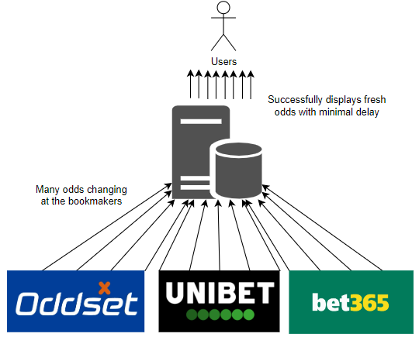
Refined Scenario 2: Massive user surge during the Champions League final
Scenario: The system responds to a lot of users during Champions League final with little delay.
Relevant quality: Performance/Scalability
Stimulus source: A lot of end users (100.000) logging in at the same time.
Stimulus: Number of users logged in increases from 1000 to 100.000 in the span of 10 minutes.
Environment: System running normally.
Artifact (if known):
Response: The system continues to serve updated odds without errors or significant delays
Response measure: Pages load within 2 seconds for 95% of requests. Odds update within 3 seconds of provider feed changes.
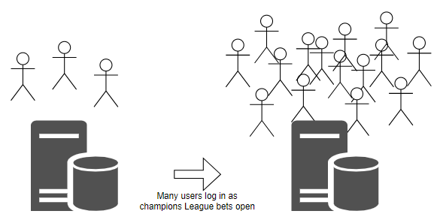
Refined Scenario 3: Massive surge of placed bets during prep for a mayor sports match
Scenario: The systems handles a lot of bets placed within a short time span with little delay.
Relevant quality: Performance
Stimulus source: A lot of end users (100.000) placing bets.
Stimulus: 100.000 bets being placed per 5 minutes.
Environment: The system running at high capacity with many users logged in.
Artifact (if known): The module(s) handling the forwarding of bets to the betting sites, and module(s) receiving confirmation from the sites.
Response: The system successfully forwards the bet placements without creating bottlenecks.
Response measure: With 100.000 bets per 5 minutes the average latency should be below 1 second from user confirms in our system to the bet being successfully forwarded to the respective betting site.
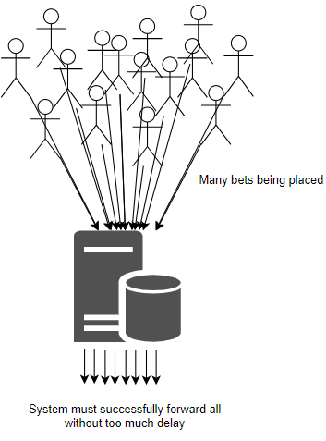
In short:
1: Handle external updates of odds.
2: Many users logs into our internal site.
3: Many bets are placed.

Availability

Refined Scenario 1: Continuous Availability Under Traffic Spike
Scenario: The platform remains fully available during an unexpected surge in user traffic.
Relevant quality: Availability
Stimulus source: End users accessing the site during a major sporting event.
Stimulus: 100.000 users simultaneously accessing and interacting with the platform.
Environment: System running on high capacity from the many logged in users.
Artifact (if known): The modules handling user activity (front end, server, load balancers, auto-scaling infrastructure).
Response: The system dynamically scales resources and distributes the load to maintain service availability.
Response measure: Achieves 99.9% uptime during peak load with 95% of requests served in under 500 milliseconds.

Refined Scenario 2: Site remains available during betting site outages
Scenario: The system handles the failure of one or more betting sites without affecting overall availability.
Relevant quality: Availability
Stimulus source: Betting sites failing to respond to requests (ping).
Stimulus: Ping requests without a response within 2 seconds from one or more betting sites.
Environment: System running normally with logged in end users.
Artifact (if known): Modules communicating with betting sites (fetching data, checking for activity).
Response: The system continues to display odds from other providers and clearly labels outed providers as “unavailable”.
Response measure: The system has a 99.99% uptime with up to 100% of betting sites unavailable.
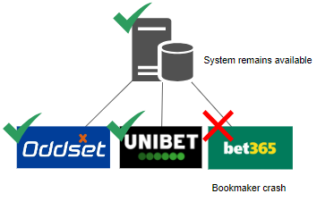
Refined Scenario 3: The integration of a new betting site does not affect availability
Scenario: A new betting site has been integrated in the system and gets deployed without affecting active users.
Relevant quality: Availability
Stimulus source: The developers deploying a new betting site opportunity in the system.
Stimulus: Initiation of the deployment of the new betting site integration.
Environment: System running normally with logged in end users.
Artifact (if known): The modules interacting with the betting site integrations/the aggregator.
Response: The system switches seamlessly to the updated version without service disruption.
Response measure: Zero downtime is observed; the switchover is completed seamlessly with monitoring confirming uninterrupted service.
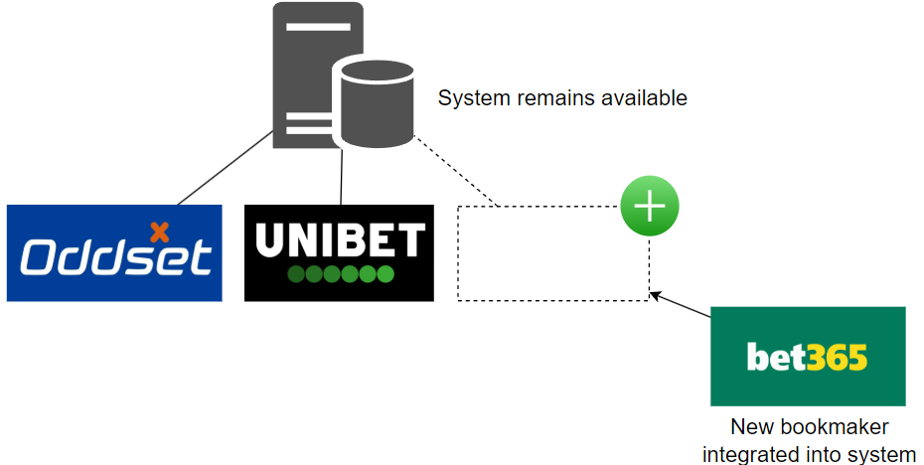

Usability

Refined Scenario 1: Consistent Navigation Across Devices
Scenario: The system provides a uniform and consistent user experience across various devices.
Relevant quality: Usability
Stimulus source: End users accessing the system on desktops, tablets, and mobile devices.
Stimulus: A user transitions between devices and expects the interface to behave consistently.
Environment: System running normally.
Artifact (if known): User interface.
Response: The user interface maintains consistent layout, design, and navigation regardless of the device.
Response measure: Less than 15% difference in the speed of user interaction across device.

Refined Scenario 2: Intuitive Filtering and Search
Scenario: Users quickly locate and filter betting events to find their preferred matches.
Relevant quality: Usability
Stimulus source: End users utilizing search and filtering tools.
Stimulus: A user applies filters (e.g., for tennis matches or events ending within 12 hours) to quickly locate relevant betting options.
Environment: System running normally with search/filter options implemented.
Artifact (if known): UI components and logical components managing search and filtering.
Response: The system delivers relevant results promptly, making it easy for users to narrow down options.
Response measure: At least 90% of search queries return results within 300 milliseconds; user feedback on the filtering process is overwhelmingly positive (95% satisfaction).

Refined Scenario 3: Streamlined, Consistent Bet Placement Process
Scenario: The bet placement workflow is intuitive and consistent across different sections of the site.
Relevant quality: Usability
Stimulus source: A user wanting to place a bet on several different betting sites using our system.
Stimulus: The user navigating through the system to place their bets.
Environment: System running normally.
Artifact (if known): The UI allowing for bet placement.
Response: The user successfully placing their bets without much delay in between bets.
Response measure: 90% of users successfully placing bets in less than 2 minutes on average and in case of multiple bets, at most 1 minute between bets on average.

Modifiability

Refined Scenario 1: Adding a New Betting Provider
Scenario: The system integrates a new betting provider with minimal disruption.
Relevant quality: Modifiability
Stimulus source: A business decision to expand service offerings.
Stimulus: Announcement of a new betting provider entering the market.
Environment: Development and production environments.
Artifact (if known): Aggregator codebase (API integration modules)
Response: Development team implements the new provider interface, tests it, and deploys it with minimal disruption, and minimal changes to the existing code base.
Response measure: Completed integration within 5 developer days. No existing functionality broken (automated tests pass). Less than 5% of the existing code base changed.

Refined Scenario 2: Removing an Existing Betting Provider
Scenario: The system gracefully removes support for a provider that is ceasing operations.
Relevant quality: Modifiability
Stimulus source: External betting site shutting down.
Stimulus: An existing betting provider has been decided to be removed from the system.
Environment: The system running with multiple integrated betting sites.
Artifact (if known): The modules interacting with the betting site integrations/the aggregator.
Response: The betting site integration is isolated for safe removal.
Response measure: Integration removal is executed in under 24 hours with zero system downtime.

Refined Scenario 3: Adapting to Changing Provider APIs
Scenario: The system is modified to handle betting provider’s changed API with minimal impact on overall functionality.
Relevant quality: Modifiability
Stimulus source: External betting provider API.
Stimulus: The betting provider releases a new version of its API.
Environment: System running with multiple integrated betting providers.
Artifact (if known): API adapter for external services.
Response: The API adapter is updated to accommodate the API changes while keeping the core system unaffected.
Response measure: The required modifications are completed and fully tested within 48 hours with only localized changes in the adapter code.

Safety

Refined Scenario 1: Acceptance of changed odds
Scenario: There is a difference in the odds between the time the user enters its desired bet, and when the bet is being confirmed at the vendor
Relevant quality: Safety/Usability
Stimulus source: External betting provider.
Stimulus: A user enters a bet and, immediately afterward, the betting odds change before confirmation.
Environment: System is running normally
Artifact (if known): Module(s) handling placement of bets.
Response: The initial desired bet is rejected, and user is asked if they want to place a new bet at the changed odds.
Response measure: 100% of bets affected by odds changes are safely rejected and re-confirmed, with user prompts issued within 1 second of detecting the change.
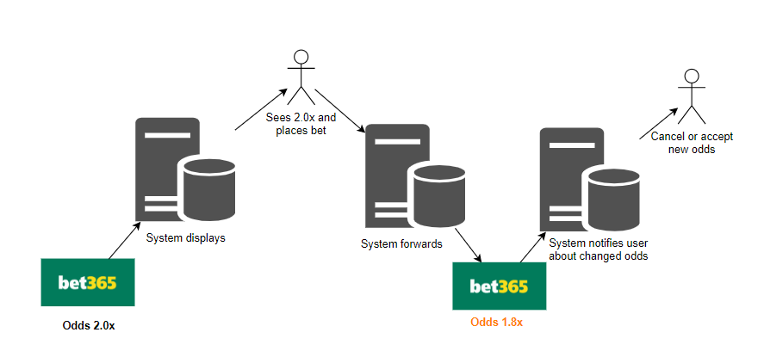
Refined Scenario 2: Impossible bets can't be placed.
Scenario: A user enters a desired bet, on a site that between confirmation and placement, gets removed from the external vendor.
Relevant quality: Safety
Stimulus source: External betting provider.
Stimulus: A user enters a bet and, immediately afterward, the bet is completely unavailable
Environment: System is running normally
Artifact (if known): Module(s) handling placement of bets.
Response: The initial desired bet is rejected. User is warned that no bet has been made, and is presented the highest available bet from another vendor.
Response measure: 100% of bets affected by removal are safely rejected, with a warning issued within 1 second of detection.

Refined Scenario 3: External betting site errors does not cause faulty behavior
Scenario: A betting provider is responding with error messages or not at all.
Relevant quality: Safety
Stimulus source: External betting providers.
Stimulus: Error responses when trying to communicate with betting provider.
Environment: System running normally.
Artifact (if known): Model(s) interacting with external betting providers.
Response: Our system continues to run without errors or faulty behaviour.
Response measure: 0 error detected in our system in the case of errors from external providers.

Architectural synthesis

Module view

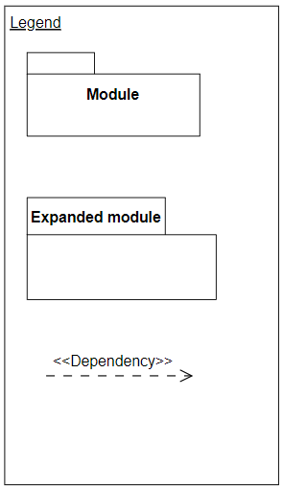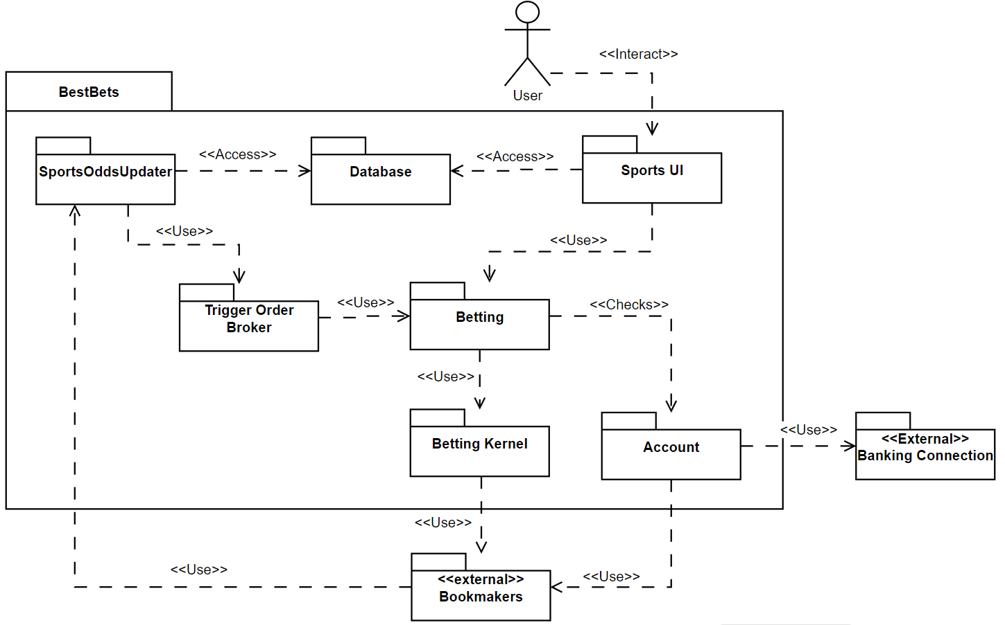
Account hold information about balance, it also has to confirm that the user is registered to the chosen bookmaker.
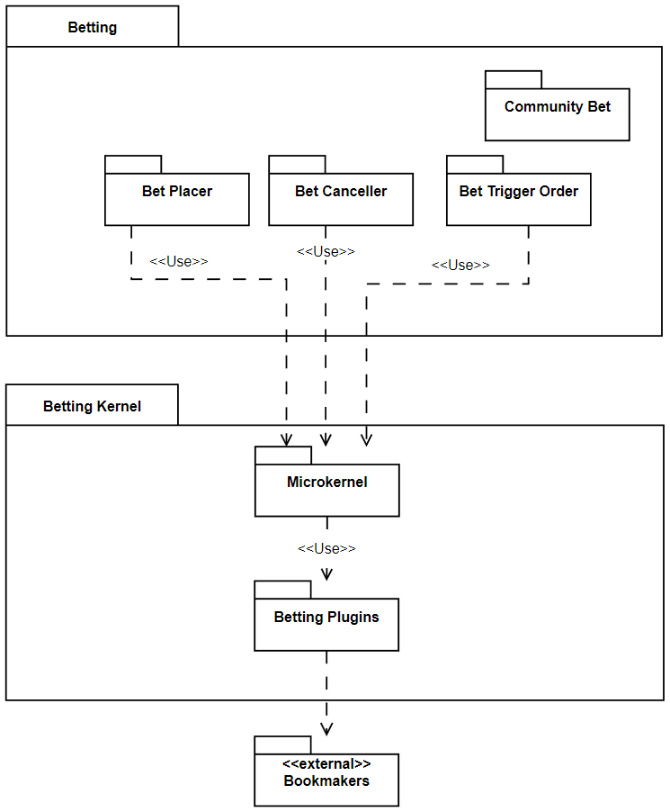
Betting is what the user interacts with. They can place bets etc. Betting kernel handles all the behind the scenes logic of placing the bets at bookmakers.

Component & connector view

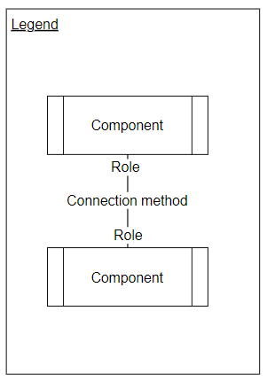
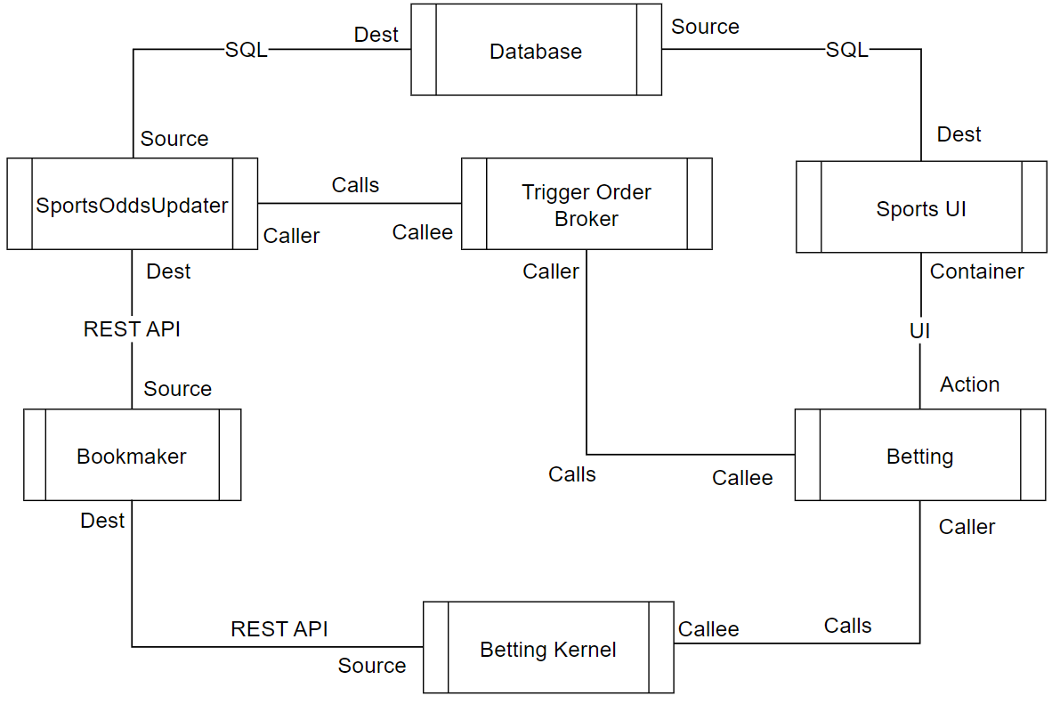

Deployment view

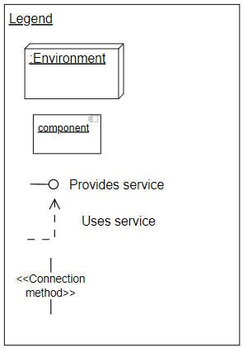
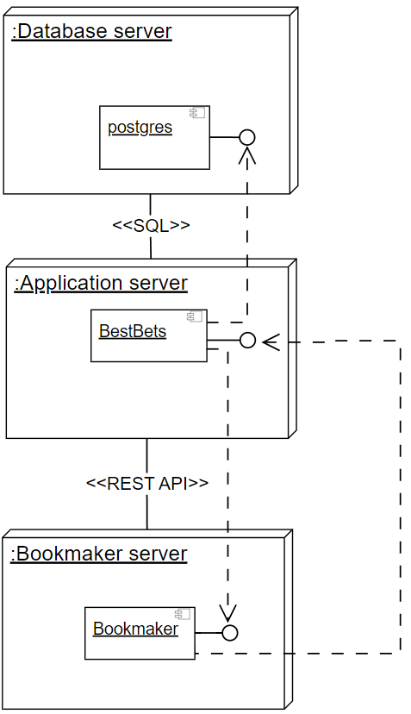
BestBets uses our database and talks to bookmakers.

Design decisions regarding Tactics & Patterns

Overall structure

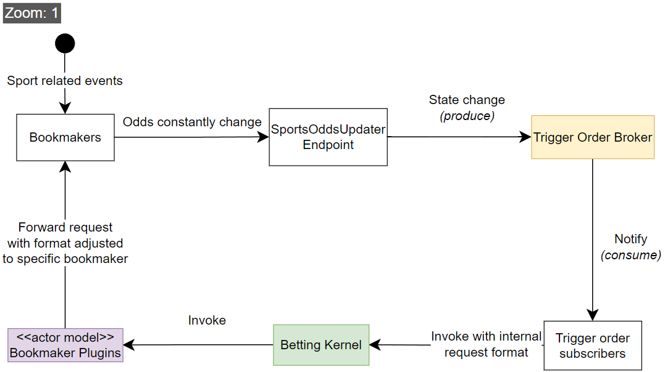
Yellow is Event broker, green is Microkernel, purple is Actor model.

Event broker zoomed in view

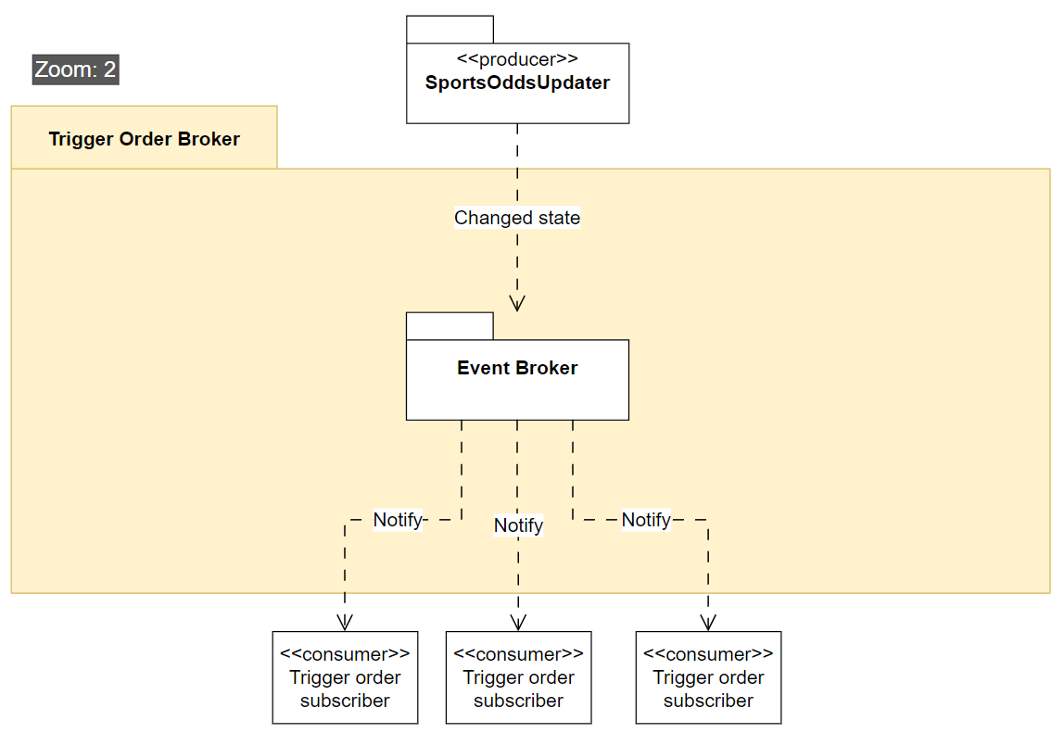Figure 9: What happens inside the event broker

Microkernel zoomed in view
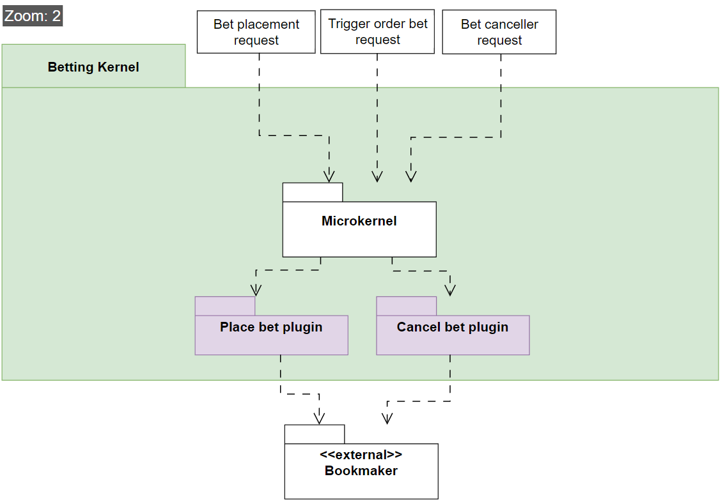Figure 10: What happens inside the microkernel

Plugin actor model zoomed in view
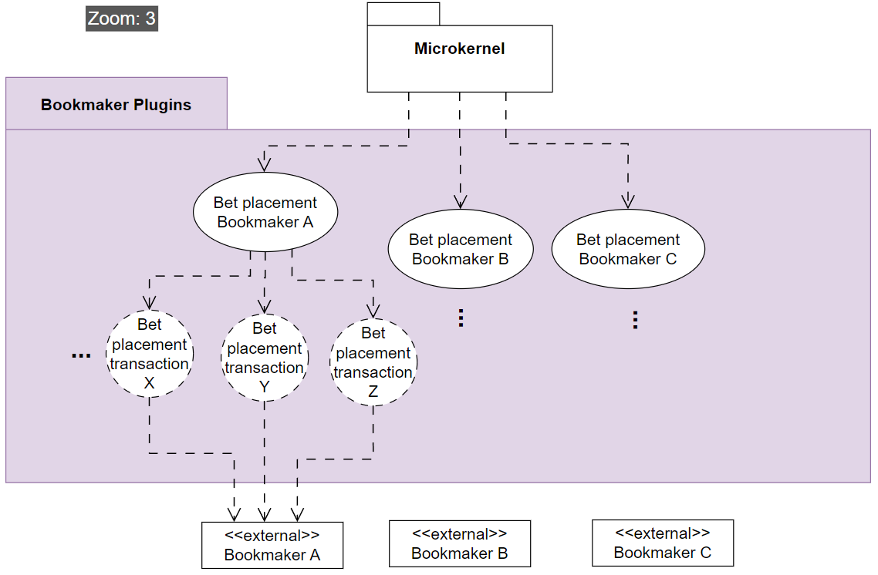
Figure 11: What happens inside the plugins that communicate with the bookmakers

Performance

Performance Patterns
A. Event broker [figure 1]
Pros
- The event broker can allow for low latency between odds being changed and the odds being displayed to our user. Each channel in the broker will be a specific match ID. Trigger orders will then act as subscribers on specific channels, using specific criteria being the odds and money placement.
Cons
- As the number of channels and subscribers increases, the broker can struggle to efficiently manage all connections, especially if channels are highly active. This can reduce performance.
- Traffic might be heavily unbalanced, as one channel might represent a local sports-match with 4 people in the audience and another represent the grand final match watched by millions. This can reduce performance.
- It can be difficult to ensure a correct ordering. In case we end up deciding that bigger bets should be prioritized higher than small bets. This can reduce usability.
- The broker might be the bottleneck, and a single point of failure. This can reduce availability.
B. Message Queuing using the Actor model [figure 3]
Pros
- Spinning up an actor to handle each transaction ensures greater resource utilization as they can work in parallel.
- Decoupling from other bookmaker, as each actor is designed to only communicate with a specific bookmaker. As thus, if the bookmaker changes the API, only a specific actor implementation is affected.
- This will also enhance safety qualities. Each actor will function as a “bet transaction”, handling cases where the bookmaker reject the bet due to odds changing, and then re-send the bet is within the users threshold setting for odds changing during placement.
- The actor model is suitable for horizontal scaling. Example by adding more “LeoVegas bookmaker actors”, in case there is high traffic on bet placements for LeoVegas.
Cons
- Spinning up actors introduces some time overhead.
- Inter-actor communication can introduce additional latency, thus reducing performance.

Performance Tactics
Control Resource Demand
Techniques: Prioritize events:
Pros:
- Events like trigger orders working with higher sums of real money should be prioritized compared to someone betting with fun-money or placing a small bet below 100 kr. This can be achieved with the event broker having a prioritization list. This will improve usability for the customer segment more important to us (The whales).
Cons:
- Less important events like updating the UI, gets higher latency.

Manage Resources
Techniques: Introduce concurrency:
Pros:
- Process multiple streams of betting data in parallel. This can be achieved with the actor model when handling bet placements. Each actor can act completely independent of other bookmaker actors, making their work “embarrassingly parallelizable”
Cons:
- Increased complexity in ensuring we don’t accidentally spin up two actors for the same task and places 2 bets etc.

Availability

Availability Patterns
A. Actor model [figure 3]
Pros
- The actor model can help preventing errors that causes the whole system to crash, by having the actors crash instead. Having a monitor on the actors lets the system know so it can notify the user or try again.
Cons
- Lots of communication handling is needed, which may introduce computation and complexity overhead.

Availability Tactics
Detect Faults
Techniques: Heartbeat:
Pros
- Regularly check the availability of external betting providers. Improves usability, if we can up-front tell a user that they can't place a bet at LeoVegas right now, compared to them trying to place a bet and afterwards getting told they can't do it.
Cons:
- Increases network traffic and monitoring overhead.

Recover from Faults
Techniques: Graceful degradation:
Pros
- When one provider fails, continue serving data from other providers. Achieved with actor model.
Cons
- Users may encounter reduced functionality in terms of bet placement options, which can lead to confusion or dissatisfaction.

Modifiability

Modifiability Patterns
A. Microkernel [figure 2]
Pros
- Provides a handler that supports placing/canceling bets on various external bookmaker API’s. This way if new bookmakers appear or change, we only have to handle the change in the microkernel logic while the rest of the system remains the same. Thus improving modifiability by decoupling different bookmakers, and isolating the system affected by external changes.
Cons
- Extra abstraction layers may lead to performance overhead.

Modifiability Tactics
Increase Cohesion & Reduce Coupling
Techniques: Split Module & Encapsulate External Calls
Pros
- Having different actors [figure 3] for different bookmakers increases cohesion and since they work independently they have low coupling.
- Letting the event broker [figure 1] encapsulate by handle detecting odds. changes
Cons:
- Split module may decrease performance, because it adds more steps to the data-flow.
- Encapsulating in one place may introduce a bottleneck or single point of failure.

Safety

Safety Patterns
A. Actor model with message passing [figure 3]
(See performance section for more info). The actor handles the transaction process and makes sure it either succeeds or quickly detects if odds have changed, so the user can be notified.

Safety Tactics
Techniques: Exception Detection, Exception Handling & Input validation:
Pros:
- Monitoring the actors to ensure crashes are handled, will avoid major faults.
- Immediately reject and rollback transactions if anomalies are detected.
- Making sure invalid bets cannot be placed by having the actors closely communicate with the bookmaker API.
Cons:
- Additional processing may introduce minor delays.
- Complex exception logic can decrease maintainability, by making it harder to make changes will maintaining a growing exception handling system.

Architectural Prototyping – Slides


Evt tekst her.

Architectural Prototyping

Architectural issue
When designing our prototype we would like to investigate how some of our identified important architectural qualities affects one another in an experimental manner. Specifically we would like to investigate how performance, modifiability and safety impact each other in the microkernel module. To facilitate this our prototype needs to be able to distribute bets in a way that simulates how the system would function in the real world. That is, we need to be able to handle uneven betting loads if e.g. a specific site has a good offer and gets disproportionately higher amount of bets than other bookmakers.

Designs
We will experiment with two different design variations: The actor model and a load balancer. We assume the former provides us with lower coupling between different actors and hereby ensuring better modifiability and safety. However, we want to explore the possible performance benefits of using a load balancer instead, and take a stand on whether the system is better suited with a load balancer or an actor model. The two designs are illustrated in Figure 4.
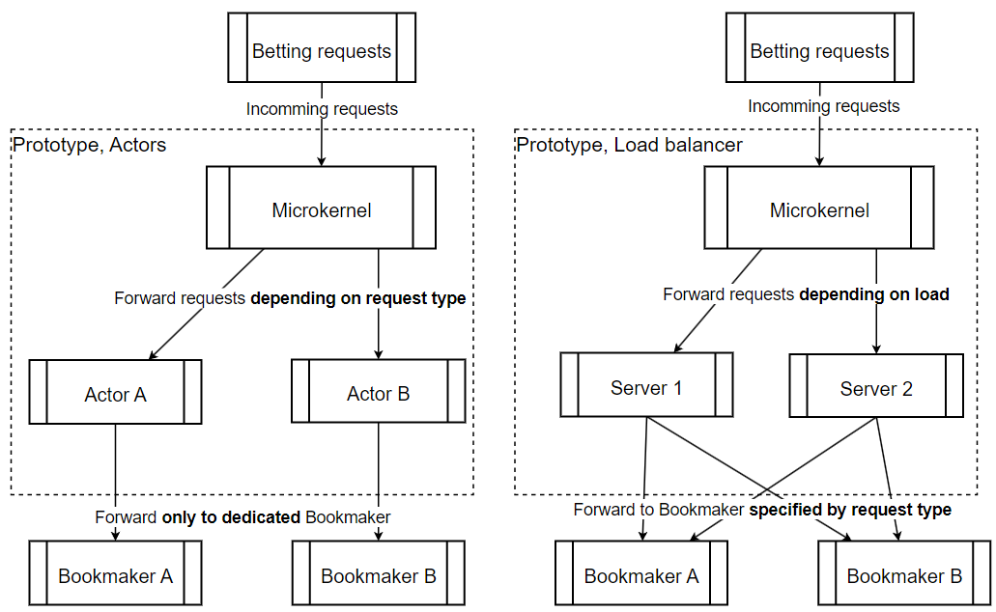Figure 12: Actor Model and Load Balancer
In the following we will describe the two systems and highlight their pros and cons.

Actor model
In this design there is an actor for each bookmaker. The microkernel forwards betting requests to the actors based on the request type. If it is a Bet365 request, it will be forwarded to the actor that handles Bet365 requests etc.
Pro: Each actor is specialized to their given bookmaker. This ensures that the different logics/interfaces for different bookmakers are isolated, creating lower coupling and better modifiability. And if something goes wrong it only affects requests to the specific bookmaker, meaning we get higher safety.
Con: The actor handles all request for said bookmaker, so uneven load between bookmakers might overwork some actors and starve others leading to poor performance.

Load balancer
There are x (2 in our prototype, but more in real world) servers that be can distributed to. Each server can handle every kind of requests because the requests are distributed based on load. The least loaded server gets the next request.
Pro: With requests being distributed based on load instead of request type, we ensure even workload among the servers. Furthermore, it is easy to scale out horizontally by adding more servers, thereby always ensuring high performance.
Con: Each server must be able to handle requests for each bookmaker. This increases complexity, which can lead to errors and make it harder to modify when new bookmakers appear.

Prototyping setup and implementation
The code for our prototype can be found at: https://github.com/Grumlebob/Architecture/tree/main/Prototyping
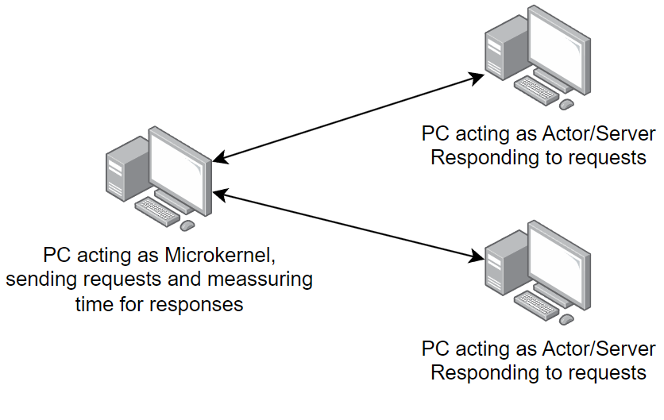Figure 13: Our setup involves three PC's.
As seen in figure 5 we have one PC (A) acting as the microkernel. It simulates forwarding requests by sending requests with message parsing to two other PC’s (B and C). The other PC’s simply print to the console and respond to the requests, nothing else.
PC A has two implementations.
- Actor model. PC A sends requests to B and C based on the type of the request. Type B goes to PC B and type C to PC C.
- Load balancer. It keeps count of how many unanswered messages has been sent to each “server” and sends the next request to the one with fewest unanswered messages.
To simulate uneven workload we make 10 times more requests of type B than of type C. PC A performs the benchmarking based on how long it takes from requests are sent to responses are received. We used both a benchmarking library and our own implemented benchmarker.

Prototyping evaluation and conclusion
This is the printed result from the benchmark library (it was too slow with 10000 requests):
Table 1
| Method | TotalRequests | Mean | Error | StdDev | Allocated |
|------------------------ |-------------- |-----------:|---------:|---------:|-----------:|
| RunActorBenchmark | 100 | 254.1 ms | 5.73 ms | 16.53 ms | 204.23 KB |
| RunActorBenchmark | 1000 | 2,308.8 ms | 44.52 ms | 41.65 ms | 2045.02 KB |

| Method | TotalRequests | Mean | Error | StdDev | Allocated |
|------------------------- |-------------- |-----------:|---------:|----------:|-----------:|
| RunLoadBalancerBenchmark | 100 | 248.9 ms | 23.58 ms | 66.13 ms | 228.59 KB |
| RunLoadBalancerBenchmark | 1000 | 2,098.3 ms | 44.36 ms | 128.70 ms | 2287.53 KB |
This is the results from our own benchmark implementation:
Approach | Requests | Fastest (ms) | Slowest (ms) | Average (ms) | Q1 (ms) | Median (ms) | Q3 (ms)
Actor | 100 | 17,11 | 263,57 | 148,11 | 90,29 | 152,06 | 212,26
LoadBalancer | 100 | 4,76 | 122,87 | 66,18 | 37,20 | 67,72 | 94,95
Actor | 1000 | 2,62 | 2278,65 | 1055,93 | 423,49 | 1031,34 | 1694,64
LoadBalancer | 1000 | 2,28 | 1273,27 | 646,01 | 321,39 | 663,64 | 970,55
Actor | 10000 | 3,25 | 26505,02 | 11940,40 | 4215,14 | 11515,58 | 19142,97
LoadBalancer | 10000 | 9,37 | 13584,77 | 7132,18 | 4032,39 | 7340,09 | 10421,72
Table 2
As expected the load balancer is faster, giving us a performance gain of roughly 45% on average. This is a significant performance improvement to the actor model. Of cause these numbers may look different in the real world, but the question is whether the gain outweighs the potential costs of choosing this solution.
In our Architectural Analysis we identified performance as the most critical quality of our system with a score 14 from our stakeholder role-play. While modifiability and safety also hold importance with scores of 11 and 10 respectively, we think the clear priority on performance justifies the decision to chose the load balancer for our system. This approach aligns with our primary system goal of high performance, however it being at the cost of both modifiability and safety. This necessitates future work to make sure we still maintain a safe and modifiable system while maintaining high performance.

Architectural Evaluation (aSQA Method)
For the final evaluation of BestBets’ architecture, we chose the aSQA method. The aSQA technique is a lightweight, metrics-driven approach for continuous architecture evaluation. It is well-suited to our agile, iterative process, with constant new lectures, feedback and learning, because it quantifies quality attribute levels and identifies focus areas with relatively little overhead.

We defined target levels and current levels (based on our design and prototyping results) on a scale where 1 = Unacceptable, 3 = Acceptable and 5 = Excellent (as in Christensen et al.).

We use the three most important identified quality attributes, found in our architectural analysis. For the components we have selected the ones we have gone most in-depth with during this project, being the key features of the entire system, namely placing bets and receiving odds updates.

Components for the first aSQA iteration
Global Odds Broker
(From deliverable 2) It is notified by the odds updater endpoint that external bookmakers uses, and then distributes to relevant trigger order consumers, as well as relevant UI pages that shows odds that are now updated.
Actor model (Microkernel)
(First deliverable 3 design) A single actor server speaks only ever with a single bookmaker.
Load balancer
(Second deliverable 3 design) A single server speaks with every bookmaker.

Performance
Component | Target | Current | Health | Importance | Focus
Global Odds Broker | 3 | 1 | 3 | 2 | 2
Actor Model | 5 | 2 | 2 | 5 | 4
Load Balancer | 5 | 5 | 5 | 5 | 1
Table 3
The Global Odds Broker mostly affects UI. But even if the UI shows wrong odds, the actual odds are used and validated by the actor model / load balancer when doing an actual bet placement, and as such have a higher importance. This is also ordinary in the stock-broker market, where most free UI's have up to 15 minutes delay of the actual price.

Modifiability
Component | Target | Current | Health | Importance | Focus
Global Odds Broker | 2 | 1 | 4 | 3 | 2
Actor Model | 4 | 5 | 5 | 4 | 1
Load Balancer | 4 | 4 | 5 | 4 | 1
Table 4
The actor model (or the servers behind the load balancer) uses a microkernel pattern, where each actor plugin has logic for one bookmaker, which separates concerns and as such makes it easy to add or remove bookmakers.
Actor model has a more natural way of separating concerns. Load balancer does not necessarily, hence the slightly lower current score.

Safety
Component | Target | Current | Health | Importance | Focus
Global Odds Broker | 2 | 1 | 4 | 2 | 1
Actor Model | 4 | 4 | 5 | 5 | 1
Load Balancer | 4 | 1 | 2 | 5 | 4
Table 5
Global Odds Broker is not in charge of doing the actual money placements and following transactions. Therefore lower target/importance. Whereas the actor/load balancer, handles actual placements of money, therefore high. The Load balancer handles retires by having requests enter the queue again to get a server to help them.

Summarized evaluation of first iteration
In general the trigger order broker have low current scores because we haven't prioritized it yet. The focus has so far been on the part of the system that Actor model and load balancer can handle. Their importance scores are also higher because this is the part of the system where the key feature for our concept is implemented: Being able to bet on all bookmakers from one place.

Changed components for the second aSQA iteration
Global Broker → Trigger Order Broker
No longer notifies the UI. How the UI gets the latest odds are currently undecided and placed as the highest priority in the backlog.
Load Balancer / Actor Model → Load Balanced Actor Model
(Exploratory result of deliverable 3) Bet requests are now passed through a load balancer and distributed to servers with actor models as shown in INSERT FIGURE NUMBER HERE.

Performance
Component | Target | Current | Health | Importance | Focus
Trigger Order Broker | 3 | 2 | 4 | 2 | 1
Load Balanced Actor Model | 5 | 5 | 5 | 5 | 1
Table 6
The Global Odds Broker is now less likely to become a bottleneck with its reduces responsibilities.

Modifiability
Component | Target | Current | Health | Importance | Focus
Trigger Order Broker | 2 | 1 | 4 | 3 | 2
Load Balanced Actor Model | 4 | 3 | 4 | 4 | 2
Table 7
Load Balanced Actor Model has more complexity and now requires each server to have a copy of the same actor model, hence a lower current score.

Safety
Component | Target | Current | Health | Importance | Focus
Trigger Order Broker | 2 | 1 | 4 | 2 | 1
Load Balanced Actor Model | 4 | 4 | 5 | 5 | 1
Table 8

Conclusion
Our current architectural design still needs a lot of work. Up until now our focus when prototyping has been on the “Betting Kernel”. This is the part of the system that implements the key feature that lets users bet on different bookmakers from our system only. We started with a proposal of using an actor model, but after testing it against a load balancer we realized it needed to be optimized for better performance. After we changed from the actor model to a load balanced actor model the performance was less of an issue.
The trigger order broker, have more simple tasks of receiving data and notifying components.
We have left to decide how the database should work. Meaning if it should be a single instance or if we want replicas with read-only data. The same goes for other components like how the UI should fetch odds data and how the Sports Odds Updater should work. These were not included in this evaluation and was instead postponed for future considerations.
Our architectural design has the overall functionality and flow, but lacks the finer details for certain parts.

Architecture backlog
3. Maintain and report on an architecture backlog. The backlog should contain decisions you have to make, work you need to do, issues you have etc. all in the scope of the system and not the project.

Our guide to our logs
1. Always remember to set dates.
2. Some idea might fit multiple logs/headers. It is not super important which is chosen, what is important is that it is written down.
3. Avoid merge conflicts of this Libre Office file by:
- If alone, write it down in your own local file first, then meet with group to get it merged.
- If with group, ensure only 1 is changing the log, then commit updates and notify group, so no concurrency issues arise.
4. If the idea is heavily conflicted by the group. Still write it down, but note down the disagreement.
5. Colors:
- Green: Finished / implemented / done
- Black: Being worked on / being discussed
- Red: Turned out to be irrelevant / discarded

EXAM RELEVANT STUFF

DETTE AFSNIT SKAL SLETTES INDEN AFLEVERING. TIL EGET BRUG.

SLIDE VERSION AF:
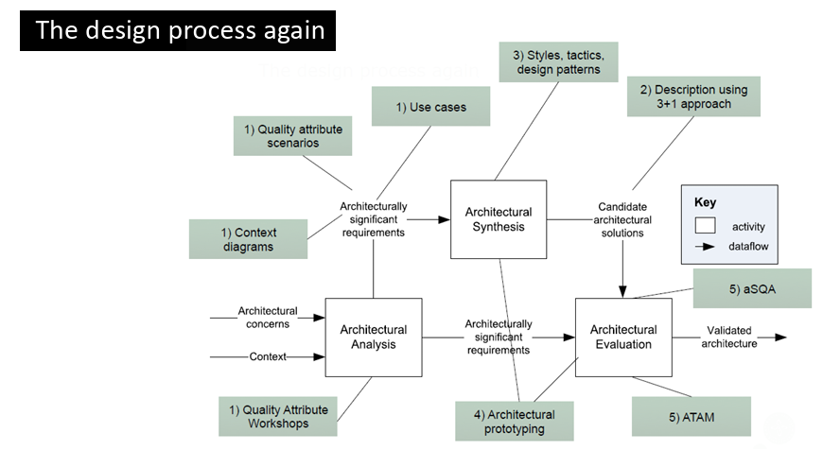
Lav en version af den her – hvor vi har highlights fra hvert punkt, som brug til eksamen.

Latest overview of top chosen items from backlog
Updated: 07.05.2025
- We need to make every decision regarding database. Example: Do we have 1 database that external bookmakers update, and then another read-only replica database that the sports UI uses?
- We also need to make every decision regarding updating the user and account information, sending bet confirmations, etc. In short, all the work that happens AFTER a bet has been successfully made and received back from the external bookmakers.
- We need to make decision regarding user settings, such as setting odds-variance-threshholds.
- We need everything regarding specific site-relevant information on specific bookmakers, such as how check of a bonus on another bookmaker, happens already in our UI before placing the bet.
- We want to look more in-depth into the combo-solution
- We want to zoom in on the event broker as well and make a prototype

Ideas related to business

Fictitious project
10.02.2025
We have made some fictitious assumptions, to make this project interesting to work with.
- All danish bookmakers have agreed to be part of BestBets.
- All bookmakers already have some API for placing/canceling bets.
- There are no legal troubles, such as not complying with various laws from Spillemyndighederne
- Transfers can be made between various bookmakers, and our own bank, as to avoid the restriction of “transfers must be through a MitId provider og NemKonto”.
Conclusion 17.02.2025: This project only works if the business is fictitious. It wouldn't be desirable for the stakeholders in the real world life. Imagine Bet365 giving major parts of their business to some tiny new bookmaker, who undercuts them by 0,001

Should we be a bookmaker, or only an aggregator?
10.02.2025
- If we are an aggregator showing the "best odds", it would be tough for us to take a margin, as that margin would possibly reduce the odds such that it isn't no longer the best odds, only due to our cut.
- Alternatively, we could do something like a subscriber model for our product. But i suspect that people would quickly calculate that as a percentage cut of their winnings as well, and therefore again reduce the chance that the customer would perceive it as the best odds available. Therefore, we think it would be easier to take a cut, on a service usually not available on other sides, which is acting as a stock broker just for betting. Meaning that people themselves would be able to open a position on some bet, and therefore act as the bookmaker themselves, for other people to buy their odds. This would cost a fee, quite similar to the ordinary fees one pays on the stock market.
Conclusion / What happened (04.03.2025): We are mostly an aggregator. We don't act as our own bookmaker, BUT we do allow our customers to act as individual bookmakers through our site, known as “community bets”.

Does this concept give a total increase in new customers across betting sites, or does it eat from the existing customer base.
10.02.2025
- So one of the biggest podcasts our there from Conan O' Brian, who is mainly on Spotify with audio only. They are now experimenting with putting episodes on Youtube with video as well. But they are afraid that it won't give more customers, instead people will migrate from Spotify to Youtube. This is a concern for the betting vendors as well, where there are mainly two scenarios:
  - Best case: Some customer who only uses X, instead now uses our platform and therefore indirectly ends up using A, B, C, D.... who never had a chance before to be used by this customer. They all see an increase, because this customer who now have more options and advantages starts betting 250 % more. So even though site X will see a decrease from this customer, there might be other customers who only uses A, that will now also start using X.
  - Worst case: Some customer who only bets 50 kr. each month on X, will now still only place 50 kr each month, but now on A, B, X. Thus no additional revenue would be added to the pot.
Conclusion (17.02.2025): We realized this case has too be fictitious, as it doesn't make real-world sense. For example, there is no way Bet365 is going to give their huge market share, to some little unknown bookmaker, that undercuts them with 0,001% - As such, these business decisions doesn't always have to make sense, as the SOLE reason we made this project, was because we found it to be architectural interesting, and not as a real feasible interesting company.

Should our concept only serve sport?
10.02.2025
Most of these sites also have:
- Bingo
- Casino & Live casino
- Poker & other card games
- Raffles
- eSport (One might claim they are the same)
- Quizzes and giveaways
While these might make sense in our business scope, it will be too much for this 1 year project, therefore we only focus on sport - not because it is the best choice, but it is feasible within our scope of this course.
But alternatively, we can implement casino easily through casino providers. So ALL of the betting sites we checked with danish license (42), all used external casino vendors, such as pragmatic.com As such, we can easily an efficiently have a casino page as well, using external vendors. There is no "down-payment", as we act merely as affiliate, and get a provision from the vendors. This might be of conflict for our own betting site key partners, as if they start using our site, the potential income generated on slot-machines, will be reduced from our partners, as we eventually eat their customers. Alternatively is we don't provide casino (slots, live roulette etc.), as to please our key partners.
Conclusion / What happened (17.02.2025): We limit ourselves to sports bets for this project.

Special offers & bonuses
10.02.2025
Is it feasible for our site to have offers, such as a welcome bonus?
This might be rough, because that would give the customers multiple stacked welcome bonuses, one from our site, as well as one from the site they are placing the bet on.
Or they might have to be designed in a smart way, we currently can’t think of.
Conclusion (07.03.2025): No, we shouldn't try hard to become our own bookmaker, with too many of our own bonuses. We should mostly be an aggregator for other bookmakers, and let them come with their own bonuses.

Follow the best users, opt-in, always on, or never show?
10.02.2025
Should we allow people to see the most successful users so they can mirror their bets? If so, should this feature always be on, or something the user opts for.
Conclusion (17.02.2025): This would make the project out of scope – we are not going to focus on these parts through diagrams and analysis. This is mostly interesting in the future, after all base features exists.

We must show betting limitations
10.02.2025
The UI must show the limitations of bets. "This bet gives odds 1.8 but max bet amount is 75kr."
Conclusion (17.02.2025): Makes sense, as it is a safety requirement that people can't use money that doesn't exist. We have added to the account overview UI mock-up columns for bonuses.

Legal concerns
10.02.2025
There must be compliance of "Rofus" and "Stop Spillet". Furthermore, there must be a timer that makes the user aware of their time spent betting. All of these and additional requirements from Spillemyndighederne must be implemented.
Conclusion (01.03.2025): As also seen through our QAW, then Spillemyndigheden is a stakeholder, where we MUST abide. For this project, it mostly means adding it in the UI mock-ups.

Separate withdraw-able cash and bonus
10.02.2025
Bonus money staying in the betting site acts differently than cash that can be withdrawn directly. The site must display how much is bonus and how much is not.
Bonuses must remain on the bookmaker, and can’t be transferred to our site.
Conclusion (17.02.2025): Added to UI Mock-up.

Forum
10.02.2025
Having a forum on the site will act as marketing when users encourage each other to place bets.
Conclusion (17.02.2025): Out of scope for this project.

Streaming
10.02.2025
We could use streaming through for example bet365 so users who want to watch matches live can be satisfied, without having to invest in our own streaming setup with people filming the match.
Conclusion (17.02.2025): Out of scope for this project.

BetBørs is apparently already a thing
10.02.2025
Our “community bets” idea already exist on BetFair. We thought it was a unique idea. Even though it already exists, we are going to continue with the idea, as we think the idea is great for showcasing various software architecture concepts.
Conclusion (01.03.2025): Added to UI mock-ups.

International
10.02.2025
Could this be expanded to be used outside of Denmark? Could this site easily be operated in USA as well?
Conclusion (03.04.2025): Out of scope for this project.

Two customer profiles
10.02.2025
We actually have at least two customer segments.
- Users who want to bet.
- Bookmakers. Imagine a newly created bookmaker, who wants to make a splash and quickly attract new users. They could sign up through us, and “out-bid” other vendors with odds, to quickly reach a massive audience.
Conclusion (17.02.2025): Shown as a stakeholder in the QAW

EU wallet
10.02.2025
Should this site serve EU customers, through the newly EU created product “EU Wallet” – This means that we should alternatively mark our diagrams as “MitID / EU Wallet”.
Conclusion (17.02.2025): We just follow what our stakeholder Spillemyndigheden demands. But this is not shown in any diagrams, except the wording “MitId”, which in the future could be updated to “EU Wallet”

Where is the money
10.02.2025
Having them place money on our site makes it easier for the user to just put 200 and then bet where ever, instead of having to place 200 on multiple site. The down side is that we now need to handle security and all the behind the scenes transactions. But this idea proposal, is one of the key differences between just “googling the best odds” and having a central betting platform, taking care of various quirks, such as minimal down-payment for the customers.
Conclusion(04.03.2025): We included a bank to our architecture so we can hold the money, this way the user does not need to deposit money on every site.

Cancel bets
10.02.2025
Users should be able to “cash out”, cancel their bet, etc.
This system should work very similar to placing bets, such as getting rejected and prompted in case they are trying to cash-out and the odds have changed during the process.
Conclusion (04.03.2025): The microkernel can forward cancel requests as well as bet placement requests.

Diagram showing bounds of our own bank connection and various payment providers
17.02.2025
It can be a bit confusing, when and where the user is going directly through our banking connection, and when the user is going through a payment provider such as Visa & MasterCard.
Such as, what is the trace of money, when a user:
- Deposits money
- Places a bet
  - The bet loses
  - The bet wins.
- Withdraws money
Conclusion (04.03.2025): Has been added to UI-mockup and informal diagrams, but still needs a great proper UML diagram.

Statistics
17.02.2025
Most sites support statistics, such as RTP on a specific feature that last X days. We should show general statistics, such as RTP, win-rate, etc.
Conclusion (04.03.2025): Out of scope.

Ideas related to patterns

Pattern for placing bets through many different bookmakers through our site.
10.02.2025
We need a system that handles our external bookmakers different processes, as to minimize the pain of the user, needing to create a profile on multiple sites.
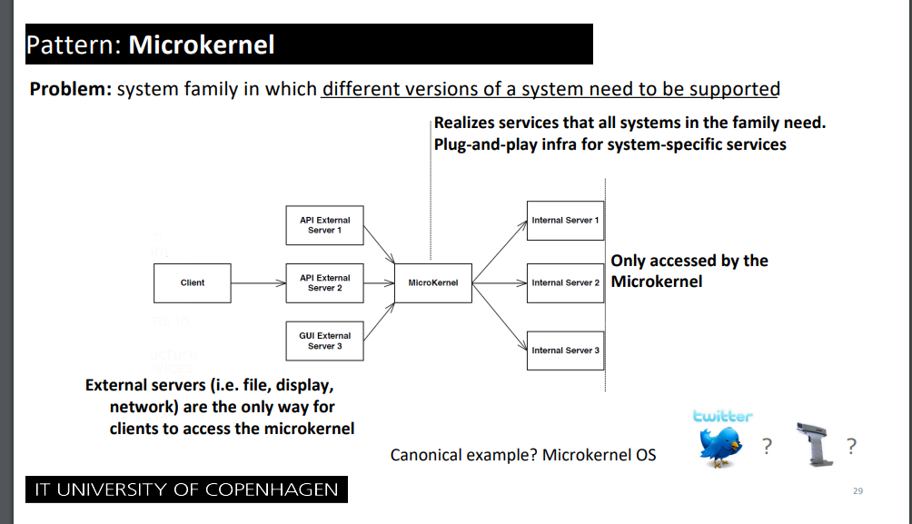
Conclusion / What happened (04.03.2025): Implemented in our diagrams.

For trigger order like a stock broker, when odds reach X < Y
10.02.2025
If a user wants to place a bet on a match reaching above 2.0 in odds (trigger order), it needs to be done quickly before the odds change. Thus the customer should “subscribe” to a match, where the “publisher” is the odds. If odds reach a certain threshold, the subscriber pipeline should automatically place the relevant bets.
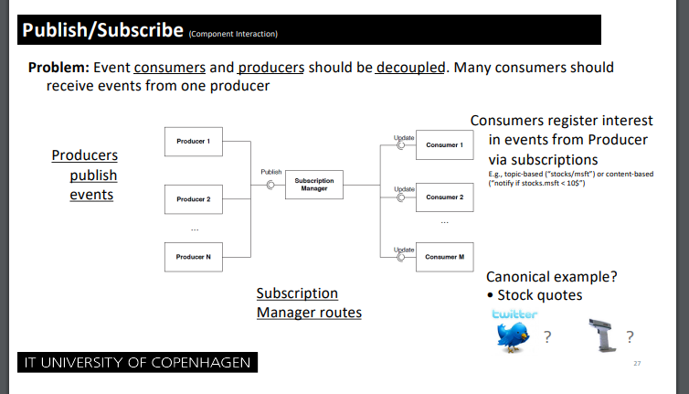
Alternatively, we want to also look at:
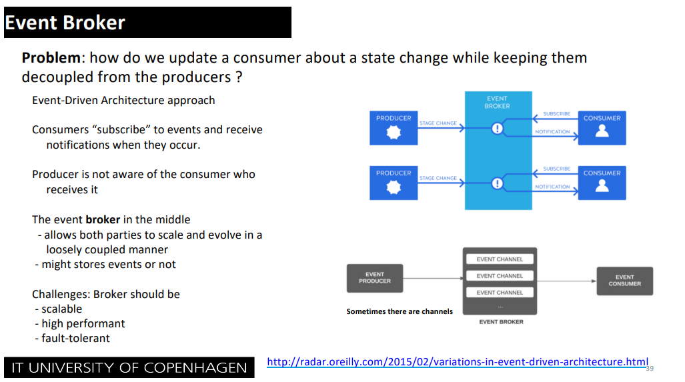

Conclusion (03.03.2025):
We decided to go with:
Trigger orders uses Event broker. The producer are “the changed odds on events”, and subscriber are the customers placing trigger orders.
This will then get forwarded to our Microkernel responsible for communicating with the different Actor models using message passing to attempt to place the bet for the customer and handling errors in case the odds have changed, by checking the odds-changed-treshold on the customer, and reattempts if within border, otherwise cancels – acting as a “transaction”.

Database setup - What happens with the database? How many databases? Separate datebases for separate concerns?
03.03.2025
We could envision something like this:
1. Bookmakers update their odds.
2. The updates odds gets sent to our API endpoint, which updates our odds database.
3. The odds database could have a replicated read-only database.
4. Our sports-overview uses only the read-only version.
If so, what do we actually gain from this – we need to prototype this.
So 1 database that takes updates from external bookmakers, and another read-only database for showing general sport odds in the UI? And if so, what should the consistency be? For example, can the odds be 10 minutes behind real-life odds for the UI? What is an acceptable range.

We still need to make every decision regarding the database
06.05.2025
Such as should It be replicated? Which database? What happens when an external bookmaker calls the odds updater endpoint. Do we have multiple databases, such as as database that allows read/write for updating, but then another read-only database that is used when the user wants simple overview of odds for football.

We need to show a diagram for what happens AFTER a placement is made
03.03.2025
Such as updating account information, sending confirmations, etc.

How should the load balancer approach safety and modifiability concerns
05.03.2025
If we choose to use a load balancer instead of an actor model we sacrifice modifiability and safety. How do we ensure that it doesn’t become too much a problem. How should we handle errors and new bookmakers?
Conclusion: After prototyping, we figured out a combination solution would be good. A load balancer placed in front of an actor model system. The load balancer ensures performance, whereas the actor model system helps with safety of getting a single bet placed correctly in a proper time.

Compare actor model against alternatives
05.03.2025
Experimental prototyping will reveal more about whether the overhead of actors will be worth the benefits.
Conclusion / What happened (10.03.2025): See section about architectural prototyping.

Ideas related to tactics

Availability
10.02.2025
We need to monitor the health of a lot of different external sites, and should use tactics such as “heartbeat”
Conclusion / What happened (04.03.2025): Added in the tactics section for deliverable 2.

Should we prioritize certain bets?
03.03.2025
Such as, should a bet placement of 1,1 million be prioritized above a freebet of 50 kr.
If so we might want to look at: Tactic: Performance: Control Resource demand: Prioritize events.
Conclusion / What happened (04.03.2025): Added in the tactics section for deliverable 2.

Discarded decisions

Placing multiple bets at once from different bookmakers with a scenario where one fails
10.02.2025
On ordinary betting sites users can place multiple bets “in a package”, where the site is able to reject the whole package if one bet fails (such as a rapid change in odds). Our system will not be able to handle this, because the package might contain different sites, and as such we can’t cancel a bet on site A, if a bet fails on site B. As such it would be easier to not support package bets on our site.

Data-scraping
11.02.2025
We are not going to do data-scraping. If we do data-scraping, it would be hard to actually place bets on the respective sites, without proper confirmations etc. It would also be insanely resource intensive, to data-scrape a bunch of sites and also expect data to be completely fresh for the user. To avoid complications of legal situations and latency, we are going to make an assumption, that all bookmakers are willing to participate and already have an API giving the necessary data.
Conclusion (17.02.2025): This is a fictitious case, where we pretend all the bookmakers have the proper needed API's for this to work.

