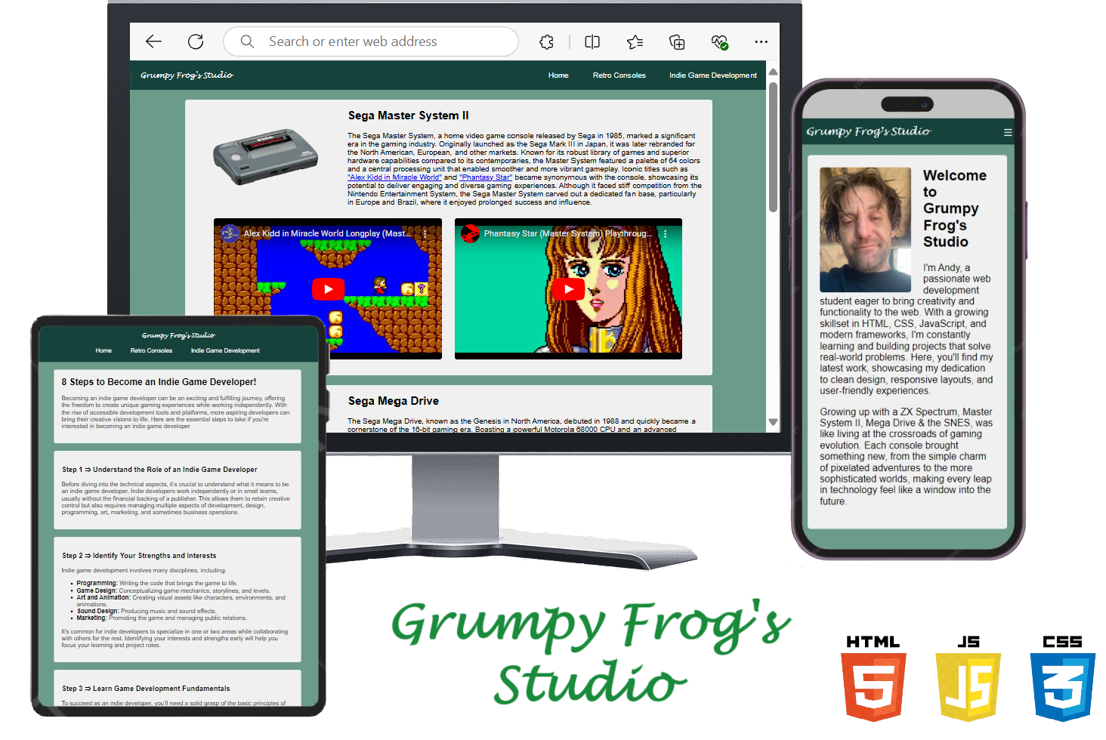

TABLE OF CONTENTS

- Project Goals
- User Goals
- Site Owner Goals

- User Experience
- Targeted Audience
- User Requirements And Expectations
- User Stories

- Design
- Design Choices
- Colours
- Fonts
- Structure
- Wireframes

- Technologies Used
- Languages
- Frameworks & Tools

- Features

- Testing
- HTML Validation
- CSS Validation
- Device testing
- Browser compatibility

- Testing user stories
- Navigation Bar Responsiveness
- External Links
- Videos
- Peer reviews

- Bugs

- Future Features

- Deployment

- Credits & Acknowledgements

1. Project Goals

User Goals
Users will be able to connect with a skilled web developer to support their project needs while also learning more about my background and expertise. Additionally, users can explore insights into retro game consoles and popular games from their release era. For those interested in game development, educational articles will provide valuable information on what it takes to enter the field.

Site Owner Goals
The primary objective of my website is to attract new clients, as well as engage returning clients, who are seeking assistance with web development projects. The site to serve as a professional platform where potential clients can easily contact me about their project needs. It is also to function as a portfolio, showcasing my previous work to demonstrate my expertise and range of skills. Additionally, the website offers an opportunity to share my personal interests within a specialized niche, allowing visitors to explore topics I'm passionate about, such as retro gaming and indie game development. Ultimately, the site aims to create a space that blends professional services with engaging, relevant content, positioning it as a valuable resource for both clients and enthusiasts.

2. User Experience
Targeted Audiences
This website is designed to reach a wide and diverse audience, welcoming people from all backgrounds and locations worldwide. Whether you're a professional, an aspiring developer, or simply someone with a passion for technology or retro gaming, the site offers valuable content and services to suit your needs. It caters to anyone looking for web development support or seeking educational resources on game development. The platform is open to all, even extending its welcome to extraterrestrial visitors with a curiosity for technology and gaming. The aim is to build an inclusive, engaging space that inspires creativity and connection for a global audience.

User Requirements & Expectations
Users expect a website that offers a simple and intuitive navigation system, with a clear menu at the top that organizes content into relevant categories. The site should feature a balanced mix of text, images, and videos to keep visitors engaged, ensuring that all links are functional and nothing is broken. A well-organized structure is essential, allowing users to easily find the information they need. Additionally, the website should provide a straightforward way to contact me regarding their projects, and it must include accurate, educational content to meet user expectations and build trust.

User Stories (First time user)
As a first-time visitor to the site, I want to easily discover key information about the range of development skill sets available. I expect the content to be both accurate and engaging, allowing me to rely on it as a trusted resource. Additionally, I would like the information to be presented in a visually appealing and well-organized format, making it easy to digest in bite-sized sections for improved readability and user experience. This ensures that I can quickly understand the services offered without feeling overwhelmed.

User Stories (Returning User)
As a returning visitor to the site, I would like to see regular updates on new projects being developed and easily access fresh content. I want a simple way to contact the owner or developer to inquire about potential projects or discuss ideas I have in mind. Additionally, I would like the ability to provide feedback and request specific topics or information I’d like to see featured in future updates. Having a space where I can engage with the site and contribute my input enhances my experience and keeps me coming back for more.

User Stories (Website Owner)
As the website owner, I want the site to serve as a platform where I can showcase the projects I have successfully completed, giving visitors a clear sense of my capabilities. I also aim to provide sneak peeks of ongoing projects and share exciting details about upcoming work. The site will offer a convenient way for potential clients to reach out to me, as well as a space for like-minded individuals to connect over shared interests. Ultimately, I want to build a community where users can engage, collaborate, and explore topics we are passionate about together.

3. Design
Design Choices
The design of my website has been carefully crafted to balance simplicity, elegance, and functionality. The primary goal was to create a user-friendly experience, ensuring that visitors can easily navigate through the site without feeling overwhelmed. The clean and organized layout allows users to quickly find relevant information, while the visually appealing design elements contribute to an overall sense of professionalism and sophistication.
In addition to its aesthetic qualities, the design has been built with scalability in mind. The structure is thoughtfully planned to accommodate future updates, allowing for seamless integration of new features, content, or projects without disrupting the overall flow. This forward-thinking approach ensures that the site can evolve and grow over time while maintaining its high standards of usability and design integrity.

The site's colour scheme was selected to complement its structure. The design incorporates five distinct colours or contrasts, chosen to enhance readability without causing eye strain. This approach ensures that the different sections are visually clear and well-defined, aligning with the overall emphasis on simplicity and ease of use.

Colours
- Body Background : #6A9C89
- Header & Nav Container : #16423C
- Brand & Nav Links : white
- Hover Effect : #ff6347
- Container Background : #f0f0f0
- About Me & Contact Me Background : #C4DAD2
- Submit Button : Background Colour : #4CAF50, Text Colour : white
- Footer : Background Colour : #16423C, Text Colour : white

Fonts
The website employs two fonts: Arial and Lucida Handwriting. Arial is used for its clean, modern appearance, while Lucida Handwriting adds a touch of elegance and personality. The bold / strong text features were utilized to highlight important information and maintain consistency with the site’s overall design structure. This careful selection of fonts and typographic elements ensures a cohesive and visually appealing user experience.

Structure
The website is organized into three pages, each featuring a consistent structural layout to ensure a seamless user experience. The homepage offers a brief welcoming introduction and provides information about me, including a direct contact form for user inquiries.
The second page is dedicated to retro consoles and games that I enjoyed during my youth, featuring strategically placed images and videos to keep users engaged and enhance their browsing experience.
The third page provides valuable insights into becoming an indie game developer, offering educational content and resources for aspiring developers.
All pages utilize a unified navigation system designed with simplicity and ease of use in mind, ensuring that visitors can effortlessly explore the site’s content.

Wireframes
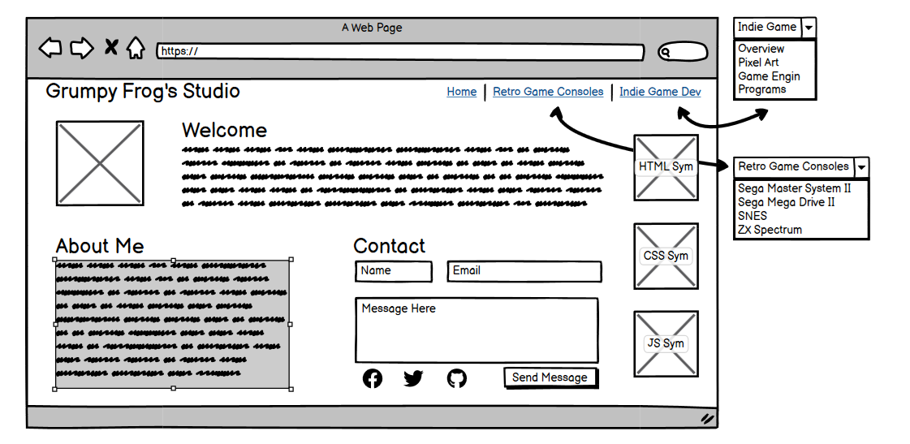

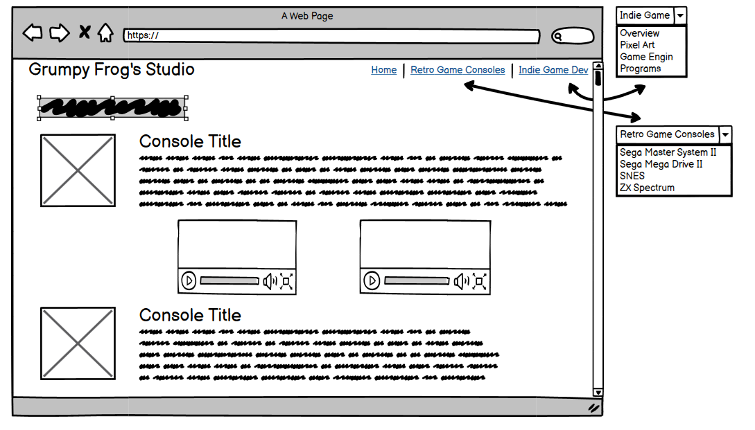

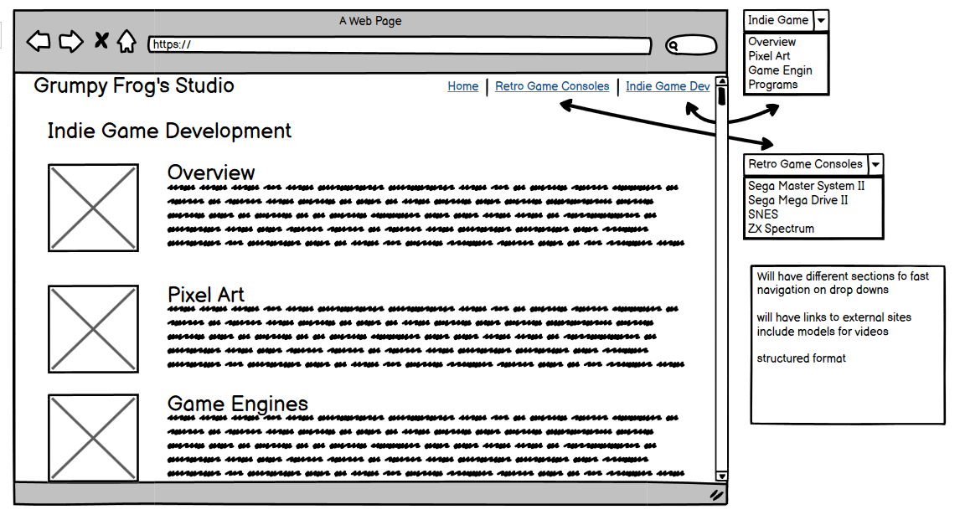

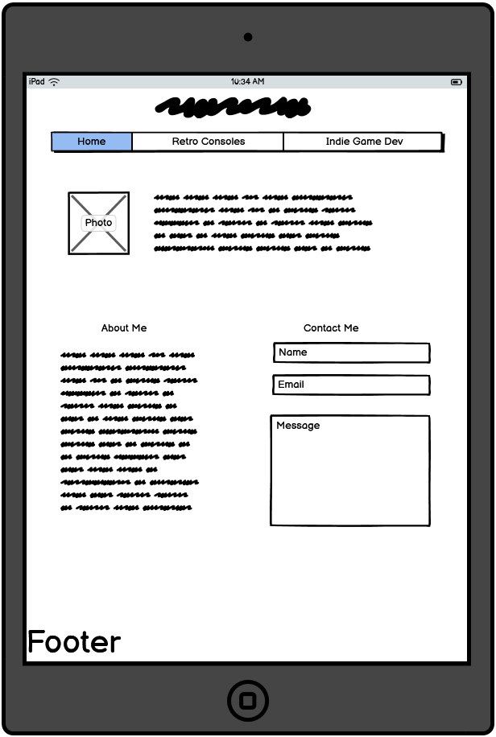

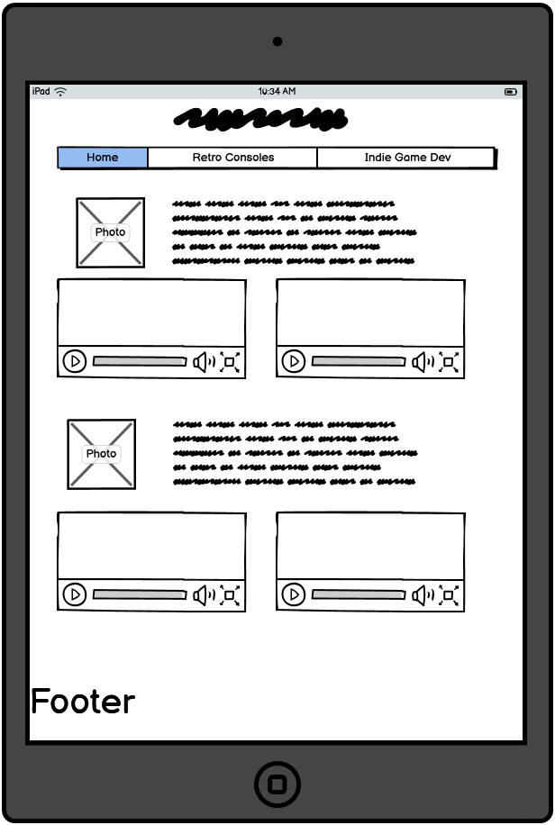

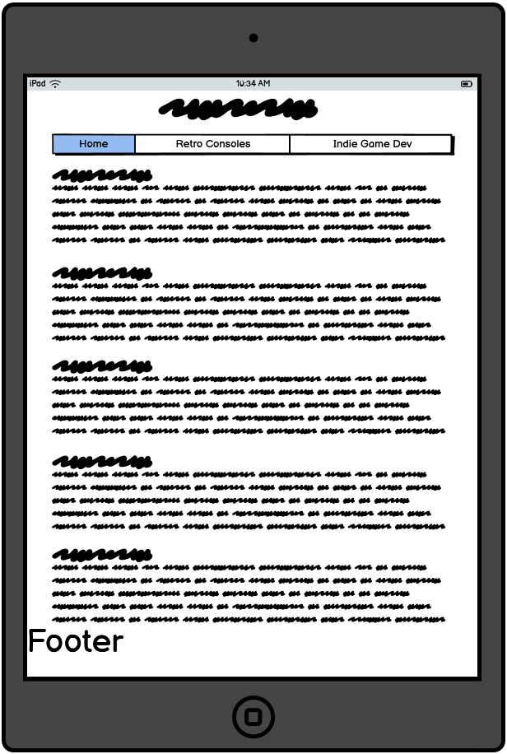

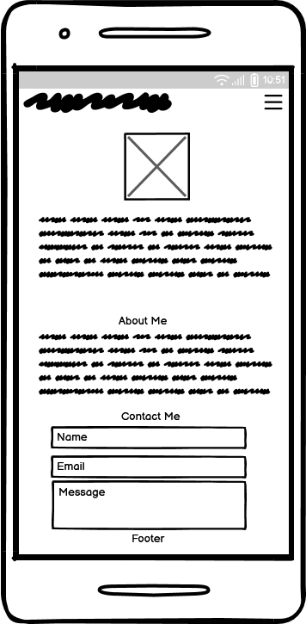

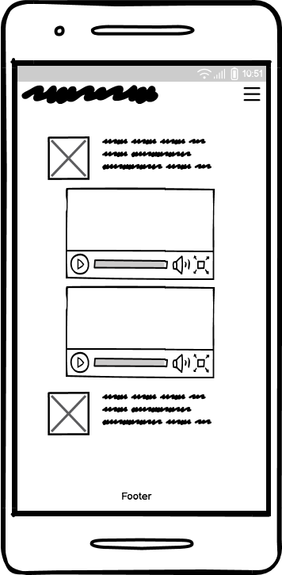

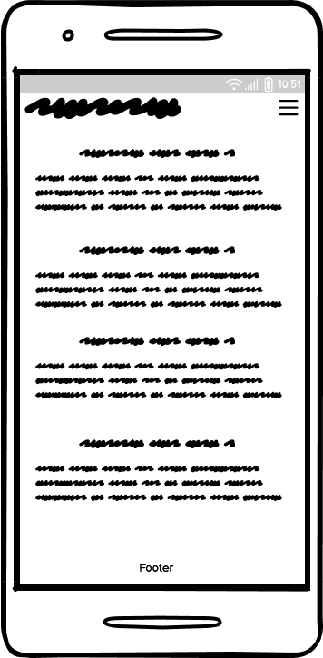
4. Technologies Used
Frameworks & Tools
- HTML
- CSS
- JS
- GitHub
- Sublime Text
- Paint
- Code Institute
- Balsamic Wireframes
- ChatGPT
- Microsoft Edge
- Google Chrome & Search Engine
- You Tube

5. Features
Brand
My brand for the website is what I plan on calling my business “Grumpy Frog's Studio”.

Navigation Bar
I built a custom navigation system for the site. It is fully responsive for desktop, tablet and mobile based on the most popular screen sizes in 2024. On desktop the brand is on the left and page links are on the right displayed inline. On a tablet the brand sits above the page links which are displayed inline and all are centred. On mobile devices the pages links toggle to a hamburger icon, where I used the HTML Entity while the brand sits on the left. The navigation bar also has a hover feature.

Welcome Introduction
An introduction to me and and what my website is about, with a photo of me. I feel that this was a good way to introduce myself.

About Me
Gives the user some more general information about myself

Contact Me
This is a form that the users are able to contact me, about work they need doing, future articles they would like to see, or just to give general feedback or suggestions.

Videos
The website comprises of several videos, this is to keep the users interested and allows them to engage with the website

Information Snippets
There are a lot of information snippets within the site, I tried to include information that would be interesting to the user, broken down into manageable pieces that are easy to read and digest.

External Links
There are links to Wiki, which gives the user more engaging content accessibility.

Footer
There is a footer on every page, which automatically grabs the current year along with copyright to my studio name

6. Validation
HTML
I ran all my code through W3C Markup Validator to make sure it was valid HTML and they all pass with no errors or warnings.

CSS
For CSS I used W3C Jigsaw, it all passes with no errors or warnings.

Device Testing
To test the responsiveness of my site I used my web browser to change the viewing size of the site and it all seemed to respond reasonably well. There are some responsive bits that could do with improving this is mainly when the site is viewed on a mobile. E.g. the videos could stack on top of each other.

Browser Compatibility
I used Edge mainly while I was building the site to check to see how it looked and responded, I opened the site within Chrome and all seemed to be the same

7. Testing User Stories
Navigation Bar Responsiveness
The navigation bar was to be built to be fully responsive and adjust but still have full functionality. Upon testing this all works fine
External Links
External Links were put in to give the user access to more information about certain products, on testing all the links worked.
Videos
I imbedded videos in to give the site a more engaging feel, the videos all work as they were expected to, the user has full functionality of the videos e.g. can play, pause, turn sound on and off & view on YouTube.
Peer Reviews
After building my site, I showed it to a couple of family members. Their feedback came back as it was easy to navigate with a good simple layout, quality and engaging information.

8. Bugs
With the testing that I have done I have not come across any bugs that I could see, this is not to say there are not any.

9. Future Improvements
Plans for future improvements are:
- Make the site more responsive across different devices. Example:- Make the retro game videos stack and resize.
- Add more content, to keep users coming back.
- Add Social Media links

10. Deployment
- I have uploaded my site to GitHub.
- I have included meta tags that should make my website more searchable within search engines, this is to include description, author & keywords.
- Future Deployment would be, to have its own domain and have full functionality of the contact form.

11. Credits & Acknowledgments
ChatGPT – Summaries of game consoles
AL82 Retrogaming Longplays - Alex The Kid Video
NintendoComplete – Phantasy Star Video
FCPlaythroughs – Sonic the Hedgehog Video
World of Longplays – Streets of Rage Video
xRavenXP – The Legend of Zelda: A Link to The Past Video
Nintendo Longplays – Super Mario World Video

