Some Class Final Exam
2022

1. What is 1 + 1 ?

2. Graph the function f(x) = x

3. If you have 2 apples, how many apples do you have?

4. In a regulation basketball game, how many points is a 3 point shot worth?

5.
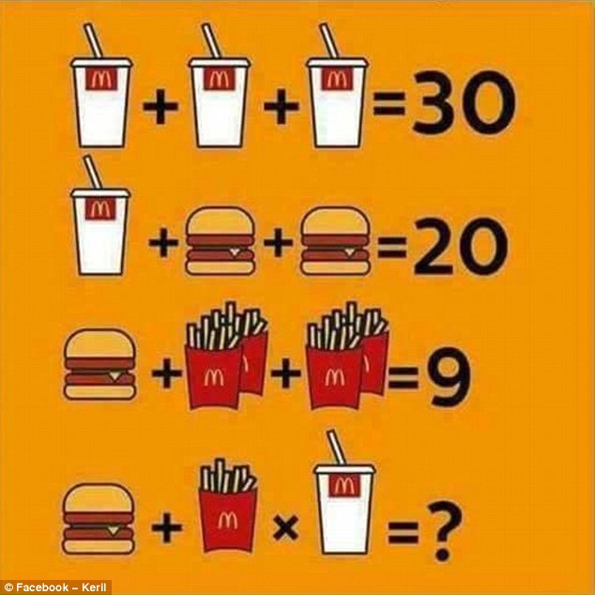

6. How many bits is 0xffff ?

