Some Class Final Exam
2022

1. A train leaves Chicago traveling west at 60 miles per hour. An hour later, at 12 noon, another train leaves Chicago traveling east at 80 miles per hour. When are the two trains the same distance from Chicago?

2. Which function increases faster as x gets very large: x^{x} or x! ?

3. Prove the Pythagorean Theorem.

4. When Was Russia's “Red October” Revolution?

5.
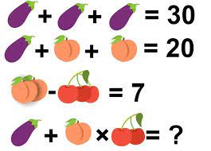

6. How many bits is 0x01_0000 ?

